shannon Wallace
1901768
Changemakers:creativity and value creation

Student name: | Shannon Wallace | Student ID number: | 1901768
Programme: | Cybersecurity and networking
Module: | Changemakers: Creativity and Value Creation
Module code: | ACCA5033 | Contribution to Overall Module Assessment (%): | 50%
Lecturer: | James Williams | Internal Verifier:
Assignment Title: | Assignment 1: E-Portfolio | Word count (or equivalent):
Submission deadline: | Sunday 6th Dec. (By 23.59pm). | Return date of provisional marks & written feedback:
Submission method: | All written assessments, where practical and possible, must be submitted via Turnitin unless otherwise instructed by the Lecturer. (Please DO NOT put this assessment specification into Turnitin or it will match many similarities with other students’ submissions.)  Alternative submission method (if applicable):  Late submission of the assessment will result in a late penalty mark. Penalties for late submission: Up to one week late, maximum mark of 40%. Over one week late, 0%. Only the Extenuating Circumstances Panel may approve a change to submission dates.
Academic honesty / referencing: | Academic honesty is required. In the main body of your submission you must give credit to authors on whose research and ideas your work is based. Append to your submission a reference list that indicates the books, articles, etc. that you have used, cited or quoted in order to complete this assessment.

Contents
E-portfolio 3
Unit 1 – Mindmap 4
Information 4
REFERENCES 5
Unit 2 – Image Based video presentation 6
Information 6
REFERENCES 7
Unit 3- Video Presentation 8
Information 8
REFERENCES 8
Unit 4 – Academic Poster 8
Link 8
Information 9
REFERENCES 9
Bibliography 12

E-portfolio
Link:
https://shannon20.wixsite.com/mysite
Screenshot:
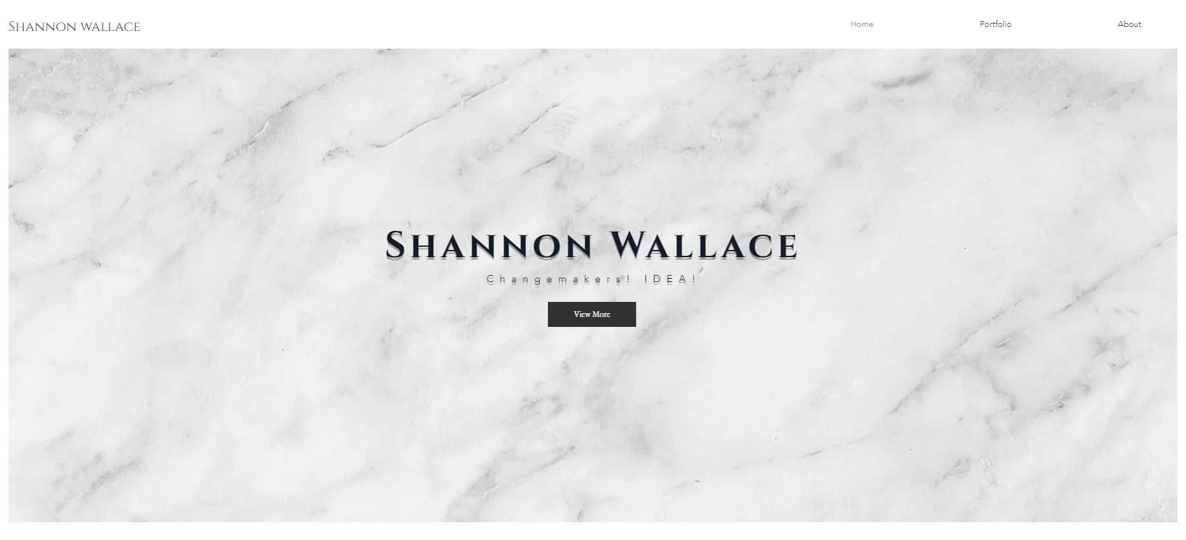
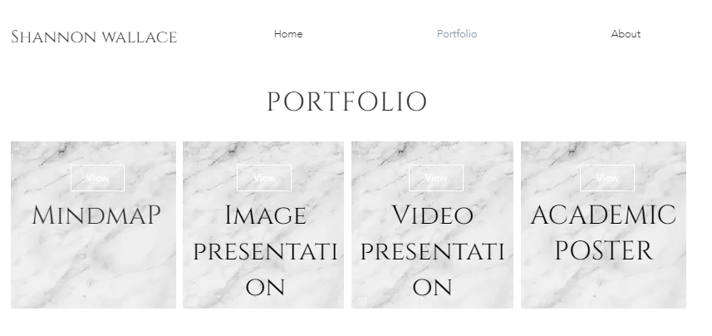
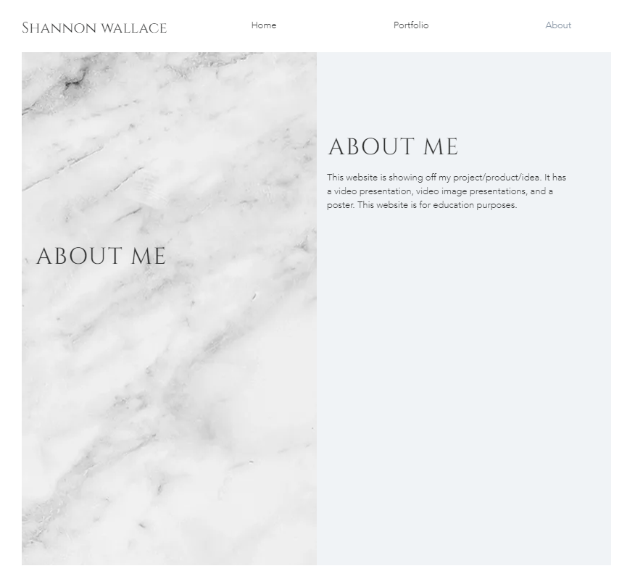

Unit 1 – Mindmap

Information
My ideas were mostly based on technology/cyber security.
I wanted my project to:
HELP PEOPLE (the main objective)
Smart technology
Secured
My ideas were 5G, Server(NAS, CLOUD ETC), and a smart mirror! I wanted to learn and expand my coding skills!
Original: mindmap LINK
Link: https://1drv.ms/u/s!AsqN4LhXntHF5GVtR4V1Rgzn9I2Q?e=pB5Nbv
https://shannon20.wixsite.com/mysite/1st-gallery
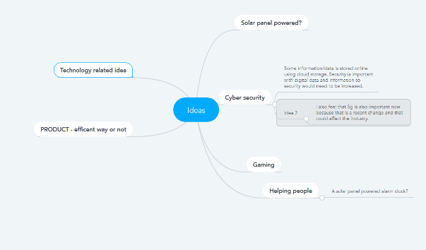
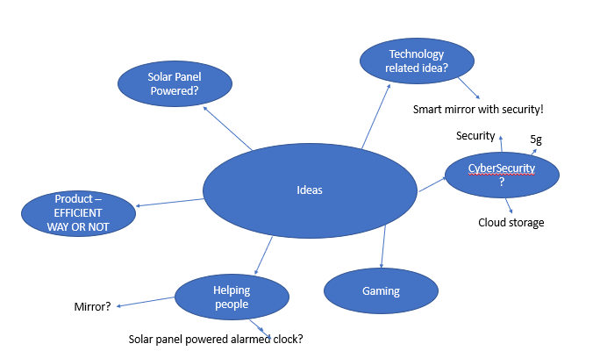
Screenshot:

REFERENCES:
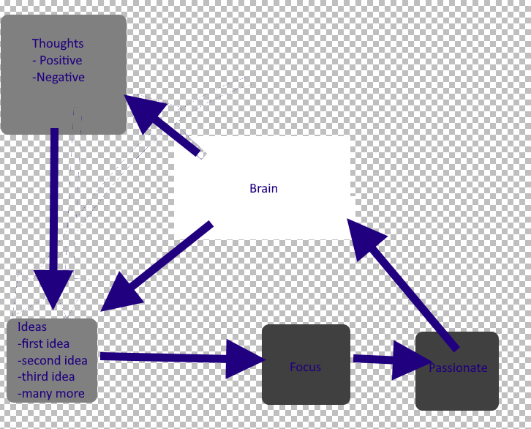
This is my mind map from unit 1. Which is accurate in what I made now as you can see above. This has helped me made a mind map which allowed me to think about ideas and something I am passionate about!
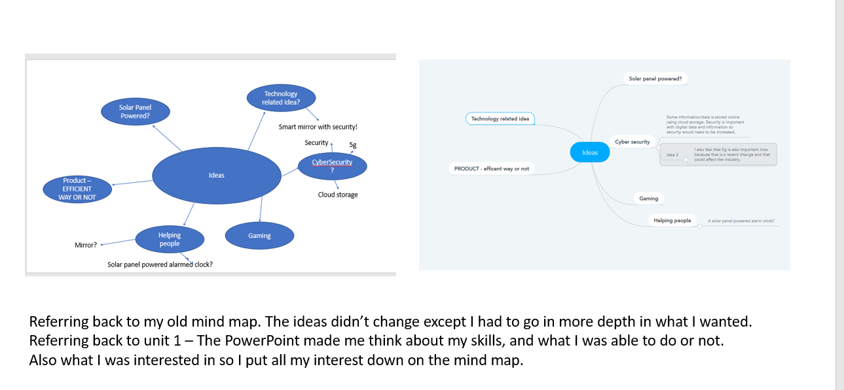

Unit 2 – Image Based video presentation

Information
This image-based presentation is me drawing and talking about my idea/project. It is 2 minutes long.
Link: CLICK HERE - references
https://1drv.ms/u/s!AsqN4LhXntHF5GiVodAnBBUZLtxw?e=jYtBlQ - references
https://www.youtube.com/watch?v=pyx5MTUtZWs – no references
https://shannon20.wixsite.com/mysite/2nd-gallery
Screenshot:
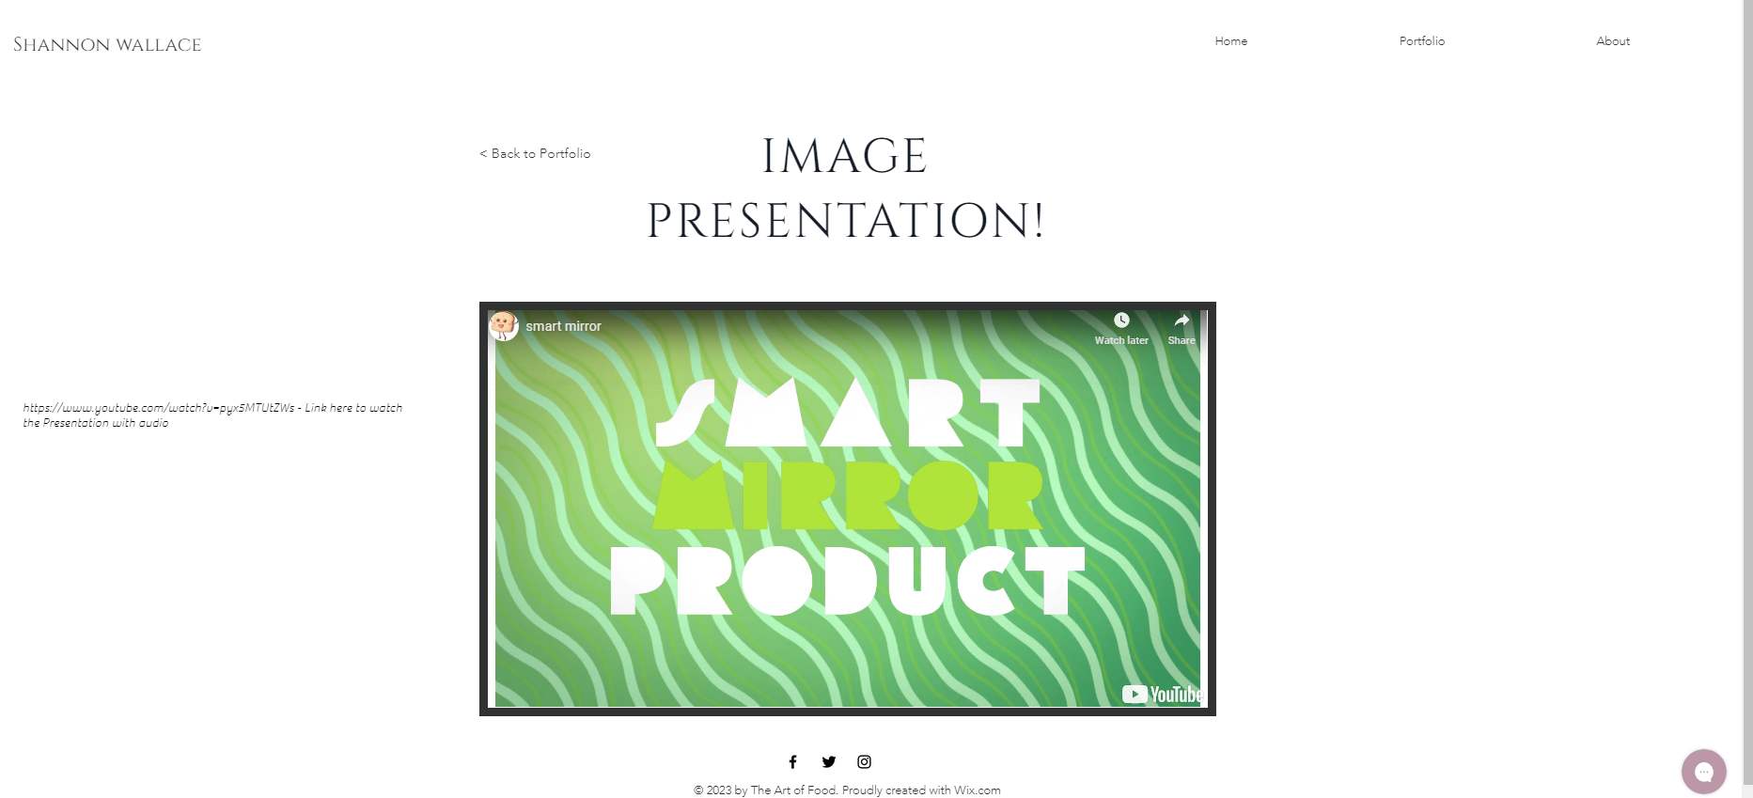

REFERENCES:
UNIT 2 allowed me to think about other creators. Also allowed me to create a “creative solution tool card” which allowed m to express my ideas, and plan what could go wrong!
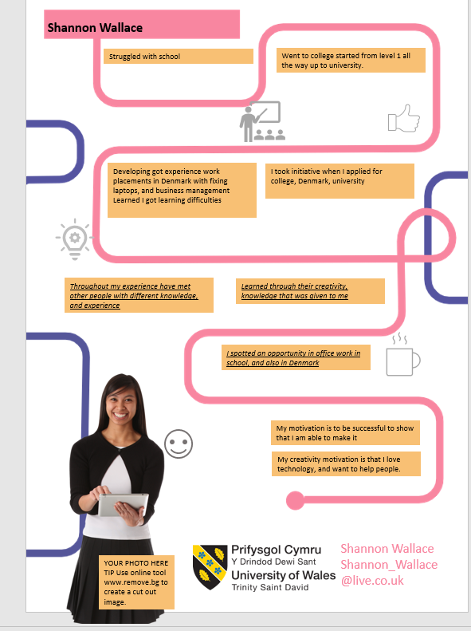

Unit 3- Video Presentation

Information
This video is general information about my idea – Smart mirror.
Link - powerpoint
https://1drv.ms/p/s!AsqN4LhXntHF5GzLMmMVGpUpz94m?e=kjbHpg – powerpoint
with audio link: https://1drv.ms/v/s!AsqN4LhXntHF5G3OjkraSkw5YSgB?e=KLvJwQ
Website:
https://shannon20.wixsite.com/mysite/3rd-gallery
Screenshot:
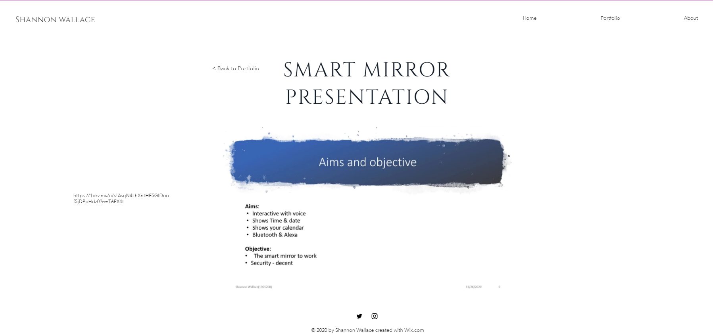
REFERENCES: UNIT 3 ALLOWED ME TO EXPERIENCE MY CREATIVITY SIDE BY ALLOWING ME TO CREATE A VIDEO PRESENTATION. It also mentions a mind map which I did talk about during my presentation. The unit has helped me create a presentation professionally.

Unit 4 – Academic Poster

Link
https://shannon20.wixsite.com/mysite/4-rd-gallery

Information
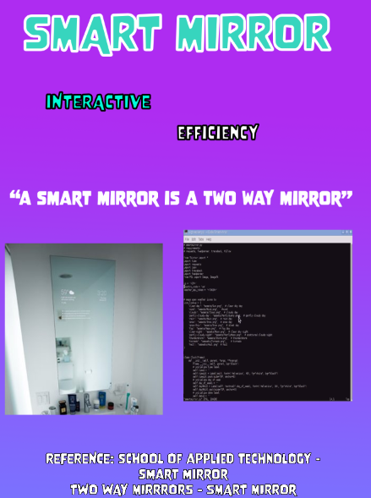
REFERENCES:
UNIT 2 ALLOWED ME TO THINK OF THE LAYOUT FOR MY POSTER, AND WHAT I WANTED ON THERE.

The poster below is what I created for unit 4. I posted some facts about Steve jobs which was from a site called biography, and some facts that were from there too
Steve jobs – image [1]
Steve was born 24th February in 1995, us [1]
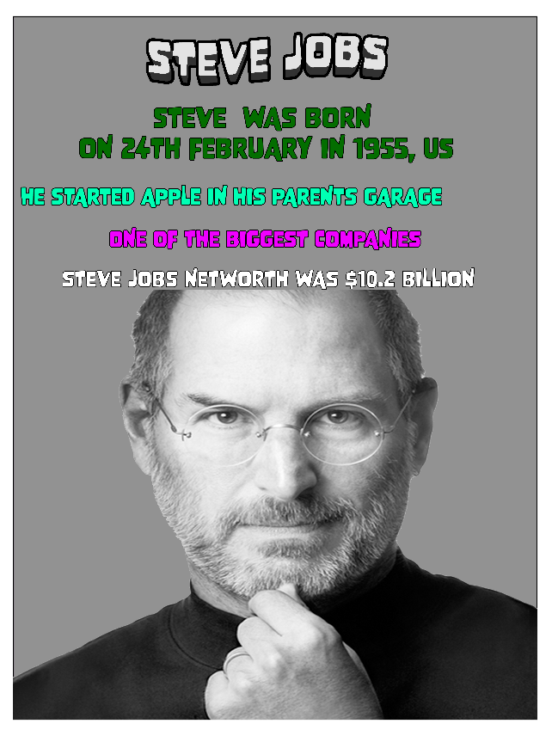
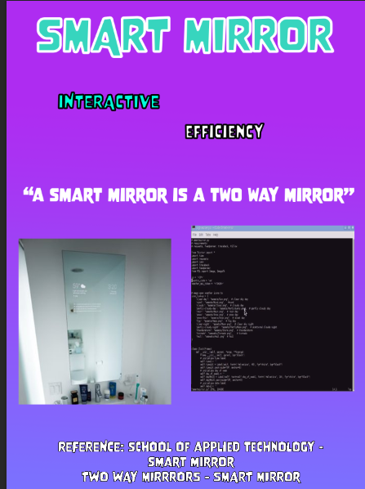

Bibliography

[1] | b. editors, “Steeve jobs biopgraphy,” BIOPGRAPHY, 2 4 2014. [Online]. Available: https://www.biography.com/business-figure/steve-jobs. [Accessed 17 11 2020].

