Module Code: BMSW4003
Digital Skills and Research Methods

The Impact of Virtual Learning Environment (VLE)

Student Name:
Student Number:
Module Name:
Module Number:
Lecturer Name:

Table of Contents
Abstract 3
Aims and Objectives 4
Research Questions 4
Literature Review 4
Primary Research 5
Methodology 5
Ethical Consideration 6
Results 7
Secondary Research 12
Limitations of the Study 13
Conclusion 14
References 15
Appendix 17

Abstract
Virtual learning has been gaining momentum in educational institutions as an integral part of academic learning. The study has aimed to understand the impact that virtual learning is causing. Thus, learning the impacts will also assist in motivating learners. Studying such a topic will also bring the benefits of it to the surface. The purpose of the study includes understand learning, its broad categories, learning management system etc. The study is qualitative in nature where 100 students are chosen randomly as respondents. After conducting a rigorous interview, observation session and survey attained data will have been shown in the form of charts and tables. It also includes some secondary research on the topic. As they are qualitative in nature, mean, median and mode will have not been shown. The most important part of the study is evaluating the perception of VLE and understanding its acceptance among the learners. As learnings are at the core of all the educational arrangements, their preferences and benefits must be at the centre of the virtual learning environment.

Aims and Objectives
The study has the following aims and objectives:
- To know whether VLE can boost the motivation of learning
- To know the acceptance of VLE and students’ perception about it
- To know some benefits of VLE

Research Questions
- What are the two types of learning?
- What is the impact of the learning management system (LMS) on virtual learning?
- What are the two categories of virtual learning environment?

Literature Review
Herrera (2017) has stated that the rapid advancement in information and communication technology (ICT) has augmented the demand for virtual education involving connectivity to students asynchronously and synchronously. Asynchronous learning is carried even if the student is offline terminating the limitations of time and distance. Here the course work is given through email or some other means. To the opposite, synchronous learning goes on a real-time basis involving videoconferencing. Skype is one of the tools available for synchronous learning.
Virtual learning is the use of information technology for distant learning aiming improvement in the education process. Kasim and Khalid (2016) have identified the learning management system (LMS) as an integral part of the virtual learning environment. This system provides materials for e-learning and establishes connectivity among students and teachers. It is also used for creating study contents and conducting tests. Some of the tools for virtual learning include Moodle, Blackboard, Edmodo etc. Using such software, a simultaneous discussion can take place where teachers make a group for different classes. Every group has their code and without access, an outsider cannot view any discussion.
Chen (2016) has classified VLE into two broad categories. Firstly, an institution oriented VLE with software sold to educational institutions to conduct virtual classes. Secondly, the teacher-led VLE which is free to use. Such teachers sometimes may find it time-consuming. However, institution led VLE is more convenient in term of the overall facility as it comes with greater usability and utility for both class and test purpose. Teacher-led VLE demands higher work with a certain degree of technical expertise to operate. Though they can make own task based on their own choice and applicability.
Cassidy (2016) has commented that the combined availability of text and audio-visual or multimedia works as an excellent platform for learning study materials. The digital format of such materials has made sharing, storing and downloading easier using high-speed internet, computer, smartphone. VLE has got the attention of both teachers and students on multiliteracy perspective. It has complemented the efforts of the teachers with the arrival of technologies. To generate the most of the benefits out of the virtual learning environment, the virtual teaching is required to be informative, communicative and productive. The learners should be given the scope to demonstrate their skills and abilities.

Primary Research
This research includes both primary and secondary data. The primary research data have been collected directly by interview, observation and questionnaire-based survey. The interview was conducted through virtual mean. The questionnaire is included in the appendix.

Methodology
Method: The research has followed qualitative methods where questions are answers abruptly with significant insights within. Later, those questions will be analysed and briefly justified. The research will also have graphical representations of the responses by using charts accumulated from the participants for greater understanding (James, et al. 2016).
Sampling method and sampling size: Random sampling was used in collecting the data through the survey. It means a large pool of students has an equal possibility of being selected as a participant for the study. The number of participants taken for this study is 100. They are students having experience with the virtual learning environment.
The survey will be conducted based on a structured questionnaire. The questionnaire has different types of questions; it includes the closed-end question, open-end question, Likert scale question and a multiple-choice question. The data presented here is collected through virtual mean as due to coronavirus face to face interaction cannot take place. Interviewing and observing the focus group also lead to some information.

Ethical Consideration
According to Barton (2016), while conducting the research, the participants must be free from any type of harm and harassment. They have not faced any pressure while answering the questions. Their full consent has been taken before the participation and the purpose of the research has been informed to them. All the required measures for the protection of their privacy and confidentiality will be preserved. The anonymity of the participants has been maintained and they have not been deceived about the aim and objectives of the research. All other types of transparency and ethical practices have been duly maintained.

Results
Question 1: What do you think about the impact of using technology in the learning process?

Answer | Number of Respondents | In per cent
(a) Positive | 84 | 84
(b) Negative | 11 | 11
(c) Not Sure | 5 | 5
Total | 100

Most of the participants (84%) echoed that virtual learning using information technology has enriched their learning process as they now can get access to all type of information easily. Availability of high-quality learning materials through virtual platforms is helpful along with the real-time class. 11% of respondents viewed that learning solely virtual means is not that much effective comparing to direct face to face interaction of learning (Eskandari and Soleimani, 2016). They prioritised physical presence as the most important requirement for learning. Remaining 5% was ambiguous and could not provide any concrete response.

Question 2: Does the use of technologies ensure a richer learning experience?

Answer | Number of Respondents | In per cent
(a) Yes | 88 | 88
(b) No | 12 | 12
Total | 100

In this question, participants were given yes and no option; most of the respondents think that they have experienced a mentionable improvement in their learning than the conventional system of learning. They said, virtual learning gives them greater flexibility and removes challenges caused by distance and time (Alam, et al. 2017). 12% of the respondents believe that though virtual teaching has some positive aspects, it lacks real interaction students may get distracted from the study easily. Moreover, they fear that lack of direct supervision of the teacher due to virtual condition, learning may get disrupted.

Question 3: How do you describing your experience while using VLE?

Answer | Number of Respondents | In per cent
(a) Satisfactory | 71 | 71
(b) Problematic | 14 | 14
(c) Disappointing | 4 | 4
(d) Moderate | 11 | 11
Total | 100

The majority (71%) of the students expressed that the existing experience that they get from virtual learning is satisfactory and there is no need to introduce any major changes to it. While 14% complained that they found existing available approaches as problematic; they faced various problems related to technical, understanding and orientational of the existing virtual system. 4% believe that there is urgent improvement needed to be conducted to improve the experience of virtual learning to make it more attractive and interactive (Rienties and Toetenel, 2016). Rest of the participants think the existing system of virtual learning as fair enough.

Question 4: VLE has increased your capability as a learner- to which extent you agree with the statement?

Answer | Number of Respondents | In per cent
(a) Strongly Agree | 38 | 38
(b) Agreed | 42 | 42
(c) Disagree | 11 | 11
(d) Strongly disagree | 3 | 3
(e) Neutral | 6 | 6
Total | 100

In this Likert scale question, 38% of students strongly responded that VLE has improved their overall competence as learners as they have attained direct benefits due to virtual learning in their life (Mosquera, 2017). 42% of the students also think similarly. 11% of the respondents do not believe that virtual learning has brought a mentionable change in their overall competence as learners. 3% of the students have strongly opposed to any visible improvement in their competence, especially by virtual learning. The remaining 6% did not give any clear answer as they neither have any specific outcome due to distant learning nor rejected the utility of the technology in learning.

Question 5: How the experience of your virtual learning can be enhanced?
Answer | Number of Respondents | In per cent
(a) Effective learning approach | 33 | 33
(b) Stronger communication | 21 | 21
(c) Flexible lesson plan | 28 | 28
(d) Others | 18 | 18
Total | 100

As respondents were asked through an open-ended question that how their virtual learning experience can be more helpful. They suggested some recommendation; for instance, 33% recommended to ensuring effective and more student orient learning process where students have a vivid understanding of the materials. 21% responded to strengthen communication during distant learning. 28% urged to ensure flexible and concise lesson plan that does not become a burden for learners (Garcia, et al. 2018). The remaining 18% gave a variety of responses.

Secondary Research
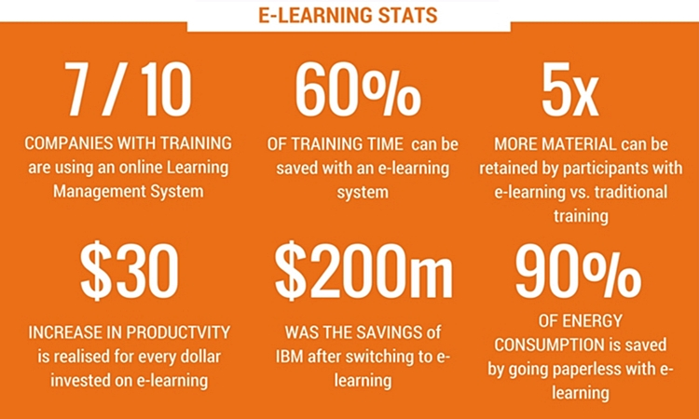
Figure- 1: some of the benefits of VLE (source: Sallis, 2020)
7 in every 10 companies have their online-based learning management system (LMS) as part of VLE. Virtual learning can reduce the training time by up to 60% causing firms to save millions of dollars. For instance, such virtual learning program has enabled IBM to reduce cost over 200million dollar. In this learning system, learners can gather 5 times higher learning materials than conventional training. It is also eco-friendly as reduces energy and paper consumption.
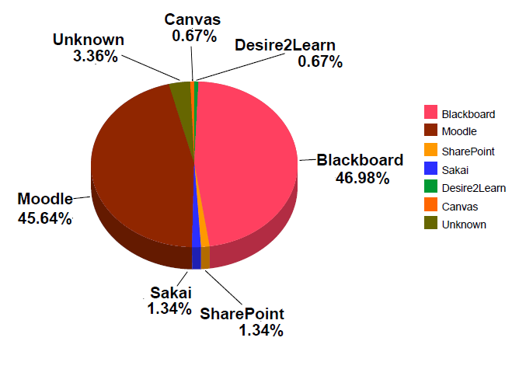
Figure- 2: Different VLE tools used in the UK in 2018 (source: Hew, et al. 2019)
In 2018, the university of the UK various VLE tools for their distant learning. As the graph shows most of the varsity used VLE tools of either Blackboard or Moodle. Combinedly they constituted more than 90% of the total users. The rest of the users depend on platforms like canvas, Desire2Learn, Sakai, SharePoint etc.

Limitations of the Study
The study has some flaws; the number of participants was 100. If it was higher, then the better real scenario would have been generated through the response. The study is conducted with limited time and it worked as a limitation in precautious designing of the overall job involved. Moreover, due to coronavirus, the data collection process got harder and it also affected the overall accomplishment of the study. Due to the various sampling profiling of the student, the response got persuaded. There was also some limitation in finding appropriate literature for the study (Velte and Stawinogo, 2017).

Conclusion
Due to the swift advancement in information technology, educational institutions are relying on virtual teaching than ever before. The conducted study has aimed at evaluating the impact of virtual learning on students. Understanding such aspects will enrich the process of motivating students’ property for effective learning. This study has discussed learning, its major categories, learning management system etc. This qualitative research considered outcome generated from 100 respondent students. After conducting the interview, survey and observation, attained information have been shown with the help of some charts. Questionnaire of the research has been attached at the appendix of the study. The crucial part of the study is assessing the perception and understanding that learners have on VLE and how to develop it. More flexible, communicative, student-oriented, easy VLE is the ultimate necessity to the learners.

References
Alam, A., Ullah, S. and Ali, N., 2017. The effect of learning-based adaptivity on students’ performance in 3D-virtual learning environments. IEEE Access, 6, pp.3400-3407.
Barton, C., 2016. Ethical considerations in research participation virality. Journal of Empirical Research on Human Research Ethics, 11(3), pp.281-285.
Cassidy, S., 2016. Virtual Learning Environments as Mediating Factors in Student Satisfaction with Teaching and Learning in Higher Education. Journal of Curriculum and Teaching, 5(1), pp.113-123.
Chen, Y.L., 2016. The effects of virtual reality learning environment on student cognitive and linguistic development. The Asia-Pacific Education Researcher, 25(4), pp.637-646.
Daniel, B., Kumar, V. and Omar, N., 2018. Postgraduate conception of research methodology: implications for learning and teaching. International Journal of Research & Method in Education, 41(2), pp.220-236.
Eskandari, M. and Soleimani, H., 2016. The effect of collaborative discovery learning using MOODLE on the learning of conditional sentences by Iranian EFL learners. Theory and Practice in Language Studies, 6(1), pp.153-163.
García, M.T., Novo-Corti, I. and Varela-Candamio, L., 2018. The effects of social networks on the assessment of virtual learning environments: A study for social sciences degrees. Telematics and Informatics, 35(4), pp.1005-1017.
Herrera, L., 2017. Impact of implementing a virtual learning environment (VLE) in the EFL classroom. Íkala, 22(3), pp.479-498.
Hew, T.S. and Kadir, S.L.S.A., 2019. Predicting the acceptance of cloud-based virtual learning environment: the roles of self determination and channel expansion theory. Telematics and Informatics, 33(4), pp.990-1013.
James, K.L., Randall, N.P. and Haddaway, N.R., 2016. A methodology for systematic mapping in environmental sciences. Environmental evidence, 5(1), p.7.
Kasim, N.N.M. and Khalid, F., 2016. Choosing the Right Learning Management System (LMS) for the Higher Education Institution Context: A Systematic Review. International Journal of Emerging Technologies in Learning, 11(6).
Mosquera, L., 2017. Impact of Implementing a Virtual Learning Environment (VLE) in the EFL Classroom. Íkala, Revista de Lenguaje y Cultura, 22(3), pp.479-498.
Rienties, B. and Toetenel, L., 2016. The impact of learning design on student behaviour, satisfaction and performance: A cross-institutional comparison across 151 modules. Computers in Human Behavior, 60, pp.333-341.
Sallis, A., 2020. 10 Strategies To Improve Your Learning Management System. [online] Intuto.com. Available at: <https://www.intuto.com/blog/10-strategies-to-improve-your-learning-management-system> [Accessed 9 May 2020].
Velte, P. and Stawinoga, M., 2017. Integrated reporting: The current state of empirical research, limitations and future research implications. Journal of Management Control, 28(3), pp.275-320.

Appendix
Questionnaire
Tick the appropriate question (1-4); write down the answer to question 5:
Question 1: What do you think about the impact of using technology in the learning process?
(a) Positively
(b) Negatively
(c) No opinion

Question 2: Does the use of technologies ensure a richer learning experience?
(a) Yes
(b) No

Question 3: How do you describing your experience while using VLE?
(a) Satisfactory
(b) Problematic
(c) Disappointing
(d) Moderate

Question 4: VLE has increased your capability as a learner- to which extent you agree with the statement?
(a) Strongly Agree
(b) Agreed
(c) Disagree
(d) Strongly disagree
(e) Neutral

Question 5: How the experience of your virtual learning can be enhanced?
Write your answer (briefly as a point):

