Northern Lights pvt Ltd: Investigation Solution

Link to database:
Charlie Williams Assignment Database.accdb

Identifying the users of this database
When designing the solution for this investigation, I think the first and most important thing to do is to identify who exactly will be accessing it frequently, as I will need to design the database around their needs and wants.
The main users who would be accessing the database management system for Northern Lights Ltd would be the staff, such as branch managers and the finance department. They would be looking for information such as client details and event location/requirements. The IT department would likely access the DBMS quite frequently as well as they may need to make changes to suit the finance department or perform maintenance as necessary.
Clients would also be accessing the database, so I will also need to keep that in mind when designing the database. I did try to find an online resource to find with regards to presenting a database like mine to clients/external personnel, however I was unable to find one that was relevant to my investigation.
User requirements
- Database should be accessible to clients and staff alike- and need to be able to query information as is necessary.
- Invoices need to be able to be generated based on purchases from suppliers.
- Needs to be secure in its design to prevent clients from accessing unnecessary information.
- Clear, concise, and easy to use.

Branch managers would be looking for staff information as well to arrange various things such as payment. The finance department would be the ones accessing the DBMS (Database Management System) most often and would oversee maintaining it and providing access to specific parts of the DBMS to clients. Each branch would require:
- Setup department: these staff members oversee the physical setup of the event; they would ensure that the sound systems are set up correctly, any decorations such as banners, posters, or boards. For the sake of clarity, they would also be the ones communicating with the client as they would have the best idea of what is/is not possible, using the DBMS to check things like stock to see if anything else needs to be ordered.
- Finance department: these staff members would oversee the DBMS, moderating the data within and overseeing who has access to it. They would also be responsible for managing orders for various supplies the company might need, and tracking stock/orders within the DBMS. Additionally, they would store various staff information such as address/billing information so that they can be paid accordingly. They would also be responsible for staff pay.
- IT department: The IT department would look after the technical aspects of the DBMS and other digital aspects of the company. Given that the company has been paper-based for a while, there would likely be a good few staff (or clients!) who are not particularly experienced with the various systems that would be used after the shift to DBMS. They would also be vital in the shift to DBMS.
- Cleaning Department: the cleaning department would ensure that venues for events are clean before and after the event takes place.
What I need to do:
- Design the access database thing
- Needs to be accessible by staff and clients alike
“When purchases are made from the supplier the relevant department should be able to view, record and also generate invoices for the transactions.”

DBMS Requirements
- Store information concisely and in a way that is comprehensible to end users/patrons of the business.
- Ensure that clients can access the information they need easily.
- For security reasons, clients/staff should only be allowed to access the bare minimum that they need.

Creating the ERD
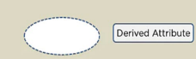

The first thing I will do is create a Visio ER diagram. This will help me when I design the solution in Access later. I’ll start by creating the client, staff, and event entities. Unfortunately, I’m not sure how to create the dotted line around the ellipse that would be necessary to replicate the appearance of a derived attribute in Visio, as seen in my notes here. As such, it will look slightly different. On the right, you can see the normal derived attribute appearance compared with the one I am using.
My derived attribute
Derived attribute normally

The attributes related to the client entity will be:
- Name
- Date of birth (I could do age as a derived entity, but I don’t think it’s relevant given the type of company this is)
- Client ID (or cID)
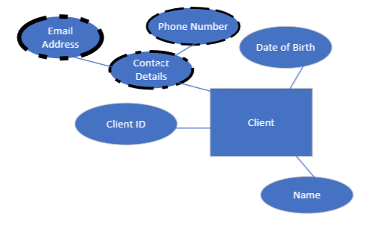
- Contact details (multivalued entity), which will be linked with phone number and email address, which are also multivalued entities.

Staff entity attributes:
- Name
- Department
- Contact Details (same as client entity)
- Department (multi valued attribute)

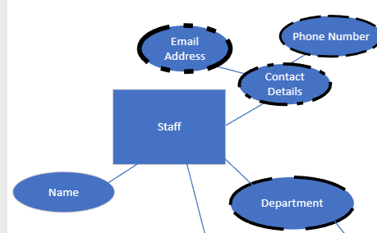
Another staff entity attribute could be payment details with regards to their pay, however, if I was creating a database to store such information I would have it be stored in an entirely separate database for security reasons. It is important to limit the risk of critical staff information to remain as secure as possible, and there is no case where a client would need to access the personal information of a staff member, so I think this is a safer approach to the security of staff and the database. While ordinarily clients would not be able to access this information due to the levels of access and permissions that will be present in the database, there are new exploits arising for popular software like Access (which is what I will be creating the DBMS in) all the time, especially if users are running an outdated version of Access or aren’t very computer savvy (as some of the staff likely would not be, given that they have been paper based beforehand). As such, I feel it would be best to go about a more secure approach.

Below is the complete entity relationship diagram created in Visio.
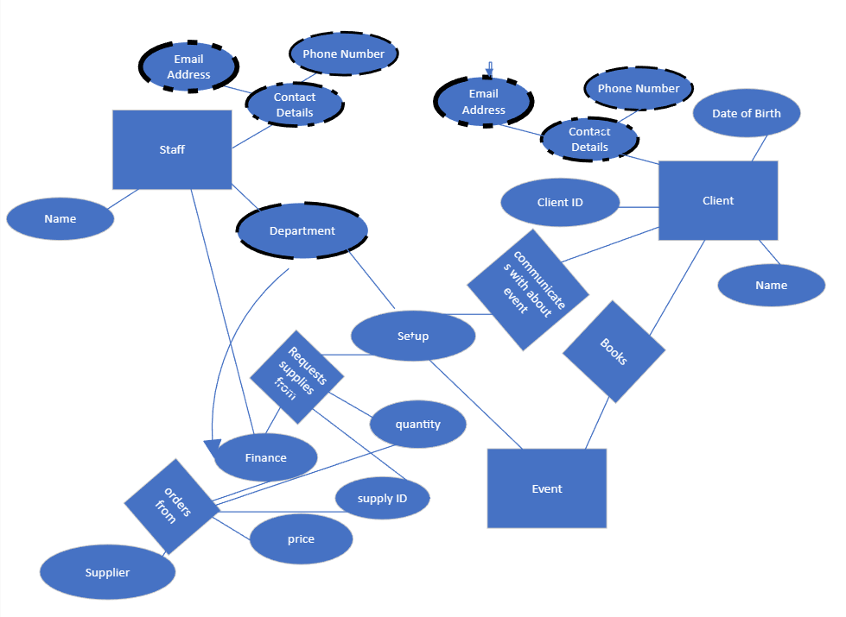
ERD Review
The main weakness of my ERD is it’s presentation. Quite a few lines cross and some do not reach the attributes/entities they were originally supposed to connect to. For example, the arrow going from department to finance is an arrow because I was unable to find a way to create an arc. It would be impossible for me to create a straight line from the “requests supplies from” relationship, so I needed the line to curve around it. I was unable to find a shape in Visio other than the arrow that arced, so I decided to use it. However, I then could not get it to connect with department and finance at the same time. While there is more than likely a way to do it, I determined that the ERD was still comprehensible like this, and communicated the information that was necessary. For this reason, I decided that it would be best to focus more on the contents than the presentation.

With this ERD, I am confident that I have outlined the basic relationships between the different entities and attributes.

Access Database
With regards to the database itself, I plan to use a guide from Microsoft, the company behind Access. Given their status as the 5th biggest tech company in the world, as shown on Wikipedia [2], I think the information provided on their website is reliable. The article itself is also no older than 2 years, as it refers to Access 2021. Microsoft’s article states that “investing the time required to learn the principles of good design makes sense. In the end, you are much more likely to end up with a database that meets your needs and can easily accommodate change.” [2] Most importantly of the information I’ve gained from this article, is the design process detailed. Microsoft describes the design process in 8 steps:
“
- Determine the purpose of your database- This helps prepare you for the remaining steps.
- Find and organize the information required- Gather all of the types of information you might want to record in the database, such as the product name and order number.
- Divide the information into tables- Divide your information items into major entities or subjects, such as Products or Orders. Each subject then becomes a table.
- Turn information items into columns- Decide what information you want to store in each table. Each item becomes a field, and is displayed as a column in the table. For example, an Employees table might include fields such as Last Name and Hire Date.
- Specify primary keys- Choose each table’s primary key. The primary key is a column that is used to uniquely identify each row. An example might be Product ID or Order ID.
- Set up the table relationships- Look at each table and decide how the data in one table is related to the data in other tables. Add fields to tables or create new tables to clarify the relationships, as necessary.
- Refine your design- Analyze your design for errors. Create the tables and add a few records of sample data. See if you can get the results you want from your tables. Make adjustments to the design, as needed.
- Apply the normalization rules- Apply the data normalization rules to see if your tables are structured correctly. Make adjustments to the tables, as needed.
”[2]

- Purpose
The purpose of my database is to make the information needed by the company easy to access, modify, and query by both staff and clients. It should also be flexible enough that if changes need to be made later on it should not be overtly difficult.
- Information Required
The information I require is mainly highlighted in my entity relationship diagram. I will have 4 different tables of information:
Client:
- Name
- CID (client ID) (primary key)
- Date of birth
- Email
- Phone Number
Staff:
- Name
- Job Role
- Contact details
- Department
- Staff ID (primary key)
- Emergency Contact Details
Booking:
- Venue
- Client ID (who booked it)
- Booking ID (primary key) (booking ID is used on a separate page to access specific requirements for the event, such as speakers/props etc.)
- Payment Due
- Finance Staff ID (the staff member in charge of the finances of the booking)
- Setup Staff ID (the staff member in charge of the setup of the booking)
Orders
- Order No. (primary key)
- Booking ID
- Quantity
- Payment Due
- Finance Staff ID
- Delivery Destination

Relationships
Here are the relationships I’ve implemented in my database:
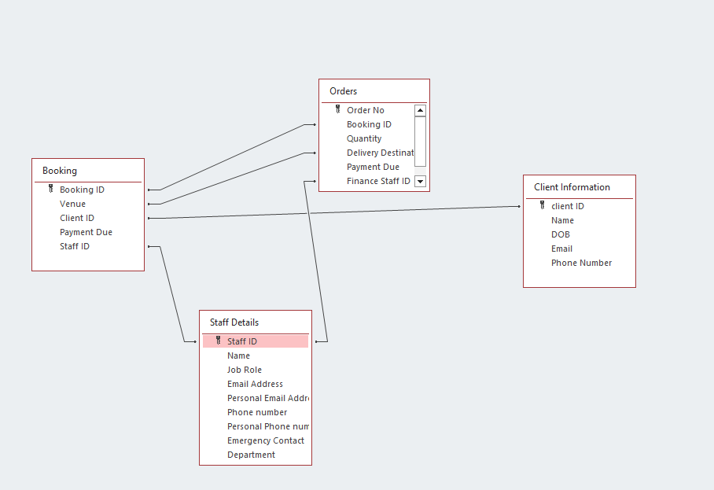

I’ve created all the relationships necessary between my tables. I did cut out some of the fields I was planning to implement, such as merging the Finance ID and Setup ID into simply “Staff ID” for clarity’s sake. I’ve also created a query that will allow users to scan different information about a booking quickly and efficiently. I’ve included a screenshot of it below.
I’ll also include screenshots of all the tables I created:
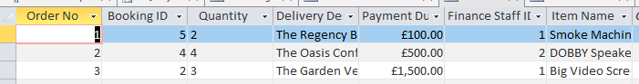
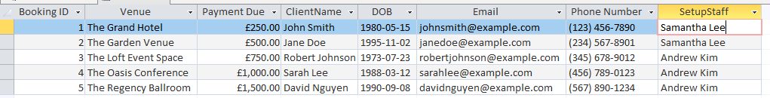

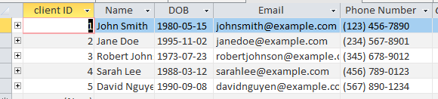
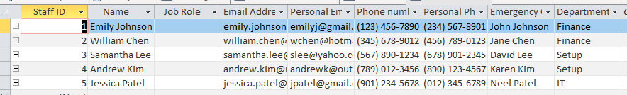

My database contains most of the information that the company needs. It is clear and concise in the way it presents information and can be used by clientele and staff alike. Queries can be used to easily access data and present it. Overall, I believe this database will enable the business to be more efficient and effective when dealing with clients.

Sources:
[1] Database design basics - Microsoft Support - https://support.microsoft.com/en-us/office/database-design-basics-eb2159cf-1e30-401a-8084-bd4f9c9ca1f5
[2] List of largest technology companies by revenue - Wikipedia - https://en.wikipedia.org/wiki/List_of_largest_technology_companies_by_revenue

