In this gobbet we will be looking at a piece of writing, written by Friedrich Engles, from his book ‘The Condition of the Working Class in England in 1844. Looking at the houses and areas the working, middle and upper classes lived in Manchester in the industrial revolution. Also looking at the author.
Friedrich Engles was a German, born in Barmen Germany. He was a philosopher, communist, social scientist, journalist, and businessman. His father owned textile factories in Salford Manchester. Where Engles was sent to one of his father’s factories to learn about the cotton industry, it was while he was their he wrote his book, ‘The Condition of the working Class in England’. The book was first published in German in 1845.
Engles is writing about areas in Manchester, that is home to the working classes, Engles described these areas as, a place of ‘filth, ruin, and uninhabitableness’, it was, quite simply, ‘Hell upon Earth’ . Before the industrial revolution, Manchester was just a small market town. Then at the start of 18th century, the first railway was built, going from Manchester to Liverpool, which had some of the biggest docks, so ideal for shipping goods all over the world. The industrial revolution started to take shape. With Manchester being in a prime location, investors soon started building factories and mills. With the offer of better wages, workers came from all the country, including Ireland. The population grew at a phenomenal rate. As city planning was still in its infancy and so many workers, with their families needing homes, there was a great need for houses. So houses were being built as quick as they could, with not much regard for quality, they were built back to back, with very little space between them, they were cold, dingy miserable places, clean running water, sewerage and waste removal was left to private companies, to supply which ended up being very inadequate. Diseases spread very quick, killing the weak. Life was very grim, with families living in just one room.
Engles also wrote about the ‘Bourgeoisie’ upper and middle classes. In the nineteenth century Europe, the term ‘Bourgeoisie’ was used to describe a society that was better off socially and financially, than the working classes. In the early part of the nineteenth century the middle classes was on the move, looking for homes in areas with better air quality, with more industry being built and the working class ‘slums’ spreading, the middle and upper classes where selling up and moving out. The middle classes couldn’t afford to be to selective, when looking suburban sites, but did manage to have either a yard or garden. But never more than a few miles from the city centre. The middle and upper classes not only didn’t want see the homes of the working class, they also didn’t to breath in the dirty, smoky air from the factories and ‘slums’. They came up with two alternative solutions, to stop/ avoid the expansion of the working-class houses. The first was ‘flight’ move out, beyond the urban fringe into the villages, small towns. The other was to build ring fencing with toll bars round the middle-class areas.
When you read what Engles wrote, you get an idea, that he wasn’t pleased, with the way the working classes had to live and suffer, that they deserved better living conditions and should be treated with more respect, from the middle and upper classes, who took the shortest route to the city centre, avoiding seeing the working classes homes, who when the working classes houses started to move closer to them, packed up and moved to better areas.

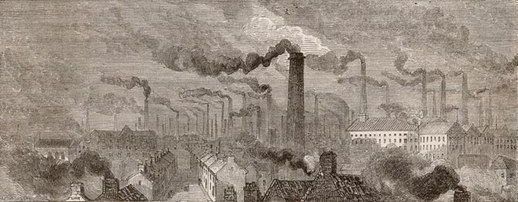Manchester in 1870, the year Engels left the city he had lived in for 28 years. It was the largest industrial town in England and a noted center of the profitable cotton trade.

https://en.wikipedia.org/wiki/Friedrich_Engels
Friedrich Engels, The Condition of the Working-Class in England in 1844 (London, 1892), p. 53
Emma Griffin, Poverty and the working classes, 2014, British Library – Discovering Literature.
Pamela Pilbeam, Bourgeois Society 1990 p.86. The companion to Nineteenth century Europe 1789-1914
H.B Roders, The Suburban Growth of Victorian Manchester. https://www.mangeogsoc.org.uk/pdfs/centenaryedition/Cent_17_Rodgers.pdf
http://links.org.au/node/3450

