
Campus Crisis: UWTSD Response

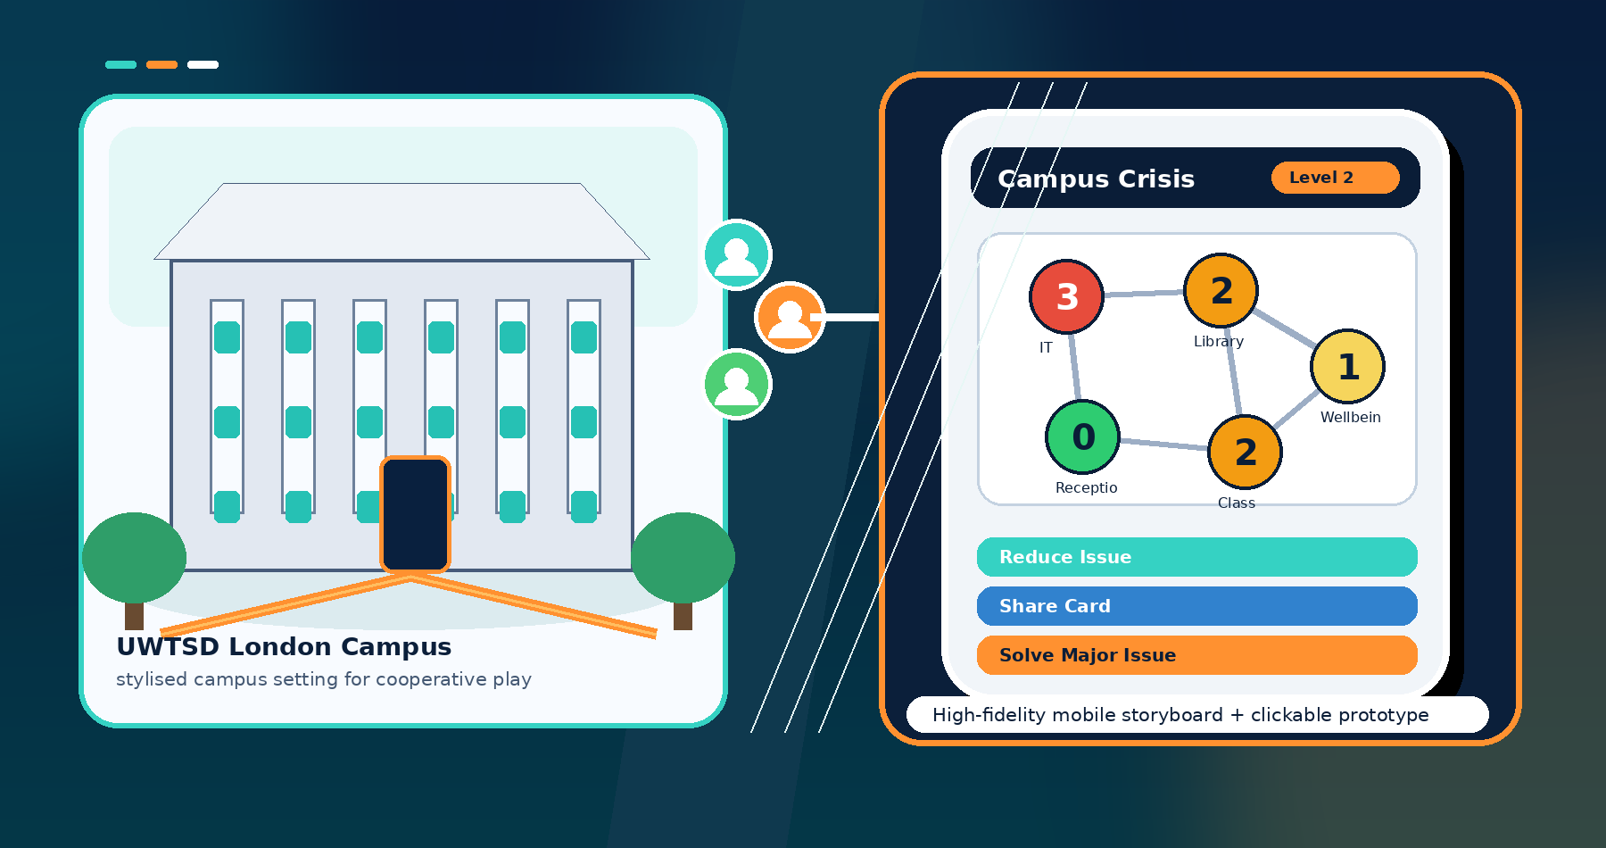
Student name: Sanobia Nosheen Ahmed
Student ID: 2314145
Module: ACCB6017
Lecturer: Fahad Ahmed
Module Name: Usability Engineering
Module code: ACCB6017
Campus: London

Contents
1. Introduction 3
2. High-Fidelity Prototype Scope 3
3. Full-Colour Storyboard Design 4
4. Colour Scheme and Graphics 6
5. Changes from the Initial Wireframe Model 6
6. Feedback Collection and Prototype Testing 7
7. Data Collection in a Working Version 7
8. Usability Versus User Experience Reflection 8
9. Reflective Summary 9
10. Conclusion 10
References 11
Appendix B: Prototype Feedback Task Script 17

1. Introduction
This report presents Campus Crisis: UWTSD Response, a UWTSD-themed cooperative strategy computer game inspired by Pandemic. Pandemic is a team-based game in which players act as specialists, manage crises and make shared decisions under pressure [1]. The proposed game adapts this structure into a university setting, where players work together to control campus issues before they become critical.
The design is presented as a mobile-phone-sized high-fidelity prototype. The brief asks for full-colour storyboards appropriate for a mobile phone, so the screens are designed as 390 x 844-pixel mobile frames suitable for Figma. The game is still a computer game, but the prototype uses mobile-sized screens to show the interaction flow.
The setting is UWTSD London Campus. Campus zones include Reception, IT Support, Library, Classrooms, Student Services, Wellbeing Support and International Advice. Instead of disease outbreaks, the game uses university issues such as Moodle library booking disruption, timetable confusion, assessment stress and support delays. The team wins by solving four major campus issues before the crisis.

2. High-Fidelity Prototype Scope
The prototype shows colour, typography, icons, example game content, navigation flow and the intended layout of the final interface. It is not only a low-fidelity sketch. Each screen includes realistic buttons, status indicators, player roles and, for example, crisis information. This supports interaction design practice, where users evaluate how the interface is likely to work before full implementation [2], [3].
The clickable prototype can be created in Figma by linking the Start Game button to Role Selection, Team Lobby, Campus Board, Crisis Card, Player Action, Confirmation, and Crisis Spread Team Progress. The Team Progress screen loops back to the Campus Board until the team wins or loses. The storyboard therefore shows both the screens and how users move between them.
The prototype is also intended to demonstrate interaction decisions rather than only visual appearance. For example, the Start Game button must clearly lead to role selection, while the End Turn button must lead to crisis spread and then progress feedback. This makes the prototype useful for testing whether users understand the game sequence before a working version is coded. High-fidelity means the screens should show the intended interface, for example content, colour, navigation and usability decisions, not a finished commercial product.
The prototype supports up to six players: IT Support Technician, Wellbeing Adviser, Library Officer, Academic Tutor, Students' Union Representative and International Student Support Officer. Each role has a special ability so that collaboration is required rather than optional. This keeps the cooperative strategy structure of the original game while making the context relevant to UWTSD.

3. Full-Colour Storyboard Design
The storyboard contains twelve mobile screens: Start, How to Play, Role Selection, Team Lobby, Campus Board, Crisis Card, Player Action, Action Confirmation, Crisis Spread, Team Progress, Win/Lose and Accessibility Settings. The complete set of screenshots is included in Appendix A.
The Start screen introduces the title and provides Start Game, Join Game, How to Play and Accessibility options. The How to Play screen explains the objective in short steps: choose a role, view the campus board, draw a crisis card, take actions, allow the crisis to spread and check team progress. This supports help and documentation for new users [4].
The main Campus Board is the central screen. It shows campus zones with issue levels from 0 to 3: stable, minor issue, warning and critical. The dashboard shows current player, actions remaining, crisis meter, cards remaining and team progress. These elements support visibility of system status and help users understand what is always happening [4].
The Crisis Card and Player Action screens create the main turn sequence. Example content includes Moodle System Failure, severity +2 and recommended role: IT Support Technician. The player can Move, Reduce Issue, Share Card, Use Ability, Solve Major Issue, or End Turn. A confirmation screen appears before important actions to prevent accidental choices and improve user control [2], [4].
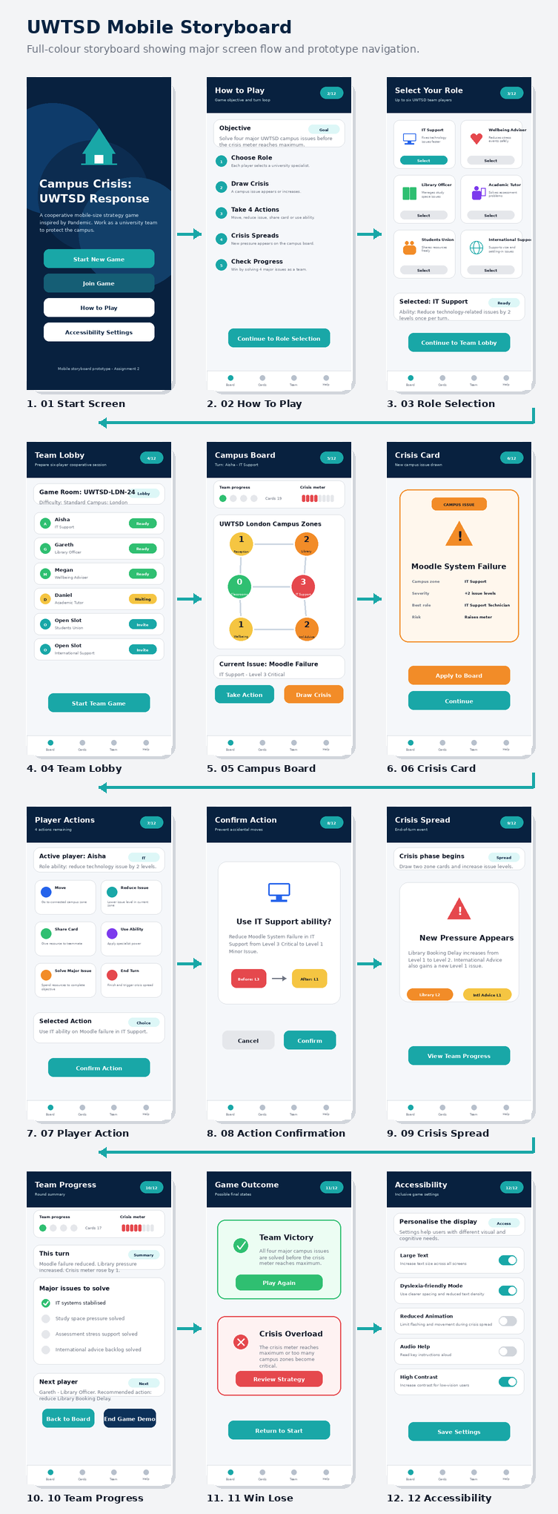
Fig. 1. Full-colour storyboard overview showing the mobile prototype flow.

4. Colour Scheme and Graphics
The colour scheme was selected to create both clarity and a sense of game emotion. Dark navy is used for the background and headers because it gives a serious strategic tone. Teal is used for teamwork and positive action buttons. Green, yellow, orange, and red indicate the progression from stable to critical issue states.
This colour combination gives a clear visual hierarchy. Warm colours draw attention to urgent problems, while cooler colours keep the interface calm enough for decision-making. Red is used only for Level 3 critical states because overusing red may increase stress and reduce readability. This reflects emotional design theory, where visual choices influence how users feel and respond [2], [5].
Colour is not used alone. Each status also includes text and numbers, such as Level 2 Warning or Level 3 Critical. This supports accessibility because users should not need perfect colour vision to understand the game state. The accessibility screen also includes large text, a dyslexia-friendly display, reduced animation and audio support, inclusive design and WCAG guidance [6], [7].
The graphics use simple icons rather than detailed photographs. For example, the library uses a book icon, IT Support uses a computer icon, Wellbeing uses a heart icon, and International Advice uses a globe icon. Simple icons are easier to scan on a small screen and make the interface feel like a game rather than a university information page.
The colour choices were not selected only for decoration. They were chosen to support rapid decision-making on a small screen. In a cooperative game, players need to identify risk quickly, discuss options and choose an action before the next crisis appears. The red, orange and yellow warning scale helps users prioritise urgent zones, while navy and teal keep the overall interface calm and consistent. This follows interaction design principles because visual design should guide attention, reduce unnecessary search and support the task that the user is trying to complete [3], [7].

5. Changes from the Initial Wireframe Model
The full-colour design differs from the initial wireframe model in several ways. First, the interface is now more clearly game-like. The wireframes showed structure, but some screens looked like a student services app. The updated prototype adds role cards, crisis cards, a crisis meter, action buttons, progress feedback and win/lose screens.
Second, the wording was changed after feedback. Users felt that the word crisis should not be used for every problem, especially wellbeing-related content. The final design uses campus issues for ordinary events and crisis only for serious events. This keeps the game tense but avoids making sensitive student problems feel like jokes.
Third, action labels were made clearer. The wireframe labels Support and Solve were too similar. They were replaced with Reduce Issue and Solve Major Issue. Reduce Issue lowers the level of a local campus problem. Solve Major Issue means completing one of the four objectives required to win.
Fourth, the prototype adds stronger feedback. Confirmation screens, crisis spread summaries, and team progress screens were included so users can see the effect of their decisions. These changes address usability concerns through clearer feedback, error prevention and improved mapping between actions and outcomes [3], [4].

6. Feedback Collection and Prototype Testing
Feedback was collected in two stages. The first stage evaluated the wireframe model and identified problems with wording, clarity, feedback and visual accessibility. The second stage tested the full-colour high-fidelity storyboard. This iterative process follows human-centred design because the interface is refined through user involvement rather than designed only from assumptions [3], [6].
The second test used scenario-based evaluation. Participants were asked to start a game, read the objective, choose a role, identify the highest-risk campus zone, read a crisis card, select an action, confirm it and explain whether the team was close to winning or losing. They were also asked to comment on the emotional feel of the colour scheme and wording.
During the second round, participants were encouraged to think aloud while they moved through the storyboard. Notes were taken on hesitation points, misunderstood labels and emotional reactions to the colour scheme. This method was useful because some problems were visible through behaviour rather than direct comments. For instance, when a participant paused before choosing between Reduce Issue and Solve Major Issue, it showed that the label needed to be supported by a short explanation. This evidence helped connect the design changes to usability theory instead of treating feedback as only opinion [3], [4].
The participants were chosen to represent the persona range: an international student, a mature or part-time student, a user who needed accessible visual design and a staff member or non-gamer. This helped check whether the design worked for different levels of language confidence, time pressure, gaming experience and accessibility needs.
Positive feedback focused on the campus board, colour-coded issue levels and role abilities. Participants said the prototype felt more like a cooperative strategy game. Negative feedback was also useful. One participant felt the mobile board could become crowded. Another wanted clearer crisis meter labels. A non-gamer wanted a guided first turn. These comments led to simplified board content, clearer labels, guided onboarding and more respectful wellbeing wording.

7. Data Collection in a Working Version
If a working version were built and released, both automatic usage data and direct user feedback would be collected. Automatic data would include selected roles, time on task, error rate, cancelled actions, turn length, win/loss rate, difficulty selected, screens where users spend the most time, drop-off points and use of accessibility settings.
The most important usability metrics would be task completion rate, error rate, time on task and recovery from mistakes. Task completion rate would show whether users can finish key actions such as selecting a role or resolving an issue. Error rate would show how often users choose the wrong action or misunderstand a warning state. Time on task would show whether users are spending too long searching for controls. These measures would give practical evidence for improving the next version.
These metrics are needed because they show whether the game is effective and efficient. For example, a high error rate on the Player Action screen would suggest unclear labels. Long time on task during role selection may mean that role descriptions are confusing. A very high loss rate may mean the crisis spread system is too difficult. Usage data can therefore guide rule balancing and interface redesign.
However, automatic data cannot fully explain emotional response. A user may spend a long time on the board because they are thinking strategically, or because they are confused. For this reason, short post-game surveys, interviews and think-aloud sessions would still be needed. These methods can collect feelings such as confidence, stress, enjoyment, confusion and motivation to play again. Game experience depends on challenge, feedback, control and emotional engagement, not only speed [8], [9].
Data collection must also be ethical. The game should collect only data, explain why it is collected, avoid personal details where possible and anonymise optional demographic or accessibility information. This is especially important because the context involves students and support services [6].

8. Usability Versus User Experience Reflection
If the storyboard had been designed only from a usability viewpoint, it would probably be simpler and less dramatic. The screen might use a plain list of campus zones, issue levels and action buttons. That would be efficient, but it would not feel like a cooperative strategy game.
The project therefore required a balance between usability and user experience. Usability focuses on effectiveness, efficiency and satisfaction in a context of use [8]. User experience also includes emotion, motivation and engagement [9]. A game that is clear but boring may fail, while one that is exciting but confusing may also fail.
One conflict was colour. Red creates urgency, but too much red can cause stress and visual overload. The solution was to reserve red for critical Level 3 states and use yellow or orange for lower warnings. Another conflict was screen density. Strategy games need information, but mobile screens are small. The solution was to show essential information on the main board and allow users to tap for more detail.
Another important issue was the difference between designing a game and designing a normal information system. A normal university app would try to remove pressure and make every journey as calm as possible. This project needed some pressure because the theme was cooperative crisis management. The solution was to make the challenge come from game rules and changing issue levels, not from confusing navigation. In this way, difficulty was kept inside the gameplay rather than created by poor interface design.
A further conflict was onboarding. Confident players want a quick start, while new players need guidance. The final design includes both a quick route and a guided first-turn option. This shows that usability and user experience were treated as connected design goals rather than separate concerns.

9. Reflective Summary
The design process showed the value of moving from wireframes to full-colour high-fidelity prototypes. The early model helped test structure, while the full-colour prototype made it easier to evaluate atmosphere, urgency, accessibility and game feel. The most important lesson was that the interface must look and behave like a game, not only a university support system.
User feedback improved the design in practical ways. It changed action labels, simplified the board, strengthened feedback, added onboarding and improved the handling of well-being-related content. The process also showed that design decisions should be justified using theory, not only personal preference.
There were limitations. More participants would have improved the evidence, and a fully coded interactive game would allow stronger testing of timing, errors and repeated play. Time and technical constraints meant the prototype remains a high-fidelity storyboard rather than a complete playable implementation. In future work, the next step would be a functional Figma or web prototype with more users and several game sessions.
If more time and technical resources were available, the next step would be to build a working Figma prototype with more branching paths and a small playable HTML version that the designer fully understands and can explain. This would allow more reliable testing of repeated turns, multiplayer decisions and longer-term engagement. More diverse participants would also strengthen the evidence, especially users with different accessibility needs and gaming experience. These improvements would make the design evaluation more rigorous.

10. Conclusion
This report presented a full-colour mobile storyboard and high-fidelity prototype for Campus Crisis: UWTSD Response. The prototype includes the main game functions: starting, learning, role selection, team lobby, campus board, crisis cards, actions, confirmation, crisis spread, progress feedback, win/lose outcomes and accessibility settings.
The report explained the colour scheme, graphics, design changes, feedback process, usability data and reflection on usability versus user experience. Overall, the design is a clear and accessible UWTSD version of Pandemic that uses cooperative decision-making, role abilities and campus issues to create a strategic game experience.

References

[1] | Z.-M. Games, "Pandemic," Z-Man Games, [Online]. Available: https://www.zmangames.com/game/pandemic/. [Accessed 5 Aug 2026].
[2] | D. A. Norman, The Design of Everyday Things, New York, NY, USA: Basic Books, 2013.
[3] | Jennifer Preece, Yvonne Rogers, and Helen Sharp, Interaction Design: Beyond Human-Computer Interaction, Wiley / John Wiley & Sons: Hoboken, NJ, USA, 2019.
[4] | J. Nielsen, "Enhancing the explanatory power of usability heuristics," Boston, Massachusetts, USA.
[5] | Marc Hassenzahl and Noam Tractinsky, "User experience — a research agenda," Behaviour & Information Technology, vol. 25, no. 2, pp. 91-97, 2006.
[6] | I. O. f. Standardisation, "Ergonomics of Human-System Interaction — Part 210: Human-Centred Design for Interactive Systems," Published and confirmed as current by ISO, Geneva, Switzerland, 2019.
[7] | W. W. W. Consortium, "Web Content Accessibility Guidelines (WCAG) 2.2," 5 Oct 2023. [Online]. Available: https://www.w3.org/TR/WCAG22/.
[8] | Penelope Sweetser and Peta Wyeth, "GameFlow: A model for evaluating player enjoyment in games," Computers in Entertainment, vol. 3, no. 3, pp. 1-24, 2005.
[9] | Marc Hassenzahl and Noam Tractinsky, "User experience — a research agenda," Behaviour & Information Technology, vol. 25, no. 2, pp. 91-97, 2006.

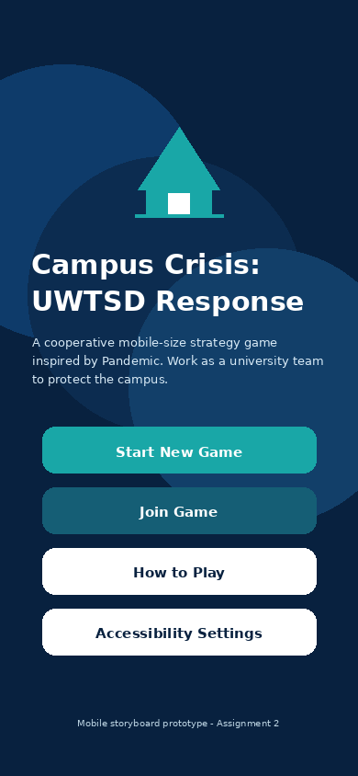  Fig. A1. Start screen. | 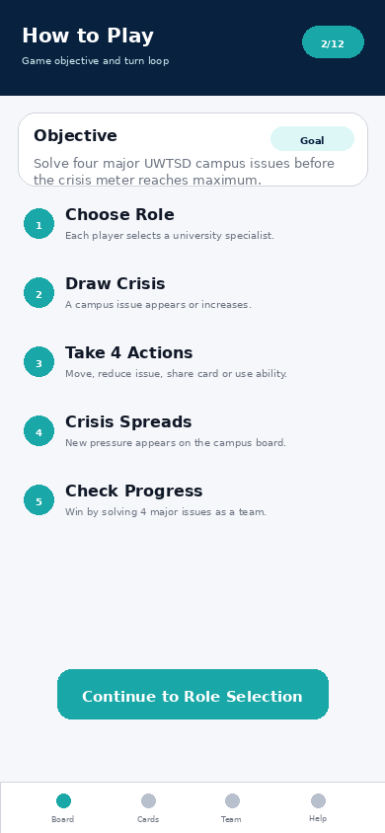  Fig. A2. How to Play screen.
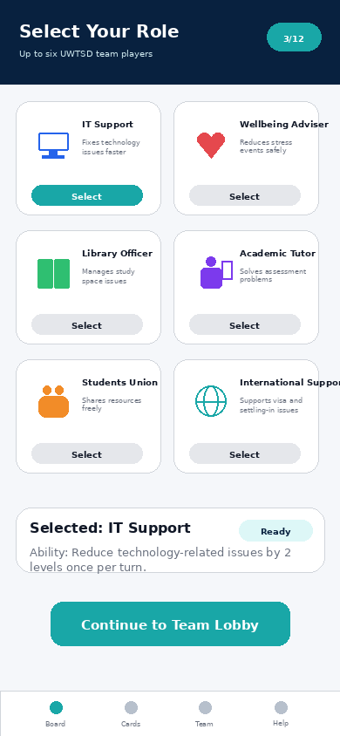  Fig. A3. Role Selection screen. | 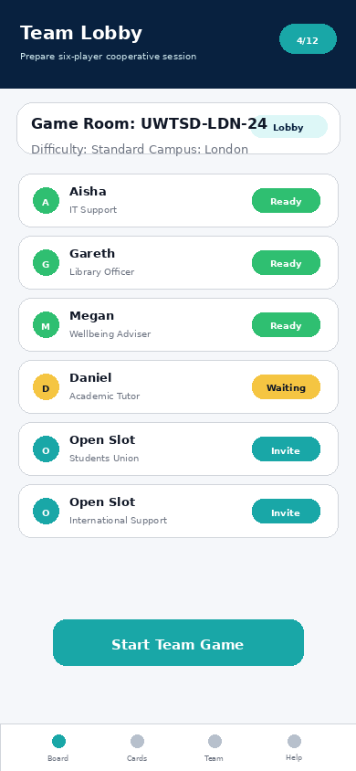  Fig. A4. Team Lobby screen.
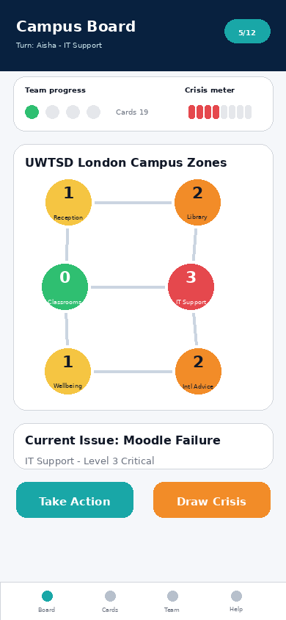  Fig. A5. Main Campus Board. | 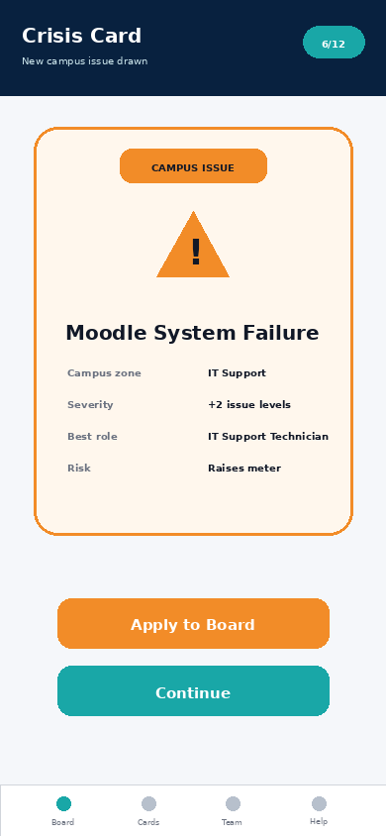  Fig. A6. Crisis Card screen.
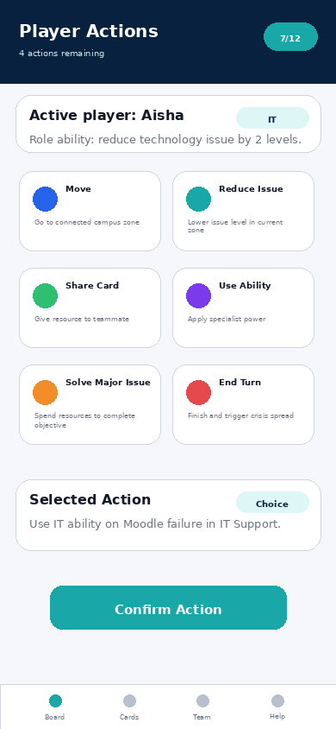  Fig. A7. Player Action screen. | 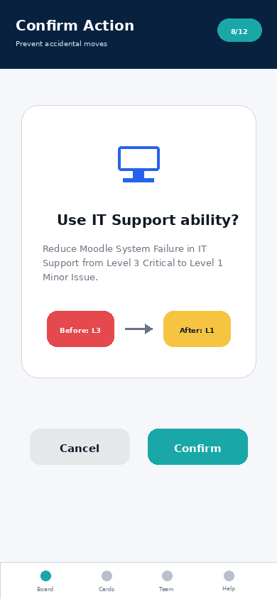  Fig. A8. Action Confirmation screen.
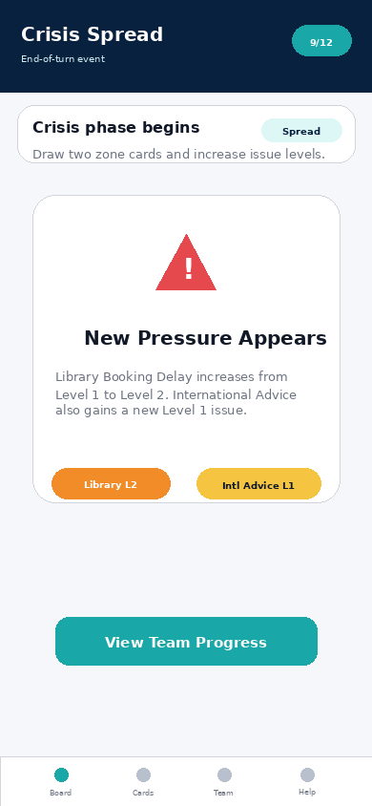  Fig. A9. Crisis Spread screen. | 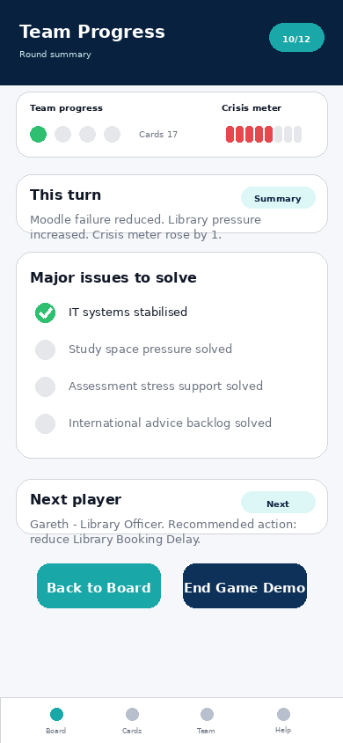  Fig. A10. Team Progress screen.
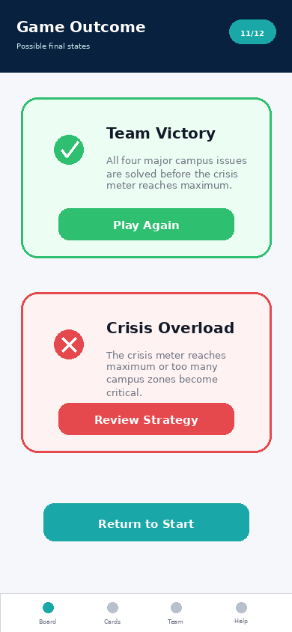  Fig. A11. Win/Lose screen. | 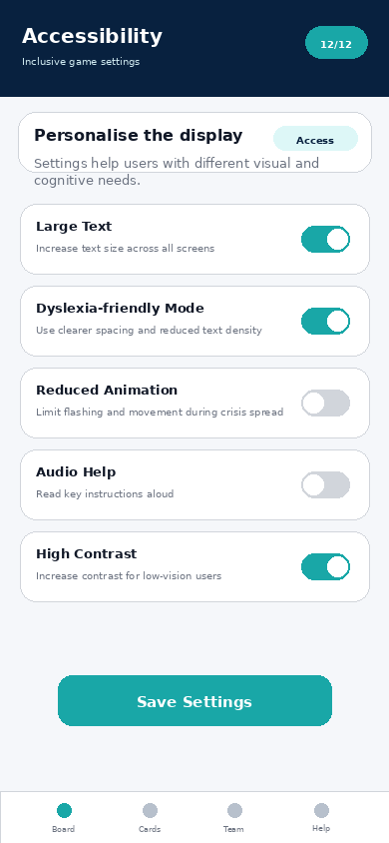  Fig. A12. Accessibility Settings screen.

Appendix B: Prototype Feedback Task Script
- Start a new game and read the objective.
- Select a role and explain its ability.
- Identify the highest-risk campus zone.
- Read the Moodle System Failure card.
- Choose and confirm an appropriate action.
- Explain the crisis spread and progress screens.
- Comment on usability and emotional response.

