Ecology of Adventure – BMOE4005
Assessment 1 – Klob’s Experiential Learning Theory
By Iestyn Nevatte – 2000703

Introduction to Kolb’s Learning Theory

Adventure is great and can be an amazing learning opportunity if conducted in the right way. One of the best ways of this is the Experiential Learning Theory (Kolb, 1984). In Kolb’s book Experiential Learning he uses these words to describe the reason for it being called Experiential Learning. “The second reason is to emphasize the central role that experience plays in the learning process.” (1) This is the key factor for using this method as reflecting and living our outdoor experiences will increase our knowledge. Klob’s Experiential Learning is made of four key sections which are stated in the following diagram (2).
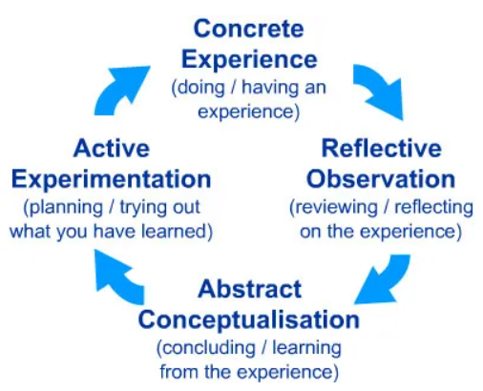

Using these elements allows us to have the best possible Learning Experience from any adventurous outdoor activity. To prove this, we will use this structure to look back at a Coasteering Experience we had earlier in the semester and see what we can take into future activities of this type. We will also look at each elements details and what other sources feel they benefit or mean.

Concrete Experience

The first element in Klob’s Learning Theory is Concrete Experience. “In Kolb's model one cannot learn by simply watching or reading about it, to learn effectively the individual, team or organisation must actually do.” (5) In other this section is all about an experience you have had as an individual. This can be anything that you feel you have gained a learning experience from or feel that it has developed you as a person allowing you to become more rounded in a way that’s easy to manage.

At the beginning of Semester one, we have had the opportunity to challenge ourselves with the extreme water sport of Coasteering, which is massively popular across West Wales, From the cold wet condition that come with the nature of the activity to the physical challenges of swimming climbing diving and jumping in these conditions, this activity is certainly not for the faint hearted. According to Collins Online Dictionary Coasteering is, “the sport of following a coastline by swimming, climbing, diving, and walking while wearing a wetsuit, a life jacket, and a helmet.” (3) We took part in this activity at the Blue Lagoon, Abereiddi Pembrokeshire. The National Trust describes the Abereiddi in the following way, “Abereiddi’s Blue Lagoon is world-class for watersports, but its rugged rocks and ruins still hint at the area’s industrial past.” (4) The lagoon is an old grey slate quarry and has played host to the Red Bull Cliff Diving three times. During of Coasteering Excursion to the Blue Lagoon we were faced with three main environmental factors that will play a huge part in the safety and wellbeing of yourself, The Weather, The Rock and The Sea. The day was so much fun and allowed us the opportunity for an all-round amazing experience.

Reflective Observation

Once you have your Concrete Experience you move on to Reflective Observation. This element consists of reviewing and reflecting on your chosen Concrete Experience. The University of Leicester view this section as “taking time-out from "doing" and stepping back from the task and reviewing what has been done and experienced.” In this element it is really important to question every little choice or decision. Sort of like rewatching the activity on a TV to gain an understanding of exactly what happened and why.

While out on the coasteering excursion everyone overcame personal challenge and concerned new achievements for themselves whether this be entering the water or jumping of the highest jump. A rather nasty weather front with rain hail and wind began to sweep in throughout the session limiting how much of the coast we could explore, the rising winds, rain and hail did not help the seas. Rough Seas created challenging swimming condition for the group as well as an all-round challenging environment. The weather also meant that the rocks and slate that made up the lagoon were becoming slippery and at points harder to move around. This gave a great adventurous experience and opportunities to put Kolb’s Experiential Learning Theory into place.

For me personally, the biggest achievement was jumping from the top platform something I have never done at Abereiddi. This caused a rise in confidence for the rest of the excursion. My biggest scary of the trip was getting caught in a big swell and thrown over the rocks while playing in the white water. After this I could not gain footing and was knocked off the rocks a few times after. This caused a small amount of panic and a few little scraps and bruises.

Abstract Conceptualisation

Following on from your Reflective Observations, you then need to looking at Abstract Conceptualisation. This element allows you to conclude on your experiences and learn from it. Again, looking at what the University of Leicester say, they said “Abstract Conceptualisation is the process of making sense of what has happened and involves interpreting the events and understanding the relationships between them.” In this section you also look at what you knew before and after the event.

From the Coasteering excursion to Abereiddi we were able to learn so much from the experience both as a group and individuals. We learnt the fundamentals of using PPE (Personal Protective Equipment). The use of helmets and buoyance aids was a good refresher as it had been a while since I went out on water activities. We were also taught the different safe jumping positions. I personally was really interested and surprised when Lecture Tom Moore spoke to use about Go Pro mounts and the fact mounting on a helmet can cause injury and damage to the helmet if landing on the water. As an inspiring adventure film director and producer this was certainly one of the biggest learning points of the day. I was also able to reassess my personal swimming abilities and fitness levels this was fundamental learning for the rest of the semester as it allowed me to well and truly know my abilities and comfort zones.

Active Experimentation

The final element is Active Experimentation. This element consists of looking at how the learner is going to put what they are learning into practice. According to the University of Leicester, “For learning to be useful most people need to place it in a context that is relevant to them. If one cannot see how the learning is useful to one's life, then it is likely to be forgotten very quickly.” (5) For example, take new skills into an adventurous activity is more likely to cement the skills into someone’s memory.

With all the new skills I learnt on our coasteering excursion to Abereiddi I will be able to apply some to other adventurous activities as well as whenever I go coasteering next. Ill be able to apply knowledge of personal abilities to keep me safe as well as knowledge on Personal Protection Equipment. I will also be able to have the knowledge that not all camera mounting is safe for the operator a fundamental safety aspect for my future career.

In the weeks following we took part in water safety programme activities. With the knowledge from coasteering we were able to build on this completing training in water rescues including line rescues, reach rescues and craft towing. The following session we built on swimming skills both safe white-water swimming positions, water entry and swimming with strong currents. Something I identified as wanting to work on. This allows us to be more efficient in water activities and in the future create great video content around water activities while being safe.

Conclusion

In conclusion the Kolb’s Learning theory of 1984 allows for a better more in-depth learning and adventurous experience. This way of learning gives opportunity to develop as a person and groups exploring the outdoors. Putting this into practice reviewing our coasteering excursion in the Blue Lagoon, Abereiddi allowed us to identify skills and safety aspect that we learnt and wanted to develop, both of this helping us in all aspects of the future. Identifying swimming techniques, I wanted to develop and taking this to water safety training upped my confidence and information such as the dangers of Go Pro mounts is massive for my future career. None of this would have been possible without Kolb’s theory and will be something I bring into future activities.

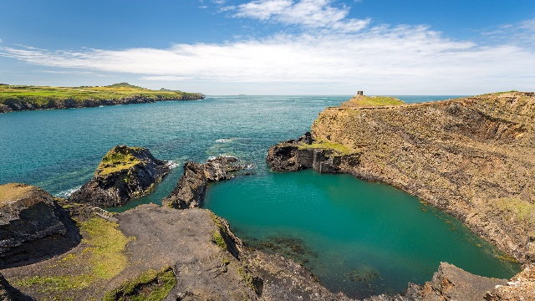

References

- Kolb, D (1984). Experiential Learning, Experience the Source of Learning and Development. London: Prentice-Hall. Page 20.

- McLeod, S. A. (2017, October 24). Kolb - learning styles. Simply Psychology. https://www.simplypsychology.org/learning-kolb.html

- Collins Dictionary. (2020). Definition of 'coasteering'. Available: https://www.collinsdictionary.com/dictionary/english/coasteering. Last accessed 21/11/2020.

- National Trust. (2018). The Blue Lagoon, Abereiddi. Available: https://www.nationaltrust.org.uk/abereiddi-to-abermawr/features/the-blue-lagoon-abereiddi. Last accessed 21/11/2020.

- University of Leicester. (2018). David Kolb. Available: https://www2.le.ac.uk/departments/doctoralcollege/training/eresources/teaching/theories/kolb. Last accessed 26/11/2020.

I have also referred to information given my course leads this is introduced with there name and roles.

