University of Wales Trinity Saint David

Wales Institute of Science & Art

BEng Manufacturing Systems Engineering

Module: Materials and Introduction to Processing (ACMA4000)

Assignment Title: Manufacturing Processes and Defects

Name: Mathew Soroka
Student ID: 2406846
Date: February 2025

Abstract

This report examines how material selection impacts everyday objects, specifically hammers, bathtubs, and crockery. It compares metals, polymers and ceramics in terms of mechanical properties, manufacturing methods, cost, and lifespan. The study also explores why certain materials are preferred and discusses optimal choices for each application.
The hammer and bathtub were selected due to an ongoing house renovation, specifically the bathroom. The bowl was chosen as a ceramic object because food is an everyday essential, and to understand why the material is so useful. Ultimately, the key finding of this report is that the right material and method choice ensures functionality and long-term value for everyday objects.

Table of Contents
1. Abstract 1
2. Table of Contents 2
2.1 Table of Figures 3
3 Introduction 4
3.1 Scope 4
3.2 Importance of Material Selection 4
3.3 Objectives 4
4 Task Specific 5
4.1 Selection and Description of Objects 5
4.1.1 Metal Hammer 5
4.1.2 Acrylic Bathtub 6
4.1.3 Porcelain Bowl 6
6
4.2 Manufacturing Methods Comparison 7
4.2.1 Metal Hammer 7
4.2.2 Acrylic Bathtub 8
4.2.3 Porcelain Bowl 9
4.3 Mechanical and Thermal Comparison 10
4.4 Lifespan and Cost Analysis 12
4.5 Material Selection and Alternative Choices 13
5 Conclusion 14
6 Bibliography 15

Table of Figures
Figure 1 - Metal Object – Hammer. Source (Zoro Tools, 2025) 5
Figure 2 - Acrylic Bathtub. Source (Big Bathroom Shop, 2025) 6
Figure 3 - Porcelain Bowl. Source (Dunelm, 2025) 6
Figure 4 - Forging methods. Source (Iqs directory, 2025) 7
Figure 5 - Thermoforming methodology. Source (Weetect, 2008) 8
Figure 6 - Slip Casting. Source (Britannica, 1997) 9
Figure 7 – Tensile strength v Thermal conductivity chart. Source (Granta, 2025) 10
Figure 8 - Density v Fatigue Strength chart. Source (Granta, 2025) 11
Figure 9 - Marble Luxury bath. Source (Lusso Stone, 2022) 13

Introduction

Scope
The scope of this report is to compare three objects that can be made from multiple materials. It examines factors such as manufacturing methods, material properties, lifespan, cost, and alternative material choices.

Importance of Material Selection
Materials can be viewed as profiles of properties, meaning that while searching for a design material, it is ultimately the properties we seek that will complement the design requirements. According to McNeill Engineering (2023), history shows strength and performance were once the primary drivers in material selection, but today, environmental sustainability has become an equally important factor. Furthermore, according to Tencom Ltd (2023), the correct design material choice is essential, as it improves performance and reduces costs, while poor choices lead to failure and damage the company's reputation.

Objectives
The objective of this report is to analyse each material in detail, exploring its properties and the manufacturing processes involved. According to Safety Culture (2023), manufacturing processes are crucial for producing goods and continually evolve with new technologies to improve efficiency, quality, and the products we rely on. Through this analysis, the report will offer a comprehensive understanding of the raw material to end-product life cycle.

Task Specific

Selection and Description of Objects

Metal Hammer
As shown in Figure 1, a metal hammer made of steel, was chosen for its strength and durability. Steel is ideal due to its high tensile strength and ability to withstand repeated impacts without deforming. Its hardness allows it to effectively transfer force, making it perfect for tasks like driving nails or shaping materials. Steel’s durability ensures long-term functionality, despite wear from usage. However, hammers can be heavy, damaging to soft surfaces, noisy, and cause hand strain due to vibrations. According to Lee (2020) Tool steels are the strongest, toughest and hardest Steels.
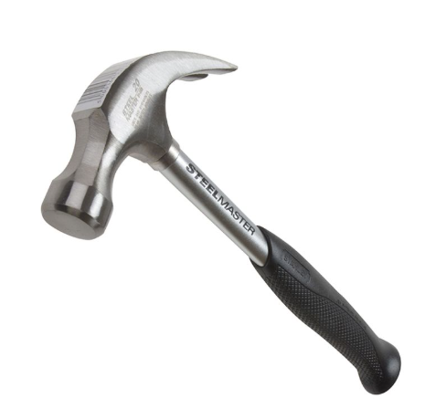

Figure 1 - Metal Object – Hammer. Source (Zoro Tools, 2025)

Acrylic Bathtub
As shown in Figure 2, an acrylic bathtub was selected for its lightweight, durability, and resistance to moisture. Its smooth, non-porous surface prevents mold growth, making it ideal for bathrooms. Acrylic retains heat well, enhancing comfort during baths, but although strong, it is prone to impact damage due to its brittleness. According to Royal Acrylic (2023) Acrylic is versatile, easily molded, cut, engraved and shaped, making it ideal for designers.
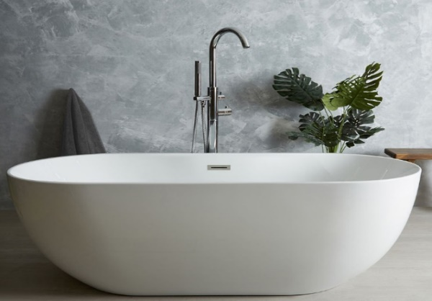

Figure 2 - Acrylic Bathtub. Source (Big Bathroom Shop, 2025)

Porcelain Bowl
As shown in Figure 3, a porcelain bowl is strong and durable making it resistant to chipping and staining. It can withstand high temperatures, making it safe for hot food and an essential item, which is why it was chosen, as well as for microwave and oven use. Its elegant, translucent appearance adds aesthetic value which is easy to clean. According to Dinesen (2024), Porcelain is clay fired at high temperatures, creating a non-porous, glass-like material.
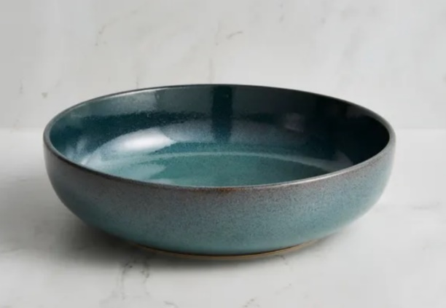

Figure 3 - Porcelain Bowl. Source (Dunelm, 2025)

Manufacturing Methods Comparison

Metal Hammer
Forging, casting, and machining are common methods for manufacturing metal hammers. As shown in Figure 4, Forging provides high strength and durability, making it ideal for impact tools, though it has higher costs. Casting is cost-effective for large runs but may compromise strength. Machining offers precision for small batches but is slow and expensive. Forging is the preferred method as according to Iron-Foundry (2025), forged parts have 37% higher fatigue strength, extending a hammers lifespan and ideal for an impact tool.

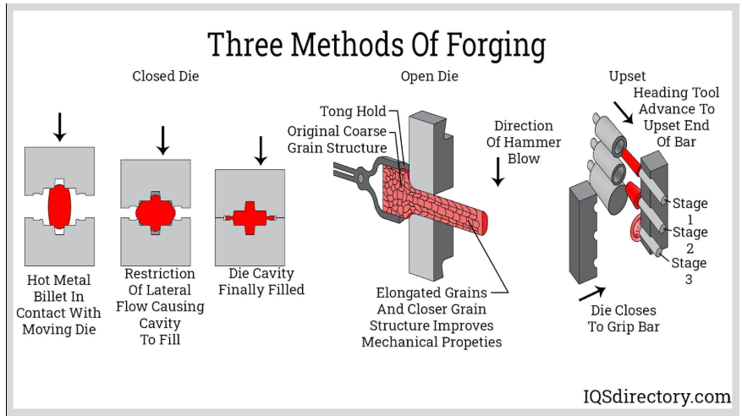
Figure 4 - Forging methods. Source (Iqs directory, 2025)

Acrylic Bathtub
As shown in Figure 5, Thermoforming is the most efficient and cost-effective method for mass-producing acrylic baths, providing speed and low costs. Casting is best for custom designs, though slower and more expensive. Vacuum forming is a middle ground, offering good speed and cost efficiency for larger, simple designs. According to British Plastic Federation (2025) Skeletal scrap of a Thermoplastic sheet is around 15%, but is reused in subsequent applications making this a sustainable option.

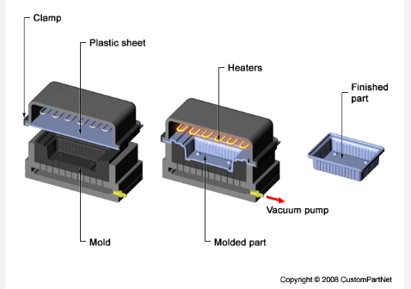

Figure 5 - Thermoforming methodology. Source (Weetect, 2008)

Porcelain Bowl
Slip casting is efficient and cost-effective for mass-producing porcelain bowls with high precision. Press molding suits medium-to-large-scale production of simpler designs but lacks flexibility. Throwing on a potter’s wheel is ideal for custom bowls, though it's time-consuming and costly. As shown in Figure 6, this shows slip casting’s effectiveness for intricate shapes. According to Hansen (2019), a thin-walled (2-3mm) bowl can be cast and demolded in minutes, unmatched in ease.
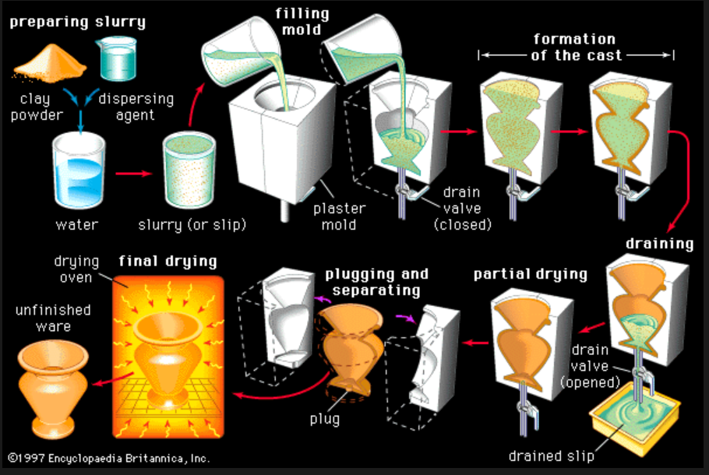

Figure 6 - Slip Casting. Source (Britannica, 1997)

Mechanical and Thermal Comparison

As shown in Figures 7 and 8, steel boasts the highest tensile and fatigue strength, making it perfect for hammerheads that endure heavy impacts. Its high density enhances efficiency when striking objects. Steel has the highest thermal conductivity among the materials, allowing it to withstand heat and temperature changes. However, it also heats up or cools down more slowly than materials with higher thermal conductivity.
Acrylic has the lowest density of the three materials, making it ideal for bathtubs due to reduced mass. It ranks second in tensile stress and fatigue strength, offering impact resistance without fracturing. It’s scores second in thermal conductivity which makes it a good insulator, helping maintain temperature stability for its application. Acrylic is highly formable, especially when heated. It can be easily molded, shaped, and bent into complex designs through processes like thermoforming.
Porcelain, displayed as Brick (90% clay), has low tensile and fatigue strength in its natural form, making it ineffective against forces and prone to cracking. However, when fired, porcelain’s mechanical properties improve significantly, gaining better strength and resistance to wear and fatigue. According to The Bright Angle (2022), Porcelain crockery is suitable for temperatures between (260-300°C), making it versatile for cooking.
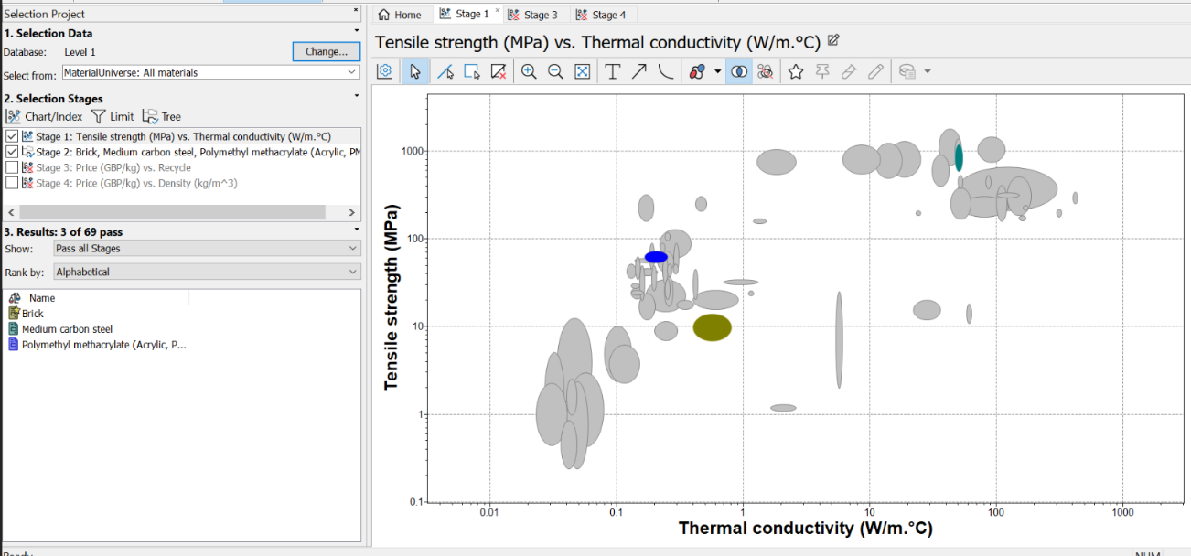

Figure 7 – Tensile strength v Thermal conductivity chart. Source (Granta, 2025)
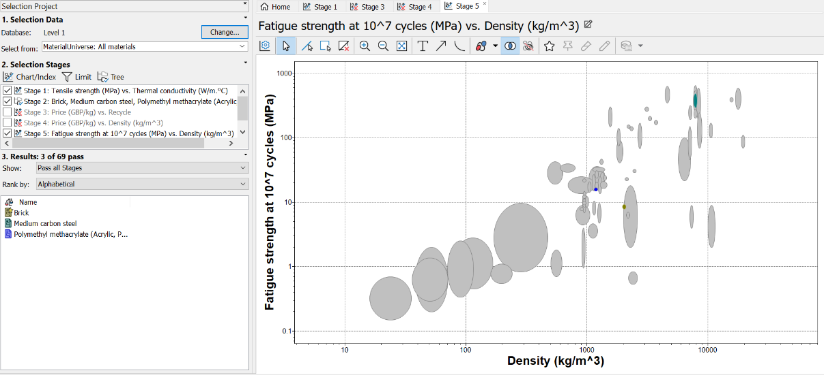
Figure 8 - Density v Fatigue Strength chart. Source (Granta, 2025)

Lifespan and Cost Analysis

As shown previously in Figure 8, Steel has excellent fatigue strength, making it durable for impact. However, corrosion is a potential issue, requiring water and oxygen. The corrosion of steel is a process that requires water and Oxygen. According to the World Corrosion Organisation (2020), corrosion costs the global economy US$2.5 trillion annually, in which 25% of this would be preventable through prevention measures. Despite this, steel remains a hard-wearing product with great cost-effectiveness and lifespan, making it ideal for impact applications.
Acrylic is cost-effective with a moderate initial cost and long lifespan, especially when well-maintained. It resists cracking and yellowing but can scratch and degrade under UV exposure. According to Conniff (2024), Acrylic over 10 years would exhibit 3% degradation through UV exposure. While durable, its brittleness limits use under high stress. Maintenance and UV protection can extend acrylic's lifespan, making it ideal for various applications especially a bathtub.
Porcelain offers a long lifespan, resistant to wear, staining, and heat, with moderate initial costs. It’s more expensive than acrylic but cheaper than metals. However, it can chip or crack under impact. With proper care and maintenance, porcelain remains a cost-effective and durable choice for kitchenware over time.

Material Selection and Alternative Choices

A steel hammer was selected over wood or plastic due to their drawbacks. While wood offers comfort it can degrade, crack, or warp. Plastic whilst light weight, is less impact-resistant and degrades under stress or extreme temperatures. For heavy-duty tasks or long-term use, steel is the preferred option.
A porcelain bowl was chosen over metal or plastic due to its advantages. Metal bowls heat up or cool quickly and aren’t microwave-safe. Plastic bowls are fragile, prone to staining, cracking and chemical leakage. Porcelain addresses these issues, offering durability, microwave safety, and resistance to odors and staining.
An acrylic bath was selected over metal or plastic for its durability, comfort, and aesthetic appeal. Unlike metal, it doesn’t conduct heat, providing a more comfortable experience. Acrylic is less prone to scratching, retains its finish better than plastic, and is easier to maintain, offering long-term value and luxury.
As shown in Figure 9 below, given complete freedom, a Marble bath would be selected for its luxury and timeless appeal. According to Lusso Stone (2022) marble baths weigh 700-750kg, indicating much higher density. Manufactured from a single block, it’s carved, tool-finished by hand and requires sealing due to its porous nature to prevent staining. At £117,000 it represents the epitome of luxury.

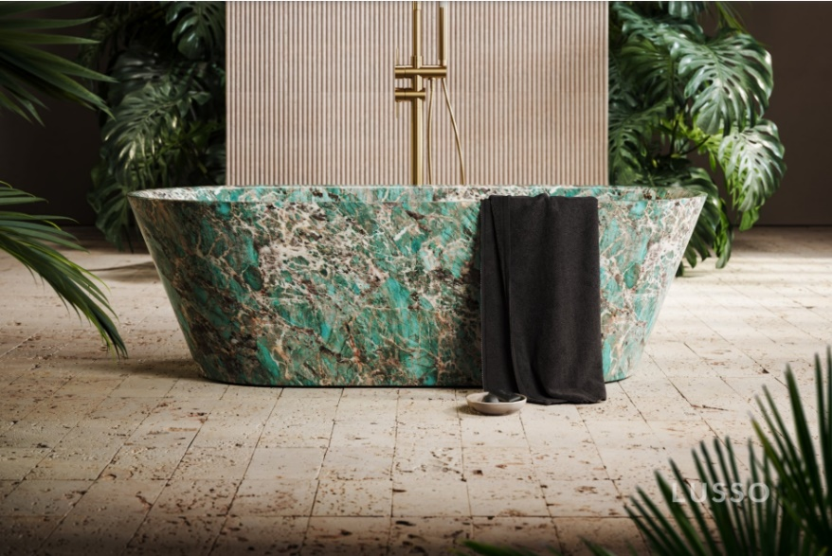

Figure 9 - Marble Luxury bath. Source (Lusso Stone, 2022)

Conclusion

In conclusion, material selection and manufacturing processes are essential for ensuring product performance, durability, and cost-effectiveness. Properly choosing materials based on their properties ensures products meet specific requirements. The right material and process directly impact functionality, longevity, and overall economic viability. Below is a summary of the material’s parameters.
- Manufacturing methods are critical as they impact production efficiency, material utilisation, cost-effectiveness, product quality, and overall performance.
- Mechanical and thermal properties are critical as they determine strength, durability, heat resistance and suitability for specific applications and conditions.
- Lifespan and cost analysis are critical for evaluating product durability, long-term performance, and ensuring cost-effective material and manufacturing choices.
- Material selection involves weighing benefits against drawbacks, as some materials may not suit specific applications due to limitations or costs.
As the report states, material properties, not the material itself, drive selection. This analysis has provided a new perspective on the materials used in everyday objects.

Bibliography
Big Bathroom Shop, 2025. Big Bathroom Shop. [Online]
Available at: https://www.bigbathroomshop.co.uk/milano-overton-white-modern-oval-double-ended-freestanding-bath-1600mm-x-750mm-118375?gad_source=1&gclid=EAIaIQobChMIgIbttceUiwMVdZdQBh2bqhVAEAQYBiABEgKp4fD_BwE&gclsrc=aw.ds
[Accessed 02 January 2025].
BPF, 2025. BPF - British Plastic Federation - Thermoforming. [Online]
Available at: https://www.bpf.co.uk/plastipedia/processes/Thermoforming.aspx
[Accessed 2025 January 18].
Britannica, 1997. Encylopedia. [Online]
Available at: https://www.britannica.com/technology/slip-casting
[Accessed 21 January 2025].
Dunelm, 2025. [Online]
Available at: https://www.dunelm.com/product/montreal-pasta-bowl-1000212489?defaultSkuId=30794672&utm_source=google&utm_medium=cpc&utm_campaign=Dine_Crockery-PMax_%5BGOO-PLA-DINE-CROCKERY%5D&gad_source=1&gclid=EAIaIQobChMI7ojovKGeiwMVv5ZQBh3ieguhEAQYAiABEgKnUPD_BwE&gcl
[Accessed 06 January 2025].
Granta, 2025. Density v Fatigue Strength. s.l.:Granta.
Granta, 2025. Tensile Strength vs Thermal Conductivity. s.l.:Granta.
Harris Lee, 2020. What is Tool Steel used For. [Online]
Available at: https://www.fushunspecialsteel.com/what-is-tool-steel-used-for/
[Accessed 21 January 2025].
Iqs directory, 2025. Open vs. Closed Die Forging: Process, Differences, Applications, and Advantages. [Online]
Available at: https://www.iqsdirectory.com/articles/forging/open-vs-closed-die.html
[Accessed 27 January 2025].
Iron-Foundry, 2025. Comparing Casting vs Forging. [Online]
Available at: https://www.iron-foundry.com/compare-casting-vs-forging.html
[Accessed 21 January 2025].
Lusso Stone, 2022. Lusso Stone. [Online]
Available at: https://www.lussostone.com/stone-resin-baths-c1/muse-tiffany-marble-freestanding-bath-1700mm-p9318/s15526?utm_medium=ppc&utm_term=muse-tiffany-marble-freestanding-bath-1700mm-mus17tif&utm_campaign=froogle&cid=GBP&glCurrency=GBP&glCountry=GB
[Accessed 30 January 2025].
Lusso Stone, 2022. Muse Tiffany Marble Freestanding Bath 1700mm. [Online]
Available at: https://www.lussostone.com/baths-c94/marble-baths-c138
[Accessed 30 January 2025].
McNeill Engineering, 2023. Material Selection. [Online]
Available at: https://www.mcneilengineering.com/material-selection-in-structural-engineering-balancing-strength-and-sustainability/
[Accessed 24 January 2025].
Megan Conniff, 2024. Polycarbonate vs. Acrylic: What to Know About These Different Plastics. [Online]
Available at: https://www.xometry.com/resources/materials/polycarbonate-vs-acrylic/
[Accessed 27 January 2025].
Michelle Dinesen, 2024. Stoneware vs. Ceramic vs. Porcelain. [Online]
Available at: https://carthage.co/stoneware-vs-ceramic-vs-porcelain-why-stoneware-reigns-supreme/.
[Accessed 14 January 2025].
Royal Acrylic, 2023. What is Acrylic?. [Online]
Available at: https://royalacrylic.com/blog/what-is-acrylic-properties-and-advantages-of-acrylic.html
[Accessed 16 January 2025].
Safety Culture Content Team , 2023. Manufacturing Systems. [Online]
Available at: https://safetyculture.com/topics/manufacturing-system/
[Accessed 25 January 2025].
Tencom Ltd., 2023. Optimizing Material Selection for Product Design Engineers. [Online]
Available at: https://www.tencom.com/blog/optimizing-material-selection-for-product-design-engineers#:~:text=The%20right%20material%20choice%20can,damage%20to%20a%20company's%20reputation.
[Accessed 25 January 2025].
The Bright Angle, 2022. Can You Put A Porcelain Bowl In The Oven. [Online]
Available at: https://thebrightangle.com/blogs/the-bright-angle-blog/can-you-put-a-porcelain-bowl-in-the-oven#:~:text=Handling%20oven%20heat&text=It%20is%20advised%20that%20porcelain,product%20a%20versatile%20kitchen%20material.
[Accessed 23 January 2025].
Titus Steel , 2020. What causes steel corrosion. [Online]
Available at: https://titussteel.com/what-causes-steel-corrosion/
[Accessed 29 January 2025].
Tony Hansen, 2019. Digital Fire. [Online]
Available at: https://digitalfire.com/glossary/slip+casting
[Accessed 20 January 2025].
Weetect, 2008. Custom Part Net. [Online]
Available at: https://www.weetect.com/thermoforming-acrylic/
[Accessed 23 January 2025].
Zoro Tools, 2025. Zoro Tools. [Online]
Available at: https://www.zoro.co.uk/shop/tools-and-machining/claw-rip-and-framing-hammers/st1-steelmaster-claw-hammer-567g-20oz-sta151033/p/ZT1293128P?utm_source=google&utm_campaign=pla%2B%7C%2BTools%20%26%20Machining&utm_term=ZT1293128P&utm_medium=pla_css_1&mkwid=-dc
[Accessed 16 January 2025].

