
Programme: Master of Business Administration

Module: Human Capital Management

Module code: LCMB7023

Assignment Title : Assessment component
1: Individual report

Student Name: Amishaben Bhikhabhai Panchal

Student ID Number: 2537875

Word count : 2732

Table of Contents
TASK A: Designing a Strategic Socialisation System for Helios Urban Mobility 3
1. Traditional On-boarding and Strategic Organisational Socialisation 3
2. A Strategic Socialisation Framework for Helios Urban Mobility 6
2.1 Phase 1: Pre-Boarding (Recruitment to Day One in Service) 6
2.2 Phase 2: Initial 90 Days 6
2.3 Phase 3: First Year-Integration 6
2.4 Measuring Success of Strategic Socialisation 7
3. Proposed Mechanism to Cultivate: 8
3.1 Organisational Identification 8
3.2 Ethical Professionalism 8
3.3 Business Activist Mindset 8
TASK B: Designing an Innovative Job Design Strategy for Helios Urban Mobility (HUM) 10
1. Innovative Job Design Strategy for Helios Urban Mobility 10
1.1 Job Characteristics Model (JCM) 10
1.2 Applying Job Crafting Theory 11
1.3 Skills-Based Architecture and Internal Talent Marketplace 11
1.4 Integrated Innovative Job Design Strategy 12
1.5 Implementation Challenges and Critical Evaluation 13
2. How the Proposed Design Stimulates Intrinsic Motivation and Innovation 13
TASK C: Reflective Report 15
Reference list 17

TASK A: Designing a Strategic Socialisation System for Helios Urban Mobility

1. Traditional On-boarding and Strategic Organisational Socialisation
Complete overhauling of on-boarding into comprehensive organisational socialisation system can increase organisational values in Helios Urban Mobility (HUM). HUM is experiencing challenges like human capital, eight-month on-boarding time, 54% employee engagement, and high attrition among potential graduates revealing drawbacks of existing traditional on-boarding practises.
Traditional on-boarding have administrative activities of policy introduction, providing role-specific training initially, and compliance documentation ensuring compliance and operations ignoring organisational commitment or cultural integration. The employees are aware about job but unclear of organisational contribution in organisational vision-mission-existence.
Strategic Organisational Socialisation is continuous developmental process integrating employees in organisational culture, values, social networks, and strategic objectives (Abdullah Türk and OzanEmreUdum). Van Maanen and Schein in Organisational Socialisation Theory (Houle et al., 2024) highlighted, it influence employee behaviour through collective induction, sequential training, mentoring and guidance reducing uncertainty, accelerated adjustment, and strengthens organisational commitment in employees. High institutionalisation may lower innovation and creativity.
Identity Construction Theory focuses on organisational engagement acquired socially through interactions, collective decision-making and sharing experiences (Pazzaglia et al., 2024). Helios can improve employee identity through social impacts developing AI-enabled sustainable transport system.
Identity construction theory has limitations as strong organisational identification may encourage excessive conformity discouraging constructive dissent in knowledge-intensive organisations.
Psychological Contract Theory (Manchia et al., 2025) explains employee engagement decline and graduate turnover in Helios. In career beginning an employee in an organisation possesses expectations like career development, meaningful job-role, recognition, and organisational support. During absence the employee perceives breach in psychological contract leading to trust reduction, disengagement, and voluntary turnover.
Psychological contracts are subjective differing in individuals, generations, and cultures. Organisations may fail to eliminate all perceived breaches. Realistic job previews and continuous manager feedback are recommended for proactive transparent communication.
Guest's HRM Model (Pal, 2024) argues that integrated HR practices, like strategic socialisation can improve employee commitment enhancing organisational quality, flexibility, and performance. For HUM, aligning recruitment, socialisation, and career development can improve employee engagement lowering graduate attrition, and accelerate organisational integration.
This model considers a universal relationship between HR practices and performance without sufficiently considering organisational aspect, leadership quality or labour market. Helios should integrate strategic HR practices with organisational culture, leadership capability and innovation strategy.
Study of Gallup (2025) shows that, the global employee engagement remains 20% and disengaged employees incurred loss of productivity in global economy for $10 Trillion.
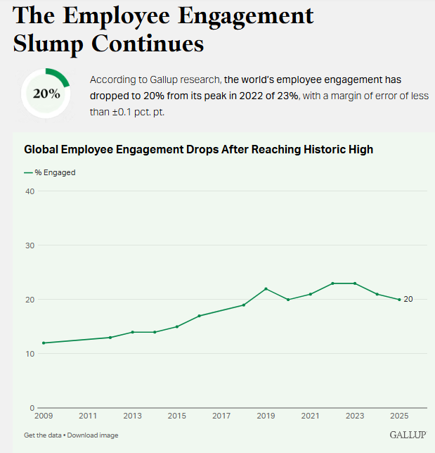
Figure 1: Decline in Employee Engagement
(Source: Gallup, 2025)
Helios’s performance of 54% is better but needs improvement for declination.

2. A Strategic Socialisation Framework for Helios Urban Mobility

2.1 Phase 1: Pre-Boarding (Recruitment to Day One in Service)
Here a fresher should be organisationally socialised through digital welcome packages from Helios learning vision-mission of developing sustainable urban mobility solutions, expected behaviours, future strategic priorities, and organisational values. A cultural ambassador and Leaders in Berlin, London and Singapore can habituate new recruits on international culture through virtual networking. AI-development tools, learning platforms and introductory projects can reduce uncertainty boosting psychological preparedness.

2.2 Phase 2: Initial 90 Days
Structured practical learning, storytelling sessions and compliance can be used here. Senior leaders should explain contributions of Helios’ technology to public well-being and sustainable cities (Kallem, 2025). Employees should know about key development milestones, social integration activities and performance expectations incorporating AI analytics, rotational exposure in engineering sustainability teams and customer solutions. Companies with proper on-boarding can improve retention highlighting strategic value of systematic socialisation evaluating progress and reinforcing psychological safety.

2.3 Phase 3: First Year-Integration
Socialisation is needed for long-term development post-initial adjustments as employees participate in innovative challenges. Leadership development programs should mentor potential graduates to boost succession planning and reducing attrition (NHS, 2015). It consist career development, operational learning and organisational identity formation. Helios should invest in employee growth and competence.

2.4 Measuring Success of Strategic Socialisation
To ensure that strategic socialisation delivers measurable organisational value, Helios should establish a balanced HR performance scorecard.
KPI | Current | Target (12-18 months)
Graduate retention | High attrition | More than or equal to 85% first-year retention
Employee engagement | 54% | More than 70% engagement
Time-to-productivity | 8 months | Reduce to 5-6 months
New hire satisfaction | Not measured | More than or equal to 90% positive onboarding feedback
Internal mobility | Low | 20% increase in cross-functional movement
Table 1: KPIs
(Source: Self-developed)
These KPIs should be monitored quarterly with the help of employee engagement surveys, HR analytics dashboards, turnover statistics, performance reviews and onboarding feedback surveys.

3. Proposed Mechanism to Cultivate:

3.1 Organisational Identification
Identification development creates employee perception for organisational success and values. Helios can encourage employees to contribute in reducing urban congestion, improve environmental sustainability, and enhance quality-of-life. The cross-location communities are aligned with organisational values and strengthening emotional attachment of employees. Social Identity Theory shows that an individual develops self-esteem from valued group membership celebrating organisational achievements strengthening psychological connection to the organisation. Excessive organisational identification can unintentionally encourage groupthink and reduce constructive criticism. Edmondson concept of psychological safety found that teams that developed team psychological safety cooperated better than those that did not (Mogård et al., 2022).

3.2 Ethical Professionalism
Helios relies on AI and public sector partnership. Ethical decision-making workshops should simulate real-time cases encouraging employees to balance commercial objectives with social responsibilities. Ethical professionalism should be integrated in organisational identity with mandatory ethics training (Caldeira and Infante-Moro, 2025), covering AI-governance, responsible data usage, cyber-security, environmental sustainability, and public accountability ensuring responsible conduct. However, only ethics cannot change behaviour,it can be changed through leadership modelling, ethical reward systems and organisational accountability mechanisms.

3.3 Business Activist Mindset
According to Ulrich's HR Business Partner evolution, HR should develop capabilities among employees to influence organisational strategy and broader business outcomes (Brynq, 2022). Instead of creating value for stakeholders, Stakeholder Capitalism perspective focuses on sustainable value creation for customers, employees, governments, communities and environment by focusing on ESG areas, mainly environmental.
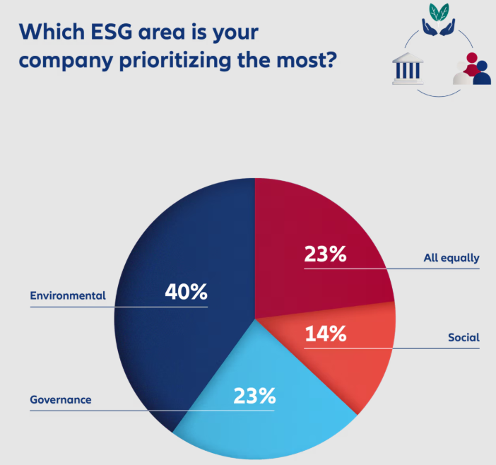
Figure 2: ESG focus on companies
(Source: Costa, 2024)
Organisational activism remains controversial. Shareholder theory explains that organisations should mainly maximise wealth of shareholders within legal boundaries, on the other hand, stakeholder theory describes balancing the interests of multiple stakeholder groups (Danielson et al., 2024). Excessive organisational activism may create conflicts when social or political positions alienate investors, customers or employees with differing values.
Strategically aligned business activism can strengthen organisational reputation, employer branding and stakeholder trust for close connection with firm's mission.
Helios should promote Business Activist Mindset to encourage employees to participate in urban sustainability projects, collaborate with city authorities. It should train employees on industry trends, ESG objectives, stakeholder management, and public policy for ethical responsibility as organisational ambassadors influencing positive social changes (Costa, 2024).

TASK B: Designing an Innovative Job Design Strategy for Helios Urban Mobility (HUM)

1. Innovative Job Design Strategy for Helios Urban Mobility
The approach of defining jobs flexibly as per skills can create more opportunities for employee engagement speeding up their skills development contributing to the company's success.

1.1 Job Characteristics Model (JCM)
According to Hackman and Oldham's Job Characteristics Model (Ali et al., 2013), five job dimensions relate to increased intrinsic motivation which still applicable in today's digital organisations.
Helios should implement cross-functional project rotation opportunities like AI-development, mobility analytics, sustainability consulting, customer solutions and public-sector implementation like rotations broaden technical or business knowledge for employees. They can lower repetitive works. The World Economic Forum states that 39% of employees' core skill sets will transform by 2030 (World Economic Forum, 2025), making cross-functional learning critical for developing an organisation's overall capability.
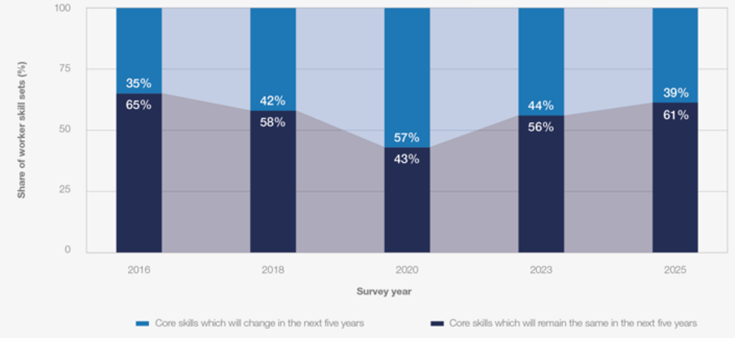
Figure 3: Disruption to skills
(Source: World Economic Forum, 2025)
To increase strength of task identity, organisations should engage employees fully in all phases of project lifecycle. It increases sense of ownership and accountability among employees knowing how their contributions support the organisation’s objectives.
Task significance can be enhanced through communication of social impact generated through Helios' AI-enabled mobility solutions (Wani, 2023). It is a key differentiator as Helios will attract and retain Gen-Z workers for their focus on meaningfulness of their work against traditional incentives.
Greater autonomy in project management can allow teams to determine work methods, allocate responsibilities, and experiment with innovative solutions within strategic guidelines. Finally, replacing annual appraisals with continuous coaching, peer feedback, and AI-enabled performance dashboards will accelerate Helios' current on-boarding period. Soraghan (2023) founded that employees receiving continuous coaching demonstrate significantly higher engagement, learning, and adaptability than relying solely on annual performance reviews.

1.2 Applying Job Crafting Theory
The Job Characteristics Model focuses on the process of job design within an organization but Job Crafting helps employees to reshape their jobs according to their strengths and interests. Job crafting mainly focuses on employee innovation and highly recommended for Helios as it needs initiative and creativity of employees (NameeraMunnisunker and NeleshDhanpat, 2025). Helios can identify and select innovative projects that employees are passionate about can help in motivating them to engage in task crafting. The company can implement virtual communities focused on innovative solutions to support innovation. The company can also support innovation through collaboration between employees located in various locations like London, Berlin, and Singapore.
Job crafting is also strategically beneficial for the company yet organisations that offer employees the chances to influence how work can be done are likely to achieve greater employee retention (NameeraMunnisunker and NeleshDhanpat, 2025). However, it is important for Helios to contact required managerial coaching and employees have clear expectations of their performances.

1.3 Skills-Based Architecture and Internal Talent Marketplace
As there is any rapid advancement of artificial intelligence, machine learning, end smart mobility it is important for Helios Urban Mobility to change its traditional job based structure to a Skill-based Architecture (Emerson et al., 2026). They needs to define employees by fixed job titles to identify, develop, as well as deploy talented workers in accordance to their technical skills like AI programming, data analytics.
The company should integrate Skill-based Architecture with an internal talent marketplace to hire employees for international assignments, short term innovation projects, mentoring programs, and also employees who can match its cross functional teams. As mentioned by (World Economic Forum, 2025) core skills of almost 39% of employees a projected to change by 2030, it is important for companies to ensure continuous reskilling.It is important for Helios to adopt Skill-based Architecture to enhance employee engagement, organizational agility, and minimise attrition.
Human Capital Theory (Leoni, 2023)explained that investment in knowledge of the employee, skills, and capabilities enhances both individual productivity and long-term performance of the organisation. For Helios, giving preference to continuous learning, AI capability development, mentoring, and cross-functional reskilling will improve its strategic human capital. It will alsominimize dependency on external recruitment. This resonates with a Build and Buy Talent Strategy (DiDomenico, 2025), where the organisation mainly develops existing employees with the help of internal mobility, learning pathways, and stretch assignments. On the other hand, organisation selectively hires external specialists for emerging technologies and critical capability gaps. This balanced approach enhance workforce agility, lowers cost of recruitment andboost innovation.Research shows that internally promoted employees outperform their externally hired peers for the first two years in that job and will cost company about 18% less (DiDomenico, 2025).

1.4 Integrated Innovative Job Design Strategy
The proposed job design strategy can be considered as interconnected system. The Job Characteristics Model (Hadi El-Farr, 2023) focuses on motivating work through greater autonomy, task significance, skill variety and continuous feedback.Job crafting help the employees to proactively align their roles and tasks with their strengths, preferences, and values (Boateng and Appiah, 2025).Skills-Based Architecture captures employees' evolving capabilities instead of restricting them to static job descriptions. Finally the Internal Talent Marketplace translates those capabilities into practical career opportunities by matching employees with strategic projects, international collaborations and learning experiences.

1.5 Implementation Challenges and Critical Evaluation
- Financial investment: Significant financial investment is needed for developing Ai powered talent platforms, digital learning system.Furthermore, during the period of implementation productivity may decrease.
- Managerial resistance: managers may resist more autonomy of employee, jobcrafting (Shin et al., 2020) and internal mobility as these practices may minimize the control on conventional job boundaries.
- Technology requirements: The effectiveness of skills-based architecture depends on HR analytics, AI-powered skills assessment, integrated learning management systems and Internal Talent Marketplace platforms.Outdateddigital infrastructure may reduce matching accuracy.
- Employee acceptance: Some of the employees may consider constant reskilling project rotations and changing job roles as workload. To decrease resistance Effective change management, transparent communication and continuous managerial support are needed.

2. How the Proposed Design Stimulates Intrinsic Motivation and Innovation
The recommended job design strategy can improve intrinsic employee motivation satisfying needs for autonomy, meaningful work, and competence aligned with self-determination theory. It develops new skills providing visible career pathways through cross-functional rotations, monitoring, and internal talent marketplace (French, 2015). Employees become focused when they understand how their work contributes to sustainable urban mobility, enhanced public services, and reduced carbon emissions by Helios’s Technology.
The proposed integrated design can improve innovation through interdisciplinary collaboration, psychological safety, and knowledge sharing. Helios can motivate employees to experiment and take calculated risk through continuous learning and productive feedback. Gallup (2025) reports, 18% higher productivity and greater innovation is seen in organisations with highly engaged employees.
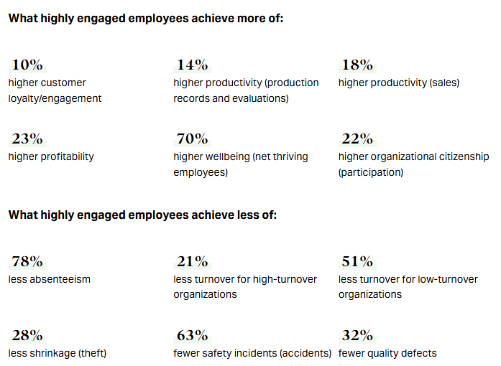
Figure 4: Benefits of Employee engagement
(Source: Gallup, 2025)

TASK C: Reflective Report
Introduction
Creating the human resources framework for Helios Urban Mobility (HUM) has been a valuable learning opportunity. With the application of Driscoll’s (2007) paradigm, this chapter lays out the challenges I experienced, my changed thinking in regard to contemporary HR practices, and how all this—with all along amid AI technologies—helped shape my approach to the HR practices of the future.
What? (The Experience)
The process of finding solutions to HUM that includes cross-functional rotations, skills-based architectures, and AI-powered performance dashboards has posed various issues. A major obstacle was the incorporation of a variety of complex academic HR theories into practical and actionable strategies in organizations. In order to facilitate this wide-ranging research, I made use of the Generative Artificial Intelligence tools that help to identify the right academic materials and proofread.
Nonetheless, this resulted in an additional obstacle: upholding academic integrity. I needed to strike a careful compromise between the usage of AI as a supplementary tool in doing research and complying with module requirements, in which all critical analysis, synthesis, and writing of the final paper is mine and was done without help from AI.
So What? (Evaluation and Analysis)
This experience dramatically changed my view of the relationship between technology and human capital management. Before, I thought of Generative AI mainly as an effective decision-making tool. But my active involvement in addressing HUM's strategic issues forced me to notice one serious limitation of AI: While it is very good at fast data processing, it lacks both contextual understanding and moral reasoning, which are necessary to perform HR tasks effectively.
For instance, while working on the ethical and professional guidelines for HUM, I realized that overreliance on AI can lead not only to algorithmic bias but also to ignoring the human consequences of managerial decisions. From my perspective, the key learning experience was that HR specialists should be aware of the fact that if they unquestioningly accept AI outputs, they stand to lose a human touch and empathy in their work.
Now What? (Action Plan)
In light of the changes that have occurred in HR practices, I have developed a personal strategy for developing my competencies in the future:
Knowledge of data and AI support: I am going to improve my data interpretation skills through courses in HR analytics.
Skills of strategic influencing: Drawing from the HR partner role according to Ulrich, I am going to participate in business congresses devoted to the issues of strategic influencing provided by activist business leaders.
Knowledge of global mobility: I plan to learn about cross-cultural experience, and employment laws around the globe.
Conclusion
In the end, the execution of this project taught me that to be successful in HR jobs in the future, I will need to strike a balance between the benefits of automation and the need for human touch in HR. As new technological solutions continue to revolutionize the workplace, the original value of an HR professional will be in using the output from automated processes effectively and ethically. With this understanding in mind, accompanying it with continuous development of my data literacy, international awareness, and leadership skills, I am confident in my ability to perform and lead in HR in the future.

Reference list
Abdullah Türk and OzanEmreUdum (2025). Understanding How Organizational Socialization Shapes Organizational Commitment: A Qualitative Study in the Aviation Industry. ActaPsychologica, 262, pp.106115–106115.doi:10.1016/j.actpsy.2025.106115.
Afnek, R. and Khadem, A. (2026).Crafting Your Employability: How Job Crafting Relates to Sustainable Employability Under the Self-Determination Theory and Role Theory. [online] Mdpi.com. Available at: https://www.mdpi.com/2071-1050/18/2/979.
Ali, S.A.M., Said, N.A., Yunus, N.M., Kader, S.F.A., Latif, D.S.A. and Munap, R. (2013). Hackman and Oldham’s Job Characteristics Model to Job Satisfaction. [online] Sciencedirect.com. Available at: https://www.sciencedirect.com/science/article/pii/S1877042814028286/pdf?md5=d22856a61e08683d63419dfdf7ba5483&pid=1-s2.0-S1877042814028286-main.pdf [Accessed 16 July 2026].
Boateng, R.K. and Appiah, S.O. (2025). Job crafting and employee commitment: Key drivers for retaining skilled talent in digitally transformed organizations. Future Business Journal, 11(1).doi:10.1186/s43093-025-00629-0.
Brynq (2022).The Evolution of the HR Business Partner by Dave Ulrich - Strategic Leadership. [online] Strategic Leadership. Available at: https://strategicleaders.com/evolution-hr-business-partner/.
Caldeira, R. and Infante-Moro, A. (2025).The Importance of Ethics in Organisations, Their Leaders, and Sustainability.Administrative Sciences, [online] 15(9), pp.372–372.doi:https://doi.org/10.3390/admsci15090372.
Costa, A. (2024).From obligation to motivation: why employee engagement is the key to ESG success. [online] World Economic Forum. Available at: https://www.weforum.org/stories/2024/12/employee-engagement-esg/.
Danielson, M.G., Hogan, K.M. and Olson, G.T. (2024).Shareholder Theory, Stakeholder Theory, and the Capital Budgeting Decision. [online] Ssrn.com. Available at: https://papers.ssrn.com/sol3/papers.cfm?abstract_id=4826778 [Accessed 16 July 2026].
DiDomenico, P. (2025). Build, Buy, or Borrow? How One HR Leader Chooses a Talent Strategy. [online] Shrm.org. Available at: https://www.shrm.org/in/topics-tools/news/organizational-employee-development/build-buy-borrow-talent-strategy [Accessed 9 July 2026].
Emerson, G., Kropp, M., Bedard, J., Krayer, L., Romanov, V., Hsu, M., Boedo, L.S. and DiyaMohnot (2026).AI Will Reshape More Jobs Than It Replaces. [online] BCG Global. Available at: https://www.bcg.com/publications/2026/ai-will-reshape-more-jobs-than-it-replaces.
French, R., 2015. Cross-cultural management in work organisations.Kogan Page Publishers.
Gallup (2025a). How to Improve Employee Engagement in the Workplace. [online] Gallup. Available at: https://www.gallup.com/workplace/285674/improve-employee-engagement-workplace.aspx.
Gallup (2025b). State of the Global Workplace Report. [online] Gallup. Available at: https://www.gallup.com/workplace/349484/state-of-the-global-workplace.aspx.
Hadi El-Farr (2023). Job Characteristics Theory.SAGE Publications, Inc. eBooks.SAGE Publishing.doi:10.4135/9781071923528.
Holliday , M. (2023). 6 Reasons Good Employees Stick Around, According to a Legendary Staffing Agency. [online] Oracle NetSuite. Available at: https://www.netsuite.com/portal/resource/articles/human-resources/employee-retention-strategies.shtml.
Houle, S.A., Morin, A.J.S., Vandenberghe, C., Tóth‐Király, I. and Fernet, C. (2024). From employee socialization to co‐evolution: A lifespan multidisciplinary conceptualization. Applied Psychology, 74(1).doi:https://doi.org/10.1111/apps.12572.
Kallem, S. (2025). How Tech Leaders Can Shape Sustainable Cities. Forbes. [online] 13 Oct. Available at: https://www.forbes.com/councils/forbestechcouncil/2025/10/13/reimagining-urban-transformation-how-tech-leaders-can-shape-sustainable-cities/.
Leoni, S. (2023). A Historical Review of the Role of Education: From Human Capital to Human Capabilities. Review of Political Economy, [online] 37(1), pp.1–18. doi:10.1080/09538259.2023.2245233.
Manchia, G.C.A., Bal, P.M. and Khapova, S.N. (2025). Unveiling the origins of psychological contract perceptions: A systematic review of 30 years of psychological contract antecedents research. Journal of Managerial Psychology, pp.1–28.doi:10.1108/jmp-10-2023-0608.
Mogård, E.V., Rørstad, O.B. and Bang, H. (2022). The Relationship between Psychological Safety and Management Team Effectiveness: The Mediating Role of Behavioral Integration. International Journal of Environmental Research and Public Health, 20(1), p.406.doi:10.3390/ijerph20010406.
NameeraMunnisunker and NeleshDhanpat (2025).Exploring the relationship between job crafting and resilience.SA Journal of Human Resource Management, [online] 23(0), p.12. Available at: https://sajhrm.co.za/index.php/sajhrm/article/view/2997/4865.
NHS (2015).Talent and Talent Management Insights.Leadership Academy.
Pal, R.K. (2024).A Short Review of Various Models of International Human Resource Management.Journal of social welfare and management, 16(1), pp.43–50. doi:10.21088/jswm.0975.0231.16124.6.
Pazzaglia, F., Sonpar, K., Kulkarni, M. and Maheshwari, N. (2024). Tokens or Trailblazers: Identity Construction of Occupants of New Inclusion-Driven Roles. Journal of Management.doi:10.1177/01492063241282762.
Shin, Y., Hur, W.-M., Park, K. and Hwang, H. (2020). How Managers’ Job Crafting Reduces Turnover Intention: The Mediating Roles of Role Ambiguity and Emotional Exhaustion. International Journal of Environmental Research and Public Health, 17(11), p.3972.doi:10.3390/ijerph17113972.
Soraghan, T. (2023).The Importance of Employee Coaching: Empowering Growth and Success - AMS. [online] AMS. Available at: https://www.weareams.com/expert-insights/the-importance-of-employee-coaching-empowering-growth-and-success/.
Wani, O. (2023). The Importance of Communications in Social Impact Engagement and Ev... [online] Hey.com. Available at: https://world.hey.com/oaw/the-importance-of-communications-in-social-impact-engagement-and-evaluation-7b3eb397.
World Economic Forum (2025).The Future of Jobs Report 2025. [online] World Economic Forum. Available at: https://www.weforum.org/publications/the-future-of-jobs-report-2025/in-full/3-skills-outlook/.

