Student Name: Sivan Schechner
Student Number: 2004529
Programme of Study: Product and Furniture Design
Module: ADAD4018
Ways of Thinking Lecturer’s Name: Julia Lockheart

Task 1: Manifesto 483

Task 2: Observational Writing 465

Task 3: Practice Based Writing 455

Manifesto
- Reduction of population means a better world for us.
- Strictly focus on products designed to last, designed to repair.
- End the plastic age we live in; we live in trash.
- Allow the AI uprising, computers know best.
- Love beautiful things, love intelligent people.
- Free education for everyone, forever.
- Tax meat at the highest tax bracket.
- Read everything.

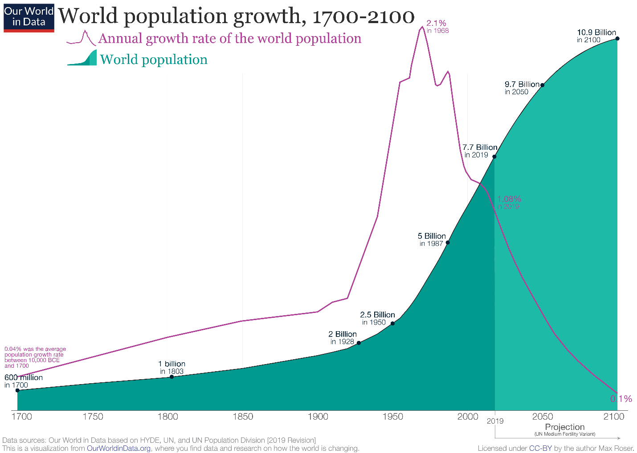
Human population has gotten out of control. No longer do we need so many people, this world has entered a new age – the autonomous age. Yet the population still rises and at an increasing rate almost doubling every 40 years since the 1940’s. People follow their biological urges to reproduce, to continue their bloodline - constantly multiplying and very soon, if not already, out growing out of control (Ehrlich, 1968). Humans greatest creation is no longer life, but artificial intelligence; This should be the baby we nurture. As population declines no longer do, we need to worry about there being enough resources to sustain us, enough food to eat (Sample, 2007). To solve the problem of population, is to solve half the problems we face today. Half the population and you have halved the CO2 humans produce. You have houses already built to end homelessness. Today governments do not reward their civilians to not conceive, instead England rewards the parents with an easy life, free education and free healthcare for children, parents do not contemplate having a child. In my opinion this is necessary, all children should be supported throughout their childhood and adolescence, yet more should be done for those who sacrifice their pride and bloodline to help cure the world of overpopulation.

Do not resist the AI uprising. Computers know what is best, they are less bias than humans (at least the newest ones), and these biases are often fault of the programmer, not the machine (James Manyika, 2019). Artificial intelligence has helped us truly separate ourselves from all other animals. It educates us, it entertains us, and it keeps us alive. As this manifesto is being written it is being rolled out for use in Europe to keep people safer when driving and alive longer in hospitals (José Pagán, 2019). Even the Guardian newspaper has an AI journalist now (GPT-3, 2020). I dream of a world where almost all decisions are dictated by the machine.


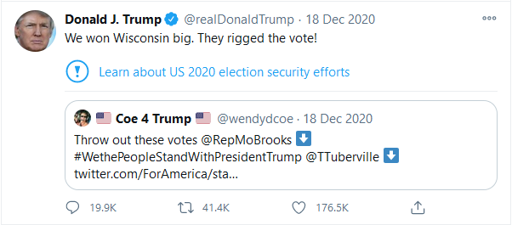
Trump, D (2020), Twitter, screenshot by author from https://twitter.com/realDonaldTrump?ref_src=twsrc%5Egoogle%7Ctwcamp%5Eserp%7Ctwgr%5Eauthor

With the rise of far right and alt right groups in America and the United Kingdom (Gray, 2018), due to fear tactics used recklessly by right wing politicians and the increase of silencing credible news outlets, political parties are converting a large portion of lower educated, politically unaware civilians to turn to extremist views. Today’s politics are making Fahrenheit 451 a reality. Donald Trump’s cries on social media discarding any news publisher that speaks against him, even in a single article. Feeding his viewers with easy-to-read sentences with, “We won Wisconsin big. They Rigged the Vote!”. It is not hard to find links to what is happening in now, to Fahrenheit 451, where the main concept is a dystopia that burns books and discards any conflicting information that the state tells its civilians; where everything is put into short, easy comprehensible headlines, that are not necessarily the truth (Bradbury, 1953).

Bibliography
Bradbury, R., 1953. Fahrenheit 451. 1st ed. United States: Ballentine Books.
Ehrlich, P. R., 1968. The Population Bomb. 1 ed. New York: Balletine Books.
GPT-3, 2020. A robot wrote this entire article. Are you scared yet, human?. Guardian, 8 September, p. 1.
Gray, P., 2018. ‘The fire rises’: identity, the alt-right and intersectionality.. Journal of Political Ideologies, 23(2), pp. 141-156.
James Manyika, J. S. B. P., 2019. What Do We Do About the Biases in AI?. Harvard Business Review, 25 October.
José Pagán, M. M. H. A. B. A. M. F. C., 2019. How AI Impacts Urban Living and Public Health. 1st ed. New York: Springer Nature Switzerland AG.
Sample, I., 2007. www.theguardian.com. [Online]
Available at: https://www.theguardian.com/environment/2007/aug/31/climatechange.food
[Accessed 15 11 2020].

Semiotics

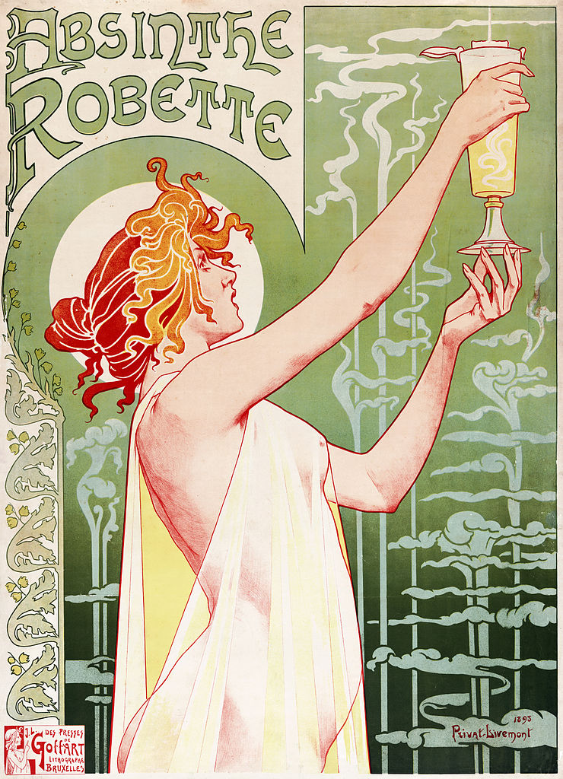
(Privat-Livemont, 1897)
I chose to evaluate an Absinthe Robette poster in 1897. Semiotics has been used in advertising. Semiotics is how cultures derive meaning from the world, both literally and metaphorically. It is used heavily in marketing, to understand consumer behavior to target markets in different regions (Oswald, 2020). With that in mind, Absinthe Robette was published in Belgium and France.
Semiotics uses key words to identify the literal and figurative meanings withing the subject, ‘denotation’ is the signifier and literal identity, and ‘connotation’ is the metaphorically signified (Chandlers, 2002).
The Poster was done in the style of Art Nouveau, an art movement that begun around 1890 ending in 1910 (Britannica, 2019). The posters focus is a woman, she is only wearing a light silk dress, making, her garment and red/blonde curly hair, giving her a Greek goddess appearance. The woman has a resemblance to the statue Venus de Milo (Aphrodite), with similar hair and attire. In this instance, the signifier is a beautiful woman dressed provocatively, and Aphrodite, a goddess is signified (Haluszka, 2008). This is also hinted through signs, for example water is pouring into the woman’s glass from an unseen source in the top corner of the poster. There are several things in the scene that lead to the connotation of the water source to be heaven. Firstly, we have had the goddess connotation. She also has a circle of light around her head that portrays a halo, a way many religions such as Christian, Greek and Buddhism. After researching this, I believe that Privat-Livemont had successfully created semiotics that do not just apply to Christian countries but has found a way to tie links for multiple countries to understand his vision. In the book ‘Ways of Seeing’ it mentions that when a painting is reproduced in film, the directors must take a segment of the painting and slowly unravel it, as a film is flows with time, where a painting has all the information already on it (John Berger, 1972). In a similar way Privat-Livemont has taken the aspects of a three-dimensional image and compressed it into two dimensions.

Looking further into the poster I had found that the fabric draped over her body is the same colour as the drink itself, tying it and the drink together. The fabric appears to be silk, a soft, comfortable and expensive material. It seems to suggest that this drink will make you comfortable, and this drink is for the wealthy. The fabric looks lightweight due to its transparency and is worn in such a way it does not restrict movement, its liberating.

The background also has organic shapes, like clouds and mushrooms. At first glance they appear to be decorative; they could be signifying the water dropping into the glass, or that of a potion – perhaps a dream like state, reinforcing the idea that absinthe causes hallucinations.

Bibliography
Britannica, 2019. britannica.com. [Online]
Available at: https://www.britannica.com/art/Art-Nouveau/additional-info#history
[Accessed 5 11 2020].
Chandlers, D., 2002. Semiotics: The Basics. 2nd ed. Abingdon: Routledge.
Haluszka, A., 2008. Sacred Signified: The Semiotics of Statues in the Greek Magical Papyri. Johns Hopkins University Press, 41(3), pp. 479-494.
John Berger, C. F. S. B. M. D. R. H., 1972. Ways of Seeing. 1st ed. London: British Broadcasting Corperation.
Oswald, L. R., 2020. Doing Semiotics: A Research Guide for Marketers at the Edge of Culture. 1 ed. Oxford: Oxford Scholarship Online.
Privat-Livemont, H., 1897. Absinthe Robette. [Art] (Brussels International Exposition).

The Chair: A look at how the most popular product is constantly changing.

The key importance of an office chair is to be comfortable and ergonomic, however many businessmen what to have a sharp, clean look to their office. Less and less CEOS are opting for ‘thrones’ to sit upon. Each year the chair makers are coming up with sleeker designs, each looking more stylish, but not necessarily comfortable. Do you want your work to be associated with comfortable chairs? They have a stigma, just like couches and bean bags, if it looks too comfortable, a lazy person may sit there. The stigma of a comfortable chair surpasses the work life. It says what kind of person you are, are you active and sporty, do you look after yourself?
The rise of the gaming chair. As new deskbound activities enter larger markets, new chairs arrive. For console games in the 2000’s it was the lazy boy. Now the gaming PC is a growing market, and ‘Gaming chairs’ have swarmed the marketplace, rising over 100% increase in sales over the past year (Don't Buy a "Gaming Chair" - Office Chair vs. Gaming Chair Round-Up & Review, 2020). This said, Herman Miller, one of the lead companies had recently released their own gaming chair in partnership with Logitech. The chair was launched in July 2020 (Faulkner, 2020)
The evolution of chairs is easily visible through flicking through 1000 chairs, while in the early 20th century, many of the materials were wooden, this was consistent with wood, wood and metal or wood and upholstered. Material technology played a large roll it the modern chairs we know today. Polymers, alloys, fabrics and even fiberglass were quick from discovery to be implemented in chairs (Charlotte, 2020).
In the 1859 a man named Michael Thonet came up with an ingenious way of mas producing chairs, these chairs were lightweight, efficient to ship and popular with homes and coffee houses all around the world. Many still exist to this day. These chairs were made from just steam bent wood and nails ending production in the 1930s with 50 million sold (Anderson, 2020). One year before Thone’s chair left production there was a whole new style, metal and leather/fabric straps. Le Corbusier’s Basculant chair was an icon for Bauhaus, and one of the last influential Bauhaus chairs made. It was manufactured with ease and its strong metal frame meant the chair would last (Meadmore, 2019).
To try and capture the latest style, I have been sketching mesh chairs. I moved away from sketching to get an understanding of shapes that will help with a cushion or spring support. I achieved this by using a paperclip and wrapping fabric around the ends. This helped me to understand what sketches I drew could work and where to improve upon them. I found this a rather fun and educational task.

Bibliography
Anderson, I. F., 2020. BRIEF WESTERN HISTORY OF FURNITURE DESIGN. PART 2. 1st ed. s.l.:s.n.
Charlotte, P. F., 2020. 1000 Chairs. 2nd ed. Cologne: Taschen GmbH.
Don't Buy a "Gaming Chair" - Office Chair vs. Gaming Chair Round-Up & Review. 2020. [Film] Directed by Gamers Nexus. North Carolina: Gamers Nexus.
Faulkner, C., 2020. Logitech and Herman Miller team up to make the Embody gaming chair. [Online]
Available at: https://www.theverge.com/21331603/logitech-herman-miller-embody-gaming-pc-chair-comfort-price-design
[Accessed 14 12 2020].
Ideologies, 23(2), pp. 141-156.
ed. New York: Springer Nature Switzerland AG.
Meadmore, C., 2019. The Modern Chair. 1st ed. s.l.:Dover Publications.

