Project management plan for restaurant extension

Name – Moshiur Rahman
Student ID- 1814025
Programme- BA (Hons) Management and Leadership- Skills for the workplace
Internal Verifier: Yohan Mendis
Assignment title: Project Management Plan
Module: Managing Project in the Workplace.
Module code – BMSW 5104
Lecturer- Dr. Vajira Balasuriya
Submission Date- 23/07/2021



brizmaker / Getty Images

Executive summary:
The purpose of this research was to demonstrate a proper and practical management plan, for the restaurant extension of Fine Dining. This report consists of the accumulated data from surveys, customer reviews, and various other methods of research. It keeps in mind the current state and stability of the restaurant in the market. This helps to come up with a proper management plan for the restaurant extension to maximize profit.

Table of contents

Introduction 3
Background 3
Methodology 5
Stakeholder analysis: 6
Findings 7
Work breakdown structure: 8
Discussion 10
The project schedule: 10
Gantt chart of the project plan to extend a restaurant: 11
Risk assessment: 12
Conclusion 13
References 13
Appendices 15

Introduction
This report proposes a management plan for the restaurant extension of Fine Dining. A project management plan is a document that outlines how to carry out and or monitor the project. Fine Dining is the most popular restaurant in the United Kingdom that sells and provides customers with homemade delicacies that remind people of their heritage. It not only has been in the market for over decades now but has also made sure to retain its quality just like the very first day it opened. It provides satisfaction and a sense of nostalgia to all the customers that come and go. Apart from locals, even tourists love Fine Dining, it is quick to be recognized by tourists and by the locals for its impeccable service and delicious food. (Kelly, 2020) Just like it provides a sense of nostalgia to the locals it shows the tourist what the United Kingdom was and how it is now by holding up the taste of flavors. (Mbengeranwa, 2015)

However, ever since the establishment of Fine dining it has not expanded or opened up any more branches apart from the original one. It is known that with increasing popularity, demand increases, so supply must increase in order for the majority of the customers to purchase the service or the food. Due to increased demand and limited supply, the profit is limited. In order to match up the competition and demand in the market, the restaurant must expand to accommodate a greater number of customers. However, this should be done with careful consideration keeping a lot of factors in mind. Thus, this report at hand provides a proper breakdown of all these factors affecting the restaurant and its business and comes up with a proper project management plan that is suitable to be proposed to the board of leaders in order to expand the restaurant.

Background
Projects are objectives or set goals that have to be reached by the given amount of time with the help of certain resources, capital, and when needed labor. (Clark, 2019) Generally, projects are goals that are being reached for the very first time. So, when a project fails the goals are modified and set again in order to increase the chances of being successful and completing the projects. For a project to be successful, it must reach its set targets or achieve the goal that was set. The success in carrying out a project depends on several factors. Among these, the most important one is the process, method, or guideline one follows or abides by while carrying out the project. Even though all the factors can not be fulfilled or be monitored to the fullest it is essential to do as much as possible for establishing a project in a safe and sustainable manner.

A plan refers to the process or method one decides to follow while doing a task or meeting an objective. (Gillinder and Stuart, 2018) To carry out a project one must follow such a guideline or a plan. This plan is known as a project management plan. In other words, it is a formal document that is approved by the board of leaders in a company or the given business that in this case is the restaurant’s owners that explains how to execute the plan for the project, it also helps keep track of the progress. The main reasons due to which the need for a project management plan might arise. These are a rise in customer focus, a closed economy, and minor projects having major problems. Without the project management plan, the route to growth or development can get very complicated or confusing. This often causes the project at hand to fail, that is why it is necessary to follow the management plan that is verified. These plans are important as they show the best use or investment of capital invested in the business, increase efficiency, and helps the economic progress of the business. In order to come up with a suitable project management plan a lot of things have to be considered and have to be researched which in this case is regarding the restaurant. The first and foremost being the lifeline or life cycle of the project at hand. Considering this while making the plan resolves the issue of not being able to complete the project within the given time, this reduces the risk of the project failing alongside acting as a reminder of the progress of the project at hand.

A project life cycle means the time, period, or the set time limit assigned to a project in order for it to be completed. (Pica, 2016) Projects almost always have a specific project manager assigned, this person monitors and executes the project according to the plan. The project life cycle consists of defining, planning, executing, and delivering. (Davis and Yen, 2019) The standard process or life cycle of a project is divided into five steps. These five steps are applicable to almost all businesses that are planning or handling a project. The five steps in the proper sequence of the life cycle are that, firstly, the project needs to be identified or recognized. This step acknowledges and shines a light on the issues that require the need to be resolved by the project or why the project needs to be started in the first place. Secondly, the design or utility of the project at hand. This step makes sure to hold up a proper analysis that shows the level of utility or feasibility of the project. Thirdly, appraisal and endorsement of the project at hand. This step helps select the project, this includes all the negotiations, approvals, and activation of the given project. Then, the implementation process is started. Here, this wraps up and completes the project as the project is carried out with careful supervision done by the project manager. Anything that is noticed or any outcomes are reported to higher authorities. Lastly, the outcomes or results of the implementation of the project management plan are evaluated or analyzed by a follow-up.

Methodology
The research or methods of research that were done to collect or accumulate data was numerous. Numerous methods were chosen to collect data or information as it increases the accuracy, validity, and reliability of the results. These methods consisted of surveys, interviews with staff and the customers, stakeholder analysis, and more. These helped to know the current stance of the restaurant in the market. It also helped identify the major problems regarding the expansion of the restaurant allowing the project manager to come up with a project management plan and project team to tackle the problem at hand. As both the staff and customers’ opinions were considered while data accumulation the project planning is overall all-rounded. It further makes the project management plan more solid and reassuring. As multiple methods were used to collect data, the data is more reliable. On the basis of these data, certain conclusions are made and the project management plan is constructed with careful consideration.

The survey and interviews consisted of a spot questionnaire that was provided to the customers before or after their meal, whenever they preferred to complete the survey in an unbiased manner. Most certainly, before providing them with the questionnaire their consent was taken on whether they want to participate in the surveying process or not. The questionnaire consisted of several questions that covered the topics regarding whether they like the items on the menu or how they think the service could be better, and most importantly whether they would like the restaurant to expand in order to accommodate more people. While the customers were asked to fill up a survey form, the staff were interviewed with the questions from the questionnaire after work or whenever they had the time to answer the questions asked. They were also made to attend a meeting afterward regarding the work environment. This helped collect information and opinions of both the customers and the staff. This was essential as the customers are given high priority because they make up a very big part of the business and the staff makes sure the business goes smoothly. When both these identities combine it turns into becoming a very big factor that must be considered at all costs while collecting data for the project management plan or even constructing the plan.

Fig: cost of the chart
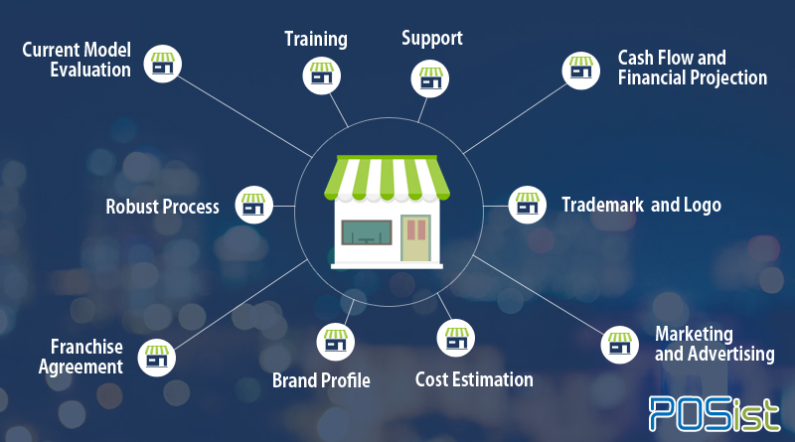
Source:(Meidabuzz,2020)

Stakeholder analysis:
Stakeholder analysis defines the group of people or organizations who are interested in the business or in the venture. (Wasieleski and Weber, 2017) Under the general circumstances, stakeholders invest in the business in one way or the other, often they do this by giving opinions, or giving ideas for the growth of the business. (see Appendix A) In another sense, stakeholders are people who are affected by the ongoing project of the business at hand. So, as they are affected by the stand of the restaurant they are interested in the business when coming up with a project management plan. However, in order to come up with an analysis, the stakeholders have to be managed properly. The management is mainly done by showing them support to promote more positive relationships between the business and the stakeholders. (Rausand and Haugen, 2020) This analysis of the stakeholder can increase the chances of the project being successful.

Stakeholder analysis table for Fine Dining:
Priority | Stakeholder | Stakeholder’s perspective | Action
High | Customers | Provide an opinion on everything, starting from the atmosphere to the quality of service and goods | Give feedback on the service, product, or environment. Invests money and makes purchases giving the restaurant exposure
High | Employees | Carry out day-to-day work around the place trying to meet customer requirement | Helps the restaurant sustain and provides time and effort in order to be the service providers

Findings
After extensive research in various methods, many factors came to light. These work together in order for a business to grow. The outcome from the research gave out a lot of information or data that helped find out the work breakdown structure for the project, the resources at hand with their limitations, and the entire project schedule. These results or findings help develop a proper project management plan.

Work breakdown structure:
Work breakdown structure is a project management structure that defines the sequence of a project management plan by breaking it down into smaller segments. (Martinelli and Milosevic, 2016) To develop a functional work breakdown structure it needs to be approached in the right manner. There are different ways a work breakdown structure can be approached. These are the analogy approach, the top-down approach, the bottom-up approach, and the mind mapping approach. In the analogy approach, the manager has an easier time handling the project as they have prior experience due to handling similar projects. This not only makes sure to increase the probability of the work getting done right the first time but also makes sure that the work done is even better than the last similar project. The top-down approach is when the major task is taken and broken down into much smaller segments. Many managers prefer this method as it requires more logic and organization. The bottom-up approach like its name suggests is when a most simple task is completed first and then more complicated problems are addressed. It is similar to brainstorming through the problems. Finally, in the mind mapping approach, the tasks to be done are written down in a branch-like manner in a non-linear format and then this is used to form the work breakdown structure. The work breakdown structure of the restaurant includes all the plans in a mind mapping approach:

Figure 1: Work breakdown structure of restaurant extension
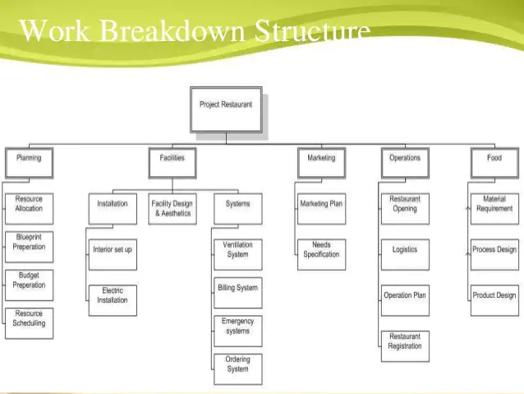
Source: (Bussinessmania,2020)

Resources are materials required to produce a product or provide a service such as money, staff, and tables or chairs in a restaurant. In this case scenario of the extension of the restaurant, the resources at hand are invested money, the restaurant staff, cookware, chairs, tables, storage shelves, fridge, and more. (Ostrom and Wilhelmsen, 2019) When extending the restaurant it has to be kept in mind that there is space for these resources. (see Appendix B) Without these resources efficiency of the restaurant and the quality of goods or service that is provided will be affected. It is extremely important that all resources are present in the right amounts at the right time to retain the quality of the restaurant. For example, without the invested money expanding the restaurant would not even be possible, to begin with. With the table or chairs, customers would have no place to sit or eat which would make it pointless for the restaurant to go on and they are not being able to provide for the customers accordingly. Without the storage shelves there would not be any space to keep or store the utensils. Without the cookware or utensils, cooking would not be possible thus there would not be anything to serve to the customers. Without the restaurant staff including the waiter to the chef or cook, serving and making the food would be impossible and the existence of the restaurant would stop then and there. These are only some of the resources that are mentioned, there are several other resources that can be used to make the restaurant go on from one day to the next. The absence of any one of these resources can significantly have a negative impact on the restaurant and thus impact the business in the market negatively.

Discussion
Considering all the data that was collected and all the outcomes a proper project schedule has to be built. Furthermore, the risks associated have to be considered as Fine Dining cares and prioritizes the health and safety of both their customers and the staff that is working for them. The project management plan has to be discussed with the board leaders in order to be approved and put into action. Once the project management plan is being executed in order for the project to be completed the project manager still has to monitor the process. (Phillips, 2018) Upon the completion of the project, it is necessary to evaluate and compare the obtained results with expected results. Even if the project is successful, evaluating and comparing the obtained and the expected results will give one the measure or statistic as to how successful the project was. This will help to come up with a better project management plan in the future if there is a similar project.

The project schedule:

The project schedule initially consists of defining. This stage consists of defining the problem or in other words cause of why the project is started in the first place. (Pryke, 2017) It sets the goals, the list of resources available, risks, requirements regarding the project. During this defining stage, a project manager suitable for the project is hired or elected by the authority. For example, the authorities or owners of the restaurant hires a person or elects a person from the list of employees to be the project manager, who identifies and brings up the problem. The problem, in this case, is the limited dining space in the restaurant. The next stage is planning. In this stage, the project manager brings together a project management plan. This project manager then brings together a group of people from the employees to form a team in charge of helping the manager to execute the project at hand. (Lock, 2016) For example, in order to accommodate more people in the restaurant or to expand the restaurant without adding more tables and chairs or without increasing the working hours can be done in many ways. Ways such as adding a pool, some people can enjoy the cold water of the pool while having their meal in the fool on a tray or the restaurant can provide a takeout service where people can simply order their food as takeaway and have it wherever they want. Thirdly the project is executed. This means the project management plan is put into action and carried out by the careful supervision of the project manager and the arranged team. (Ulusoy and Hazir, 2021) For example, the pool is constructed and a takeaway service is generated. Lastly, the plan is delivered meaning the customer response, the efficiency of the staff coping up with the new system, and the progress of sales are recorded. (Dimsdale and Thomas, 2019) These points help evaluate and conclude whether the project was successful or not.

Gantt chart of the project plan to extend a restaurant:

Activities | Week 1 | Week 2 | Week 3 | Week 4 | Week 5 | Week 6 | Week 7 | Week 8 | Week 9 | Week 10 | Week 11 | Week 12
Research groundwork
Proposal submission
Gathering literature
Questionnaire development
Data collection
Data analysis
Data evaluation
Recommendations and reflection
Writing report
Final Submission

Risk assessment:
Risk in this context basically refers to the possible loss that can occur if the project is not planned, managed, or executed with careful consideration. (Popov, Lyon, and Hollcroft, 2016) Risk assessment is the process by which potential risks regarding a project or action are assessed and proper precautions or safety measures are taken accordingly. ( Baker, Filbeck, and Kiymaz, 2015) In a restaurant, there are many things that can go wrong. For example, especially, around the cooking area, there are bound to be sharp objects such as knives or cutlery, these can affect both the staff and the customers. Sharp objects can cause cuts and even be fatal to small children. This can easily be prevented by keeping children away from the cutlery and by careful using sharp objects. It is seen that with a little bit of cautiousness a lot of these risks can be avoided. Other risks include wet floors, these can cause anyone present to trip over or slip causing them to fall down be it the customer, the employer, or the employees. This can be avoided by setting up a poster that aware people of the wet floor, or by simply cleaning the floor before people come in. Just as there are risks there are safety measures too. Every project has associated risks which are why proper and legitimate risk assessment has to be done to educate everyone about them (Alexander, 2020).

Conclusion
Overall, throughout the report, it is seen that the project management plan is developed keeping in mind the risk associated. The plan is made after a considerable amount of research and analysis. This allows and ensures a reliable and legitimate plan in order to expand the restaurant without violating any rules or laws set by the government. It also evaluates the possible outcomes and provides solutions for the problem at hand. Moreover, it provides a detailed work breakdown structure along with a stakeholder analysis of the project for the restaurant extension. It has all the necessary details to generate a proper project management plan.

References
- Alexander, K. (2020) ‘Burn the Ice: The American Culinary Revolution and Its End’ in London: Penguin Publishing Group.
- Baker, H. K., Filbeck, G., Kiymaz, H. (2015) ‘Private Equity: Opportunities and Risks’ in London: Oxford University Press.
- Clark, W. (2019) ‘The Gantt Chart, a Working Tool of Management’ in London: Alpha Editions.
- Davis, W. S., Yen, D. C. (2019) ‘The Information System Consultant’s Handbook: Systems Analysis and Design’ in London: CRC Press.
- Dimsdale, N., Thomas, R. (2019) ‘UK Business and Financial Cycles Since 1660: Volume I: A Narrative Overview’ in London: Springer Nature.
- Gillinder, B., Stuart, S. (2018) ‘Cambridge National Level 1/2 Certificate in Information Technologies’ in London: Hodder Education.
- Kelly, P. M. (2020) ‘The Restaurant’ in London: Piping Plover Press.
- Lock, D. (2016) ‘Project Management in Construction’ in London: CRC Press.
- Martinelli, R. J., Milosevic, D. Z. (2016) ‘Project Management Toolbox: Tools and Techniques for the Practicing Project Manager’ in London: John Wiley & Sons.
- Mbengeranwa, A. (2015) ‘Restaurant Exit Plan: How to obtain the Maximum Valuation’ in London: Lulu.com
- Ostrom, L. T., Wilhelmsen, C. A. (2019) ‘Risk Assessment: Tools, Techniques, and Their Applications in London: John Wiley & Sons.
- Phillips, J. (2018) ‘IT Project Management in London: Tata Mc Graw-Hill Education.
- Pica, M. (2016) ‘Project Life Cycle Economics: Cost Estimation, Management, and Effectiveness in Construction Projects’ in London: Routledge.
- Popov, G., Lyon, B. K., Hollcroft, B. (2016) ‘Risk Assessment: A Practical Guide to Assessing Operational Risks’ in London: John Wiley & Sons.
- Pryke, S. (2017) ‘Managing Networks in Project-Based Organisations’ in London: John Wiley & Sons.
- Rausand, M., Haugen, S. (2020) ‘Risk Assessment: Theory, Methods, and Applications’ in London: John Wiley & Sons.
- Ulusoy, G., Hazir, O. (2021) ‘An Introduction to Project Modeling and Planning’ in London: Springer Nature.
- Wasieleski D. M., Weber, J. (2017) ‘ Stakeholder Management’ in London: Emerald Group Publishing.

Appendices
Appendix A
Importance of a stakeholder
Stakeholders are essential people in any business. Not only do they invest in the business but also helps it grow in the market and become more established. This helps the business to keep going on.
Stakeholders make purchases whether the business is providing services or products. The money obtained from these purchases helps build up a profit or is used to reinvest in the business helping it continue. The money that comes is also used to repay debts or pay the employees.

Appendix B
Importance of resources
Resources are extremely important to generate services and or produce products that can be used or sold by a business. Without resources, a business would not be able to conduct business so there would not be any profit or money coming in at all.

Resources can be of a wide variety. Starting from chairs and tables to staff and employees, all of it can be considered to be resources as they help generate service or produce products. Without resources conducting business would be impossible.

