
THE EFFECTS OF CRIMINAL ACTIONS AGAINST CHILDREN
An In-Depth Exploration of the Mental and Physical Effects of Crime on Children

Name: Oliver Edwards
Student ID: 1900345
Student Email: 1900345@student.uwtsd.ac.uk
School: University of Wales Trinity Saint David – Swansea
Due Date: 06/05/2022
Word Count: 8,622

Declarations

This work has not previously been accepted in substance for any degree and is not being concurrently submitted in candidature for any degree.
STATEMENT 1
This dissertation is being submitted in partial fulfilment of the requirements for the degree of BA/BSc.
STATEMENT 2
This dissertation is the result of my own independent work/investigation, except where otherwise stated.
Other sources are acknowledged in the Reference Section.
STATEMENT 3
I hereby give consent for my dissertation, if accepted, to be available for photocopying and for interlibrary loan, and for the title and summary to be made
available to outside organisations.
STATEMENT 4
I hereby give consent for my dissertation, if accepted, to be available on the university’s IT system to those who have consent to use the system.
Oliver Edwards
Signed: O. Edwards
Date: 06/05/2022

Acknowledgements

I would like to thank my dissertation supervisor, Mike Durke for his continuous support and efforts throughout the dissertation in helping me complete and achieve the best mark I can get.
I would also like to thank my partner and family for supporting me throughout my three years of study especially during the lockdown when studying had become harder. Without the family and friends around me I would not have been able to achieve everything I have.

Abstract

Children as victims of crime, are a common occurrence with crimes such as physical abuse being on the rise especially during the UK lockdown. The effects of crime do not go away with age but stay with the child as they develop and mature into adults where the physical and mental affects can only worsen. The research into children, crime and the damaging effects is varied as there is a lot of different areas to look at such as the cycle of adverse childhood experiences. The fact that a crime that affects an individual when they are a child will stay with them potentially for the rest of their life, causing their quality of life to drop which in turn will cause many familial and personal issues to occur is worrying and their needs to be prevention and intervention put into place.
The study aimed to look deeper into these physical and mental effects of crime on children growing up, it is vital to gain an understanding about how the crime still affects children when the mature into adults and how they find ways to cope with the stresses brought about by the crime. It is important look at the support that is currently available for children such as the school system and counselling services. It was crucial to understand the public knowledge and opinions on the topic therefore a questionnaire was created which had 52 respondents. The questionnaire found that 86% believe that children need to have that extra protection in law, as well as 48% of the respondents do not believe that schools are not doing enough to protect children. The answers to the questionnaire support research that the negative experiences a child has will cause them to act in a way that they would not have normally such as by abusing substances or committing crimes. The primary research was a good insight into the thoughts, beliefs and knowledge of a sample of the public but as the sample size was small the whole view was not able to be captured so thoughts and feelings of certain individuals were not recorded.

Table of Contents

Chapter One: Introduction …………………………………………………………………… 7
1.1 Rationale……………………………………………………………………………………… 8
1.2 Objectives…………………………………………………………………………………….. 9
1.3 Research Techniques………………………………………………………………………. 10
1.4 Conclusion…………………………………………………………………………………… 11
Chapter Two: Literature Review……………………………………………………………. 12
2.1 How are children affected by crime?............................................................................ 12
2.2 What help is available for children that have been affected by crime?........................ 14
2.3 What it is like for children that have been affected by crime?...................................... 15
2.4 How children that are affected by crime are effected growing up?.............................. 17
Chapter Three: Research Methods………………………………………………………… 20
3.1 Research Strategy…………………………………………………………………………… 21
3.2 Data……………………………………………………………………………………………. 22
3.3 Framework for Data Analysis……………………………………………………………….. 23
3.4 Limitations and potential problems………………………………………………………… 24
Chapter Four: Data Analysis……………………………………………………………….... 25
4.1 Findings………………………………………………………………………………………. 25
Chapter Five: Conclusion……………………………………………………………………. 33
5.1 Recommendations………………………………………………………………………….. 35
Chapter Six: Bibliography…………………………………………………………………… 37
Chapter Seven: Appendices………………………………………………………………… 45

Chapter One: Introduction

It is important that the most vulnerable are protected in society due to not being able to protect themselves as well as looking after their needs. Vulnerable groups include the elderly, physically and mentally disabled people as well as children. Children are a vulnerable group in society due to many factors such as not being capable of looking after their hygiene and well-being, not being able to protect themselves and the fact that they are dependent on adults. As children are still developing and learning, it is important that they are protected from any risks that could affect them when they are young as any negative impacts will carry on until they become an adult and could ruin any chances of a happy and successful life. One factor that could negatively impact a child is if they are affected by crime in anyway. When a victim has been affected by crime it negatively impacts their life such as causing fear or depression but when the victim is a child the impacts become more varied and if there is not any intervention then it becomes highly possible that the life of that child has been broken before it has had a chance to start.

Children can be affected by crime in numerous ways for instance if a child is born in a poor area there will be a high chance that they are going to witness a crime at least once in their life, this is since areas with economic deprivation will experience more criminal activity (Trust for London, 2021). When a child is growing up in a poor area that is seeing crime take place on a frequent basis there is a high chance that the child will grow up to partake in criminal activity, this is due to the child not knowing anything else as well as not having the skills or abilities to be able to find a full-time job (Malloy, 2021).

Adverse Childhood Experiences are experiencing that people face in their childhoods that affect the way that they interact and behave as adults, these experiences have negative impacts that affect every part of a person's life from a young age to adulthood. When an individual has experienced Adverse Childhood Experiences it is highly likely that their children will also experience the same experiences as well as their parents will more than likely either continue the cycle of abuse or alcoholism (NHS Scotland, 2021). Children being victims of crime and having Adverse Childhood Experiences are more common than people realise as fifty per cent of people in Wales have had at least one Adverse Childhood Experience and fourteen per cent have had four or more (Welsh Government, 2021). As around fifty per cent of the population in Wales as experienced at least one Adverse Childhood Experience, it shows that no matter where a child is that they are not safe from crime or negative experiences.

1.1 Rationale

The topic is worthy for consideration as research into the physical and mental effects on children growing up that have been affected by crime can help the public and professionals dealing with children and crime. This will help to understand the topic and find ways to make sure that children that have been affected can still grow up to be happy and not have as severe mental health or physical affects. Early intervention is important when stopping potential future offenders, but it is also important when a person has become victimised, especially children. If a child can get help as early as possible then there is a better chance that they will be able to live a life with less mental and physical effects of the crime. As children can be affected by crime in numerous ways researching the topic can help identify how and why these crimes take place and put in safeguarding measures to stop them. As if a child lives in a household where the parents or siblings have been known to commit criminal offences intervention needs to take place to make sure that the child does not get involved in criminal behaviour and that they know that there are other options for their future.

1.2 Objectives

There are four main objectives of the research being undertaken. The first objective is to look at how children are affected by crime, there are many ways that children are affected by crime such as being victims, living in an area where crime is normal or being brought up in a family that commit crimes. The research aims to find out how children are more likely to be affected and in what ways. The second objective is what it is like for children who have been affected by crime, the research aims to find out what the child experience after the crime has taken place or their feelings and reactions in the days after the crime has taken place. It is important to look at how a child reacts after experiencing traumatic events as if the behaviours are understood then early intervention can take place.

The third objective is to look at the help that is available for children that have been affected in anyway and is it easily accessible. To find this out research on schools, children’s mental health facilities and social services needs to be conducted by looking at already conducted research. Finally, the fourth objective that is being explored is how crime affects children growing up, being affected by crime will affect a child in many ways, the objective is to find out how it affects children’s mental health and physical health when they mature into teenagers, adolescence and into adulthood.

1.3 Research Techniques

The research techniques that will be used to gather research will be conducted with questionnaires and secondary research. Questionnaires are important when conducting research as it allows the researcher to widely distribute the questionnaire to many people in a short amount of time. Using questionnaires will allow people to share their knowledge and opinions about the topic without going into too much detail as well as not being able to be identified.

Using questionnaires, it will be highly possible to identify what the public know about the topic at hand as well as what the public are not too sure of or do not know. Being able to identify what the public do not know will be helpful for the research as it will help to understand and target the areas where the public lack knowledge, but it would be important for them to know about the topic.

Secondary research will include research that has already been conducted through journals, books, and statics. A range of secondary research will be used as it is important to use varied materials as it will give a better understanding rather than just one point of view. Secondary research will be used in the literature review to gather information and gain knowledge around different subjects of the topic but also to answer the objectives. Due to the wide variety of research that has already been conducted it is important that it is looked at to gain a better understanding but also being able to research case studies will give a real example that will back up the research and give a perspective of the people involved with the study.

1.4 Conclusion

The first chapter of the dissertation has provided an insight into the background of the topic, the research methods that are going to be used and the objectives of the dissertation. The first chapter has outlined the second chapter the literature review.

Chapter Two: Literature Review

It is important that research that has already been conducted into the topic of the physical and mental consequences of crime on children growing up is reviewed and analysed. Within the topic of the effects of crime on children growing up, there are questions that need to be looked at. These questions include how are children affected by crime? What help is available for children that have been affected? What it is like for children who have been affected by crime? And how children that are affected by crime are affected growing up? Being able to answer the questions will give an insight on the effects of crime on children and what help is available especially when they are growing up.

2.1 How are children affected by crime?

Crime occurs in many ways, there are more serious crimes such as rape and assault but there are also less serious crimes such as theft. No matter what type of crime has been committed if there is a victim the harm that could be inflicted could be monumental, the harm could be physical like a broken bone or mental such as Post Traumatic Stress Disorder (PTSD) (Shapland and Hall, 2007). In England and Wales, a child is defined as anyone under the age of eighteen no matter the circumstances, (Children’s Act 1989). Children are more vulnerable to the risks of crime as their minds are still developing meaning that they process information in a unique way. The way that the information is processed can mean that children feel the effects differently than an adult but also that if the child is either incredibly young or has disabilities, they do not understand what is going during certain crimes such as sexual abuse and statutory rape (Glaser, 2014). The ways that children are affected by crimes vary from being a victim of a crime, this can be in the form of child abuse carried out by a parent or witnessing a crime (Morgan and Zedner, 1993).
According to the National Association for People Abused in Childhood (2019) in 2019 there were 8,600 calls to their support line. It is estimated that one in eight sexual abuse cases towards children are reported, meaning that around one in seven child abuse cases go unreported (Elkin, 2020). When a child has witnessed abuse within their family it can cause and lead to many various ill effects on the mental and physical wellbeing of the child, as it can cause many mental disorders such as borderline personality disorder and Post Traumatic Stress Disorder. There is also research that suggests that it can have long lasting impacts into adulthood and can cause the child to pursue relationships that are violent and replicate what they saw as a child (Callaghan et al, 2015).
It is important that when a child has been a witness to domestic abuse that they are treated as seriously as a victim as according to (Sousa et al., 2010), the effects of witnessing and being affected by domestic abuse can be the same as being a victim of domestic abuse. This means that an individual does not have to be physical hit or verbally abused to feel the effects, but just seeing someone such as their mother being hit can cause the same trauma. When a child witnesses abuse between parents it can cause flashbacks the incident which is a symptom of PTSD (Bogat et al., 2006), this can cause a child to live in fear that one day they could get abused or have the feeling of anger that they are unable to do anything about the abuse (Swanston, Bowyer and Vetere, 2013).

2.2 What help is available for children that have been affected by crime?

It is vital that when a child has been affected by crime in any way they get as much help as they can as soon as possible, if a child gets help before it is to late it is feasible that they could be able to live a normal life (Allen, 2011). Tools are a useful way that the police and providers of a service such as the National Health Service can use to look for symptoms in children, one tool is called the Trauma Symptoms Checklist for Children. The check list is used when a child has faced a traumatic situation to look for symptoms that would have been caused by the situation. Within the checklist are indicators such as potential self-harm and fears of men or women, these checkers show signs and symptoms as if a child is scared for any reason of men or women then there must be a reason behind it (Radford, Corral, Bradley and Fisher, 2013).
Along with the Trauma Symptoms Checklist for Children there are various mental health counselling services that cater to children that have been victims. One of these services is called Childline, Childline is a charity that focuses solely on children and their wellbeing (Harrison, 2000). ChildLine is a confidential service that helps children whenever they need it for any type of issue or problem. Services such as ChildLine are one of the most important factors when it comes to children getting help as the charity only focusses on children but also listens to them when they need someone to talk to. According to the National Society for the Prevention of Cruelty to children (NSPCC, 2020), abuse towards children such as sexual and physical rose in 2020, this is due to the pandemic and the lockdown as a result.
Due to the families being confined in their homes from March to June 2020 it caused abuse that had been going on to increase in frequency and intensity. New stresses such as job loss and lack of financial stability caused a surge in new child abuse cases (Sidpra et al., 2020). With the emergence of a new wave of child abuse cases, the services that children need have become more vital than ever. As children spend most of their time in the school system it is crucial that schools put systems into place that protect children in school but more importantly out of school. It is a legal requirement for schools and educators to safeguard and look after the wellbeing of children under the age of eighteen (Childrens Act 2004).
As teachers have the most contact with children outside of their homes it means that the teachers play a crucial role when protecting children. According to (Lloyd, 2018) between 2016 and 2017 seventeen percent of referrals to social services were made by schools. This shows that schools are playing a proactive role in helping and keeping children safe but in some respects, it should be higher due to being a system and service that sees children more than anyone else. With counselling, the Trauma Symptoms Checklist, and schools there are diverse ways for children to get help with many being private and confidential. it is important that these systems only increase as children becoming victims is on the rise with crimes such as abuse, sexual exploitation, and trafficking increasing (Geoghegan, 2020).

2.3 What it is like for children who have been affected by crime?

When an adult has been affected by a crime it is a physical, mental, and an emotionally stressful time, but when the victim is a child that is still growing, learning, and developing the effects can be detrimental to such a degree that their life has been ruined before they fully mature into adults (Carr, Duff, and Craddock, 2018). As the brain of a child is still growing the experiences that a child has will stay with them forever, this can cause strains and stresses that lead to mental illness and disorders (Macpherson et al., 2021). According to Singh Chandan, Taylor and Nirantharakumar, (2019) children are four times more likely to develop serious mental illnesses such as Schizophrenia or bipolar disorder if they were a victim of abuse of any kind, showing that mental health is linked to abuse and trauma.
As mental health is not taken as seriously as physical health children can be suffering silently for years after their experience. Due to mental illness being invisible but causing a lot of suffering it is necessary that the mental health of children is taken more seriously (House of Commons, 2021). Emotional abuse and verbal abuse will not have physical signs such as bruising but it will leave mental and emotional scarring, verbal abuse can be as damaging or worse the physical abuse as it can cause the child to feel worthless and useless (Burns, Jackson, and Harding, 2010). Emotional abuse does not just happen within the home as it can manifest as humiliation in public or in front of friends and family (Negrao et al., 2005). Verbal and Emotional abuse can cause insecurities and self-hatred that can lead to mental illness as well as make the child withdrawn and change who they once were because they feel that they are not good enough and that they fail at everything (Department of Education, 2018).
Depending on the age of the child it is possible that the child does not fully understand what is going on when they are victimised. When younger children get sexually abused it is usually by a person they know and trust, this could be a family member or a carer but nevertheless it causes distress to the child even if they do not fully understand what is or has happened (Seto, Babchishin, Pullman and McPhail, 2015). With emotional and mental changes in a child that has been affected by a crime it can cause serious issues and worsen the quality of life of the child. Along with mental illnesses and emotional distress, physical injuries can take place, depending on the type of crime that the child has been a victim of or witness a variety of physical injuries will be acquired. These injuries will either go away with time, but some are more serious and can stay with the child for the rest of their life (Norman et al., 2012).
If a child has been physically abused then there will be bruises on their body, if the abuse is worse there can also be broken bones or permanent damage such as scarring. Depending on the severity of the abuse the physical effects can be life threating, this can be due to the type of abuse that the child has gone through such as if they have been fed a poison (Meadow, 1989).

2.4 How children that are affected by crime are effected growing up?

A child that has suffered from trauma and victimisation will live with the physical and mental affects for the rest of their lives. According to Jay, (2018) around twenty-eight per cent of adults that had been a victim of sexual abuse when they were a child has trouble and issues surrounding relationships and intimacy. When an individual that is supposed to be trusted takes advantage of a child then it will be difficult for them to be able to trust others in the future (Razak et al. 2017). The adverse childhood experiences that a child faces will have negative health impacts that can make the life of an adult unhappy and lead to health-related illnesses that can be a major factor in death such a heart attack or stroke (Bellis et al., 2013). For every 100 adults, 14 have experienced four or more adverse childhood experiences, this means that at least fourteen people out of every hundred is at a risk of a disease that can be fatal. It shows that the future of children has already been sealed the moment they witnessed or become a victim of any negative experiences (National Health Service, 2015).
Crime and adverse childhood experiences do not just have physical affects long term on children as they mature into adults, but mental health issues are a factor. Crime and adverse childhood experiences can cause mental illness in children which will then continue as they mature into adults (Sheffler, Stanley and Sachs-Ericsson, 2020). As mental health is hidden and can be very fragile the symptoms can only worsen overtime so an experience that an individual had when they were child can stay with them forever and cause illnesses. These illnesses can cause coping mechanisms that will only worsen the situation such as Alcoholism or drug abuse (Bellis et al., 2014). If alcoholism or drug abuse are methods that an individual uses to cope with the stress, anxiety, and depression of their trauma from when where children this can cause more issues that are physical. Issues caused by substance abuse are a fatty liver, but it can also have greater effects on their family especially if they have children (Manning, Best, Faulkner and Titherington, 2009).
Children watching their parent abuse drugs or alcohol will cause trauma as well as causing the child to be scared, this in turn can cause the parent to take their anger out on their partner or children. This will then create adverse childhood experiences for their children which in turn would mean that the cycle of crime against children and adverse childhood experiences will never end (Lowey and Bellis, 2016). The fact that the experiences a child has can cause so many physical, mental, and emotional issues when the child becomes an adult is concerning. It shows that the distress that a child goes through will have an impact on how healthy, successful, and happy an individual will be in life but also it will affect the people around them especially their family as they will themselves will continue the cycle causing Adverse Childhood Experiences on their children.
The chapter looked at the four questions that were asked and found that overall children that have been affected by crime have their future destroyed unless intervention takes places which in most cases does not happen as the child is either too scared to tell anyone or cannot get the help. The next chapter will look at primary research that will be conducted.

Chapter Three: Research Methods

Within any topic it is important that research is used to gain not only perspectives from professionals but also the public. When researching a given topic there will be many experienced professionals that have written their thoughts, conducted research, and written academic literature, this called secondary research. Secondary research will help greatly when researching as it will help to gain an understanding of the topic but will give an overall overview of the thoughts, feelings, and beliefs of academics that will have greater knowledge. This will give a basis to gain and understanding but also to gather primary research (Long-Sutehall, Sque and Addington-Hall, 2010).
When researching a topic, the view of academics and professionals will help to gain knowledge and understanding of the topic but only using already written sources will not give an overall insight into the topic, this is due to the fact that when collecting primary research, the data is collected by the individual without an outside source. Collecting primary data means that the data will be one hundred percent truthful and will also gain an insight to how the general public feels or views the topic instead of an individual that’s been learning and researching the topic for years (Primary vs Secondary Research Methods: 15 Key Differences, 2021).
The primary research that will be used to gather information will be a questionnaire with a set of twelve questions. The research will focus on the knowledge and views that the public hold on children affected by crime. By conducting this research, the knowledge of the public on the topic of children and crime will be tested, this means that by answering the questionnaire the public will show how much they know but also their feelings on the topic at hand. Collecting this data is important because the research surrounding the publics opinion on children effected by crime is scarce as the only opinions come from the victims or experts in the field.

3.1 Research Strategy

There are many diverse types of strategies to collect the data that is needed for primary research, from case studies to ethnographic research. Case studies investigate a person, or a group of individuals in their natural environment. Using the ethnographic method helps the researcher to understand more about the issue that they are studying whilst it occurs naturally, such as in an educational setting when learning about how individuals learn (Heale and Twycross, 2018). The research strategy that will be used when conducting the primary research will be the survey method, when conducting research, the survey method is effective for collecting data on a large scale within a short amount of time. The reach of using the survey method is far greater than using methods such as case studies but can only be used when trying to reach the public or a group of people (Ponto, 2015).
When conducting research, it is important to think about what type of data wants to be collected either quantitative or qualitative. Depending on what is being researched numbers could be more important than opinions as quantitative data uses numbers and statistics whilst qualitative data deals with words such as the opinions of the participants (Mcleod, 2019). The survey method can be used to collect either qualitative or quantitative data, which gives the researcher a choice when conducting research (Survey Method - Research-Methodology, 2022). When conducting research, it is very unlikely that every individual will communicate and participate such as during questionnaires, it is vital that samples are used to make sure that the research will be successful and will be answered. Simple random sampling is going to be the method that is used when sending out the questionnaires, as it is impossible to tell who will fill out the questionnaire, other sampling methods such as cluster sampling would not work as selecting who is going to fill out the questionnaire is not possible (Martínez-Mesa et al., 2016).

3.2 Data

To conduct the primary research a questionnaire with around thirteen questions will be created, the questionnaire will contain questions that both engage the publics knowledge and understanding on the topic but will also ask for their opinions. According to (Jones, Baxter, and Khanduja, 2013), questionnaires are a reliable source of gathering a large amount of research in an efficient way. As a questionnaire is free to create it will be inexpensive and due to social media and the internet distribution of the questionnaire to friends, family, and the public will be a quick and effortless process.
As the intended audience of the questionnaire is the public it is expected that they will not have the knowledge of a professional in the topic, it is crucial that the questions that are asked are straightforward, explained and do not use complicated language. If the questionnaire uses language that the participant is unfamiliar with this can cause confusion which could lead to answers that are unrelated to the question or the questionnaire not being answered as many times as it could have been (SurveyMonkey, 2022). The subject of how crimes affect children is a sensitive topic that can cause many people to feel uneasy and uncomfortable. Using a questionnaire will provide a level of anonymity where other forms of research such as interviews do not, as no names will be asked for just sex and age range as this will form a basis to sort the research into groups. Using a questionnaire to collect data will make the sorting and comparing of the data simpler, questions, age and sex of the participants can create a range and when comparing the data will make it easier to compile into graphs which will be used to help analyse answers.

3.3 Framework for Data Analysis

Once the questionnaires have been filled out and the raw data has been collected analysis needs to take place. To gain an understanding of the data and the answers the participants have given it is vital that comparisons need to be made. To be able to compare the data, it is important that graphs and charts are used to be able to visualise and understand the data. As the data is going to be a mixture of quantitative and qualitative it is crucial that a mixture of graphs is used with an explanation, this is due to quantitative data being numerical meaning that it is represented through graphs and charts whilst qualitative data being expressed through words such as the written answers that are given (Ahmad et al., 2019).
Graphs are an effective way of being able to visually interpretate the data and can help link relationships between answers that have been given, an example would be an age group and a certain number of answers they gave; this would show that primarily individuals in the age group have the same beliefs (Slutsky, 2014). To be able to begin analysis it is important that the questionnaire has frequent questions such as the age range or the sex of the participant, having these broad questions will help to discover relationships between the demographics and answers given and could help to find links and give answers that you could be looking for such as what an age range believes compared to older age ranges. Analysing the data along with comparing and contrasting will help with the research of the dissertation by discovering what people believe and linking it with their knowledge on the subject, this could show any misbelieves that the public have but also what they do not know but should.

3.4 Limitations and Potential Problems

There are potential problems that could arise with the questionnaire, these problems could make it difficult to analyse the data but also could cause the research to be unreliable thus useless. A potential problem with sending out a questionnaire through the internet and social media is that few individuals will respond or fully answer the questions, without any respondents the primary research would fail as due to a lack of data there would not be any analysis to compare or reliable data. As the questionnaire will be answered anonymously it means that a single individual could complete the questionnaire multiple times or purposely give incorrect information, this could cause the research and data to be inaccurate meaning the information is useless, and all analysis would become meaningless.
Current global events such as the covid-19 pandemic has made face to face contact hard and sometimes impossible, the pandemic and the high chance of becoming ill has made many unable to come into close contact. The pandemic has made physically handing out the questionnaire impossible, this has limited the number of responses that could have been handed out physically but now must be completed fully online. If the questionnaire were physically handed out it would have had a greater chance of being answered as when it is online, it is easy to get distracted or click off the questionnaire. When the questionnaire is online it is easier for the participants to google answers or opinions to answer the question, this ties back to making the research unreliable as the answers and opinions are not truly their own but those that they found online.

Chapter Four: Data Analysis

Within the previous chapter research methods and primary research was explored and discussed. After considering the potential positives and negatives of each possible method of primary research, such as surveys and interviews to collect data for analysis, surveys and questionnaires were chosen. When deciding what type of research should be conducted there were different questions and scenarios that needed to be considered, these questions included what type of data was wanted or should be collected? And who would be the sample audience? These questions where vital as the two types of data are, qualitative and quantitative.
The two different types of data depend on what type of research you want to collect whether people’s opinions are important or just figures. Sample size was crucial as choosing who the target audience are and how many responses are needed. To make sure that the respondents understand the questions and the topic, a blurb was written at the start of each question where necessary. As the data has now been collected this chapter will focus on analysing the responses, finding trends and coming to conclusions based on these responses. Common similarities between responses will show any trends as well as any differences between questions answered.

4.1 Findings

The primary research that was conducted was a questionnaire, the aim of the survey was to get around 50 responses, this goal was exceeded with 52 responses meaning that as the target has been hit then the analysis of the results will have a bigger range of answers. Due to the amount of responses the questionnaire will be reliable. The questionnaire had wide ranging questions that wanted to test the knowledge of the participants as well as ask for their opinions. As a result of this there were a variation of closed questions that had a list to choose from but also questions where the participant was asked to write their opinions and answers. Using both closed and open questions helped to gain an understanding that using just one type would not give as you can gain opinions and what or how people feel when they get asked to explain themselves. The questionnaire proved to provide a great understanding about the how the public feel about the topic of children and how they are affected by crime but also gives a better understanding of their knowledge about the subject.
The questionnaire was made up of 13 questions, the first two questions were demographic questions that asked the age of the participants as well as their sex. These were the first questions that were asked as it gives a better understanding to the age groups that answered the questionnaire the most and their sex. Most of the respondents of the questionnaire were quite young with 16 being in the age group of 18 to 24 and another 15 being in the age range of 25 to 34, this means that 59% of the respondents are under the age of 35. 23% of respondents where in the age group of 35 to 44. Overall, most of the responses gathered are from people under the age of 45 with only nine responses from individuals over the age of 50. Whilst the age ranges where quite varied the sex of the participants was not with an overwhelmingly majority of the participants being female with a 67% rate, this means that 35 of the participants where female. 15 males answered the questionnaire and two stated the preferred not to say.
The third question which was the first non-demographic question asked was In British law, do children have rights? This question was to start off the questionnaire testing the basic understanding of the participants as it is common knowledge that children are one of the most protected groups in society. Expectantly out of 52 responses 49 responded that Children did in fact have legal rights, this means that 94% of the participants know that children do have rights. Two individuals said that children do not and two said that they did not know. The fact that 94% of participants know that children do have legal rights mean that the public do have a basic understanding that children are a protected group in society.
The fourth question that was asked was, do you think children and young people, as those who have not reached the age of 18, need additional protection in law? This question was the first opinion question asking the participants their opinions on if they believe children need that extra protection in law. 86% of the participants believe that children do need that extra protection in law, this again was the majority answer. This goes along with the third question as the general understanding is children do have legal rights, this means that overall, the participants know that children have legal rights and believe that they need the extra-legal rights. Even though a majority believe that children should have additional protection, three said no and four said they do not know.
It was unsurprising that the fifth question, how would you describe the impact of crime on children who are victims or who witness criminal acts? Had a 92% answer rate of it will have serious psychological effects on the child. With 47 respondents believing that it will have serious negative psychological affects it shows that there is a common understanding that children do feel serious impacts of crime, and it will stay with them for a long time. It is interesting that the same amount of respondents felt the same way as with question four with 94% also believing children need extra protection, this means that many people have the same thoughts, feelings and opinions about children and crime. It is also curious that 5.8% respondents believe that children would not feel the effects like an adult would and 5.8% said it would barely have an effect depending on the crime.
As experiencing any sort of crime will have negative psychological impacts on adults, the sixth question wanted to find out if the respondents believe that crime will have the same psychological impacts on children. The sixth question asked, do you believe that a child who has experienced a crime will feel the negative impacts mentally or physically through to adulthood? This could be mental health issues such as Post Traumatic Stress Disorder. A trend is able to be formed looking at the previous three questions with an overwhelming majority believing children are protected in law and are seriously affected by crime, that is why it is expected to see that 88% of the respondents feel that children will develop mental illnesses such as Post Traumatic Stress Disorder after experiencing or being a victim of crime. As this question is an opinion-based question it can be challenging for the participants that probably have never thought about this type of question before, this could be the reason why 7% of the respondents answered that they did not know.
Question seven is the first question that is asked about Adverse Childhood Effects also known as ACEs. The results of the seventh question are quite differing compared to the other questions as even though there is a majority answer there are not that many respondents that agree. The question asked, do you believe that the negative experiences that a child has will cause them to get involved with antisocial or criminal behaviour? 65% answered yes whilst 25% answered that they were not sure and finally 9% answered no. This question even though opinion based can be quite tricky especially for the public that quite likely have not heard the term Adverse Childhood Experiences before, this might be the reason 25% said they are unsure. The results of this question support overall research on ACEs as shown in the literature review negative experiences can cause children to act how they would normally not have.
ACEs encompass a whole series of differing types of experiences a child could go through that will negatively affect them throughout their childhood into adulthood, the eighth question wanted to find out if the respondents had any idea of what type of experiences where classed as ACES. This question is the first open question as the researcher wanted to find out how many the individual participants knew and specifically asked, in your opinion, what are some negative experiences that will have the biggest impact on a developing child? This question had a wide range of answers with many being common responses such as domestic abuse or physical or mental abuse. The responses where place into a category of abuse as abuse is wide ranging term as there are many differing types of abuse, this answer was the most common with an overall 31 respondents putting it as an answer. Secondly came rape, sexual assault and parental substance abuse. Sexual assault and rape were stated 12 times as well as parental substance abuse stated 12 times. The answers that were given are official causes of ACEs stated on the Welsh Government website, this shows that many people know that negative experiences will cause children harm throughout their life.
It is crucial to ask, do you believe that we as a society support children, so they become healthy and proactive adults? This was another split question with 59% answering that society does do enough, even though this is a majority it is not as big as a majority as previous questions had been. 23% answered that they are not sure and 17% answered no society does not do enough. This question shows that many people even though not the majority believe society does not do enough to help children become healthy and proactive adults. There are many reasons why they could believe this, it could be down to schools as children spend most of their daily life in schools and around an education setting and if educators are not helping with issues and problems then it can cause children to feel unheard.
The tenth question wanted to find out how the public feel about schools with a focus on protecting children at school with the question asking, do you feel that schools are doing enough to protect children at school? It is a common belief that schools are not doing enough to protect students from harm especially bullying, the respondents back up this belief with a 48% answer rate of no schools are not doing enough. With another 23% of respondents answering they do not know. This goes against the research that says that 17% of referrals to social services where made by schools which shows they are playing a proactive role, it is clear that even though the school system is playing a role, the public are either misinformed or believe they should be doing more.
After looking at protecting and helping children in school the eleventh question asks, do you believe that schools and agencies that schools work closely with such as child protective services and the NSPCC provide an adequate system that provides support to children that suffer or have suffered from crime such as abuse at home? It was surprising looking at the results of this question as by far this was the most equally balanced replies with almost a third answering yes, no, and do not know for the question but yes was the majority with 36% of the answers being yes whilst equally 30% said no and do not know. Even though the responses of the questionnaire were almost equal it is not that shocking that a third said they did not. This question might have been tricky as most people do not think about schools in the context of helping for outside issues only for issues inside schools.
Previous questions have asked if society are supporting children, so they grow up to be healthy and proactive adults as well as questions about if schools and other agencies are protecting and helping children. The twelfth question is focussed around if society as a whole is doing enough to keep children safe, this question asks, do you believe that as a society we do enough to keep children safe? There was an overwhelmingly negative response to this question with 61% of respondents believing that we as a society are not doing enough. With over 60% of the respondent’s believing society is not protecting children, a question needs to be asked, what can and should be done to protect children and what more will need to be done in the future?
The final question of the questionnaire asked the respondents if they believed the pandemic and resulting lockdown caused child abuse to rise and if so what where the factors causing it to rise. Many of the responses believed that the increase of abuse was a result of the lockdown with around 84% believing that lockdown was the cause. After seeing so many responses saying lockdown was the cause, it is vital to see why the respondents feel why it was. The most common answer was that parents where stressed due to losing a job which result in financial problems causing them to take their anger out on their children. It was also commonly mentioned that as everything was lockdown such as schools, care facilities and after school activities children did not have any safe spaces to go. Increasing their time with the abusers but also there was nobody to tell as everything was closed and social workers went online, and it is easy to hide any abuse when visits are through the internet.
The chapter has helped give an understanding about the knowledge, opinions, and feelings of a small section of the public about aspects of the effects of crime on children. As the data has been analysed it is now possible conclusions and recommendations can and are made to help create a bigger picture into education in teaching the public what they do not know about the subject as well as what needs to be done in creating a safer system that looks after the wellbeing of children as the number one priority.

Chapter Five: Conclusion

The dissertation was set out to address the research questions, through critical evaluation of key objectives, these objectives were to find out the effects of crime on children, the support that is available for the children, how crime affects children whilst they grow up, and what it is like for the children? Throughout the paper these questions were answered in the literature review. The primary research focussed on the thoughts, feelings, and knowledge of the public, with conclusions easily being made.
The second chapter underlined that crime against children has devastating effects on their life as suggested by (Walker et al., 2019), from the physical trauma such as bruises or broken bones. Mental trauma that will cause severe mental illnesses that will last a lifetime. Evidence highlighted that it is not important how a crime occurs as if there is a child involved it will have severe affects even if the crime is not directed towards the child themselves (Rivett, Howarth and Harold, 2006). It could be one parent domestically abusing the other parent, if the child witnesses the abuse happen there will be negative effects. The help that is available for children is open meaning that there are various ways that children can get help, this could be from the school system by teachers reporting it to social services or the child contacting a charity that providers confidential help such as ChildLine.
The help is not enough especially due to the lockdown, this is because the abuse that children had suffered before lockdown has had only gotten worse due to the abuser and child being in the same household all day every day. Stresses due to the pandemic and lockdown has caused parents to become abusive, with abuse being rampant during lockdown there needs to be more services that help and protect children (Ellis, Briggs, Lloyd and Telford, 2021).
Many studies have shown that the effects of crime do not disappear with age but in some ways only worsen. The impacts of crime will stay with the child throughout their life even when they become adults, this causes many more issues such as worse mental health that develops into disorders. As well as creating coping mechanisms that are unhealthy such as drug and alcohol abuse, which then will affect their family especially children and cause the children to have negative experiences. With one in five adults that are ages between 18 and 74 suffering at least one form of abuse (ONS 2019). The studies into the effects of crimes against children is important as it will help charities and the public services find better ways of helping children and adults that have been victimised, but also it will show that crime against children is more common than most people realise and that abuse and crimes against children is currently on the rise.
The data collected gave an insight into the thoughts, beliefs, and feelings of a small group of the public. Being able to get an insight into the thoughts of the public will help to create a greater understanding, as well as to help come up with recommendations to help create an awareness of the issue that will be able to increase public knowledge. One of the major discoveries of the questionnaire is that a majority of the participants have similar views, these views show that over 90% of the participants know and believe that children have legal rights and that they need extra protection in law.
It is a commonly held belief by the participants that any type of adverse experience that a child faces this could be being a victim of a crime or being witness to domestic violence between parents will cause serious negative psychological and physical affects that will continue into adulthood and worsen if no intervention takes place during childhood. A trend that was clearly shown is the belief that as a society especially the school system is not doing enough in any way to help children inside or outside of school that are facing issues and crises. When a great amount of the public feel that the school system and society is not doing enough to protect and safeguard children then changes need to be made. Finally, it is generally agreed upon the lockdown caused by Covid 19 has caused an increase in child abuse.

5.1 Recommendations

The critical evaluation has demonstrated that the health and welfare of children are of central importance to the law and especially public consciousness (Levine, Morton and O’Reilly, 2020). There are a number of areas that have emerged that have areas to improve on potential safeguarding for children and young people.
- Firstly, after looking at public opinion surrounding the beliefs of society and the safeguarding of children it is clear that the public do not trust the systems that are put into place are not helping or protecting children in school such as bullying or from home. It is vital that more effort needs to be put into place to protect children, there should be more services in school such as counselling services or groups where children are able to speak freely about what is happening and just generally able to speak. As children spend most of their time in school it is crucial that children need to be taught about signs of abuse at home, how to spot it, and how to report it, this will at the very least will help to give children confidence to speak up but also able to spot the signs of abuse.
- Secondly, as abuse rose in lockdown it needs to be questioned why this abuse rose as soon as stress was felt nationwide. If anything like another lockdown ever effects the United Kingdom safeguards to be put into place to make sure that children are kept safe during difficult times and that there will be options for children that need to escape from abusive households when the country is in a lockdown.

- Finally, as the safety of children is vital there needs to be more national awareness around the safeguarding of children, Adverse Childhood Experiences, and overall, how crime affects children. Even though the survey showed that overall, the majority of the respondents had beliefs, there were still a few that did not especially on the adverse childhood experience questions. ACEs are a very vital aspect into learning how children get negatively affected by witnessing and experiencing traumatic events and how it can to many different negative effects. The public should be taught about Adverse childhood experiences, how crime affects children and signs of these experiences, awareness could be raised through television and national media as well as in schools and online, which would be an effective way of raising awareness.

Chapter Six: Bibliography

- Ahmad, S., Wasim, S., Irfan, S., Gogoi, S., Srivastava, A. and Farheen, Z., 2019. Qualitative v/s. Quantitative Research- A Summarized Review. Journal of Evidence Based Medicine and Healthcare, 6(43), pp.2828-2832.
- Allen, G., 2011. Early Intervention: The Next Steps. London, pp.3 - 13.
- Bellis, M., Lowey, H., Leckenby, N., Hughes, K. and Harrison, D., 2013. Adverse childhood experiences: retrospective study to determine their impact on adult health behaviours and health outcomes in a UK population. Journal of Public Health, 36(1), pp.81-91.
- Bellis, M., Hughes, K., Leckenby, N., Perkins, C. and Lowey, H., 2014. National household survey of adverse childhood experiences and their relationship with resilience to health-harming behaviors in England. BMC Medicine, 12(1).
- Bogat, G., DeJonghe, E., Levendosky, A., Davidson, W. and von Eye, A., 2006. Trauma symptoms among infants exposed to intimate partner violence. Child Abuse & Neglect, 30(2), pp.109-125.
- Burns, E., Jackson, J. and Harding, H., 2010. Child Maltreatment, Emotion Regulation, and Posttraumatic Stress: The Impact of Emotional Abuse. Journal of Aggression, Maltreatment & Trauma, 19(8), pp.801-819.
- Callaghan, J., Alexander, J., Sixsmith, J. and Fellin, L., 2015. Beyond “Witnessing”: Children’s Experiences of Coercive Control in Domestic Violence and Abuse. Journal of Interpersonal Violence, 33(10), pp.1551-1581.
- Carr, A., Duff, H. and Craddock, F., 2018. A Systematic Review of the Outcome of Child Abuse in Long-Term Care. Trauma, Violence, & Abuse, 21(4), pp.660-677.
- Childrens Act 1989. 1.
- Childrens Act 2004. 11.
- Department of Education, 2018. Working Together to Safeguard Children. London, p.107.
- Elkin, M., 2020. Child abuse extent and nature, England and Wales - Office for National Statistics. [online] Ons.gov.uk. Available at: <https://www.ons.gov.uk/peoplepopulationandcommunity/crimeandjustice/articles/childabuseextentandnatureenglandandwales/yearendingmarch2019#child-abuse-cases-that-come-to-the-attention-of-childrens-services> [Accessed 28 December 2021].
- Ellis, A., Briggs, D., Lloyd, A. and Telford, L., 2021. A ticking time bomb of future harm: Lockdown, child abuse and future violence. Abuse: An International Impact Journal, 2(1), pp.37-48.
- Formplus Blog, 2021. Primary vs Secondary Research Methods: 15 Key Differences. Available at: <https://www.formpl.us/blog/primary-secondary-research> [Accessed 12 March 2022].
- Glaser, D., 2014. The effects of child maltreatment on the developing brain. Medico-Legal Journal, 82(3), pp.97-111.
- Geoghegan, S., 2020. In 2020, more children than ever identified as potential victims of trafficking. [online] ECPAT UK. Available at: <https://www.ecpat.org.uk/news/2020-more-children-than-ever-identified-potential-victims-of-trafficking> [Accessed 28 December 2021].
- Harrison, H., 2000. Current topic: ChildLine---the first twelve years. BMJ Journals.
- Heale, R. and Twycross, A., 2018. What is a case study?. [online] British Medical Journal. Available at: <https://ebn.bmj.com/content/21/1/7.info> [Accessed 12 March 2022].
- House of Commons, 2021. Children and young people’s mental health. London, pp.7 - 24.
- Jay, A., 2018. Interim Report of the Independent Inquiry into Child Sexual Abuse. Independent Inquiry Child Sexual Abuse, p.21.
- Jones, T., Baxter, M. and Khanduja, V., 2013. A quick guide to survey research. The Annals of The Royal College of Surgeons of England, 95(1), pp.5-7.
- Lloyd, M., 2018. Domestic Violence and Education: Examining the Impact of Domestic Violence on Young Children, Children, and Young People and the Potential Role of Schools. Frontiers in Psychology, 9.
- Levine, D., Morton, J. and O’Reilly, M., 2020. Child safety, protection, and safeguarding in the time of COVID-19 in Great Britain: Proposing a conceptual framework. Child Abuse &amp; Neglect, 110.
- Long-Sutehall, T., Sque, M. and Addington-Hall, J., 2010. Secondary analysis of qualitative data: a valuable method for exploring sensitive issues with an elusive population?. Journal of Research in Nursing, 16(4), pp.335-344.
- Lowey, H. and Bellis, M., 2016. Adverse Childhood Experiences. [video] Available at: <https://www.youtube.com/watch?v=0tyZnASq8aQ> [Accessed 28 December 2021].
- Macpherson, J., Gray, S., Ip, P., McCallum, M., Hanlon, P., Welsh, P., Chan, K., Mair, F., Celis-Morales, C., Minnis, H., Pell, J. and Ho, F., 2021. Child maltreatment and incident mental disorders in middle and older ages: a retrospective UK Biobank cohort study. The Lancet Regional Health - Europe, 11, p.100224.
- Malloy, D., 2021. Supporting effective early intervention to prevent crime and violence: EIF and the Youth Endowment Fund.
- Manning, V., Best, D., Faulkner, N. and Titherington, E., 2009. New estimates of the number of children living with substance misusing parents: results from UK national household surveys. BMC Public Health, 9(1).
- Martínez-Mesa, J., González-Chica, D., Duquia, R., Bonamigo, R. and Bastos, J., 2016. Sampling: how to select participants in my research study?. Anais Brasileiros de Dermatologia, 91(3), pp.326-330.
- Mcleod, S., 2019. What’s the difference between qualitative and quantitative research?. [online] Simplypsychology.org. Available at: <https://www.simplypsychology.org/qualitative-quantitative.html> [Accessed 12 March 2022].
- Meadow, R., 1989. ABC of child abuse. Poisoning. BMJ, 298(6685), pp.1445-1446.
- Morgan, J. and Zedner, L., 1993. Researching Child Victims — Some Methodological Difficulties. International Review of Victimology, 2(4), pp.295-308.
- Napac.org.uk. 2021. Key facts and figures – NAPAC. [online] Available at: <https://napac.org.uk/key-facts-figures/> [Accessed 28 December 2021].
- National Health Service, 2015. Adverse Childhood Experiences. p.4.
- Negrao, C., Bonanno, G., Noll, J., Putnam, F. and Trickett, P., 2005. Shame, Humiliation, and Childhood Sexual Abuse: Distinct Contributions and Emotional Coherence. Child Maltreatment, 10(4), pp.350-363.
- Norman, R., Byambaa, M., De, R., Butchart, A., Scott, J. and Vos, T., 2012. The Long-Term Health Consequences of Child Physical Abuse, Emotional Abuse, and Neglect: A Systematic Review and Meta-Analysis. PLoS Medicine, 9(11), p.e1001349.
- NSPCC, 2020. The impact of the coronavirus pandemic on child welfare: sexual abuse. NSPCC, pp.5 - 10.
- ONS, 2019. Child abuse extent and nature, England and Wales - Office for National Statistics. [online] Ons.gov.uk. Available at: <https://www.ons.gov.uk/peoplepopulationandcommunity/crimeandjustice/articles/childabuseextentandnatureenglandandwales/yearendingmarch2019#:~:text=1.-,Main%20points,years%20(8.5%20million%20people).> [Accessed 28 December 2021].
- Ponto, J., 2015. Understanding and Evaluating Survey Research. Journal of the Advanced Practitioner in Oncology, 6(2).
- Radford, L., Corral, S., Bradley, C. and Fisher, H., 2013. The prevalence and impact of child maltreatment and other types of victimization in the UK: Findings from a population survey of caregivers, children and young people and young adults. Child Abuse & Neglect, 37(10), pp.801-813.
- Razak, M., Ibrahim, H., Mokhtar, S. and Romar Nuraya, R., 2017. The Personality Development Of Child Abuse Survivors. Journal of Humanities, Language, Culture and Business (HLCB), 1(2), pp.1-9.
- Research-Methodology. 2022. Survey Method - Research-Methodology. [online] Available at: <https://research-methodology.net/research-methods/survey-method/#_ftn1> [Accessed 12 March 2022].
- Rivett, M., Howarth, E. and Harold, G., 2006. ‘Watching from the Stairs’: Towards an Evidence-based Practice in Work with Child Witnesses of Domestic Violence. Clinical Child Psychology and Psychiatry, 11(1), pp.103-125.
- Scotland, P., 2021. Overview of ACEs. [online] Healthscotland.scot. Available at: <http://www.healthscotland.scot/population-groups/children/adverse-childhood-experiences -aces/overview-of-aces> [Accessed 4 December 2021].
- Shapland, J. and Hall, M., 2007. What Do We Know About the Effects of Crime on Victims?. International Review of Victimology, 14(2), pp.175-217.
- Sheffler, J., Stanley, I. and Sachs-Ericsson, N., 2020. ACEs and mental health outcomes. Adverse Childhood Experiences, pp.47-69.
- Seto, M., Babchishin, K., Pullman, L. and McPhail, I., 2015. The puzzle of intrafamilial child sexual abuse: A meta-analysis comparing intrafamilial and extrafamilial offenders with child victims. Clinical Psychology Review, 39, pp.42-57.
- Sidpra, J., Abomeli, D., Hameed, B., Baker, J. and Mankad, K., 2020. Rise in the incidence of abusive head trauma during the COVID-19 pandemic. [online] BMJ Journals. Available at: <https://adc.bmj.com/content/106/3/e14.info#article-bottom> [Accessed 28 December 2021].
- Singh Chandan, J., Taylor, J. and Nirantharakumar, K., 2019. Abused or neglected children are four times more likely to develop serious mental illness, study finds. [online] University of Birmingham. Available at: <https://www.birmingham.ac.uk/news/latest/2019/09/abused-neglected-children-mental-health.aspx> [Accessed 28 December 2021].
- Slutsky, D., 2014. The Effective Use of Graphs. Journal of Wrist Surgery, 03(02), pp.067-068.
- Sousa, C., Herrenkohl, T., Moylan, C., Tajima, E., Klika, J., Herrenkohl, R. and Russo, M., 2010. Longitudinal Study on the Effects of Child Abuse and Children’s Exposure to Domestic Violence, Parent-Child Attachments, and Antisocial Behavior in Adolescence. Journal of Interpersonal Violence, 26(1), pp.111-136.
- SurveyMonkey, 2022. Avoid Bad Survey Questions: Loaded Question, Leading Question | SurveyMonkey. [online] SurveyMonkey. Available at: <https://www.surveymonkey.com/mp/5-common-survey-mistakes-ruin-your-data/> [Accessed 12 March 2022].
- Swanston, J., Bowyer, L. and Vetere, A., 2013. Towards a richer understanding of school-age children’s experiences of domestic violence: The voices of children and their mothers. Clinical Child Psychology and Psychiatry, 19(2), pp.184-201.
- Trust for London, 2021. Crime and income deprivation | Trust for London. [online] Trust for London. Available at: <https://www.trustforlondon.org.uk/data/crime-and-income-deprivation> [Accessed 4 December 2021].
- Walker, S., Hester, M., McPhee, D., Patsios, D., Williams, A., Bates, L. and Rumney, P., 2019. Rape, inequality and the criminal justice response in England: The importance of age and gender. Criminology &amp; Criminal Justice, 21(3), pp.297-315.
- Welsh Government, 2021. Review of Adverse Childhood Experiences (ACE) policy: report. Cardiff.

Chapter Seven: Appendices

Appendix 1: Copy of questionnaire

- Which age group describes you?
18 –24
25 – 34
35 – 44
45 – 54
55 – 64
65 – 74
75 – 84

- How would you describe your sex?
Male
Female
Prefer not to say

- In British law, do children have rights?
Yes
No
Not sure

- Do you think children and young people, as those who have not reached the age of 18, need additional protection in law?
Yes
No
Not Sure

- Often crime has an immediate and lasting impact on victims and those who witness the offence. How would you describe the impact of crime on children who are victims or who witness criminal acts?
Depending on the crime it will have barely an affect
It will affect the child but not as much as it would an adult
It will have serious psychological effects on the child

- Do you believe that a child who has experienced a crime will feel the negative impacts mentally or physically through to adulthood? This could be mental health issues such as Post Traumatic Stress Disorder
Yes
No
Not Sure

- Adverse Childhood Experiences (ACEs) are highly stressful, and potentially traumatic, events or situations that occur during childhood and/or adolescence. They can be a single event, or prolonged threats to, and breaches of, the young person’s safety, security, trust or bodily integrity. Do you believe that the negative experiences that a child has will cause them to get involved with antisocial or criminal behaviour?
Yes
No
Not Sure

- There are many experiences that a child may face that can have negative impacts, some of these impacts may not have much of an effect whilst others can affect their whole life. In your opinion, what are some negative experiences that will have the biggest impact on a developing child?

-------------------------------------------------------------------------------------------------------

- In Wales we have the Wellbeing of Future Generations Act, this act makes sure that the public bodies and agencies make life for the future generations better by thinking about their actions and working with others and the community. Do you believe that we as a society support children, so they become healthy and proactive adults?
Yes
No
Not Sure

- Under the Education Act 2002 teachers and caregivers have a duty to protect and safeguard children from any type of harm such as abuse at home, do you feel that schools are doing enough to protect children at school?
Yes
No
Not Sure

- Do you believe that schools and agencies that schools work closely such as child protective services and the NSPCC provide an adequate system that provides support to children that suffer or have suffered from crime such as abuse at home?
Yes
No
Not Sure

- In the UK children have rights enshrined in law, that are protected by multiple governmental bodies such as the police and the NHS but do you believe that as a society we do enough to keep children safe?
Yes
No
Not Sure

- According to Sidpra et al., (2020) from the Great Ormand Street Hospital for Children, abusive head trauma in children rose to around 1400% in only a 3-month period in 2020, Do you believe this is due to the pandemic and the resulting lockdown? If so, why do you believe the lockdown and pandemic caused an increase in abuse?

---------------------------------------------------------------------------

Appendix 2: Graphs and Charts – Primary Research
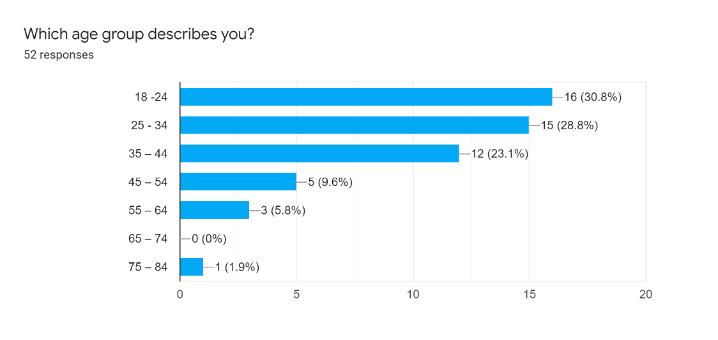
Figure 2.1 – Age range of Participants

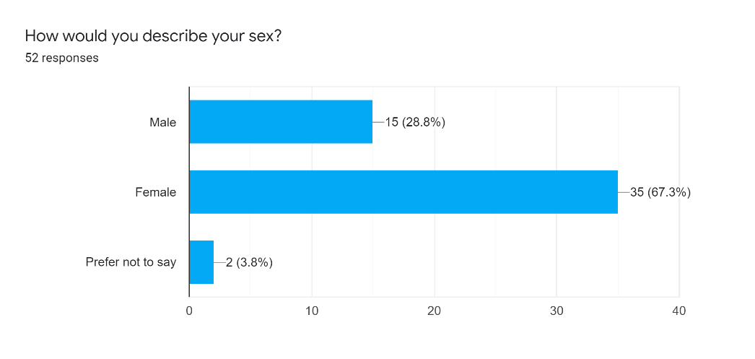
Figure 2.2 – Chart showing sex of participants

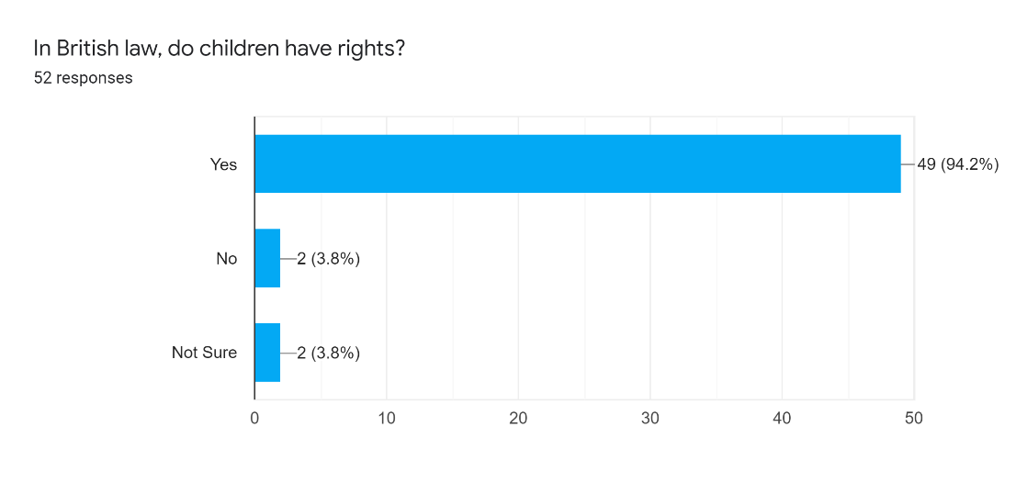
Figure 2.3 – Graph showing results of In British law, do children have rights?

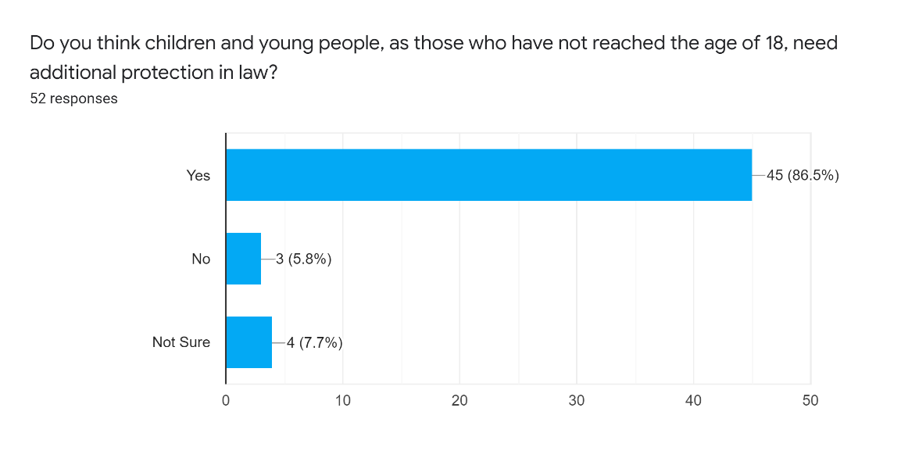
Figure 2.4 – Chart showing results of do you think children and young people, as those who have not reached the age of 18, need extra protection in law?

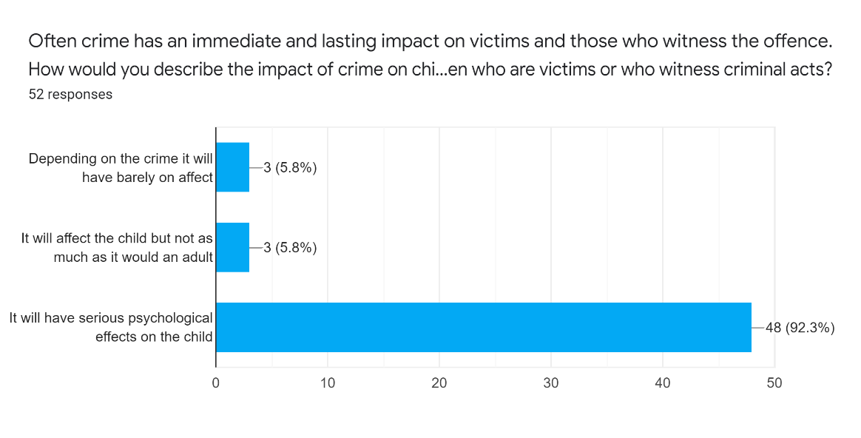
Figure 2.5 – Opinions based on where children are affected by crime

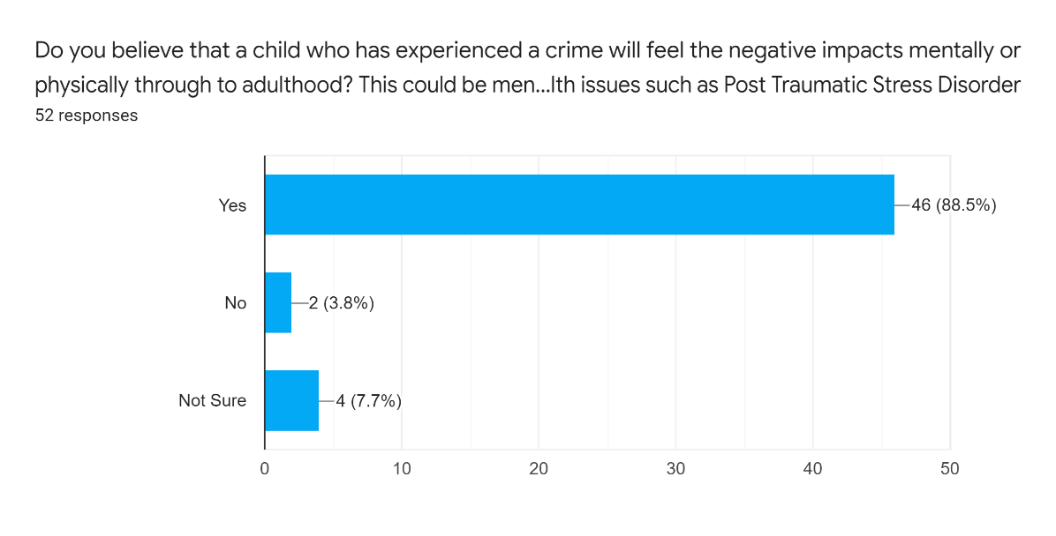
Figure 2.6 – Results of opinion based on if children will feel the effects of crime through until adulthood

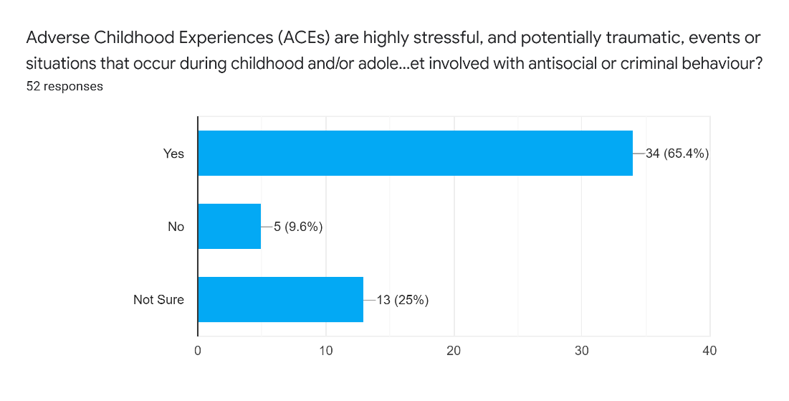
Figure 2.7 – Opinions on if ACEs cause children to change

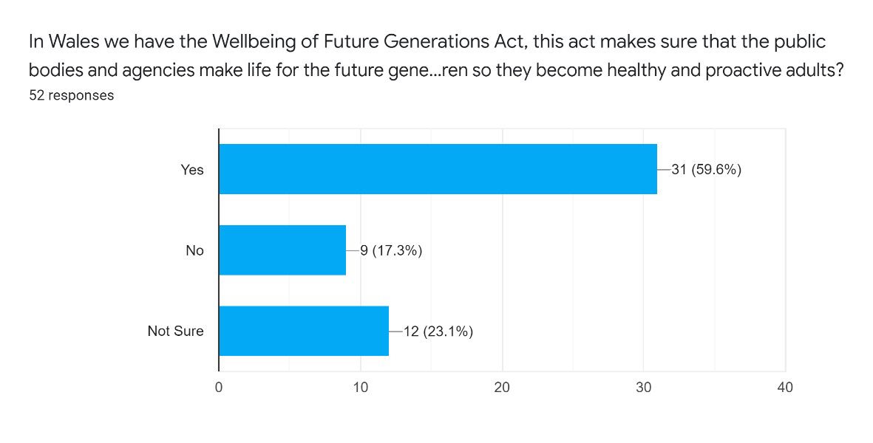
Figure 2.8 – Respondents opinions on if they believe society supports children so they become healthy and proactive adults
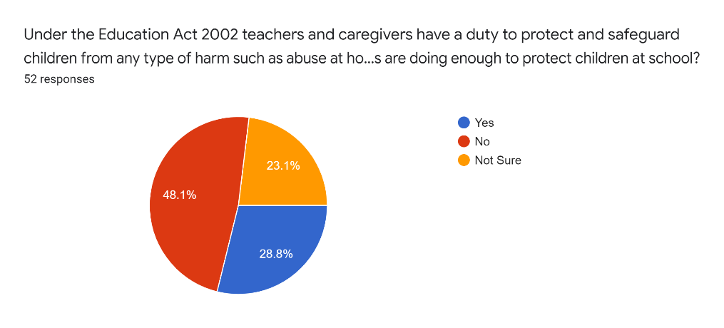
Figure 2.9 – Pie Chart showing the opinions on whether the respondents believe the school system is helping children at school

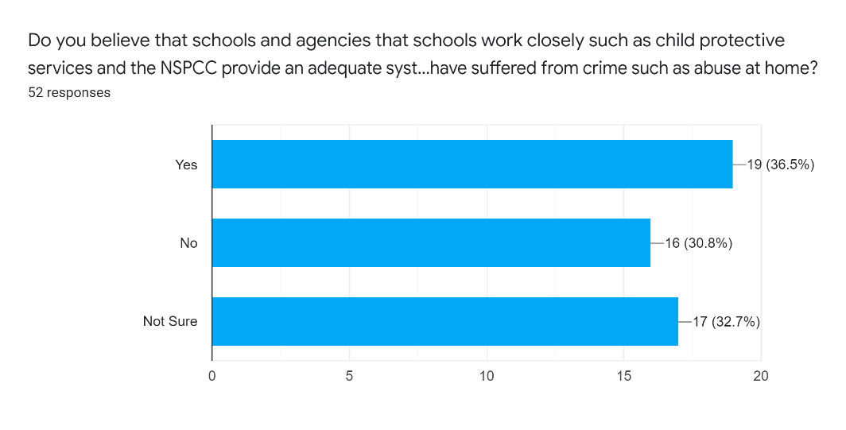
Figure 2.10 – Chart showing the results of the question do schools and agencies that work closely with schools provide an adequate system that provides support to children that suffer or have suffered from crime such as abuse at home?

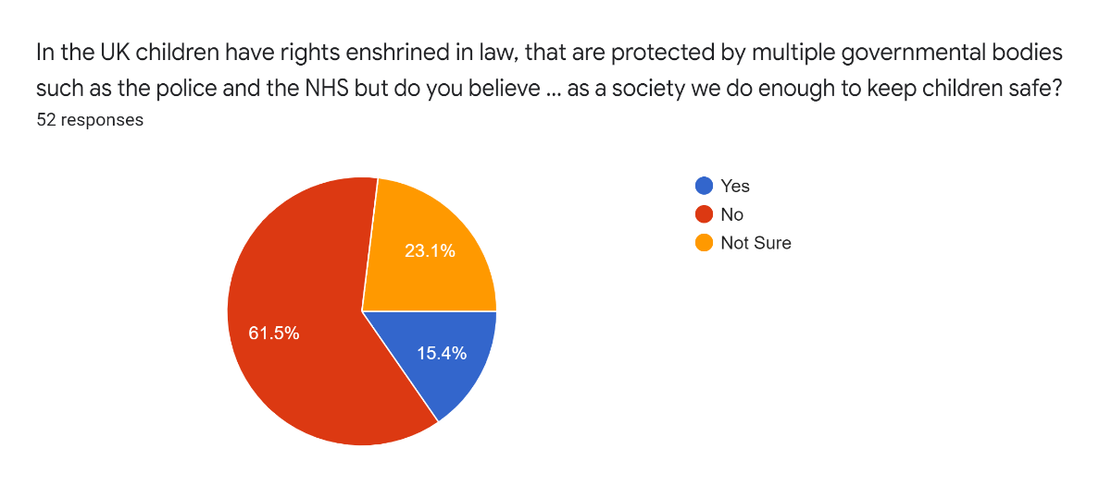
Figure 2.11 – Pie Chart of results of question, do you believe that as a society we do enough to keep children safe?

