
APPENDIX GA36d

LEVEL 7 ASSESSMENT SPECIFICATION

Student name: | Amy Yuen-kwan MAK | Student ID number: | 1922250
Programme: | DBA
Module: | Visions for the Future – Theoretical Perspectives on Management
Module code: | HKBM7006 | Contribution to Overall Module Assessment (%): | 100%
Lecturer: | Dr Eddie Yu | Internal Verifier:
Assignment Title: | Research Paper | Word count (or equivalent): | 7,500 words
Submission deadline: | 9:00 am, 13 September 2020 | Return date of provisional marks & written feedback: | 5 October 2020
Submission method: | All written assessments, where practical and possible, must be submitted via Turnitin unless otherwise instructed by the Lecturer. (Please DO NOT put this assessment specification into Turnitin or it will match many similarities with other students’ submissions.)  Alternative submission method (if applicable):  Late submission of the assessment will result in a late penalty mark. Penalties for late submission: Up to one week late, maximum mark of 50%. Over one week late, 0%. Only the Extenuating Circumstances Panel may approve a change to submission dates.
Academic honesty / referencing: | Academic honesty is required. In the main body of your submission you must give credit to authors on whose research and ideas your work is based. Append to your submission a reference list that indicates the books, articles, etc. that you have used, cited or quoted in order to complete this assessment.

Title: | Key Successful Factors in the New Economy: A Case study of Stan Group

Research Question and Objectives

The characteristics of the New Economy include digitalisation, connectivity, ecosystem development, shared value creation etc. This paper is going to do the qualitative analysis and identify the key successful factors of a fifty years old local traditional company and see how it would be transferred from a typical property investment company to a diversified corporate. The analysis would apply the 3-H framework which was developed by Dr. Eddie Yu to examine the corporate or management issues of Stan Group in a holistic way. “Heart”, “Head” and “Hand” are the three key elements of this framework. If a company is going to generate a better performance of a company, this company needs to effectively and efficiently manage and integrate these three domains (3-H).

Background of the company

Mr. Tang Shing Bor (鄧成波) is the founder of the company. He established this company in 1970. At present, his youngest son, Mr. Stan Tang, is the Chairman of the Stan Group. Originally, the Tang’s family business is just an active investor and runs all the businesses related to the investment of commercial, retail, shopping mall and residential real estate. It started to do some new things after twenty years. In 1991, Tang’s family acquired a tradition Chinese restaurant. In fact, it is also related to his core business as it later converted this restaurant building into a shopping centre which mainly selling computer and its accessories. In 2007, they bought Laser Video and then sold it to an appliance chain, Suning Commerce Groups Co. Ltd., to catch the wave of free travellers from PRC and upgrade the ranking of their existing commercial building as the image of Suning Commerce Groups is familiar with the mainland Chinese and their brand equity is not bad in late 2000. In 2014, Stan Group was founded. One year later, the Group revitalised an industrial building in Kwan Tong manufacturing and industrial area and transform it to a large coworking space and become the new signature building in the eastern Kowloon district. In 2017, the Tang’s family was ranked no. 50 on the Forbes 50 Richest in Hong Kong list and moved up to no. 40 in 2018. At present, Stan Group is a conglomerate and managing a HK$75 billion property portfolio including 40 brands across six business pillars, i.e., property, hospitality, communication services, financial services, senior care services and entrepreneurial platform. Based on the history and the development of Stan Group, you could see the diversification and innovativeness of this Group (from Good to Great), it is due to the leader’s intellectual (Stan) and the strong organisational culture he created, especially creating shared value is part of the Group’s unique DNA. According to the website of the company, its motto, vision, and mission are along the line.

Motto: Today is for Tomorrow
Vision: Drive Vibrancy of Society
Mission: Creating Share Value

Stan Group’s corporate philosophy is deeply inspired by the ideology of “Confucianism in business”. All communication materials and messages both inside and outside the Group are human focus and aim to create heart-to-heart communication atmosphere. They believe in the Confucian principle of putting people first. They also keep watch by the essential Confucian spirit of harmony. They stated that as a premier conglomerate, they would create shared value for their stakeholders including customers, employees, shareholders, business partners, and society. Mr. Stan mentioned that if they need to achieve this destination, they have to start with entrepreneurial spirit and a deep human focus.

The 3-H framework

At this paper, the 3-H framework is adopted to do the qualitative analysis. The major reason to select this framework to do the analysis is that it could figure out the most effective way managing people and corporate issues from a holistic perspective. According to the founder of this framework, few organisations could develop long-term competitiveness if they only partially master certain conditions of the 3H framework. Based on 3-H framework, we could systematically develop and execute a holistic strategic plan via the three domains, i.e., Heart domain, Head domain, and Hand domain.

Name of the domain | Short form | Meaning
Heart domain | H1 | emotional appeal, leading, motivating and engaging people abilities
Head domain | H2 | logical & strategic appeal, planning, organisational, cognitive abilities
Hand domain | H3 | competence appeal, operational/functional abilities

If it is successfully embedded this thinking paradigm or mental schema into the mind of the leaders, the leaders would be able to intuitively plan and execute their strategies effectively and efficiently. In Dr. Yu’s terminology, scenario Case 1 would be generated, it implies “committed & capable of managing the right thing”.

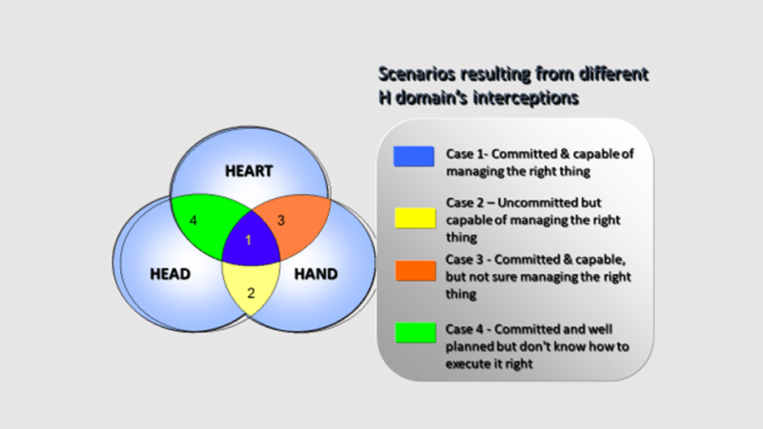

One of the examples to illustrate Case 1 is the Stan Group intrapreneurs which are entrepreneurial thinkers who drive organizational change and are motivated by creation. In Stan Group, in addition to the traditional workshop and seminar, according to Ms. Mary Suen, Director of Corporate Culture and Talent Development of Stan Group, they specially arrange design thinking workshops for their staff. They also renovated one whole floor of their headquarter building and turn it become a coworking space for the staff. Mr. Mark Sims was hired to lead SG Ventures, a division of Stan Group (Holdings) Limited. In Stan Group culture, they strong encourage the staff to become intrapreneurs. In October 2019, Stan Group launched Buy-a-Brick to reward staff members through revenue sharing. With the expertise and the comprehensive set up of the Stan Group, they developed an innovative employee incentive and recognition programme which could apply blockchain technology and real estate tokenization via the cloud base system to enable Stan Group employees to create wealth together with Stan Group. Through the smart contracts, the brick owner entitle to a share of the capital gain when the property is sold.

In addition, Stan and his management team would like to develop strong culture with care which develop their people and culture with Confucian leadership. They believe their work is more than just a job – it is a journey of discovering the true potential they are all born with.

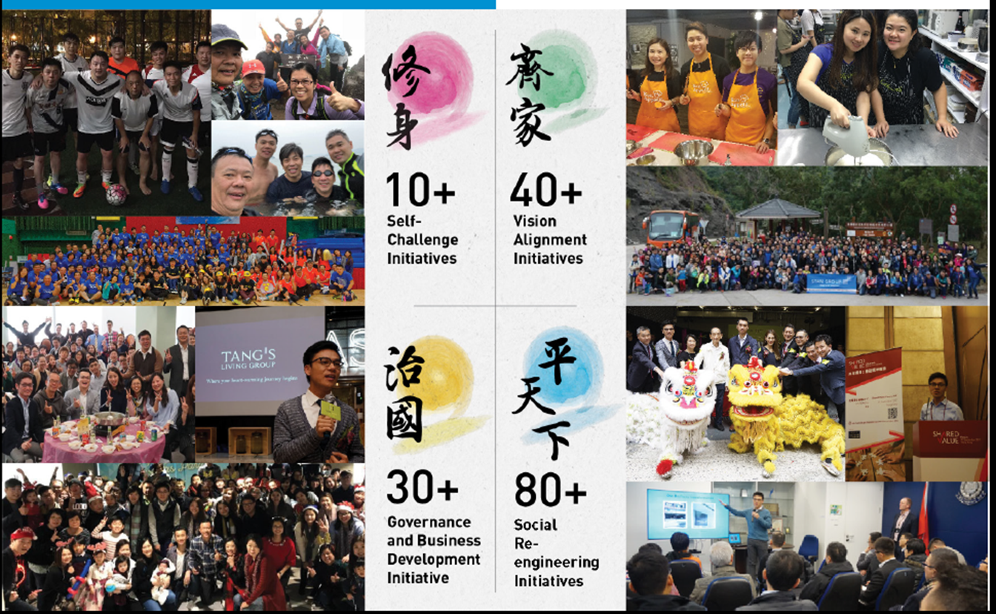

We could also apply the VRIO (four question analysis on its resource or capability) to determine Stan Group’s competitiveness. potential: the question of Value, the question of Rarity, the question of Imitability (Ease/Difficulty to Imitate), and the question of Organization (ability to exploit the resource or capability). For the question of Value, it depends on the resource or capability works to exploit an opportunity or mitigate a threat in the marketplace. At Stan Group, Stan understands the demographic change, the demand of quality senior care services would be increased, The Stan Group form partnership in February 2020 Pine Care Group (Hong Kong stock code: 1989) to provide professional and quality senior care services and redefine the rules of the games in the industry.

Having rarity or not is also a key question to lead to competitive advantage. In Stan Group case, a diversified corporate with that scale is not common and difficult to imitate. Through our discussion, we can see that Mr. Stan Tang is able to organise the Group in a way to exploit these resources.

In that case, we are able to explain why Stan Group could create comparative advantage (CA) to earn above average profit with 40 brands and more than 4000 staff across six business pillars.

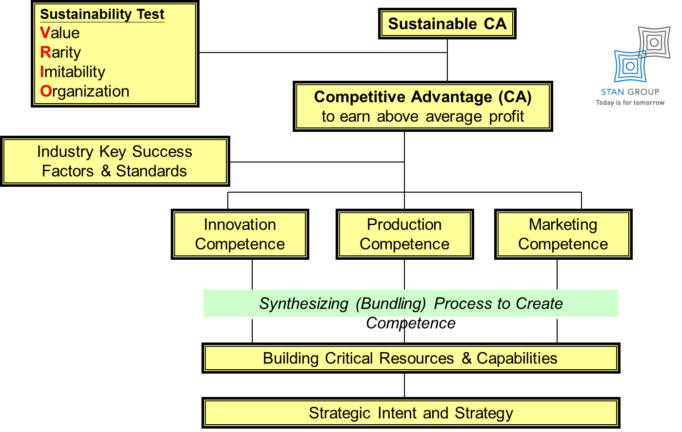

References:

Discover Stan Group, The Stan Group Culture Chapter 2018.

Stan Group News, January 2018.

