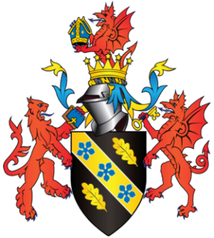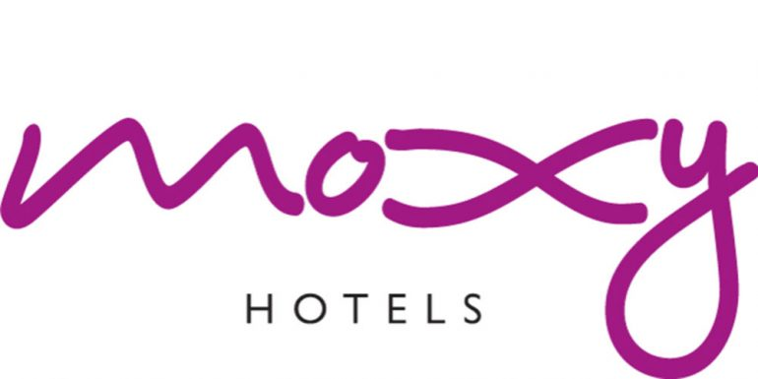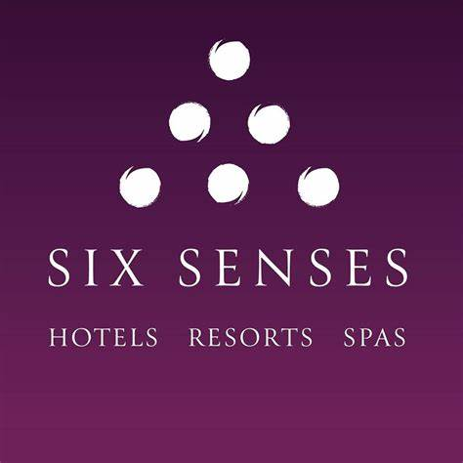

Rework: A comparison of the marketing methods of two multinational hotel brand

Augusta-Roxana Toth 2226559
  - Marketing Essentials BMIH4005
  - Luciana Suardi
  - Word count: 1350

Introduction
In this essay, it is about comparing between two hotels Six Senses Hotels & Moxy Hotels, analyzing their marketing strategies, categorizing to which they belong, which is their target, what kind of customers want to attract but also about the strong impact that the war with Ukraine had and the increase of utilities on the industry. The rapid emergence and evolution of new competitors and technological change have caused the market environment to become unpredictable (Bolton, 2019).
In 1995, Six Senses became known as a pioneer in the hospitality industry. Neil Jacobs leads Six Senses Hotels Resorts Spas. They have thirty-eight hotels with 1366 rooms in various parts of the world. Marriott International's Moxy Hotels brand is one of its newest brands. (IHG,2022). In 2014, Moxy Hotel opened its first location in Milan in partnership with IKEA, the well-known Swedish furniture brand. Today, more than seventy locations are open worldwide on three different continents (Jamerson,2023).
Six Senses belongs to the category of luxury hotels, compared to Moxy Hotel which is accessible to everyone who has a low budget. “I never thought after nearly 35+ years in our industry that I would be using words at work like empathy, gratitude and love but that’s how we evolve and the excitement of what we do.” (Jacobs, 2022). Moxy is a brand of hotel defying all conventions. Style, playfulness, and affordability are the defining characteristics of this stylish, playful, and affordable brand. Six Senses is committed to sustainability and fulfils its obligation to society and the environment. Neil has been involved in the hotel and spa industry for over three decades, and he is passionate about sustainability and the importance of providing guests with the best possible experience. As the managing director of Six Senses, he is responsible for overseeing the company's environmental and social responsibility (Saglam,2021).
Main Body
Every business operates in a world impacted by both internal and external variables. These elements influence the organization's total income generation performance. These tasks include doing SWOT (Strengths, Weaknesses, Opportunities, and Threats) and PEST (Political, Environmental, Social, and Technological) evaluations.
External elements in a business environment are those over which the business enterprise has no influence, whereas internal variables are those over which the organization has control. The internal ones include strengths and weaknesses, Moxy the strengths decision making that is flexible and fluid, rather than constrained by the limitations established by large brands and Six Senses characteristics (building, interior, knowledgeable personnel, location). The weaknesses are high labour and material costs (due to high-quality goods) for luxury hotels and for the budget, new brand, low awareness in the market, increasing competitive rivalry in the addressed segment, and they have a small footprint. External, opportunities targeting visitors searching for highly personalized, distinctive, and private offerings (Speros,2023).

The rise of the Moxy platform and the increasing number of millennials are some of the key factors that are expected to drive the hotel industry's future. However, the main threat to both the industry and the company is the competition from online alternatives and the same old industry practices. (Ting,2018).
This makes it necessary for companies to update their marketing plans frequently to stay competitive. This creates a complex situation, as decision-makers must consider a variety of factors. These include understanding the needs and preferences of the target customers, analyzing the current market landscape and evaluating the performance of rival companies. In addition, companies need to remain aware of the latest trends in technology and consumer behaviours, as well as the legal and regulatory frameworks that companies must comply with.
Various factors can affect the performance of the hotel industry. These include legislative changes, unpredictable weather, and high-stakes competition. Political issues, such as the government's significant control over the hotel business, and a tax change in which hotel owners pay reduced taxes might benefit the sector. Economic variables, weakening currencies, economic cycles, and personalised products are all aspects to consider. The hotel industry is vulnerable to economic changes, as it emerges first from cycles of economic decline. Customers prefer to stay in cheaper establishments due to sociocultural issues, while they also resort to Airbnb due to its popularity. Most travellers, especially millennials, prefer Airbnb's large selection of accommodations. Various technological aspects, such as social media, blogging, and scratching reviews, have made their way into the hospitality industry. While traditional media remains the primary method of disseminating information, hotels are now turning to the Internet to reach their customers. Mobile applications and social media are the most popular tools, but they should be utilized with caution.
By analyzing and understanding the changing market environment, companies can develop innovative and effective marketing strategies that will help them capture and retain customers. In addition, companies need to have the ability to quickly adapt and adjust their marketing plans to seize opportunities or respond to threats.
This requires close market monitoring, close collaboration between departments, and the implementation of sophisticated analytics tools to collect and analyze data.
The marketing mix of a hotel is a vital aspect of any hotel's operations to ensure that it can effectively target its intended customers. It involves the use of various promotional factors, such as the establishment of a variety of facilities, including a conference centre, restaurant, and parking lot.
The Six Senses Resort and Hotel is a luxury establishment that puts a premium on mental and physical health. It features various facilities and services for both leisure and business travellers. (Silver,2022). A hotel's location can be found in a city, a resort area, or a hill station. A hotel chain can have a presence in many locations. To attract potential clients, a hotel can use either indirect or direct distribution methods. Direct methods for both hotels are online pay-per-click or Banner Advertisements (Google ads, Facebook), printed media advertisements, other media advertisements, a hotel website booking system, and a global distribution system. Indirect techniques are the travel agents.
Promotion and communication are also part of the marketing mix of hotels. Hotels interact with their target clients through promotion. Brochures, television commercials, hotel websites, Twitter channels, and Facebook. A hotel's marketing department must consider the pricing of its services and products when it comes to promoting itself. A lack of competition can cause potential customers to choose not to book a room.

Pricing and packages have a tremendous effect on guests in this highly competitive sector. The hotel pricing codes and packages are designed to entice or impress guests. The difference between Six Senses and Moxy Hotel, the price is an important component. Six Senses attracts businesspeople, and families with an important status, but also for those who want to have a vacation or a dream honeymoon (Wan,2023). Moxy belongs to those with a low budget, who are passing through a city, businessmen but in principle youth. The term process refers to the processes taken to provide a positive guest experience (Miceli,2022).
All lodging providers seek to create a smooth, efficient, and customer-friendly trip, but this is impossible without the necessary systems in place.
Conclusion
In general, continuous market monitoring, the desire to adapt and the use of advanced analytics are essential components of successful marketing in the modern environment. Companies that can effectively manage these tasks will be better positioned to take advantage of growth opportunities and remain competitive in the increasingly dynamic market. The marketing and sales department of a company can help identify the various requirements of its customers by conducting a study. This can then be used to either establish or make changes to the facility.
In conclusion, the two hotel brands' preferred marketing strategies are that they are trying to keep up with the new generation, with technology, with organic food that helps both physically and mentally, because today with so many carbon emissions in the big cities, with the stress that comes with all these price increases, travellers want to clear their minds, to detach themselves from all that means daily life, need peace, relaxation but at the same time a sense of security. Due to the locations where they are placed, Six Senses and Moxy Hotels, are now enjoying the biggest success.

Referencing List:
Forshaw, I. (2022) Six Senses to Open Hotel in the Historic Center of Rome. Available at: https://elitetraveler.com/travel/hotel-news/six-senses-rome-hotel-opening/ (Accessed 25 April 2023).
IHG Hotels Resorts (2022) Our brand Six Senses. Available at: https://www.ihgplc.com/en/our-brands/six-senses/ (Accessed 02 May 2023).
Jameson, J. (2023) Moxy Lower East Side hotel embraces the colorful history of the Manhattan neighborhood [blog]. Available at:: https://www.traveller.com.au/moxy-lower-east-hotel-embraces-colourful-history-of-manhattans-lower-east-h290wh/ (Accessed 29 April 2023).
Marriot International New Center (2022) Moxy Lower East Side Debuts as an Eclectic and Stylish Pleasure Garden in the Neighborhood That Defines New York Cool. Available at: https://news.marriott.com/news/2022/11/02/moxy-lower-east-side-debuts-as-an-eclectic-and-stylish-pleasure-garden-in-the-neighborhood-that-defines-new-york-cool/ (Accessed 25 April 2023).
Marriot International (2023). Moxy Expands into The Middle East and Africa. Available at: https://www.hotel-development.marriott.com/global-expansion-of-moxy-hotels/ (Accessed 26 April 2023).
Mailman, E. (2023). This once-abandoned, historic resort in Napa is making a comeback. Available at: https://www.timeout.com/usa/news/this-once-abandoned-historic-resort-in-napa-is-making-an-comeback-020823/ (Accessed 26 April 2023).
Miceli, C. (2022) Everything You Need to Know About Moxy Hotels: Are They Worth It? [blog].9 February. Available at: https://www.pilotplans.com/blog/moxy-hotels-review#:~:text=The%20first%20Moxy%20Hotel%20was%20opened%20in%20Milan,locations%20are%20open%20worldwide%20on%20three%20different%20continents/ (Accessed 28 April 2023).
Michelin Guide (2022) The Pursuit of Healthiness at Six Senses. Available at: https://guide.michelin.com/en/article/travel/six-senses-sustainability-michelin-guide/ (Accessed 29 April 2023).
Saglam, B. (2021). Interview: The Story of Six Senses. Available at: https://www.travelinsightpedia.com/interview-the-story-of-six-senses/ (Accessed 02 May 2023).
Six Senses (2023). What`s the story of the Six Senses? Available at: https://www.sixsenses.com/en/about-us/history/ (Accessed 02 May 2023).
Silver, H. (2022). The luxury minimalism of Six Senses’ London flagship hotel and residences. Available at: https://www.wallpaper.com/architecture/six-senses-london-hotel-and-residences-avroko-uk/ (Accessed 03 May 2023).
Smith, A. (2023). Historic Marriott Moxy Hotel Renovation Underway Downtown [blog].7 February. Available at: https://www.linkedin.com/pulse/historic-marriott-moxy-hotel-renovation-underway-downtown-adam-smith/ (Accessed 03 May 2023).
Speros, W. (2023) Six Senses to Debut Tel Aviv Property in 2025.Available at: https://hospitalitydesign.com/news/hotels-resorts/six-senses-tel-aviv/ (Accessed 03 May 2023).
Telford, W. (2022) Inside Plymouth's Moxy hotel as images show how £9m project will look. Available at: https://www.plymouthherald.co.uk/news/plymouth-news/gallery/inside-plymouths-moxy-hotel-images-7720250/ (Accessed 02 May 2023).
Ting, D. (2018) The Inside Story Behind Marriott`s Moxy-Led Invasion of Manhattan. Available at: https://skift.com/2018/04/24/the-inside-story-behind-marriotts-moxy-led-invasion-of-manhattan/ (Accessed 02 May 2023).
Tuttle, B. (2013) Marriott & IKEA Launch a Hotel Brand for Millennials: What Does That Even Mean? Available at: https://business.time.com/2013/03/08/marriott-ikea-launch-a-hotel-brand-for-millennials-what-does-that-even-mean/ (Accessed 02 May 2023).
Wan, A. (2023) Luxury brand Six Senses is opening its first hotel in Australia. Available at: https://www.cnbc.com/2023/02/08/six-senses-is-opening-its-first-hotel-in-australia-in-the-dandenongs.html/ (Accessed 03 May 2023).

Appendices


