Please delete the box below and replace it with an “appropriate” passport style photograph that clearly shows your face. Your photo should be roughly the same size as the box:

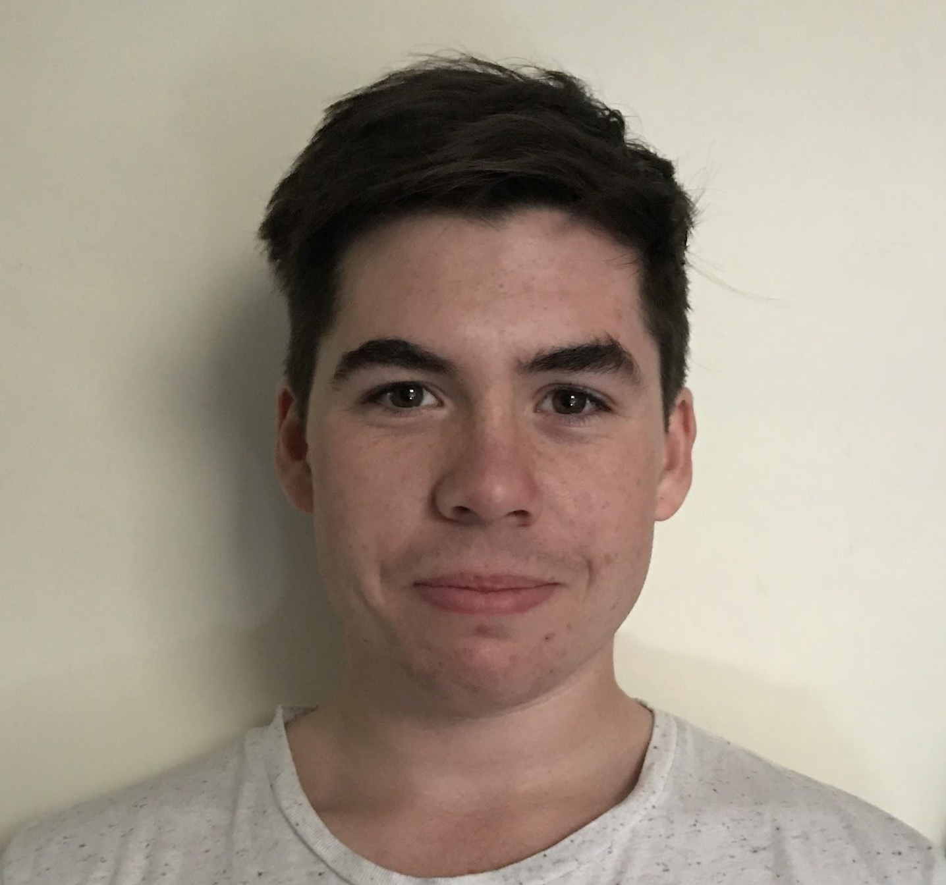

Name: Joshua Atkins

Student number: 1701740

Student email address: 1701740@student.uwtsd.ac.uk

Contact number: 07739699947

Please use the remaining space to give a brief outline of why you have chosen your course of study and any relevant special interests or experiences:
I have chosen to study sport therapy as when doing my BTEC sport i became very interested with injuries, how they body works to overcome the injuries and heal itself. I am very into playing rugby so when watching a game i have been curious of how they treat the injuries in a professional game. I would be looking once I have completed my course of study to go back to my local club to give them the best treatment possible and then would look to work within a professional rugby club or look into other sports e.g American football another big love of mine. I have also been politically excited to learn the method of massage as it is another topic that really interests me.

