
26/10/2017
Bastien PERROT
University of wales trinity saint david, swansea
Personnel Management VS Human Resource Management

Personal Management and Humans Resources Management at first sight they seems to be similar in the title but we are going to see there are some differences but also some extent similar. Before to speak about personal management and human resources management, we have to speak about humans relations. Some theoreticians adopted positions more or less closed about human’s relations. Elton MAYO (1880-1949), psychologist and sociologist who have completed Taylorism hypothesis (1912) adding some advantages for employees like career development, decent salary or job security and friendly environment (Elton Mayo 1927-1932). Others theoreticians have contributed at the human’s relations development and thus a dedicated service department for staff. Abraham MASLOW, American psychologist (1908-1970) best known for the hierarchy of needs (1954), its pyramid explain individual satisfaction in order of importance with different needs:
- Psychological needs
- Safety needs
- Esteem needs
- Membership needs
- Achievement needs
By contrast with Henry FORD (1863-1947) who encourages assembly line with assembly workers (1910) where worker’s fulfilment was not important, mass production was the only way. A theory, most precisely the Theory X developed in the 1960s by Douglas McGregor (1906-1964) management professor at the MIT Sloan School of Management seems to correspond with Ford’s ideas. In fact, Mc Gregor, has developed two theories which describe contrasting models of workforce motivation:

Theory X |  | Theory Y
Dislike work, work is boring, will avoid if they can | ATTITUDE | Need to work and want to take an interest, can enjoy it
Must be forced or coerced into compliance | DIRECTION | Direct themselves towards on accepted target
Need to be directed and prefer to avoid responsibilities | RESPONSIBILITY | Thrive on responsibility
Motivated by fear, lack of money and lack of job security | MOTIVATION | Motivate by the desire of self-development and to contribute to the company’s world
Little creativity, except when getting arounds rules | CREATIVITY | Highly creative when given recognition and opportunity

With both theories, we can distinguish directly two theories totally exposed. One suppose that people can find an interest in the work and can enjoy it whereas another given evidence to the contrary. Also, we can make a link between Ford’s ideas and Theory X, in fact they seems to be closed because they explain the same major position with:
- Little creativity employees can’t be creative, they have to follow the machine production
- Motivated by fear, lack of money Firing people if they can’t follow the machine production
- Dislike work fulfilment is not important, only production is important
In this situation, we can see human beings is perceived like people who don’t like work. Moreover, employees have to settle for the speed of the machine. We can based on Charlie Chaplin movie “Modern Times” (1936) which is based on Fordism and thus assembly line work to illustrate working conditions and no-fulfilment in factories at that time.

“Nothing is particularly difficult if it’s divided into small tasks” (Henry FORD)
At first sight, this sentence seems to be intelligent, however it reflects the will to divided the work into small tasks and give birth to assembly line.
Henry Fayol (1841-1925) French mining engineer, also had an important role in the business world. In fact, his name “Fayol” given birth to a new theory called Fayolism, inspired by Taylorism, Fayolism has been developed with the aim of human’s organization and the introduction of Administration which has been divided into five different functions:
- Organise
- Constitute
- Command
- Coordinate
- Control
His theory represent a progress because it take care of the human’s organization and thus applies for directors and subordinate in the interest of rationalisation. “Not many people are familiar with its constitution and powers; our senses cannot follow its workings – we do not see it build or forge, sell or buy – and yet we all know that, if it does not work properly, the undertaking is in danger of failure.” (Henri Fayol – 1995)

With these ideas we realise that all the theoreticians had not the same idea about “Human relations”. We can therefore guess that personnel management and human resource management are methods whether management can be different in each company.

This essay is divided into three parts:

- Definition of key words to well understand the topic of this essay and a short historical part about development of human relations.

- Differences, development and explications of Personnel Management (PM) and Human Resources Management (HRM)

- Common objectives between PM and HRM

Management:
Manage is about organisation, coordination, commands and controls of the activities to lead to business success. For this reason, we can describe management like a factor of production. To manage a company you need to be in interact with:
- Funding Employees and machines are not free
- Technical employees training
- Return To be able to measuring the benefits
Manage is also about take strategical decision which can impacting the company:
- Remuneration policy
- Production policy
- Recruitment/ layoff policy

Taylor’s definition (Shop management: a paper read before the American society of mechanical engineers - 1903) “Management is an art of knowing what to do, when to do and see that it is done in the best and cheapest way”

Resources:
When we think about “Resources” frequently we think about “Humans Resources”, but in a company we can identify various kind of resources:
- Financial resources
- Material (Premises, machines…) and immaterial (brand image, reputation…) resources
- Humans resources
Without these resources a firm cannot assure its continuity.

Human:
Human being is very important in a company because he is at the heart of the productivity, in fact, it’s not a robot, and so it’s necessary to take care of him and to meet his needs. In every sector of activities, there are trade union applied rules reform to support employees.
“A person who makes full use of and exploits his talents, potentialities, and, capacities; such a person seems to be fulfilling himself and doing the best he is capable of doing. The self-actualized person must find in his life those qualities that make his living rich and rewarding. He must find meaningfulness, self-sufficiency, effortlessness, playfulness, richness, simplicity, completion, necessity, perfection, individuality, beauty, and truth.” (Abraham Maslow -)
Abraham Maslow is often spoken as the “Philosopher who defined human needs”. Closed to human’s right and well-being at work, Maslow is an emblematic figure in the human right development.

Industrial Relations
“Industrial relations cover the relationship between management and employees and how they interact, and through which they regulate conflict in the workplace” (Mindset Learn, 2013). You have to know there are different style of management/relationship. Each company have their own characteristics of relationship and that is clearly explained through those three industrial theory:
- Marxist/Radical Fundamental inequality creates frictions between employees and directors.

- Pluralist Composed of diverse sets of beliefs, attitudes, values and behaviour (Giles 1989: 131). Conflicts are inevitable because of competitive interest (Dabschek 1989: 59, and Dzimbiri 2008: 3) but they can be helpful if identified and controlled within institutional responses.( Farnham 1993: 36)

- Unitarist one mind, one direction, only a single source of authority in the company where rival leaders are non- existent (Ross and Bamber 2009: 25). Every people in the company working in the same direction (employees, shareholder, board of directors…). No need for Trade Unions. (Farnham 1993: 36)

History of Personal/ Human resources Management:
Before to speak about Human Resources Management or Personnel Management, we have to understand the worker’s rights evolution.

- 1900 1920
Taylor (1856-1915) with Scientific Management. People are controlled, they are as a part of machine.

- 1920 1950
From 1930s beginning of humans relations with Elton Mayo (1927-1932). Recognition, security and sense of belonging, work is a group activity, social capital and social control

- 1950 1960
Birth of management with Peter Drucker who was nicknamed “the management’s pope”.
Abraham Maslow’s needs apparition.

- 1960 1973
Douglas Mac Gregor Theories.
X -- Motivated mainly by money; no responsibility; dislike work.
Y — Seek and accept responsibilities; need to work and want to take an interest in it; motivated under the rights conditions.

(Weston & Associés – Metz)

- Before World War 2
It was at the beginning of the 20th century that personal department management was born, most precisely in 1912 with personal department’s appearance which was distinct of the others firm’s department. However, at that time, employee’s rights was still limited and work fulfilment was out of time, moreover, turn-over remained high. It was in the 30’s with Mayo’s principles appearance that human’s relations action was born in the United State. (Ecole MEDAV Koléa-Tipaza)

- After World War II
We can distinguish before and after World War 2 because the real development begun after the war in 1945. In fact, there was a lot of different companies in the market, and competition between them was constantly evolving. Firm realized that to stay competitive they needed to:
- Stop turn-over of the employees
- Increase productivity
- Develop loyalty of the employees

Therefore, they had to change working methods to have a competitive advantage and to win loyalty. (Creative HRM 2012-16)
After the war, progress have been made for example with Peter Drucker who think about team work and don’t think only about individuality: “The leaders who work most effectively, it seems to me, never say “I”; and that not because they have trained themselves not to say “I”. They don’t think “I”. They think “we”; they think “team”. They understand their job to be to make the team function. They accept responsibility and don’t sidestep it, but “we” gets the credit. This is what creates trust, what enables you to get the task done.” (Peter Drucker).
Or also with Maslow pyramid which describe different worker’s needs:
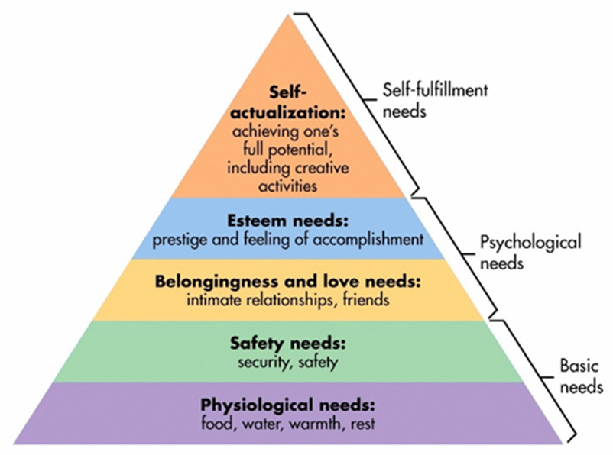

“If you plan on being anything less than you are capable of being, you will probably be unhappy all the days of your life” (Abraham Maslow)

Differences
Today, Human resources management and personnel management seems to be the same, however they have different functions and characteristics. Before to speak about human resources management, we have to speak about Personnel Management. In fact we can describe Personnel Management like the predecessor of Human Resources Management.
Personnel Management (PM) evolved in the business with the purpose of daily management of the personal (work-force), from supervision of hiring to firing and includes supervision of the employee (delay, sick leave, vacation…) and also payment of wages. PM is focused on personnel administration, labour relation (relationship between employee and employer) and employee welfare. (Mohammed Alturkistani – 2005). The Personnel Manager’s main job is to ensure that the needs of employees are answering to their immediate concerns.
The scope of the personal management is limited, the behaviour of the employee (the worker) can be manipulated, in fact, worker answer directly to the need of the organization.
We can divided PM in two functions:
- Operative functions in conjunction with procurement, job evaluation, development, employee and maintenance.

- Managerial function in conjunction with planning, control, motivation, coordination… which answer at the basic managerial activities led by Personnel Management.

Personal Management tend toward the Theory Y which has been developed by Douglas McGregor (1960s), in fact the personal Manager has initially an optimistic and positive view of their employees, he played the role of mediator between employees and the management. His aim is to motivate, solve troubles, support and take care of employees.

Today, with Trade Union’s clams and competitor’s continual increasing, it has become imperative to place people before everything else in the interest of maximizing the Return On Investment (ROI).
Human resources management’s concept emerged in the 1980s in the United States. Defined as the successor of the personal management, human resources management (HRM) have a larger scope than PM. In fact, HRM take part in each stage of the collaborator’s life in the company. We can say that HRM guides its activities about 3 approaches:
- Administer
- Communicate
- Management
HRM have a policy’s role, in fact it dictate the broad policy’s lines of the company. With a strategical role, HRM establish:
- Recruitment policy
- Wage policy
- Training policy
- Motivational policy
The HRM’s function is to ensure sustainable company development and at the same time individual development by career management system. The work-force, before considering as “resources” became “assets” and a valuable source of competitive advantage. HRM is now trying to align individual goals and objectives with company’s goals and objectives by adopting participative approach.

We can say that Personnel Management and Human Resource Management are different firstly because of scope of application, moreover we have on the one side a strategical function with HRM and on the other side routine function with PM. HRM and PM are complement one another but they have a different view, in fact, one is reactive (approach based on responding to events after they have happened) and the other is proactive (focuses on problem’s elimination before they have a chance to affect the company).

The borderline between Human resources management and personnel management is not sharp, in fact, the personnel management played an important role in the history of the human resource management. Firstly, they have a common objective: The company durability in particular by focusing on recruiting the best employees and generally manage them for the benefit of the company. These two services are required to work together to discuss about recruitment process, new hiring, details job grading etc. Also, we can see that staff well-being is one of the major concern, inspired by theoreticians as Abraham Maslow or Elton Mayo, PM and HRM understood that worker fulfilment or worker well-being can have an important impact about the productivity. To illustrate similarities we can use this sentence: “The same wine, only different bottles” It means that only the name is different, but job descriptions and objectives are mainly the same. It is just that the Human Resource Management has a wider way compared to Personnel Management but what they do are basically the same, in fact they have to managing people. Moreover, both of their strategies flow from the business strategy and they use the same managerial techniques like motivating, training, orienting, etc.
- Both models focus on personnel or HRM organization techniques
- Both use payroll software packages and monitor employee’s time worked
- Same requirements of selection, competence analysis training and reward management methods.
All are shared by HRM and PM, so, although they are two different approaches with different names, we can see that a certain number of responsibilities remain the same.
Conclusion

To resume this essay we can see that Personnel Management and Human Resource Management are both complementary and useful for an organization. Increasingly applied, HRM seems to take advantage over PM. In fact HRM come up with an extension over PM. We can make a distinction between these two methods mainly because of the scope, and also we can describe the PM as the department to achieve organizational objectives and HRM as the department which set up these objectives.
Today it’s not easy to maintain good employees for a long time in a company, they are aware of their rights and any organizations cannot treat them like machines. For this reason, HRM has been evolved to rationalise the organization with employees to work together of a common goal.

REFERENCES
- Introduction

- Daniel A. Wren, (1995) "Henri Fayol: learning from experience", Journal of Management History, Vol. 1 Issue: 3, pp.5-12, https://doi.org/10.1108/13552529510095116

- Taylor F. W (1903) Shop management: a paper read before the American society of mechanical engineers “Management is an art of knowing what to do, when to do and see that it is done in the best and cheapest way”

- History

- Abraham H Maslow

- Industrial Relations

- Giles, A. (1989) ‘Industrial relations theory, the state, and politics.’ In Theories and concepts in comparative industrial relations. ed by K. Barbash. South Carolina: Univ. of South Carolina Press.

- Dzimbiri, L.B. (2008) Industrial relations in a developing society: the case of colonial, independent one-party and multiparty Malawi. Germany: Cuvillier Verlag.

- Dabscheck, B. (1989) ‘A survey of theories of industrial relations.’ In Theories and concepts in comparative industrial relations. ed. K Barbash. South Carolina: Univ. of South Carolina Press.

- Farnham, D. (1993) Employee relations in context. Great Britain: Short Run Press.

- Ross, P. and Bamber, G.J. (2009) ‘Strategic choices in pluralist and unitarist employment relations regimes: a study of Australian telecommunications.’ Industrial & Labor Relations Review 63, (1) 24-41.

