Using loops (1) – While

1. Ask the user to enter their age, which must be 18 or more. If they enter something out of range, keep prompting them to enter a number. Don't forget to test on the boundary (exactly 18)

Sample output:

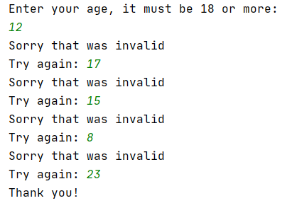

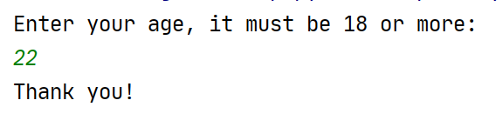

2. Ask the user to choose a number – this time, it must be between 1 and 10. Any numbers outside that range should trigger a "Try again" message.

Sample output:

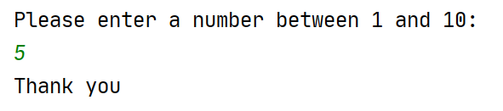

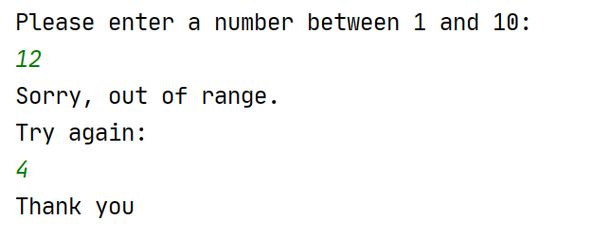

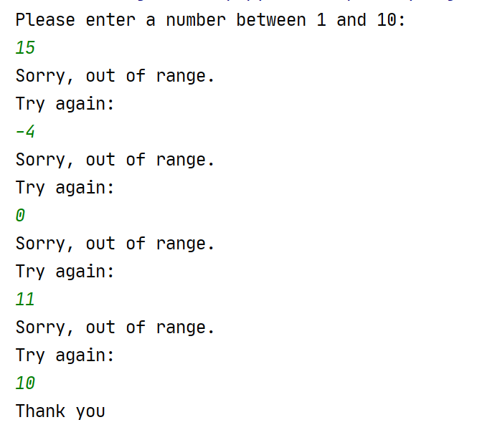

3. Write a program to count up from 1 using a while loop. The user will decide where we stop.

Sample output:

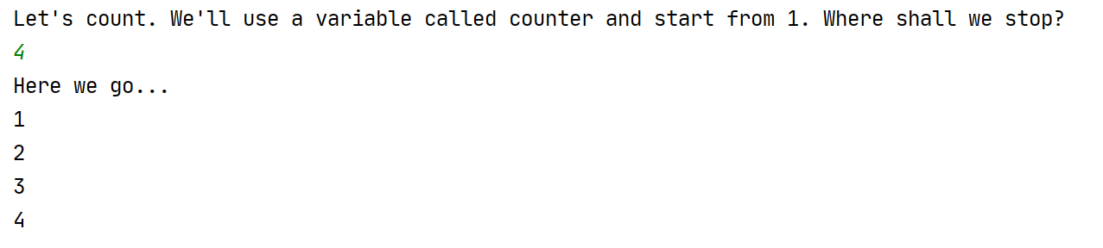

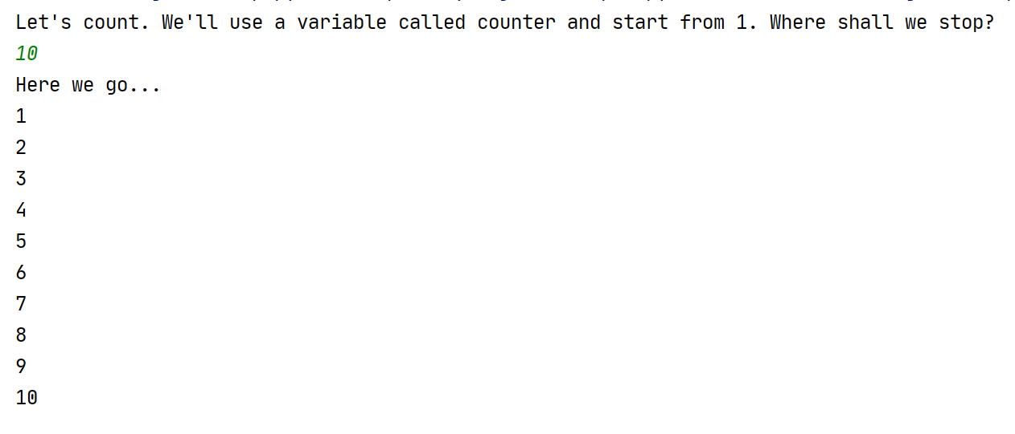

4. This time, count down. The user will decide where to start the countdown (use a variable called counter) and we will finish at 1.

Sample output:

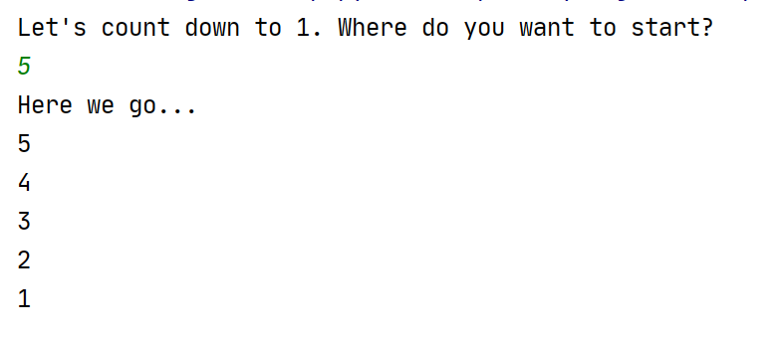

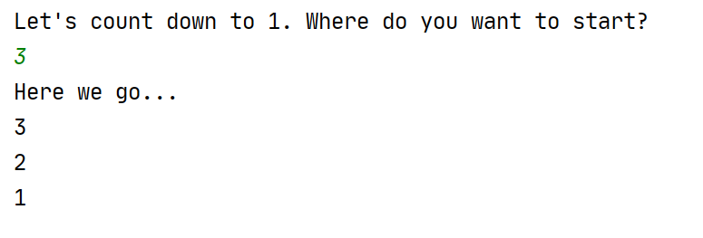

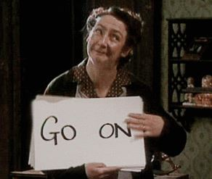
5. Mrs Doyle (pictured right) likes her employer, Father Ted Crilly, to drink tea. She will not take no ('n') for an answer. Write a program that will not exit until you agree ('y') to have a cup of tea.

Note: This is a reference to the classic Channel 4 comedy Father Ted.

Sample output:

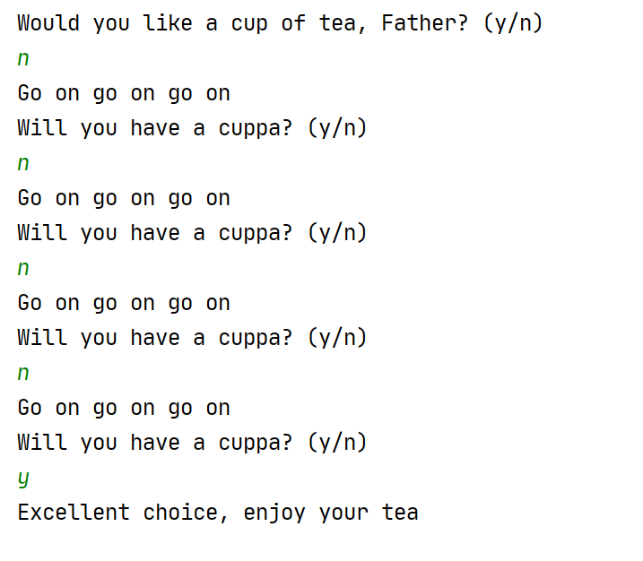

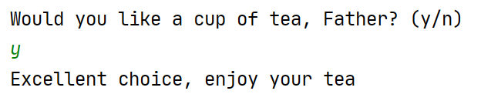

6. Write a calculator program to add two numbers. Let the user add as many sets of numbers as they like, until they decide to stop (use a while loop for this)

Note: Break the problem down by doing the calculator program on its own first (no loop). Once it is working, add the loop on.

(Hint: there is a tiny sting in the tail with this one. There is a bit of logic to getting the program to enter the loop in the first place – everything else behaves as normal)

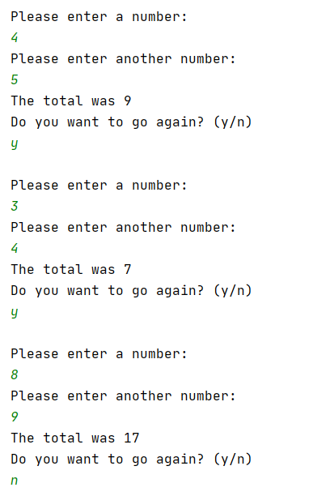

7a. Write a program to allow the user to guess my age (we'll set this as 21 years)

Sample output:

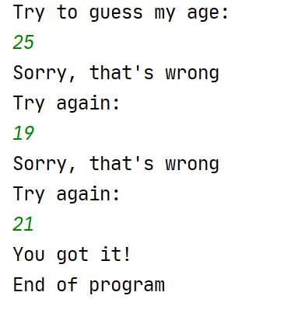

7b. For fun, put in an extra insult to the user if they enter a number that's is too old – let's say over 70.

(Hint: use an if statement to do this. Think carefully about where to place it.)

Sample output:

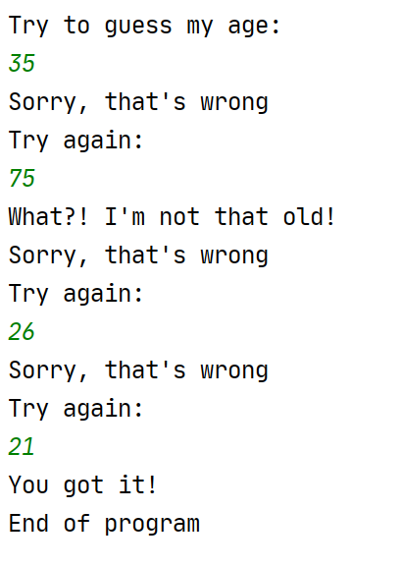

7c. (Harder) Allow a maximum of 3 guesses (I put this one in as an extra stretch question!)

Sample output:



