

Summiyah kousar
2330601
BMHP5015
Lecturers name Olufemi Oluranti
COMPONENT 1- ONLINE PORTFOLIO OF SET EXERCISES

Task 1 – Personal Brand
My personal brand is based on being caring, reliable, respectful and hardworking. I enjoy helping others and believe that treating people with kindness and dignity is important, especially in the health and social care sector. I am a good listener and work well with others, which helps me build positive relationships with colleagues and service users. I am also willing to learn new skills and improve myself so that I can provide the best possible care.
To achieve my employment goals, I need to continue developing my personal brand. One way I can do this is by completing my Health and Social Care course and gaining practical experience through placements or volunteering. These opportunities will help me improve my confidence, communication skills and understanding of professional practice. According to the Chartered Institute of Personnel and Development, continuous professional development helps people improve their knowledge, skills and career prospects (CIPD, 2023).
I also want to improve my digital skills, teamwork and problem-solving abilities because employers value these qualities in the workplace. Keeping my CV updated, behaving professionally and building a positive reputation will help me stand out when applying for jobs. The National Careers Service states that employers look for transferable skills such as communication, teamwork and organisation, alongside qualifications (National Careers Service, 2024).
Overall, my personal brand reflects my commitment to becoming a compassionate, trustworthy and professional health and social care worker. By continuing to develop my knowledge, skills and experience, I will increase my confidence and improve my chances of achieving my future employment goals.

Task 2 - Network Map and Rationale
Community
- Local community centre
- Volunteer organizations
- Nhs services

Career
- lecturers
- Placement
- Careers

Me

Social
- classmates
- gym/club
- study groups
Support
- Family
- Friends
- Personal tutor

Rationale
My personal network includes people and organisations that support my education, wellbeing, career development and community involvement. My lecturers, placement supervisor and careers adviser help me build professional knowledge, improve my skills and prepare for employment in health and social care. Working with classmates also allows me to share ideas, solve problems and develop teamwork skills that are essential in practice.
My family and friends provide emotional support and encouragement, especially during busy periods of study. Their support helps me stay motivated and manage stress. Research suggests that social support has a positive effect on wellbeing and resilience, allowing people to cope better with challenges (Taylor, 2011).
My community network includes NHS services, volunteering opportunities and local organisations. These connections help me understand the needs of different groups within society while improving my communication and confidence. Bronfenbrenner (1979) explains that people's development is influenced by the relationships and environments around them. This shows that building positive relationships with different people can improve both personal and professional development.
Although my current network provides valuable support, there is still room for improvement. I would like to expand my professional contacts by attending careers events, gaining more volunteering experience and connecting with healthcare professionals. Doing this will improve my knowledge, confidence and future employment opportunities. Overall, maintaining a strong and diverse network is important because it provides emotional, educational and professional support while helping me achieve my long-term career goals in health and social care.

Task 3- Blog
Staff Shortages in UK Health and Social Care
Target Audience: Students, new care workers, and anyone interested in working in the sector

Why Are There So Few Staff in Health and Social Care?
Walk into almost any hospital, care home, or community service in the UK today, and you will hear the same thing: there are not enough people to do the work. Staff shortages are one of the biggest issues facing health and social care right now, and it affects everyone — from patients and residents to the people working in the jobs.
There are a few clear reasons behind this problem. First, pay and working conditions.

Many roles in social care are lower paid compared to similar jobs, and shifts can be long, physically tiring, and emotionally demanding. When people feel undervalued or overworked, many choose to leave the profession or look for work elsewhere.
Second, the UK’s population is changing. We have more older people who need support, and fewer young people joining the workforce. This means demand for care is growing, but the number of available workers is not keeping up.

The results of this shortage are easy to see. Staff often have less time to spend with each person, which can reduce the quality of care. Waiting lists get longer, and existing teams become exhausted. For those receiving care, it can mean less consistency — seeing different staff members every week, which can be confusing and worrying, especially for older people or those living with dementia.
However, there is hope. The government and local organisations are starting to promote these roles more clearly, offering better training, career paths, and improved pay. Many people still find care work deeply rewarding, knowing they make a real difference to lives every day.

Understanding this issue helps us see why the sector needs support — not just from leaders, but from communities too. When we value care workers properly, we build a stronger system for everyone.

Task 4- NHS Equality, Diversity and Inclusion Quiz (250 words equivalent)
- What is the primary goal of the NHS Equality, Diversity, and Inclusion Improvement Plan?
The primary goal is to advance equality, diversity, and inclusion across the workforce, eliminate discrimination, and build a culture of belonging, fair treatment, and equal opportunity for all staff, ultimately improving staff experience and patient care.

- How does the NHS EDI Improvement Plan propose to tackle the gender pay gap?

It requires analysing pay gaps by gender, publishing data, implementing fair job evaluation, addressing occupational segregation, and applying the Mend the Gap recommendations to reduce unequal pay progression.

- What is meant by the term ‘intersectionality’ as used in the NHS EDI Improvement Plan?
It means recognising that people have multiple overlapping identities; disadvantage or discrimination can combine across characteristics, requiring solutions that consider the whole person rather than one single trait.

- Why is it important for the NHS to create a psychologically safe work environment?
It allows staff to speak up, report concerns, and be their authentic selves without fear of retribution, boosting wellbeing, inclusion, retention, and overall team and patient safety.

- How does the NHS EDI Improvement Plan suggest improving the experience of internationally recruited staff?
It offers targeted induction, recognition of overseas qualifications, equal career progression, and tackling discrimination to ensure fair treatment and a smooth integration into NHS teams.

- What role does leadership play in advancing EDI objectives according to the NHS Improvement Plan?
Leaders must set measurable EDI objectives, be held accountable, model inclusive behaviour, and embed fair practices throughout policies, recruitment, and daily operations.

- Identify one way the NHS EDI Improvement Plan aims to reduce health inequalities within the workforce.
It monitors and addresses disparities in recruitment, retention, promotion, and health outcomes across all protected characteristics, reducing barriers for marginalised groups.

- Why does the NHS EDI Improvement Plan emphasise the importance of collecting and analysing data on protected characteristics?
Data identifies gaps, hidden inequalities, and trends; it enables targeted action, measures progress, and ensures plans are evidence-based and accountable.

- Explain how flexible working policies can contribute to equality and inclusion in the NHS workforce.
Flexible working removes barriers related to care responsibilities, disability, or lifestyle, supporting work-life balance and enabling equal access to roles and career advancement.

- What is one strategy mentioned in the NHS EDI Improvement Plan to combat bullying and harassment in the workplace?
It requires setting reduction targets, reviewing policies, ensuring fair disciplinary processes, and providing safe reporting channels to prevent and address bullying and harassment.

Task 5- A Letter to Yourself
Dear Me,
I am writing to you looking back at that challenging period when everything felt overwhelming, and you often felt unsure, stressed, and unable to keep up. Back then, you believed that strength meant ignoring difficult feelings and simply pushing through until things felt easier. But having studied emotional intelligence and resilience, I now understand how much these skills could have helped you navigate those days with far more confidence and calm.
Emotional intelligence would have made a real difference. It is the ability to recognise, understand, and manage your own emotions, as well as notice how they influence your behaviour. Instead of feeling confused or overwhelmed by what you were feeling, you would have been able to pause, process those feelings, and respond thoughtfully rather than reacting impulsively. This awareness also helps build better communication and stronger relationships, reducing the isolation you sometimes felt.
Resilience is equally important. It does not mean avoiding problems or pretending they do not exist; it means having the mental strength to bounce back from setbacks and view difficulties as opportunities to grow. If you had developed this earlier, you would have seen challenges as temporary, not permanent barriers. You would have maintained focus, kept perspective, and understood that mistakes do not define your worth.
Together, these attributes give you the tools to stay balanced and motivated. They do not remove difficulties, but they let you face them with clarity and self-belief. You are far stronger and more capable than you realise — these skills would have helped you recognise that sooner.
With care,

Your Future Self

Task 6- GANTT Chart (200 words equivalent)

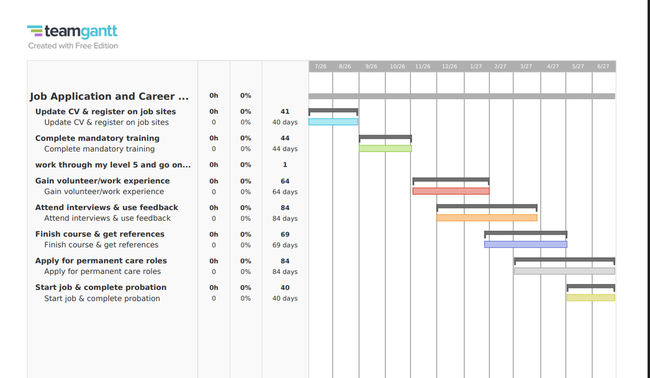

In my gantt chart it describes outlines a structured career development plan spanning from late July to early June. It begins with updating a CV and registering on job sites, followed by completing mandatory training and progressing to Level 5 studies. The schedule then focuses on gaining volunteer or work experience before attending interviews and using feedback to improve performance. After completing the course and obtaining references, the plan moves to applying for permanent care roles. The final stage involves starting employment and successfully completing probation. Each task is allocated a specific timeframe, showing a logical sequence of activities and clear milestones toward achieving long-term career goals.

Task 7- Making Changes- Report
1. What change we want to make
We want to introduce a regular, person-centred activity programme. Right now, activities are done whenever we have time. The new plan will have clear, planned activities that match what each resident enjoys and can do. This will help residents feel happier, more active, and more connected to others.

2. How we will do it – Using a simple change model
We will follow Lewin’s 3-Step Change Model:
- Unfreeze: Talk to staff, residents and families to explain why this change is needed and listen to their ideas.
- Change: Start the new plan, give training, and make small adjustments as we go.
- Refreeze: Make the new way part of our daily routine so it becomes normal practice.
We also use the ADKAR Model to make sure everyone understands and supports the change.

3. Skills we need
To make this work, staff will need:
- Knowledge of how to support people with different needs, including dementia.
- Good communication skills to talk and listen to residents.
- The ability to plan simple, safe activities.
- Flexibility to change plans if needed.
Training will be provided by the National Activity Providers Association and local health services.

4. Possible problems and how to fix them
- Not enough staff time: We will make activities part of normal care work, not extra tasks. We can also ask volunteers or students to help.
- Limited money: We will use low-cost materials and ask local groups or charities for support.
- People being unsure or worried: We will explain clearly, start with simple activities, and ask residents what they want.
- Keeping it going: We will check progress every month and include it in our regular work reviews.

5. Conclusion
This change will improve life for residents and help us meet care standards. By planning carefully and solving problems early, it will become a lasting improvement.
Reference List

Chartered Institute of Personnel and Development (CIPD) (2023) Continuing Professional Development (CPD). Available at: https://www.cipd.org/uk/knowledge/guides/continuing-professional-development/ (Accessed: 30 June 2026).
National Careers Service (2024) Skills assessment. Available at: https://nationalcareers.service.gov.uk/skills-assessment (Accessed: 30 June 2026).
Bronfenbrenner, U. (1979) The Ecology of Human Development. Cambridge, MA: Harvard University Press.
Taylor, S.E. (2011) Social Support: A Review. In: Friedman, H.S. (ed.) The Oxford Handbook of Health Psychology. New York: Oxford University Press.

Skills for Care (2025). The state of the adult social care sector and workforce in England 2024/25. Leeds: Skills for Care.
The King’s Fund (2025). Workforce challenges in health and social care. London: The King’s Fund.
Department of Health and Social Care (DHSC) (2024). Care workforce strategy: delivering for people who work in adult social care. London: HMSO.
UNISON (2025). Under pressure: staffing levels and quality of care in social care. London: UNISON.
NHS England (2025). NHS workforce statistics – June 2025. London: NHS England.
Thomas Pocklington Trust. (2015). Models of Change for Care Homes.
Prosci. (2021). ADKAR: A Model for Change in Health and Care.
NHS England. (2018). The Change Model Guide

