

Name: Shamaila Sakhawat
Student ID: 2309140
Lecture: Chloe Harries
Module: Independent Project
Module Code: BMHP6020
Assignment Title: Methods Search Strategy Academic Poster

PHYSIOLOGICAL MECHANISMS AND LONG-TERM HEALTH IMPACTS OF TYPE 2 DIABETES MELLITUS (T2DM) IN OLDER ADULTS LIVING IN BIRMINGHAM
- Introduction And Research Aim
A search strategy is a structured and systematic process used to find relevant literature through predefined keywords, databases, and selection criteria (Sánchez-Meca, 2010). For this dissertation, academic databases including PubMed, CINAHL, ScienceDirect, Google Scholar, and the UWTSD Online Library were searched to ensure comprehensive coverage of evidence relating to Type 2 Diabetes Mellitus (T2DM), physiological mechanisms, and long-term health outcomes in older adults. Key words and Boolean operators were applied to refine search results and improve the relevance, transparency, and reproducibility of the literature review process.

2 Search Strategy
A structured search strategy was used to identify relevant evidence on T2DM in older adults. Multiple databases, keywords, Boolean operators, and quality filters were applied to ensure the inclusion of current, peer-reviewed research. This strengthened the reliability and validity of the evidence, although publication bias and the exclusion of grey literature remain limitations (Heath, Leavy and Tuvey, 2021).
1

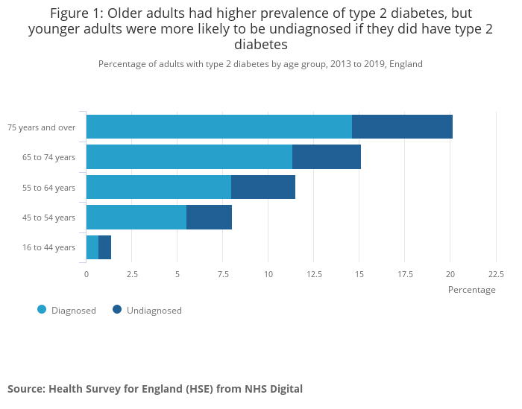
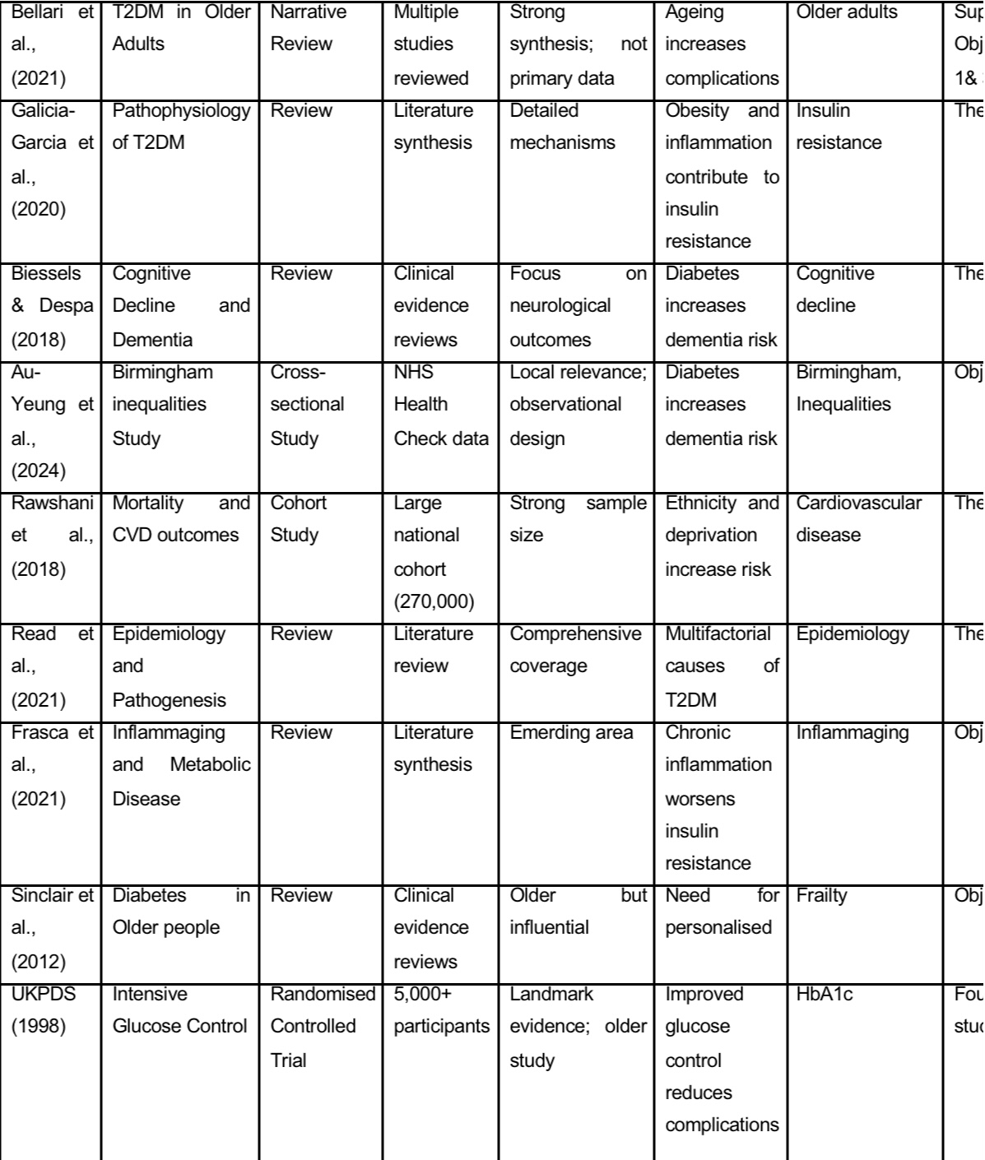
Type 2 Diabetes Mellitus significantly affects older adults in Birmingham. Age-related insulin resistance, beta-cell dysfunction, and chronic inflammation contribute to disease progression and complications, while socioeconomic and ethnic inequalities influence outcomes. These findings highlight the need for targeted, integrated care to improve diabetes management and reduce health inequalities.

3.Conclusion
4.Searching For Information
A step-by-step search process was implemented to identify key concepts, generate relevant keywords, apply filters, and screen articles according to the inclusion and exclusion criteria. Searches were conducted across multiple academic databases to ensure comprehensive coverage of biomedical, public health, and epidemiological evidence related to Type 2 Diabetes Mellitus (T2DM). Titles and abstracts were initially reviewed, followed by full-text assessment where relevance was identified. This structured approach ensured that only high-quality, peer-reviewed studies were included and helped minimise selection bias. However, limitations included the exclusion of non-English publications and grey literature, which may have restricted the breadth of available evidence (Page et al., 2021).

5.Research Validity on and Analysis

/

6. Inclusion Criteria
Sources were excluded if they:
- Focused solely on Type 1 Diabetes.
- Included children or younger populations only.
- Were non-peer-reviewed or opinion-based sources.
- We are not available in English.
- Lacked full-text access.
- We are not relevant to the research aims.
- Were published before 2014, unless considered seminal literature.

To ensure quality and relevance, sources were included if they met the following criteria.
- Published between 2014–2024.
- Peer-reviewed journal articles.
- Studies focused on Type 2 Diabetes Mellitus (T2DM).
- Research involving older adults (60+ years).
- UK-based studies or comparable Western populations.
- Full-text articles available.
- Evidence relating to physiological mechanisms or long-term complications of T2DM.

7. Exclusion Criteria
4.Searching For Information
Validation in this secondary research involved assessing the credibility, reliability and relevance of sources using the CRAAP framework (Currency, Relevance, Authority, Accuracy and Purpose) (Wickham, 2020). Peer-reviewed articles and official reports published within the last ten years were included, while irrelevant or low-quality sources were excluded. Thematic analysis, guided by Braun and Clarke (2006), involved coding the literature and grouping codes into the themes of insulin resistance, beta-cell dysfunction, long-term complications, and health inequalities. This strengthened the trustworthiness of the findings, although limitations include publication bias and variations in study quality (Kiger and Varpio, 2020).

2. Search Strategy

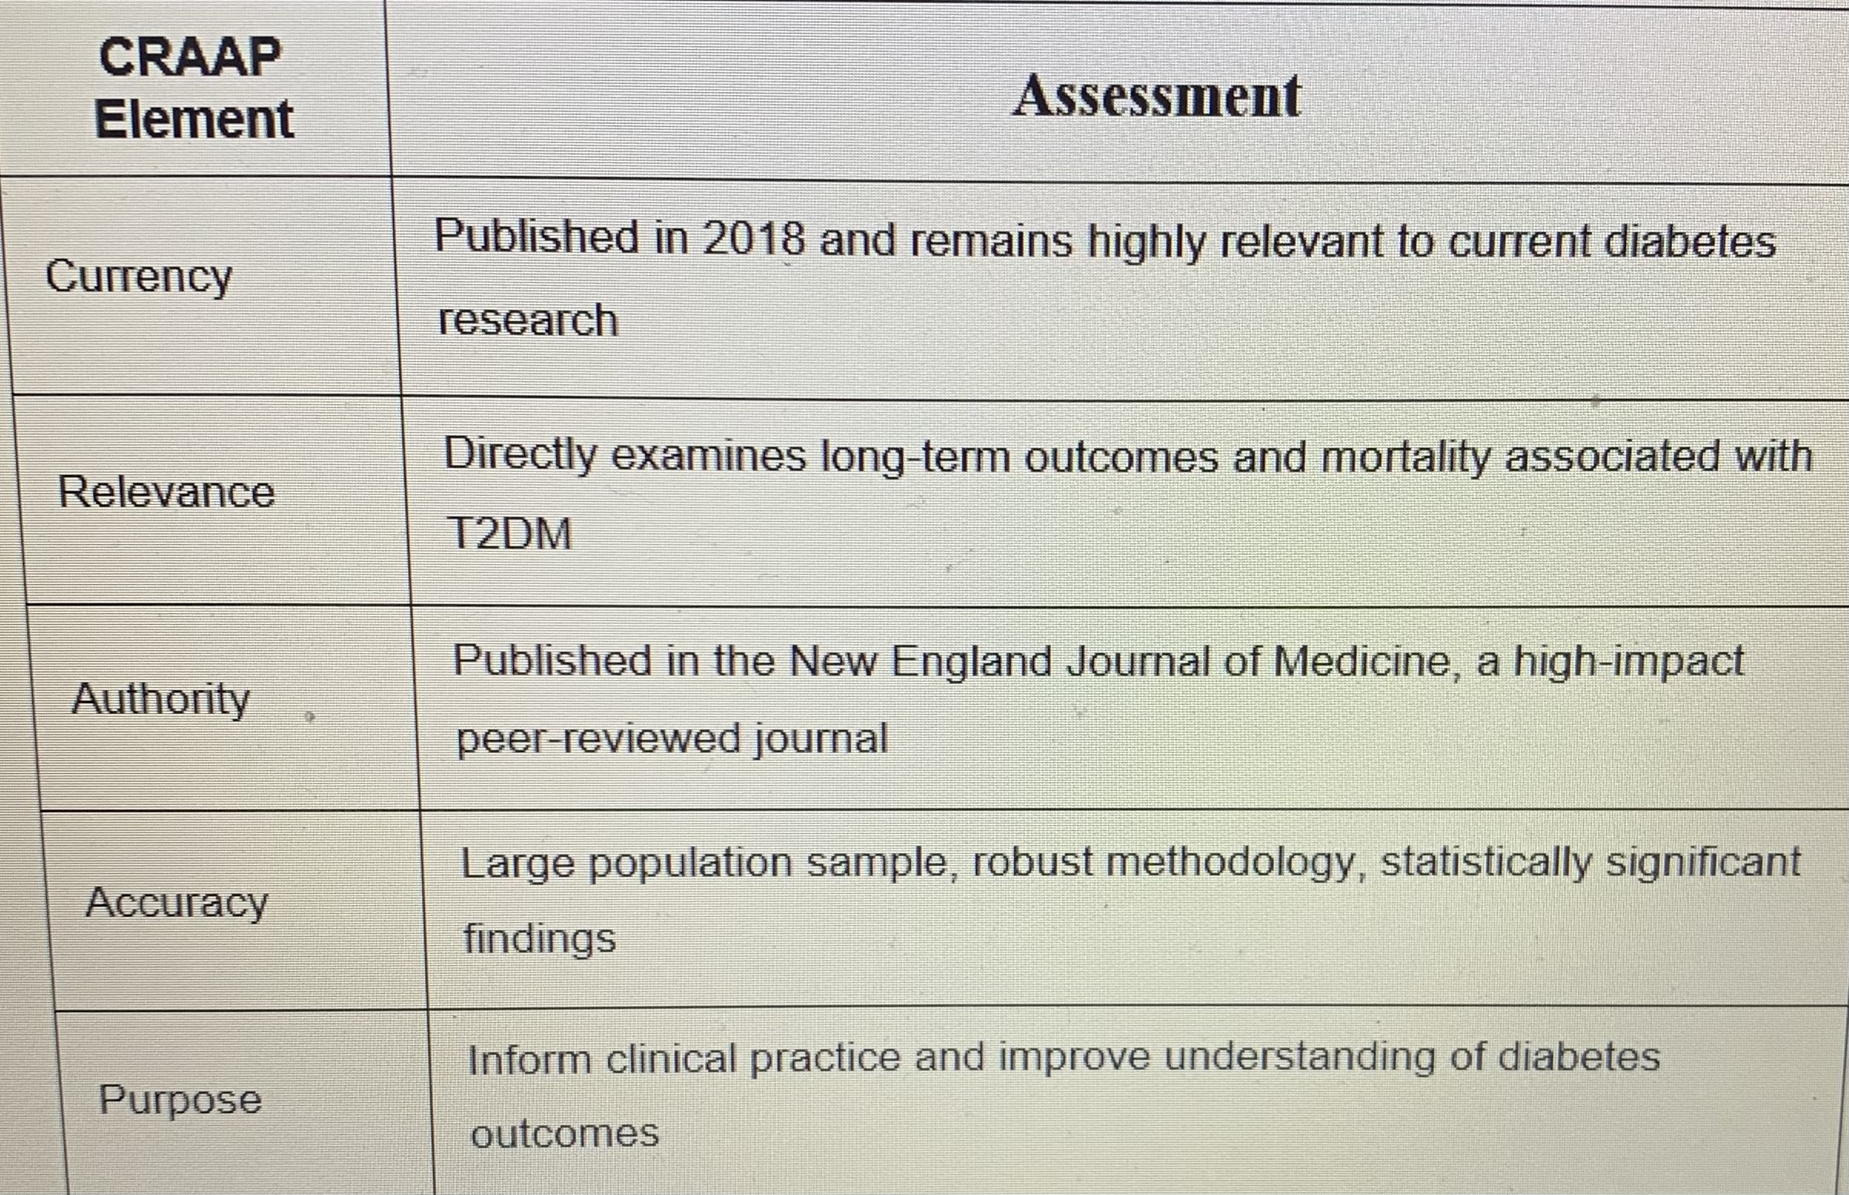
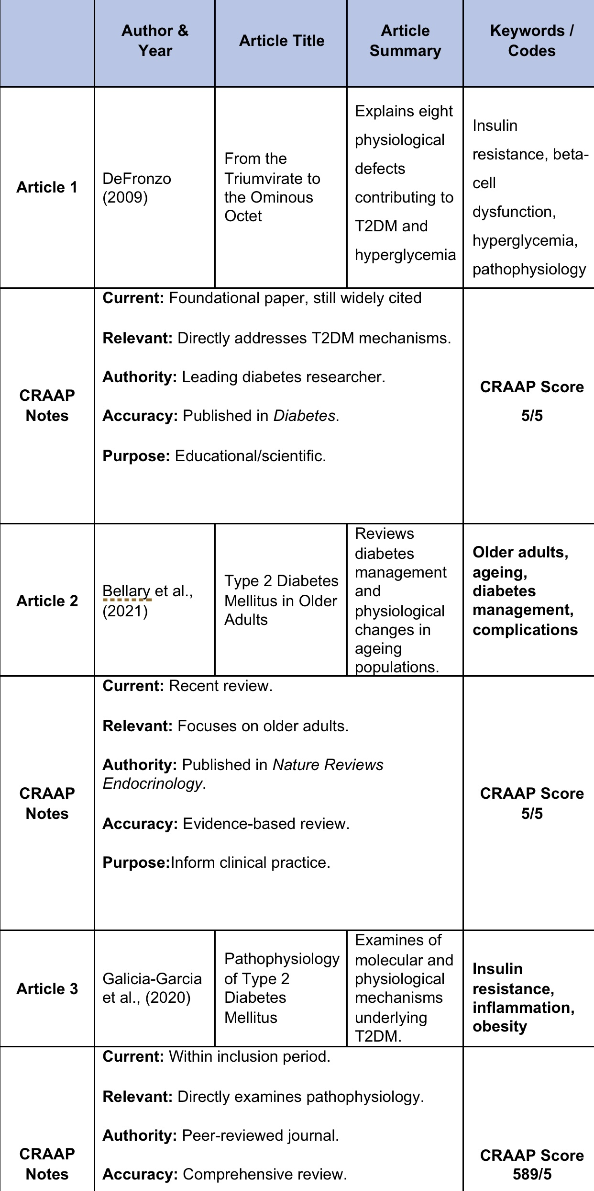
CRAAP GUIDANCE
Source Tracking Table
This study used secondary research and therefore involved no direct participant involvement or primary data collection. Ethical standards were supported through the use of credible, peer-reviewed sources, accurate Harvard referencing, and adherence to academic integrity principles. All information was reported objectively to minimise bias and ensure the reliability of findings. Compliance with university guidelines and research ethics principles helped maintain the validity and trustworthiness of the study (Snyder, 2019).

8.Ethical Considerations
References
Braun, V., and Clarke, V. (2006) ‘Using thematic analysis in psychology’, Qualitative Research in Psychology, 3(2), pp. 77–101. Available at: https://reorg/10.1191/1478088706qp063oa.
Chatterjee, S., Khunti, K. and Davies, M.J. (2017) ‘Type 2 diabetes’, The Lancet, 389(10085), pp. Available at: https://.org/10.1016/S0140-6736(17)30058-2.
DeFronzo, R.A., Ferrannini, E., Groop, L., Henry, R.R., Herman, W.H., Holst, J.J. et al. (2015) ‘Type 2 diabetes mellitus’, Nature Reviews Disease Primers, 1, 15019. Available at: https.
Diabetes UK (2023) Diabetes prevalence 2023: Key statistics on diabetes. Available at: https://www.diabetes.org.uk (Accessed: 18 July 2026).
Heath, G., Leavy, P. and Tuvey, S. (2021) Research methods for health and social care. London: Sage.
International Diabetes Federation (2021) IDF Diabetes Atlas. 10th edn. Brussels: International Diabetes Federation.
Kiger, M.E. and Varpio, L. (2020) ‘Thematic analysis of qualitative data: AMEE Guide No. 131’, Medical Teacher, 42(8), pp. 846–854. Available at: https://org/10.1080/0142159X.2020.1755030.
Merriam Library (2023) CRAAP Test: Evaluating information. Available at: https://library.csuchico.edu/craap (Accessed: 18 July 2026).
Page, M.J., McKenzie, J.E., Bossuyt, P.M., Boutron, I., Hoffmann, T.C., Mulrow, C.D. et al. (2021) ‘The PRISMA 2020 statement: an updated guideline for reporting systematic reviews’, BMJ, 372, n71. Available at: https://org/10.1136/bmj.n71.
Rawshani, A., Rawshani, A., Franzén, S., Eliasson, B., Svensson, A.-M., Miftaraj, M. et al. (2018) ‘Risk factors, mortality and cardiovascular outcomes in patients with type 2 diabetes’, New England Journal of Medicine, 379(7), pp. 633–644. Available at: https://org/10.1056/NEJMoa1800256.
Sánchez-Meca, J. (2010) ‘A review of recent research on assessment of publication bias’, British Journal of Mathematical and Statistical Psychology, 63(2), pp. 235–246. Available at: https://org/10.1348/000711010X502995.
Snyder, H. (2019) ‘Literature review as a research methodology: An overview and guidelines’, Journal of Business Research, 104, pp. 333–339. Available at: https://org/10.1016/j.jbusres.2019.07.039.
Zheng, Y., Ley, S.H. and Hu, F.B. (2018) ‘Global aetiology and epidemiology of type 2 diabetes mellitus and its complications’, Nature Reviews Endocrinology, 14(2), pp. 88–98. Available at: https://org/10.1038/nrendo.2017.151.

