Tensile Test

ACHA4002 Engineering Science

Finlay Kingscott
Motorsport Engineering
December 8th, 2024
Word count: 1,497



Contents

1. Introduction 3

2. Experimental Procedure 4

2.1 The Tensile Tester 5

3. Results

3.1 Steel & Aluminium

3.2 Duralumin & Polyvinyl Chloride

4. Analysis

4.1 Steel

4.2 Aluminium

4.2 Duralumin

4.4 Polyvinyl Chloride

5. Conclusion

6. Evaluation

7. Further Work

8. Bibliography

Introduction

A tensile test is a form of destructive testing used to find the stress and strain values of a certain material by applying a progressively increasing load against it, usually until failure. This report will cover a tensile test performed on four materials in a university classroom and give an analysis to each of their properties based on results carried out. There will also be an evaluation of the test, weighing up its credibility and looking at similar experiments performed by external parties as a way of comparing data. Finishing off this report will be a short section looking at how the experiment could have been conducted with fewer limiting parameters.
Experimental Procedure

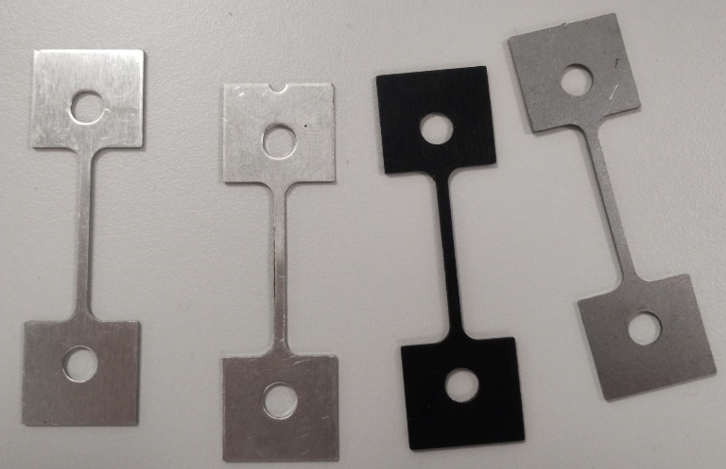
To test a material, it needs to be a certain shape to fit in the tester and produce results without the need for massive amounts of force. Figure 1 shows each specimen, with the thin section measuring approximately 1mm by 2mm and 31mm long – measured using a vernier calliper. This thin section allows for the material to shear under low load, making it a much safer experiment to conduct in a classroom.

Each specimen is secured in the tensile tester at either end in the chucks before zeroing the dial indicator. During the initial stages of each test, the increase in rotations of the top chuck is very minimal as the materials may not have reached their yield point yet. It is important that the top nut is rotated slowly and with a consistent amount of force as to not create weak points in the material that may skew the results away from the true values of the material.
Figure 1: Material Specimens. From top to bottom: Duralumin, Aluminium, PVC & Mild Steel

After all the results have been collected, the force can be calculated by multiplying the values indicated on the dial by one hundred. Stress is calculated by dividing the force at each measured interval by the cross-sectional area of the specimen. Strain is the extension at a given time divided by the original length. Strain does not have units as it is a ratio between two lengths but is represented by the symbol ‘ε’.

Regarding health and safety, there are no real risks associated with this practical. The only thing that may be an issue it any material shrapnel flying outwards when a material shears. The plastic guard is designed to slot over the front and sides of the tester to contain everything.
The Tensile Tester

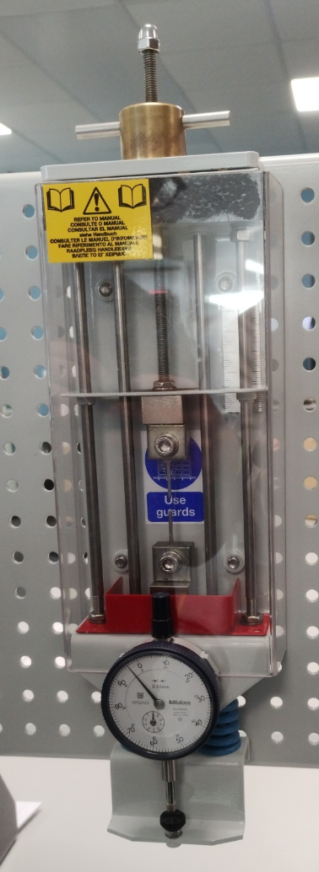
The dial shows the amount of deformation achieved by the specimen by measuring the deflection of the springs. The outer bezel is used to zero the dial before each test. Reading need to be taken quickly after each increase in the amount of force applied as the material may slightly shrink back, especially when still within the elastic region of its deformation range.
The load nut at the top has a very tight thread pitch which allows for the small increases in the amount of force able to be applied. One whole revolution of the nut equates to the top chuck moving 1mm. There are indicators on the top plate around the load nut signifying 0.1mm between each notch.
The specimen is secured at either end in a chuck. It is important that the bolts on each chuck are tightened to ensure the specimen cannot slip, skewing the results.
Figure 2: The Tensile Tester
There is a removeable safety guard made of a clear plastic that must be attached to the tester before each test to ensure that when the specimen shears, all material is contained within the tester.
Results

STEEL ALUMINIUM
Load nut movement (mm) | Dial indicator (mm) | Extension (mm)
0 | 0 | 0
0.2 | 0.17 | 0.03
0.4 | 0.36 | 0.04
0.6 | 0.55 | 0.05
0.8 | 0.74 | 0.06
1 | 0.93 | 0.07
1.2 | 1.11 | 0.09
1.4 | 1.3 | 0.1
1.6 | 1.49 | 0.11
1.8 | 1.67 | 0.13
2 | 1.85 | 0.15
2.2 | 2.03 | 0.17
2.4 | 2.22 | 0.18
2.6 | 2.4 | 0.2
2.8 | 2.57 | 0.23
3 | 2.73 | 0.27
3.2 | 2.9 | 0.3
3.4 | 3.05 | 0.35
3.6 | 3.28 | 0.32
3.8 | 3.29 | 0.51
4 | 3.42 | 0.58
4.2 | 3.54 | 0.66
4.4 | 3.67 | 0.73
4.6 | 3.78 | 0.82
4.8 | 3.88 | 0.92
5 | 3.99 | 1.01
6 | 4.48 | 1.52
7 | 4.8 | 2.2
8 | 5.04 | 2.96
9 | 5.2 | 3.8
10 | 5.28 | 4.72
Load movement (mm) | Dial indicator (mm) | Extension (mm)
0 | 0 | 0
0.2 | 0.07 | 0.13
0.4 | 0.24 | 0.16
0.6 | 0.42 | 0.18
0.8 | 0.61 | 0.19
1 | 0.79 | 0.21
1.2 | 0.96 | 0.24
1.4 | 1.15 | 0.25
1.6 | 1.32 | 0.28
1.8 | 1.5 | 0.3
2 | 1.66 | 0.34
2.2 | 1.78 | 0.42
2.4 | 1.89 | 0.51
2.6 | 2.02 | 0.58
2.8 | 2.13 | 0.67
3 | 2.27 | 0.73
3.2 | 2.33 | 0.87
3.4 | 2.44 | 0.96
3.6 | 2.49 | 1.11
3.8 | 2.59 | 1.21
4 | 2.62 | 1.38
4.2 | 2.71 | 1.49
4.4 | 2.74 | 1.66
4.6 | 2.76 | 1.84
4.8 | 2.79 | 2.01
5 | 2.82 | 2.18

Load movement (mm) | Dial indicator (mm) | Extension (mm)
0 | 0 | 0
0.2 | 0.05 | 0.15
0.4 | 0.11 | 0.29
0.6 | 0.16 | 0.44
0.8 | 0.19 | 0.61
1 | 0.21 | 0.79
1.2 | 0.06 | 1.14
1.4 | 0.09 | 1.31
1.6 | 0.1 | 1.5
1.8 | 0.09 | 1.71
2 | 0.09 | 1.91
2.2 | 0.09 | 2.11
2.4 | 0.09 | 2.31
2.6 | 0.09 | 2.51
2.8 | 0.09 | 2.71
3 | 0.1 | 2.9
3.2 | 0.1 | 3.1
3.4 | 0.1 | 3.3
3.6 | 0.1 | 3.5
3.8 | 0.09 | 3.71
4 | 0.09 | 3.91
4.2 | 0.09 | 4.11
4.4 | 0.1 | 4.3
4.6 | 0.09 | 4.51
4.8 | 0.08 | 4.72
5 | 0.09 | 4.91
6 | 0.09 | 5.91
7 | 0.08 | 6.92
8 | 0.03 | 7.97
9 | 0.05 | 8.95
10 | 0.08 | 9.92
20 | 0.04 | 19.96
30 | 0.05 | 29.95
40 | 0.05 | 39.95
DURALAMIN POLYVINYL CHLORIDE
Load movement (mm) | Dial indicator (mm) | Extension (mm)
0 | 0 | 0
0.2 | 0.13 | 0.07
0.4 | 0.29 | 0.11
0.6 | 0.46 | 0.14
0.8 | 0.64 | 0.16
1 | 0.81 | 0.19
1.2 | 0.98 | 0.22
1.4 | 1.16 | 0.24
1.6 | 1.34 | 0.26
1.8 | 1.52 | 0.28
2 | 1.69 | 0.31
2.2 | 1.87 | 0.33
2.4 | 2.05 | 0.35
2.6 | 2.24 | 0.36
2.8 | 2.41 | 0.39
3 | 2.59 | 0.41
3.2 | 2.77 | 0.43
3.4 | 2.94 | 0.46
3.6 | 3.12 | 0.48
3.8 | 3.3 | 0.5
4 | 3.48 | 0.52
4.2 | 3.65 | 0.55
4.4 | 3.83 | 0.57
4.6 | 4.01 | 0.59
4.8 | 4.18 | 0.62
5 | 4.35 | 0.65
6 | 5.02 | 0.98
7 | 5.37 | 1.63

Analysis
STEEL
Load nut movement (mm) | Force (N) | Stress (MN/m^2) | nominal strain (με)
0 | 0 | 0 | 0
0.2 | 17 | 9.351 | 967.742
0.4 | 36 | 19.802 | 1290.323
0.6 | 55 | 30.253 | 1612.903
0.8 | 74 | 40.704 | 1935.548
1 | 93 | 51.155 | 2258.065
1.2 | 111 | 61.056 | 2903.226
1.4 | 130 | 71.507 | 3225.806
1.6 | 149 | 81.958 | 3548.387
1.8 | 167 | 91.859 | 4193.548
2 | 185 | 101.760 | 4838.710
2.2 | 203 | 111.661 | 5483.871
2.4 | 222 | 122.112 | 5806.452
2.6 | 240 | 132.013 | 6451.613
2.8 | 257 | 141.364 | 7419.355
3 | 273 | 150.165 | 8709.677
3.2 | 290 | 159.516 | 9677.419
3.4 | 305 | 167.767 | 11290.323
3.6 | 328 | 180.418 | 10322.581
3.8 | 329 | 180.968 | 16451.313
4 | 342 | 188.119 | 18709.677
4.2 | 354 | 194.719 | 21290.323
4.4 | 367 | 201.870 | 23548.387
4.6 | 378 | 207.920 | 36451.613
4.8 | 388 | 213.421 | 29677.419
5 | 399 | 219.4712 | 32580.645
6 | 448 | 246.425 | 49032.258
7 | 480 | 264.026 | 70967.710
8 | 504 | 277.228 | 95483.871
9 | 520 | 286.029 | 112580.645
10 | 528 | 290.429 | 152258.065
As steel is iron based, meaning it is a ferrous metal, it appears to have an elongated yield point. This is due to something known as Lüders’ bands – small, localised areas of plastic deformation due to the material being a not entirely metallic alloy (Mason, 2002) – which cause the material to not stretch uniformly.

The yield point is reached at around 328N of force.

The plastic region of the graph has a very smooth and gradual curve, indicating that the steel used did not have any imperfections or defects created during manufacturing such as oxide scaling and quench cracking. However, most defects are merely cosmetic and shouldn’t have any significant effects on the materials performance (Regan Industrial, 2020).
ALUMINIUM
Load movement (mm) | Force (N) | Stress (MN/m^2) | Nominal strain (με)
0 | 0 | 0 | 0
0.2 | 7 | 12.768 | 4193.548
0.4 | 24 | 43.776 | 5161.290
0.6 | 42 | 76.608 | 5806.452
0.8 | 61 | 111.264 | 6129.032
1 | 79 | 144.096 | 6774.194
1.2 | 96 | 175.104 | 7741.935
1.4 | 115 | 209.760 | 8064.516
1.6 | 132 | 240.768 | 9032.258
1.8 | 150 | 273.600 | 9677.419
2 | 166 | 302.784 | 10967.742
2.2 | 178 | 324.672 | 13548.387
2.4 | 189 | 344.736 | 16451.613
2.6 | 202 | 368.448 | 18709.677
2.8 | 213 | 388.512 | 21612.903
3 | 227 | 414.048 | 23548.387
3.2 | 233 | 424.992 | 28064.516
3.4 | 244 | 445.056 | 30967.742
3.6 | 249 | 454.176 | 35806.452
3.8 | 259 | 472.416 | 39032.258
4 | 262 | 477.888 | 44516.129
4.2 | 271 | 494.304 | 48064.516
4.4 | 274 | 499.776 | 53548.387
4.6 | 276 | 503.424 | 59354.839
4.8 | 279 | 508.896 | 64838.710
5 | 282 | 514.368 | 70322.581
Aluminium was the first material to break but achieved by far the highest stress values but compared to steel, not particularly high strain values. This is most likely due to it being very lightweight for a metal but still maintain a very high strength to weight ratio.

The yield point where the plastic region begins is a more definitive point than in steel, being at around 166N of force applied to the specimen. This is by far the lowest of the three metals.
DURALUMIN
Being an aluminium alloy, duralumin has a similar shape of graph to aluminium. However, due to it not being a pure metal, its values are drastically different, having only around have the stress and slightly less strain. This is most likely caused by the inclusion of copper and magnesium which have very low stress tolerances for metals.

With its yield point at around 241N, it sits at a good middle ground between steel and aluminium.
Load movement (mm) | Force (N) | Stress (MN/m^2) | Nominal strain (με)
0 | 0 | 0 | 0
0.2 | 13 | 8.420 | 2258.065
0.4 | 29 | 18.782 | 3548.387
0.6 | 46 | 29.793 | 4516.129
0.8 | 64 | 41.451 | 5161.290
1 | 81 | 52.461 | 6129.032
1.2 | 98 | 63.472 | 7096.774
1.4 | 116 | 75.130 | 7741.935
1.6 | 134 | 86.788 | 8387.097
1.8 | 152 | 98.446 | 9032.258
2 | 169 | 109.456 | 10000
2.2 | 187 | 121.114 | 10645.161
2.4 | 205 | 132.772 | 11290.323
2.6 | 224 | 145.078 | 11612.903
2.8 | 241 | 156.088 | 12580.645
3 | 259 | 167.746 | 13225.806
3.2 | 277 | 179.404 | 13870.968
3.4 | 294 | 190.415 | 14838.710
3.6 | 312 | 202.073 | 15483.871
3.8 | 330 | 213.731 | 16129.032
4 | 348 | 225.389 | 16774.194
4.2 | 365 | 236.399 | 17741.935
4.4 | 383 | 248.057 | 18387.097
4.6 | 401 | 259.715 | 19032.258
4.8 | 418 | 270.725 | 20000
5 | 435 | 281.736 | 20967.742
6 | 502 | 325.130 | 31612.903
7 | 537 | 347.7978 | 52580.645

PVC
PVC, like all plastics has a very short and steep elastic region, reaching its yield point very quickly but having an extremely long plastic region. This makes sense as PVC is a thermoplastic, and with plastic in the name, this makes a lot of sense. However, as the graph demonstrates, the results obtained during the practical may not be the most accurate.

Despite having the load chuck pull the top of the specimen 40mm before shearing, the measured extension and subsequent calculated force is incredibly low.
Load movement (mm) | Force (N) | Stress (MN/m^2) | Nominal strain (με)
0 | 0 | 0 | 0
0.2 | 5 | 2.551 | 4807.692
0.4 | 11 | 5.612 | 9294.872
0.6 | 16 | 8.162 | 14102.564
0.8 | 19 | 9.693 | 19551.282
1 | 21 | 10.713 | 25320.513
1.2 | 6 | 3.061 | 36538.462
1.4 | 9 | 4.591 | 41987.179
1.6 | 10 | 5.102 | 48076.923
1.8 | 9 | 4.591 | 54807.692
2 | 9 | 4.591 | 61217.949
2.2 | 9 | 4.591 | 67628.205
2.4 | 9 | 4.591 | 74038.462
2.6 | 9 | 4.591 | 80448.718
2.8 | 9 | 4.591 | 86858.974
3 | 10 | 5.102 | 92948.718
3.2 | 10 | 5.102 | 99358.974
3.4 | 10 | 5.102 | 105769.231
3.6 | 10 | 5.102 | 112179.487
3.8 | 9 | 4.591 | 118910.256
4 | 9 | 4.591 | 125320.513
4.2 | 9 | 4.591 | 131730.769
4.4 | 10 | 5.102 | 137820.513
4.6 | 9 | 4.591 | 144551.2821
4.8 | 8 | 4.081 | 151282.051
5 | 9 | 4.591 | 157371.795
6 | 9 | 4.591 | 189423.077
7 | 8 | 4.081 | 221794.872
8 | 3 | 1.530 | 255448.718
9 | 5 | 2.550 | 286858.974
10 | 8 | 4.081 | 317948.718
20 | 4 | 2.041 | 639743.590
30 | 5 | 2.551 | 959935.897
40 | 5 | 2.551 | 1280448.718

Conclusion

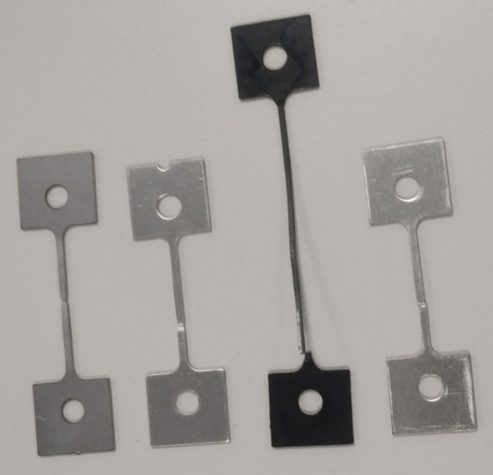
There is very clearly an outlier amongst the four materials tested - PVC. However, this makes a lot of sense considering the property similarities between steel, aluminium and duralumin, chief among which is the fact that they are all metals.
Figure 3: Specimens after testing.

Figure 3 shows the amount of elongation achieved by each material after testing. PVC by far had the highest percentage of elongation at 123% and duralumin had the lowest, coming in at only 8%. Steel and aluminium had 26% and 9.5% elongation respectively.

None of the graphs produced are wildly different from what should be expected of the materials. However, there are a few irregularities – particularly with the aluminium and PVC specimens. For any given thermoplastic, the plastic region of its stress/strain chart should be relatively flat whereas in the graph produced form the data collected it is rather sporadic but does even out towards the failure point.

The ultimate tensile strength (UTS) of mild steel should be around 400MPa (Le, 2024) which is a considerably higher value than what was extrapolated from the data obtained.
UTS of aluminium is normally around 500MPa (AMS, 2001) for pure aluminium but can differ quite a lot for its different alloys, with duralumin being anywhere between 420-500MPa depending on composition (casted duralumin can reach up to 620MPa) (Chintalapati et al, 2017). These figures, particularly the aluminium values found closely resemble values achieved during the conducted experiment.
The value for UTS for PVC can vary depending on type and temperature. Averaging out to around 16MPa (Vinidex Pty LTD, 2024), the calculated values from this experiment are not too dissimilar.

Evaluation
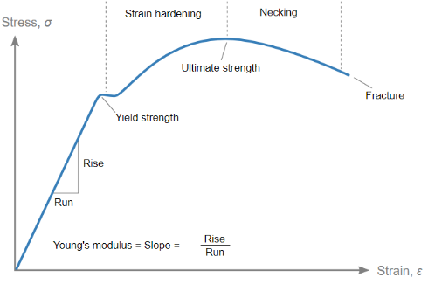
Typically, in metals being stretched, they will reach their UTS before the curve falls slightly and the specimen breaks. However, in all tests conducted on metals in this experiment, breakages occur either before or at their respective UTS values. This is most likely due to human error in taking readings, but could also be down to temperature fluctuations or cold flow/creep – gradual deformation due to constant mechanical stress (www.sciencedirect.com, n.d.).
Figure 4: An ideal example of a stress/strain graph for metals (Nicguaro, 2020)

Further Work

This experiment was conducted in a university lab room so there are most likely a lot of external factors at play such as minor temperature differences which may affect the materials (particularly PVC) and cause the reading to become inaccurate; to combat temperature having any influence on the experiment, it should ideally be conducted in a vacuum. Furthermore, only one run of each material was conducted which is not good for getting accurate results as it would be much better to repeat the experiment multiple times (at least three times) and take an average whilst accounting for any anomalies or irregularities in the results; something that cannot be done with such a limited data set.

Taking readings off the indicator dial is not the most accurate way of acquiring data as there is no way of accounting for any parallax error or mechanical issues within the dial and how it reads off the springs. Having a digital indicator would be a much more reliable way of taking readings due to the lack of human error. It is also beneficial as the needle is constantly moving, making it somewhat difficult to take readings quickly so by having a digital system able to detect when the values may be fluctuating slightly with each increase of force would also improve accuracy and credibility of the test.

Bibliography

Information & data
ASM (2001). ASM Material Data Sheet. [online] asm.matweb.com. Available at: https://asm.matweb.com/search/SpecificMaterial.asp?bassnum=MA7075T6.

Chintalapudi, B., Chaithanya, B., Gonuguntla, M., Pothuri, J., Kant, S., Pathan, A. and Kumar Pittala, R. (2017). Article ID: IJMET_08_05_046 Arief Pathan and Raj Kumar Pittala, Investigation of Mechanical Properties of Duralumin Sandwich Hybrid Composite Using E-Glass Fiber. International Journal of Mechanical Engineering and Technology (IJMET), [online] 8(5), pp.425–431. Available at: https://iaeme.com/MasterAdmin/Journal_uploads/IJMET/VOLUME_8_ISSUE_5/IJMET_08_05_046.pdf.

Encyclopaedia Britannica, Inc. (2019). “Duralumin”, Encyclopaedia Britannica. Available at: https://www.britannica.com/technology/duralumin

Le, N. (2024). All about tensile strength of mild steel that you need to know. [online] MRS STEEL. Available at: https://mrssteel.com.vn/blogs/steel-blog/tensile-strength-of-mild-steel.

Mason, W. (2002). The Lüders’ Lines on Mild Steel. Proceedings of the Physical Society of London. Doi: https://doi.org/10.1088/1478-7814/23/1/331

Regan Industrial. (2020). 5 Defects in Steel Products. [online] Regan Industrial. Available at: https://reganindustrial.com/blog/defects-steel-products/

www.sciencedirect.com. (n.d.). Creep - an overview | ScienceDirect Topics. [online] Available at: https://www.sciencedirect.com/topics/physics-and-astronomy/creep.

Vinidex Pty Ltd. (2024). PVC Properties - Vinidex Pty Ltd. [online] Available at: https://www.vinidex.com.au/resources/technical-resources/material-properties/pvc-properties/# [Accessed 8 Dec. 2024]

Images
Nicoguaro (2020). Español: Diagrama típico de esfuerzo vs. deformación para un material dúctil (p.ej. acero). [online] Wikimedia Commons. Available at: https://commons.wikimedia.org/wiki/File:Stress_strain_ductile.svg.

ResearchGate. (2021). Fig. 2. Stress-strain curve for a typical grade of mild steel. [online] Available at: https://www.researchgate.net/figure/Stress-strain-curve-for-a-typical-grade-of-mild-steel_fig2_347488498.

