

Module Name: International Marketing: Principles and Practices
Module Code: LCMB7026
Selected company: Toyota
Selected country: India and Japan
Word: 5027
Student Name: Hiraben Devshibhai Modhwadiya
Student ID: 2520086

Table of Contents
SECTION 1: INTERNATIONAL MARKETING REPORT 4
1. Introduction 4
1.1 Background of Toyota 4
1.2 Aim of the Report 4
1.3 Overview of Japan and India 5
1.4 Structure of the Report 6
2. Macro-Environmental Comparative Analysis: PESTEL Framework 6
3. Cultural Analysis: Hofstede Framework 16
4. Comparative Analysis of STP Strategy 19
4.1 Segmentation Strategy 19
4.2 Targeting Strategy 20
4.3 Positioning Strategy 22
5. International Marketing Mix (7Ps) Strategy 24
5.1 Standardization vs Adaptation Strategy 24
5.2 Product Strategy 26
5.3 Pricing Strategy 27
5.4 Place Strategy 28
5.5 Promotion Strategy 29
5.6 People strategy 30
5.7 Process strategy 31
5. 8 Physical Evidence 32
5.9 Toyota Market Share Comparison 32
6. Market Entry Strategy: India 33
7. Ethical Considerations in Marketing Mix 36
8. Strategic Recommendations and Conclusion 37
Section 2: Reflective account 38
Reference 42

SECTION 1: INTERNATIONAL MARKETING REPORT

1. Introduction

1.1 Background of Toyota
Toyota is one of the largest multinational automobile companies. It is recognized for its innovations, extensive global supply chain, and quality management systems. Toyota was established in Japan in 1937 and currently operates in more than 170 countries. In 2025, the company sold almost 11.3 million vehicles around the world (Toyota, 2026a).
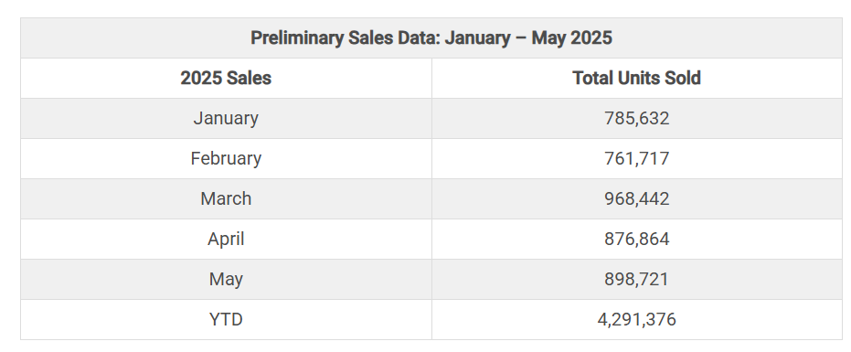
Figure 1: Toyota Car Sales Statistics
(Source: Road Genius, 2026)
The international success of Toyota has been driven by the ability to balance global standardization.

1.2 Aim of the Report
The report aims to critically evaluate Toyota's international marketing strategies in Japan and India. This will be achieved by examining how macro environmental, cultural, and marketing factors influence business operations in both countries.

1.3 Overview of Japan and India
Overview of Japan: Japan is Toyota’s home market and is considered one of the most technologically advanced automotive economies. Japan's GDP reached almost USD 4.28 trillion in 2025 (IMF, 2026). Furthermore, Japan remains a global leader in hybrid vehicle adoption and sustainable automotive manufacturing processes.
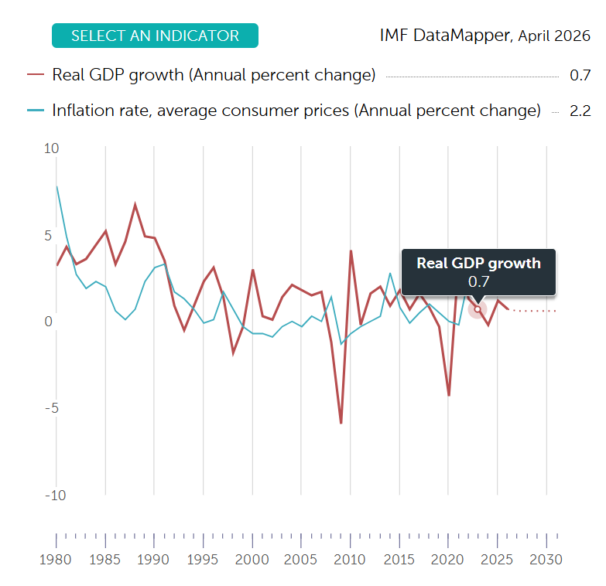
Figure 2: Real GDP growth of Japan
(Source: IMF, 2026)
Overview of India: India shows one of Toyota's most effective host markets due to rapid economic growth. India's GDP growth rate is expected to exceed almost 6% during 2025-2026 (The Economic Times, 2025). This makes it one of the fastest-growing economies globally.

1.4 Structure of the Report
The report consists of two sections to cover international marketing analysis through “PESTEL, Hofstede, STP, 7Ps, market entry strategy models”. The other section will consist of a reflection based on Gibbs’ Reflective Cycle.

2. Macro-Environmental Comparative Analysis: PESTEL Framework
Political factor
These government mandate and political stability are highly significant for green mobility which mainly generate divergent strategic risks.
- Political stability
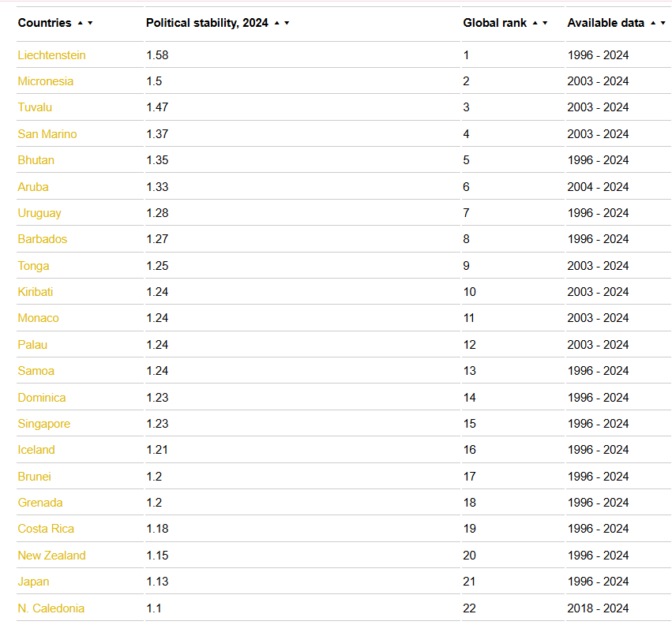
Figure 3: Global rank of Japan in Political stability
(Source: theglobaleconomy, 2025)
The global rank of Japan in political stability is 21, and the rate is 1.13 (The Global Economy, 2025). The governmental policy and political stability in Japan are highly influential on the automobile industry, as they promote hydrogen-powered and hybrid vehicles based on environmental regulations.
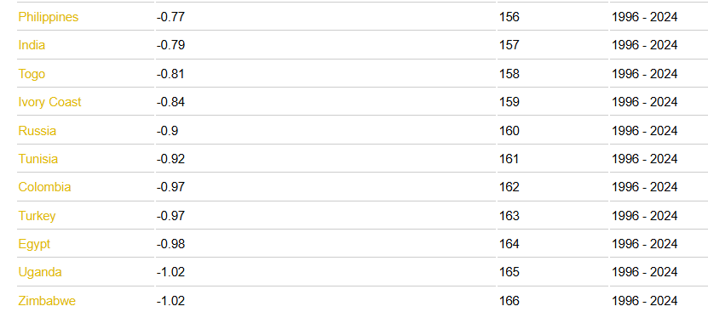
Figure 4: Global rank of India in political stability
(Source: theglobaleconomy, 2025)
The political stability of India in comparison to Japan is lower, as the rank of India is 157, and the rate was -0.77 (The Global Economy, 2025).
- Governmental support for electric or hybrid vehicles
Japan's vehicle fuel efficiency regulations, along with Corporate Average Fuel Economy (CAFE) Standards, are highly significant to promote 100% of electrification of vehicles.
The government has also focused on increasing 20-30% sales of this EV by 2030 (Influencemap, 2026). In the same way, the Indian government, based on the NITI Aayog scheme, promote 30% EV sales target by 2030 (autocarindia, 2026).
Strategic Implecation
The managers of Toyota have adopted pioneer strategy in Japan however in India, it needs to focus on flexible hedge.

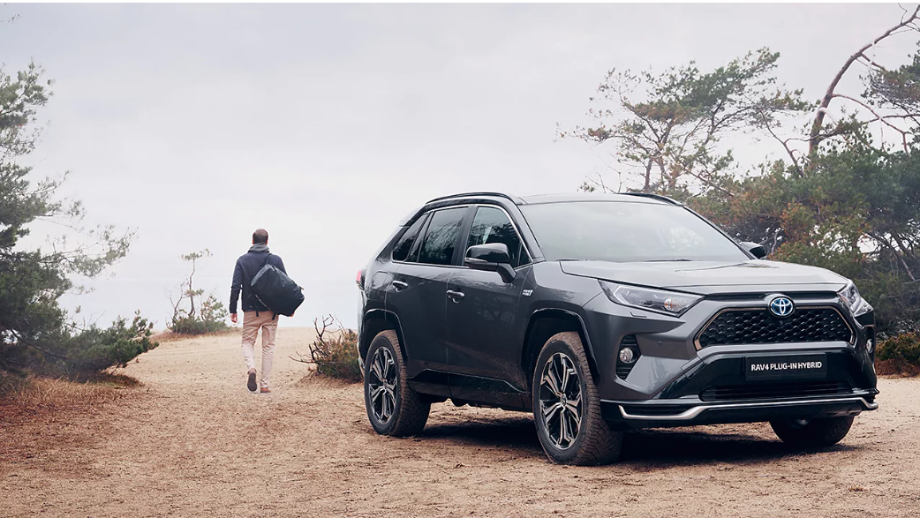
Figure 7: plug-in hybrid vehicles (PHEVs) of Toyota
(Source: Toyota, 2026a)

Economic factor
Ownership model and variability in purchasing are essential for shifting the product sale into the mobility services.
- Contribution of the automobile market to GDP
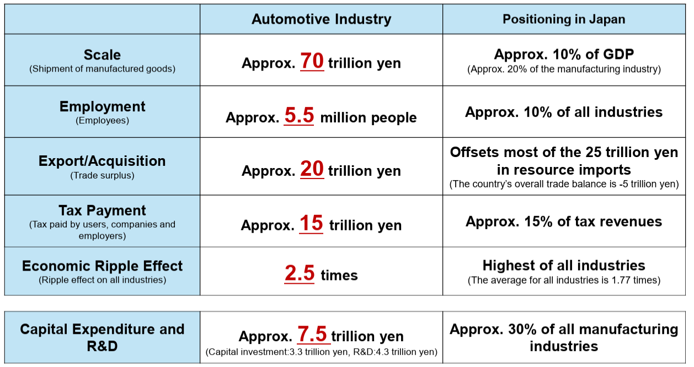
Figure 5: The automobile industry contributes to Japan's GDP
(Source: Toyota, 2025)
As per the above image, the manufacturing scale of Japan’s automobile industry is 70 trillion yen, which contribute 10% on Japan’s GDP. It is also observed that the industry has exported 20 trillion yen in 2025, and from imports, it gains 25 trillion yen (Toyota, 2025).
- Purchasing power of customers
The purchasing power and intention of Japanese customers are stronger, as 44.5% customers focus on an eco-friendly approach (Statista, 2026).
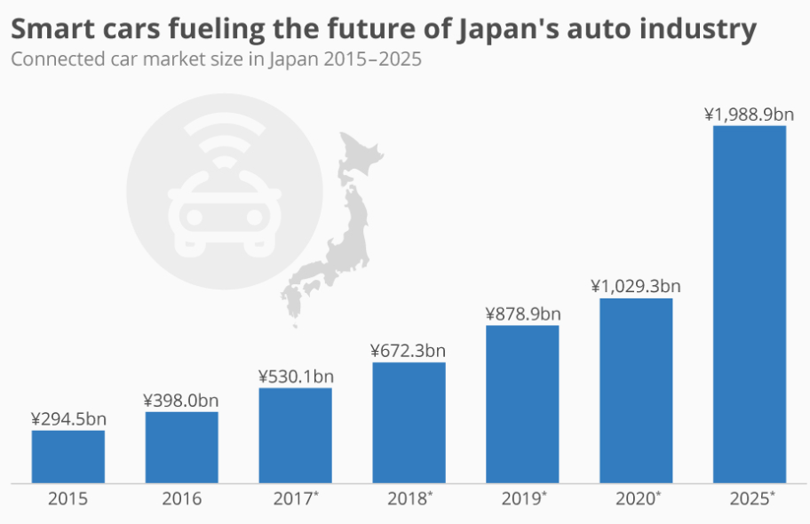
Figure 6: Market of smart car financing in Japan
(Source: Statista, 2025a)
Based on the above image, it is observed that from 2015 to 2025, the customer's expectation for smart cars fully equipped with EV products has increase approx. 700%, which is approximately two trillion Japanese yen (Statista, 2025). In the case of India, from 2024-2025, demand for 6 million units of automobile vehicles has increased among middle-class income people (Niti, 2025).
Strategic Implication
As per the Deloitte report, approx. 69% Indian customers make their vehicle ownership based on a subscription-based model (Deloitte, 2024). The intention rate to purchase a vehicle based on non-ownership was 41% in India and 6% in Japan (Statista, 2025b).
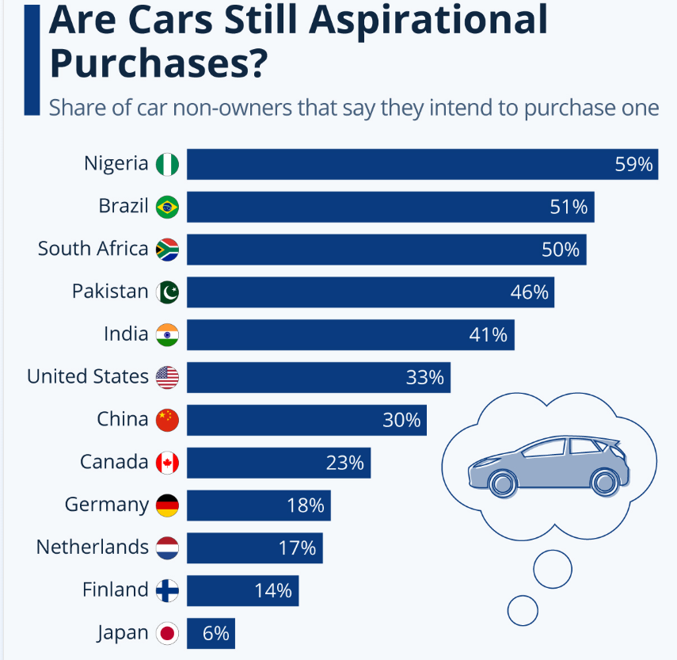
Figure 7: Purchase intention based on non-ownership
(Source: Statista, 2025b)
Social factor
Demographic trend divergent play significant role for the regional product portfolio.
- Employment rate in the automobile industry
The automobile industry in Japan is responsible for 8.2% total workforce in Japan (Statista, 2025c). Approximately 5.5 million people in 2025 were involved with the Japanese automobile industry which indicates industrial demand and high people engagement (Toyota, 2025). On the other hand, the automobile industry in India has offered approximately 30 million jobs (26.5 million indirect and 4.2 million direct) in FY2025 (PIB, 2026).
- Young customers’ engagement with the automobile industry
Young Japanese mainly focus on the omnichannel market as product sales have increased 34% from 2024-2025 (Counterpoint Research, 2025).
The above evidence shows that the purchase rate of Mercedes has increased 145% in 2024, and the sale of super luxury cars over the price of 325,000 has increased 500%, which also increased by 1% (economictimes, 2025).
Strategic Implication
The attitude of Young Japanese has shifted from car ownership to mobility-as-a-service (MaaS) to remain intact with the domestic market. This indicates that young, rich Indian customers' attitudes have changed towards luxury automobile purchase.
Technological factor
The demand of Software-Defined Vehicles (SDV) has been increasing within the competitive landscape to digital ecosystem from hardware.
- Innovation in the automobile industry
The Japanese automobile industry adopted green and digital transformation, which increased the workforce to 5.54 million people (Tus, 2026). It has transformed towards tech-driven mobility, software-defined vehicle (SDV), and carbon-neutral vehicle. The automobile industry in this market has introduced Advanced Driver Assistance Systems (ADAS), which develop road safety and prevent traffic accidents (Trade, 2025).
- Digital automobile ecosystem
The expansion of the automobile ecosystem in India has been transformed towards operational management and customer interaction for both India and Japan.
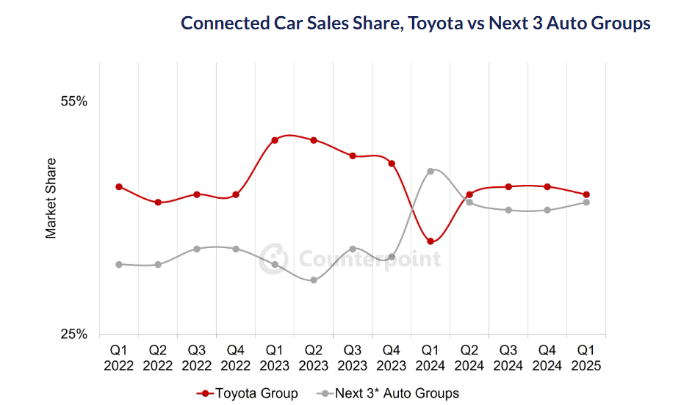
Figure 8: Digital push to increase car sales
(Source: Counterpoint Research, 2025)
The above image shows that the car sales have increased for the Toyota Group by 43% in 2025 in comparison to Counterpoint Research (2025). On the other hand, Indian customers have engaged with the digital ecosystem through the virtual marketing platform and digital finance (The Economic Times, 2026b).
Strategic Implication
In the same way, the Indian automobile industry has been shifted towards software-defined mobility (SDV), electric vehicle (EV), and alternative fuel like ethanol and hydrogen blends (Economic Times 2026a).
Legal factor
Trade packs and safety regulation have highly influence brand reliability and manufacturing cost.
- Trade agreement
Japan has focused on developing trade agreements with South America, which helps to get 15% relief on the tax for Japanese manufacturing vehicles (Reuters, 2026). US auto tech companies focus on hybrid vehicle solutions from Japan, which boosts its sale 9.2% HV products in 2024 (Trade, 2026). On the other hand, the free trade agreement between India and the EU is beneficial for pricing imports in the EU as it reduces tax from 110% to 10% (economictimes, 2026c).
- Safety and quality regulation
Quality and safety regulation is comparatively strict in Japan, focusing on quality control and safety standards (igarr, 2026). This is beneficial for Toyota to maintain reliability and a strong brand image in this market. However, India has comparatively poor safety regulations, and regulatory practices have frequently changed as per needs.
Strategic Implication
Japan’s managers have mainly focus on strict standard as per quality benchmark within Indian competitive market.
Environmental factor
It has been tailored the localised environmental pressure focusing on the narrative of carbon neutral.
- Environmental sustainability policy
Toyota can design its sustainability commitment as per environmental policy (Ministry of Environment, 2026). The Indian government has strictly focused on carbon emissions in urban areas through emission standards and environmental regulations (MOEF, 2026).
- Pollution concern
Japan’s air quality Index indicator takes real-time action for controlling air pollution (iqair, 2026). As per India’s Air Quality Index, the most polluted city is Kanpur, where AQI is 167 (AQI, 2026).
Strategic Implication
Global sustainability leadership in effective in Japan however in India, it is required to maintain practice solution based on hybrid technology.

3. Cultural Analysis: Hofstede Framework
Hofstede's cultural framework is an important strategic tool that helps to analyse the contribution of culture on business strategy, management and customers’ behaviour (Kole, 2025).
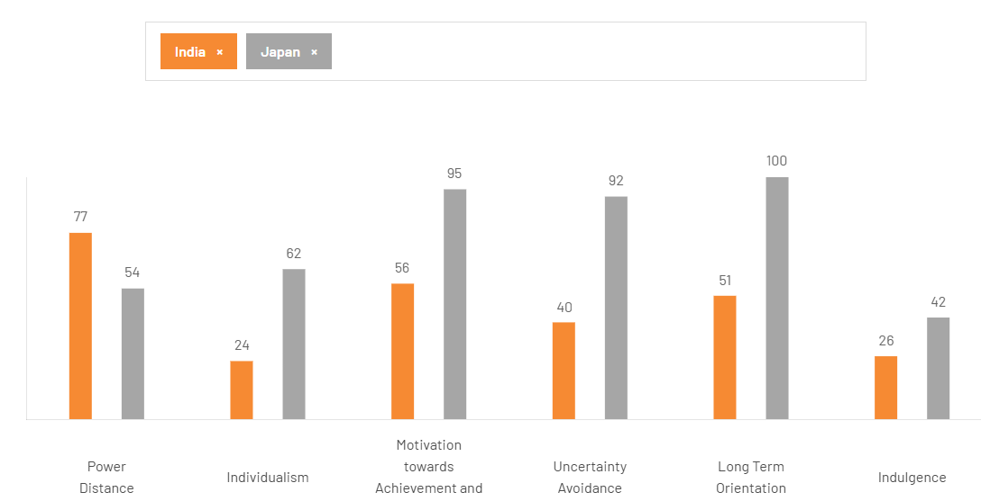
Figure 9: Country Comparison between Japan and India
(Source: theculturefactor, 2026)
Power Distance
As per the above image, the power stance score of India is comparatively higher, that is 77, and in Japan it is 54 (The Culture Factor, 2026). While operating a business in India, Toyota needs to focus on a stronger relationship with customers and develop a structured management system. On the other hand, Japanese customers prefer transparency in product and effective communication.
Strategic implication
In India, Toyota needs to maintain its SUVs position in premium segment however Japan’s society is reliable with environmental commitment and prefers greener vehicle choice.
Individualism
The image below shows that the electrification trends of the automotive industry have been growing from 10 models to 61 models, 2019-2025 (JATO, 2025). In contrast, Indian customers are highly price sensitive.
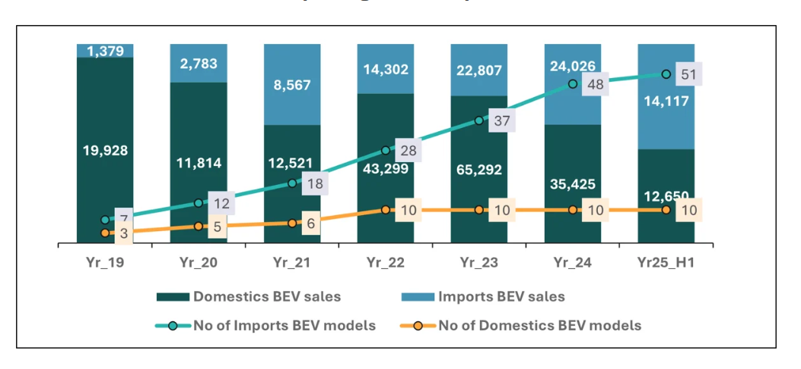
Figure 10: EV sales increase in Japan
(Source: JATO, 2025)
Achievement and success
The motivation towards success score for Japan is 95%, and for India it is 56% (The Culture Factor, 2026). Japanese society focuses on high work performance and values competition, which contributes to Toyota’s operational process excellence.
Uncertainty avoidance
Uncertainty avoidance capacity in Japan is higher than hat is 92% and Indian score is 40% (The Culture Factor, 2026). Japanese customers strongly prefer safety assurance, quality, reliability, and long-term stability. Toyota needs to be concerned about high standardisation and safety systems. On the other hand, the automobile industry in India is highly fluctuating based on inflation.
Strategic implication
The marketing team of Japan in Toyota needs to focus on data heavy and information mainly to minimise customer’s tension. However, in case of India, the management needs to deliver experimental value proposition to emotional connection and lifestyle benefit.
Long-term orientation
Long-term orientation score for India is 51, and Japan is 88 (The Culture Factor, 2026). Japanese culture focuses on long-term investment and future planning. Toyota needs to invest in developing sustainable technologies for innovation in EV and HV. However, Indian customers highly prefer affordable products (Chaudhuri et al., 2025).
Strategic implication
Toyota makes to future promise for Japan market focusing on hydrogen however in India, it needs to deliver value in low maintains cost and resale.
Indulgence
The indulgence score for India and Japan is lower; however, Japan has a comparatively high 42, and India has 26. Toyota's sales of the Innova Hycross model were approximately 9.7 thousand, which is considered the best-selling model (Statista, 2025d).
Advantages
Application of Hofstede's Cultural Dimensions is highly useful for comparing culture and customer market. This framework is reliable for national culture analysis which is related to customer’s preferences in Japan and India. Toyota has reliable on the guidance of Hofstede's model mainly for designing marketing strategy.
Limitation
Beside the advantage of this model, there is some disadvantage in Japan and India’s context. As Japan’s has strong preferences for technological innovation and safety India has high price sensitivity and price relevance. Moreover, excessive localisation is also responsible for increasing production complexity related to brand consistency.

4. Comparative Analysis of STP Strategy

4.1 Segmentation Strategy
Segmentation Variable | Japan | India
Demographic Segmentation | Targets ageing populations.  High-income professionals.  Environmentally conscious consumers. | Targets middle-class families.  Young professionals.  Affluent SUV buyers.
Geographic Segmentation | Focuses on urban cities such as Osaka and Tokyo, where compact and hybrid vehicles are needed. | Focuses on metropolitan cities such as Mumbai, Delhi, and Bengaluru along with semi-urban regions.
Psychographic Segmentation | Targets customers who value innovations, advanced technology, and sustainability. | Targets consumers seeking status, affordability, and fuel efficiency
Lifestyle Segmentation | Customers prefer compact, eco-friendly vehicles suitable for urban lifestyles. | Customers prefer spacious SUVs and MPVs suitable for family-oriented lifestyles.
Benefit Segmentation | Focus on safety, technological innovation, nd environmental sustainability (El Islami and Wandebori, 2025). | Focus on maintenance costs and resale value.
Commitment Levels | Strong brand loyalty due tolong-termm trust and reputation of Toyota. | Increasing customer loyalty for strong after-sales service
Usage Patterns | Daily commuting and urban transportation. | Family travel, long-distance journeys, and multi-purpose vehicles.
Table 1: Segmentation Strategy of Toyota in Japan and India
(Source: Self-developed)
The above table shows the segmentation strategy of Toyota reflects the concept that companies need to identify customer groups. India's higher power-distance culture suggests consumers place greater trust in recognised brands and dealership authority. Consequently, Toyota should emphasise relationship-based selling and dealership experience.

4.2 Targeting Strategy
Country | Target Customers | Vehicle Examples | Targeting Strategy
Japan | Environmentally conscious customers, high-income professionals | Prius, bZ Series, Lexus | Differentiated Targeting
Japan | Premium luxury consumers | Lexus | Concentrated Targeting
India | Middle-class families and urban professionals | Innova Hycross, Urban Cruiser Hyryder | Differentiated Targeting
India | Premium SUV and status-conscious consumers | Fortuner | Concentrated Targeting
Table 2: Targeting Strategy of Toyota
(Source: Self-developed)
The above table shows that in Japan; the company focuses on technology-driven consumers. In India, Toyota targets middle-class families and SUV buyers.
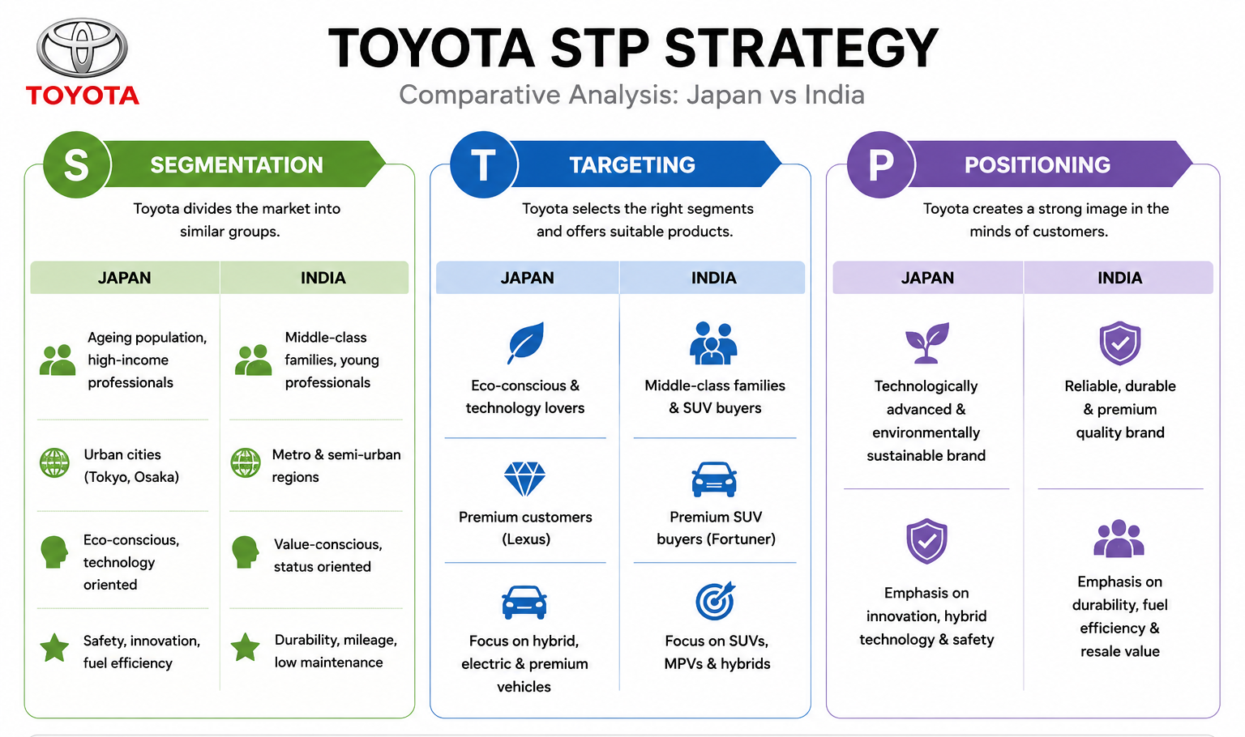
Figure 11: STP analysis of Toyota
(Source: Self-developed)

4.3 Positioning Strategy
Positioning Factors | Japan | India
Brand Image | Technologically advanced and sustainable brand | Premium automobile brand.
Main Consumer Benefits | Innovation and environmental sustainability | Fuel efficiency, durability, and resale value.
Competitive Positioning | Competes with hybrid and electric innovations. | Compete with quality and SUV dominance.
Key Competitors | Honda, Nissan
Table 3: Positioning Strategy of Toyota
(Source: Self-developed)
The table shows that Toyota positions itself differently in both countries as per the market conditions. In Japan, Toyota focuses on innovations and sustainability. Whereas in India, the company focuses on premium quality, reliability, and long-term value.
Advantages
STP strategy has strengthened marketing resources mainly for differently meet the needs of India and Japan. This segmentation is helpful for Toyota to concise its electric and hybrid vehicle in India market. Country-specific positioning has strengthened Toyota for increasing its competitive advantage.
Risk
Beside advantage, there is some important limitation which assume customer segment in a stable process. Customer needs have overlap traditional segmentation which helps to grouping the customers. For example, younger customers have mainly sought mobility subscription services however adult group focused on longevity. This extensive adaptation has declined its brand consistency and also enhancing marketing expenditure.

5. International Marketing Mix (7Ps) Strategy

5.1 Standardization vs Adaptation Strategy
Toyota follows a "Glocal strategy" by including global standardizations with local adaptation. As per the lecture materials, standardisation involves offering similar products globally (Reuters, 2026). The adaptation modifies the product and marketing activities as per the local market conditions. Toyota standardizes the global brand image along with quality, innovation, reliability, and sustainability across India and Japan. In Japan, Toyota emphasizes hybrid and electric vehicles due to environmental awareness and strict emission regulations (Anchukova, 2025). In India, the company focuses more on fuel-efficient SUVs and affordable family vehicles. Toyota sold almost 10.3 million vehicles globally in 2025 (Toyota, 2026b). This maintains its position in the automobile industry. Toyota's segmentation demonstrates that economic development, infrastructure and environmental regulation interact to shape customer needs. However, excessive adaptation may increase operational costs and reduce global consistency.
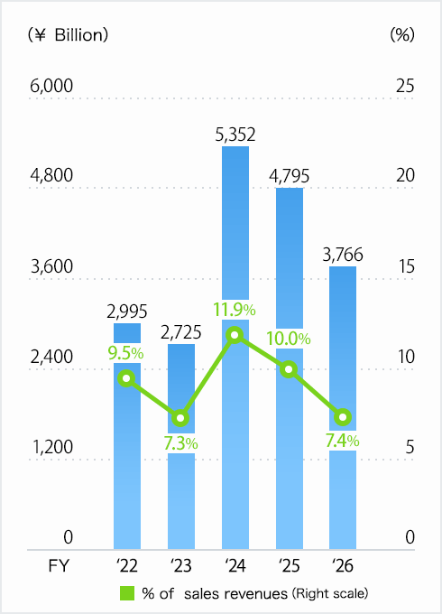
Figure 12: Financial Highlights of Toyota
(Source: Toyota, 2026b)

5.2 Product Strategy
Toyota adapts its product portfolio as per customer preferences and the road infrastructure.
Product Strategy | Japan | India
Main Focus | Hybrid & EV vehicles | SUVs & fuel-efficient cars
Product Adaptation | Compact eco-friendly vehicles | Larger SUVs for family use
Innovation Level | Advanced autonomous features | Fuel efficiency and practical safety.
Table 4: Product Strategy
(Source: Self-developed)
Toyota's product adaptation reflects the lecture concept related to changes in product features. Japanese consumers prefer technologically advanced vehicles. Toyota also dominated India's strong hybrid market with almost 81% market share in 2025 (Mordor Intelligence, 2026). With the help of the effective product strategy the company can ensure the significant market entry in India. This strategy is highly fit for product market as it reflects on customer’s lifestyle, purchasing power and infrastructure. On the other way, for improving Toyota’s competitive position, it needs to strengthen its carbon emission practices.
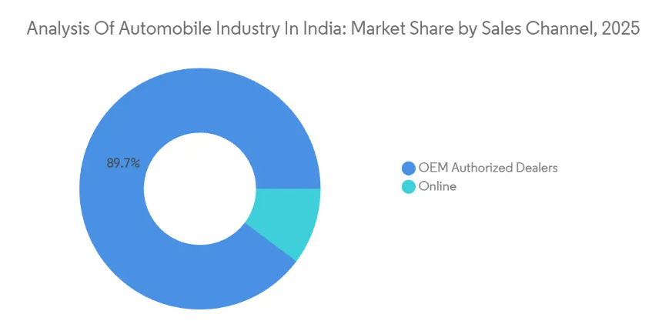
Figure 13: Analysis of automobile industry in India
(Source: Mordor Intelligence, 2026)

5.3 Pricing Strategy
Toyota applies different pricing strategies based on the economic conditions and customer purchasing power. In Japan, Toyota mainly uses premium pricing for the hybrid and electric vehicles. In India, Toyota adopts competitive pricing strategies to attract the middle-income customers. While Toyota adopts competitive pricing in India, the strategy is challenged by dominant cost leaders such as Maruti Suzuki and Hyundai. Consequently, Toyota's premium positioning may restrict market penetration among price-sensitive consumers.
Pricing Factor | Japan | India
Pricing Strategy | Premium pricing approx. ¥3.2 million (£16,500) (Statista, 2026) | Penetration & competitive pricing approx. ₹1.1 million (£10,200) .
Consumer Income | High | Moderate
Market Competition | Moderate | Very high
Key Pricing Influence | Sustainability demand | Fuel prices & affordability (Statista, 2026)
Table 5: Pricing Strategy
(Source: Self-developed)

5.4 Place Strategy
Toyota uses different distribution and dealership strategies in India and Japan based on the infrastructure development. In Japan, Toyota operates through a highly advanced dealership network. It is supported by the platforms and smart showrooms. In India, Toyota focuses on expanding dealerships in Tier-2 and Tier-3 cities. The brand will need to focus on wider distribution for supporting long-term market growth. In contrast, it also needs to focus on dealership network for enhancing investor management. As suggested by Belostecinic and Chiriac (2026), the company also develops after-sales service centers.
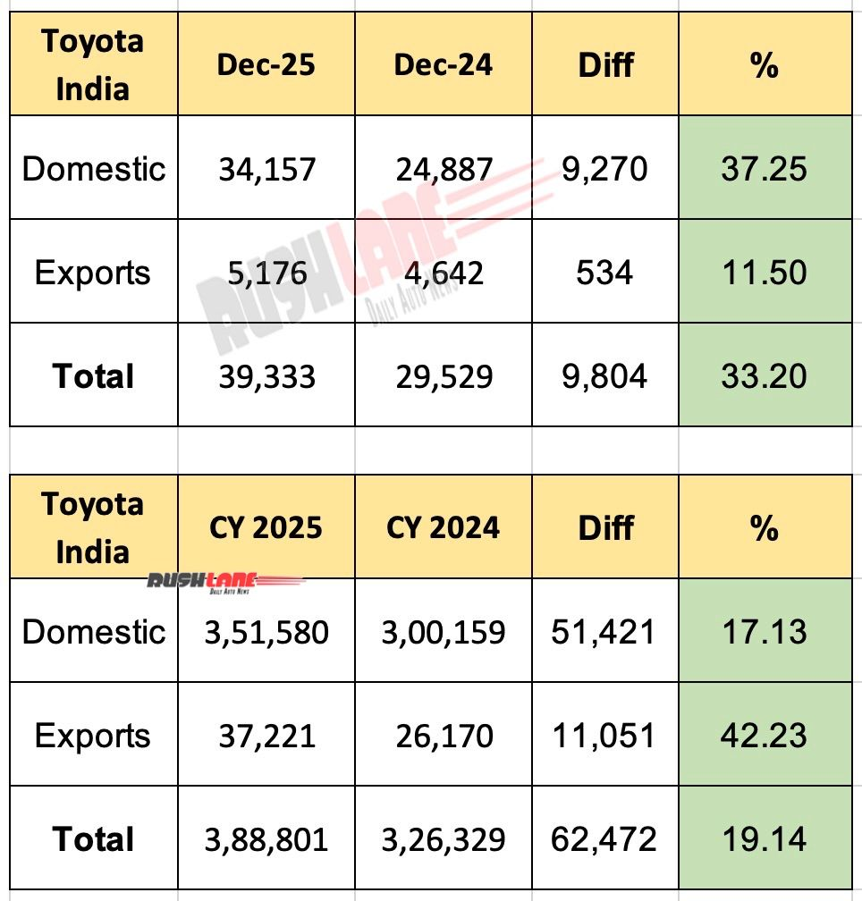
Figure 14: Toyota Dec 2025 Sales Grows 37%
(Source: Rush Lane, 2026)

5.5 Promotion Strategy
Toyota adapts the promotional strategies as per the cultural preferences and the media consumption patterns in India and Japan. As opined by Taboada (2025), in Japan, the promotional campaigns mostly focus on sustainability and advanced hybrid technology. In India, Toyota uses emotional and family-oriented advertising to improve safety. On the other way, the brand will also need to focus on localised promotional strategies for maintain consistency of global brand image.
Promotion Factor | Japan | India
Main Message | Sustainability & innovation | Family safety & fuel efficiency
Advertising Style | Informative & technology-based | Emotional & lifestyle-based
Major Platforms | Digital media & websites | TV, YouTube & social media
Promotional Focus | Promotional Focus | SUVs & hybrid affordability
Table 6: Promotion Strategy
(Source: Self-developed)

5.6 People strategy
In Japan, Toyota focuses on developed discipline and the teamwork process. As suggested by Gore (2025), Toyota employed more than 380,000 employees globally in 2025. This supports the international operations and the customer service systems. In India, differences of organisational culture are responsible for lower employee collaboration. Due to these cultural differences the brand face complexity to balance service consistency.
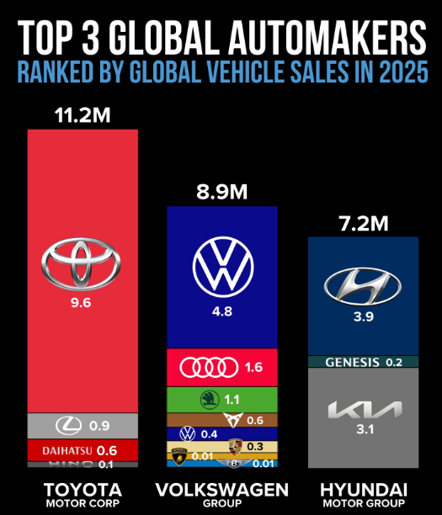
Figure 15: Toyota Tops Global Vehicle Sales
(Source: Gore, 2025)

5.7 Process strategy
Toyota standardised most of the operational processes globally through the Toyota Production System. As stated by Dubcová et al. (2025), this focuses on lean manufacturing and the waste reduction process. Toyota also increased localizations of production in India during 2025 (Singh et al., 2025). However, the excessive localisation the organisational production system which will also diminish its global standard. This reduces operational costs and enhances supply chain flexibility.

5. 8 Physical Evidence
In Japan, fthe dealership focuses on modern architecture and the digital interactions process. As suggested by Khan (2026), in India, Toyota showrooms also focus more on customer lounges and the visible service centers process.

5.9 Toyota Market Share Comparison
Toyota maintained its global performance in 2025. Despite increasing competition and supply chain challenges. The company remained Japan's leading automobile manufacturing company. India also became one of Toyota's fastest-growing Asian markets during 2025 due to rising middle-class income and SUV demand (Mordor Intelligence, 2026). The market size is expected to grow from USD 137.06 billion in 2025 to USD 147.58 billion in 2026 (Mordor Intelligence, 2026).
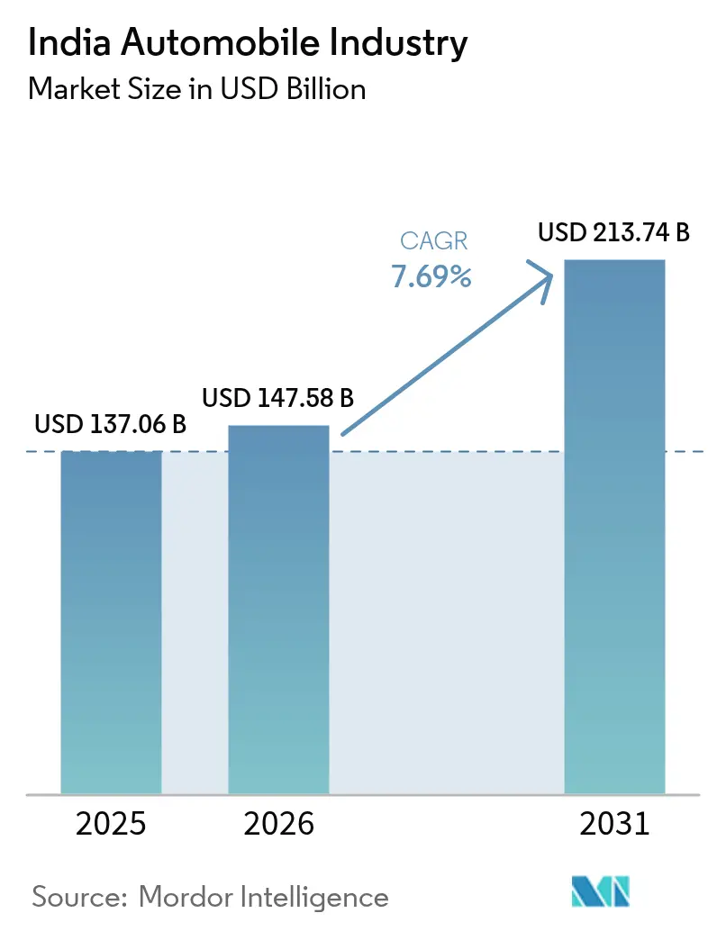
Figure 16: The India Automobile Industry
(Source: Mordor Intelligence, 2026)

6. Market Entry Strategy: India
“Joint Venture Market Entry Strategy”
Toyota entered the Indian market with the help of a joint venture market entry strategy. As suggested by Hossain (2025), the joint venture strategy is suitable for international expansions, as this provides local market knowledge. Toyota selected India as it has a large population, with expanding middle-class consumers. In 2025, the Indian passenger vehicle market is expected to exceed 4.3 million units (Auto Punditz, 2025).
In other way, exporting is also relevant market entry strategy that delivers greater responsiveness to Toyota in the context of local market condition. Exporting market entry strategy has increase global interconnectedness that supports for value chain practices (Chopra et al., 2024). In this market entry strategy, there will be minimise operational risk with lower financial investment will be required.
wholly owned subsidiary will be also effective for Toyota as a market entry strategy in India as it supports for managerial control over strategic decision. Implementing wholly owned operations will help the brand to save time.
Limitations
The joint venture strategy reduces investment risk and provides local market knowledge. This may limit Toyota's managerial control and slow strategic decision-making.
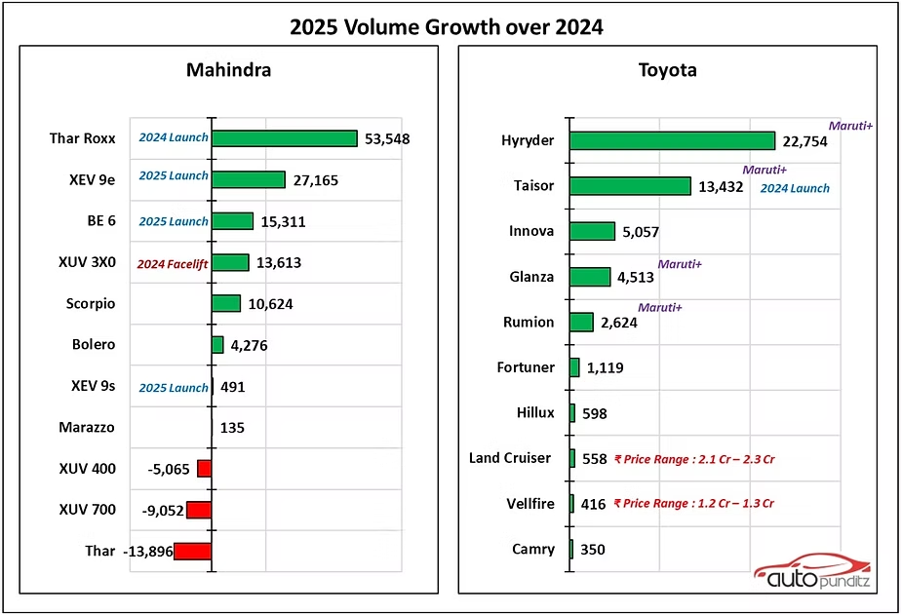
Figure 17: The brand growth of Toyota
(Source: Auto Punditz, 2025)
Justification by using OLI framework
The selection of joint venture has been supported by OLI framework which consist with Ownership, Location, Internalisation (Batschauer et al., 2022). Toyota will access ownership advantages including hybrid technology and brand equity. In India, it can also gain location advantage through expanding automotive supply chain, lower production cost along with favourable government initiatives. It can also access internalisation advantage which will support quality standard and production technology.

7. Ethical Considerations in Marketing Mix
- It is important to promote the SUV model of Toyota, traffic congestion and urban pollution have been detected. However, to overcome this, the organisation focusses on eco-initiatives and develops a CO2 emission target by 90% in 2050 (Toyotabharat, 2026). The organisation promotes hybrid technology and fuel efficiency to control the environmental pressure.
- One of the significant issues is market accessibility and affordability. For the Indian customers, Toyota needs to offer sustainable, affordable mobility products by maintaining equity among the upper-middle class and the lower-middle class.
- As the organisation also adapt digital campaigns, it needs to be highly concerned for maintaining transparency. The brand needs to focus on data privacy to track both online and offline customers.

8. Strategic Recommendations and Conclusion
Recommendation
- It is recommended that Toyota strengthen its localisation strategy for maintaining brand consistency in India. It needs to offer EV and hybrid options within an affordable range rather than offering a premium product. Toyota can implement this strategy by increasing sourcing components, local manufacturing specially focusing on hybrid technology.
- Another recommendation is to use AI-based customer service, personalised offers, and a virtual showroom. This will increase brand’s competitive advantage and will be helpful to attract young customers. Digital showrooms in the automotive industry have drastically contributed to increasing digital sales (Gundupagi et al., 2026). This result will show higher customer expectation with conversions of digital sales.
- Toyota needs to invest in a green supply chain network for India, which increases its environmental impact reputation and customers' awareness. This carbon-neutral practice will be helpful for Toyota to attract young customers by accelerating hybrid technology. By using the renewable energy, Toyota can drives the manufacturing facility through recycling vehicle component and follow environmental standard which drives the outcome of strong ESG performance.
Conclusion
The international marketing strategy of Toyota in Japan and India helps to evaluate its business operational practice, focusing on regulatory, technological, cultural and economic conditions. This comparative analysis based on two international markets helps to understand how different governmental policies, customers' behaviour, and market expectations differ. The organisation is able to balance the global and local needs, focusing on pricing, product development and promotional practices. The organisation faces competitive pressure on ethical expectations, digital transformation, and environmental pressure. In India, Toyota suffers from ethical issues which can be overcome based on eco-friendly practices and digital investment. Technological integration and sustainability commitment are highly influential for changing international marketing strategy.

Section 2: Reflective account
Reflective Account Using Gibbs’ Reflective Cycle
Description
For this assignment, I used a comparative international marketing analysis of Toyota in Japan and India. The study applied several theoretical frameworks including the "PESTEL framework, Hofstede's cultural dimensions, STP strategy, and the International Marketing Mix (7Ps)". The report also incorporated several secondary research studies by using academic journals, industry reports, and statistical data. Along with that, Toyota's annual reports, industry websites, and government publications have been used. At first, I focused on understanding economic, technological, political, and cultural differences between Japan and India. During the PESTLE analysis, I learnt that electric and hybrid vehicles affect the international operations of Toyota. These findings helped me to understand how environmental regulations shape the product and pricing strategy of Toyota in both Japan and India. In STP detection, I found that Toyota targets environmentally conscious customers in Japan. Overall, this process involved the combination of theoretical models from the lectures and real-world satisfaction evidence.
Feelings
During the report preparation, I faced both confidence and challenges. At the beginning, I felt stressed due to the assignment requiring extensive comparative analysis. The collection of reliable data from 2025 and 2026 sources was time-consuming. I was initially concerned about integrating statistical concepts such as PESTEL, Hofstede, and STP with real-world business analysis effectively. With progress, I became more confident as the lecture materials provided a strong depth of understanding for structuring the report properly. I mostly enjoyed the analysis of the international marketing strategy of Toyota. The use of recent statistics, such as Toyota's hybrid vehicle dominance in India and Japan's sustainability policies, was helpful. The study analysed more practical as well as engaging data. Overall, the assignment improved my confidence in academic research (Aneeis Hashim et al., 2023). Along with that, the analytical writing and the critical evaluation skills helped develop in the process.
Evaluation
The overall research was highly beneficial for me. It improved my understanding of the international marketing strategies and the practical applications in the global markets. One positive aspect of the report was the effective use of the theoretical frameworks from the lectures, such as PESTLE analysis, Hofstede's cultural dimensions, and the 7Ps marketing mix. All of these models helped me to critically compare the operations of Toyota in India and Japan. These identified how economic, cultural, and technological differences influence international marketing decisions.
Another strength of the report was including updated statistical data and industry evidence from sources such as Statista. The report on Toyota also included industry evidence as well. All of these improved my academic credibility and analytical depth of the report. For instance, the political stability of Japan and India's growing EV market helped me to develop the comparative discussion process. However, one weakness in this process was time management during the research. As suggested by Najib and Anisa (2025), a lack of time management can affect the project quality. The simplification of complex data findings was challenging as well.

Analysis
This individual report is highly beneficial to increase my understanding regarding the way international businesses are able to design marketing strategies based on cultural conditions and external environment. I have recognised one significant learning outcome that the customer market has been diversified due to geographical and cultural change. Observing Toyota's strategic decision, I understand how MNCs have balanced local responsiveness and global efficiency. Through this module, I have demonstrated the successful marketing strategy of Toyota, which is highly related to standardisation and strategic adaptation. I have researched that Toyota focus on environmental sustainability and hybrid technology in Japan and India. This has strongly influenced tech-savvy customers and environmentally aware customers. However, while operating a business in the Indian market, the brand has experienced demand for price sensitivity. This comparison is helpful for my knowledge that it is important to change strategic action based on customers' needs. It is the brand's responsibility to maintain customers' loyalty and needs to take a significant strategy (Dyatmik et al., 2025).
My understanding has improved about the contribution of cultural factors to changing organisational managerial decisions. I have used Hofstede’s cultural framework where I have learned 6cultural dimensions and also made country differences in Hofstede’s country comparison tool. Hofstede’s cultural dimension model increases theoretical understanding of the impact of culture on leadership (de Souza Sant’Anna, 2025). Long-term orientation and uncertainty avoidance are highly beneficial for changing organisational practice and meeting customers’ expectations. For example, I have noticed Japanese customers' demand for technological reliability and safety standards. However, Indian customers are only focused on durability and affordability. The brand needs to develop its CSR policies to deliver customer value (Tessema, 2025). Product adaptation, marketing communication and customer engagement have been shaped by culture. I have realised that modern business is focused on a digital ecosystem and environmental responsibility.
Conclusion
It can be concluded that I have gained valuable experience in the international marketing process in the automobile industry. I have used different strategic tools like PESTLE, Hofstede's cultural dimensions, STP, and marketing mix. These are helpful to improve my evaluation of strategic analysis based on a cultural approach. I have learned what factors influence strategic decisions for MNCs like Toyota, including technological, economic, cultural, and environmental conditions. However, I have suffered issues related to critical analysis and time management. My supervisor has guided me on how to improve my time management skills. He also shared with me some structure notes for improving my critical analysis.
Action Plan
To improve my time management skills, I need to make a necessary action plan. I need to focus on improving my scheduling and give priority to the urgent and high-risk tasks. I need to avoid multi-tasking process which will increase my strength for managing and organising time.
Besides this, I also need to focus on increasing my critical writing skills rather than describing information only. In this case, I need to improve my academic research skills, focusing on industry databases and peer-reviewed journals. This will also be significant for developing my proofreading and guide on maintaining referencing accuracy. Furthermore, I also need to be concerned about the application of the theoretical framework.

Reference
Chopra, R., Bhardwaj, S., Baber, H. and Idris Sanusi, O., 2024. Navigating global horizons: a review of export promotion and foreign market entry strategies for small and medium enterprises (SMEs). Journal of Business & Industrial Marketing, 39(12), pp.2774-2790. https://www.researchgate.net/profile/Seema-Bhardwaj-2/publication/385753408_Navigating_global_horizons_a_review_of_export_promotion_and_foreign_market_entry_strategies_for_small_and_medium_enterprises_SMEs/links/6869192439c35835120731bd/Navigating-global-horizons-a-review-of-export-promotion-and-foreign-market-entry-strategies-for-small-and-medium-enterprises-SMEs.pdf.
Batschauer da Cruz, C.B., Eliete Floriani, D. and Amal, M., 2022. The OLI Paradigm as a comprehensive model of FDI determinants: a sub-national approach. International Journal of Emerging Markets, 17(1), pp.145-176. https://www.researchgate.net/profile/Claudia-Cruz-7/publication/329151644_The_Eclectic_Paradigm_as_a_Comprehensive_Model_to_Analyze_Subnational_Determinants_of_FDI/links/5f76e322a6fdcc0086502bc6/The-Eclectic-Paradigm-as-a-Comprehensive-Model-to-Analyze-Subnational-Determinants-of-FDI.pdf.
Anchukova, A., (2025). . Developing a student carpooling service in Finland: business model and marketing strategy. https://www.theseus.fi/bitstream/handle/10024/888089/Anchukova_Aleksandra.pdf?sequence=2
Aneeis Hashim, S.N., Yaacob, A., Suryani, I., Mohd Asraf, R., Bahador, Z. and Supian, N., (2023). Exploring the Use of Gibbs’ Reflective Model in enhancing in-Service ESL teachers’ reflective writing. Arab World English Journal (AWEJ) Volume, 14. https://papers.ssrn.com/sol3/Delivery.cfm?abstractid=4497558
AQI (2026) India Air Quality Index (AQI) | Air Pollution, Available at: https://www.aqi.in/in/dashboard/india. [Accessed on 29.05.2026]
Auto Punditz, (2025). 2025: Indian mass-market passenger vehicle Brand analysis Available at: https://www.autopunditz.com/post/2025-indian-mass-market-passenger-vehicle-brand-analysis [Accessed on: 29th May, 2026]
Autocarindia (2026) No tax breaks on EVs above Rs 30 lakh: 2026 Delhi EV policy proposal, Available at: https://www.autocarindia.com/industry/delhi-ev-policy-proposes-no-road-tax-for-evs-up-to-rs-30-lakh-till-march-2030-439442. [Accessed on 29.05.2026]
Belostecinic, I. and Chiriac, L., (2026). Strategic branding as a driver of long-term equity. https://repository.utm.md/bitstream/handle/5014/36129/JSS-N1-2026_p39-64.pdf?sequence=1&isAllowed=y
Chaudhuri, R., Chatterjee, S., Ghosh, A., Vrontis, D. and Thrassou, A., 2025. Sustainable innovation for shared mobility: contextual and consumer factors of an Indian car subscription business model. International Journal of Entrepreneurial Behavior & Research, 31(2-3), pp.344-368. https://www.emerald.com/ijebr/article-pdf/31/2-3/344/9663020/ijebr-01-2022-0090.pdf.
Counterpointresearch (2025) Japan Connected Car Sales Jump 34% YoY in Q1 2025 as Domestic OEMs Accelerate Digital Push, Available at: https://counterpointresearch.com/en/insights/japan-connected-car-sales-jump-34-yoy-in-q1-2025-as-domestic-oems-accelerate-digital-push. [Accessed on 29.05.2026]
de Souza Sant’Anna, A., 2025. Leadership Styles Across Cultures: A Comparative Study of Western and Asian Contexts Through Hofstede and Deleuzian Lenses. Millennial Asia, p.09763996251370804. https://www.researchgate.net/profile/Anderson-Santanna-2/publication/382206570_Leadership_Styles_Across_Cultures_A_Comparative_Study_of_Western_and_Asian_Contexts_Through_Hofested_and_Deleuzian_Lenses/links/66916685c1cf0d77ffd27f10/Leadership-Styles-Across-Cultures-A-Comparative-Study-of-Western-and-Asian-Contexts-Through-Hofested-and-Deleuzian-Lenses.pdf.
Deloitte (2024) 69% consumers in India keen for subscription-based vehicle ownership: Deloitte Global Automotive Study, Available at: https://www.deloitte.com/in/en/Industries/automotive/perspectives/69-consumers-in-india.html. [Accessed on 29.05.2026]
Dubcová, G., Velinov, E. and Kosikova, M., (2025). . Evaluating ESG practices and financial impacts: A comprehensive analysis of leading european enterprises under CSR Europe's framework. Financial Internet Quarterly, 21(2), pp.89-104. https://www.econstor.eu/bitstream/10419/329904/1/10.2478_fiqf-2025-0013.pdf
Dyatmika, S.W., Suyanto, B., Setijaningrum, E., Rizky, A. and Mkhize, T., 2025. Enhancing brand loyalty through customer satisfaction strategies in digital business. Aptisi Transactions on Technopreneurship (ATT), 7(2), pp.556-566. https://att.aptisi.or.id/index.php/att/article/download/558/369.
Economictimes (2025) young rich indians rev-up lamborghini and mercedes maybach sales, Available at: https://auto.economictimes.indiatimes.com/news/passenger-vehicle/young-rich-indians-rev-up-lamborghini-and-mercedes-maybach-sales/119306742. [Accessed on 29.05.2026]
Economictimes (2026a), India's Automotive Innovations from Software-Defined Vehicles to Hydrogen Mobility, Available at: https://auto.economictimes.indiatimes.com/news/newsletters/indias-automotive-innovations-from-software-defined-vehicles-to-hydrogen-mobility/131344424. [Accessed on 29.05.2026]
Economictimes (2026b), transforming India's auto industry-the rise of software-defined vehicles, Available at: https://auto.economictimes.indiatimes.com/news/auto-technology/transforming-indias-auto-industry-the-rise-of-software-defined-vehicles/126351159. [Accessed on 29.05.2026]
Economictimes (2026c) India-eu-trade-pact-to-help-boost-domestic-auto-manufacturing-senior-official, Available at: https://economictimes.indiatimes.com/news/economy/foreign-trade/india-eu-trade-pact-to-help-boost-domestic-auto-manufacturing-senior-official/articleshow/131199496.cms?from=mdr. [Accessed on 29.05.2026]
El Islami, A.K.N. and Wandebori, H., (2025). Strategic Marketing Approaches to Enhance The Adoption of Toyota Battery Electric Vehicles in Indonesia, Tunas Toyota Cawang. Syntax Literate; Jurnal Ilmiah Indonesia, 10(3), pp.2932-2941. https://digilib.itb.ac.id/assets/files/2025/MjAyNSBUUyBQUCBBTUFMWUEgS0hBTElTSEEgTlVSIEVMIElTTEFNSSAtIENPVkVSLnBkZg.pdf
Gore, M., (2025). Why Western Strategy Frameworks Fail in India and Southeast Asia: A Critical Analysis and a Proposal for a Hybrid Consulting Model. Available at SSRN 5876342. https://papers.ssrn.com/sol3/Delivery.cfm?abstractid=5876342
Gundupagi, M., Balraj, I., Chandhan Prashad, N. and Durdana, M., 2026. Driving Sales Digitally: An Empirical Study of Digital Showrooms in the Automotive Sector. Cureus Journals, 3(1). https://www.cureusjournals.com/articles/11243-driving-sales-digitally-an-empirical-study-of-digital-showrooms-in-the-automotive-sector.pdf.
Hossain, M.K., (2025). Artificial Intelligence Driven Analytics for Market Entry Strategy, Digital Marketing Optimization, and Enterprise Workflow Transformation. ASRC Procedia: Global Perspectives in Science and Scholarship, 1(01), pp.1999-2034. https://global.asrcconference.com/index.php/asrc/article/download/93/93
Igarr (2026) Vehicle type approval, automotive regulations and vehicle requirements in Japan,Available at: https://igarr.com/vehicle-regulations-in-japan/. [Accessed on 29.05.2026]
IMF, (2026). Japan. Available at: https://www.imf.org/en/countries/jpn [Accessed on: 29th May, 2026]
Influencemap (2026) Need for Vehicle Electrification, Available at: https://japan.influencemap.org/policy/2035-vehicle-electrification-target-5357. [Accessed on 29.05.2026]
Iqair (2026) Air quality in Japan, Available at: https://www.iqair.com/japan. [Accessed on 29.05.2026]
JATO (2025) Japan's Automotive Electrification Trends (2025 H1), Available at: https://www.jato.com/resources/news-and-insights/japans-automotive-electrification-trends-2025-h1. [Accessed on 29.05.2026]
Khan, N.I., (2026). Strategic & Operational Analysis of Toyota Motor Corporation. I made this just out of hobby in my leisure time. https://papers.ssrn.com/sol3/Delivery.cfm?abstractid=6208539
Kole, J.K.T., 2025. Applying Hofstede’s cultural dimensions in education: Insights, critiques, and implications for diverse classrooms. Open Journal of Social Sciences, 13(5), pp.94-110.https://www.researchgate.net/profile/John-Kole/publication/391910625_Applying_Hofstede's_Cultural_Dimensions_in_Education_Insights_Critiques_and_Implications_for_Diverse_Classrooms/links/682d39da026fee1034f97883/Applying-Hofstedes-Cultural-Dimensions-in-Education-Insights-Critiques-and-Implications-for-Diverse-Classrooms.pdf.
Ministry of Environment (2026) Environmental Protection Policy in Japan - Introduction, Available at: https://www.env.go.jp/en/policy/plan/intro.html. [Accessed on 29.05.2026]
MOEF (2026) Ministry of Environment, Forest and Climate Change (MoEF&CC)., Available at: https://moef.gov.in/. [Accessed on 29.05.2026]
Mordor Intelligence, (2026). INDIA AUTOMOBILE INDUSTRY SIZE & SHARE ANALYSIS - GROWTH TRENDS AND FORECAST (2026 - 2031). Available at: https://www.mordorintelligence.com/industry-reports/analysis-of-automobile-industry-in-india [Accessed on: 29th May, 2026]
Najib, A.F.R.A. and Anisa, H., (2025). The Influence of Self-Efficacy and Teacher Academic Support on Students’ Time Management in Extracurricular Activities at Islamic Boarding Schools. Urwatul Wutsqo: Jurnal Studi Kependidikan Dan Keislaman, 14(3), pp.843-858. https://pondokjurnal.uwj.ac.id/index.php/UrwatulWutsqo/article/download/2406/1191
Niti (2025) Powering India’s participation in Global Value Chains, Available at: https://www.niti.gov.in/sites/default/files/2025-06/Automotive%20Industry%20Powering%20India’s%20participation%20in%20GVC_Non%20Confidential.pdf. [Accessed on 29.05.2026]
PIB (2025) Automotive Industry: Powering India's Participation in Global Value Chains (GVCs), Available at: https://www.pib.gov.in/PressReleasePage.aspx?PRID=2121826&reg=3&lang=2. [Accessed on 29.05.2026]
PIB (2026) STATUS OF HEAVY INDUSTRIES SECTOR, Available at: https://www.pib.gov.in/PressReleasePage.aspx?PRID=2225882&reg=3&lang=2.[Accessed on 29.05.2026]
Reuters (2026) Japan set to start trade talks with Mercosur, Nikkei reports, Available at: https://www.reuters.com/business/autos-transportation/japan-set-start-trade-talks-with-mercosur-nikkei-reports-2026-05-26/. [Accessed on 29.05.2026]
Reuters, (2026). Toyota retains top auto crown in 2025 with record sales. Available at: https://www.reuters.com/business/autos-transportation/toyota-retains-top-auto-crown-2025-with-record-sales-2026-01-29/ [Accessed on: 29th May, 2026]
Road Genius, (2026). Toyota Car Sales Statistics. Available at: https://roadgenius.com/cars/statistics/sales-by-manufacturer/toyota/ [Accessed on: 29th May, 2026]
Rush lane, (2026). Toyota Dec 2025 Sales Grows 37% – Records Highest Ever Yearly Sales. Available at: https://www.rushlane.com/amp/toyota-dec-2025-sales-grows-37-records-highest-ever-yearly-sales-12537067.html [Accessed on: 29th May, 2026]
Singh, D.P., Moitra, D. and Kar, S.K., (2025). India's Supply Chain Transformation: Strategies for global impact. https://ir.iimcal.ac.in:8443/jspui/bitstream/123456789/5300/1/India%27s%20Supply%20Chain%20Transformation.pdf
Statista (2025a) Smart cars fueling the future of Japan's auto industry, Available at: https://www.statista.com/chart/13785/smart-cars-fueling-the-future-of-japans-auto-industry/?srsltid=AfmBOor-Mo3nBsCvr7kqnjScq1FEIAAGXTfuv5vDTW5o-RYPQlRfz_nr. [Accessed on 29.05.2026]
Statista (2025b) Are Cars Still Aspirational Purchases?, Are Cars Still Aspirational Purchases? Available at: https://www.statista.com/chart/28182/share-of-car-non-owners-intending-to-buy-one/?srsltid=AfmBOopilntOQnkZeQExfrtlxp3VFE7_-Psxv-x7s0JZq5w4CSYoYU_C. [Accessed on 29.05.2026]
Statista (2025c) Number of employees engaged in automobile-related industries in Japan as of 2024, by industry, Available at: https://www.statista.com/statistics/1173829/japan-employees-in-automobile-related-industries-by-industry/?srsltid=AfmBOooNnXeD-TPq8imJXFAaJXvfzIJDH18n8NUW8AXGTFFjj48urGYe. [Accessed on 29.05.2026]
Statista (2025d) Sales volume of Toyota cars across India in December 2024, by model, Available at: https://www.statista.com/statistics/1091765/india-toyota-car-sales-by-model/?srsltid=AfmBOoomwbZDiaYSA82F_JSWBLZWWhuaXF8LgcZj2W33-Vqw1CXLHGYo. [Accessed on 29.05.2026]
Statista (2026) Japanese consumers root for green vehicle technologies, Available at: https://www.statista.com/chart/15483/the-main-passenger-car-features-required-by-consumers-in-japan/?srsltid=AfmBOoq2ssEBHoi9JTLnhHmyC4hlMDsoNYYuREUGch8bL_Jz0lvfDczG. [Accessed on 29.05.2026]
Statista, (2026). Worldwide number of vehicles produced by the Toyota Motor Corporation from FY 2007 to FY 2025. Available at: https://www.statista.com/statistics/267272/worldwide-vehicle-production-of-toyota/?srsltid=AfmBOooMQpatHjLkT7Z2ZC_lpxyneF4XcRX2VqiWlHkRZSgwdIWLwma6 [Accessed on: 29th May, 2026]
Statista, (2026). Worldwide number of vehicles produced by the Toyota Motor Corporation from FY 2007 to FY 2025. Available at: https://www.statista.com/statistics/267272/worldwide-vehicle-production-of-toyota/?srsltid=AfmBOooMQpatHjLkT7Z2ZC_lpxyneF4XcRX2VqiWlHkRZSgwdIWLwma6 [Accessed on: 29th May, 2026]
Taboada, C.M., (2025). Efficiency analysis of internationally diversified equity portfolios. https://bibliotecavirtual.unl.edu.ar/bitstream/handle/11185/8629/Tesis.pdf
Tessema, D.B., 2025. Enhancing corporate sustainability: A Meta-analysis of agile mindset, customer centricity, and corporate social responsibility. Business Ethics and Leadership, 9(1), pp.1-13. https://armgpublishing.com/wp-content/uploads/2025/04/BEL_1_2025_1.pdf.
The Economic times, (2025). RBI GDP Growth 2025: Central bank raises FY26 growth forecast to 7.3%. Available at: https://economictimes.indiatimes.com/news/economy/indicators/rbi-gdp-growth-2025-central-bank-raises-fy26-growth-forecast-to-7-3/articleshow/125780237.cms?from=mdr [Accessed on: 29th May, 2026]
Theculturefactor (2026) Country Comparison tool, Available at: https://www.theculturefactor.com/country-comparison-tool?countries=india%2Cjapan. [Accessed on 29.05.2026]
Theglobaleconomy (2025) Political stability - Country rankings, Available at: https://www.theglobaleconomy.com/rankings/wb_political_stability/.[Accessed on 29.05.2026]
Toyota (2025) Contribution of the Automotive Industry, Available at: https://global.toyota/pages/fact-data/fact-data_001_01_en.pdf. [Accessed on 29.05.2026]
Toyota, (2026a). Sales, Production, and Export Results for April 2026Available at: https://global.toyota/en/company/profile/production-sales-figures/202604.html [Accessed on: 29th May, 2026]
Toyota, (2026b). Financial Highlights & Financial Performance. Available at: https://global.toyota/en/ir/finance/ [Accessed on: 29th May, 2026]
Toyotabharat (2026) For a sustainable future, we must have, Available at: https://www.toyotabharat.com/toyota-in-india/environment/vehicle-zero-co2.html. [Accessed on 29.05.2026]
Trade (2025) Japan Country Commercial Guide, Available at: https://www.trade.gov/country-commercial-guides/japan-automotive. [Accessed on 29.05.2026]
Trade (2026) Japan Hybrid Vehicles, Available at: https://www.trade.gov/market-intelligence/japan-hybrid-vehicles. [Accessed on 29.05.2026]
Tus (2026) Digital and Green Transformation in Japan’s Automobile Industry and Changes of Structure, Conduct and Performance, Available at: https://tus.elsevierpure.com/en/publications/digital-and-green-transformation-in-japans-automobile-industry-an/. [Accessed on 29.05.2026]

