SA1 DESIGN ltd
Design Proposal for Swansea foreshore development


Tobias Adamson
1804011
Contents

1. INTRODUCTION 1
1.1 General 1
1.2 Client Requirements 2
1.3 The Site 2
1.4 Surrounding Land Use 2
2. DESKTOP STUDY 2
2.1 General 2
2.2 Walk -over inspection 3
2.3 Desktop assessment 3
3. FURTHER INVESTIGATION 4
3.1 General 4
3.2 Recommended Additional Investigations 5
4. SITE SETUP AND BUILD RECOMMENDATIONS 6
5. SUMMARY 6

1. INTRODUCTION

1.1 General
City and County of Swansea are proposing to develop a site located between Swansea County Hall and Marriot Hotel Swansea. The sites intended use is commercial and residential.

SA1 Design have been appointed to complete a desktop study and propose further investigation to ensure the success of this development. SA1 Design have been appointed to provide the substructure, external wall, roof and opening details and designs.

This report presents the findings of the desktop study and gives recommendations for necessary information needed. Furthermore, this report will offer options for potential foundations, walls, roofs and other geoenvironmental and build aspects of the project.

1.2 Client Requirements
SA1 Design have been briefed on the clients requirements in regards to gross internal area. The ground floor of the development is required to have gross internal floor area of 300 square metres. This ground floor is to comprise a restaurant and an ice cream parlour.

The first and second floors of the development are to serve as staff welfare facilities a manager’s apartment. These floors are required to have a gross internal floor area of 150 square metres, respectively.

1.3 The Site

The site is located to the outer limits of the car parks of both the Marriot Hotel and the Swansea Civic Centre. There is a public path running through the centre of the site. Along the South edge of the public promenade. The site is a rectangular shape and occupies an area roughly of 2727 m2, see Figure %. There is a strip along the side of the public path of mature hedgerows and trees. The site ground consists mainly of tarmacadam from the car parks. There is built up mound currently acting as a sitting and viewing area towards East within the site boundary.
Access to the site is gained from Oystermouth Road to the North.

1.4 Surrounding Land Use
The land surrounding the site is commercial and residential. There is a marina basin towards the North East of the site. The public promenade runs directly adjacent to the southern boundary of the site. This is immediately followed by a sea wall onto Swansea Bay.

2. DESKTOP STUDY

2.1 General
This section will assess the available information for the development area. This information will be used to ensure the success of the design and build of this development whilst adequately satisfying the clients requirements. This section will attempt to draw upon the environment, ecology and social efficiency of the proposed site and the surrounding area.

2.2 Walk -over inspection
The walk-over inspection proved informative as it gave an indication as to the existing amenities and potential constraints. The main findings are listed as follow:

    - Dense hedgerow with good condition trees (Figure %)
    - The public footpath (Figure %)
    - Road Gullies in Car park (Figure %)
    - A number of man holes (Figure %)

It is likely that the dense hedgerow will need to be removed, whether this is a small section of the hedgerow or the majority. The design will aim to integrate as much of these hedges and trees as possible, especially given the quality of the trees. We have proposed that the development is to be situated either side of the public path to avoid rerouting the path. This is suggested to avoid planning permission being declined, but also to use path to promote public footfall and promote the economic success of the development. The tree

It was found that storm drainage road gullies were situated, mainly in the Civic Centre carpark, which indicates that there is surface rainwater drainage available on site. A number of man holes were situated to the south of the site, indicating further drainage to be tapped into, Main drainage routes will be designed at a later stage, once further information is gained, namely existing drainage pipelines likely running through the site.

2.3 Desktop assessment

We have obtained surrounding area information that is available to the general public. The following section will comprise and summarise this available information and develop an understanding as to how this effects the design and build of this proposed development.

Ecology maps
As discovered through ‘Magic Maps’, there are no potential wildlife conservation areas within the site boundary to take into consideration. An attempt will be made to keep the hedgerow and tree line intact to preserve any local habitats within the site boundary.

Bedrock geology
The bedrock geology study can be seen in figure 3, where it is highlighted that the ground makeup is likely to be sedimentary with mudstone, siltstone and sandstone. This would mean that the potential foundations for the site would need to be deep trench fill to combat any poor quality ground.

Borehole study
The borehole study that was completed can be seen in figure 6. We can see that the made ground level is reasonably shallow and no vegetation layer is detected. It should be noted that the borehole samples that were available during this desktop study were not situated in close proximity to the foundation location of this development.

Flood risk areas
The site is situated between potential flood zones, neighbouring the sea and a marina basin. As seen in figure 5, there is a high flood risk area to the North-East of the site in close proximity. It is likely that the site will need sufficient surface water drainage to combat this hazard. As found in the walk-over inspection, road gullies are available in the existing ground makeup. It is likely that these will need to be utilised and expanded to ensure good drainage of rain water.

Contaminant map
We have consider potential ground contamination in the area. An investigation was carried out by looking into potential coal mining in the area. It was discovered through the desktop study that no historical coal field sites were found within the site boundary or in the surrounding area. Also, we looked into the possibility of historical landfill sites within the site boundary. None were found. We have deduced that the ground quality should be free of both of these contaminants. These investigations can be found in Figure 7 and 8.

3. FURTHER INVESTIGATION

3.1 General
Main recommendation would be a more site specific shot of all of the information gathered so far. Unfortunately, the level of detail and how close we can get to our specific site is limited across all of the layouts gathered thus far. This would be our main recommendation but we will go into more detail as to the necessary information to further our study.

3.2 Recommended Additional Investigations

More suitably positioned boreholes required
The boreholes which were discovered during the desktop study have been informative in regards to the potential ground sub strata make up of the site. We would recommend more suitably positioned boreholes. We would recommend that these borehole tests should be taken at the corners of our foundation. This will indicate the ground conditions and makeup directly below the proposed development and will allow to select the most effective foundation. This will also tell us the likely depth of vegetation strip that will be needed at the preliminary stages of this development.

Flexibility of right of way path
The public path that runs vertically through the centre of the site may cause issues in regards to potential planning permission. We have design the public path into our proposal to avoid this, with the restaurant and parlour either site of the path. We feel that this will best suit the clients and planning authority’s requirements. Further information in to the flexibility of altering the shape of the path would benefit this proposal.

Radon report
This study will indicate the level of radon in the area and will indicate the level of radon defence needed.

Existing services
This investigation is imperative for the success of the development.
Information is needed in regards to existing water, gas, electricity and any other service lines or connection points within the site or the surrounding area. By mapping these existing services, we are able to reroute if needed, before excavating trenches. This will also help us draw up our own plans for services route for the developments, aiming for the nearest access points to break in to.

Tree Value & Quality
As highlighted, there are a number of trees and hedges running
vertically through the centre of the site. An Arboricultural Assessment and Constraints report is needed as to the type of tree and quality assessment of this plant life. The type of tree within our site will indicate if any should be protected and will also show the depth of foundation needed to combat the tree root influence. We may also looks at tree removal to improve the efficiency of the construction stage and ensure the longevity of the development. We will also gain shadow pattern information from this report, which will inform the window locations of the our design.

4. SITE SETUP AND BUILD RECOMMENDATIONS

It would be most beneficial to have our welfare, site office and material storage areas closer to the site entrance, near Oystermouth Road. This seems logical as deliveries to site will need be dropped at storage areas. Also, all visitors will sign in at the site office, and site operatives will usually use welfare when they arrive and before they depart site.

5. SUMMARY
The desktop study and site walk-over have proved informative and have given us indications on what can be utilised and what may hinder this project at site. We have highlighted further information that will be needed to ensure the success of the build. We hope you consider our proposal and are open to any design requirement changes.

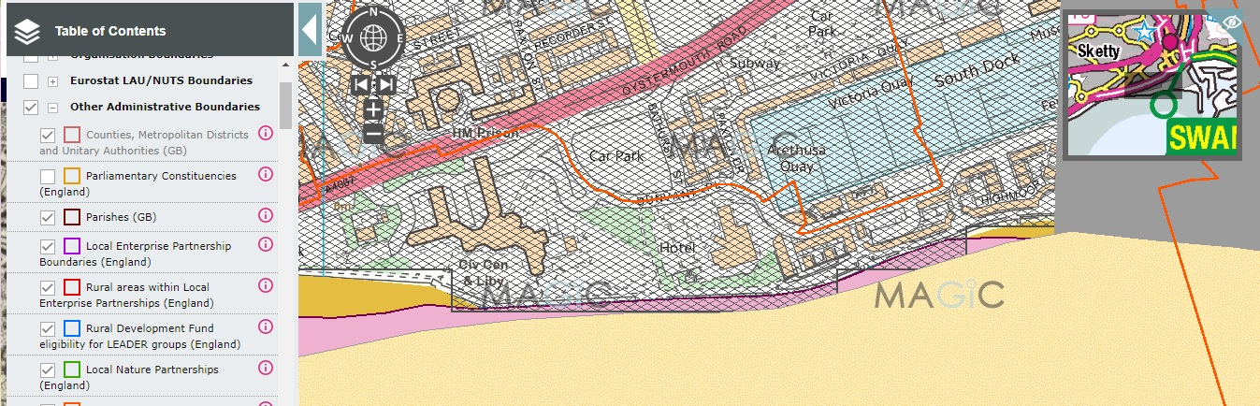
Figure 1 – Map of Local Area by landscape types
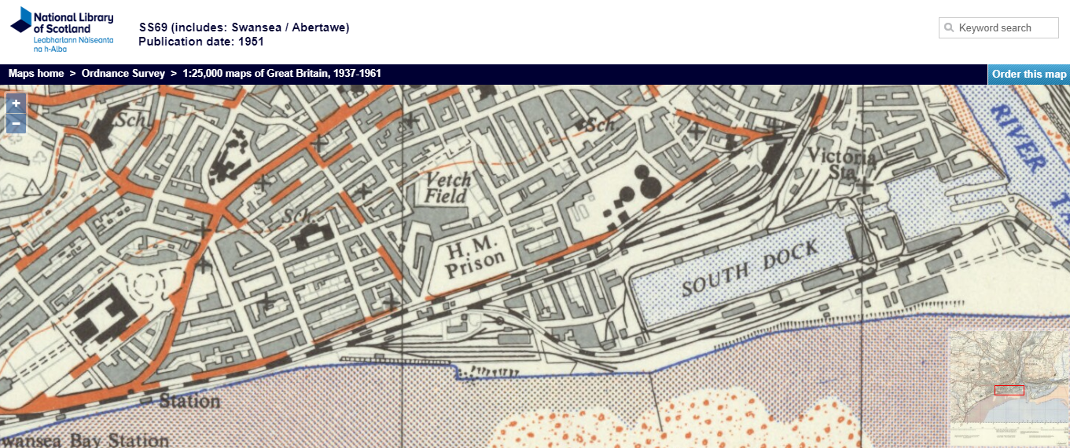
Figure 2 – Map of Local Area as of 1951
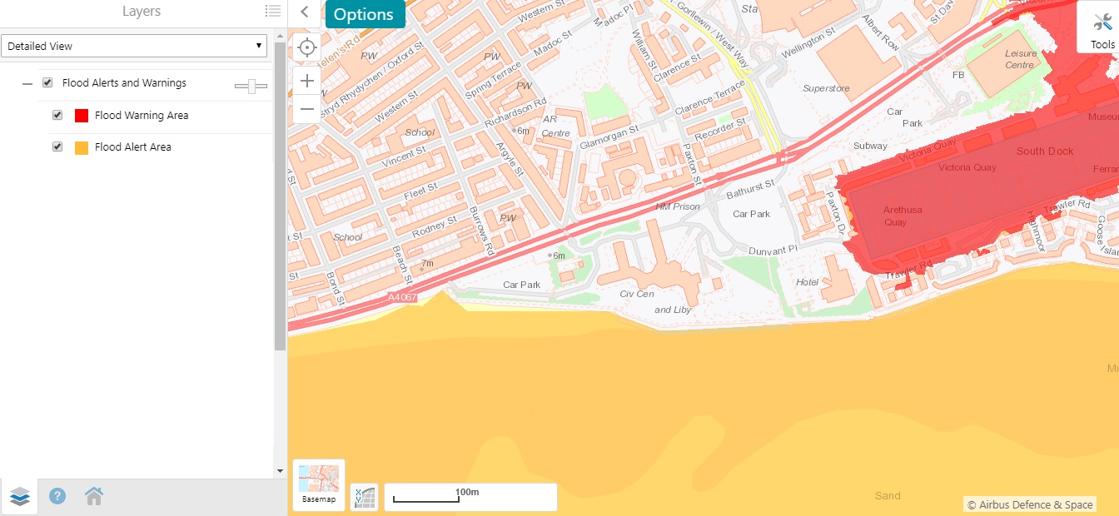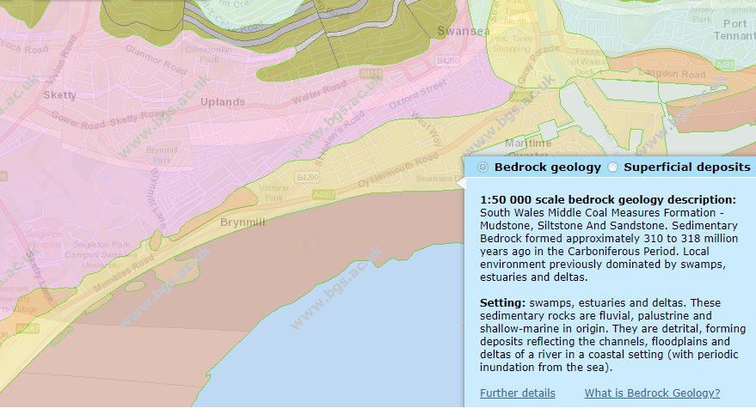
Figure 4 - Map of Flood Risk
Figure 3 - Map of Bedrock Geology
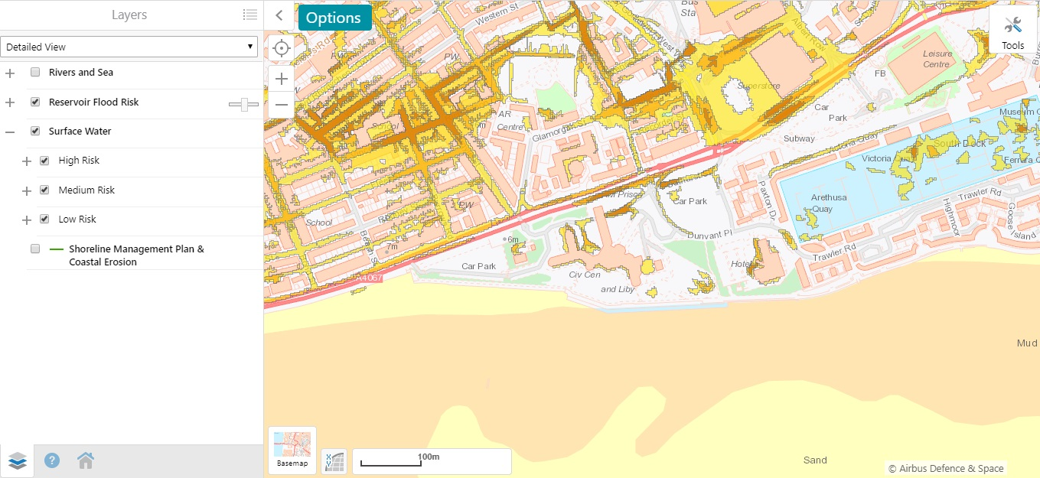
Figure 5 – Map of Floor Risk in the Area
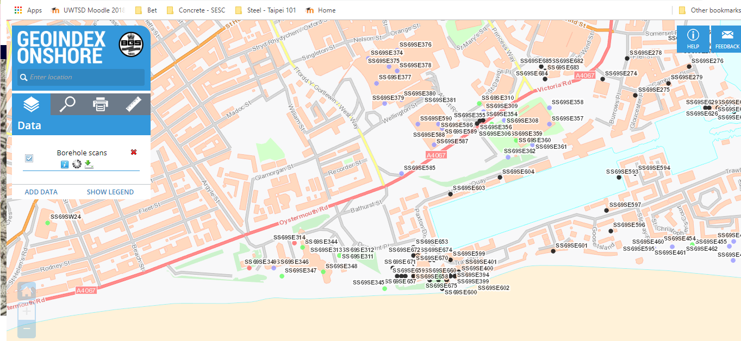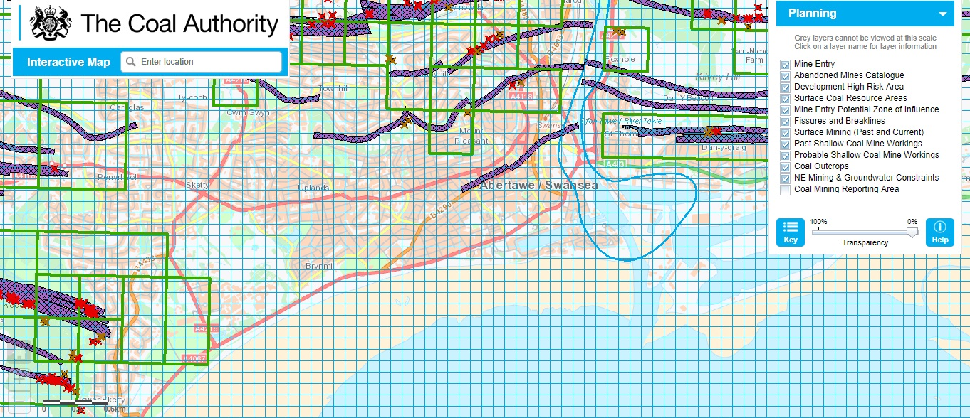
Figure 6 – Map of Borehole data in the Local Area
Figure 7 – Map of Historical Sites of Coal Excavation

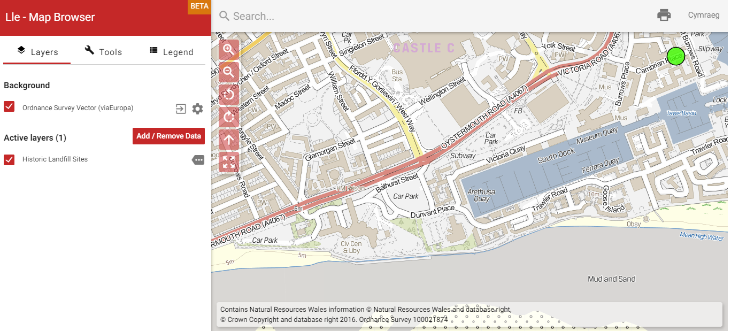
Figure 8 – Map of Historical Landfill Sites



