
Title page

Name | Zachury Shane Jassi
Student id | 2017021
Module code | BMSW6102
Module title | Developing Innovation and Creativity for Business Advantage
Lectures name | Dr Olu Adegbite
Assignment title | Coursework (Innovative Product/Service Plan)

Introduction
This report will pitch and discuss a new innovative vegan coffee shop, covering such aspects like the service provided, and the steps taken to open the business, the report expand on product, service, financing, and advertising regarding the vegan coffee shop. And determine payment techniques. The report will discuss ways to implement sustainability for the business.
Innovative idea
The innovative idea is to create a vegan based coffee shop/cafe that focuses purely on providing market worthy coffee and snacks made with all vegan products, whilst adopting a reduced carbon footprint approach. The product will be made using carefully sourced coffee beans that abide by fair trade certified regulations ensuring that all products are correctly obtained through the supply chain to meet sustainability and labor standards. The coffee shop will specialize in creating the most popular barista beverages using a range of vegan based milk alternatives, providing milk alternatives made from beans, nuts ,seeds and grains. The coffee shop aims to provide baked and confectionary products that similar non vegan based coffeeshops within the similar market offer, the coffee shop would adopt a unique approach to recycling by utilizing recyclable biodegradable, compostable cutlery and packaging to help lower the carbon footprint produced by the shop. the shop will provide Recycling points located throughout the store to allow easy recyclable options for customers who decide to dine in, the plan is to launch the shop in a prime city center location alongside similar market competitors, allowing easy and efficient access for the target customers.

The element of innovation within this coffee shop would be that an all-vegan coffee shop that adopts a reduced carbon footprint would allow a convenient place for customers who are vegan or have special diet requirements to visit and purchase their coffee. rather than customers having to purchase beverages and food from a limited menu in other similar non vegan establishments. this coffee shop would offer an extensive menu specializing in vegan products, focusing purely on vegan ingredients would allow for the shop to be able to offer a wide variety of products. Another main factor of innovation the coffee shop would offer is customers would be able to take away products to use at home. The shop would offer a range of vegan friendly coffee sachets, tea bags and vegan friendly milks to allow customers to enjoy the products in the leisure of their own homes, this type of service has not been offered by any other similar market competitor within the coffee shop market. The shop would utilize different types of innovative packaging for example re-usable coffee cups, customers who choose to take out their drink would have an option to reuse their cups which would result in less waste for the environment.

(The Vegan Society, 2017) Survey suggests that 91 percent of vegans crave and struggle for more vegan friendly embellishments. with many groups, companies and organizations highlighting the need for a more vegan plant-based lifestyle, claiming the great effects on environment if more people were to adopt a plant-based diet and lifestyle. And with many other animal cruelty parties who believe in minimizing animal products among the masses, major diet and lifestyle changes are happening in the current climate (Jones, 2020). With the number of vegans in the UK currently being at 3.5 million and growing rapidly the coffee shop would be a great innovator for the UK food and beverage market and would ultimately be a pioneer of the UK vegan market being one of the very first all vegan coffee and lunch establishments amongst the other high street brands like costa and Starbucks. The vegan coffee shop would allow for many people who ae vegan or people who have special diet requirements or even people who would like to replace their usual coffee with a healthier option to be able to conveniently be able to stop off at the shop and be able to purchase a wide range of vegan drinks and foods without having to worry about special diet requirements or truthfulness of the ingredients being used to make the products, creating a healthy alternative amongst other main high street competitors would provide great convenience for people who are on the go allowing people to choose healthier options and not being forced to use other brands just for convenience, research by (Smithers, 2020) suggest that vegans are calling for more vegan friendly establishments as the plant based lifestyle approach is rising dramatically.
Customer needs and wants.
with the vegan plant-based lifestyle increasing at a phenomenal rate, along with people being constantly urged by the government to become more ecofriendly, the coffee shop would be an excellent opportunity to fill a gap in the market, providing such customers with an establishment that caters for their needs as well as their beliefs and lifestyle choices. (Oliver, 2021) suggest there is a major growth in veganism, implying that this would be a major opportunity for business owners, investors and food developers, the coffee shop would essentially answer the wishes of vegans by finally providing an all-vegan ecofriendly coffee shop. The shop would provide a comfortable relaxed environment equipped with internet and charging points to be able to meet up for a coffee without having to worry about limited menus and diet requirements. the coffee shop would allow people to have somewhere to enjoy their favorite vegan drinks and food amongst family, friends, or colleagues, whether it’s a social meeting or a professional meeting. The coffee shop would also benefit the busy on the go customers by allowing them to purchase their vegan coffee conveniently and quickly, allowing customers to be able to take their coffee out to enjoy whilst they are completing their daily tasks.
Market competitors
popular high street coffee shops would pose as major competitors for the vegan coffeeshop, as well as smaller independent coffeeshops and cafes within the current market. brands like Costa and Starbucks are strong competitors for the coffee shop as these brands are major players within the current market. Costa coffee is said to have around 3,883 stores nationwide and is considered the nations preferred coffee for the 13th year in a row by world portals independent panel of customers (Costa.co.uk, 2019). Starbucks said to be the world’s leading coffee franchise operates over 1000 stores across the country and is planning to open more due to the rapid rise in customers (Masud,2023). Both competitors have major advertising campaigns with a substantial larger budget compared to the vegan coffee shop. both companies offer drive through services for customers, both companies also pride themselves are being carbon efficient and concentrating on the needs and wants of their customers. however, these competitors offer a limited range of vegan products within their stores giving the vegan coffee shop an advantage within the market. the vegan coffee shop plans to offer the same services as such competitors, with a lower cost to the environment and plans to fill the gap for today’s growing vegan society by providing an only vegan establishment, which in result would allow a major advantages for the vegan coffee shop.
The vegan coffee shop would plan to introduce customer loyalty cards to retain customers, the coffee shop would also utilize many offers and incentives for existing customers, the coffee shop offers customers to retain a reusable cup, this is part of the innovative approach to reducing the carbon footprint for the coffee shop. The coffee shop would offer customers a discount every time they use the reusable cups instore, the coffee shop would concentrate on finding new ways to be more efficient this in result would ensure sustainability for the business (Griffin, 1995).
Value chain analysis
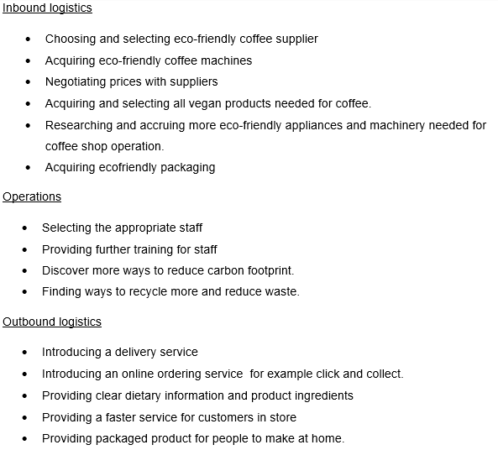

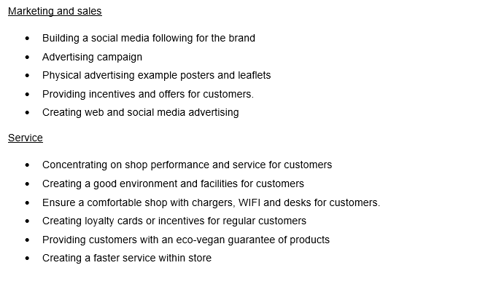
The plan is to open to the vegan coffee shop in a busy city center location, alongside similar market competitors for example costa or Starbucks. many benefits would arise from locating the store alongside market competitors, the shop would become a recognized brand and become recognized by the customers of competitors. The shop will offer the same convenience to customers that the market competitors have to offer, another benefit of setting up alongside market competitors, is the shop would have an advantage of passing traffic from competitors allowing a strong alternative option for vegans and persons with special diet requirements.
The vegan coffee shop would have to obtain a commercially leased property in order to set up the vegan coffee shop business, in order to secure a commercially leased property the coffee shop would have to arrange a legally binding contract with a landlord to secure the property. the building needed for the coffee shop would need to be a minimum of 1750 – 2000 square foot, with a large window shop front installed, the building would need to have such facilities like a kitchen, toilet, seating area, front of house /counter and provide wheelchair access, the property must be on a main high street alongside other major competitors within the current market, the shop would provide a relaxed environment with comfortable seating areas, desks, Wi-Fi, and charging ports.

Consideration of resources
People needed | Cost
Designers | £1000
Decorators | £1,450
Advertising team | £300
staff | £3,420 per month
Website/ social media designer | £600
Events planner | £900
Chief | £427 per month
Cleaner | £427 per month
Accountant | £50 per hour
Financial needs | Cost
Staff wages | £3,420 per month
Food and drink supplies | £600 per week
Payroll taxes | £513
Relative insurances | £600 per month
Rent | £2000 per month
Loan payments | £200 per month
Utility bills | £1,400
Equipment needs | Cost
Coffee machines | £3000
Coffee grinder | £2000
Cooking equipment | £1,500
Fridge and freezers | £1000
Ovens | £1000
Industrial blenders | £400
Industrial Dishwasher | £600
Industrial Microwaves | £300
Food preparation equipment | £3000
Shelving/ counters | £600
Decorating equipment | £600
Security system | £2000
Advertising equipment | £200
Cleaning equipment | £400
Materials needed | Cost
Food | £300
Ingredients | £1000
Cleaning products | £200
Flooring | £3,500
Décor materials | £645
Seating | £2000
Tables | £1,200
Cutlery | £600
Recyclable food packaging | £670
Staff uniform | £450
entertainment | £2,600
Soft drinks machine | £1000

The vegan coffee shop will cost around £50,000 to set up. the vegan coffee shop will plan to apply for government startup up business loan. A financial plan would be put together to demonstrate the finances needed to set up the business, the financial plan would include, investment budget, financial budget, operating budget, cash flow budget and personal expense budget, this would allow the government to gain an understanding of the business and determine they type of loan needed the amount and duration of the loan.
The vegan coffee shop would utilize numerus payment methods, to ensure the most convenient experience for customers. customers would be able to pay using cash, bank card, contactless payments and apple pay. The coffee shop will comply with all Payment Card Industry Data Security Standards Rules and regulation, to ensure the privacy of customers personal information and details. Such standards will be adhered to by producing self-reported questionnaires and undergoing a security assessment and providing an AOC (Fruhlinger, 2020).

The coffee shop will take advantage of a wide range of promotion techniques to promote the coffee shop, to expand on this, theses promotion techniques can be broken down into further segments.
Social media
The coffee shop will use a range of various social media platforms to promote and advertise. social media platforms are a highly useful for advertising in current times, social media advertising is said to be the most cost-effective way to advertise a new business costing next to nothing if social media is set up and designed in house. As previously mentioned in the assignment the coffee shop will target customers between the ages of 18 and 35, research by (The Global Statistics, 2022) suggest people spend on average of 2 hours per day on social media in the UK, so this would be an extremely effective way to reach customers, the shop would make use of various social media platforms, like Facebook Instagram and Tik Tok, with the use of such social media platforms would allow the shop to boost brand awareness and reach target customers, most social media platforms provide some analytic tools for users, which would be extremely helpful in understanding the customer base and gain an idea of customer buying habits as well as increasing customer traffic within store. A strong social media presence would help build brand credibility and allow customers to view products, store location, and prices (Leung, 2013).
Billboard and leaflet marketing
The coffee shop would implement a range of billboard and leaflet marketing techniques, the shop will promote and advertise the brand and service in high traffic areas, creating a touch point for customers and allowing customers to gain an idea of the shop. The billboard would allow customers to be able to gain a brief knowledge about the product and service available, and in return provide a brief pitch for consumers, by using bright colors and images to catch customer attention. The coffee shop would also utilize a range of leaflets for customers and business, the shop would provide door to door and hand to hand leaflets within the local area providing customers an idea of the service and product available. The shop would also distribute leaflets to other business within distance of the shop allowing their staff to gain knowledge of the shop, which could result in them swapping out their local morning coffee establishments for vegan coffee shop. The coffee shop would also use redeemable promotions in store with the use of one of the leaflets, this would result in customers willing to try the shops products for a reduced price.

Website and paid search engines
A website would provide a detailed evaluation of the service the shop has to offer, allowing users to find the location of the shop and the products the shop has to offer as well as a detailed price list. The web site will have the coffee shops mission statement on the homepage allowing customers to really understand how the shop operates, the products provided and the shops purpose. Paid search engine advertising would be extremely useful for the vegan coffee shop as the website would pose as great advertising for when customers are searching for establishments that provide vegan food and drinks, this would result in recognition and provide a sense of legitimacy for the shop.
Target market
As the research of (Wunsch, 2023) suggests that a vegan diet is more adopted by the younger generations rather than the older generations the coffee shop would target customers aged between 18 to 35 who essentially live a vegan life style or have unique diet requirement or those who have chosen to make a healthier choice whilst purchasing their daily coffee or lunch, the coffee shop would also target customers who are concerned with creating a lesser carbon foot print on the planet and people who are choosing to avoid any animal products within their diets. The shop would target customers who work, live, or visit the city center, appealing to such customers who are concerned with demonstrating a lower carbon footprint, with the use of ecofriendly and biodegradable packaging (Wark, 2021).
The target market/customers for the vegan coffee shop would be reached by all the customer touch points the marketing, promotion, and advertising techniques the shop has utilized, incentives and advertisements would allow customers to feel intrigued and invited, by creating these positive touch points through advertising would essentially draw customers into the store.

Pre-launch/opening promotion event.
To launch the vegan coffee shop cafe the shop would host a pre-launch opening ceremony event for customers, the event would offer redeemable in store offers on all products and provide free samples of each product for customers to try and allow customers to gain an experience of the service, decor, facilities, and products the shop has to offer. By offering a pre-launch promotion for consumers this would attract new customers and passersby’s and could possibly attract customers who generally aren’t vegan or haven’t tried vegan products before. This would allow staff to interact and engage with customers and create an unforgettable welcoming experience for customers. Ultimately providing customers with an idea of the mission of the coffeeshop.

Reference list
Costa.co.uk. (2019). Terms & Conditions | Costa Coffee. [online] Available at: https://www.costa.co.uk/terms-and-conditions#the-nations-favourite [Accessed 6 Mar. 2023].
Fruhlinger, J. (2020). PCI DSS explained: Requirements, fines, and steps to compliance. [online] CSO Online. Available at: https://www.csoonline.com/article/3566072/pci-dss-explained-requirements-fines-and-steps-to-compliance.html [Accessed 8 Mar. 2023].
Griffin, J. (1995). Customer Loyalty. [online] Available at: http://altfeldinc.com/pdfs/Customer%20Loyalty.pdf. [Accessed 16 Mar. 2023].
Jones, L. (2020). Veganism: Why is it on the up? BBC News. [online] 2 Jan. Available at: https://www.bbc.co.uk/news/business-44488051 [Accessed 10 Mar. 2023].
Leung, X.Y., Bai, B. and Stahura, K.A. (2013). The Marketing Effectiveness of social media in the Hotel Industry. Journal of Hospitality & Tourism Research, 39(2), pp.147–169. [Accessed 16 Mar. 2023].
Masud, F. (2023). Starbucks to open 100 new UK stores this year. BBC News. [online] 6 Mar. Available at: https://www.bbc.co.uk/news/business-64861166 [Accessed 11 Mar. 2023].
Oliver, C. (2021). Veganism, Archives, and Animals: Geographies of a Multispecies World. [online] Google Books. Taylor & Francis. Available at: https://books.google.co.uk/books?hl=en&lr=&id=M7Z9EAAAQBAJ&oi=fnd&pg=PP1&dq=veganism+growth&ots=R0HxjZcHO6&sig=PIxflcjgyL6bO6s8lvbF2oe0faE#v=onepage&q=veganism%20growth&f=false [Accessed 16 Mar. 2023].
The Vegan Society. (2017). New survey shows 9 in 10 vegans want more ‘grab and go’ food options. [online] Available at: https://www.vegansociety.com/whats-new/news/new-survey-shows-9-10-vegans-want-more-%E2%80%98grab-and-go%E2%80%99-food-options [Accessed 9 Mar. 2023].
The Global Statistics (2022). United Kingdom (UK) Social Media Usage Statistics | Mobile & Internet Statistics. [online] The Global Statistics. Available at: https://www.theglobalstatistics.com/uk-social-media-usage-statistics/. [Accessed 11 Mar. 2023].
Smithers, R. (2020). UK demand for new vegan food products soars in lockdown. The Guardian. [online] 25 Jul. Available at: https://www.theguardian.com/lifeandstyle/2020/jul/25/uk-demand-for-new-vegan-food-products-soars-in-lockdown [Accessed 9 Mar. 2023].
Wunsch, N.-G. (2023). Topic: Veganism and vegetarianism in the UK. [online] Statista. Available at: https://www.statista.com/topics/7297/veganism-in-the-united-kingdom/#topicOverview. [Accessed 15 Mar. 2023].
Wark, C. (2021). 30 Ways to Be More Eco Friendly in 2020 | GreenMatch. [online] www.greenmatch.co.uk. Available at: https://www.greenmatch.co.uk/blog/how-to-be-more-eco-friendly. [Accessed 9 Mar. 2023].

