database design
SAMIA ASSEBAB

Table of Contents

INTRODUCTION 1
Immediate Retrieval 2
Immediate Information Storage 2
Prompt Update 2
Automated Calculation 2
Security 2
Recovery and Backup 2
Efficiency 2
REQUIREMENT SPECIFICATIONS 3
ERD OF BOOKSTORE MANAGEMENT INFORMATION SYSTEM 3
DATABASE TABLE SCHEMA 4
QUERY DESIGN AND REPORTS 4
USER INSTRUCTION 8
How to use a switchboard to navigate database application? 8
How to use reports to produce managerial information? 10
USER MANUAL 12
Introduction 12
Uploading and Downloading files 12
Running the Application 12
Configuring the system 12
Accessing the database 12
CONCLUSION 12

INTRODUCTION

A bookstore’s daily activities include handling customer transactions, purchasing books from publishers, and effectively coding the relevant data. The metadata of a book includes: title, Author credentials, publishing body, price, stock amount, etc. The database system provides a simple way of managing inventory, managing sales and customer data. This report will evidence and explore all the appropriate processes involved in creating a bookstore management database system.
Due to the rapid growth of Dylan's Bookstore, its management has experienced several challenges in properly maintaining and storing data, they have requested the implementation of a computerized database system that will aid them in their day to day activities as well as eliminate or reduce any of the prominent challenges previously faced. These challenges are as follows;
- Data Redundancy, the unstructured and unorganized nature of the current database makes it increasingly difficult to locate files on demand. The recreation of files creates a larger storage vent which exhausts the companies time and capital.
- The lack of data entry due to poor functionality means appropriate stock intake and sales are not recorded. Leaving the company vulnerable to theft and unavailable stock.
- The loosely estimated number of stock available is unreliable and causes multiple threat such as fire hazards (as shot has reached beyond capacity) and financial threat as ordering the wrong book could lead to a revenue deficit.
- Product damage, overestimating produce leads to innovative methods of storing, the use of unsuitable surfaces such as the floor allows the possibility of product to be damage with dust and dirt, moreover, it effects the company’s image as the store looks unprofessional and unkept.
- The rapidity of service depends on the limited numbers of staff, thus subjecting customers to long waiting periods this can be perceived as bad customer service and discourage consumers from revisiting.

The proposed database system will aim to solve the current dilemmas faced by the staff at Dylan’s Bookshop or lack thereof. System functionality will be improved by focusing first on the challenges faced by the current system.

Immediate Retrieval
The automated system will allow user to simply and promptly retrieve the required information by simply clicking a button.

Immediate Information Storage
Data storage will inherit an uncomplex process in the proposed system as it will be making use of storage devices. This will be implemented through visualization of data and information. This will be backed up will backup protocols in place to insure maximum availability and data integrity.

Prompt Update
Integrated software to automatically update the system will reduce time exhaustion and the need to be technically informed, the system will automatically edit and delete the unwanted information such as cache. This will insure a smooth-running system with little downtime.

Automated Calculation
The integrated calculator application will allow the staff member to accurately imburse customers while simultaneously tracking revenue and other consumer patterns such as bestselling book, most favored genre and so forth, this will allow Dylan to optimize and customize his book store in correlation to the consumer demands.
The proposed database system will help to reduce and eliminates data repetition (redundant data) across the files, thereby maintaining originality (integrity). For updating, manipulation, and editing of data, the proposed system will enable an easy quick and editing experience with a path of previous version, if a file needs to be reverted to its original state. focus will also be extended to improving the data processing and security of business information, supplier data and customer data.

Security
The system will be secure as unauthorized persons will not be able to access the system without authentication credentials.

Recovery and Backup
The system will enable the user to recover all the system database in case of power cut, drive failure or any other compromise. it will be able to backup using external drives and an online backup database.

Efficiency
The system will include all the elements necessary for efficiently running the bookstore, this will cause a spike in efficiency and productivity as its automated nature requires little upkeep.

REQUIREMENT SPECIFICATIONS

Software and Hardware requirements include the following:

- Operating systems Windows XP,7.8,8.1&10
- Microsoft Acess 2010
- Intel i5 +
- Antivirus software
- QUAD Core Processor
- 4/8 GB RAM
- 4 TB hard Disk
- NAS units (dependent on budget)
- Scanner / Printer

ERD OF BOOKSTORE MANAGEMENT INFORMATION SYSTEM

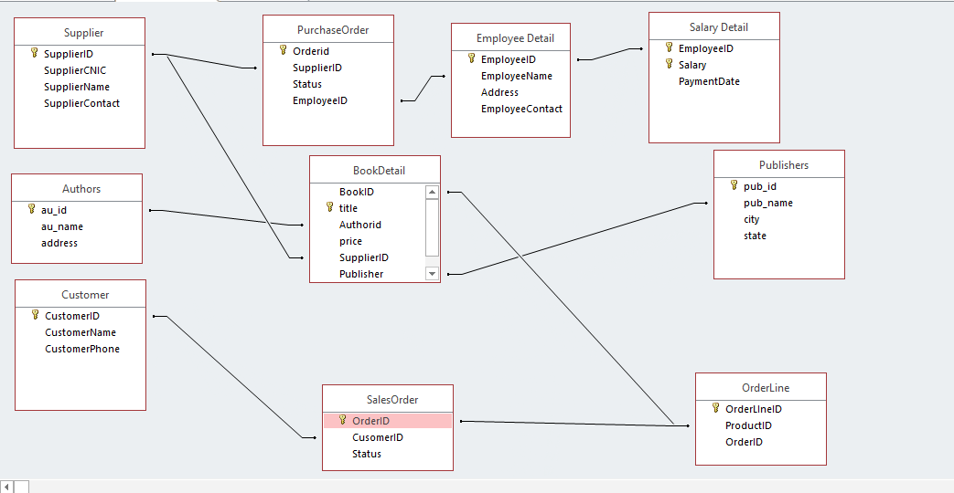

Having established the requirements and provided a specifications list, the first part of the planning process begins, whereby the user’s requirements are contextualized into an entity relationship diagram.

DATABASE TABLE

The entity-relation database is adapted from the requirements stage with all appropriate entities outlined and apparent. The entities then become a table in the database and where they form the attributes where data is stored.

QUERY DESIGN AND REPORTS

Select all customers
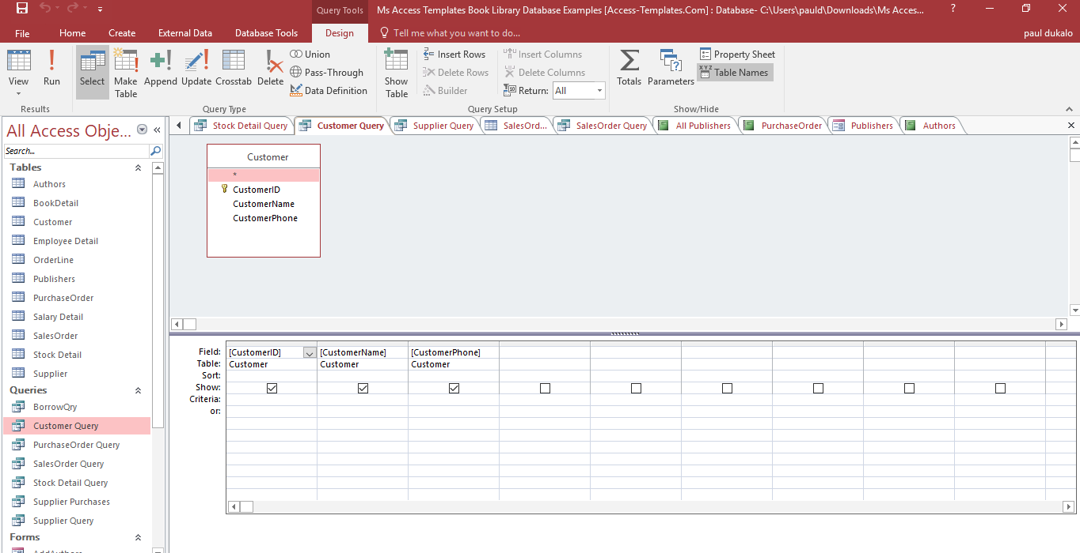

Select All Current orders
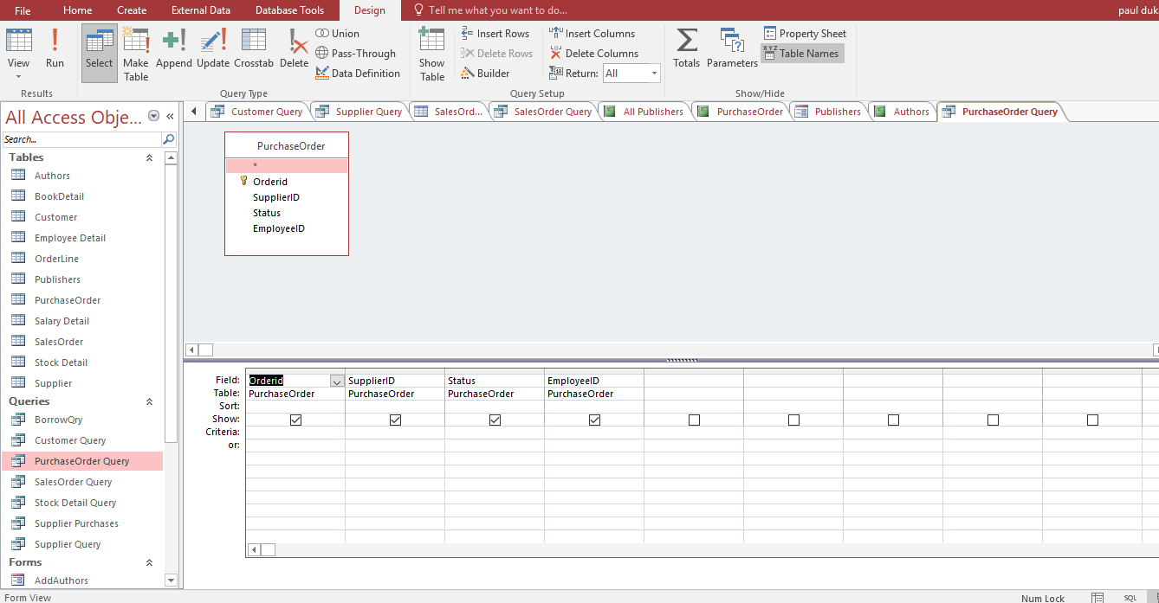

Select all Pending orders
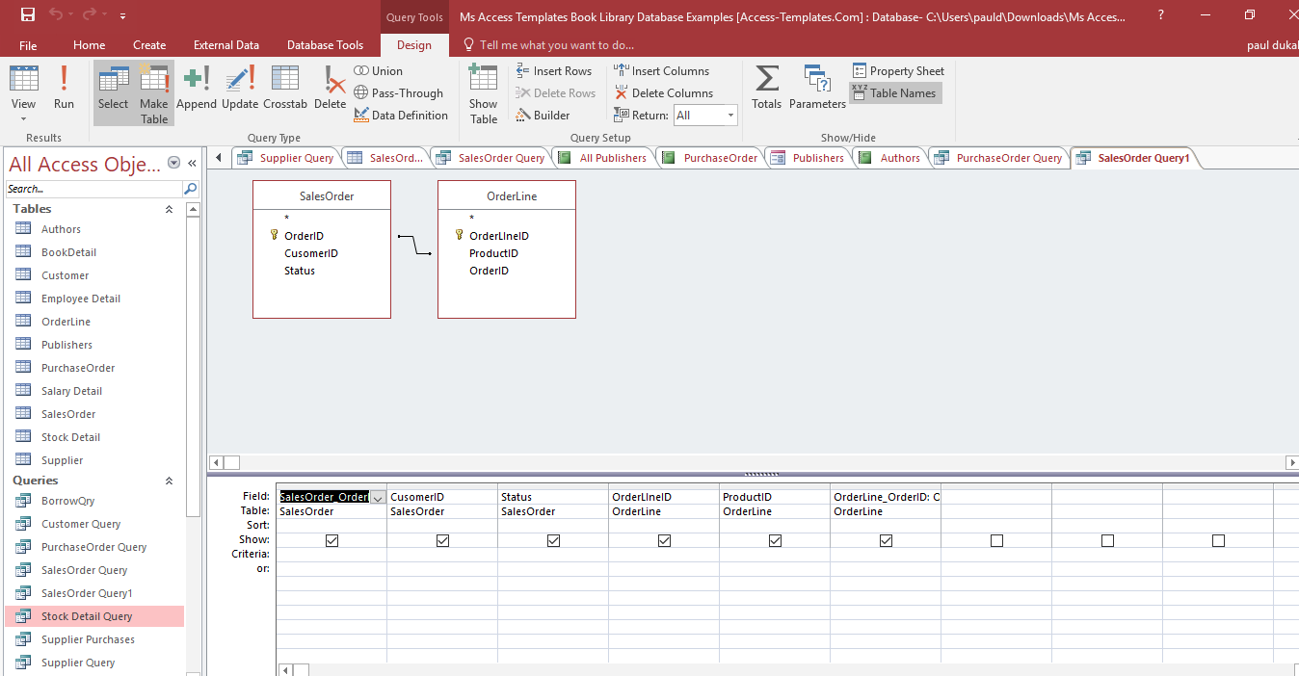

All Publishers
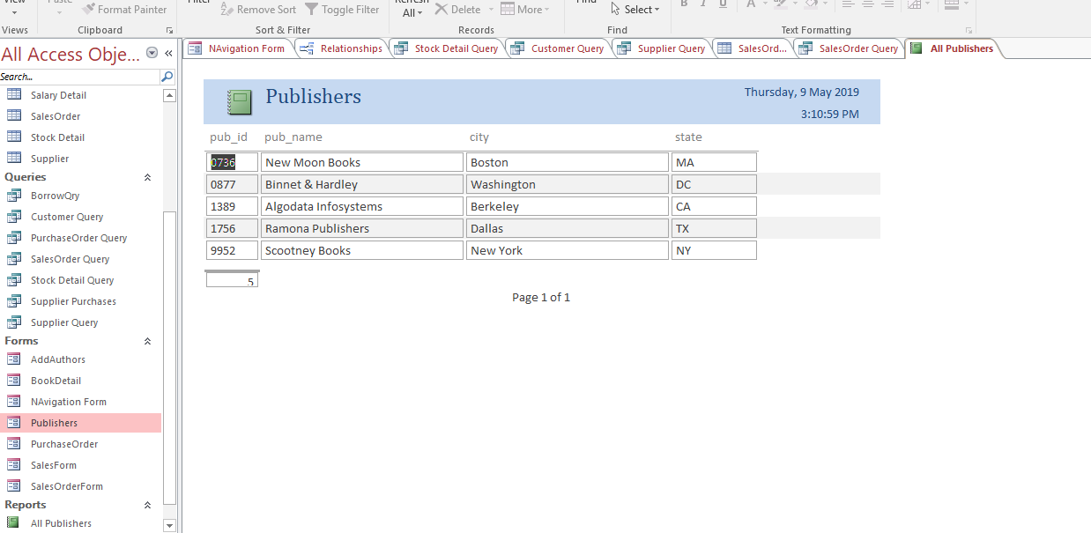

Purchase Order Report Design
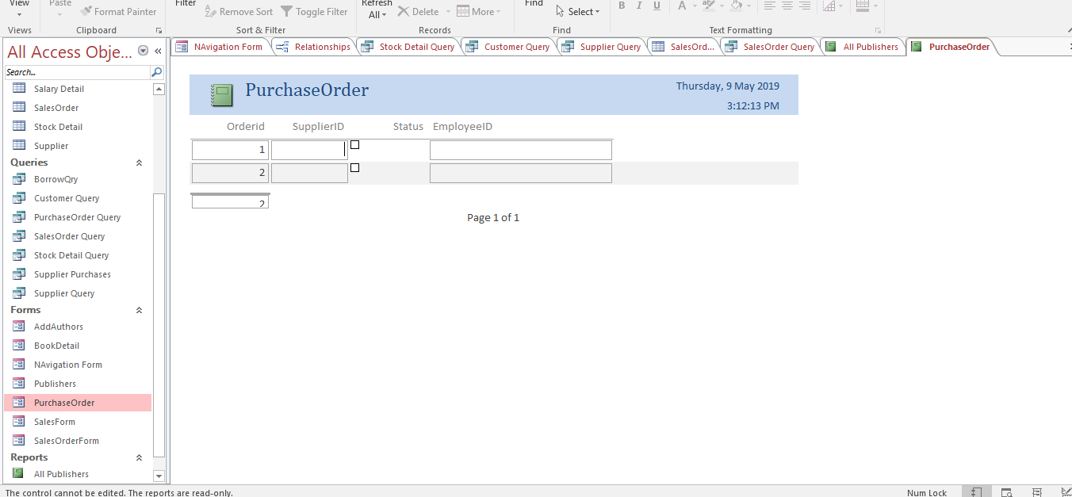

Report Authors
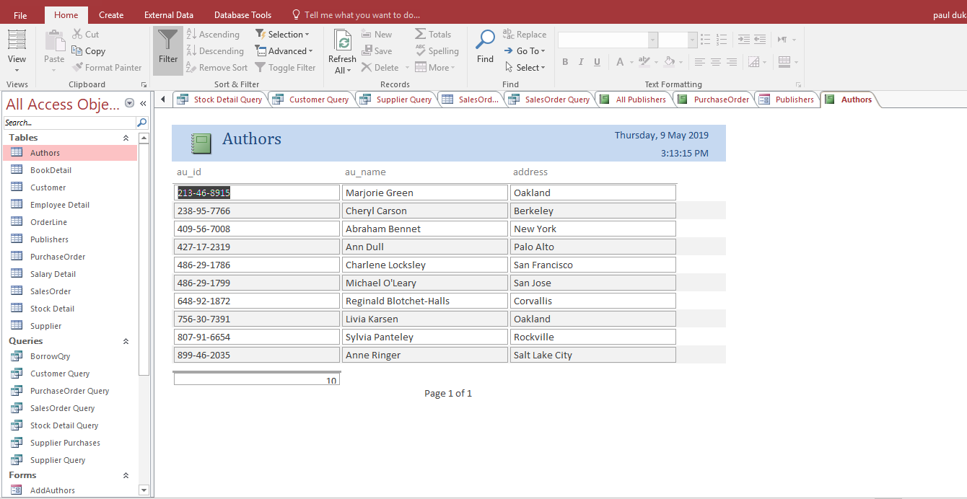

Navigation Menu
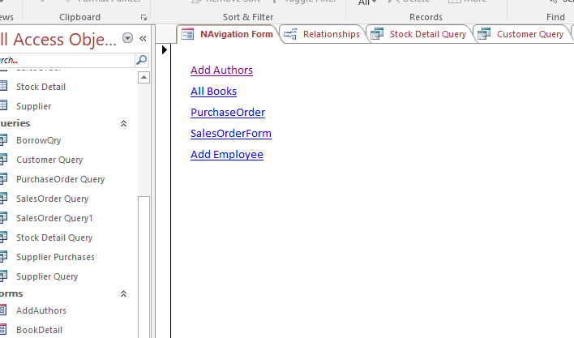

The database system for the proposed system will enable Dylan to create a query of their products by selecting the type of product, the quality of said product, the accumulative cost and the customer wishing to purchase or borrow it. It will determine the amount of stock remaining in the premises and the amount stock sold, which help in the budgeting and stock replenishment through query creation. Additionally, to find the total stock value by each author, we create a query with the design view as follow:

USER INSTRUCTION

How to use a switchboard to navigate database application [1]?

- Open the file “Bookstore management system.accdb”
- In the interface is the Menu which contains buttons which link to forms and reports.
- On the left side, there are three forms: Authors, Books, and Publishers. On the right side, there are three reports: LBC's books published in 2001, Stock Amount of each book and Total Stock Value by Author.
- To open a form or report, click on the button.
- To return to Menu and open other form and report, close the current form or report by right click on the tab and click close.
- To open other objects such as a table, query, etc. double click on the "All Access Objects" panel on the left.
- To close the Menu, click the "Close" button on the left side of the title "Dylan’s Bookstore".
- To close the system, click the "Exit" button on the right side of the title “Dylan’s Bookstore”.

How to use the form to enter data to table implemented?

- If you want to enter the new data, you can do it via the form. For illustration, if you want to enter data of a new author, please follow these steps:
- Open the form Author by click on it on Menu or on the “All Access Objects” panel.
- Click the button at the bottom of the form.

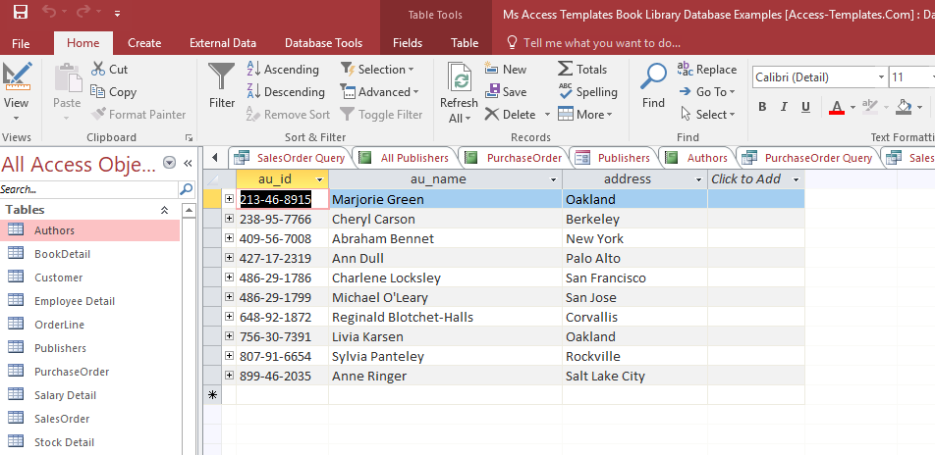
Figure 19: Enter new data

- Enter the data of the new author in the box next to the title: Author ID, Last Name, etc.
- The other new information of books or publishers will be entered with the same process with a different form.

How to use queries to extract data from the database [2]?

- QryBooksbyAuthor15in2002. This query helps users to find the books written by Author 15 and published in 2002.
- QryLBCbook2001. This query helps users to find books published by LBC in 2001.
- QryMaxStockAmt. This query helps users find the books have the largest stock amount. With this information and the report about sales, the users can know sales status of this book and find some solution to boost the sales such as gives discounts, display at the place which attracts buyers, etc.
- QryMinStockAmt. This query helps users find the books have the smallest stock amount. With this information and the report about sales, the users can decide on whether to import more books to sell.
- The Queries are grouped in the "Query" tab in the "All Access Objects" panel. Please, double click on the query you want to open.

DYLAN BOOKSHOP

How to use reports to produce managerial information?

- LBC’s books published in 2001: The report is about the books published by LBC in 2001.
- Stock Amount of each book: The report displays all the stock amount of each book in the order from the largest quantity to the smallest. The report also includes the total stock amount. Therefore, this report helps the users to know more about the inventory of the store. Through this, the manager can make decisions on importing which book, boost which book's sales, etc.
- Stock Value by Author: The report displays all the stock value by each author. This report helps users forecast the maximum sales if they can sell all the books, find the author who can bring more sales and profit to the stores, etc.
- To open the report, click on the button on the Menu or on the "All Access Objects”.
DYLAN BOOKSHOP
Figure 21: Open reports

USER MANUAL

Introduction
This document entails the procedures and processes necessary to guide the user to accomplish the task that the system should perform.

Uploading and Downloading files
This phase allows the user to install the operating system by downloading the files and uploading them to their computer. The user follows the steps of installation until completion.

Running the Application
Upon successful installation, they will need to run the program by simply pressing continue. The user will have to enter their pre assigned credentials to access the system they will be promoted to change these credentials for security purposes before commencing

Configuring the system
The system does not rely on manual configuration, except that the admin would assign other users if they wish, however the admin will always have full RW permissions so this can be altered at any time.

Accessing the database
The user will have to access the database by refreshing each form, in case the database is not visible. If the database is visible the user will only access it through the correct credentials.

CONCLUSION

At this moment the Bookstore Management system is complete and functioning effectively as it has met all the specification as per the requirements presented. The system is faster compared to the previous system thus increasing productivity. The issue with data redundancy, loss of data, delay when serving the clients among others have been successfully remedied.
Long term recommendations are as follows:
Insure healthy hardware and software maintenance through proper ventilation and checking package temperature internally. Regularly cleaning the hardware from dust as the library environment is known to be dust prone.
- Never postponing software update
- Uninstalling any files from the operating system file
Neglecting to adhere to these recommendations may cause system failure or irreversible damage or data loss.

REFERENCES

[1] | Microsoft, "Create and use a switchboard," Microsoft, [Online]. Available: https://support.office.com/en-us/article/create-and-use-a-switchboard-f8b3d607-8f1f-4ecf-9979-79b1565f5471. [Accessed 2019].
[2] | Microsoft, "Create a simple select query," Microsoft, [Online]. Available: https://support.office.com/en-us/article/create-a-simple-select-query-de8b1c8d-14e9-4b25-8e22-70888d54de59. [Accessed 2019].

