STUDENT NAME  PROGRAMME | PETER NGUTY ACHA  2018019  CERTIFICATE OF HIGHER EDUCATION SKILLS FOR THE WOEKPLACE, HEALTH AND SOCIAL CARE
MODULE CODE | BMSW4001_BIRM
LECTURER | ABDI RAHMAN
ASSIGNMENT TITLE | REFLECTIVE REPORT
Contents
- Introduction
- Report
- Personal Development Plan.
- Conclusion
- Reference list

In my reflective report I have used the GIBB’S reflective cycle because it has help me to plan, analyse, and examine what I did well and what I did not in these 9 weeks of learning at the UWTSD. It is also the most famous reflective cycle ever used to let you go through distinct phases to make sense of an experience and its consequences.
The GIBB’S (1998) reflective model has six stages of reflection which are:
- Description
- Feelings
- Evaluation
- Analysis
- Conclusion
- Action plan.
Gibbs reflective cycle (1998)
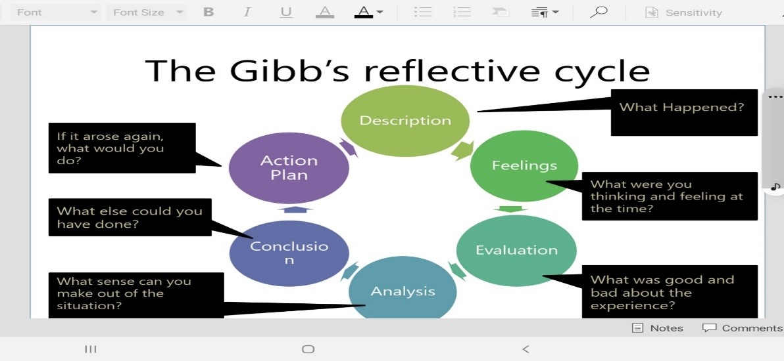
A reflective report is a piece of writing that summarises a student's evaluation reflection on a particular subject.
- According to Hatton and Smith (1995) Reflective reports are one of the most common methods used to assess work–based learning. Students across all disciplines are assessed on the quality of their reflective report.

- In week one
In the first week we received induction into the module, the aims, and the learning outcomes.
Aims: -
- To provide students with the underlying study, research strategies and software skills to facilitate effective study in Higher Education
- To enable students to take responsibility for their own learning.
- To enable students to gain confidence and competence as effective employees by developing a range of employability skills such as reflection, time management and presentation skills.
Learning outcomes-
- Analyse published literature relating to specific topic or subject area and produce a fully referenced, correctly structured academic report-
- Reflect on their learning using recognised models of reflection-
- Research and present their findings in a variety of formats on a range of employability skills and collect and analyse feedback on their delivery.

We learned about diverse types of notes taking and note taking skills and why note taking is vital.
According to Brown, C, (2015) “If it feels like you forget new information as quickly as you hear it, even if you write it down, that is because we tend to lose almost 40% of new information within the first 24 hours of first reading or hearing it. If we take notes effectively, however, we can retain and retrieve almost 100% of the information we receive.”
We also learned about the importance of time management and how effective it could be applied in diverse forms and situations.
In a concise summary I will say we discussed and practiced notes taking and note taking techniques.
We also discussed time management and even developed diverse study plans.

- In week 2
We learned and discussed about how to identify what is needed of an assignment and the purpose of assignment.
We learned that the purpose of assignments is for formative assessment such as class task while summative assessments are mid-term and end of term assignments.
We also discuss that what makes a good assignment are: -
- Focus on the set question/topic/task
- It should have a clear structure and easy to follow
- Is professionally research and supported with evidence
- It should be in accord with academic conventions
- Is correctly referenced
- Is well presented respecting the instructions given
We also discussed and practice how to apply the “CRAAP” test while gathering our information.
We also learned about using important sources to gather our information.
We also learned about sources that are not reliable for finding information.
Here is a summary of what we learned in week 2
- understanding assessment
- Finding important sources of gathering our information
- Using the CRAAP test while gathering our information.
According to Nazlin Bhimani (2017) CRAAP test is important to evaluate where and what you search and find. This means we must check the Currency, the Relevance, the Authority, the Accuracy, and Purpose of the information.

In week 3 we explore the following: -
- we explore about understanding Referencing and citation.
- We also explore the dangers of breaching academic laws or rules.
- We also learned and practised constructing references from websites, journals, and books.
We learned that when referencing we must take into consideration these words:
- The who
- What
- When
- Where
- Why
- How
Jacob Smith (2020) Referencing, or citation is a way of giving credit to someone's work that you have used in your research. It helps in pointing to the originality of the thoughts and ideas used in the research activity. For your academic assignment or finding, works.
We also learn that we can reference from the following sources:
- Books
- Journal articles
- Magazines
- News papers
- Websites
- Diagrams or printed pictures
- Documents
- Interviews
- Etc
We did also explore the dangers of plagiarism.
As stated by Olivia Valdes (2019) Plagiarism is the practise of taking credit for some else's words, works or ideas in another sense presenting someone else's works like your own.
We also learned how to use the ‘cite’ tool on the library website.
We also explore using citations and we also learned that longer quotations should be entered as separate paragraph.
We also explore about paraphrasing, paraphrasing Skills and referencing skills.
- In this week I can summarise that we explore the meaning of plagiarism, and the dangers of plagiarism.
- We learn and even practice referencing and citation.
- We also explore how to paraphrase our work.

In week 4
In week 4 we learned about academic writing.
What is academic writing?
As stated by Zhihui Fang (2015) Academic writing is done for academic purposes. It is entering in conversation with others, but the method this conversation is executed is different from how everyday conversation unfolds. It involves expressing your ideas, but those ideas need to be presented as answer to some other person or group, and they also need to be carefully analysed, well propped with evidence, logically sequenced, rigorously reasoned, and firmly joint together.
We also learned about the following: -
- Composition of sentences.
- Composition of paragraphs.
- Using data.
- Planning our assignments.
We learned that sentences must have a verb, a doing word.
We also learned and practiced about the three distinct types of sentences which include simple sentences, compound sentences, and complex sentences.
- WE learned that a simple sentence has a subject (the person or thing doing the action) and a verb, sometimes followed by a phrase of other information. Putting them together it makes sense a unit.
- WE also learned that compound sentences are two simple sentences usually joined by (and) or (but). There will be two verbs in this combined sentence.
- We also learned that complex sentences have a main clause and subordinate clauses. A main clause is a unit of meaning built around a verb. A subordinate clause also contains a verb, but it would not make sense if it were written on its own but often provides depth of description to the main clause.
- We also learned that a paragraph is a unit of text which usually contains several sentences.
We also learned how to use data in our work and how to build a sentence around data.
We learned how to plan our task and how to structure or work.

In week 5
In week 5 we had a presentation skills workshop.
As stated by Alison Doyle (2020) Presentation skills refers to all the qualities one needs to create and deliver a clear and meaningful presentation. While what you say during presentation matters.
Employers also value the ability to create supporting materials, such as PowerPoint slides.
We also learned that any good presentation has three phases.
- Preparation
- Delivery
- Follow-up
Preparation
Preparation involves research and constructing the presentation.
This may imply writing notes, designing the whole text, and creating any slides and other supporting visual or audio materials.
Delivery
This is the part that attracts the audience. A sound delivery depends on careful preparation and needs its own distinctive abilities.
Follow-up
The follow-up includes contacting any audience members with whom you agreed to communicate further, and asking, collecting, and analysing feedbacks.
You may even collect information from them such as their names and even their contact information or completed surveys.
- We also learned about some presentation skills such as: -
Verbal communication
- The skill to communicate in a clear, concise, and substantive manner Infront of an audience is the paramount key required of public speakers.
Delivery
- This is how you connect with your audience. It includes skills such as body language and pauses that give your words meaning.
Hamor
- Your presentation should be amusing and entertaining. You do not have to be a good entertainer to deliver a good presentation.
Selling or Persuasion
- A presentation is about marketing your ideas adapting persuasion techniques.

Written and visual communication
- Your visual elements such as your slides should be short, easy to perceive, understand, or interpret.
Adaptation
- No matter how much you prepare it is possible for your presentation to go off in an unusual way especially when you involve audience. The ability to adapt is a vital presentation survival skill.
Listening
- Listening actively is key to leading audience participation.
Gestures and using 3d Space
- Physical communication consists of effective use of the stage and gestures.
Dealing with difficult personalities
- You should have the ability to deal with audience participation challenges.
We ended up week 5 with Task1 Academic Report Workshop.

In week 6
In week 6 we learned about employability skills.
As claimed by Alison Doyle (2020) Employability skills are key skills required in every job. These are the general skills that make someone outstanding to an organisation.
Hiring agents or employers look for employees with these skills.
We also learned what is employability.
Harvey (2003) Employability is more than about developing attributes, techniques, or experience just to enable a student to get a job, or to progress within a current career. It is about learning and the emphasis is less on ‘employ’ and more on ‘ability.’ The emphasis is on developing critical, reflective abilities, with a view to empowering and enhancing the learner.
We also learned that employability skills are the transferrable skills that makes a person employable.
We explore some top employability skills such as:
- Spoken communication
To be able to express your ideas clearly and confidently in speech.
- Teamwork
To have the ability to work confidently in group.
- Commercial awareness
Understand the commercial reality affecting the company.
- Leadership.
Show leadership by motivating and directing others, taking responsibility for the direction and activities of a team, setting goals and objectives, breaking down work into attainable and shareable components, directing and mentoring colleagues and introducing improvements into work practices.
- Written communication.
Be able to express yourself clearly in writing.
- Time management
Manage time effectively, prioritising tasks and able to work to limited time.
- Zeal the Drive.
Determination to get things done. Make things happen and constantly striving for better.
We also explore that the top two skills required by employers are
- Are good verbal communication.
- Team working.
In a summary of week 6, I would say we learned what is employability, what is employability skills, top employability skills and the top two skills required by most employers.

In week 7
In week 7 we explored the key features of job advertisements.
We were shared into groups and were given time to work on our group task.
We also explored that the key features of job adverts. are
- Employer name
- Job title
- Description of job role
- Details of qualifications and skills required
- Information relating to pay and benefits
- Application deadline

In week 8
In week 8 we had a power point presentation on job advertisement, and I my group designed an advertisement on PowerPoint about a job vacancy for a Cognitive Behavioural Therapist (CBT).
As stated by Parker (2001) PowerPoint, Keynote, and their electronic slideshow siblings have become pervasive and means of communication.
In the slides we gave a brief description about the job, the role, qualifications, and the benefits and pay.
During our working together as a group of 4 we had to share the slides to each group member and each group member was asked to do some research and bring the information needed for their slides. We also learned that the bigger the salary involved the tougher the conditions to acquire the job.
It was such a wonderful experience to work as a group.

WEEK 9
In week 9 we learned what reflective writing.
According to Gibb’s (1988) It is not sufficient to have an experience in order to learn. Without reflecting on this experience, it may quickly be forgotten, or its learning potential lost.
WE also saw what reflective writing involves.
We learned about the importance of reflective writing, some models of reflection such as the Bassot (2020), Jasper (2013), Driscoll (2007), Kolb’s (1984).
We also learned about the Gibbs reflective cycle.
We also learned about identifying the steps of reflection.
WEEK 10
In week ten we had a Task 2 Workshop.

MY PDP
As maintained by Michelle Putter (2021) “A PDP is a form of self-evaluation and self-reflection that is mostly used in higher education and the workplace. Also, it can also be a beneficial exercise in one's personal life. For example, you may want to learn a new language before travelling to a different country, a PDP can help you achieve this goal.”
PERSONAL TARGET | HOW WILL I ACHIEVE THIS? | HOW WILL THIS IMPROVE MY ACADEMIC OR EMPLOYABILITY PROSPECTS? | HOW WILL I KNOW THAT I HAVE ACHIEVED THIS? | WHEN WILL I ACHIEVE THIS BY?
I need to improve on group work | I will achieve this by doing more group work with my colleagues and ask for their feedbacks | This will enable me work amicably alongside my colleagues to achieve common goal. | From the feedbacks I receive from colleagues | I want to achieve this by the end of December 2022
I need to improve on time management | I need to improve on time management by always applying the 4Ds method | This will help me manage well my time | When I start doing things on time not always behind schedules | I want to accomplish this by December 2022
I need improve on my research skills | I need to work more on research projects, read research books more, getting involve in research projects the more. | This will help me work on my academic assignments, reports, and research. It will also help me understand the questions I want to answer, finding credible sources and using effective search strategies | From the results I obtain in my research assignments | I want to accomplish this December 2022
I need to improve my computer skills | By taking more computer classes, and doing more practical works with the computer | This will help me improve my performance at school and work. It will also help me to draft written assignments, perform research and use software. It will also help me create graphics | When I start finding it easier to use most of the applications in the computer, and when I start creating applications using the computer | I want to accomplish this by December 2024
Multitasking | By engaging on many tasks simultaneously | It will help me to work on several projects at the same time | When I start working easily on different projects at the same time | I want to accomplish this by 2024

- After these ten weeks of studies and workshops at the uwtsd particularly in this module, I can now conclude that I am a better person in knowledge than 10 weeks ago, because I now know what is note taking and time management, types of assignments and finding information, plagiarism and referencing, structuring academic work and academic writing, employability skills and presentation skills, group presentation and working in groups, and reflective writing, and most of all the dangers of plagiarism.
I would also admit that there is more I still need to learn as I I continue my studies in the UWTSD.
In my PDP, I have made mentioned of some of the things I would still need to learn and their timeline. Learning is a cycle that that never ends.

REFERENCE LIST
- Alison Doyle (2020)
- Brown, c, (2015)
- Bassot (2020)
- Driscoll (2007)
- Gibbs (1998)
- Gibbs (1988)
- Hotton and Smith (1995)
- Harvey (2003)
- Kolbs (1998)
- Michelle Putter (2021)
- Nalin Bhimani (2017)
- Olivia Valdes (2019)
- Parker (2001)
- Smith Jacob (2020)
- Zhilui fang (2015)

