How are children represented and perceived in storybooks and advertising?

Alexandra Davies
P150587

Submitted in partial fulfilment of the requirements for the degree BA Hons Illustration University of Wales Trinity Saint David Swansea

Word Count: 5966

Table of contents
- Page 3-Summary of Topic (page 3-
- Page 4 - Introduction
- Page 6 -Chapter 1-how are children perceived in storybooks?
- Page 10-Chapter 2-how are children perceived in advertising.
- Page 14 -Chapter 3- Changes throughout the years timeline; compare and contrast.
- Page 18 -Conclusion

Summary of Topic

This topic will explain and show how children have been represented in children
storybooks, picture and the media and what the differences are and why. That’s the
question to be answered, why are children represented differently in two different
avenues of design and illustration? The aims are to show how they differentiate from
each other. As a children’s illustrator and author, the aim is to unlock how designers
and thinkers work with children and how they want to convey them to their target
audiences which are parents, children and teenagers so that I can progress with this
knowledge and use this further into the avenue of the children’s storybook and
picture book industry and the media. However, because they are represented
differently, this needs to be handled properly when approaching both industries as
an artist. This dissertation explores the question “How are children represented, who
has represented them this way, how the target audience has approached this in the
past and present and what this means for the book industry and the media in the
future. Will this change? Will social culture be a defying aspect of why it changes so
drastically?

Introduction

The issues that I want to address are why children are such an important aspect in
the storybook/picture book and media industry. This relates to my background as an
artist because as being a learner of children storybook art, advertising and storybook
writing, this is an important aspect knowing how to represent a child whether it’s
based on a real person and how to approach this effectively and decently. This was
a strong interest to explore the way children have been represented in the past all
the way to the present and future and how substantial the changes have been and
whether as artists we have learnt from the past and whether we find enough
research to support how we may want to represent them in our own personal way in
our own story and picture books, advertising and media. This is not the only topic
that is important the way the reader and main target audiences have reacted and
learnt from these representations but also how some artists and designers and
thinkers have criticized these representations and some have rebelled against these
theories and designs.

This dissertation is designed into 3 chapters and a conclusion to summarise what
has been explored in these chapters and what the final overall theory of this is. Each
chapter has illustrations for visual representation to support my research and
arguments and also thinkers and artists whom I’ve found inspirational, controversial
and also extremely important in the reasons of why child representations have
changed so drastically. The sources of information and research are a combination
of traditional research such as books, magazines and sometimes newspapers and
leaflets to non-traditional research such as internet sources, newspaper websites,
authors websites and publications. Both sources of research were completely
different in the way it was written and compiled. When researching books, there are
a lot of thinkers, artists and psychologists who have very strong opinions about child
representation, some backed up with evidence and structured research and some
are personal opinions which you as the reader have to decide what you make of this.
These elements proved dominant and repetitive in magazines and newspapers
especially in types like “The Guardian” and “The Independent” which are research-
based papers mixed with strong intellectual opinions. However, the non-traditional
types of research where easy and approachable with bullet points and further links to
themes and sites related to the one you where researching originally. The only sites
that where similar to the books with opinions where the blogs and social media sites
where this are very open to viewers and open judgements and opinion.

The most challenging part was deciphering the research and figuring out my own
thoughts and opinions and being what is called “both sides of the coin”, the thinkers
views and the target audiences views and making my own decision on the topic at
hand. The first chapter talks about briefly how children have been represented in
famous books and goes in depths with the child characters, their mannerisms and
what they provoke to child readers and also how the parents have responded to this.
It also explains how thinkers and authors have represented children in their stories,
and what the inspiration was behind it. The second chapter goes into detail about
how children are represented in different types of media ranging from magazines, to
merchandise and the fashion industry and what the differences are and why. This
chapter also goes into depth about gender stereotyping and sexism and how the
genders are represented in children across the media. The third chapter explains the
timeline of child representation and the aim of this chapter was to show the changes
from the dawn of time until the present and how and why it has changed so quickly.
What where the causes who influenced the changes and whether social culture
played a key role throughout the centuries of child representations especially of
today. This is then all finalised with a conclusion which recaps what was discussed
and what the final statement, opinion and possibly argument is from this research
and what has been learnt. This will also be open to opinions of what child
representation will become in the future.

Chapter 1
How are children represented in
storybooks?

This chapter will explain how children are represented as characters in different
genres may it be fantasy, non-fiction, but also how they are perceived to the target
audiences of picture, children storybooks and poems. Also why they are represented
and perceived in that light?. What are the different perspectives of this question and
how has this effected childhood in real life and also has changed throughout the
generations in the past, present and future.

The largest subject that is a fantastic and obvious representation of a child in any
story and picture book is the element of play.
Whether a child is seen on a stealthy adventure or in the corners of a family
bedroom, the element of play is vital on how its executed for a child character in a
story. When solving a problem or tackling a hard subject there is always an element
of play. Its also surprisingly similar in parenting techniques. When instructing a child
or getting a child to get involved in a chore or activity which may be considered
boring, the parent will try and have this executed in a playful manner or turn the job
into a game.

In the words of that the child then psychologically believes that its not actually a
chore or job that its actually child’s play.

“Play is an expression of euphoric values of freedom, authenticity, purposefulness, creativity and above all enjoyment and fun”
Picturing childhood (2014)

In storybooks, the element of play gives that character a sense of freedom, of
excepting self-identity but also independence. To be able to play freely and in a way
that’s considered aloof and crazy gives a character a sense of excepting ones own
identity and ones own rules rather than being told to be, or how to play or how to
express ones self in a marginalised and structured way.

Play there is no structure. Such books such as Peter Pan, play is life. Peter Pan is a
classic example of every child’s dream of never growing up to be old, to play and
always have fun on adventures and no parents to tell him the rules of life or what to
do.

Children being represented in this image gives the readers a sense of
mischievousness and curiosity for adventure and freedom to discover for themselves
and to create their own unusual and crazy imaginations in their heads in the form of
play.

Another great example is the stories of Roald Dahl. Dahl’s stories always depict
children characters being smart and strong against the adult characters who are in
some portrayed as the enemies.

Examples include the story “Mathilda”, a child who’s remarkably intelligent because
she teaches herself how to read and learn so much so that she has powers to move
things with her mind and her parents have no love or interest in her and cause her
powers to develop from the insults they throw at her on a daily basis because of how
different and intelligent she has become compared to them which she has
accomplished all on her own. This displays independence and courage for a child
character and also encourages for a child to overcome people (even your own
parents) who treat you differently or insult you because of your personality, existence
or intelligence.

However, you have stories such as Charlie and the chocolate factory which is about
a poor boy called Charlie who wins a golden ticket to this out of this world chocolate
factory with four other children who disappear one by one in the factory because of
one of the deadly sins, greed. Dahl proved in this story that being the richest or most
spoilt child didn’t necessarily make you the greatest and that greed even in children
is a deadly sin which ends very horribly when conceited in it in life. Charlie was great
because he was a boy who may have seemed meek and feeble on the outside but
was of humble and great heart on the inside regardless of what he had which was
nothing. The story told an important message, using children as characters to say
being greedy you will always lose, being humble and you will always win. This, then
concluded to Charlie winning the chocolate factory which changed his life and his
families because of his humility and pure of heart.

This is an example of how he admired children to have imaginations and
independence and to triumph this against adults. He thought that children where the
ones in charge, in charge of their own minds, imaginations and independence when
it came to solving problems or fighting bad adults, in his mind they had the
extraordinary power to do this. Is there any wander why Dahl has been an inspiration
to children and adults in the generations and generations to come? In another sense
children can be portrayed in a clever way to give out an important life lesson to other
readers in the form of a story, which is relatively similar to a fable where a lesson is
always learnt in the story and told at the end. Dahl represents children as the strong,
independent heroes and heroines of his stories and deemed the adults as meek,
monstrous and sometimes crazy.

However, another different perspective from the way children are perceived is by
stories that have children seem mischievous, wild and naughty. Some may argue
that this is a way a child tries to figure out its own independence and courage but yet
most deem this a myth in itself. The great examples of these portrayals is firstly
Francesca Simons “Horrid Henry” which is a series of storybooks about a boy called
Henry that does ridiculously horrid things to his parents, his brother Perfect Peter
and his friends. Reading this as a child myself, this was entertaining and funny
because of all the mischievousness that was in this however some target audiences,
which mainly included the parents of children, complained that portraying a child
character as horrid and naughty has had a negative influence on their little ones
because children do what children do best, copy by examples. That’s the only way
children learn and think for themselves is to look at examples all around them and
copy because they deem this as the only right way to do so because children don’t
know the right or wrong way unless it’s taught. Parents have protested for these
stories to be banned because of the examples being set but the argument is when a
book is advertised and, on a shelf, a child points it out if they want this yes but what
approval do they need to buy this? The parents of course and yet even though
presumably they have read the blurb, perhaps flicked through the pages and made a
decision on whether the story was deemed appropriate for their children and at that
time it was because they have bought this for their children to read, but yet complain
about the influence afterwards.

Before this story came out, there were other stories such as Dennis the Menace and
Minnie the Minx in comics such as the Dandy and The Beano which where very
common in childhoods of the 40’s upwards. The children in this are also portrayed as
mischievous and menacing and yet not a single parent complained about the
influence or example that it was setting so in other words; Why is Horrid Henry any
different? Is it the change of social culture in throughout the future or are parents
becoming more sensitive because the generations of children are growing up at a
faster rate?

In the words of artist and writer, Greenway (1902) says,

“Peter Pan and Christopher Robin are adventurous and independent beings”

This supports my research of how children are represented in storybooks by a
woman with extraordinary knowledge of characters in picture and storybooks and
how to portray the. In addition to this quote, another classic example is the way the
famous character Christopher Robin, has represented children in the famous novels
“The many adventures of Winnie the Pooh”. Christopher Robin is a young boy who
embarks on many adventures with his stuffed animal characters which are depicted
as quite daft and ditsy and need assistance a lot of the time. A.A Milne portrays
Christopher as somewhat the parent of these toys, looking after them, guiding them
on the right paths and the right ways of doing things. This representation of a child is
one of the strongest because this teaches a child reader to be kind, friendly and
caring at an early age by being this way to your toys or in Robin’s case his stuffed
animals. It also teaches children to have an adventurous and playful imagination by
using toys as a way to talk to people and take them into imaginative worlds and
situations that children create and face on their own by being influenced by
characters such as this one.

Chapter 2
How are children represented in advertising?

This chapter will explain how children are represented and perceived in different
types of advertising to target audiences and what sort of influences this has had
throughout the decades and generations in the past, present and future. The most
important question that needs to be worked out is “Are children getting older
younger”? because of how they are perceived.
Children have played a big part in the advertisement industry since the renaissance
period. During this period children where used for renaissance paintings and
greetings cards which were usually deemed religious. These children where usually
perceived as naked babies with wings to make the religious characters as innocent,
pure angels from heaven and helpers of the lord Jesus Christ. However, pictures of
naked babies are still used today but usually to promote new born and baby products
after pregnancy. In the Renaissance period, babies where angelic but where posed
more independently than they are now. Pictures of baby Eros god of love sitting
upright independent and capable compared to babies now who are always perceived
as far too dependant perhaps even uncapable of doing things for themselves with
the way advertising has them pose usually laying down on the side sleeping or on its
back looking into its mothers eyes looking for guidance and support as opposed of
babies looking straight ahead at the viewer and body outright with the mother to
show that strong independence just by a certain pose.

“Advertising shows dependence and powerless representation of children”
This quote in some ways is in advertising of babies it is right in that sense yes but in
another sense no because some forms of advertising such as fashion and clothing
perceive children as the opposite of this quote indefinitely.

A child is usually represented as if they are dependent on an adult’s guidance and
help because its very rare that children are advertised without what people call
“cereal packet” family. This depicts a child with siblings and a mother and father
doing what people redeem normal family activities which make a whole
representation of what a perfect family image is supposed to be like.

Family advertisements that include children are usually used in adverts such as
television games and sometimes by fashion. These are the elements that most
families engage in as one unit so it’s understandable however viewers have said for
decades, are family advertisements provoking and encouraging gender stereotypes
and sexism subliminally to children?. One example of this is the 1970’s Heinz beans
advert which depicts two frames separate from each other. One frame depicts a girl
trying on her mother’s clothes which are a dress, hat, jewellery and standing in front
of the mirror proud of her beauty like her mother would. This could be a gender
stereotype of girls only deemed for their beauty and image and that the only focus is
for a child to lead by example from that stereotype. But yet this tradition of a child
trying on its mothers’ clothes has been passed on for centuries because
psychologically all children want to be like their parents.

As the saying goes: “Children are a mirror image of their parents” which perhaps
shows using the child in front of the mirror in this frame to depict that phrase into an
advertisement. The second frame depicts two boys in a garden shed using garden
tools which yet again is copying by example from the father parent figure of him
being in the shed fixing things and doing the DIY and garden, metal jobs. This
representation of the two boys gives them a sense of masculinity and knowledge to
be curious of how tools work and how to mend something yourself trying out these
tools just like their father. In this sense of gender stereotyping, does this advert
depict boys being more independent and smarter than girls. The girls can only rely
on their beauty, image and pride to succeed while the males can be strong and
independent in handling tools out of the reach of their age. Perhaps now if an
advertisement like that was presented in the 21st century it would provoke upheaval
on sexism of the ways girls are perceived but also how boys are perceived also
because this representation does not go to every child so to speak.

Gender stereotypes on the other hand, still exist in advertising for children. The most
repetitive example is the way children are advertised in toy catalogues and posters
such as Smyths, Toys R Us and Argos. The toys that are made and advertised for
girls are usually a representation of what the roles a mother takes on. These roles
include looking after a baby, cleaning a house using utensils and dressing up nice to
go somewhere. These roles have been condensed in a child friendly way for children
such as a plastic baby which includes a plastic baby which cries and poos like a real
one, a pretend small plastic hoover which usually has beads in so when the child
turns it on it resembles the sound a hoover makes and lastly dress up clothes such
as a nurse, apron or pretty dress. Almost always, female children are always the
ones who advertise these toys in catalogues and not the opposite gender.

However, the toys that are made and advertised for boys are usually a
representation of superheroes and the roles a father takes on. These roles include
being the one who saves the day, driving a car, fixing things using tools and building
things. These have also been condensed in a child friendly way for children which
includes spy gadgets to combat and save the day, play model cars and figurines,
model plastic tool station with dinky working tools and wooden and plastic blocks for
building. The models for these toys are always male in the catalogues. This is a
strong representation of splitting female and male children in two different categories
at an early age as if to say that’s the roles that they have to play because of one
primary factor. Gender.
Dolls are another gender stereotype. Barbies with makeup and fashion accessories
for girls as opposed as to Action Man dolls who fight and swim with uniforms and
weapons for boys. Does this depict that a girl again, has to focus on body image,
vanity and fashion at a young age as to opposed to boys who have to be strong and
fit to fight and do endurance filled activities. But in argument to this, what would
happen if supposedly the gender stereotypes of female and male children where
swapped?
How would that change social culture and effect children of today and the future?
This question was already answered by a Swedish toy company called “TOP TOY
GROUP” which also happens to be a part of the Toys R Us company. Upon their
Christmas catalogue, the roles are joined together as one, the boys are taking part in
the roles of girls such as cleaning, taking care of baby dolls and playing with princess
dolls in castles and the girls are the ones taking part with the spy and science
gadgets, driving cars and playing knights and dragons. This advertised the children
as equals in gender. That their gender as children doesn’t pigeon hole them into
boxes. Gender neutral has become a growing part of social culture for children and
not just in toy advertisements. John Lewis has now taken away the labels of “girl”
and “boy” clothes in children so there are no longer separate sections, the clothes
are now designed equally for both genders. So in this sense boys can wear dresses
with dinosaurs on and girls can wear shirts with hearts on. This was designed to
make children equal. This is a fair representation of children because it shows
children watching that they can be who they want to be regardless of gender and
they are encouraged to put themselves in the opposite genders role and be
empathetic and accepting of that.

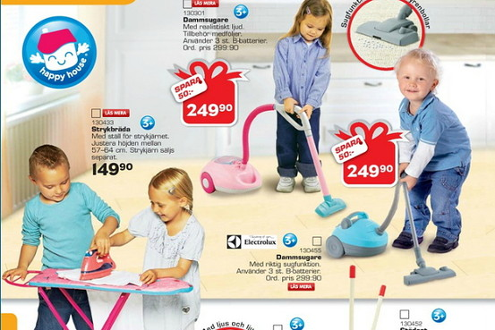

There are also bad and worrying representations of how children are perceived in
the media and that’s through fashion modelling and advertising. The way girls are
modelled are usually wearing clothes that look almost far too grown up for a little girl
to wear and the way they are made up with makeup on the face almost make them
look like mini adults. Along with this comes the way the girl has to model, most cases
the girl is usually modelled more to the face and use the hair to provoke beauty
which are similar models of Greek goddesses, such as Aphrodite (Goddess of
fertility) shown with long flowing hair and a solemn, graceful look. In this sense in
advertising, the most prominent role for a girl is showing face and solemn, calm
expressions with the eyes, hair and smile. However, boy models are also usually
wearing clothes far too grown up for their age but the way the boys are posed are yet
again different. Boys are usually posed laughing or smiling and the shot is usually of
the whole body and he’s standing tall with the element of cool. For a boy, in
advertising the most prominent role is the physique. Fashion magazines have been
blasted over the years from sexualising girl children to make them look more
independent and older at a younger age and the toughie image on boys to make
them look more masculine. Is the way girls and boys being represented in this type
of advertising, provoking stereotypes and sexism?

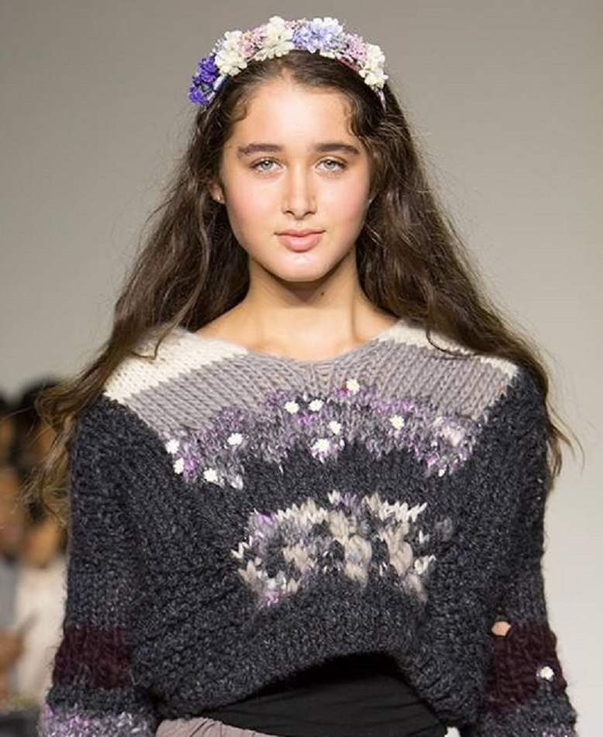

Chapter 3
Timeline of child representations in narrative

The times of the Old testament Jews, children were dressed in modified adult
costumes representing a mirror image of their parents and adults. In this time, a
child’s noble place in society was relived by the parents by the parents and their
relations to God in religion. The girls of this time where seen and represented as the
carrier and future mothers of future citizens and warriors especially in the literature of
Rome and Ancient Greece. Most of the children’s books of this time, the stories
portray how to save a child’s soul through instructions and rules and using adult
characters to provide moral behaviour for the children to interpret. Along the times of
the Middle Ages, children came to be seen as close to God and a force for good and
radiating angelic innocence. They were merely seen as a small mould for the parents
to carve into mini versions of themselves and that the children should follow by
example and have no unusual independence or follow their own needs and
instructions.

Comenius(1654) quotes:
“Which such Book, and in such a dress may (I hope) serve to entice witty children to
it, that they may not conceit a torment to be in the school, but dainty fare. For it is
apparent, that children (even from their infancy almost) are delighted with Pictures,
and willingly please their eyes with these lights: And it will be very well worth the
pains to have once brought to pass , that scare-crows may be taken away out of
Wisdom’s Gardens”

This was the year of revolution and was also known as the “turning point for
children”. The first picture book was written by this writer John Amos Comenius in
1657 and it was called the “Orbis Pictus” or better known today as “The visible world

in pictures”. For the first time, children where not mini versions of adults or as others
say “scaled down” adults. This picture book displayed 150 chapters relating to
inanimate nature, botanics, zoology, religion and humans and their activities and
proved to be a big success and influence on children’s education. It starts with an
image of a child along with his teacher and the student asks “What doth this mean to
be wise”? After this the teacher replies “To understand rightly, to do rightly and to
speak out rightly all that are necessary”? Which in translation means by
understanding the readings and teachings of this book you will be somewhat wise.

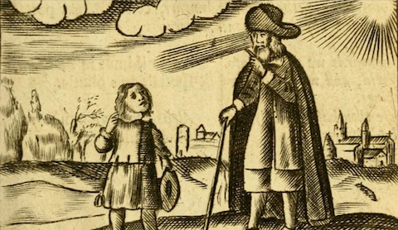

In the mid 18th century became the rise of the middle-class teachings and
romanticism. But along this era children where started to be represented as an
independent person. These independent children where always categorized into
types rather as one type of child which includes “The moral child”, “The naughty
child”, “The well-instructed child”, “The rational child”, “The little angel”, “The forlorn
child” and lastly “The manly outdoor child”.

However, these types are still used in today’s stories such as “The naughty child”
(Horrid Henry by Francesca Simon and Dennis the Menace) and “The well-
constructed child” (Matilda by Roald Dahl). The way that children were starting to be
represented was more positive and it made people think about children in new ways.

Moving into the 19th and 20th century this era was known as the golden age of
illustration because of how the styles changed and how quickly and drastically
children representations in picture and storybooks changed for the better. This was
also known as “The cult of childhood” because it was the time where child characters
broke free from the rules and where doing things unheard of away from instructions
and etiquette.

The one most iconic story that gave childhood freedom and imagination was “Alice’s
adventures in Wonderland” by Lewis Carroll. This story was starting a trend of child
characters remaining a child forever without ever growing up this was known as the
immortal child.

Carrol explains in his poem:

“I’d give all the wealth that years have piled,
The slow result of life’s decay,
To be once more a little child,
For one bright summer day”

It’s as if this explains his dream of never growing old, to be a little child free of the
woes and innocently playing again and this was living proof that this was the
inspiration that he poured into his character “Alice”.

Alice’s behaviour in Wonderland was completely unheard of in 1875. This character
insists on having a voice by asking questions in a confident way to characters on
where she is and what is happening in the surroundings that she’s in. The twist of
this story is how the adult characters behaviour is portrayed which is usually rude
and irrational rather than polite which causes Alice to have a very bad temper not
just with the characters but the lack of power she has over what happens to her body
and the fact nothing makes sense and has no order or rules she’s in which to most
child readers of today is a dream but for a child in Alice’s era of rules, order and
routine is an absolute nightmare unheard of.

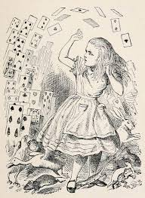

In this era, Alice’s and the characters behaviour would have been unheard of and if
so would be very punishable. For example, the Mad Hatter’s tea party shows
complete lack of dining etiquette and decorum and Alice speaking without being
spoken to because in Victorian society, children were seen and not heard but in this
story, Carroll made sure that Alice was heard out loud by all the characters and he
did this by giving her a voice. This then encouraged “The cult of childhood” into other
stories of breaking the rules and having adventures of never growing old such as
“Peter Pan” by James Matthew Barrie and “Winnie the Pooh” by A.A.Milne.

The themes of children then became more realistic after World War 2, stories then
began to target race, class, war and sex. Although this was spoken of and used in
the 1850’s, these themes became more prominent in this time and this was most
popular in Enid Blytons stories “The Famous Five”.

This caused controversy in later years that children were being represented using
racism, sexism and gender stereotypes. In the 1970’s, a storybook called “I’m glad
I’m a boy! I’m glad I’m a girl!” by Whitney Darrow Jr was criticized for having a small
and narrow mind set on what boys and girls should grow up to be. This story
explains that boy children should grow up to be doctors, policeman, pilots and
presidents and girl children should grow up to be nurses, meter maids, stewardesses
and first ladies. This basically depicts the same types of jobs for example doctor and
nurse, policeman and meter maid, same industry and profession except one
profession is higher up in authority, experience and salary for the boys than the girls.
In opinion, it depicts boys as being more superior in skill and ambition than girls. Not
only is this gender stereotyping, it’s also representing sexism in the form of a
children’s story.
Thinker and professor Kimberley Reynolds claimed that gender stereotypes and
division has remained in children’s books from the beginning of the 20th century till
the late 1990’s. In most storybooks, girls are represented for domestics and
motherhood as where the boys are represented with leadership, ambition and war.
The 20th century has seen boy characters outnumber girl characters more than 3 to
2.

Reynolds (2012) says :
“Both boys and girls have been presented by limited representations of appropriate
behaviour, identities and careers through the illustrations and text of children’s
literature”.

This pushes the idea that the way girls and boys are represented is narrow and small
and both genders have been put in separate boxes when depicting behaviour and
careers in the stories.

Children’s picture books and storybooks of today are so versatile and diverse with
child representation that no two stories are the same. Some teach morals similar to
fables, some teach independence and mischievousness through adventure and
some are instructional and educational. However, stories of today are now written
more for enjoyment and entertainment purposes rather than etiquette and pigeon-
holing on what a child should be. Books now range from something ridiculous and
unheard of like “Ketchup in my cornflakes” by Nick Sharratt, “I will not ever never eat
a tomato” by Lauren Child to something like “Horrid Henry” by Francesca Simon and
“Diary of a wimpy kid” by Jeff Kinney. In this era, children are represented as fun,
entertaining and likeable for readers to relate and unleash that fun and imagination
rather than teach and make them into a mini version of an adult or limit their
expectations because of their gender through a story.

Conclusion

This final conclusion is that children are represented in a strong, immortal and
imaginative way whereas in media and advertising they are represented more
stereotypically to differentiate the two genders to the main target audiences and the
viewers. However, because there are different types of storybooks and picture books
depending on age and advertising, again the representations are different. For
example, a story such as Peter Pan represents a chid as immortal to childhood,
never growing up and going on adventures independently where as a story such as
Northern Lights by Phillip Pullman, the child is represented more or less like a small
adult in mind, following their own path, getting away from the bad adult characters
and being headstrong. So even though both are storybooks with child characters in
them, the representations are different. Also with advertising its different as well and
examples of this are fashion and toy marketing, in fashion children are represented
as older than what they are and strong (ready to conquer) whilst in toy marketing
magazines, children are made to look young, sometimes younger than what they are
and stereotyped because of gender. In agreement to author Lewis Carrols
inspirations, children should be young, free, full of life and play and its uplifting for a
child reader for a child character whether boy or girl to be represented in this light
because it encourages imagination, entertainment and hope for a child reader who is
struggling to find their character or is perhaps shy.

Play is a key aspect of what a child is and should be the strongest element used to
depict and represent and a child character in a book or advertising. In disagreement
with the child fashion industry, children should not be represented in such a sexual
way because it can badly encourage children who have trust in stories like Peter Pan
to want to change their image and make them want to grow up at a faster rate. The
generation that we live in now children are growing old at a younger age thanks to
the growth of social culture which includes mass involvement in technology, and bad
fashion model representations which these are a massive factor of peer pressure.

Children should be represented as what they truly are, not what superiors,
companies and parents want them to be. They should remain young, wild and free
and be open to imagination. Gender stereotyping and sexism are now a crime and
yet it’s still being continued to this present time. Will this be a continuing ongoing
factor in the advertising industry in the future or will there eventually be a different
approach to how children will be represented differently, some positive and some
negative we as viewers have to be open to interpretation and opinion and if in
disagreement have a voice. Children should be represented the same in both fields
of advertising, storybooks and picture books and with future designers and thinkers,
hopefully they will be the ones to make this change happen in the future that is yet to
come.

Bibliography

Bailey, A. (2016). Fiction for children in the first 40 years of the 20th century. [online] British Library.
Available at: http://www.bl.uk [Accessed 10 Jun. 2019].

Eccles, L. (2017). John Lewis ditches 'boys' and 'girls' labels from its children's clothes to avoid 'reinforcing gender stereotypes'. [online] daily mail. Available at: http://www.dailymail.co.uk [Accessed 15 Jun. 2019].

Fadiman, C. (2019). Children's literature. [online] Britannica.com. Available at: http://www.britannica.com [Accessed 5 Jun. 2019].

Holland, P. (2014). Picturing Childhood. London: I.B.Tauris.

Marshall, C. (2014). The First Children’s Picture Book, 1658’s Orbis Sensualium Pictus. [online] open culture. Available at: http://www.openculture.com [Accessed 13 Jun. 2019].

Piper, A. (2012). Swedish toy catalog goes gender-neutral [11 pictures]. [online] twenty two words. Available at: http://www.twentytwowords.com [Accessed 15 Jun. 2019].

