

EFFICACY OF TASK ORIENTED EXERCISE PROGRAMS IN IMPROVING GAIT AND BALANCE IN PEOPLE WITH MULTIPLE SCLEROSIS IN THE UK

Name:- Misbabegum Mahammad Jilani
Student ID Number:- 2419913

A Dissertation submitted in partial fulfilment of the requirements for the degree of Masters of Science in Public Health and Social Care in Practice

Submission date:- 02/02/2026

The Institute of Inner-City Learning
University of Wales Trinity Saint David – London Campus

February 2025 – 2026
Words count:- 15920

Acknowledgement
I am grateful towards my supervisor and model lecture for their support in completing my research and also guiding me throughout. I am also thankful towards my family and friends for providing me with effective guidance and encouraging me to complete the research.

Declaration
I declare that the current research, which is focused on “EFFICACY OF TASK ORIENTED EXERCISE PROGRAMS IN IMPROVING GAIT AND BALANCE IN PEOPLE WITH MULTIPLE SCLEROSIS IN THE UK”, has been conducted by me. I have obtained support and encouragement from my family, friends and professionals to conduct the research with integrity.

Abstracts
Introduction
The research has aimed to evaluate the benefits of Task-Oriented exercise programs on conditions of adults having multiple sclerosis across the UK that can effectively improve gait and balance. The significance of this research has been based on evaluating the necessity of providing Task-oriented exercise program in terms of enhancing balance as well as gait of patients having MS syndromes within the UK's population.
Methods
The influence of both the explanatory and exploratory designing process comes with the risk of non-conclusive factors. The use of secondary qualitative methodology has been effective for accumulating secondary information based on the treatment that are required for curing gait and balance among MS populations. The quality data from the existing resources such as current journal articles assist to collect updated data on this neurological crisis that are further interpreted through thematic analysis.
Findings
The research findings reflects that task-oriented exercise programs have been effective for preventing gait imbalance among people with MS. Increasing MS within individuals led to issues such as muscle weakness, stiffness, tremors, lack of coordination and balance issues, which can affect walking and may eventually require the use of mobility aids. Psycho-educational and therapeutic interventions directed to emotional health, social support, as well as adaptive coping strategies used in healthcare organisations to treat MS.
Conclusion
The thesis concludes that MS disease involves long-term disability as it is responsible for some critical clinical conditions with inflammatory diseases. The question criticises the roles and effectiveness of Task-Oriented exercise programs on adults with multiple sclerosis across the UK that can effectively improve gait and balance.

Table of Contents
Chapter 1: Introduction 5
1.1 Background of the thesis 5
1.2 Rational and problem statement 6
1.3 Research aims and objectives 9
1.4 Research question(s) 9
1.5 Significance of the research 10
1.6 Methodological overview 10
1.7 PICO framework 10
1.8 Thesis structure 11
Chapter 2: Literature review 12
2.1 Introduction 12
2.2 Impact created by multiple sclerosis among the people with multiple sclerosis 12
2.3 Effectiveness of “Task-Oriented exercise programs” in improving the gait and balance of “people with multiple sclerosis” 16
2.4 Identifying and mitigating the issue with the implication of “Task-Oriented exercise programs” to improve the condition of adults having multiple sclerosis 19
2.5 Theoretical analysis 23
2.5.1 Theory of Planned Behaviour (TPB) 23
2.5.2 Maslow's Hierarchy of Needs Theory 25
2.5.3 Bureaucratic management theory 26
2.6 Conceptual framework 27
2.7 Literature gap 27
2.8 Summary 28
Chapter 3: Methodology 29
3.1 Chapter Introduction 29
3.2 Research onion 29
3.3 Philosophy 30
3.4 Approach 31
3.5 Research strategy 31
3.6 Design 32
3.7 Data collection method 32
3.8 Inclusion and exclusion criteria 33
3.9 Data Analysis approach 34
3.10 Sampling method 34
3.11 Ethical considerations 35
3.12 Reliability and validity 35
3.13 Limitation 35
3.14 Time Line 37
3.15 Chapter summary 39
Chapter 4: Results and Discussion 36
4.1 Introduction 36
4.2 Search of databases 36
4.3 Data Characteristics (findings) 37
4.4 Data Extraction (analysis) 52
4.5 Summary of the key findings (Discussion) 55
4.6 Chapter summary 57
Chapter 5: Conclusion and Recommendations 58
5.1 Introduction 58
5.2 Critical evaluation of findings and comparison with other studies 58
5.3 Discuss themes in relation to the research question 59
5.4 Implications and Future Research Needs 60
5.5 Strengths and Limitations/bias 61
5.6 Recommendation 62
5.7 Conclusions 62
References 63

List of Figures

Figure 1.1: Number of individuals affected by MS in the UK 6
Figure 1.2: MS among UK’s population based on gender 7
Figure 1.3: Complexities within the UK healthcare system 9
Figure 1.4: Research structure 12
Figure 2.1: Clinical Conditions and Respective Symptoms of MS Disease 14
Figure 2.2: Type of disease among people with MS disease 16
Figure 2.3: Rehabilitation v/s TOET Technique 18
Figure 2.4: Functional outcomes before and after task-oriented gait training 19
Figure 2.5: Key Barriers to Successfully Implementation of TOET among PwMS 21
Figure 2.6: Key Strategies to Successfully Implement TOET among PwMS 23
Figure 2.7: Theory of Planned Behaviour 25
Figure 2.8: Theory of Maslow's Hierarchy of Needs 27
Figure 2.9: Conceptual Framework 28
Figure 3.1: Research onion 31

List of Tables
Table 1.1: PICO framework 12
Table 3.1: Inclusion and exclusion criteria 35
Table 3.1: Research time Line 41
Table 4.1: Systematic search of databases 36
Table 4.2: Data characteristics 49

Chapter 1: Introduction

1.1 Background of the thesis
The task-oriented exercise programs are considered to be effective for improving the gait and balance in Multiple Sclerosis (MS). It has been observed that approximately 150000 people in the UK in 2025 have MS syndrome, which has increased from 130000 in 2019 (Mssociety, 2025). The increase in the number of affected people has raised concern among the UK healthcare system professionals as well as influenced the demand for higher neurology services. Additionally, 71% of the MS cases are considered to be females within the UK, whereas 7100 individuals are diagnosed with MS each year within the country (Mssociety, 2025). This signifies that MS is more prevalent among females as compared to males within the UK population.
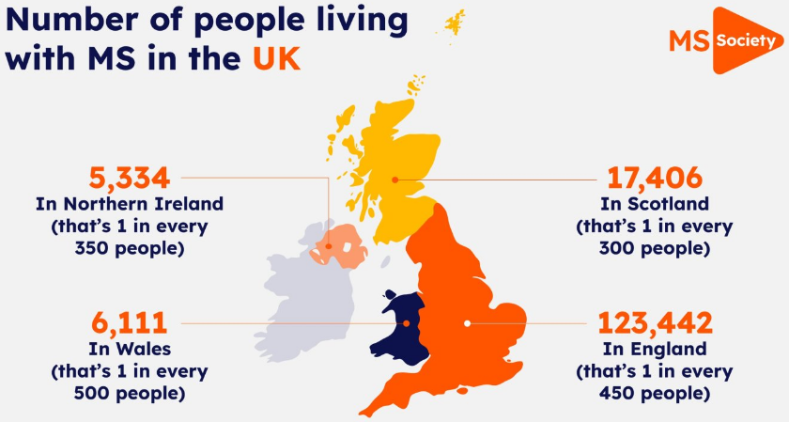

Figure 1.1: Number of individuals affected by MS in the UK
(Source: Mssociety, 2025)
MS is considered to be a disease that causes the breakdown of the myelin covering of nerves within an individual’s body (Mayoclinic, 2025). Individuals having MS have no significant treatment; however, the possibilities for treating MS are by reducing inflammation as well as damage to the nerve cells. However, early diagnosis of MS can lead to reducing the severity of the syndrome to a great extent. According to a survey report, only 29% of men in the UK populations are having MS syndrome (Consultancy.Uk, 2025). Apart from this, approximately 20 to 40% of the people having relapsing-remitting MS can eventually develop a steady progression of symptoms (Mayoclinic, 2025). Thus, the presence of such an increasing diagnosis of MS has been a challenging phase for healthcare professionals in the UK.
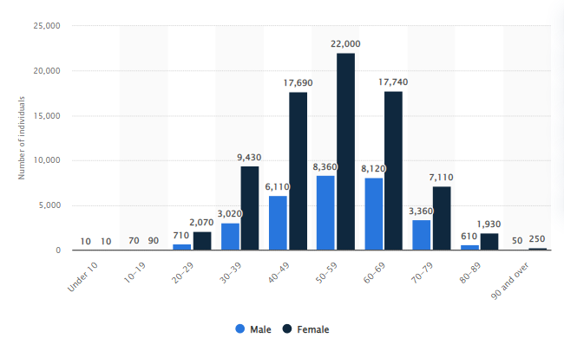

Figure 1.2: MS among the UK’s population based on gender
(Source: Statista, 2025)
Task-oriented training (TOT) combined with conventional balance training is considered to be a favourable approach that has helped individuals with MS and experiencing ataxia to balance rehabilitation. As per the figure mentioned above, approximately 22 thousand of women in the UK aged between 50 to 59 years had MS (Statista, 2025). Similar to the context, Wolf et al. (2022) have argued that task-oriented training can lead to enhancements in walking speed as well as related neural changes for individuals having MS. Gait, balance as well as fatigue disorder are considered to be most revealing symptoms within an individual daily life. As per the analysis of Cardini et al. (2024), the influence of circuit training rehabilitation has been an effective option regarding the treatment of balance, gait as well as fatigue in individuals diagnosed with MS. This signifies the necessity for providing TOT to individuals with MS in terms of enhancing their balance as well as gait.

1.2 Rational and problem statement
Problem statement
The pressing need to determine whether task-oriented exercise programs offer measurable benefits within gait as well as balance for individuals with MS within the UK
Rationale
TOT shows potential for improving functional abilities in MS patients in the UK, but efficiency depends on the specific goals, with some studies indicating non-significant differences compared to conventional physical therapy. Inconveniency as well as short lived effect of training has been identified as the major issue faced by individuals having MS syndrome while obtaining TOT. As per the argument of Wallin et al. (2023), maximising the effectiveness of the training required maintenance of a high challenging phase throughout the intervention period. Apart from this, the limitation in understanding the physical exercise intervention's impacts on patient and clinical outcomes. Similar to the context, the balance training interventions, especially adopted for individuals having MS utilises gradual progression of complexities as well as difficulties. As argued by Pathan et al. (2024) lack of effective evidence for motor learning techniques and task-oriented training is considered to be a contemporary neuro-rehabilitation intervention that promotes central nervous system. The influence of circuit training rehabilitation has been an effective option regarding the treatment of balance, gait as well as fatigue in individuals diagnosed with MS. However, the function of motor learning techniques remains uncertain regarding the improvement of ADL performance.
The healthcare system of the UK has been alleged with poor treatment regarding the care of MS among its population. According to a survey, more than 10000 adults with MS syndromes were on seven licensed medicines that have been approved by the NHS for use (BBC, 2025). The inefficiency of the UK healthcare system regarding the treatment of MS-associated individuals has been a challenging phase for the country's population. Apart from this, the effectiveness of task-oriented training for MS is not fully established, with some evidence suggesting that improvements may only be temporary, requiring continued or combined approaches. On the other hand, Usman et al. (2025) found that functional intervention as well as exercise development can enhance everyday functioning capabilities and cognitive impairments in patients with MS. However, resistance training signifies a process for maintaining, enhancing as well as preserving patient muscular strength and structural features. The implementation of various types of turning can influence different parameters. The emerging evidence signifies the possibility for improving gait speed as well as balance among patients having MS syndromes that involve performances of function baked activities.
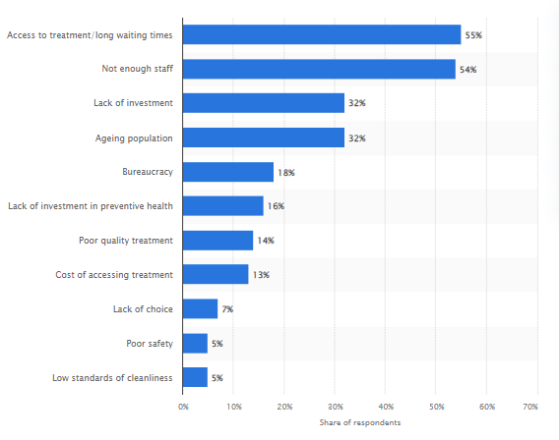

Figure 1.3: Complexities within the UK healthcare system
(Source: Vankar, 2024)
The increase in MS among the UK’s population has been a challenging phase for healthcare practitioners. Additionally, the presence of a complex healthcare system within the UK has developed a challenging phase for patients with MS in the present times. It has been recognised that approximately 13% of MS-associated patients have increased in 2024 compared to the prior year (Mstrust, 2025). Apart from this, it has been observed that lack of staff, longer waiting times and high cost of treatment are the potential challenges faced by the UK’s population. As per the above-mentioned table, 55% of the survey participants have selected long waiting times and poor access to treatment within the UK’s healthcare system (Vankar, 2024). Apart from this, only 32% of the survey participants stated that the ageing population has been the main reason behind increasing complexities within the system (Vankar, 2024). It has been observed that the majority of the women, belonging to the age group 50 to 59 years, have MS syndrome compared to the other age groups. Thus, the presence of such complexities within the UK’s healthcare system can be a challenging phase for individuals diagnosed with MS.
TOT programs should be individualised, focus on the repetitive practice of specific real-life tasks, and incorporate technology-assisted or circuit-based approaches to manage complexity and engagement. The revenue growth of the MS drug market in the UK has reached 58.27 million US dollars in 202, which signifies a CAGR growth of 1.91% (Statista, 2025). This signifies the increasing prevalence of MS among the UK’s population. Apart from this, High-intensity TOCT followed by a home-exercise program has been shown to be feasible and safe, potentially improving walking abilities and health-related quality of life in MS patients with mobility impairments. Thus, the rationale behind conducting this research can be beneficial in evaluating the effectiveness of TOT in terms of improving Gait and Balance among Individuals diagnosed with MS.

1.3 Research aims and objectives
Aims
The aim of the research is to evaluate the benefits of Task-Oriented exercise programs on condition of adults having multiple sclerosis across the UK that can effectively improve gait and balance
Objectives
- RO 1: To analyse the impact created by multiple sclerosis among the people with multiple sclerosis
- RO 2: To explore the impedance of “Task-Oriented exercise programs” in improving the gait and balance of “people with multiple sclerosis”
- RO 3: To acknowledge and mitigate the issue with the implication of “Task-Oriented exercise programs” to improve the condition of adults having multiple sclerosis
- RO 4: To identify the barriers to patients suffering from multiple sclerosis

Research question(s)
- What are the roles and effectiveness of Task-Oriented exercise programs on adults with multiple sclerosis across the UK that can effectively improve gait and balance?

1.5 Significance of the research
The significance of this research is to evaluate the necessity of providing TOT in terms of enhancing balance as well as gait of patients having MS syndromes within the UK population. Apart from this, the challenges faced by the healthcare system regarding the treatment of MS can be critically analysed within this report. Individuals having MS have no significant treatment; however, the possibilities for treating the treatment are by reducing inflation as well as damage to the nerve cells. TOT shows potential for improving functional abilities in MS patients in the UK, but efficiency depends on the specific goals, with some studies indicating non-significant differences compared to conventional physical therapy.

1.6 Methodological overview
A secondary qualitative approach is going to be utilised within this research in terms of accumulating secondary data that are available within existing literature. Additionally, the information is going to be interpreted through a thematic analysis in terms of evaluating the thesis aims and objectives.

1.7 PICO framework
Population | UK adults with multiple sclerosis
Intervention | Task-Oriented exercise programs to improve gait and balance
Comparison | Clinical therapies and medication
Outcome | Improved gait and balance from MS patients

Table 1.1: PICO framework
(Source: Created by author)

1.8 Thesis structure
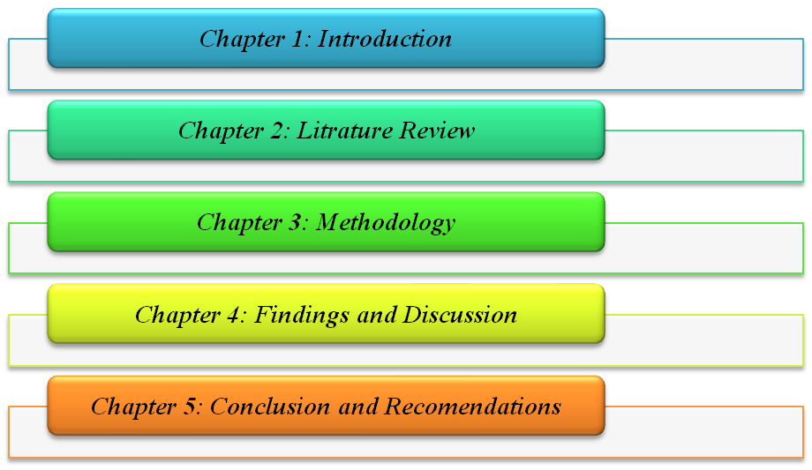

Figure 1.4: Research structure
(Source: Created by author)

Chapter 2: Literature review

2.1 Introduction
Literature review is the way of reviewing previous literature relevant to the research contests to gather available information with critical arguments. Multiple sclerosis or MS is a chronic disease which is the core concept of this research study. This chapter is going to evaluate some relevant aspects of this chronic disease based on the key arguments of previous literature. In addition, the application of TPB or Theory of Planned Behaviour, Systems Management Theory and Bureaucratic Management Theory is also discussed within this research to develop theoretical knowledge of the research objectives. Along with these, the conceptual framework of this research is going to be presented in this chapter that can mitigate the literature gap.

2.2 Impact created by multiple sclerosis among the people with multiple sclerosis
Multiple Sclerosis refers to the disrupted neurological condition of a person that can affect the nervous system through a multi-functioning approach of the immune system. As per Hunter et al. (2021), Multiple Sclerosis has a profound impact on different areas of a person’s life and their family’s lives as well. Supporting this argument, Graves et al. (2023) stated that MS is a chronological age that young adults experience more than older adults. However, this article has failed to focus on the prevalence of MS disease at the global-level. On the other hand, this article has evaluated the prevalence of MS disease among the younger generation rather than the older generation. Supporting this argument, Capasso et al. (2023) mentioned that the young females are the most affected population by MS disease due to limited public awareness. However, prevalence of MS disease has been observed among all aged people from childhood to old aged people, which has been avoided by this article. Hence, it can be mentioned as a weakness of this article as it reduces the insightful knowledge relevant to this topic.
MS disease has a significant impact on the nervous system of a human body which is directly linked with other body parts such as the brain and heart. On the other hand, Attfield et al. (2022) mentioned the prevalence of MS diseases while already over 2.5 million people have experienced it worldwide. However, diagnosing this neurological condition is quite difficult that mainly delays the treatment process. Hence, the people with MS disease can face delays in the treatment process due to delay in the diagnosis process. Based on the previous literature-based arguments, negative health impacts of MS disease have been evaluated. Supporting this statement, Kołtuniuk and Chojdak-Łukasiewicz (2022) stated that multiple sclerosis creates incurable conditions by attacking the central nervous system which has poor health outcomes in terms of mental and physical disabilities. However, Talente et al. (2025) highlighted limited treatment and intervention practices against MS disease. This synthesis supports the negative health impact of MS disease which requires immediate actions for prevention strategies.
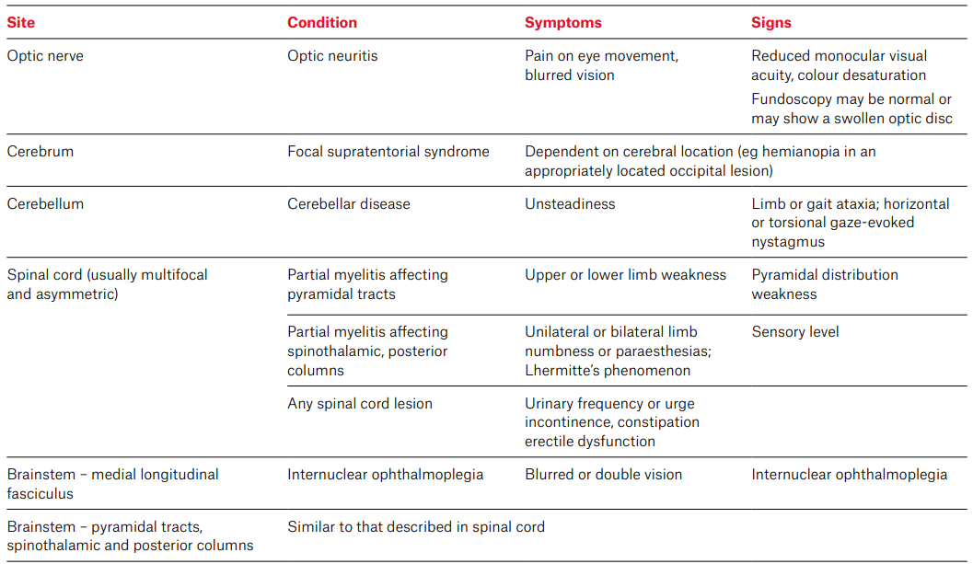

Figure 2.1: Clinical Conditions and Respective Symptoms of MS Disease
(Source: Travers et al. 2022)
The above figure showcases different clinical conditions and respective symptoms of MS disease to understand its impact on a person’s physical and mental health. According to the views of Travers et al. (2022), optic neuritis, cerebella disease and focal syndrome are some common clinical conditions of MS disease. During these clinical conditions, a person can experience some primary symptoms such as pain with eye movement, unsteadiness and depending on cerebral locations. However, Ponzio et al. (2024) argued that MS disease is mainly diagnosed among young people belonging to the age group between 20 and 40. In addition, it has been observed that MS disease is quite unpredictable as it involves a non-traumatic disability at the early stage. In contradiction, Jawad et al. (2023) highlighted the tendency of falling among the people with MS disease that increases the risk of serious injuries. Thus, the complex impact of MS disease has been observed as it can affect people’s daily life style by affecting mental well-being.
Apart from the above impacts, MS disease has a negative impact on the employment status of a person as it reduces their professional skills and ability due to neurological disorder. As opined by Ponzio et al. (2024), only 20% to 40% people with diagnosis of MS can continue their professional career due to the risk factors such as working disability, working type and disease duration. Due to these kinds of risk factors, people with MS disease are unable to work at the professional level which can affect their regular lifestyle and socio-economic status as well. Supporting this argument, Vitturi et al. (2023) highlighted the occupational risk factors of MS disease while people with MS disease have high risk of poor productivity with accidental cases in the workplace. However, this article has limited insights into the occupational impact of MS disease with real-life examples or evidence which can be considered as a weakness of this article. On the other hand, Oechtering et al. (2024) argued the presence of complications in the immune mechanisms involving B and T cells among the people with multiple sclerosis disease. Based on the above arguments, it can be stated that MS disease has a severe impact on the regular lifestyle of people due to poor psychological well-being.
Long-term disability is a key barrier to the people with MS disease due to its long-term health and occupational impacts which can create poor health quality among the people with MS disease. According to the perspectives of Makhani and Tremlett (2021), MS disease involves long-term disability as it is responsible for some critical clinical conditions with inflammatory diseases. For example, people with MS disease experience numbness, poor coordination, electric-shock sensation, double vision and trouble with sexual and bladder function (Mayoclinic, 2025). Further, this chronic disease can be diagnosed after reaching a high stage which makes the treatment process more critical and delay while people become mentally stressed and anxious due to the limited timeline. In this context, Lutfullin et al. (2023) highlighted some key risks of Multiple Sclerosis disease such as high BMI or Body Mass Index that create childhood obesity as well. However, this article provided limited in-depth knowledge about the psychological impact of MS disease that can create further gaps in this research.
The negative impact of MS disease on balance of Body Mass Index, which is harmful for the human body due to the risk of overweight or underweight-related health issues, has been found. In addition to this, Lutfullin et al. (2023) stated that MS disease is a clinically isolated syndrome that typically increases the risk of poor physical and mental health. On the other hand, Dobson et al. (2022) highlighted the complex relationship of MS disease with social determinants such as gender and racial background. For example, MS disease is comparatively more severe among women in comparison to men that support the relationship between gender and MS disease risk (Dobson et al. 2022). This synthesis supports the interconnection between gender and MS disease impact which is its key strength in terms of improving logical information about the impact of MS disease among people with MS disease. On the other hand, Sabanagic-Hajric et al. (2022) highlighted the relation of MS disease with a person’s age, gender and marital status as well. Additionally, women feel comparatively lower pain for MS disease in comparison to men that supports the interconnection between gender and MS disease impact. Furthermore, this article evaluated the relevant influential factors of MS disease which have been experienced by the people with MS disease.
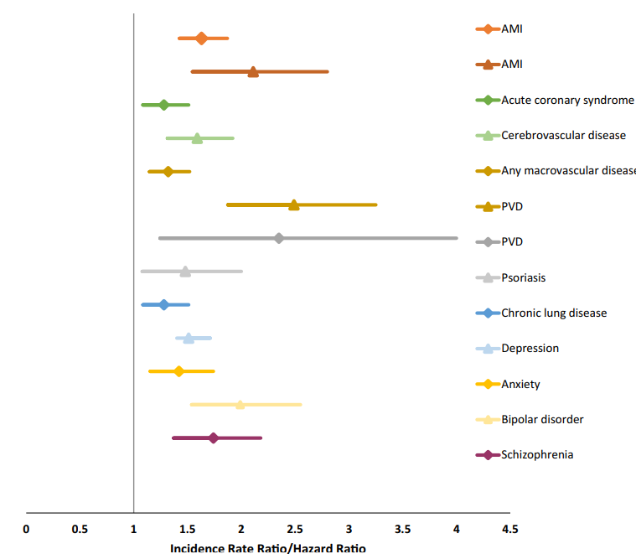

Figure 2.2: Type of disease among people with MS disease
(Source: Marrie et al. 2023)
Limited knowledge of MS disease symptoms can also increase health risks among people with MS disease. According to Dobson et al. (2022), women with MS disease experience more anxiety and worse fatigue than men with MS disease. This implies that MS disease becomes complicated in different gender and other social determinants. Supporting this argument, Marrie et al. (2023) stated that people with MS disease experience anxiety, bipolar disorder, depression and vascular disease. In addition to this, chronic lung disease and acute coronary disease are also common among people with MS disease. However, there is a gap in identification of actual physical and mental health impact of MS disease in the available literature that can be considered as a gap. This research is going to cover this gap with evidence-based approaches.

2.3 Effectiveness of “Task-Oriented exercise programs” in improving the gait and balance of “people with multiple sclerosis”
“Task-oriented exercise programmes" are applicable as a neurological rehabilitation technique which can improve multi organ functional performance. Supporting this statement, Badaru et al. (2021) stated that TOET or “The task-oriented exercise training programs” can be defined as a potential technique of neurological rehabilitation through which functional performance such as movement and social involvement can be enhanced. Additionally, the purpose of using the TOET technique is to improve functional performance through consistent task-based practices. However, this article has avoided the application opportunities of TOET in different types of functional disorders for multi sclerosis disease. On the other hand, Baygaliev et al. (2024), task-oriented training programs are an applicable method in terms of promoting daily basis physical activities and motor skills of children. However, the application of this technique among adults has not been specified in this article that minimised the application-based knowledge of this research. On the other hand, Badaru et al. (2021), the application of “task-oriented exercise training programs” is beneficial in terms of improving functional balance with increase of muscle straights. Hence, it can be said that TOET programmes support improvement of functional performance and BMI of people with MS disease.
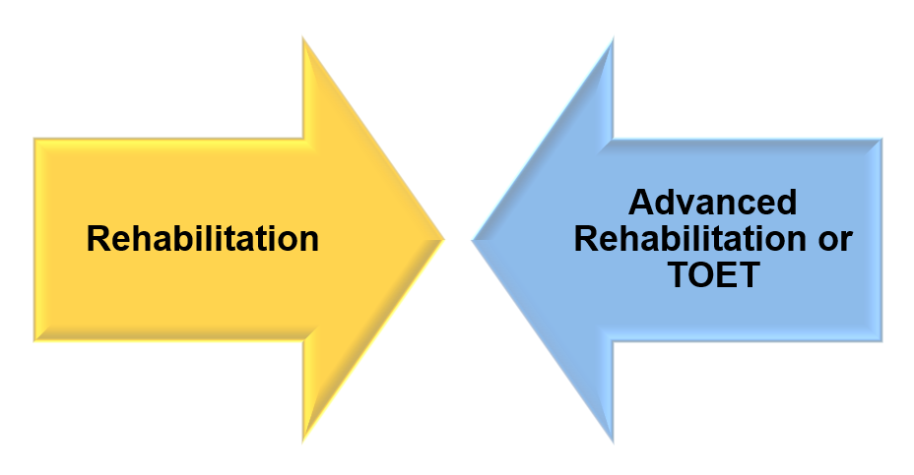

Figure 2.3: Rehabilitation v/s TOET Technique
(Source: Influenced by Gao et al. 2024)
Rehabilitation is an effective technique for improving PwMS or People with MS disease as it can drive their motor learning approach to develop social skills. Supporting this argument, Alashram (2025) stated the usefulness of TOET technique, a part of rehabilitation technique in helping PwMS to develop their motor skills such as movement balance and performance. Additionally, the task-oriented practice involves various daily basis activities that promote an individual’s functional performance, even with cognitive impairments. However, there is limited theoretical knowledge of TOET technique in applying to people with MS disease. According to the perspectives of Hassanin et al. (2023), TOET is an evidence-based method of rehabilitation for people with MS disease due to the physical therapy that supports functional performance improvement. This synthesis the application of TOET or task-oriented exercise training programs to effectively prevent the risk and prevalence of MS disease. On the other hand, Gao et al. (2024) highlighted the effectiveness of TOET technique in enhancing gait balance by improving motor functioning which is comparatively better than traditional rehabilitation technique. This supports the advancement of rehabilitation techniques through the implementation of the TOET approach.
The application of TOET involves regular basis task-based key activities that promote gait and body balance. Supporting this argument, Tonghua et al. (2024) stated that task-oriented training supports improvement of body muscle strengths and joint movement which are required to improve walking ability, gait and body balance. This implies that people with MS disease can improve their gait and body balance through some task-oriented activities which involve physical-based therapy. However, this article overlooked the importance of mental therapy as a part of MS disease treatment as this disease affects the mental well-being by increasing anxiety and depression among people. On the other hand, Lee (2024) highlighted the use of step-by-step approaches in task-oriented training methods for gait functional movement. Through this approach individuals can get multiple advantages including maximising gait function with prevention of abnormal gait patterns. Thus, it can be deduced from this article that task-oriented training programmes are effective in improving gait and balance of people with MS disease by reducing underlying impairments.
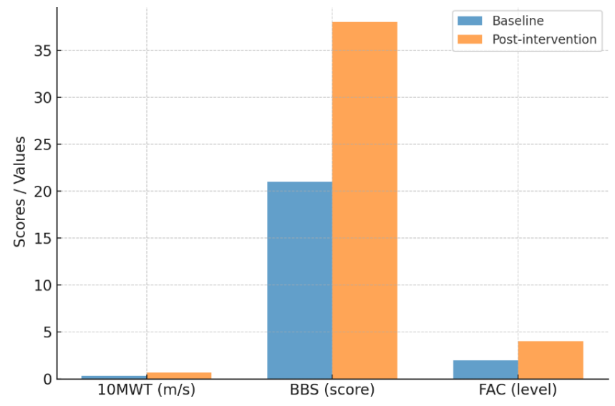

Figure 2.4: Functional outcomes before and after task-oriented gait training
(Source: Atif et al. 2025)
Based on the above argument, it can be said that TOET programmes are beneficial for the people with MS disease. As per the discussion by Atif et al. (2025), functional outcomes of task-oriented gait training are positive in comparison to traditional rehabilitation techniques. For example, functional outcomes after task-oriented gait training implementation are comparatively higher than before the implementation. Supporting this argument, Pathan et al. (2024) stated that task-oriented training is a contemporary neuro-rehabilitation intervention that can enhance the neural plasticity in the CNS or Central Nervous System. This supports the effectiveness of TOET programmes in improving nervous system performance of people with MS disease. However, this article outlines limited application-based data, which has limited the research outcomes as well. As per the views of Straudi et al. (2022), effective use of task-oriented prorates is helpful in preventing the prevalence of MS disease through improving patient’s walking endurance. This synthesis helps to evaluate the usefulness of task-oriented training to enhance the health condition of people with MS disease, which is required to reduce the prevalence of MS disease. Therefore, it can be considered as a considerable strength of this article as it provides insightful knowledge of using task-oriented training programmes in preventing MS disease.
People with MS disease can experience difficulty in selecting a suitable TOET approach to achieve effective treatment. According to Pathan et al. (2024), Effective TOET programs involve multiple components such as specialised, repetitive, challenging, exceptional, intensive and diverse task-oriented exercises that offer multiple opportunities for patients. However, this article includes limited theoretical knowledge that reduced the theoretical understanding of the TOET programme's effectiveness in PwMS. On the other hand, Baygaliev et al. (204) stated that physical activities and motor skills of people can be improved through adequate application of task-oriented practices. Additionally, this article synthesises that a patient's potential in physical activities can be enhanced with improved motor skills by considering the task-oriented practices. However, this article has limited evidence-based knowledge relevant to the key benefits of applying task-oriented practices for people with MS disease. This can be considered as a weakness or gap in this research due to producing limited knowledge of MS disease prevention strategies.

2.4 Identifying and mitigating the issue with the implication of “Task-Oriented exercise programs” to improve the condition of adults having multiple sclerosis
Identifying issues with task-oriented exercise programmes implication
Successful implementation of task-oriented exercise programmes requires some key aspects such as team collaboration, understanding patients and cooperative approach. According to the views of Halford et al. (2024), task-oriented training requires to be highly proactively interactive and collaborative in terms of achieving positive outcomes after implementation. However, the lack of these key approaches can reduce effectiveness of task-oriented training on improving gait and balance of people with MS disease. On the other hand, Baglio et al. (2025) highlighted the limited standard in task-oriented training that can hinder evidence-based protocols during treatment for PwMS. This synthesis helps to evaluate the risk of poor treatment standards which can reduce healthcare outcomes after the implication of task-oriented exercise programmes in terms of reducing functional imbalance. However, this article has limited evidence-based discussion for the limitations of task-oriented exercise programmes that have limited the research outcomes. This can be considered as a considerable weakness of this article as it reduced the insightful understanding of functional imbalance reduction through task-oriented practices.
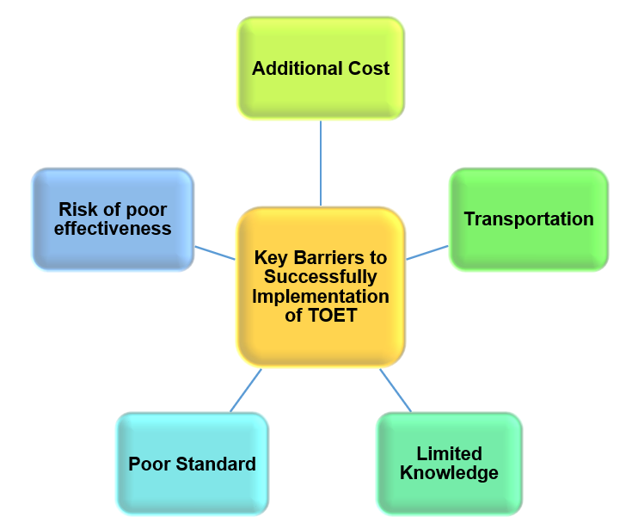

Figure 2.5: Key Barriers to Successfully Implementation of TOET among PwMS
(Source: Influenced by Salbach et al. 2025)
Apart from the above-mentioned key issues, additional cost and transportation can make the task-oriented exercise program implementation process quite complicated. Supporting this argument, Salbach et al. (2025) mentioned that additional cost and transportation are some key barriers to the successful implementation of task-oriented exercise programmes. These key barriers can reduce the engagement of people with MS disease due to lack of flexibility and motivation. However, the implementation of virtual task-oriented exercise programmes can solve these identified key barriers (Salbach et al. 2025). This synthesises the use of virtual task-oriented exercise programmes in terms of solving the key barriers of people with MS disease by encouraging virtual engagement. However, this article has not evaluated the successful implementation process step-by-step which has reduced the research outcomes potential to address the research question. This can be considered as a limitation or weakness of this article that is going to be filled through this research.
Limited knowledge about implementing task-oriented practices on people with MS disease is a common weakness of previous literature. On the other hand, Moslemi et al. (2023) highlighted limited evidence of exercise-based practices to improve functional outcomes. This implies the risk of no response in MS disease treatment through random task-oriented exercise programmes without accurate understanding of a patient's mental and physical status. However, this article provided limited knowledge of this limitation of task-oriented exercise programmes in the MS disease treatment process which has limited the research outcomes as well. On the other hand, Adnan et al. (2024) supported the effectiveness of the task-oriented therapies to overcome the possible barriers in treatment processes. Henceforth, people with MS disease can experience poor effectiveness of task-oriented exercise programmes due to lack of knowledge.
Mitigation strategies to improve condition of PwMS
Successful implication of task-oriented exercise programmes requires a combination of virtual and in-person practices to encourage people with MS disease. Virtual TOET is applicable in resolving the cost and transportation issues of in-person TOET practices (Salbach et al. 2025). In addition to this, it has more flexibility rather than in-person task-oriented practice that can also reduce time for transportation. On the other hand, Chen and Chen (2023) highlighted the importance of task-specific training with transparency in task goal setting and effective interaction to improve implementation of task-oriented practices. This implies the need for transparent collaboration while involving people with MS disease as it supports mutual understanding of tasks and their respective goals. According to the discussion by Mason and Mullen (2022), supervision is required in task-oriented exercise practices to ensure supervised development. The lack of strict supervision can reduce the control of social and health care staff over the people with MS disease due to risk of internal conflicts. However, this article has limited specification of supervision strategies to improve the condition of people with MS while engaging in task-oriented exercise programmes.
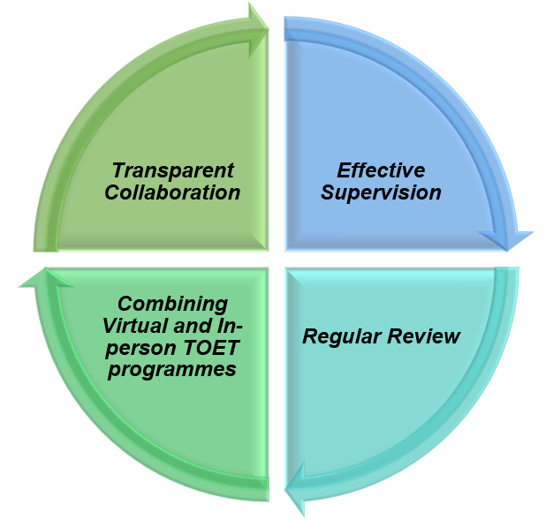

Figure 2.6: Key Strategies to Successfully Implement TOET among PwMS
(Source: Inspired from Salbach et al. 2025)
The lack of proper review after implementing task-oriented exercise can minimise the improvement flow due to lack of self-awareness. According to the views of Chen and Chen (2023), task-oriented activities are supportive in improving movement practices. However, the lack of proper review after every task-based activity can reduce the effectiveness of task-oriented programmes in improving physical and mental well-being of people with MS disease. As opined by Salbach et al. (2025), virtual task-oriented practices offer flexibility to the patients. Hence, limited supervision and review over the virtual task-oriented programmes can be considered as key barriers that must be resolved through effective supervision and review. However, this article has limited evidence about maintenance of standards in virtual task-oriented exercise practices. On the other hand, Halford et al. (2024) argued that TOT or Task-oriented training is one of the proven interventions of stroke rehabilitation which has been considered by the healthcare professionals. This synthesis the application of task-oriented training as an effective intervention for the people with stroke-related health issues instead of highlighting the MS disease-based intervention that diverts the readers from the main focus. This can be mentioned as a considerable weakness of this article as it reduced the informative quality of the research outcomes.

2.5 Theoretical analysis

2.5.1 Theory of Planned Behaviour (TPB)
The theory of planned behaviour suggests predicting the behavioural aspects of a person before trying to convince them for any societal matter. According to the views of Hagger and Hamilton (2024), the planned behaviour theory is applicable in terms of predicting behavioural aspects of individuals to ensure successful motivation strategy. Similarly, the social and healthcare staff can involve more PwMS disease in task-oriented exercise programmes by predicting their behavioural approach towards the programme. In this context, behavioural issues of people with MS disease can be solved by motivating them to engage proactively and collaboratively with the task-based practices. Thus, the application of the planned theory can help the behavioural aspects of individuals who are struggling with multiple sclerosis in the UK to engage with rehabilitation and task oriented programmes. On the other hand, Aliedan et al. (2022) stated that TPB is guidance for effectively predicting and comprehending the intentions of individuals. This synthesis evaluated the importance of accurate prediction of health issues while applying new strategic intervention as it can reduce the possible barriers in the adoption stage. This explanation implies the actual needs in the successful implementation of new strategic interventions such as task-oriented training for people with MS disease to address the research questions. Through applying this theoretical guidance, the supervisors of the task-oriented exercise programmes can convince PwMS diseases to improve their gait and body balance with maximum flexibility.
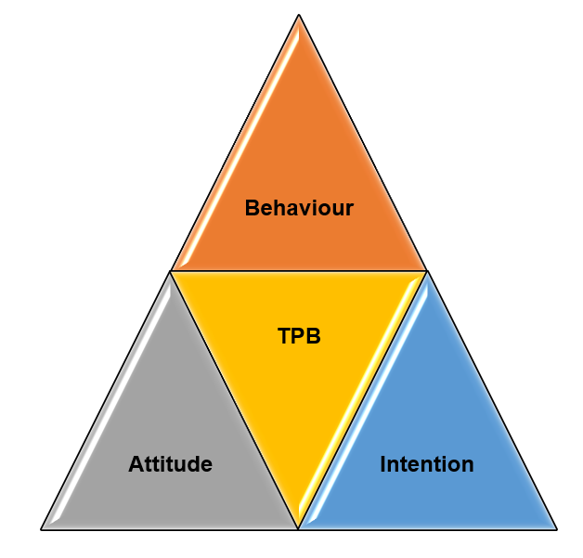

Figure 2.7: Theory of Planned Behaviour
(Source: Inspired by Hagger and Hamilton, 2024)
The above theoretical knowledge supports transparent interaction and collaboration with people to understand their behavioural aspects towards any societal matter, which is required to successfully implement TOET. According to the perspectives of Opoku et al. (2021), TPB described crucial individual beliefs, which can influence their intentions as well. Hence, applying this theoretical knowledge is helpful in terms of improving gait and body balance of people with multi sclerosis disease. On the other hand, it has been observed that TPB highlighted three key elements such as behaviour, attitude and intention, which have significant impact on an individual's approach towards any societal factor (Hagger and Hamilton, 2024). However, this article supports in evaluating the influential aspects such as behaviour, intention and attitude in terms of successfully implementing task-oriented training for people with MS disease. This can be considered as the strength of this article to produce quality information, which is highly relevant to the new strategic approach such as task-oriented training.
The planned behaviour theory supports in developing positive behaviour, attitude and intention of individuals to join task oriented exercise programs for better mental and physical health. The people with multi sclerosis disease can improve their engagement in task oriented exercise programmes with a positive behavioural approach. Therefore, it can be said from this theoretical knowledge that behavioural aspects of PwMS can be changed positively towards MS disease and TOET through transparent interaction and collaboration.

2.5.2 Maslow's Hierarchy of Needs Theory
Maslow’s hierarchy of needs is a motivational theory that is applicable in terms of motivating the people with multi sclerosis disease to join task-oriented exercise programmes. As per Ihensekien and Joel (2023), the motivational theory of Maslow supports multiple types of individual’s needs including social, psychological, safety and security, esteem and self-actualisation needs to motivate a person. Similarly, considering the psychological, security, safety and self-esteem needs of PwMS disease is helpful in improving the effectiveness of task-oriented programmes to improve their gait and balance. The theoretical knowledge of Maslow’s hierarchy of needs supports individual’s motivation, which is required to encourage people with MS disease to be involved with effective MS care plan and motor learning.
Theoretical knowledge of this motivational theory is applicable in developing motor learning intention among the individuals due to the motivation of improving mental and physical health by fighting for needs. The lack of motivation can reduce the engagement of patients with task oriented and motor learning-related MS care practices. According to the theory of Maslow’s hierarchy of needs, satisfying the needs of individuals is required to convince them of a particular societal factor (Ihensekien and Joel, 2023). This article evaluated the need for analysing diverse needs of individuals with MS disease to ensure their maximum cooperation to adopt new strategic approaches in the healthcare system such as task-oriented training. This can be mentioned as the strength of this article in terms of valuing the research outcomes with theoretical understanding instead of generalised knowledge. The tendency of depression, anxiety and other mental health issues can be reduced by applying this theoretical aspect while treating them clinically with implementation of task-oriented practices.
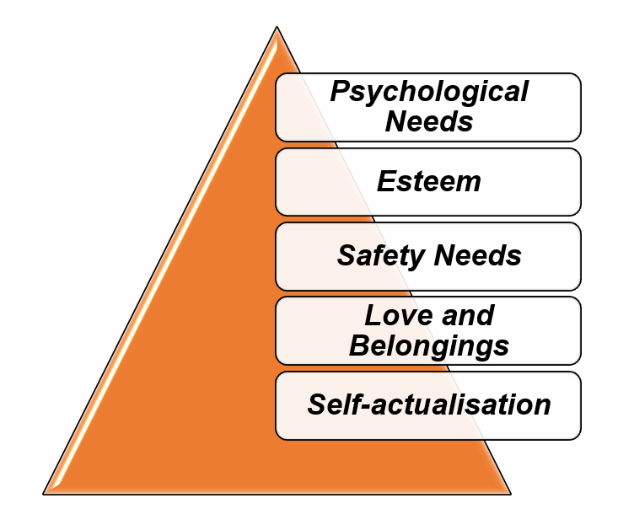

Figure 2.8: Theory of Maslow's Hierarchy of Needs
(Source: Influenced by Ihensekien and Joel, 2023)
According to the above theoretical representation, it can be said that satisfying these motivational needs is essential to ensure a positive approach towards treatment-based activities such as TOET among PwMS. According to the views of Rojas et al. (2023), life satisfaction can be enhanced through the satisfaction of the motivational needs. Thus, the negative approach of task-oriented activities of PwMS can be removed through motivating them effectively and improving their gait and body balance. Moreover, the application of this theoretical knowledge can improve the perspectives of PwMS towards the disorder and create a hope to improve their living style by engaging the task-oriented exercise programmers. Furthermore, applying this theoretical knowledge, healthcare professionals can reduce the possible change resistance-related risks by fulfilling actual needs of patients with MS disease. Thus, the research questions can be answered through the fulfilment with strategic recommendations for the health issue with theoretical knowledge.

2.5.3 Bureaucratic management theory
The application of Bureaucratic management theory can be beneficial in evaluating the effectiveness of TOT in improving the care quality for MS syndromes as well as increasing well-being. As per the opinion of Almhairat (2025), Bureaucratic management theory emphasizes efficiency as well as consistency through a strict hierarchy, formal rules, and specialization of labour. The theory also emphasises that breaking a specific task within multiple variances develops expertise as well as gains potential to perform the task efficiently. Adopting the key concept of such theoretical perspectives, the effectiveness of TOT in improving balance and Gait can be analysed and deployed. For instance, influencing an individual with TOT having MS syndrome can be effective in reducing the severity of MS symptoms. This can also help in enhancing well-being to a great extent. However, lack of effective evidence for motor learning techniques and task-oriented training are considered to be the contemporary neuro-rehabilitation interventions that promote central nervous system. Therefore, it can be said that individual can overcome their mental and physical condition by meeting their specific needs with maximum motivation, engagement and productivity. This supports the collaborative MS care practices to fight against MS disease in the UK. Thus, the effectiveness of task-oriented training for MS is not fully established, with some evidence suggesting that improvements may only be temporary, requiring continued or combined approaches.

2.6 Conceptual framework
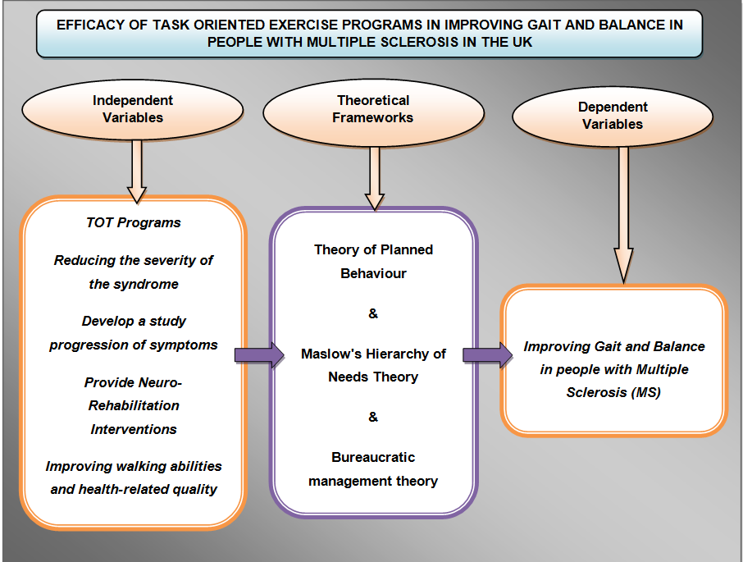

Figure 2.9: Conceptual Framework
(Source: Self-developed)

2.7 Literature gap
The primary literature gaps regarding task-oriented exercise for gait and balance within MS in the UK include a lack of large-scale, high-quality studies as well as unclear optimal exercise protocols. However, a need for more research on the specific UK context, and a need to understand the long-term sustainability as well as real-world implementation are considered to be limited within the existing literature. There is a general shortage of comprehensive studies with large participant numbers to definitively establish the efficacy of task-oriented training for gait and balance in MS patients. Based on the literature-based synthesis, most of literature has considerable weaknesses such as limited evidence-based argument, poor theoretical understanding and lack of focus on MS disease. However, this research can eliminate these identified literature gaps with real-life examples and evidence-based logical arguments with theoretical understanding. Task-oriented approaches are considered to be generally considered safe as well as well-tolerated for people with MS. Moreover, the specific parameters for task-oriented exercise are considered to be not well-defined. Thus, this research can be beneficial in addressing the identified literature gap within the finding chapter.

2.8 Summary
The above-mentioned chapter concludes that the task-oriented exercise programs are considered to be effective for improving individuals having gait and balance with Multiple Sclerosis syndrome. It has been recognised that this signifies that MS is more prevalent among females as compared to males within the UK’s populations. Apart from this, individuals having MS have no significant treatment; however, the possibilities for treating the treatment are by reducing inflation as well as damage to the nerve cells. Similar to the context, the influence of circuit training rehabilitation has been an effective option regarding the treatment of balance, gait as well as fatigue in individuals diagnosed with MS. On the other hand, the limitation for understanding the physical exercise intervention impacts on patient and clinical outcomes. It has been observed that lack of staff shortage, longer waiting times and high cost of treatment are the potential challenges faced by the UK’s population. Thus, the presence of such complexities within the UK’s healthcare system can be a challenging phase for individuals diagnosed with MS. Moreover, the chapter has presented literature-based arguments to identify the existing gaps. Therefore, it can be stated that task-oriented approaches are considered to be generally considered safe as well as well-tolerated for people with MS.

Chapter 3: Methodology

3.1 Chapter Introduction
The methodology chapter is considered to be a crucial aspect as it explains as well as justifies how a dissertation's research was conducted, providing a roadmap for readers in terms of understanding, assessing and replicating the study. The methodological chapter aims to evaluate the overall data collection as well as analysis techniques that have been used for gathering information relevant to improving Gait and balance among people. The evaluation of this chapter can be beneficial in acknowledging the various methodological procedures that are required for collecting information. Apart from this, this chapter is going to critically evaluate the limitations of the selected methodological approach in terms of establishing a critical analysis. Thus, the evaluation of this chapter can be helpful in illustrating the significant sources through which information related to Gait and balance among people has been accumulated.

3.2 Research onion
The methodological as prescribed within Saunders Research Onion has been utilised within this research paper in terms of evaluating the necessity of task-oriented exercise programs in curing gait and balance among individuals. As per the opinion of Saunders and Bristow (2023), Research onion framework positively influences a researcher to design a suitable methodological approach considered a series of nested layers that moves from philosophical assumptions to the data collection techniques. The framework signifies that overall plan for how to conduct research, such as a case study, survey, or experiment. Thus, the use of such a framework has been helpful in evaluating the information that is related to the treatment of gait and balance among populations.
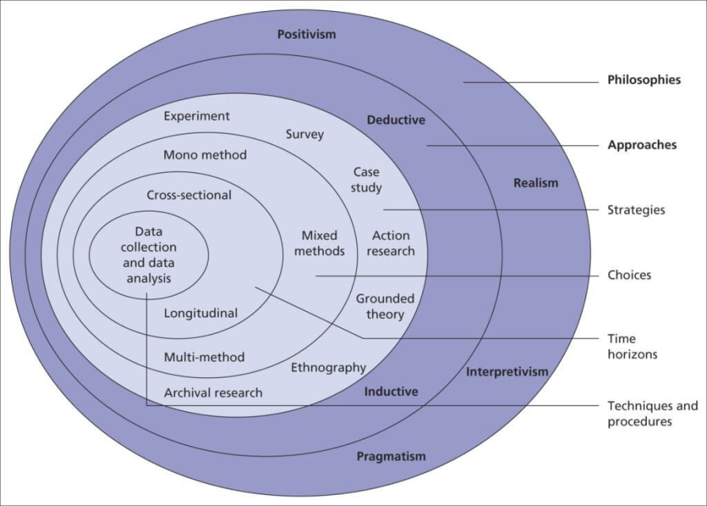

Figure 3.1: Research onion
(Source: Saunders and Bristow, 2023)

3.3 Philosophy
The philosophical assumption undertaken within this thesis in terms of evaluating information based on task-oriented exercises programs for improving gait as well as balance among people has been performed through interpretivism paradigm. As per the opinion of Ikram and Kenayathulla (2022), interpretivism philosophy within secondary research provides a suitable framework in terms of analysing qualitative information. Based on these aspects, the thesis has focused on adopting such a paradigm in terms of gaining better understanding of factors that are related to task-oriented exercises utilised for curing gait as well as balance within people having multiple sclerosis. The justification behind using such a paradigm has allowed us to move beyond the surface level information through underlying intention as well as emotion of secondary information. However, Pervin and Mokhtar (2022) have contradicted that potential for subjective bias has been the key limitation of interpretivism philosophy while conducting a secondary paper. It has been recognised that the presence of systematic errors while applying the methodological approach was the subjective bias for this thesis. In this respect, the thesis has focused on peer reviewed qualitative articles in terms of addressing the potential bias. Thus, the influence of such paradigms has been beneficial in emphasising qualitative data that are related to gait and balance improvement as well as task-oriented exercises.

3.4 Approach
The methodological approach for this research has been effective for developing a systematic framework through which information related to healthcare has been accumulated significantly. It has been recognised that, deductive approach has been used within this thesis in terms of framing research questions that highlights the effectiveness of task orient exercises for addressing gait and balance among people with multiple sclerosis. As per the opinion of Fife and Gossner (2024), deductive approach within secondary qualitative methodology gains potential to test existing theories as well as hypothesis through analysing information in a systematic as well as specific pattern. The justification behind using such an approach has been beneficial in reducing the potential bias that was raised due to the selection of interpretivism philosophy. Additionally, the implication of theoretical approach through deductive approach helps in establishing critical analysis of the research topic. On the other hand, Zhang et al. (2025) have argued that high rigidity as well as dependency on accuracy level is considered to be the potential limitation of deductive approach. In essence, the use of such an approach has reduced flexibility for accumulating information from existing sources that were based on improving gait and balance among people having multiple sclerosis. Thus, the adoption of such an approach has been utilised within a systematic manner in terms of evaluating the key exercises that are essential for curing gait and balance among people with MS.

3.5 Research strategy
The information related to the task-oriented exercises programs from treating people’s gait and balance were accumulated from existing data sources using a qualitative method. As per the opinion of Cheong et al. (2023), the qualitative method is considered to be an essential method for accumulating secondary information through analysing existing data sources. The influence of such methodological approach has helped in gaining deeper human insights on task-oriented exercises used in improving gait and balance. Lim (2025) has highlighted that a qualitative approach allows researchers to explore a topic in-depth through gathering information from existing secondary sources. The justification behind selecting this approach has also helped in relating the topic-oriented information with existing theories that are found within the existing literature. Additionally, the influence of qualitative methods has helped to gain deeper understanding of the thesis topic and accumulate risk information. However, Fife and Gossner (2024) have contradicted those difficulties for verifying originality of the data has been identified as the potential limitation of qualitative methods in secondary methodology. In this respect, the research has focused on selecting only peer reviewed articles that are published within the last five years for the research findings. Thus, the influence of such methodology strategy has been effective for accumulating secondary information based on the treatment that are required for curing gait and balance among MS populations.

3.6 Design
Descriptive research design has been selected in exploring the efficacy of task-oriented exercise programs in order to promote gait as well as balance in people with multiple sclerosis. Based on the views of Escudero-Mancebo et al. (2023), the key purpose of applying research design includes overarching structure and execution of a study in an effective manner. Furthermore, the research question regarding the effects of task-oriented programs for promoting health of people with multiple sclerosis has been analysed in a systematic way. It has been recognised that descriptive research design allows the generated evidence based on the research variables (McCartney and Fu, 2022). The descriptive design selection in this research on healthcare has provided the opportunity of understanding the blueprint of the specific health crisis as well as its relation with gait and imbalance among individuals. The entire research process has been conducted by describing the specific health concerns along with the ways of preventing this using task-oriented exercise programs. On the other hand, explanatory or exploratory research design has been avoided from the research paradigm. It has been recognised that both the explanatory and exploratory designing process comes with the risk of non-conclusive factors. The actuarial effects of task-oriented exercises for people with multiple sclerosis are difficult to recognise from the explanatory or exploratory research design. Thus, descriptive design has ensured an effective conclusion by answering the research question regarding the relation between multiple sclerosis and task-oriented exercise.

3.7 Data collection method
This healthcare research in the UK that focuses on the people with multiple sclerosis along with the issue of gait and imbalance is selected as the secondary data collection method. It has been recognised that secondary data collection indicates the way of gathering data from the existing resources (Ghanad, 2023). In this context of healthcare research, the database included reports by UK healthcare organisations, journal articles from medical databases (from PubMed and Google Scholar), news and governmental sites. Benefits have been collected within this research through secondary data collection including cost and time effective data gathering. Furthermore, data regarding effectiveness of the task-oriented exercise program for gait as well as imbalance, the health condition of people with multiple sclerosis after participating in these types of exercise have been gathered within a short time from the existing database. The quality data from the existing resources such as current journal articles assist to collect updated data on this neurological crisis. On the other hand, the primary data collect method is totally avoided from this research due to its complex process. Based on the views of Mazhar et al. (2021), survey, interview, peer discussion and team meetings are the core resources of primary data collection. Conducting interview sessions with individual multiple sclerosis or healthcare teams can be expensive and lengthy.
Focusing on research variables such as multiple sclerosis, imbalance in gait, and task-oriented exercise, information has been collected through the secondary database. This database has been used for further analysis and the research questions are answered in a systemic way. As per the views of Baldwin et al. (2022), a large database has been operated for collecting relevant information under secondary data analyses. Furthermore, this healthcare research on multiple sclerosis has been conducted in a comparative way under this data collection process. In addition, the reliability of research is increased by using updated data through the secondary data collection method. The existing workers from credible resources regarding multiple sclerosis and task-oriented excesses have been added in this research that enhanced the analytical focus to meet the research aim.

3.8 Inclusion and exclusion criteria
Articles included | Articles excluded
Articles published after 2021, January 1 | Articles published before 2021, January 1
Articles only with English language | Articles other than English language
Articles with specific date, year and author | Articles missing with date, year and author
Articles related with Multiple sclerosis | Articles not related with Multiple sclerosis
Only peer reviewed articles | Articles other than peer reviewed

Table 3.1: Inclusion and exclusion criteria
(Source: Self-developed)

3.9 Data Analysis approach
Thematic data analysis has been chosen in this research related to multiple sclerosis and task-oriented exercise that allows exploring the secondary database in a step-by-step manner. As per the opinion of Christou (2022), thematic analysis provides a structured way to identify patterns as well as meanings within qualitative information and further gains better understanding of options and behaviour. It has been recognised that thematic analysis has helped to analyse data that are mostly relevant to MS as well as task-oriented exercises that are essential for curing balance and gait among people. The data analysis techniques have also helped in meeting the research aims and objectives through developing themes using keywords. In essence, 3 objectives-oriented themes have been generated for conducting thematic analysis which has been supported by 18 peer reviewed journals. The development of the themes has been based on the research objectives. Additionally, the thematic coding has been used using Brawn and Clark thematic coding in terms of developing key themes that are relevant to the thesis objectives. Thus, conducting a thematic analysis has been effective in evaluating the different task-oriented exercises that are prescribed by the practitioners in terms of curing gait as well as balance among people having MS.

3.10 Sampling method
The overall research has been based on accumulating secondary qualitative information that is available from secondary sources. In this respect, this research has utilised convenience sampling techniques in terms of selecting 18 topic-oriented articles that are available on secondary sources such as Google scholars, PubMed as well as newspaper articles. Winton and Sabol (2022) have mentioned that Convenience sampling in qualitative research is considered to be vital for quick, low-cost, and practical data gathering. In this respect, the section of such sampling techniques has been used within this research in terms of selecting articles relevant to the thesis topic. However, Borodovsky (2022) has argued that potential for researcher bias as well as limited generalisability are considered to be the potential limitation of convenience sampling technique. This signifies that samples are selected based on specific criteria, so the findings are specific to that particular group and cannot be reliably generalized to the entire population. Thus, the selection of such sampling techniques has been effective for selecting articles that are relevant to task-oriented training with other exercises such as core stability training and conventional balance rehabilitation is a favourable approach for balance recovery.

3.11 Ethical considerations
The research has focused on maintaining ethical standards throughout the research in terms of validating the research findings. It has been recognised that the research has utilised several policies in terms of maintaining ethical standards. For instance, the research has followed the university guidelines throughout the thesis in terms of enhancing the research findings. As per the opinion of Adeoye (2024), maintaining ethical practice while conducting research helps to ensure the validity and integrity of the findings, builds public trust, and promotes values such as accountability and respect among researchers. In this respect, the research has maintained Copy Rights Act 1988 in terms of avoiding the practice of copy pasting. It has been recognised that the practice of plagiarism has been restricted from the university. According to the Copy Rights Act 1988, UK, the habit of copy pasting has been protected by enforcing the rights of creators as well as balancing their interests with public access (Gov, 2025). Additionally, the research has ensured that no manipulation was held with the existing information as well as only the appropriate information was used through the practice of paraphrasing. Thus, the presence of such practice within this research has been beneficial in addressing the unethical practice through the thesis process.

3.12 Reliability and validity
The reliability as well as validity of the research has been maintained through various practices. For instance, the thesis has focused on selecting the articles that have been published within the last five years. Apart from this, the articles that have been selected within this research are based on its citation numbers. Additionally, the use of keyword searching strategy for selecting the articles has been helpful in maintaining the thesis validity. As per the opinion of Ahmed (2024), maintaining validity with research helps to ensure the results are accurate, credible, and trustworthy as well as makes the findings applicable for the real world. Thus, maintaining reliability as well as validity within the research has been effective for obtaining valuable findings.

3.13 Limitation
The overall research has been followed through a secondary qualitative approach in terms of gathering existing information. However, lack of empirical information within this research has hindered the in-depth analysis of the research variables. The lack of primary information has prohibited the evaluation of the relationship between the research variables. Thus, the absence of empirical or primary information within this research has been identified as the methodological limitation.

3.14 Time Line
“Tasks” | Week 1 & 2 | Week3, 4 & 5 | Week 6 & 7 | Week 8 & 9 | Week 10, 11 & 12 | Week  13 & 14 | Week  15 & 16 | Week  17 & 18
Developing research aims and objectives
Reviewing of existing literatures
Methodological assumptions
Development of research design
Analysis data collection and analysing techniques
Conducting thematic analysis
Collaborating with existing literatures
Summarising overall research
Recommending for future implication

Table 3.1: Research time Line
(Source: Self-developed)

3.15 Chapter summary
The methodological chapter has concluded that descriptive design followed by interpretivism paradigm and deductive approach has been useful in evaluating the different task orient exercises that are essential for curing gait and balance among individuals having MS. in this respect; secondary qualitative method has helped used within this research in terms of conducting a thematic analysis. It has been recognised that thematic analysis has helped to analyse data that are mostly relevant to MS as well as task-oriented exercises that are essential for curing balance and gait among people. Thus, the research has followed the university guidelines throughout the thesis in terms of enhancing the research findings.

Chapter 4: Results and Discussion

4.1 Introduction
The data analysis chapter is going to evaluate the data collection as well as the interpretation method in terms of achieving suitable thesis findings. Based on this aspect, the characteristics of the selected articles are going to be evaluated within this chapter. The interpretation of the information through thematic analysis will be beneficial in evaluating the research's key findings.

4.2 Search of databases
Databases | Search results | Left after  exclusion | Inclusion results
Research gate | 159 | 24 | 4
PubMed | 225 | 52 | 6
Springer | 134 | 51 | 4
Wiley | 203 | 23 | 4

Table 4.1: Systematic search of databases
(Source: Self-developed)
The above table has highlighted the systematic search database, which is used for identifying the 18 articles by considering the research questions and objectives. The inclusion and exclusion criteria are considered for the selected relevant database and answer the research question in a systematic manner. For instance, Research Gate, Springer, PubMed and Wiley are the main databases used to collect secondary qualitative databases on task-oriented exercise programs in order to solve gait imbalance among people with MS.

4.3 Data Characteristics (findings)
Author name | Objectives | Sample | Methodology | Strengths | Weakness | Result | Conclusion | Data extraction criteria | Data extraction criteria | Themes per articles
Battaglia et al. (2022) | The key aim of this article is to explore the burden and cost for Patients with multiple sclerosis. | Questionnaires completed by 944 patients and caregivers | Primary quantitative method: Using past survey databases | Usage of a wide sample size that supports avoiding bias in findings | Assumptions related to DMTs adherence are limited | MS carries a substantial burden to patients and society, which indicates the need to be more aware about this disease. | Social isolation and high treatment costs are the main factors of MS faced by patients | This article supports objective 1 by providing data on MS factors. | This article supports objective 2 by highlighting broad evidence of taste-oriented exercise programs. | Themes 1 and 2
Hosseini et al. (2022) | The core aim of this article is to recognise the barriers to quality of life in patients with multiple sclerosis. | 15 interviews with patients and 3 interviews with the  patient’s relatives | Primary qualitative analysis | Physical problems, psychological disorders, turbulent future, functional limitations, job loss and pennilessness all the aspects are described in this article. | MS in Iranian culture is only described; other cultural aspects are avoided. | Interpersonal problems and environmental barriers are the main challenges of exercise programmes, recognised through this article. | This article has concluded that family tensions, lack of social support and fun and entertainment are the challenges faced by MS patients. | This article supports objective 1 by providing data on MS factors. | This article supports objective 2 by highlighting broad evidence of taste-oriented exercise programs. | Theme 1 and 2
Ståhl et al. (2022) | This article aims to illustrate the context of the disabled in society with MS that impacts the quality of life. | 96 included articles | Secondary qualitative articles | The social model of disability model application is used to illustrate the aspect of MS risk among patients. | No primary data is used in this article which can be considered as limitations of this article. | Healthcare individuals are required focus on the socio-economic issues to improve the treatment quality | It can be summed up from this article that persons with MS face disabling barriers and discrimination in  relation to employment, social welfare and social services. | Supporting objective 1, by providing data on MS patients, gait imbalance. | Supporting objective 3, by highlighted challenges faced by healthcare team during MS treatment | Theme 1 and 3
Pourhaji et al. (2022) | The key purpose of this article is to explain the burden of psychosocial factors among people with MS. | Twenty-one patients with Multiple sclerosis | Primary qualitative analysis: semi-structured interviews | Physical symptoms, emotional symptoms, and behavioural symptoms that worsening symptoms of MS are highlighted in this article. | Secondary databases are not added in the findings section which impacts the quality of findings. | Psychosocial factors of patients with Multiple sclerosis have created challenges to the treatment planning. | Physical and psychosocial health challenges are recognised in the MS treatment segment, from this article. | This article supports objective 1 by providing data on MS factors. | This article supports objective 3 by highlighting strategies to support taste-oriented exercise programs. | Theme 1 and 3
Benini et al. (2023) | The core aim of this article is to recognise the burdens faced by caregivers of MS that impact the quality of treatment. | 17 caregivers | Primary qualitative analysis: semi-structured individual interviews | Fatigue is the main focus of this article that creates barriers in implementing task-oriented exercise programs in the MS treatment plans. | Physical and emotional breakdowns due to MS health situations are not broadly elaborated. | Physical disabilities such as fatigue have lowered the effectiveness of MS treatment. | Multiple  Sclerosis Clinical Pathway supports caregivers in improving the MS care plan. | This article supports objective 1 by providing data on MS factors. | Gain and balance issues among the patients with MS are highlighted through this article that can meet objective three. | Theme 1 and 3
Rodríguez-Agudelo et al. (2023) | This article aims to explore the relation between Quality of life and mental health among people with MS. | Information of 142 PwMS | Primary quantitative data collection method | The relation chronic neurological illnesses, fatigue and MS are elaborated in this article. | Strategies of psychosocial wellbeing to MS patients are not highlighted. | Higher fatigue and disability scores have lowered the treatment effectiveness. | Promoting emotional support, MS patients can adopt exercise programs in an effective manner. | This article supports objective 1 by providing data on MS factors as well as task-oriented exercise programs. | Elaborating challenges of implementing task-oriented exercise programs to address MS, this article supports to meet objective 3. | Theme 1 and 3
Donzé and Massot, (2021) | The key purpose of this article is to recognise the factors of task-oriented programs for preventing the negative health aspects among MS patients. | 35 PwMS | Primary quantitative data collection method | Disability measures, MRI and global brain volume description with MS treatment are the strengths of this article. | The findings section of this article lacks secondary qualitative data. | ‘MS Patients  had less perceived fatigue, improved walking speed and following rehabilitation exercise’. | It can be summed up that ‘higher baseline total PS levels were  associated with favourable outcomes of rehabilitation’. | This article supports objective 1 by providing data on MS factors as well as task-oriented exercise programs. | Objective 2 that aims to determine the factors related to task-oriented exercise programs for MS patents has been met through this article. | Theme 2 and 1
Asghari et al. (2025) | The core aim of this article recognises the impacts of virtual reality interventions to improve gait balance among MS patients. | 36 MS patients | Primary quantitative data collection method | Strengths of this article includes wider  range of tools, such as the Berg Balance Scale, and Functional Reach Test. | Small sample size and limited day of experiment | It has been recognised that SN intervention compared to VR on most performance indicators in the context of SM patents. | ‘Improvement in walking speed, dynamic balance, quality of life and sleep  quality of MS patients’ after through SN and VR interventions. | Objective 2 that aims to determine the factors related to task-oriented exercise programs for MS patents has been met through this article. | This article supports objective 1 by providing data on MS factors as well as task-oriented exercise programs. | Theme 2 and 1
Baroni et al. (2022) | This article aims to illustrate the combined effects of task-oriented circuit training in people with multiple sclerosis. | Double-blind pilot randomized clinical trial on 16 subjects | Primary quantitative data collection method | Double-blind pilot randomized clinical trial | Small sample size and limited day of experiment | Functional mobility, balance, walking performance and quality of life are promoted among MS patients through participating in task-oriented exercise programs. | Task-oriented training improves balance and mobility in MS patients. | Going through this article, the factors related to task-oriented exercise of MS treatment are recognised that create the way to meet objective 2. | This article meets objective 1 by providing data on MS factors as well as task-oriented exercise programs. | Theme 2 and 1
Bouquiaux et al. (2022) | The key purpose of this article is to recognise the benefits of the exercise programmes to improve the quality of life of MS patients. | 18-week program | Primary quantitative data analysis | Elaboration on “potential benefits of an adapted training program”. | Small sample size and limited day of experiment | Relation among MS symptoms and fatigue. | Improving mobility and quality of life through task-oriented exercise programs | This article provided an in-detail analysis on the MS health crisis and its impact on patients. It can meet objective 1. | Objective 2 that aims to determine the factors related to task-oriented exercise programs for MS patents has been met through this article. | Theme 2 and 1
Argento et al. (2023) | The core aim of this article is to explore “individualised training circuits on physical capacities and quality of life of patients suffering from multiple sclerosis”. | Forty-eight PMS | Primary quantitative data analysis | Illustration on Working memory (WOME) exercises, Figural memory (BILD) and Verbal memory (VERB). | Complex statistical analysis, difficulties to understanding the outcome | Cognitive disability impact  on pMS negatively. | Rehabilitation of cognitive function to promote treatment effectiveness. | Going through this article, the factors related to task-oriented exercise of MS treatment are recognised that create the way to meet objective 2. | Gain and balance issues among the patients with MS are highlighted through this article that can meet objective three. | Theme 2 and 3
Kamari et al. (2024) | This article aims to explore the Motor, cognitive, and combined rehabilitation approaches for MS patients within the field of cognitive impairment. | Cannot identified | Secondary qualitative data collection | Usage of VR for improving the task-oriented exercise program to treat MS patients | Lack of primary database different from healthcare professionals | Balancing gain among MS patients includes occupational therapy, supervised exercise training, and  memory exercises, problem-solving games, as well as mental exercise. | Deliver high-intensity,  task-oriented, multisensory collected feedback training | Objective 2 that aims to determine the factors related to task-oriented exercise programs for MS patents has been met through this article. | The challenges faced by the healthcare team during treating MS among patients and preventing issues among MS patients are highlighted through this article that can meet objective 3. | Theme 2 and 3
Enoka et al. (2021) | The key purpose of this article is to explore the impacts of Virtual reality technology to deal with cognitive function rehabilitation in among multiple sclerosis patients. | Cannot identified | Secondary qualitative data collection | Providing strategy for improvement in fatigue and enhancing the treatment quality of MS. | Lack of primary database different from healthcare professionals | Improving interceptive networks, MS symptoms have been handled in an effective manner. | Fatigue as well as fatigability is  critical for the development of effective strategies to reduce gait imbalance. | This article provided an in-detail analysis on the MS health crisis and its impact on patients. It can meet objective 1. | Elaborating challenges of implementing task-oriented exercise programs to address MS, this article supports to meet objective 3. | Theme 3 and 1
Wolf et al. (2022) | This article aims to challenge fatigue and fatigability in MS treatment through task-oriented exercise programs. | Cannot identified | Secondary qualitative data collection | Application of The MAT framework to exhibit problems with processing speed or attention | Lack of primary database different from healthcare professionals | Improving interceptive networks, MS symptoms have been handled in an effective manner. | Lacks any  This kind of agility exercise impacts the MS treatment quality. | This article provided an in-detail analysis on the MS health crisis and its impact on patients. It can meet objective 1. | The challenges faced by the healthcare team during treating MS among patients and preventing issues among MS patients are highlighted through this article that can meet objective 3. | Theme 3 and 1
Liu et al. (2023) | The key purpose of this article is to identify the effects of ‘multimodal agility-based exercise training’ for individuals with multiple sclerosis. | 72 participants from a tertiary  hospital | Primary quantitative method | Board illustration of task-oriented training | Only focus on stroke survivors of gait balance and MS | Protocol design for traditional occupational therapy for MS treatment | Controlled trail for MS plan effectiveness | This article provided an in-detail analysis on the MS health crisis and its impact on patients. It can meet objective 1. | Gain and balance issues among the patients with MS are highlighted through this article that can meet objective three. | Theme 3 and 1
Bonanno et al. (2024) | The core aim of this article is to explore the intensity of task-oriented training to improve the quality of life of MS patients. | 10 MS patient | Secondary quantitative data using past survey database | Application of conventional gait training (CGT) | Small sample size | Improving the effectiveness of exercise program by improving intensity of training | MS patients received manual guidance and supervision from trained physiotherapists | This article supports objective 1 by providing data on MS factors. | The challenges faced by the healthcare team during treating MS among patients and preventing issues among MS patients are highlighted through this article that can meet objective 3. | Theme 3 and 1
Culicetto et al. (2024) | This article aims to reflect the importance of improved life quality of patients with MS. | 19 studies | Secondary quantitative data using past survey database | Description on physical disability and cognitive impairment | Small sample size | ‘Influence of cognitive abilities in MS on coping strategies’ | ‘Importance of tailored psycho educational and therapeutic interventions focusing on emotional health’ | Objective 2 that aims to determine the factors related to task-oriented exercise programs for MS patents has been met through this article. | Elaborating challenges of implementing task-oriented exercise programs to address MS, this article supports to meet objective 3. | Theme 3 and 2
Asghari et al. (2025) | The aim of this article is to highlight the usage of sensory motor and virtual reality interventions to improve gait, balance as well as quality of life in MS patients. | 36 MS patients | Primary qualitative analysis | Discussion on sensory, motor and cognitive components | Small sample size | ‘Balance disorders are also thought to negatively affect walking performance of MS’ | ‘Multiple sclerosis (MS) is the primary reason of non-traumatic neurological dysfunction’ | Objective 2 that aims to determine the factors related to task-oriented exercise programs for MS patents has been met through this article. | The challenges faced by the healthcare team during treating MS among patients and preventing issues among MS patients are highlighted through this article that can meet objective 3. | Theme 3 and 2

Table 4.2: Data characteristics
(Source: Self-developed)

4.4 Data Extraction (analysis)
Theme 1: Multiple sclerosis affects people physically and emotionally
An overwhelming sense of physical and mental exhaustion is considered to be one of the most common and disabling symptoms of MS, often disproportionate to the activity performed. Battaglia et al. (2022) have stated that Multiple Sclerosis is considered to be a chronic neuro-inflammatory and neurodegenerative disease that negatively impacts psychological and social well-being, leading towards an increasing economic burden. However, Hosseini et al. (2022) have contradicted that higher levels of MS among the population lead to increased mental health problems such as anxiety, depression, sleep problems and sexual dysfunction. Apart from this, vision problems, bladder and bowel dysfunction, pain, numbness, tingling, and speech or swallowing difficulties are also common and can disrupt daily activities. Similar to the context, Ståhl et al. (2022) have argued that MS within individuals faced issues such as muscle weakness, stiffness, tremors, lack of coordination as well as balance issues, which can affect walking and may eventually require the use of mobility aids. It has been recognised that depression and anxiety disorders are significantly more common in people with MS than in the general population, partly as a reaction to living with the disease and partly due to direct damage to areas of the brain that regulate mood.
Depression and anxiety are frequent, sometimes as a direct result of damage to areas of the brain that regulate mood, and sometimes as a psychological reaction to living with a chronic, unpredictable illness. Pourhaji et al. (2022) have argued that the influence of MS leads to impairment of motor function, sensitivity, vision and balance among individuals that are further categorised within neurological symptoms. This signifies that individuals may experience anger, frustration, and reduced self-esteem, a sense of loss of their previous life and future dreams, and difficulty with emotional expression or control. As per the analysis of Benini et al. (2023), individuals with MS face issues of fatigue as well as an increase in physical disabilities. Loneliness and self-isolation are considered to be one of the critical symptoms of MS. On the other hand, Rodríguez-Agudelo et al. (2023) have highlighted that the advent of pandemic situations has increased the effect of MS among individuals. It has been recognised that the lack of healthcare access during the time of the pandemic has been a critical time for patients having MS. Physical symptoms and a perceived lack of understanding from others can lead to social withdrawal and isolation. Thus, patients may face social stigma and misconceptions about the disease, which can make them feel devalued or lead them to hide their condition.
Theme 2: Repetitive practice and cognitive elements under Task-Oriented exercise programs improve gait and balance
Task-oriented exercise programs, which focus on specific goal-directed movements, show promise and are generally safe for improving gait, balance, and functional abilities in people with Multiple Sclerosis. Donzé and Massot (2021) have stated the use of task-oriented circuit training that involves the practice of real-life tasks, such as pouring a glass of water in terms of treating the severe consequences of MS among individuals. It helps the brain rewire itself by practising specific movements, like stepping or rising from a chair, to relearn lost functions. On the other hand, Asghari et al. (2025) have stated that the use of VR applications in terms of enabling high-intensity task-oriented multisensory feedback practice for individuals having MS. VR-based therapy is a feasible, safe, and potentially superior or complementary approach to conventional therapy, leading to significant improvements in balance, gait, fatigue, and quality of life. Similar to the context, Baroni et al. (2022) have stated that task-oriented exercise for treating MS promotes physical functions as well as cerebella direct current stimulation. This signifies that task-oriented training improves balance as well as mobility in people with MS.
Integrating task-oriented training with aerobic exercise and resistance training can boost overall fitness as well as function. Bouquiaux et al. (2022) have also contradicted the use of individualised task-oriented circuit training that comprises personalised exercises required for treating patients with MS. Exercises such as walking sessions and other physical exercises are included within such task-oriented activities. Apart from this, Argento et al. (2023) have stated that the use of task-oriented training for treating people with MS is a different type of passive treatments that enhance muscle power and strength as well as enable mobility-related activities. This signifies that Task-oriented circuit training is an effective format for addressing balance, gait as well as fatigue. On the other hand, Kamari et al. (2024) have argued that a lack of task-oriented training can lead a patient with MS towards severe physical as well as cognitive impairment. Thus, task-oriented training is a valuable approach for MS, focusing on functional goals to enhance walking and balance, but it works best when part of a comprehensive exercise plan with consistent, quality repetitions.
Theme 3: Temperature Sensitivity, Fatigue Management, and Individual Variability
Task-oriented exercise programs for MS are considered to be effective when addressed through a multidisciplinary approach involving physical therapy, occupational therapy, as well as sometimes speech therapy, as this integrated approach targets a wide range of functional impairments and optimises recovery. Enoka et al. (2021) have highlighted that fatigue is considered to be one of the common debilitating symptoms that affects people having MS. Temperature sensitivity in MS means neurological symptoms worsen temporarily with body temperature changes, due to demyelinised nerves conducting impulses poorly when warm. On the other hand, Wolf et al. (2022) have argued that managing MS fatigue is challenging due to its pervasive nature, but effective strategies involve a mix of non-pharmacological and sometimes pharmacological approaches. The above-mentioned approach focuses heavily on identifying and tackling secondary causes such as sleep issues, pain, and depression, and customising plans with regular rest. A multidisciplinary team creates a patient-centred plan that harnesses the benefits of task-oriented training while addressing the complex and varied symptoms of MS.
A multi-disciplinary approach helps to manage swallowing, speech, language, as well as cognitive issues that may impact a patient's ability to follow instructions or perform dual tasks. On the contrary, Liu et al. (2023) have stated that different intensities of ‘task-oriented training’ on the upper extremity motor function in MS patients. ‘Multicar parallel-group randomised controlled trial’ has been identified as a commonly used method in tertiary hospitals. Thus, the separated occupational therapy centres are established in hospitals to deliver an effective exercise program and balance the gait issues within MS patients. There are some vital signs in MS that indicate limb problems among patients. Clinical manifestations are important during this critical time to minimise the balance between physical and physiological factors. The controlled trial under MBI can help patients to survive the critical conditions. Apart from this, Bonanno et al. (2024) have recognised the significance of Robotic Gait Training to enhance the limb functions of patients with MS. Traditional rehabilitation training and regular walking are some effective activities for patients that can lower the risk of this disorder. The issues regarding the lack of support to patients with disability conditions have been addressed through Robotic Gait Training.
Task-oriented exercises are specific, repetitive, goal-directed activities that train coordinated, functional movements in terms of promoting neuro-plasticity among patients having MS. On the other hand, Culicetto et al. (2024) stated that psycho educational and therapeutic interventions are directed to emotional health, social support, as well as adaptive coping strategies. Improving the quality of life of these patients, the healthcare team is required to apply problem-solving and task-oriented coping strategies. It can drive patients' mental ability and influence them to actively participate in task-oriented programs. However, Asghari et al. (2025) have highlighted Sensor motor (SN) and virtual reality (VR) interventions for delivering an effective treatment to MS patients. It has been recognised that cognitive impairments have been handled in a symmetric way under the therapy. SM patients with gait disorders can balance their disabilities through effective therapies. Thus, the combined approach also helps manage common MS symptoms such as fatigue, which can improve adherence to the program as well as overall quality of life.

4.5 Summary of the key findings (Discussion)
According to the thematic analysis, MS primarily attacks the brain, spinal cord as well as optic nerves, resulting in disrupting nerve signals by damaging myelin. This has led to varied symptoms such as vision problems, fatigue, numbness, balance issues, cognitive impairment as well as bladder dysfunction. As per the analyses of Battaglia et al. (2022), MS is considered to be a chronic neuro-inflammatory and neurodegenerative disease that negatively impacts psychological and social well-being, leading towards an increasing economic burden. It has been recognised that the influence of such diseases affects individuals' immune systems. Contrary to existing literature, Hunter et al. (2021) have argued that MS has a profound impact on different areas of a person’s life as well as their family’s lives by affecting physical and mental health aspects. This signifies that increasing cases of MS have highlighted the impact on the population's economic aspects. The concept of theory of planned behaviour in existing literature states that the social and healthcare staff can involve more PwMS disease in task-oriented exercise programmes by predicting their behavioural approach towards the programme. The existing literature also argues that higher levels of MS among the population lead to increased mental health problems such as anxiety, depression, sleep problems and sexual dysfunction (Hosseini et al. 2022). Thus, MS effects are widespread and unique to each person, impacting nearly every bodily function depending on where the lesions form, from daily tasks to complex cognitive processes.
According to the qualitative analysis, Managing MS fatigue is considered to be a challenging aspect as its pervasive nature; however, effective strategies involve a mix of non-pharmacological and sometimes pharmacological approaches. This has helped in focusing heavily on identifying as well as tackling secondary causes such as sleep issues, pain, and depression, and customising plans with regular rest to avoid the "boom-and-bust" cycle. Ståhl et al. (2022) have highlighted that increasing MS within individuals have led to issues such as muscle weakness, stiffness, and tremors, lack of coordination as well as balance issues, which can affect walking and may eventually require the use of mobility aids. Adopting the concept of Maslow's theory, satisfying the motivational needs is considered to be essential for ensuring a positive approach towards treatment-based activities such as TOET among PwMS. This signifies that the increasing cases of MS can have a higher mortality rate within a country. As per the existing literature, Attfield et al. (2022) mentioned that the prevalence of MS has already increased to over 2.5 million people across the global platform. The Maslow theory has supported the key finding by stating that fulfilling care seekers needs helps them in improving physical and mental health. On the other hand, Capasso et al. (2023) have argued that young females are the most affected population by MS due to limited public awareness. The argument signifies that the prevalence of MS is found in categories, males and females, all across the global platform.
According to the secondary findings, Physical symptoms as well as a perceived lack of understanding from others can lead to social withdrawal and isolation. However, contradicting existing literature, Ponzio et al. (2024) argued that MS disease is mainly diagnosed among young people belonging to the age group between 20 and 40. In addition, it has been observed that MS disease is quite unpredictable as it involves a non-traumatic disability at the early stage. Similar to the context, Jawad et al. (2023) highlighted the tendency of falling among people with MS that increases the risk of serious injuries. Argento et al. (2023) have stated that the use of task-oriented training for treating people with MS is a different type of passive treatments that enhance muscle power and strength as well as enable mobility-related activities. Thus, task-oriented training is a valuable approach for MS, focusing on functional goals to enhance walking and balance, but it works best when part of a comprehensive exercise plan with consistent, quality repetitions.
It has been recognised from the literature review section that there are several challenges faced by healthcare professionals during task-oriented exercise programs. It promotes the symptoms of MS disorder and gait imbalance among patients. Halford et al. (2024) have identified those task-oriented training needs to be highly proactively interactive as well as collaborative for achieving positive outcomes after the programme implementation. The complexity in protocols and regulations among healthcare organisations has made the implementation of these approaches difficult. The objective of balancing gait among MS patients is difficult to achieve. On the other hand, the findings section has pointed out the physical disability. Enoka et al. (2021) have discussed the issue of fatigue, which is considered to be one of the common debilitating symptoms that affect people having MS. Similarly, Pourhaji et al. (2022) have stated that the influence of MS leads to impairment of motor function, sensitivity, vision and balance among individuals that are further categorised within neurological symptoms. The task-oriented activities for gait and limb balance within MS patients include regular walking and traditional movement activities. The critical condition of fatigue makes the MS patient disabled as well as inactive in regulating exercise tasks.
From the findings section, it has been recognised that Wolf et al. (2022) have highlighted that managing MS fatigue. It is challenging due to its pervasive nature; however, effective strategies involve a mix of non-pharmacological as well as sometimes pharmacological approaches. The literature review section has stated the limited standard in task-oriented training which can hinder evidence-based protocols (Baglio et al. 2025). The Key Strategies to Successfully Implement TOET among PwMS includes transparent collaboration, regular reviews, effective supervisions, and combining virtual activities. The treatment for PwMS is associated with the risk of poor treatment standard. Successful application of this strategy can lower the healthcare outcomes and make the symptoms more critical. The implication of task-oriented exercise programmes in terms of reducing functional imbalance in this disorder.
Liu et al. (2023) have stated that different intensities of ‘task-oriented training’ on the upper extremity motor function in MS patients. In addition, the virtual task-oriented practices have promoted the structure of gait balancing under task-oriented exercise and offer flexibility to the patients. However, the literature review section has recognised the limited supervision and review over the virtual task-oriented programmes. It can be considered as key barriers that must be resolved through effective supervision and review. Maintenance of standards in virtual task-oriented exercise practices for MS patients is this unique operational need to be followed. However, Bonanno et al. (2024) have recognised the importance and effectiveness of Robotic Gait Training to enhance the limb functions of patients with MS. The application of Bureaucratic management theory emphasizes that breaking a specific task within multiple variances develops expertise as well as gains potential to perform the task efficiently. Adopting the key concept of such theoretical perspectives, the effectiveness of TOT in improving balance and Gait can be analysed and deployed. The mental disorder includes anxiety, depression, lack of social support, isolation and others. Lack of motivation have lack of motivation the patients with MS, and the symptoms of gait imbalance to conduct regular walking and conducting other exercises. Psycho-educational and therapeutic interventions are directed to emotional health, social support, as well as adaptive coping strategies. Thus, Sensor motor (SN) and virtual reality (VR) interventions are applied in health organisations for delivering an effective treatment to MS patients.

4.6 Chapter summary
It can be summed up from the above discussion that Multiple Sclerosis is considered to be a chronic neuro-inflammatory and neurodegenerative disease that negatively impacts psychological as well as social well-being, leading towards an increasing economic burden. Robotic Gait Training, Sensor motor (SN) and virtual reality (VR) interventions can ensure effective delivery of a task-oriented exercise program to MS patients.

Chapter 5: Conclusion and Recommendations

5.1 Introduction
This chapter 5 describes conclusions and recommendations on the basis of findings in terms of task-oriented exercise programmes among individuals with multiple sclerosis in the UK. Additionally, it is the critical assessment of evidence, collecting themes to the research questions and outlining implications, limitations, and future research direction in an academic setting of public health.

5.2 Critical evaluation of findings and comparison with other studies
This part critically analyses the competitive discussion between the Literature review and research results on the efficacy of task-based exercise programs in enhancing gait and balance in individuals with multiple sclerosis. Hunter et al. (2021) describe that MS not only impair neurological functioning but also results in long-term disability and lower quality of life. In the previous study, it was found that multiple sclerosis poses multidimensional physical, psychological, social, and economic problems to sufferers. The observation resonates well with the result of the study, which reported extreme fatigue, balance disturbance, emotional distress and social isolation among MS patients. Therefore, the comparison supports the fact that MS is a complicated and disabling disorder among adults across the UK.
The results revealed that heightened psychological load, low self-esteem, and high emotional vulnerability are the conditions that people with MS have (Battaglia et al. 2022; Benini et al. 2023). Moreover, the existing literature supported these observations and highlighted the high number of women and younger adults with mental health complications, such as anxiety and depression (Dobson et al. 2022; Marrie et al. 2023). Therefore, the analysis ensured that the cumulative emotional impact of critical situations would limit access to healthcare, such as the COVID-19 pandemic (Rodriguez-Agudelo et al. 2023). Maslow’s Hierarchy of Needs explains the need to be involved in task-oriented exercise programmes based on the importance of psychological safety, esteem, and self-actualisation. Ihensekien and Joel (2023) indicate that unmet emotional needs motivation; however, results indicate that fatigue, anxiety, and depression affect participation and functional outcomes among the patients (Battaglia et al. 2022; Benini et al. 2023). The results indicated that task-based practices with high intensity and repetitions contributed to a significant improvement in walking skills, balance, and functional mobility in individuals with MS (Donze and Massot 2021; Baroni et al. 2022; Bouquiaux et al. 2022). Similarly, according to existing literature, the effectiveness of such programmes in enhancing gait and balance is based on repetitive, task-specific and goal-oriented activities (Badaru et al. 2021; Hassanin et al. 2023). This comparison validates that the specificity and intensity of tasks are the key mechanisms that underlie functional advancement, which was proposed in the theoretical assumptions of the literature. Moreover, the Theory of Planned Behaviour (TPB) explains the engagement, intention and adherence to exercise task-oriented programs in MS patients. The result points out that motivation, fatigue control, and personal willingness play significant roles in participation and performance, which supports TPB constructs of attitude, intention, and behaviour (Hagger and Hamilton, 2024). Describing the challenges, the findings explain the relevance of multidisciplinary and technology-assisted interventions, including virtual reality and robotic gait training, in managing such problems (Asghari et al. 2025). Additionally, current literature describes the limiting factors, such as fatigue, sensitivity to temperature, and personal variation, which were mentioned (Wolf et al. 2022). These obstacles were also constantly evident in the results, which validated the thesis statement, that task-based interventions should be undertaken with adaptive and personalised methods. Therefore, the results are mostly consistent with the literature and provide more detailed information on the application issues and adaptation.

5.3 Discuss themes in relation to the research question
In this section, the identified theme of the chapter findings is discussed in connection with the research questions, concerning the effect of multiple sclerosis and its effects on task-oriented exercise programs. Theme one describes the fact that multiple sclerosis impacts the body, mind, social and economic life of a person, which has a direct impact on gait and balance functioning. More than three out of five individuals with multiple sclerosis develop mobility impairment within a decade of diagnosis and balance dysfunction, which is a leading cause of falls and diminished autonomy. This fact directly evidences the first research question since it is asking for the effect of multiple sclerosis on functional mobility and daily living are impactful.
The second theme describes the usefulness of the intensive, repetitive, and task-specific exercises in the enhancement of gait and balance. The theme analysed that task-based exercise programs include the use of repetitive practice and cognitive tasks to achieve significant change in walking velocity. The outcome of this task-based exercise revealed a functional gain by improving walking speed, step symmetry, and postural control. This result is highly associated with the second research question since task-oriented exercise programmes are effective in reducing gait instability and balance deficits in the case of proper design. Therefore, the theme supports the applicability of the specificity and intensity of tasks in neuro-rehabilitative practices.
The third theme describes fatigue, sensitivity to temperature and variability as indicators that influenced the process of implementing a task-oriented exercise program. About 80-90% of individuals with multiple sclerosis experience fatigue, and it serves as a major contributory factor to lower rates of exercise compliance and performance inconsistency. This is directly connected to the third research question, as it describes why task-oriented interventions can lead to different results among people. Therefore, the theme demonstrates the importance of individual and flexible program design to maximise performance.
The most important UK policy that benefits the people with multiple sclerosis is the ‘NHS Clinical Commissioning Policy on Disease-Modifying Therapies’ to Patients with Multiple Sclerosis. It helps the patients with approved disease-modifying medicines and newly added interventions in the form of customised tablets and injections. In these NHS programs the services are provided through door-to-door services, with routinely-check-ups as well as this service is provided to people suffering from the MS. Although the themes together show that task-based exercise programmes are effective in enhancing gait and balance, their effectiveness depends on the multifaceted and irregular nature of multiple sclerosis. Therefore, the combination of symptom management, individual progression and multidisciplinary support will be needed to address task-oriented interventions with research questions and to achieve the outcome of sustainable functional results.

5.4 Implications and Future Research Needs
This section provides a description of the practical implications of the findings and sets the priorities of future research concerning multiple sclerosis rehabilitation. The research provides a practical implication of task-oriented exercise programmes in enhancing gait and balance among individuals with multiple sclerosis in the UK. The implementation procedure is associated with individualised programme, multidisciplinary supervision, long-term adherence, and adequate NHS resources. However, task-oriented exercise interventions have a limited ability to ensure long-term sustainability, inconsistent outcomes, and decreased real-world effectiveness in people living with multiple sclerosis. This approach helps physicians to execute planned and practical rehabilitation processes and educates healthcare professionals on patient-focused and evidence-based physiotherapy programs. The task-oriented exercise programmes can be effective in reducing the risk of falls by up to 30% and enhancing functional independence in individuals with multiple sclerosis. These results suggest that task-based intervention needs to be more systematically implemented in the UK rehabilitation pathway to improve the gait and balance outcomes. Therefore, standardised but flexible task-based protocols in the community and clinical context might be advantageous to healthcare providers. Nonetheless, the inconsistency in personal response demands more studies and critical analysis describing Task-Oriented exercise programs for persons having multiple sclerosis across the UK to mitigate the challenges of gait and balance. It is found that there is a lack of available evidence on the long-term sustainability of functional gains beyond 12 months; there is still a relative lack of research in this field. However, the gap suggests that future studies are necessary to investigate longer intervention periods and follow-up periods. Additionally, further research ought to examine models of hybrid delivery, such as integrating face-to-face and online task-oriented programs to enhance accessibility and compliance. Furthermore, the research needs will be addressed, which will lead to evidence-based optimisation of task-oriented rehabilitation in multiple sclerosis patients.

5.5 Strengths and Limitations/bias
This section describes the methodological strengths and limitations of the study that was conducted during the dissertation. An important strength of the study is that it has utilised recent peer-reviewed literature, and the findings were applicable to the current clinical practices and new rehabilitation practices. Additionally, qualitative synthesis can be used to investigate evidence in a multi-dimensional context by increasing the depth of the concept published within the past five years. Therefore, the thematic method employed in this research paper reinforced the explanation of the complicated gait and balance performance in multiple sclerosis.
Nevertheless, a number of limitations are found during the conduction of the dissertation finding Task-Oriented exercise programs on people with multiple sclerosis to improve gait and balance in the UK. Primarily, using secondary data in the methodological analyses limits the establishment of causal relations and increases the risk of biased publication due to the disproportionate publication of studies with positive findings. Moreover, the intervention durations, intensity, as well as outcome measures of the studies included in the research was heterogeneous, and this fact did not allow direct comparability. The information was only taken from the republished academic articles and journal. The data provided in those articles were not verified all the time, resulting in a misconduct of information that may affect the research providing a negative outcome. Therefore, these restrictions could have affected the reliability and applicability of the results, through the transparent reporting and critical assessment used to reduce interpretive bias and analytical analysis.

5.6 Recommendation
Fatigue related to MS is a significant issue, as it reduces physical abilities and motivation in patients to engage regularly in rehabilitation. The execution of the task-based exercise programmes diminishes compliance and vigour including task-oriented gait training and circuit-based functional exercise, undermining balance and mobility gains (Lee and Lee, 2025). To mitigate this problem, it is suggested that the NHS should include more task-oriented programmes to manage fatigue in the Community Neuro-Rehabilitation Services. Furthermore, these kinds of services enhance the system of pacing, multidisciplinary support, and long-term sustainability are facilitated by NHS England by policies of Personalised Care and MS Disease-Modifying Therapy.

5.7 Conclusions
The study synthesises the general results of the overall effectiveness of task-based exercise programmes in the enhancement of gait and balance of individuals with multiple sclerosis in the UK. The findings indicated that task-oriented exercise programmes were linked to significant gains in walking capacity, balance, and functional mobility within a variety of clinical environments. These observations suggest that the neuromuscular coordination and postural stability in multiple sclerosis patients can be positively impacted by repetitive training, goal-focused training, and contextual training. Therefore, task-based exercise programmes are a promising technique of rehabilitation in neurological care. Furthermore, it is found that the individual factors that determine the effectiveness of task-oriented exercise programmes are the severity of fatigue, sensitivity to temperature, and progression of the disease. It is also found that fatigue-related restrictions may decrease the frequency and adherence to training in 90% of individuals with multiple sclerosis, according to recent clinical research. However, the significance of individual and adaptive intervention plans to maximise therapeutic benefits resulting from multidisciplinary intervention and the adjustments of the symptom-responsive program are necessary to maintain the functional gains. In conclusion, task-based exercise programmes may not be a universal solution, but the evidence confirms their efficacy in cases of properly designed and included in overall rehabilitation pathways. Therefore, the integration of task-oriented methods in the UK healthcare services can help to enhance mobility, lower the risk of falls, and provide people with multiple sclerosis with a better quality of life.

References
Adeoye, M.A., (2024). Mastering the basics: A guide to research methodology for effective writing and publication. Chalim Journal of Teaching and Learning, 4(1), pp.30-41.
Adnan, R., Roikjaer, S.G., Samadzadeh, S., Richter, C.J., Weinshenker, B.G., Paul, F., Skou, S.T., Dalgas, U. and Asgari, N., (2024). At home e-based physical exercise programs in patients with multiple sclerosis: a scoping review. Frontiers in Neurology, 15, p.1449519.
Ahmed, S.K., (2024). The pillars of trustworthiness in qualitative research. Journal of Medicine, Surgery, and Public Health, 2, p.100051.
Alashram, A.R., (2025). Efficacy of task-oriented training on balance ability in people with multiple sclerosis: A systematic review and meta-analysis. Journal of Bodywork and Movement Therapies.
Aliedan, M.M., Elshaer, I.A., Alyahya, M.A. and Sobaih, A.E.E., (2022). Influences of university education support on entrepreneurship orientation and entrepreneurship intention: Application of theory of planned behaviour. Sustainability, 14(20), p.13097.
Almhairat, A., (2025). Bureaucracy Theory Revisited: Max Weber's Ideal Type and its Contemporary Relevance in Organizational Science. Australian Academic & Educational Services (AAES), Business and Administrative Studies, 2(3), pp.16-27.
Argento, O., Piacentini, C., Bossa, M., Caltagirone, C., Santamato, A., Saraceni, V. and Nocentini, U., (2023). Motor, cognitive, and combined rehabilitation approaches on MS patients’ cognitive impairment. Neurological Sciences, 44(3), pp.1109-1118.
Asghari, S.H., Ilbeigi, S., Ahmadi, M.M., Yousefi, M. and Mousavi-Mirzaei, M., (2025). Comparative effects of sensory motor and virtual reality interventions to improve gait, balance and quality of life MS patients. Scientific Reports, 15(1), p.20310.
Atif, M., Ullah, Z., Zahra, S., Naveed, S., Zia, K., Ahmed, A. and Hameed, K., (2025). Effect of Task-Oriented Gait Training on Functional Mobility in a Post-Stroke Patient: A Case Report. Journal of Health, Wellness and Community Research, pp.e694-e694.
Attfield, K.E., Jensen, L.T., Kaufmann, M., Friese, M.A. and Fugger, L., (2022). The immunology of multiple sclerosis. Nature Reviews Immunology, 22(12), pp.734-750.
Badaru, U.M., Ogwumike, O.O. and Adeniyi, A.F., (2021). Effect of task-oriented exercise training program on the functional performance of children with cerebral palsy. Physiotherapy Quarterly, 29(3), pp.40-48.
Baldwin, J.R., Pingault, J.B., Schoeler, T., Sallis, H.M. and Munafò, M.R., (2022). Protecting against researcher bias in secondary data analysis: challenges and potential solutions. European Journal of Epidemiology, 37(1), pp.1-10.
Baroni, A., Magro, G., Martinuzzi, C., Brondi, L., Masiero, S., Milani, G., Zani, G., Bergonzoni, A., Basaglia, N. and Straudi, S., (2022). Combined effects of cerebella tDCS and task-oriented circuit training in people with multiple sclerosis: a pilot randomized control trial. Restorative Neurology and Neuroscience, 40(2), pp.85-95.
Battaglia, M.A., Bezzini, D., Cecchini, I., Cordioli, C., Fiorentino, F., Manacorda, T., Nica, M., Ponzio, M., Ritrovato, D., Vassallo, C. and Patti, F., (2022). Patients with multiple sclerosis: a burden and cost of illness study. Journal of neurology, 269(9), pp.5127-5135.
Baygaliev, A., Butabayeva, L., Autayeva, A., Eszhanov, Z. and Nishanbayeva, S., (2024). Task-Oriented Training Effect on Promoting Motor Skills and Daily Physical Activities in Learners with Musculoskeletal Impairment. Journal of Education and e-Learning Research, 11(2), pp.272-282.
BBC, (2025). Multiple sclerosis patients are missing out on drugs. Available at: https://www.bbc.com/news/health-22307916 (Accessed on: 24 September 2025)
Benini, S., Pellegrini, E., Descovich, C. and Lugaresi, A., (2023). Burden and resources in caregivers of people with multiple sclerosis: A qualitative study. PLoS One, 18(4), p.e0265297.
Bonanno, M., Maggio, M.G., Ciatto, L., De Luca, R., Quartarone, A., Alibrandi, A. and Calabrò, R.S., (2024). Can robotic gait training with end effectors improve lower-limb functions in patients affected by multiple sclerosis? Results from a retrospective case–control study. Journal of clinical medicine, 13(6), p.1545.
Borodovsky, J.T., (2022). Generalizability and representativeness: Considerations for internet-based research on substance use behaviors. Experimental and Clinical Psychopharmacology, 30(4), p.466.
Bouquiaux, O., Beaudart, C., Thibaut, A., Detal, T., Marsala, L., Dorban, G. and Kaux, J.F., (2022). Beneficial effects of a supervised and individualized training circuit on physical capacities and quality of life of patients suffering from multiple sclerosis. Science & Sports, 37(5-6), pp.468-476.
Capasso, N., Virgilio, E., Covelli, A., Giovannini, B., Foschi, M., Montini, F., Nasello, M., Nilo, A., Prestipino, E., Schirò, G. and Sperandei, S., (2023). Aging in multiple sclerosis: from childhood to old age, etiopathogenesis, and unmet needs: a narrative review. Frontiers in neurology, 14, p.1207617.
Cardini, R., Corrini, C., Bertoni, R., Anastasi, D., Cattaneo, D. and Gervasoni, E., (2024). Exploring the effectiveness of circuit training rehabilitation on balance, gait, and fatigue in multiple sclerosis: a systematic review and meta-analysis. Physiotherapy, 125, p.101413.
Chen, K. and Chen, K.B., (2023). Task-oriented and imitation-oriented movements in virtual reality exercise performance and design. Human factors, 65(1), pp.125-136.
Cheong, H.I., Lyons, A., Houghton, R. and Majumdar, A., (2023). Secondary qualitative research methodology using online data within the context of social sciences. International Journal of Qualitative Methods, 22, p.16094069231180160.
Christou, P.A., (2022). How to use thematic analysis in qualitative research. Journal of Qualitative Research in Tourism, 3(2), pp.79-95.
Consultancy.UK, (2025). 120,000 people in UK live with multiple sclerosis. Available at: https://www.consultancy.uk/news/37390/120000-people-in-uk-live-with-multiple-sclerosis (Accessed on: 24 September 2025)
Culicetto, L., Lo Buono, V., Donato, S., La Tona, A., Cusumano, A.M.S., Corello, G.M., Sessa, E., Rifici, C., D’Aleo, G., Quartarone, A. and Marino, S., (2024). Importance of coping strategies on quality of life in people with multiple sclerosis: a systematic review. Journal of Clinical Medicine, 13(18), p.5505.
Dobson, R., Rice, D.R., D’hooghe, M., Horne, R., Learmonth, Y., Mateen, F.J., Marck, C.H., Reyes, S., Williams, M.J., Giovannoni, G. and Ford, H.L., (2022). Social determinants of health in multiple sclerosis. Nature Reviews Neurology, 18(12), pp.723-734.
Donzé, C. and Massot, C., (2021). Rehabilitation in multiple sclerosis in 2021. La Presse Médicale, 50(2), p.104066.
Enoka, R.M., Almuklass, A.M., Alenazy, M., Alvarez, E. and Duchateau, J., (2021). Distinguishing between fatigue and fatigability in multiple sclerosis. Neurorehabilitation and Neural Repair, 35(11), pp.960-973.
Escudero-Mancebo, D., Fernández-Villalobos, N., Martín-Llorente, Ó. and Martínez-Monés, A., (2023). Research methods in engineering design: a synthesis of recent studies using a systematic literature review. Research in Engineering Design, 34(2), pp.221-256.
Fife, S.T. and Gossner, J.D., (2024). Deductive qualitative analysis: Evaluating, expanding, and refining theory. International Journal of Qualitative Methods, 23, p.16094069241244856.
Gao, L., Jin, Q., Zhou, C., Huang, Y., Liu, J., Chen, Y., Hu, H., Dai, Y. and Jin, R., (2024). Effect of Task-Oriented Biomechanical Perception-Balance Training on Motor Gait in Stroke Patients With Hemiplegia. Journal of Alternative and Complementary Medicine, 30(8), pp.290-294.
Ghanad, A., (2023). An overview of quantitative research methods. International journal of multidisciplinary research and analysis, 6(08), pp.3794-3803.
Gov, (2025). Copyright, Designs and Patents Act 1988. Available at: https://www.legislation.gov.uk/ukpga/1988/48/contents (Accessed on: 27 November 2025)
Graves, J.S., Krysko, K.M., Hua, L.H., Absinta, M., Franklin, R.J. and Segal, B.M., (2023). Ageing and multiple sclerosis. The Lancet Neurology, 22(1), pp.66-77.
Hagger, M.S. and Hamilton, K., (2024). Longitudinal tests of the theory of planned behaviour: A meta-analysis. European Review of Social Psychology, 35(1), pp.198-254.
Halford, E., Jakubiszak, S., Krug, K. and Umphress, A., (2024). What is Task-Oriented Training? A Scoping Review. Student Journal of Occupational Therapy, 4(1), pp.1-23.
Hassanin, M.A., Aly, M.G., Atef, H., Marques-Sule, E. and Ahmed, G.M., (2023). Task-oriented training for upper limb functions in patients with multiple sclerosis: Systematic review and meta-analysis. Multiple Sclerosis and Related Disorders, 73, p.104625.
Hosseini, Z., Homayuni, A. and Etemadifar, M., (2022). Barriers to quality of life in patients with multiple sclerosis: a qualitative study. BMC neurology, 22(1), p.174.
Hunter, R., Parry, B. and Thomas, C., (2021). Fears for the future: A qualitative exploration of the experiences of individuals living with multiple sclerosis, and its impact upon the family from the perspective of the person with MS. British journal of health psychology, 26(2), pp.464-481.
Ihensekien, O.A. and Joel, A.C., (2023). Abraham Maslow’s hierarchy of needs and Frederick Herzberg’s two-factor motivation theories: Implications for organizational performance. The Romanian Economic Journal, 85(1), pp.133-146.
Ikram, M. and Kenayathulla, H.B., (2022). Out of touch: comparing and contrasting positivism and interpretivism in social science. Asian Journal of Research in Education and Social Sciences, 4(2), pp.39-49.
Jawad, A., Baattaiah, B.A., Alharbi, M.D., Chevidikunnan, M.F. and Khan, F., (2023). Factors contributing to falls in people with multiple sclerosis: the exploration of the moderation and mediation effects. Multiple sclerosis and related disorders, 76, p.104838.
Kamari, M., Siqueira, V., Bakare, J. and Sebastião, E., (2024). Virtual reality technology for physical and cognitive function rehabilitation in people with multiple sclerosis. Rehabilitation Research and Practice, 2024(1), p.2020263.
Kołtuniuk, A. and Chojdak-Łukasiewicz, J., (2022). Adherence to therapy in patients with multiple sclerosis. International Journal of Environmental Research and Public Health, 19(4), p.2203.
Lee, M.-H. and Lee, D.-Y. (2025). Effects of Task-Oriented Training on Gait Outcomes and Balance in Individuals with Stroke: A Systematic Review and Meta-Analysis of Randomized Controlled Trials. Journal of Clinical Medicine, [online] 14(24), p.8766.
Lee, Y.S., (2024). Task-Oriented Gait Training. In Task Oriented Gait Training (pp. 137-141). Singapore: Springer Nature Singapore.
Lim, W.M., (2025). What is qualitative research? An overview and guidelines. Australasian Marketing Journal, 33(2), pp.199-229.
Liu, S., Zhang, K., Li, X., Li, C. and Peng, M., (2023). Effects of the different intensities of task-oriented training on the upper extremity motor function and self-care ability of stroke survivors: study protocol for a multiarm parallel-group randomised controlled trial in a tertiary hospital in China. BMJ open, 13(12), p.e074106.
Lutfullin, I., Eveslage, M., Bittner, S., Antony, G., Flaskamp, M., Luessi, F., Salmen, A., Gisevius, B., Klotz, L., Korsukewitz, C. and Berthele, A., (2023). Association of obesity with disease outcome in multiple sclerosis. Journal of Neurology, Neurosurgery & Psychiatry, 94(1), pp.57-61.
Makhani, N. and Tremlett, H., (2021). The multiple sclerosis prodrome. Nature Reviews Neurology, 17(8), pp.515-521.
Marrie, R.A., Fisk, J.D., Fitzgerald, K., Kowalec, K., Maxwell, C., Rotstein, D., Salter, A. and Tremlett, H., (2023). Etiology, effects and management of comorbidities in multiple sclerosis: recent advances. Frontiers in immunology, 14, p.1197195.
Mason, N. and Mullen, P.R., (2022). The task-oriented developmental model of supervision: facilitating comprehensive supervisee development. Journal of Counselor Preparation and Supervision, 15(2), p.20.
Mayoclinic, (2025). Overview. Available at: https://www.mayoclinic.org/diseases-conditions/multiple-sclerosis/symptoms-causes/syc-20350269 (Accessed on: 24 September 2025)
Mazhar, S.A., Anjum, R., Anwar, A.I. and Khan, A.A., (2021). Methods of data collection: A fundamental tool of research. Journal of Integrated Community Health, 10(1), pp.6-10.
McCartney, S. and Fu, N., (2022). Bridging the gap: why, how and when HR analytics can impact organizational performance. Management Decision, 60(13), pp.25-47.
Mssociety, (2025). Number of people living with MS in UK increases. Available at: https://www.mssociety.org.uk/research/news/number-people-living-ms-uk-increases (Accessed on: 24 September 2025)
Mstrust, (2025). The number of people living with MS in the UK increases. Available at:https://mstrust.org.uk/news/number-people-living-ms-uk-increases (Accessed on: 24 September 2025)
Oechtering, J., Stein, K., Schaedelin, S.A., Maceski, A.M., Orleth, A., Meier, S., Willemse, E., Qureshi, F., Heijnen, I., Regeniter, A. and Derfuss, T., (2024). Complement activation is associated with disease severity in multiple sclerosis. Neurology: Neuroimmunology & Neuroinflammation, 11(2), p.e200212.
Pathan, N.M., Yelikar, A., Saxena, R. and Kumar, C., (2024). Effectiveness Of Task Oriented Training on Balance, Mobility, Function in Subacute Stroke Patients-A Randomized Controlled Trial. Cuestiones de Fisioterapia, 53(03), pp.3779-3793.
Pervin, N. and Mokhtar, M., (2022). The interpretivist research paradigm: A subjective notion of a social context. International Journal of Academic Research in Progressive Education and Development, 11(2), pp.419-428.
Ponzio, M., Podda, J., Pignattelli, E., Verri, A., Persechino, B., Vitturi, B.K., Bandiera, P., Manacorda, T., Inglese, M., Durando, P. and Battaglia, M.A., (2024). Work difficulties in people with multiple sclerosis. Journal of Occupational Rehabilitation, 34(3), pp.606-617.
Pourhaji, F., Peyman, N., Taraghdar, M.M., Jamali, J. and Tehrani, H., (2023). Explaining the burden of psychosocial factors on the worsening symptoms of MS: a qualitative study of patients' experiences. BMC neurology, 23(1), p.98.
Rodríguez-Agudelo, Y., Nava-Adán, J., Paz-Rodríguez, F., Abundes-Corona, A., Flores-Rivera, J. and Corona, T., (2023). Quality of life and mental health in multiple sclerosis patients during the COVID-19 Pandemic. Multiple Sclerosis and Related Disorders, 70, p.104487.
Rojas, M., Méndez, A. and Watkins-Fassler, K., (2023). The hierarchy of needs empirical examination of Maslow’s theory and lessons for development. World Development, 165, p.106185.
Sabanagic-Hajric, S., Suljic, E., Memic-Serdarevic, A., Sulejmanpasic, G. and Mahmutbegovic, N., (2022). Quality of life in multiple sclerosis patients: influence of gender, age and marital status. Materia Socio-Medica, 34(1), p.19.
Salbach, Nancy Margaret, C. Allyson Jones, Ruth Barclay, Heidi Sveistrup, Lisa Sheehy, Mark T. Bayley, Elizabeth L. Inness et al. (2025). "Short-term effects of a virtual, community-based, task-oriented group exercise programme incorporating a healthcare–community partnership compared to a waitlist control on increasing everyday function among adults with mobility limitations: protocol for the TIME™ at Home randomised controlled trial." BMJ open 15, no. 7 (2025): e102694.
Saunders, M. and Bristow, A., (2023). Research Methods for Business Students Preface and Chapter 4. Research Methods for Business Students.
Ståhl, D., Bjereld, Y. and Dunér, A., (2022). Disabled in society-a scoping review on persons living with multiple sclerosis and disability. Journal of Multidisciplinary Healthcare, pp.375-390.
Statista, (2025). Multiple Sclerosis Drugs - United Kingdom. Available at: https://www.statista.com/outlook/hmo/pharmaceuticals/multiple-sclerosis-drugs/united-kingdom?srsltid=AfmBOopmburfYSukT7MC_IPl2sRwoPAJVrk-07TJkGBaooOqrPcB3zj8 (Accessed on: 24 September 2025)
Statista, (2025). Number of individuals with multiple sclerosis in the United Kingdom (UK) in 2014, by age and gender. Available at: https://www.statista.com/statistics/572136/multiple-sclerosis-prevalence-in-the-united-kingdom-uk/?srsltid=AfmBOoqujr1atGU8pmhJECU3pGDfMzrJDGepsysnFBLBdDnebNAp0b35 (Accessed on: 24 September 2025)
Straudi, S., De Marco, G., Martinuzzi, C., Baroni, A., Lamberti, N., Brondi, L., Da Roit, M., Pizzongolo, L.D.M., Basaglia, N. and Manfredini, F., (2022). Combining a supervised and home-based task-oriented circuit training improves walking endurance in patients with multiple sclerosis. The MS_TOCT randomized-controlled trial. Multiple sclerosis and related disorders, 60, p.103721.
Talente, B., Finseth, L.T., Blake, N., Costello, K., Schmidt, H., Vandigo, J. and Oehrlein, E.M., (2025). Patient Experiences with the Impacts of Multiple Sclerosis & Disease-Modifying Therapies. ClinicoEconomics and Outcomes Research, pp.199-215.
Tonghua, D.U.A.N., Yulei, L.I.A.N.G., Xiaoping, Y.E. and Hongbin, X.I.E., (2024). Effect of task-oriented training on balance and gait of stroke patients with hemiplegia. Journal of Bengbu Medical University, 49(10), pp.1359-1363.
Travers, B.S., Tsang, B.K. and Barton, J.L., (2022). Multiple sclerosis: Diagnosis, disease-modifying therapy and prognosis. Australian journal of general practice, 51(4), pp.199-206.
Usman, J.S., Wong, T.W.L. and Ng, S.S.M., (2025). Effects of home or community-based strength training on muscle, walking, mobility, and balance performances in patients with multiple sclerosis: A systematic review and meta-analysis. Multiple sclerosis and related disorders, p.106413.
Vankar, P., (2024). Share of individuals who said select problems were the biggest issue facing the health care system in Great Britain in 2024. Available at: https://www.statista.com/statistics/1274307/problems-with-national-health-care-system-in-great-britain/?srsltid=AfmBOoru_6NN_6gj3CQxPc9XPmFNLWW-jQ1e8OlNA0tVQzID9dz1pgxf (Accessed on: 24 September 2025)
Vitturi, B.K., Montecucco, A., Rahmani, A., Dini, G. and Durando, P., (2023). Occupational risk factors for multiple sclerosis: a systematic review with meta-analysis. Frontiers in public health, 11, p.1285103.
Wallin, A., Franzén, E., Ekman, U., Piehl, F. and Johansson, S., (2023). A highly challenging balance training intervention for people with multiple sclerosis: a feasibility trial. Pilot and Feasibility Studies, 9(1), p.41.
Winton, B.G. and Sabol, M.A., (2022). A multi-group analysis of convenience samples: free, cheap, friendly, and fancy sources. International Journal of Social Research Methodology, 25(6), pp.861-876.
Wolf, F., Eschweiler, M., Rademacher, A. and Zimmer, P., (2022). Multimodal agility-based exercise training for persons with multiple sclerosis: a new framework. Neurorehabilitation and Neural Repair, 36(12), pp.777-787.
Zhang, L., Wu, H., Duan, T. and Du, H., (2025). Automatic deductive coding in discourse analysis: an application of large language models in learning analytics. Sage Open, 15(4), p.21582440251390054.

