NAME:-PEARL .A. PANCHAL
STUDENT.ID.NO:-1604518

ASSIGNMENT 2: Business Plan (Gluten Free)

[Type the abstract of the document here. The abstract is typically a short summary of the contents of the document. Type the abstract of the document here. The abstract is typically a short summary of the contents of the document.]

Contents
Assignment 2: Business Plan of Gym and Gluten Free Restaurant 2
Description of the business 2
Management 2
Target Customers: 3
Funding of the Business and Initial startup capital 3
Industry Analysis’ 4
Analysis of the macro environment 4
SWOT Analysis 6
Marketing and Promotional Strategy 7
Primary Research to determine the prospect of the business 9
Financial Estimations and projections: 12
References 15

Assignment 2: Business Plan of Gym and Gluten Free Restaurant

Description of the business
The business concept is to introduce a gym with the option of a gluten free restaurant. Considering the current situation in UK, there are a rising number of cases of obesity within the population the new business will aim to promote healthy living among the people. People can avail the services of the gym in addition to healthy snacks and food experiences which can keep them significantly healthy and fit. In this regards the business with focus upon a differentiating marketing strategy that can help them to attract to a wider segments of customers with more product categories and offerings (Erasmus, 2016).
The mission of the business is to achieve a steady growth and success in the UK market through introducing of new services and products through differentiation.
The vision of the business is to cater to the health needs and requirements of the UK population through introducing a new product in the respective market.

Management
In terms of management the business will have a well dedicated organizational structure. The owner of the business will preside over the position of CEO. The rest of the management will comprise of representatives from investors, HR manager, marketing and sales manager and operational manager. This specific structure will help the business in better and improved decisions and strategies that can help in sustaining of the business in the UK market.

Fig: Management Structure of the Business (source: self)

Target Customers:
The main target customers of the business are health conscious people who are within the age bracket of 22 years to 40 years of age with annual income of 20000 euro or £15000. Moreover, people who are residing within the radium of 5kms of the business establishment are the main customers. The target customers of the business would be essentially attracted with various promotional campaign by means of distribution of pamphlets, small awareness evenrs and posting hoarding within the locality of the business establishment.

Funding of the Business and Initial startup capital
The overall funding for the start up is estimated to be around 400000 GBP. Out of this overall startup capital, 20 percent of the capital will be self funded, 20 percent will be acquired from the concerned investors in the market and the remaining 60 percent will be obtained in form of loans from bank upon specific interests rates.

Fig: Business Funding (source: self)

Industry Analysis’
The fitness industry market of United Kingdom (UK) is highly developed. The industry has been successful in achieving a high growth and development and is forecasted to be reaching the value of over 22 billion GBP by the year of 2020. As estimated in the year of 2016 to 2017, the overall revenue of the health and fitness industry market is nearly over 7 billion USD.
Considering the statistics of the UK fitness and health industry the business can face a high competition from some of the prominent gyms in UK such as Gold Gym, Infinity Fitness, Lifestyle Fitness and others (Polyakova, 2016). However with the additional product offerings of gluten free restaurant the business can enjoy a competitive market position by making the restaurant cum gym their unique selling point.

Analysis of the macro environment
The analysis of the macro environment is essential for the business in context of identifying the different external parameters which have a high potential in influencing the success and activities of the business in the concerned United Kingdom (UK) market. This can help the business in making valid responses to the factors which is required for better business sustainability in the market. The analysis of the macro environment can be done through a PEST analysis as discussed below;
Political Factors: The stability of the political system in UK is seen to be offering the business with a proper environment for their operations. However, considering the business to be focused upon gym and restaurant it is needed for the business to comply with the health standards and norms of the UK government.
Economic Factors: Considering the economic perspective the UK market is seen to hold high growth and development opportunities for the business. The stable economy of United Kingdom (UK), along with the high expenditure and spending capabilities of customer segments makes the market a highly profitable one for the business (Hill, 2014).
Social Factors: The diversified demographics of UK also offer the business with a high opportunity of implementing a differentiating strategy for their products that can help to fulfill the demands and expectations of different segments of customers in the UK market.
Technological Factors: The correct or optimized usage of the different technology available in the UK market can help the business in sustaining of their growth and development in the concerned industry or market sector. In this regards, the correct usage of technology can substantially help the business in improving their business processes, customer support and services leading to better growth and revenues in the UK market.
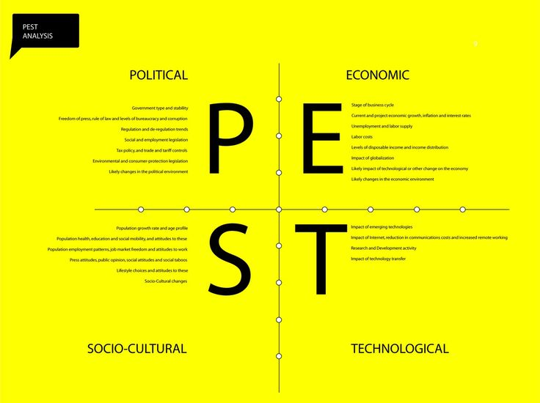
Fig: PEST Analysis (source: mindtools.com)

SWOT Analysis
The implementation of SWOT analysis helps the business in proper identification and determination of their key strengths, weaknesses, opportunities or threats relative to the concerned UK market of their business activities and operations. This can help the business in responding to such factors with proper strategies and approaches. The SWOT analysis has been explained in details as below;
Strengths: The key strengths of the business have been discussed below;
- The new services and product offerings can help the business to have a high appeal to the UK customers (Mariotti, 2014).
- The products and services can help the organization in fulfilling the health needs of UK customers resulting in better profitability and revenues in the market.
Weaknesses: The weaknesses of the business have been discussed below;
- The business lack proper brand image and recognition in the market.
- There is an unavailability of a suitable location in the metropolitan areas of UK to start up the gym cum gluten free restaurant.
- The organization also needs to recruit trained staffs and personnel such as gym trainers, chefs and others.
Opportunities: The opportunities include the following:
- The business can help in reducing obesity among the UK population by catering to their health needs and benefits by offering them with both gym and healthy eating facilities.
- Considering the low level of competition in the market the business idea has a high growth prospects in the UK market.
Threats: Some of the threats that can be faced by the organization include the following;
- The market is prone to unwanted variations and fluctuations on a much larger scale.
- Owing to the changes in customer preferences over time the business revenues can suffer high loss.
- There are also high chances of financial risks in the respective market.
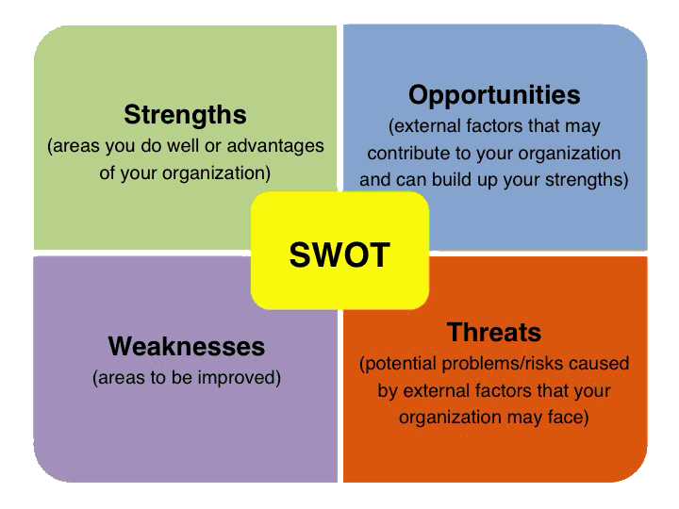
Fig: SWOT Analysis (source: slideshare.net)

Marketing and Promotional Strategy
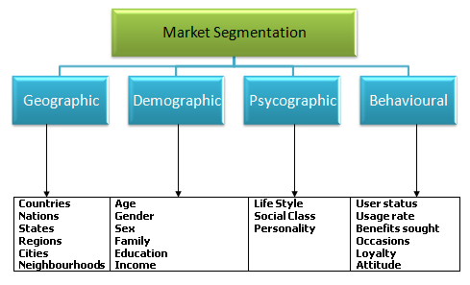
The business must be focused upon developing specific marketing strategies or approaches that can help in better promotion and branding of the products and the business among the targeted customer segments. Thus prior to implementing the strategies of marketing, the business needs to segment their core customer groups who can potentially buy the specific services and products (Hollensen, 2015). The segmentation of the market can be done through considering certain specific factors or parameters that include demographics, psychographics, behavioral and geographic.
Now considering the UK market, the targeted customer segments for the business is the customers within the age group of 18 to 45 years having high health needs and effectively prefers healthy living and lifestyle. In addition the business can also target the UK population suffering from obesity and want to improve their health and fitness levels for better and healthy lifestyles.
For successful product promotion and business branding there is a need to implement proactive strategies and approaches that can help in better product and service promotion among wide segments of customers in the respective UK market. In this regards, the focus of the business must be upon implementing the use of different marketing and promotional media and channels available. Some of these marketing and promotional channels have been discussed in details as below;
Print and Television Media Channels: The business of the gym cum the gluten free restaurant must effectively focus upon printing advertisements in newspapers, health and fitness magazines, journals or articles so that successful product promotion can be achieved (Solomon, 2014). In addition distribution of leaflets, pamphlets and others can also be incorporated for promotion. Advertisements can be broadcasted and aired on the specific television channels.
Display Media Channels: To achieve successful marketing and promotions the use of visually appealing hoardings, banners, billboards and posters can be used so that it can appeal and attract the customer segments towards the products and services (Eshuis, Braun and Klijn, 2013).
Digital Media Channels: In the present age of digital media, it is necessary for the business to be well aware of the digital marketing and media channels so that higher marketing and promotional success can be achieved at much reduced costs or expenses. Thus the use of social media channels must be effectively done by the business. This can help the respective business to make the optimum use of the innovative social media marketing platforms and reach out to large customer numbers or audiences without the constraint of geographical boundaries and limitations (Keller, 2016). This can also help the organization in developing long term customer relations which can further benefit the marketing and promotional success of the business. Some of the social media channels that can be utilized include Facebook, Instagram, You Tube, twitter and others.

Fig: Marketing and Promotional Channels (source: self)

Primary Research to determine the prospect of the business
The overall prospects and opportunities of the startup business were evaluated through conducting a detailed market survey and analysis. The survey was initiated among 50 respondents within the age group of 18 to 45 years who are the targeted customer segments or audiences of the respective business. The overall results of the survey have been discussed as below;

Q 1) Do you agree that the business can introduce innovative services and products in the UK market?
Options | Frequency | Percentage (in %)
Strongly Disagree | 2 | 4
Disagree | 3 | 6
Neutral | 1 | 2
Agree | 27 | 54
Strongly Agree | 14 | 28

Q2) Do you agree that the services and products offered can fulfil the health needs of the UK population?
Options | Frequency | Percentage (in %)
Strongly Disagree | 3 | 6
Disagree | 4 | 8
Neutral | 2 | 4
Agree | 25 | 50
Strongly Agree | 16 | 32

Q3) DO you agree that the innovative business concept can result in a competitive advantage in the UK market?
Options | Frequency | Percentage (in %)
Strongly Disagree | 4 | 8
Disagree | 5 | 10
Neutral | 1 | 2
Agree | 23 | 46
Strongly Agree | 17 | 34

Q4) How far do you believe that the products and services offered can benefit the obese UK population in living a fit and healthy lifestyle?
Options | Frequency | Percentage (in %)
Strongly Disagree | 7 | 14
Disagree | 8 | 16
Neutral | 2 | 4
Agree | 17 | 34
Strongly Agree | 16 | 32

Q5) Do you believe that the business needs to enhance their branding activities for better promotion and market presence?
Options | Frequency | Percentage (in %)
Strongly Disagree | 5 | 10
Disagree | 7 | 14
Neutral | 1 | 2
Agree | 26 | 52
Strongly Agree | 11 | 22

As showcased in the above analysis, it is evident that the business of the gym cum gluten free restaurant has a high prospects and opportunities for growth and development in the United Kingdom (UK) market. The analysis clearly suggests that the new and innovative business concept can help the business In appealing to a large customer groups or audiences in the market. The products and sufferings can also help the organization in context of fulfilling the health needs and requirements of the people which offers better opportunities in terms of earning high profitability in the respective industry market. In addition considering the rise in obesity among the population of UK, the new services offered by the business can help to serve people’s needs. However as per the analysis it is also evident that it is required for the business in engaging in highly active marketing and promotional activities so that the brand recognition and market presence can be improved or enhanced.

Financial Estimations and projections:
The cost of business establishment of the business is given below:
Heads of Expenses | Amount (in £)
Yearly Rent of the business Establishment | 40000
Purchase of Instruments for Gym | 60000
Purchase of Furniture of the restaurant | 60000
kitchen set up for restaurant | 20000
Human Resource Cost on yearly basis including gym trainer, chefs and other staffs | 200000
License | 50000
Initial marketing Expenses | 50000
Other miscellaneous cost | 20000

Revenue Estimation:
The initial subscription fees of gym for 1 year would be £100 per head per month and more over an additional revenue of £250 is expected from gluten free restaurant for per head basis per month.
Month | Number of Enrollment | Revenue from gluten Free Restaurant (in £)
Month 1 | 20 | 7000
Month 2 | 25 | 8750
Month 3 | 40 | 14000
Month 4 | 50 | 17500
Month 5 | 52 | 18200
Month 6 | 55 | 19250
Month 7 | 60 | 21000
Month 8 | 65 | 22750
Month 9 | 67 | 23450
Month 10 | 70 | 24500
Month 11 | 7 | 2450
Month 12 | 80 | 28000
Total revenue in Year 1 |  | 206850

Revenue Estimation & profit Estimation for 3 years :
It is expected that the revenue would be increased by 10% in 2nd year due to increased demand and 15%in third year of operation. The operating cost would be 50% of revenue therefore gross profit of the business would be 50% of the yearly revenue.
Year | Revenue (in £) | Profit Before Tax (in £)
year 1 | 206850 | 103425
year 2 | 227535 | 113767.5
year 3 | 261665 | 130832.5

References
Adekola, A. and Sergi, B.S., 2016. Global business management: A cross-cultural perspective. Routledge.
Erasmus, B., Strydom, J.W. and Rudansky-Kloppers, S., 2016. Introduction to business management. Oxford University Press Southern Africa.
Eshuis, J., Braun, E. and Klijn, E.H., 2013. Place marketing as governance strategy: An assessment of obstacles in place marketing and their effects on attracting target groups. Public Administration Review, 73(3), pp.507-516.
Ghezzi, A., Cavallaro, A., Rangone, A. and Balocco, R., 2015, April. A Comparative Study on the Impact of Business Model Design & Lean Startup Approach versus Traditional Business Plan on Mobile Startups Performance. In ICEIS (3) (pp. 196-203).
Gollenia, L.A., 2016. Business transformation management methodology. Routledge.
Gollenia, L.A., 2016. Business transformation management methodology. Routledge.
Hill, C.W., Jones, G.R. and Schilling, M.A., 2014. Strategic management: theory: an integrated approach. Cengage Learning.
Hollensen, S., 2015. Marketing management: A relationship approach. Pearson Education.
Keller, K.L. and Kotler, P., 2016. Marketing management. Pearson.
Lee-Ross, D. and Lashley, C., 2010. Entrepreneurship and small business management in the hospitality industry. Routledge.
Longenecker, J., Petty, J., Palich, L. and Hoy, F., 2013. Small business management. Nelson Education.
Mariotti, S. and Glackin, C., 2014. Entrepreneurship and small business management. Pearson Higher Ed.
McKeever, M., 2016. How to write a business plan. Nolo.
Polyakova, O. and Mirza, M.T., 2016. Service quality models in the context of the fitness industry. Sport, Business and Management: An International Journal, 6(3), pp.360-382.
Solomon, M.R., 2014. Consumer behavior: Buying, having, and being (Vol. 10). Upper Saddle River, NJ: Prentice Hall.

