Client Technical report
Ryan Lewis-Edwards – UWTSD - 1808182

TABLE OF CONTENTS
- Cover Page (Pages 1-1)
- Table of Contents (Pages 2-2
- Client Proposal (Pages 3-5)
- Proposal Introduction (Pages 6-6)
- Sketches (Pages 7-9)
- Timber Rafters and Alternate roofing methods (Pages 9-10)
- References (Pages 11-11)

Client Proposal
Miss A Client has approached me having received planning permission for a single, two storey detached domestic building with attached floor plans and elevations. These are attached below.
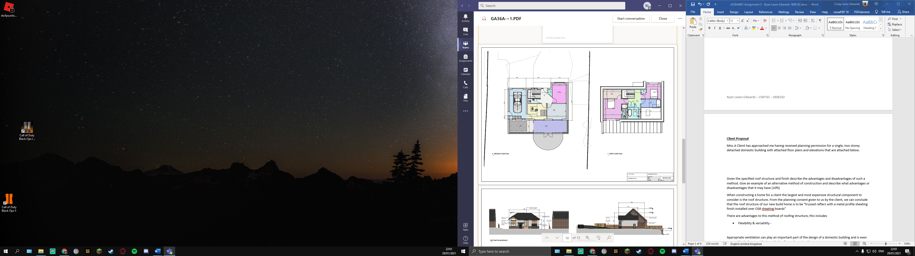
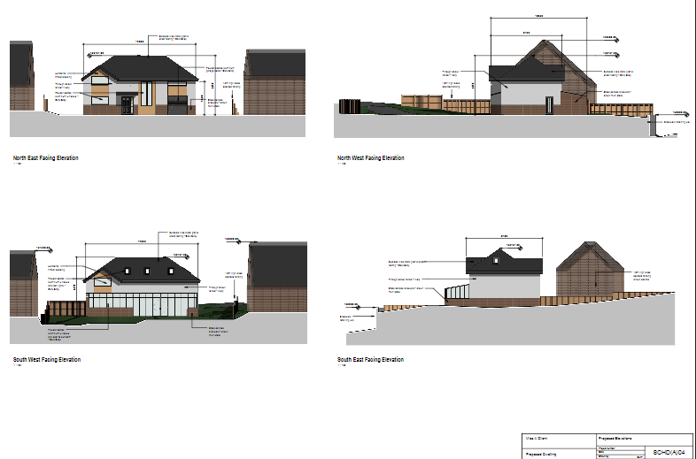
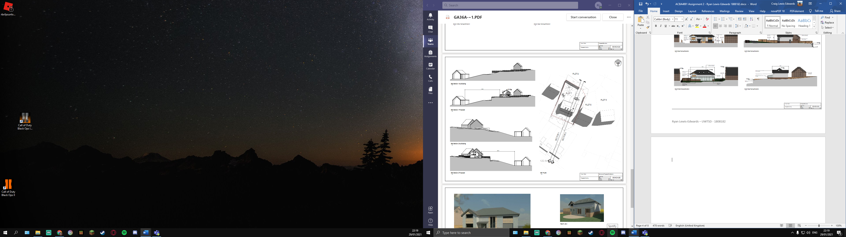

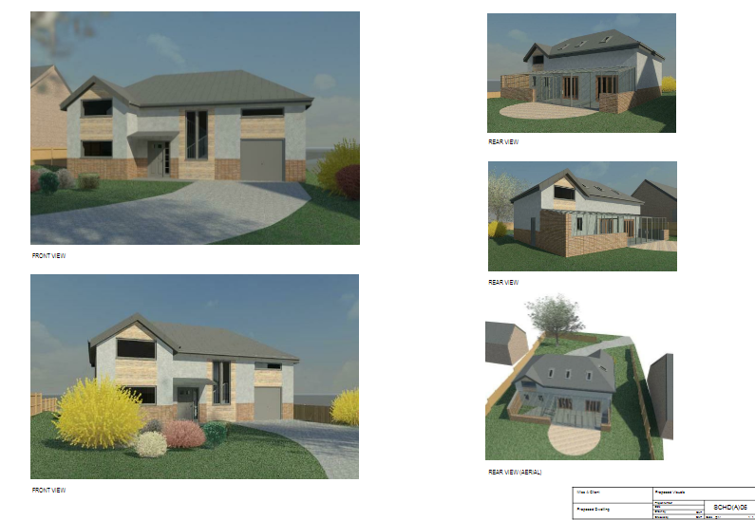
I have also been given grounds work details and building specifications for the two-storey build, this state:
“It is to be built on a level but reclaimed site, which prior to advanced ground works had been used as agricultural land. There is a retaining wall structure to the south of the site and the Ground Investigation report suggests a suitable raft foundation be constructed for the property. The building is a timber framed construction where the inner skin of the ‘cavity wall’ is 140mm thick insulated C16 timber frame. The outer skin consists of stack bonded facing brick work and blockwork with a smooth render finish. Additional PIR insulation is contained within the cavity to improve the thermal performance. There is to be an insulated ground floor with underfloor heating in the screed and the upper floors are to be traditional solid timber with tongue and groove softwood flooring. Windows and external doors are to be powder coated aluminium; windows are triple-glazed units. Roof structure is to be trussed rafters with a metal profile sheeting finish installed over OSB sheathing boards.” – (Miss A Client 2020)
As part of this proposal, the client has asked for the preparation of a technical report including proportionate and suitably annotated sections and sketches, these must illustrate:
- The materials that are to be used in construction
- The methods for the detailing of the following building elements and construction inter-faces.
- “Ensure all detailing show how the design will meet the current Building Regulations for a domestic new-build”
The sketches themselves should show:
i)The Ground floor Construction, detailing and junctions with external walls.
ii)The First floor Construction, detailing, junctions with external walls and restraints.
iii)Eaves detailing and roof covering – indicating appropriate weathering, fixing and laps.
iv)The main roof structure. Construction, detailing and fixing.

Sketches
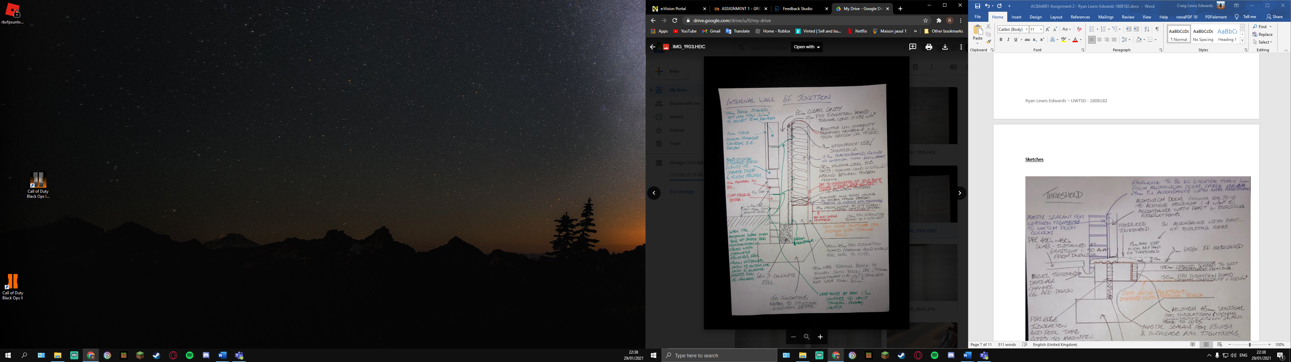
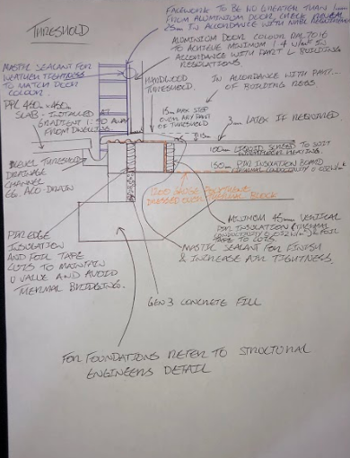

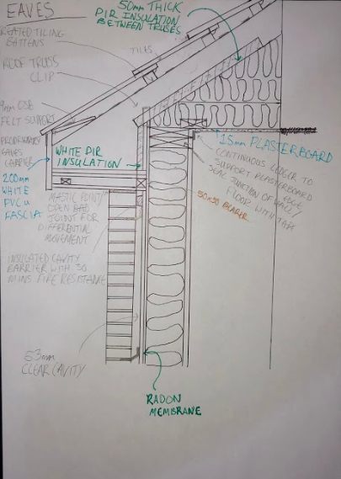

Timber Rafters and Alternate roofing methods
When constructing a home for a client the largest and most expensive structural component to consider is the roof structure. From the clients planning permissions we can conclude that the roof structure of our new build home is to be “trussed rafters with a metal profile sheeting finish installed over OSB sheating boards”
There are advantages to this method of roofing structure, this includes
- Flexibility & versatility – Timber is a very versatile material to be used as a truss structure since it is compatible with lots of structural objects. It can be linked to other trusses or combined with other structural components such as steel beams.

- Price – Timber truss roofs are generally less expensive than steel and can be installed without the use of heavy machinery which significantly lowers the installation price. They have a low develop time in comparison to other parts of the project cycle lowering the labour costs required.

- Design – Timber roof trusses are preferred in design as they are suitable for many building types and offer more design variety to experiment with the aesthetics of the building. Overall timber offers more visual impact in comparison to alternative materials.

- Thermal Properties – Timber has excellent thermal properties in comparison to alternative truss materials such as steel or concrete. A cavity can be formed using timber which allows for better insulation to be made.

- Sustainability – Timber is an eco-friendly construction material as it exhales in Carbon dioxide and releases oxygen into the environment. Timber consumes far less energy to process minimizing air and water pollution.

However, there are also disadvantages to the use of Timber rafters such as the limitation of attic space and the possibility of rot and infestation if the timber is not heated or well-maintained.
An alternative that could be used in place of timber roof trusses are Steel roof trusses. Steel roof trusses are predominantly used in the construction of large sports arenas, warehouses and hangars but can also be used in the construction of homes. The advantages of Steel roof trusses include:
- High strength-to-weight ratio – Overall, steel is a stronger material in comparison to timber. It can withstand heavy weight loads from wind and snow and can span longer than timber.

- Durability – Galvanised steel trusses are extremely durable and require little maintenance. Steels properties can be altered allowing it to be engineered to become pressure and tension resistant making it perfect against natural occurrences such as hurricane-force winds and heavy snow.

- Fire resistance – Steels properties can be altered to make it fire-retardant rendering them virtually indestructible by fire which is beneficial in areas with a high fire risk.

- Pest resistance – Infestation of timber is one of the main disadvantages and in areas which are prone to pest infestation it is only correct to use Steel trusses as applying pest resistant treatments lowers the air quality indoors.

References
https://www.hunker.com/12613319/advantages-and-disadvantages-of-a-timber-truss-roof
https://theconstructor.org/structural-engg/timber-roof-trusses-advantages/13875/
https://www.whirlwindsteel.com/blog/bid/407704/the-lowdown-on-building-with-steel-roof-trusses

