BMHP6030 Health, Wellbeing and Sustainable Development

Component 2: Report

Evaluating the Impact of SDG 3 and SDG 6 on Global, National and Local Health and Wellbeing Outcomes

Student Name: Sehrish Kayani
Student ID: 2315822

Table of Contents
1. Introduction 3
2. Section 1: SDG 3 - Good Health and Wellbeing 3
2.1 Overview of SDG 3 3
2.2 Critical Evaluation of Global Policies and Initiatives 4
2.3 Critical Evaluation of National and Local Examples 5
2.4 Recommendations 6
3. Section 2: SDG 6 – Clean Water and Sanitation 6
3.1 Overview of SDG 6 6
3.2 Critical Evaluation of Global Policies and Initiatives 7
3.3 Critical Evaluation of National and Local Examples 8
3.4 Recommendation 9
4. Conclusion 9
References 10

Introduction
The Sustainable Development Goals are a global strategy used in addressing issues of social, economic, and environmental concerns. The 17 Sustainable Development Goals established by the United Nations in 2015 are geared towards promoting human well-being and sustainable development up until 2030 (UNDP 2025). Good health and well-being, one of the Sustainable Development Goals, is a critical aspect in achieving sustainable development, since it ensures healthy lives and well-being for all individuals of all ages. However, social and environmental aspects such as access to clean water and sanitation impact health status (World Health Organization, 2023).
This report is intended to critically evaluate SDG 3 and SDG 6: Clean Water and Sanitation to comprehend how these goals assist in the achievement of health and sustainability results globally, nationally, and locally. Interdependency of SDG 3 and SDG 6 is vital because a lack of water and sanitation services could cause higher chances of having infectious diseases and disparities in health (World Health Organization, 2023).

Section 1: SDG 3 - Good Health and Wellbeing

Overview of SDG 3
Ensuring healthy lives and promoting well-being for all at all ages (SDG 3) aims at improving health outcomes, reducing preventable deaths, and strengthening health systems (The Global Goals, 2025). The target includes indicators related to universal health coverage, maternal and child mortality rates, communicable and non-communicable diseases, and access to essential medicines and health services. Bad health adversely affects education opportunities and economic productivity as well as well-being; that is why it is acknowledged as an important element of sustainable development (World Health Organization, 2023b).
While there were significant advances in achieving SDG 3, health care access disparities, growing non-communicable diseases, lack of health care workers, and the emergence of challenges such as pandemics hinder the achievement of the goal. The COVID-19 pandemic brought out the vulnerabilities of global health systems, affecting different aspects of health outcomes (United Nations, 2022).

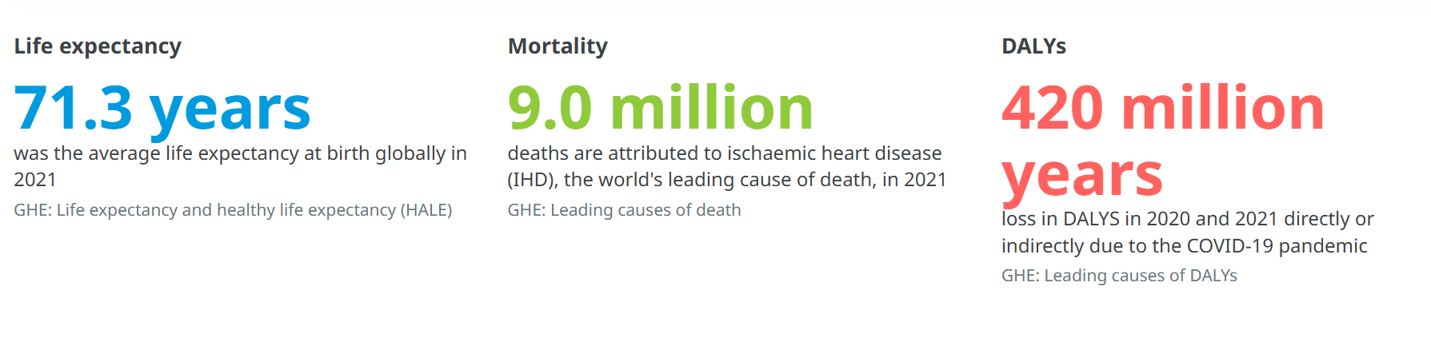
Figure 1: Global Health Estimate (WHO, 2023)

Critical Evaluation of Global Policies and Initiatives
One of the key strategies that has been adopted by WHO towards achieving SDG 3 is the development of the Global Action Plan for the Prevention and Control of Noncommunicable Diseases (NCDs). It has been developed to ensure the prevention, early detection, and management of deaths which are caused by diseases such as cardiovascular disease, cancer, diabetes, and chronic respiratory diseases (WHO, 2022). This action plan has been adopted because noncommunicable diseases are among the leading causes of death across the world. However, this strategy has not been successful in ensuring the achievement of the objectives since the implementation process lacks uniformity across different countries. In addition, within the developing countries, there are challenges such as inadequate health care services, inadequate disease surveillance, and the influence of commercial factors such as the tobacco and alcohol industry (Abbas, 2024). Thus, the strategy provides a strong prevention strategy, but its effectiveness depends on the will of the country.
The WHO's International Health Regulations (IHR) are supposed to increase the ability of nations to detect and manage public health emergencies (Howden-Chapman et al., 2021). However, the ongoing pandemic has proven some weaknesses in global preparedness, such as a lack of cooperation, insufficient information sharing, and a lack of emergency response capability. Even though the IHR offers guidelines on how to respond to outbreaks, many countries failed to respond due to underdeveloped public health infrastructure (Rossi et al., 2020). Therefore, more accountability and funding are needed, and voluntary compliance will not work.
The social determinants of health framework, apart from healthcare, also demonstrates how a range of other elements contribute to people's wellbeing. According to Marmot (2020), income, education, working conditions, and housing are among the crucial determinants of health inequalities. Therefore, SDG 3 needs to be implemented on a larger scale and include interventions both in health care and regarding social inequalities, the environment, and healthy behaviours.

Critical Evaluation of National and Local Examples
Health policies in the UK represent examples of how this goal can be addressed by the government to enhance access, prevention, and reduce inequalities in health to achieve SDG 3. The NHS is contributing to the achievement of SDG 3 by working in areas such as universal access, prevention, and improvement of population health. For example, the NHS Long Term Plan stresses the need for prevention, early detection, and tackling inequalities among populations with worse health outcomes (NHS, 2023). Still, despite all these initiatives, significant inequalities persist in terms of life expectancy and the development of preventable diseases between residents of deprived areas and richer communities (Marmot, 2020). It indicates that while the presence of health care is an essential but not the only condition for the realization of SDG 3, social and economic determinants of health play an important role.
In an effort to discover if adults between 40 to 74 years old (between 45 to 74 years old for blacks and Asians and between 50 to 74 for people from ethnic minorities) face a chance of developing a preventable disease or require early intervention like early intervention for cardiovascular diseases, diabetes, kidney diseases, and stroke, the NHS initiated the Health Check Program (Stevenson et al., 2021). This intervention plays a vital role in achieving SDG 3 as it focuses on providing preventive healthcare and early detection of health problems and lifestyle interventions. However, the program has faced challenges in implementation due to the unequal participation of individuals from deprived and minority communities due to a lack of awareness, accessibility, and health literacy. (Gadsby et al., 2023) Although the program demonstrates the transition from the reactive method of treatment to prevention, there is a necessity to enhance the role of the community and to devise strategies to ensure that vulnerable segments of society do not lag in achieving SDG 3.
Interventions in communities, such as vaccinations, screenings, and education, assist in meeting the SDG 3 goals through prevention and better behaviour. These interventions are guided by the principles of Social Cognitive Theory (Martin et al., 2020), where behaviour is shaped by one’s beliefs and social and environmental factors. However, participation is lower among disadvantaged communities due to low health literacy, distrust, and access issues. The Health Belief Model stresses the significance of engagement in protective behaviours when an individual believes he or she is in danger of developing some health issues, and when he or she perceives that protection against those problems is feasible (Howden-Chapman et al., 2021). Therefore, it is necessary not just to provide services, but also to address behavioural and social barriers in order to meet the SDG 3 goals.

Recommendations
Health policy efforts could be directed more toward preventive measures, inequality reduction, and wider determinants of health to increase progress in SDG 3. Investments in primary care and community health can contribute to a preventive approach and ease pressure on health systems (WHO, 2023). Moreover, behavioural methods rooted in theories such as Social Cognitive Theory and Health Belief Model can increase participation of the population in health initiatives. Interaction among the spheres of health, education, environment, and social life could be increased in order to address the wide variety of determinants of health in the SDG 3 context.

Section 2: SDG 6 – Clean Water and Sanitation

Overview of SDG 6
The aim of SDG 6 is to "ensure availability and sustainable management of water and sanitation for all" (Rajapakse et al., 2023). Although SDG 6 is focused on environmental sustainability, it is also closely connected to SDG 3 because access to clean water, sanitation, and hygiene (WASH) is the basis of good health. Water pollution and inadequate sanitation systems can lead to the development of many infectious diseases, including diarrhea, which remains one of the main causes of child mortality in developing countries (World Health Organization, 2023a). Therefore, there are connections between SDG 6 and the targets set by SDG 3.
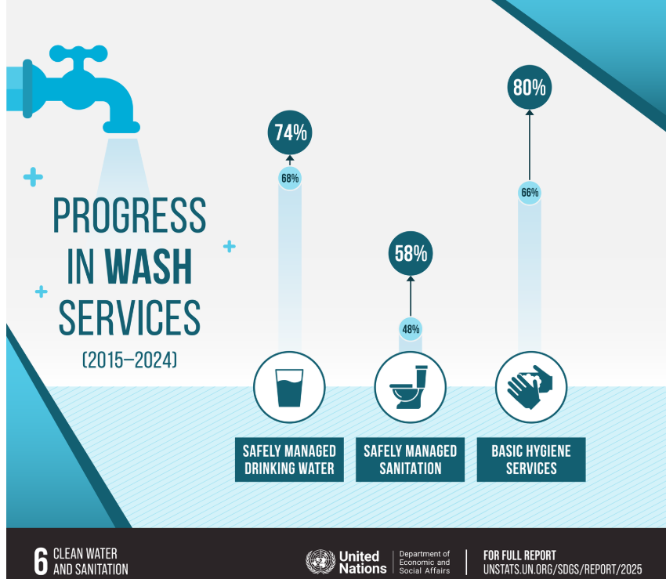
Figure 2: Clean Water and Sanitation (United Nations, 2025)

Critical Evaluation of Global Policies and Initiatives
The WHO/UNICEF Joint Monitoring Programme (JMP) for drinking water, sanitation, and hygiene is an important worldwide program that measures achievements in these areas and indirectly contributes to SDG 6 and SDG 3 as well. This is an important source of data necessary to define which populations are susceptible to preventable diseases because of inadequate water supply and poor sanitation. According to Bain et al (2020), millions of people remain exposed to dangerous diseases and even death because of contaminated water and sanitation, with diarrhea and cholera being two main ones. Although the JMP has brought about increased responsibility worldwide through the identification of inequalities, one of the limitations of the program is that monitoring alone does not make a difference without additional actions.
UN Water Action Agenda is another international agenda that emphasizes the link between SDG 6 and SDG 3 through promoting sustainable water management to protect health. The initiative recognizes that safe water and sanitation facilities are vital for preventing disease, adapting to climate change, and ensuring health (United Nations, 2023). However, implementation remains a slow process due to a lack of funding, institutions, and the ability to maintain water supply systems in many countries. Therefore, while international agendas provide an effective strategy, their contribution to SDG 3 will depend on the effectiveness of government initiatives.
The Social Determinants of Health model can further be applied to examine the connection between SDG 6 and SDG 3. As per Marmot (2020), social and environmental determinants of health have been found to play an important role in influencing health disparities; hence, people in deprived regions face adverse effects on their health because of poor environmental conditions. This means that preventive steps in terms of the availability of clean water and adequate sanitation must be taken to reduce the chances of health disparities, along with improved healthcare service delivery, to meet SDG 3 goals. Consequently, SDG 6 can be termed as a foundation step for SDG 3 as it aims at addressing environmental determinants of ill health rather than its outcomes.

Critical Evaluation of National and Local Examples
The initiatives by the UK in relation to Goal 6 clearly demonstrate the significance of the WASH approaches to SDG 3 because they address the environmental determinants affecting health. As pointed out by Bond (2022), WASH influences many dimensions, including health, education, gender equality and environment, and is an important factor in the wellbeing of society. However, the initiatives aimed at the accomplishment of SDG 6 have not been sufficient, and the inequities in access to safely managed water and sanitation services have been increasing globally.
The UK has a well-documented record of supporting SDG 6 within the country in terms of research, international WASH programming, and the operations of organizations that focus on improving water and sanitation. However, what Bond clearly sees is the fact that the ability of the UK to be a leader in this area has been weakened because of cuts in Official Development Assistance (ODA). While funding for WASH went down from 2.7% of ODA in 2018 to 0.5% in 2021, it has negatively impacted programs related to water systems, health, and hygiene, all of which are affected by climate change (Bond, 2022). It creates a problem in relation to SDG 3, which can result in decreased investment in preventive health.
According to Bond (2022), community involvement, particularly from marginalized communities, at a local level is paramount to implement SDG 6 effectively. Community-based activities are important because they can enable local needs identification and data gathering. For SDG 3 to be attained, the provision of health services alone is not enough; it requires the presence and accessibility of clean water, sanitation, and hygiene. This is in line with the social determinants of health model, which argues that health inequalities are influenced by various social and environmental conditions and not health care (Marmot, 2020).

Recommendation
Sustainable water infrastructure needs to be prioritized by the government, particularly in communities at risk, in order to enhance the effectiveness of SDG 6 on SDG 3. Policies need to be coordinated with health education campaigns to ensure that proper hygiene and disease prevention measures are carried out, alongside infrastructure development (Kleinman et al., 2021). Moreover, there is a need for increased collaboration among health officials, environmentalists, and local governments since good water and sanitation conditions can help reduce health service provision in the future.

Conclusion
This report demonstrates that achieving SDG 3: Good Health and Wellbeing requires addressing wider social and environmental determinants of health. The analysis of SDG 6 highlights that access to safe water and sanitation plays a crucial role in preventing disease, reducing inequalities, and improving population wellbeing. While global and national initiatives have contributed to progress, challenges remain due to unequal implementation, resource limitations, and social inequalities. Therefore, sustainable health improvement requires integrated approaches that combine healthcare interventions with environmental and social policies. Strengthening collaboration between sectors is essential to ensure that no communities are excluded from achieving better health outcomes.

References
Abbas, S. (2024) “Pathway for attaining SDG3: The role of ICT infrastructure, natural resources, and environmental sustainability,” Sustainable Futures, 8(12), p. 100339. Available at: https://doi.org/10.1016/j.sftr.2024.100339
Bain, R., Johnston, R. and Slaymaker, T. (2020) “Drinking water quality and the SDGs,” Npj Clean Water, 3(1). Available at: https://doi.org/10.1038/s41545-020-00085-z.
Bond (2022) The UK’s global contribution to the Sustainable Development Goals | Bond, Bond | The international development network. Available at: https://www.bond.org.uk/resources/the-uks-global-contribution-to-the-sustainable-development-goals/ (Accessed: July 11, 2026).
Gadsby, E.W. et al. (2023) “The NHS Health Check programme: A survey of programme delivery in England before and after the Covid-19 pandemic response,” NIHR Open Research, 3(13), p. 32. Available at: https://doi.org/10.3310/nihropenres.13436.2.
Howden-Chapman, P. et al. (2021) SDG 3 ENSURE HEALTHY LIVES AND PROMOTE WELL- BEING FOR ALL AT ALL AGES. Available at: https://council.science/wp-content/uploads/2017/03/SDGs-interactions-3-healthy-lives.pdf (Accessed: July 9, 2026).
Marmot, M. et al. (2020) Marmot Review 10 Years on - Institute of Health Equity, Institute of Health Equity. Available at: https://www.instituteofhealthequity.org/resources-reports/marmot-review-10-years-on (Accessed: July 9, 2026).
Martin, J.J. and Guerrero, M.D. (2020) “Social cognitive theory,” Routledge Handbook of Adapted Physical Education, 23(1), pp. 280–295. Available at: https://doi.org/10.4324/9780429052675-22.
NHS (2023) NHS Health Check, NHS.uk. Available at: https://www.nhs.uk/tests-and-treatments/nhs-health-check/ (Accessed: July 9, 2026).
Rajapakse, J., Otoo, M. and Danso, G.K. (2023) “Progress in delivering SDG6: Safe water and sanitation,” Progress in delivering SDG6: Safe water and sanitation, 1(56). Available at: https://doi.org/10.1017/wat.2023.5.
Rossi, M. et al. (2020) “ESG, Competitive Advantage and Financial Performance: A Preliminary Research,” Handle.net, 1(1), pp. 969–986.
Stevenson, S. et al. (2021) “A hybrid approach to identifying and assessing interactions between climate action (SDG13) policies and a range of SDGs in a UK context,” Discover Sustainability, 2(1). Available at: https://doi.org/10.1007/s43621-021-00051-w.
The Global Goals (2025) Goal 3: Good health and well-being, The Global Goals. Available at: https://globalgoals.org/goals/3-good-health-and-well-being/ (Accessed: July 9, 2026).
UNDP (2025) Sustainable Development Goals, United Nations Development Programme. United Nations. Available at: https://www.undp.org/sustainable-development-goals (Accessed: July 8, 2026).
United Nations (2023) Water Action Agenda | Department of Economic and Social Affairs, Sdgs.un.org. Available at: https://sdgs.un.org/conferences/water2023/action-agenda (Accessed: July 9, 2026).
United Nations (2022) The Sustainable Development Goals Report 2022, Unstats.un.org. United Nations. Available at: https://unstats.un.org/sdgs/report/2022/ (Accessed: July 9, 2026).
United Nations (2025) Goal 6 | Department of Economic and Social Affairs, Sdgs.un.org. United Nations. Available at: https://sdgs.un.org/goals/goal6 (Accessed: July 10, 2026).
WHO (2022) Targets of Sustainable Development Goal 3, World Health Organisation. Available at: https://www.who.int/europe/about-us/our-work/sustainable-development-goals/targets-of-sustainable-development-goal-3 (Accessed: July 2, 2026).
World Health Organization (2023a) Drinking-water, World Health Organization. Available at: https://www.who.int/news-room/fact-sheets/detail/drinking-water (Accessed: July 3, 2026).
World Health Organization (2023b) Healthy environments for healthier populations: Why do they matter, and what can we do?, Www.who.int. Available at: https://www.who.int/publications/i/item/WHO-CED-PHE-DO-19.01 (Accessed: July 5, 2026).
World Health Organization (2023c) Tracking Universal Health Coverage: 2023 Global monitoring report, Www.who.int. Available at: https://www.who.int/publications/i/item/9789240080379 (Accessed: July 9, 2026).

