 | Student No: | 2434712
 | Module Title: | Business Skills for the International Hotel Industry
 | Module Code: | BMIH4007
 | Lecturer: | Daniel Payne

Component One: Reflective Journal 1000 words

Introduction
In this Reflective journal, I am writing about what I learned in weeks 2–8 of the Business Skills module. I worked on many academic and professional skills over the course of these weeks, such as communication, time management, digital literacy, referencing, professional growth, and reflective practice. Each subject helped me grow as a person and in school. All of these skills were important, but managing my time was the most important to me. As a priest, I have a lot of tasks. Learning how to manage my time well helped me think about both my schoolwork and my work in the community. I will be writing about my adventures and thinking about what I have learned in this journal, with a focus on time management.

Experience
The lesson taught time management and how to use the online library in the second week. We learned how to use academic resources, find accurate information, and put our study in the best order possible. Time management strategies were talked about, including how to plan tasks, set priorities for important work, and handle multiple jobs at once. This was especially important to me because, along with studying, my job at church often includes planning activities, writing sermons, and helping people in the community. Learning about these tactics helped me understand how important it is to plan and organise.
In week three, we focused on digital skills and using Moodle. The workshop taught us how to navigate the university’s online learning platform, access course materials, submit assignments, and communicate with lecturers. This session showed me how technology can help save time and organise work more efficiently.
In the fourth week, you learned how to use citations, write academically, and paraphrase. We learned how to properly cite sources in Harvard style and how to quote them. This is an important skill to have because it protects academic honesty and makes homework less stressful. It also helps with time management because you do not have to make changes at the last minute.
We looked at reflective models and business networking on LinkedIn in week five. The reflective models helped me think about how I could grow professionally and personally, and LinkedIn showed me ways to show possible employers my skills and experiences. It reminded me that making time for professional and personal growth is just as important as getting daily chores done.
We took a field trip to London's Institute of Hospitality in week six to see how professionals do their jobs in a real business setting. The trip showed how to work together, be a leader, and organise things. Watching how businesses handle many tasks and meet deadlines taught me how important it is to manage my time in a work setting.
In week seven, we went to Bluestone, which gave us more experience with how things work in the real world. Seeing how the staff planned events and kept track of schedules made me realise how important it is to plan and set priorities, which are skills I can use in school and in my community work.
Lastly, in week eight, we took part in a class on content creation. We learned how to use PowerPoint, Canva, and CVs. Putting together presentations and designing business papers taught me how important it is to be organised and plan ahead in order to get things done quickly and on time.

Reflection
Reflecting on these experiences, I think that one of the most useful skills I learned during the module was how to handle my time. Before this class, it was hard for me to balance my schoolwork with my duties as a church leader. I would sometimes spend too much time on some jobs and not do others at all. Time management classes taught me how important it is to plan ahead, put important tasks in order of importance, and set goals that are attainable.
For example, learning how to set priorities helped me see that some jobs, even though they need to be done right away, are not as important as others that will have a bigger effect in the long run. This helps me a lot in my job as a priest at a church, where I often have to handle administrative tasks, pastoral care, and community events. I can better manage my time by using these methods, which will help me meet both my academic and community obligations.
The workshops on digital skills helped people learn how to handle their time better. I can save time when I need to access course materials or turn in assignments by using Moodle well and organising my learning tools. In the same way, tools for making content like PowerPoint and Canva help me plan and put together slideshows more quickly and better. As a church leader, these skills help me plan sermons, make educational materials, and get words across to the people in my community.
Another important reflection is the connection between time management and leadership. Observing professional organisations during field trips highlighted how effective leaders plan, delegate, and manage multiple responsibilities simultaneously. As a church leader, I have learned that leading a team of volunteers or organising events requires the same principles: clear planning, prioritisation, and coordination. The module helped me reflect on how I can improve these skills in practice. I thought a lot about how to organise my time, but the other skills I learned were also very important. Communication helped me get my point across clearly and successfully, which is important in both school and the community. Referencing and writing for school gave me confidence in my studies, which made me less stressed and saved me time by keeping me from having to make last-minute changes. Reflective practice helped me regularly look at my work and find ways to improve, which is related to using my time more efficiently.
Overall, thinking about these events has taught me that managing my time well is important for juggling many responsibilities, reaching my goals, and feeling less stressed. The Business Skills program not only taught me useful skills, but it also helped me see how they can be used in both school and work situations. By focusing on time management, I have come up with plans that will help me with my studies, my church work, and my career growth in the future.

Component Two: Action Plan

Following my reflections on weeks 2–8 of the Business Skills module, this action plan focuses on how I will implement the skills and strategies I have learned. In particular, I will apply the lessons on time management, communication, leadership, and digital skills to both my academic studies and my responsibilities as a church leader. The aim of this plan is to enhance my strengths, address areas for improvement, and ensure that these skills contribute effectively to my professional and personal development.

Areas for Improvement
Time management is one of the main things I need to work on. Even though the lesson taught me some useful skills, it can be hard to balance my schoolwork with my duties at church. To fix this, I am going to start planning every week. Using calendars and digital planners (Covey, 2004), I make a list of important and long-term tasks every Sunday evening and put them in order of importance (Taylor, 2010). This plan will help me find time for preparing for a sermon, doing things in my neighbourhood, and doing schoolwork without getting too busy. Academic writing and referencing is another area that needs work. I learned how to use Harvard citations and paraphrases in this module, but I plan to keep practicing these skills by reading academic pieces and summarising information once a week. This will help me do better on my tasks and make me less stressed at the last minute.
Now, I want to get better at using technology to talk to people at work. I will often use programs like Canva and PowerPoint to make presentations for school and neighbourhood events. This will help me feel more confidence about making professional, clear materials that save time and get my point across clearly.

Core Strengths and Enhancement
One of my core strengths is communication. To lead a church community, you need to be able to communicate clearly and effectively. According to Goleman (1998), effective leaders demonstrate strong communication and emotional intelligence, which helps them build trust and positive relationships with others. Continuing to develop these abilities will support both my academic and professional development. The workshops in this section helped me get better at this. To get better at this skill, I will practise speaking in public once a month at community meetings and ask coworkers and congregation members for comments. This practice will help me get my point across easily and keep people interested.
Being a leader is another strength. The field trips and group activities showed how important it is to work together, delegate tasks, and keep people motivated. To improve my leadership even more, I will put together volunteer teams to work on community projects while using time management techniques and pushing everyone to talk to each other. This will help me lead teams better and make the workplace a better place to work.

Professional Practice and Application
By following this action plan, I hope to be able to use what I have learned in both school and the workplace. Managing my time well will help me handle many tasks at once, and getting better at talking to people and being a leader will make my role in the church community stronger. Better digital skills will allow me to make professional presentations and learning tools that can be used for school projects and community events.
Overall, this plan will make sure that the Business Skills I learned are not just theoretical. They are also used in my everyday life. I will keep growing as a student and a worker by reviewing my progress once a week and making changes to my plans as needed.

Reference:
Covey R., (2004); The 7 Habits of highly effective people; Available at: https://icrrd.com/public/media/01-11-2020-212827The%207%20Habits%20of%20Highly%20Effective%20People.pdf.
Goleman, D. (1998). Working with Emotional Intelligence. Available at: https://www.scirp.org/reference/referencespapers?referenceid=1735476.
Component Three: Professional development: build a personal brand and promote a professional identity. (700 words)
Canva Document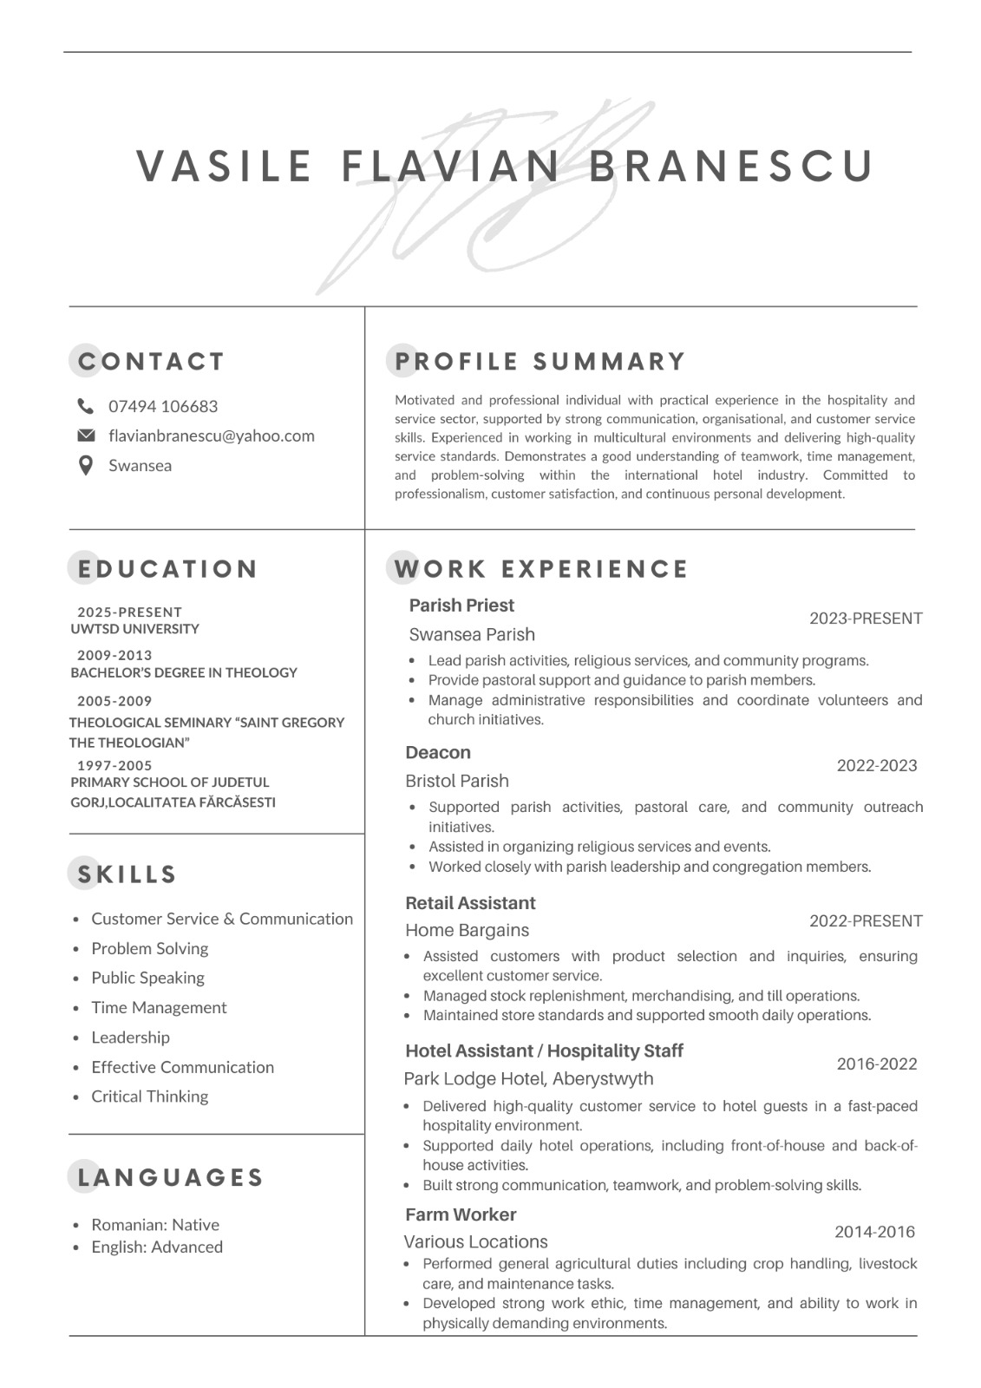

Linkedin Screenshot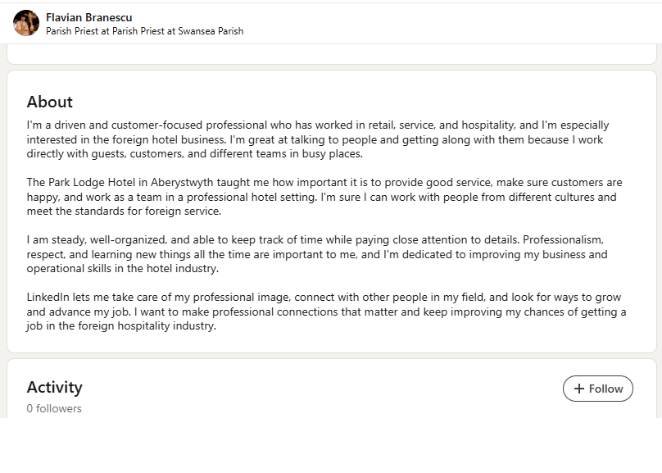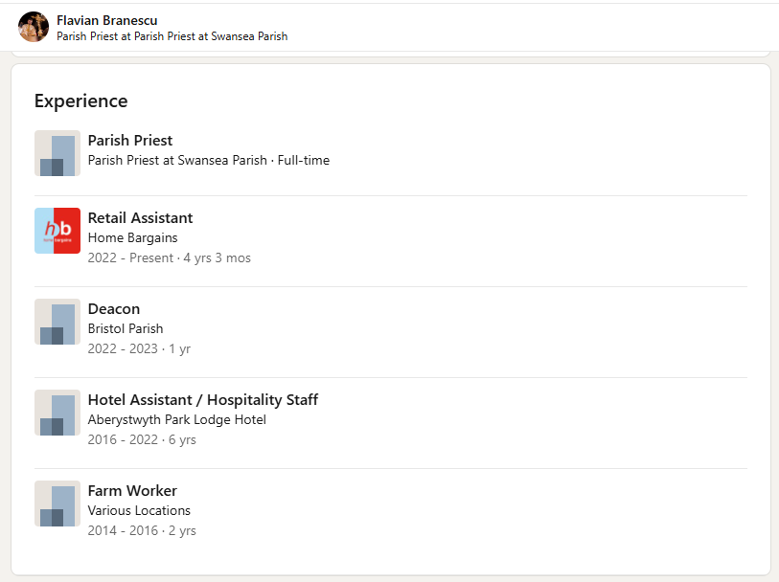
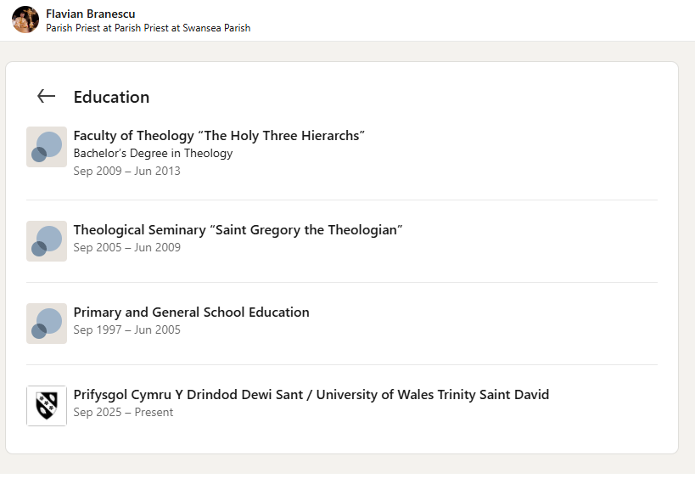
https://www.linkedin.com/in/flavian-branescu-92b6453a5/
Component Four: Using the information prepared for your CV, present a 5 minute presentation on the key attributes that a person working within the hospitality industry should possess.

This Presentation will be completed in person on site.

Place your presentation time below.

Timeslot: 10AM

