Programs in C and Documentation

Student Name: Lloyd Johnson
Student Number: 1802820
Module Code: ACCA4017

Table of Contents
What is a variable? 3
For Loop 3
Array 3
Pseudo Code for exercises in Visual studio 4
Code 5
Testing 7

What is a variable?
Variables in programming are used to store information in programs. A few examples of variables that are used in C are:
Int – this is an integer used to store whole numbers - “int number = 1;”
Float – this is used to store numbers with decimals - “float decimalNumber = 1.1;”
Char – this is used to store characters such as letters – “char letter = ‘A’;”
String – this is also declared by using char this will store multiple characters such as names
– “char myname[6] = {‘L’ , ‘l’, ‘o’, ‘y’, ‘d’};
These variables can then be called to be used further in the program. It is very important that the programmer names the variables well as the names of the variables will help the programmer to understand what that variable is used for in the program.
The programmer does not have to assign a value to a variable when it is declared and can leave it to the user to enter the variable. If doing this the programmer declares the variable like this.
Int number;
Then the programmer can use the scanf function to store data in the variable to be used.

For Loop
A for loop is used to repeat a section of code to several times that the programmer knows. It can also be called a counting loop as the programmer will enter the number of how many times the program will run through the code and when running through the code it will count to the number specified by the programmer then stop running.
An example of when a for loop will be used is counting to a number.

Array
An array is like a large table used to store data. The table has boxes and in those boxes the data is stored, a box can only hold one piece of data. When creating the program, the programmer can declare how large they want the table to be. data that is stored in the array needs to be the same data type ,so characters and integers cannot be housed in the same array.
The code will look like this.
//variables
int numbers[5];//how large they want the array to be
int i;
//array
for (i = 0; i <= 4; i++)

An array would be used to enter various prices of items and find the total of all of those prices.

Pseudo Code for exercises in Visual studio
Exercise 1: prints enter name
Store entered value in name variable
Print enter height
Store entered value in height variable
Print enter age
Store entered value in age variable
Print name variable
Print height variable
Print age variable

Exercise 2: declare PI as 3.14
print enter radius of circle
area of circle = (radius * radius) * PI
display circle area
enter height of triangle
enter base length of triangle
area of triangle = (height * base) / 2
display triangle area
calculate shade area
shade area = circle area – triangle area
display shade area

Exercise 3: Declare variables
Create an array for entering numbers and store the numbers
Create an array for adding the numbers together
Add the array numbers together
Sum = sum + numbers[i]
Print the sum of the array numbers
Find 20% of the sum
VAT = sum * 0.2
Create a final total of the array numbers plus VAT
total = sum + VAT
Display the total numbers

Code
This code was entered in visual studio. The green text areas are comments.
  - Exercise 1:
#include <stdio.h>
void main()
{
char firstname[20];//variable for first name
char surname[20];//variable for second name
int age;
float height;

//firstname
printf("Enter your first name: ");//text displayed on screen
scanf("%s", &firstname);//stores entered data in the firstname variable
//surname
printf("\nEnter your second name: ");//text displayed on screen
scanf("%s", &surname);//stores entered data in the surname variable
//age
printf("Enter your age");//text displayed on screen
scanf("%d", &age);//stores the data in the age variable

//height
printf("Please enter your height");//displayed on screen
scanf("%f", &height);//stores the entered data in the height variable

printf("\n\nHello %s %s,", firstname, surname);//displays the entered firstname and surname
printf("\nYou are %d", age);//displays the age entered
printf("\n You are %.2f ha that's short", height);//displays the height entered.

}

  - Exercise 2:
#include <stdio.h>

void main()
{
//finding area of the circle
float radius, circleArea;// Variables
//finding the area of the triangle
float base, height, triangleArea;//Variables
float shade;
float PI = 3.14;

printf("Enter the radius of your circle: ");
scanf("%f", &radius);//the amount entered by the user

circleArea = (radius*radius)*PI;//area of circle calculation

printf("\nThe area of your circle is: %f\n\n", circleArea);// prints the area of the circle

//finding the area of a triangle
printf("Enter the height of the triangle:\n");
scanf("%f", &height);//height of the triangle

printf("\nEnter the base length of the triangle:\n");
scanf("%f", &base);//base length of the triangle

triangleArea = (height * base) / 2;
printf("the area of the triangle is %.2f\n", triangleArea);

//Calculating blue shade
shade = circleArea - triangleArea;
printf("Area of the blue shade %.2f\n", shade);

}

  - Exercise 3:
#include <stdio.h>

void main()
{
//variables
int numbers[5];
int i;
int sum = 0;
int total, VAT;
//array for entering array numbers
for (i = 0; i <= 4; i++)
{
printf("Enter next value: ");//user enters numbers
scanf("%d\n\n", &numbers[i]);//stores in variable
}
printf("The sum of all the numbers is\n\n");//prints on screen
for (i = 0; i <= 4; i++)
{
sum = sum + numbers[i];//totals the arrays up together

}
printf("\n %d", sum);//prints the sum of the array numbers

VAT = (sum * 0.2);//calculates the VAT from the numbers
total = sum + VAT;//adds the VAT number to the sum of the array numbers

printf("\aThis is the total plus 20% VAT %d", total);//displays this on screen

}

Testing
To test the code, it was copied from this text file and pasted into visual studio separately. When programming the first exercise I did not encounter any problems when running the code.
A screenshot of the code running in visual studio:
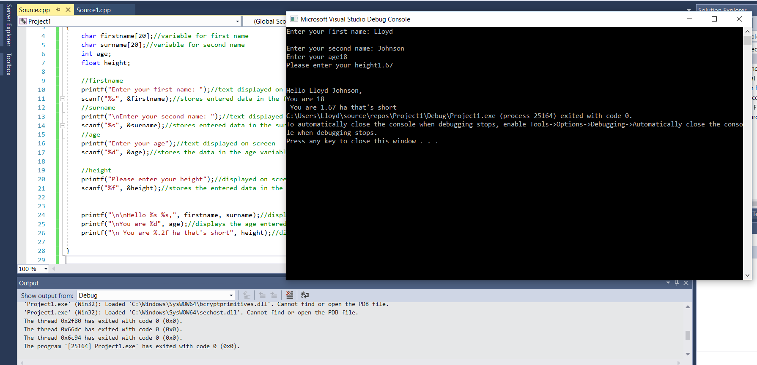
Next the second exercise was tested in visual studio and there were no errors with the code. There is a screenshot of the code done with a calculator to verify the calculations work.
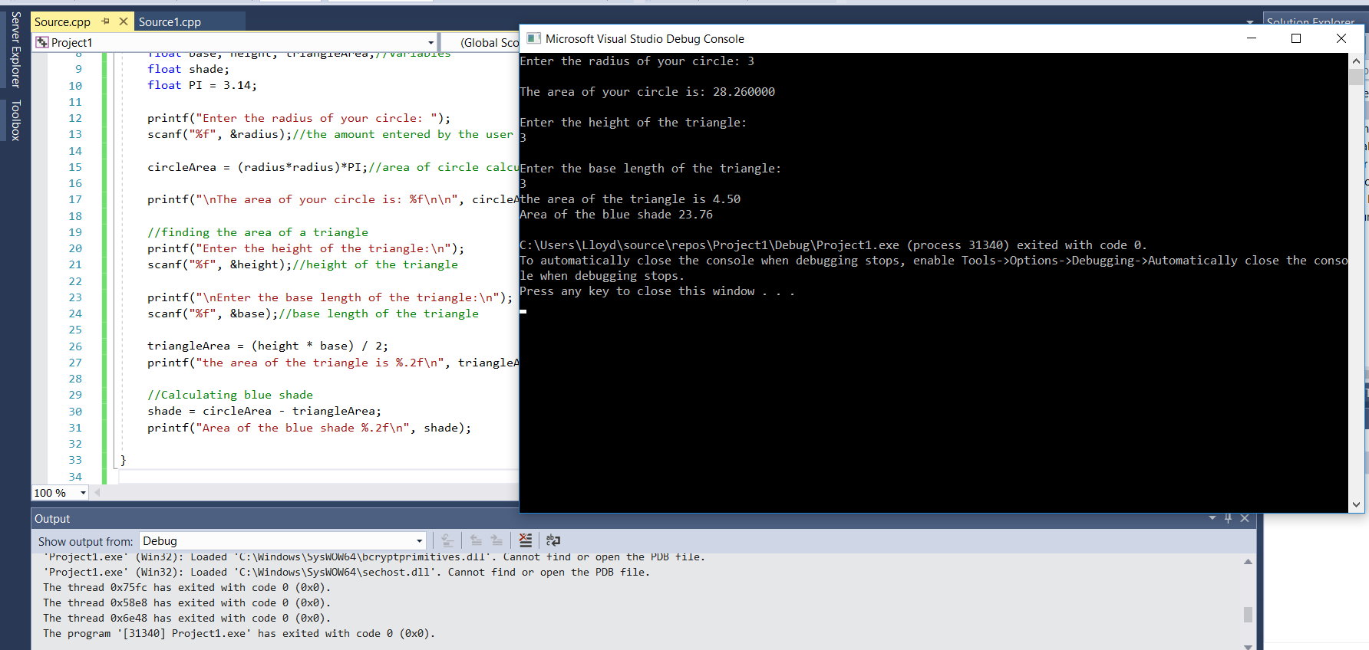
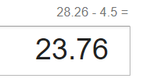
Verification
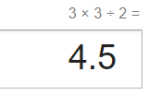
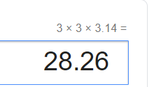

On the third exercise I encountered a problem when trying to add up all of the array numbers.
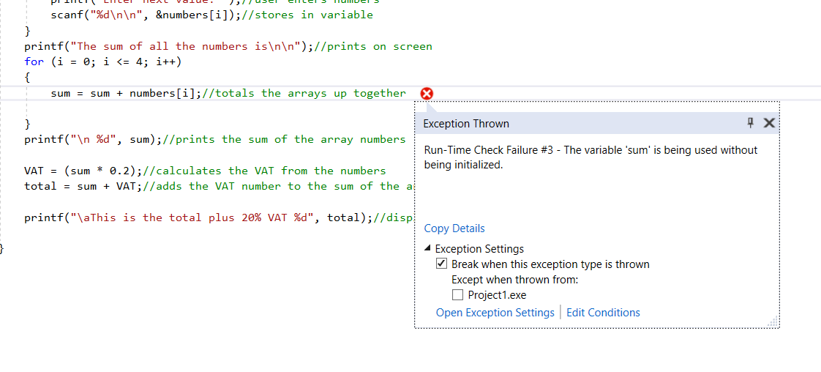
The problem was I was using the number stored inside of the sum variable however, there was no number stored in that variable. To fix this problem I simply stored the number 0 in the variable so it would have a number to begin with.

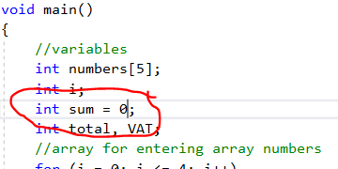
After this fix the code worked


