COURSEWORK PORTFOLIO: ANALYSIS OF DENTISTRY SERVICES IN THE UK AND THE HISTORICAL BACKGROUND OF NHS
BY SUFIA SULTAN

STUDENT ID: 2431993
MODULE NAME: HEALTH AND SOCIAL CARE
MODULE CODE: LCHS 4003
ASSIGNMENT NAME: COMPONENT 1 TWO TASKS
LECTURE NAME: AISHA BAKRE
UNIVERSITY OF WALES
SUBMISSION DATE: OCTOBER 20TH, 2025

TASK 1 A POSTER
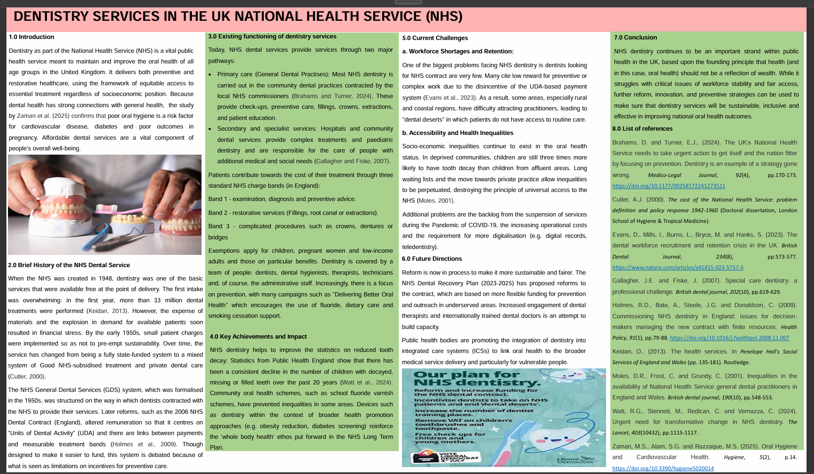

Task 2: Essay on NHS
The National Health Service (NHS) of the United Kingdom has its roots in the Beveridge Report of 1942, which suggested a welfare programme to fight the five giants of Want, Disease, Ignorance, Squalor, and Idleness (Clement, 2023). This essay motivates post-war policymakers to establish a system of social protection for every citizen. The NHS took its legislative basis in the National Health Service Act 1946, which enforces a universal health service for England and Wales based on general taxation. The three principles it established were universality, free access at the point of need, and provision based on clinical need, not ability to pay (Roderick and Pollock, 2022).
The establishment of the NHS was spearheaded by Aneurin Bevan, the Minister of Health, who faced heavy opposition from the private medical practitioners. The NHS brought hospitals, general practitioners and community services under state ownership when it was launched on 5 July 1948 (Clement, 2023). It was branded as one of the largest governmental welfare projects ever.
Evolution and Existing Structure
Since its inception, the NHS has adapted to demographic, technological and financial pressures. The last structural change was by the Health and Care Act 2022, which introduced Integrated Care Systems (ICSs) throughout England. They substituted Clinical Commissioning Groups and were intended to encourage hospital-community care and local authority cooperation (Lalani et al., 2025). ICSs consist of two central organisations: the Integrated Care Board (ICB) budgetary and planning services and the Integrated Care Partnership (ICP), the body that brings together NHS organisations, councils, and voluntary sectors to plan health strategies (Thomson, 2024).
There are three levels of work in the NHS: primary care, the first point of contact and preventive services provided by general practitioners, secondary care, hospital and specialist care, and tertiary care, which is advanced services (NHS England, 2022). The system mainly receives funding via general taxation in England, with the budgets allocated by the Department of Health and Social Care to NHS England, which allocates money to ICBs. Irrespective of the simplicity of this model, the NHS is experiencing rising costs as a result of an ageing population, chronic diseases, and demand.
Challenges and Criticisms
Although the NHS is still admired due to its universal access and cost-effectiveness, there are several systemic issues. Staffing shortages, especially of nurses, general practitioners, and midwives, have caused unsustainable stress on the workforce, resulting in burnout and turnover (Zarbiv et al., 2025). The limitation of funding still restricts innovation and service capacity. Inequality in health remains, and the most disadvantaged groups, particularly ethnic minorities, have worse results (Eberhardt et al., 2025).
Inability to identify accountability structures and resistance to cultural change among partner organisations are also listed among implementation barriers of ICSs (Lalani et al., 2025). Written to support local independence, flexibility and inventiveness are often limited by national control and achievement standards (Thomson, 2024). Despite these issues, there has been an upward trend in the aspects of maternity and mental health, where coordination and access were revised among the integrated local partnerships (Bradford et al., 2022).
Conclusion
The NHS is a creation of the dream of equity, holistic care and universality. It has been able to adapt to the changing needs in society over the years, but has simultaneously not compromised its founding values. However, now that the concept of sustainability is grounded on the scarcity of manpower, economic stressors, and health inequalities. Local autonomy through ICSs, staff wellbeing, and equity will continue to play a decisive role in making sure that the NHS will not lose its original purpose in the 21st century anyway.

Reference list
Bradford, B.F., Wilson, A.N., Portela, A., McConville, F., Fernandez Turienzo, C. and Homer, C.S.E. (2022). Midwifery Continuity of care: a Scoping Review of where, how, by whom and for whom? Waqas, A., ed. PLOS Global Public Health [online]. 2 (10). Available from: https://www.ncbi.nlm.nih.gov/pmc/articles/PMC10021789/.
Brennan, A. (2024). Applying the CORE20PLUS5 to Address Health Inequalities for Patients Under the Rehabilitation and Recovery Service in the London Borough of Hackney. BJPsych Open [online]. 10 (S1), pp. S223–S223. Available from: https://www.cambridge.org/core/journals/bjpsych-open/article/applying-the-core20plus5-to-address-health-inequalities-for-patients-under-the-rehabilitation-and-recovery-service-in-the-london-borough-of-hackney/06A38B23F0ED34ADD142497EB935D108.
Clement, M. (2023). The founding of the NHS: 75 years on - History of government history.blog.gov.uk. 2023 [online]. Available from: https://history.blog.gov.uk/2023/07/13/the-founding-of-the-nhs-75-years-on/.
Eberhardt, J. et al. (2025). Barriers and Facilitators of NHS Health Checks in Socioeconomically Deprived Communities in the North East of England: A Qualitative Study With Peer Researchers. Health Expectations [online]. 28 (2). Available from: https://pmc.ncbi.nlm.nih.gov/articles/PMC12000538/.
Lalani, M. et al. (2024) New Ways of Working to Manage and Improve Quality in Integrated Care Systems in England. International Journal of Health Policy and Management [online]. 14 (1). Available from: https://pmc.ncbi.nlm.nih.gov/articles/PMC11845859/.
NHS England (2022). The healthcare ecosystem, NHS Digital. 2022 [online]. Available from: https://digital.nhs.uk/developer/guides-and-documentation/introduction-to-healthcare-technology/the-healthcare-ecosystem.
Roderick, P. and Pollock, A.M. (2022) Dismantling the National Health Service in England. International Journal of Health Services [online]. 52 (4), pp. 470–479. Available from: https://journals.sagepub.com/doi/10.1177/00207314221114540.
Thomson, L. (2024). Barriers and Enablers of Integrated Care in the UK: a Rapid Evidence Review of Review Articles and Grey Literature 2018–2022. Frontiers in Public Health [online]. 11 (1). Available from: https://pmc.ncbi.nlm.nih.gov/articles/PMC10794528/.
Zarbiv, G., Perlman, S. and Ellen, M.E. (2025). Barriers and facilitators for implementation of continuity of midwife care: A review of reviews. Women and Birth [online]. 38 (2), p. 101892. Available from: https://www.sciencedirect.com/science/article/pii/S1871519225000265.

