

Student name: Gloria Abimbola Oke
Student ID: 2417815

Module name: Protecting and Supporting Families in Health and Care
Module code: BMHP5021
Lecturer name: Shaila Hussain

Component 2: Written Report: An examination and analysis of how the ‘Early Help’ system is signposted to UK families by their local authority website.

Table of Contents
1. Introduction 3
2. Main body 4
2.1 The Early Help System 4
2.2 Multi-Agency and Interdisciplinary Working 4
2.3 Evaluation of Local Authority Websites 6
2.4 Comparative Analysis 6
3. Conclusion 7
4. Recommendations 8
References 10

1. Introduction
The Early Help framework in England is a preventative framework which helps children, young people and families before statutory child protection thresholds are met. It is part of wider safeguarding practice and early identification and timely intervention are vital to protecting practice. Early Help is described in the Early Help System Guide (DfE, 2022) as a coordinated system of working, not a service – involving schools, health, and social care as well as voluntary partners. Working Together to Safeguard Children (HM Government, 2026) also requires local authorities to be the lead for Early Help arrangements, and partner agencies to be involved with identifying, referring and delivering Early Help.
The statutory priorities of accessibility and engagement are reinforced by research. Families disengage, because information is unclear or inaccessible, as Department for Education (DfE, 2024) highlights, and Edwards & Parkinson (2025) show how family group conferencing builds resilience and participation. These findings highlight the importance of Early Help being professionally solid and family focused.
This report critically examines the ways in which Early Help is promoted on the websites of Leicestershire County Council, Staffordshire County Council and Tower Hamlets Council. The councils were chosen for their analytical breadth - Leicestershire is a semi-rural authority with structured referral routes, Staffordshire has a strong base of practitioner focused resources and Tower Hamlets has an inclusive culture and diverse population. The analysis is planned around the learning outcomes to:
- Defining the concept of 'Early Help' and its role in safeguarding.
- Investigating multi agency working using statutory guidance.
- Reviewing council websites to ensure they are clear, inclusive and accessible.
- Making comparisons of strengths and weaknesses for evidence-based recommendations.

2. Main body

2.1 The Early Help System
According to the Early Help System Guide (DfE, 2022), early Help in England is a preventative safeguarding system that supports children, young people and families before statutory child protection thresholds are met. It is a coordinated process, not a distinct service, that involves the collaboration of education, health, social care and voluntary partners. Having clear thresholds of concern is important to help practitioners respond proportionately and act at an early stage to avoid statutory intervention.
The Local authorities have a statutory duty to lead Early Help arrangements in accordance with Working Together to Safeguard Children (HM Government, 2026). Partner agencies are encouraged to do their part, such as identifying needs, referrals, and providing support. The collaborative approach increases the resilience of families and ensures timely intervention, which is a key principle of the guidance for 2026, inclusive safeguarding and equitable access.
Effective online signposting is one of the key factors that can facilitate Early Help. There are often some barriers, such as technical jargon, a lack of clear information or inaccessibility of the interface, that prevent families from being engaged in the use of websites of local authorities. The statutory guidance (HM Government, 2026) emphasises the need for communication to be clear, inclusive and family friendly, to ensure equitable outcomes. It is essential, therefore, to have accessible digital pathways to support families to access support when and if they need it and to access it in a consistent manner.
Statutory expectations translated into user friendly communication is the most effective delivery of Early Help in the UK context. Local governments can provide children and families with protective practice that is fair and sustainable, by putting in place a professional strength, family friendly structure to support children and families early.
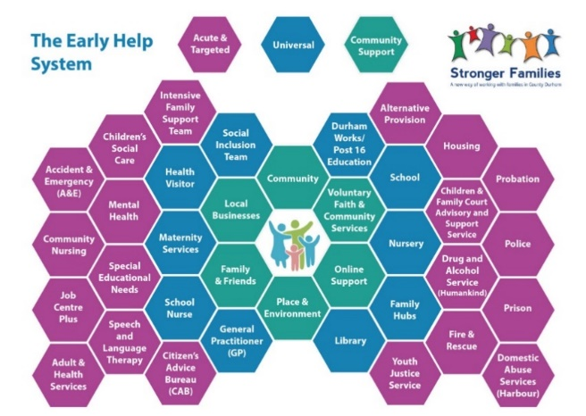
Picture 1
https://www.victorialaneacademy.org.uk/parents/early-help

2.2 Multi-Agency and Interdisciplinary Working
The HM Government (2026) definition of multi-agency working is collaboration between health, education, social care, police and voluntary organisations. Interdisciplinary practice demands professionals to incorporate perspectives and co‐design interventions which support family resilience. The Early Help System Guide (DfE, 2022) supports this with the emphasis on the need for a clear referral system, regular review meetings and accountability systems to promote effective coordination.
These statutory requirements are exemplified in the degree of success achieved by local authority websites. Leicestershire County Council has good referral systems in place for practitioners, but there is limited visibility of wider partnerships which limits families' awareness of co-ordinated support. This is a lack of transparency and mutual responsibility, in contrast to the statutory focus. Staffordshire County Council is supportive of national guidance and provides practitioner toolkits, family self-referral opportunities and multi-lingual resources. However, if not differentiated, the wide range of information would overload users. Tower Hamlets' culturally responsive design is encouraging inclusion; however, disjointed navigation is decreasing clarity and partnership working is not apparent to families (Purcell et al.,2025).
The differences are of particular importance because they illustrate the difficulties in making statutory requirements into a digital practice that is accessible. Staffordshire exhibits the best balance, but also shows the danger of an information overload, which shows the conflict between comprehensiveness and usability. The practitioner focus in Leicestershire is marred by opaque terminology and Tower Hamlets' welcoming approach is hampered by structural incoherence (Purcell et al., 2025).
Overall, Staffordshire is the most accessible and detailed site which offers practitioner detail without excluding family-friendly pathways. It represents statutory expectations of shared responsibility and inclusive safeguarding and is a model that others UK councils could replicate.
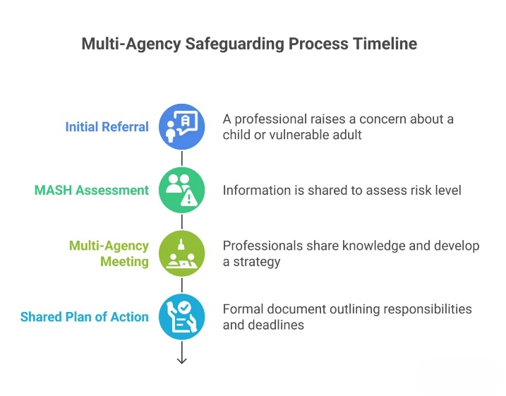
Picture 2
https://uk.hfonline.org/what-is-multi-agency-working-in-safeguarding

2.3 Evaluation of Local Authority Websites
Local authority communication of services online is critical to the effectiveness of Early Help provision (Wharton et al, 2026). Web design and language are important as well as ensuring that protective services are visible, which is central to equitable access in Working Together to Safeguard Children (HM Government, 2026).
Leicestershire County Council follow a stepped referral approach with practitioner guidance and resources to download. Although this is professional clarity, but using jargon language hinders the accessibility of families. Importantly, the inclusion of services for domestic abuse and SEND is not sufficiently highlighted, restricting the effectiveness of the site to delivering statutory requirements of inclusiveness and transparency (Wharton et al., 2026).
Staffordshire County Council provides comprehensive toolkits, family self‑referral forms, and mobile‑friendly design. There is good statutory alignment with integration with wider protective services including youth support and mental health services. It is, however, hard to keep users from drowning in the amount of information. If the practitioner and family pathways are not better distinguished, there may be problems with access even if the content on the site is strong.
Tower Hamlets Council's approach to inclusivity is in line with statutory requirements for equal access and is supported by multilingual resources and culturally sensitive communication. However, the lack of cohesion in navigation and links to external resources diminish clarity and make services for SEND and mental health more difficult to find. This is contrary to the council's good work in being inclusive.
Overall, Staffordshire is the most in line with statutory guidance, with practitioners detailed, but family friendly pathways. However, the further development of navigation and differentiation of the audiences would improve provision further. Leicestershire and Tower Hamlets are examples of the dangers of inaccessible language and incoherence of structure – highlighting the importance of councils to ensure their digital safeguarding communication is clear, inclusive and accessible.

2.4 Comparative Analysis
A comparison of the three councils illustrates a number of distinct differences in the way EH and PS are signposted online (MacDonald et al., 2026). Leicestershire County Council exhibits clear professional practice with planned referral processes and guidance for practitioners. The use of technical jargon however, does make it difficult for families and is not in line with statutory expectations of inclusive safeguarding. Domestic abuse and SEND support are not sufficiently visible and does not fully enable the site to achieve equity.
Staffordshire County Council offers the most extensive resources including practitioner toolkits, family self-referral forms and mobile-friendly design. Linkage with youth and mental health services is good and is aligned with Working Together to Safeguard Children (HM Government, 2026). However, the extent of information is overwhelming for users and there is a need to differentiate practitioner and family information so that it is easier for users to access.
Tower Hamlets Council adopts a multilingual approach and culturally sensitive communication in line with statutory requirements for equality of access. However, the disjointed navigation and external links reduce clarity and make protective services like SEND and mental health more difficult to find. This structural disunity undermines the council's good efforts to be inclusive.
Overall, Staffordshire combines practitioner and family resource requirements best, consistent with statutory guidance and replicable dual focus approach. Navigability is poor in Tower Hamlets and inaccessibility is the problem in Leicestershire due to its practitioner clarity (MacDonald et al., 2026). The comparative analysis shows that communication in Early Help is all about being clear, inclusive and accessible, and that Staffordshire is the best example of statutory compliance and family centred practice
.
Council | Accessibility | Inclusivity | Clarity
Leicestershire | ❌ Limited by jargon | ❌ Minimal family-friendly design | ✅ Clear for practitioners, unclear for families
Staffordshire | ✅ Mobile-friendly, strong pathways | ❌ Limited cultural inclusivity | ✅ Clear signposting, but risk of overload
Tower Hamlets | ❌ Fragmented navigation | ✅ Multilingual, culturally sensitive | ❌ External links reduce clarity

3. Conclusion
This report has critically addressed Early Help as a preventative safeguarding approach, highlighting the statutory responsibilities of local authorities and the inter-agency responsibility. Three local authority websites were analysed showing differing practices with regards to signposting Early Help and protective services. Leicestershire County Council has clear pathways to refer and clarity for practitioners, but this is difficult for families to understand and reduces inclusiveness as there is a reliance on technical jargon. Tower Hamlets Council's multi-lingual resources and culturally sensitive communication help to promote an inclusive approach but there is a lack of structural coherence and clarity due to the fragmented navigation and use of external links. Practitioner and family resources are integrated well with Staffordshire County Council, and are mobile friendly with easily identifiable protective services, but may be too much information for the users.
Staffordshire demonstrates the best practice in communicating Early Help whilst meeting statutory requirements and achieving equality of access. Because of its dual focus it is aligned with and supports Early Help System Guide (DfE, 2022) and Working Together to Safeguard Children (HM Government, 2026) both professionally robust and family centred.
This analysis meets all three learning outcomes – an analysis of multi agency working, safeguarding communication, and comparative practice – in a critical way. It emphasises the importance of councils working together to be clear, inclusive and accessible to help achieve equal outcomes for children, young people and families throughout the UK and to maximise the effectiveness of Early Help.

4. Recommendations

- There is a need to ensure that councils are working towards effective communication of Early Help, ensuring digital practice is in line with statutory requirements to be clear, inclusive and accessible.
- There should be a standardisation of the language, use of visual aids and step‑by‑step referral guidance in family communication between Leicestershire County Council and the family. This would minimise the use of technical language and make sure that protective services (in relation to domestic abuse and/or support for SEND) are clearly signposted in line with Working Together to Safeguard Children (HM Government, 2026).
- Staffordshire County Council to improve the navigation, to differentiate practitioner pathways from family pathways. Statutory focus on inclusive safeguarding would be best served by enhancing the mobile menus and making sure signposting is done to minimise information overload and keep practitioners clear.
- Tower Hamlets Council should make Early Help and protective services more coherent as they should be more accessible from one point. Accessibility without professional mediation of SEND and/or mental health services would increase inclusiveness and equal access.
- In all councils there is a need to ensure that partnerships with voluntary and community organisations are more clearly promoted online, alongside statutory ones and to fill gaps in provision. Clarifying and consistency of safeguarding terminology and systems for referral nationally would further promote clarity and consistency.
- Finally, other councils should follow the Staffordshire model of having two focuses, one with the detail of the practitioner and a second with family friendly communication. This is a way of achieving robust Early Help provision, whilst ensuring that it is fair and equitable, and provides a good model for other UK authorities looking to improve Early Help provision.

References
Department for Education (2022). Early help system guide a toolkit to assist local strategic partnerships responsible for their early help system. Available at: https://assets.publishing.service.gov.uk/media/628de13be90e071f5f7e1bd2/Early_Help_System_Guide.pdf
Department for Education (2024). Information sharing advice for Practitioners providing safeguarding services for children, young people, parents and carers. Available at: https://assets.publishing.service.gov.uk/media/66320b06c084007696fca731/Info_sharing_advice_content_May_2024.pdf
Edwards, D. and Parkinson, K. (2025). Early Help Family Group Conferences: A Small-Scale Analysis of an Existing Service and Implications for Practice. Child Care in Practice, pp.1–12.
https://www.tandfonline.com/doi/abs/10.1080/13575279.2025.2578768
HM Government (2026). Working Together to Safeguard Children: A guide to multi-agency working to help, protect and promote the welfare of children. London: HM Government. Available at: https://assets.publishing.service.gov.uk/media/69fb1c28d0e316a40f269a5b/Working_together_to_safeguard_children_2026_a_guide_to_multi_agency_working.pdf
Leicestershire County Council - https://www.leicester.gov.uk
MacDonald, S., Hewitt, G., Jones, S., Rees, A., Brown, R., Anthony, R. and Evans, R. (2026). Multiagency collaborations to support well‐being amongst care‐experienced children and young people in school and during transition to further education college: Stakeholder perspectives on facilitators, challenges and innovations. Child & Family Social Work. doi:10.1111/cfs.70109.
https://onlinelibrary.wiley.com/doi/abs/10.1111/cfs.70109
Purcell, C., Baginsky, M. and Steils, N. (2025). No quick fixes: Multi-agency working to improve information-sharing on men and keep children safe. The British Journal of Social Work, [online] 56(4), pp.1610–1630. Available at: https://academic.oup.com/bjsw/article-abstract/56/4/1610/8324434
Staffordshire County Council - https://www.staffordshire.gov.uk/
Tower Hamlets Council - https://www.towerhamlets.gov.uk/
Wharton, R., Kavanagh-Smith, L. and Douce, C. (2026). Evaluating the accessibility of local authority public facing websites in England. Universal Access in the Information Society, 25(2). doi:10.1007/s10209-025-01269-5.
https://link.springer.com/article/10.1007/s10209-025-01269-5

