 APPENDIX GA36d
LEVEL 7 ASSESSMENT SPECIFICATION
Student name: | Simranjeet Kaur | Student ID number: | 2106253
Programme: | Computer Networks and Security
Module: | Security Analysis Techniques and Procedures
Module code: | ACCA7030 | Contribution to Overall Module Assessment (%): | 100%
Lecturer: | Dr Carlene Campbell | Internal Verifier: | NitheeshKaliyamurthy
Assignment Title: | Penetration testing on a Live Website and research into cyber security incident and defensive technique case study. | Word count (or equivalent): | 5,000
Submission deadline: | 5 May 2022 | Return date of provisional marks & written feedback:
Submission method: | All written assessments, where practical and possible, must be submitted via Turnitin unless otherwise instructed by the Lecturer. (Please DO NOT put this assessment specification into Turnitin or it will match many similarities with other students’ submissions.)  Alternative submission method (if applicable):  Late submission of the assessment will result in a late penalty mark. Penalties for late submission: Up to one week late, maximum mark of 50%. Over one week late, 0%. Only the Extenuating Circumstances Panel may approve a change to submission dates.
Academic honesty / referencing: | Academic honesty is required. In the main body of your submission you must give credit to authors on whose research and ideas your work is based. Append to your submission a reference list that indicates the books, articles, etc. that you have used, cited or quoted in order to complete this assessment.

Executive Summary
Website applications are dependable upon the system for operating features, external programs and processed data queries that are being submitted by users. Part A of the project signifies pen-testing and identifies the risks on website application of HPC, a pharmaceutical company. In this report, Black Box penetration testing has been focused in depth and it also include OWASP Top 10 risk of 2021. Risk vulnerabilities has been identified, in context to that, new methods have also been suggested in this project.It has been found that the security layers in the computer system of HPC were very poor as any cyber attacker would have easily stolen data from their security. Therefore the threat modelling approach has been applied by the investigator in the computer system to protect all the systems from cyber-attacks.

Table of Contents
Part A 5
Introduction 5
Findings 5
Part B 11
1.0 Introduction 11
2.0 Black box penetration testing 11
3.0 Vulnerabilities identified and ways to exploit weaknesses 12
4.0 OWASP top 10 security risk 14
a. List of vulnerabilities 14
b. Attack tool 15
c. Protocols which are involved in the attack 16
d. Attack launch process 16
e. Success and failure 17
5.0 Findings 19
a. Changes in configuration 19
b. New hardware and software 20
c. Defence strategy 20
6.0 Cost of Solution 20
a. Cost of Hardware and Software Replacement 20
b. Cost of Fix Implementation 21
7.0 Timetable 21
Part 2: Research into cyber security incidents and defensive techniques 22
1.0 introduction 22
2.0 Forensics report 22
2.1 Risk considerations: 23
2.2 Threat Modeling 23
2.3 data recovery perform without the third party software 24
2.4 Data recovery through a third-party software 25
3.0. Ethical Process of Hacking 27
4.0 Analysis of findings 27
5.0 Discussion on the whole Coding Process Mechanism 28
6.0 Invoice for the professional service taken 29
7.0 Conclusion 29
References 31

Part A

Introduction
Network security involves calculations taken by organizations to identify and stop disallowed control from outside muggers. Kali Linux is software that enhances the level of distribution structure for digital theoretical and insight testing. It is handled by an abusive form of security that strongly focuses on the development of the key effectiveness toward the potential industry. Throughout the whole, the process of this application helps to enhance the leading industry standard that significantly optimized the configuration of integrated tools that are to be focused on them to develop the key growth. The approach has been significantly adopted in this application to serve the ultimate accessibility on the whole.

Findings
This part has been developed by kali-Linux. There are using Uniscan library. Kali Linux is one of the most famous Operating systems. This system has been helped by Security experts in over the world. Kali Linux is based on Debian. Linux position focuses on security and testing on penetration. Kali Linux has many hundred tools and libraries that are matched many various data of security tasks.From this kali, Linux software first installs the library that this Uniscan. Uniscan is an example of a distant File with, a Local File and Command implementation threat scanner. In this coding portion, there has been must be an install Uniscan library. Active security experts that help the organization in multiple ways to generate key effectiveness [1] have significantly operated Uniscan Library. Through the application of this integrated application, it helps to scan, arrange vital files, commanding, ranging on associated URLs.
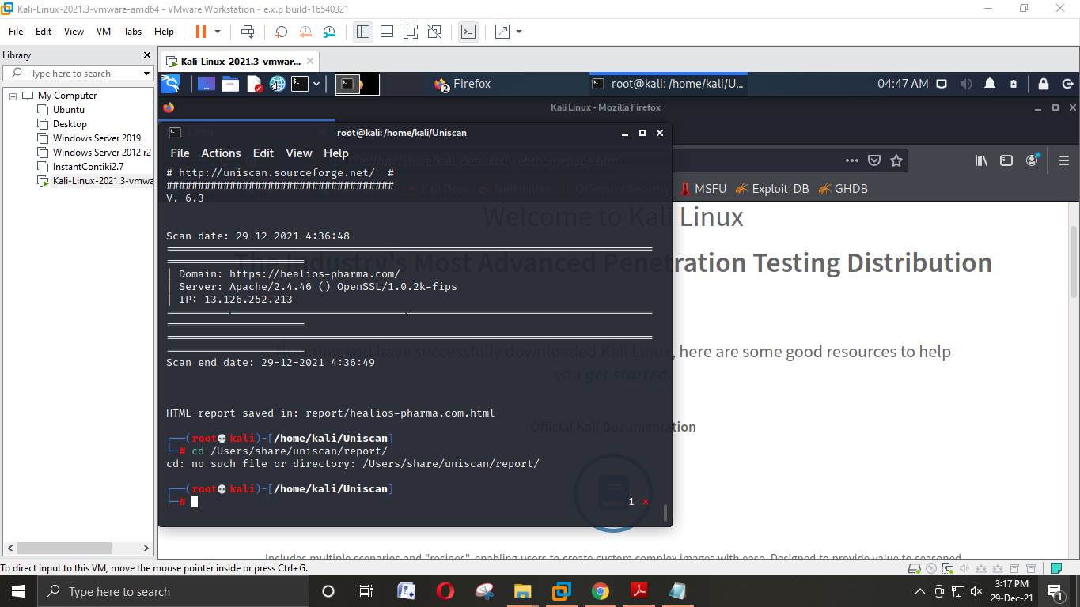
Figure 1: Basic scan of this website
(Source: Self-created)
This figure mainly shows the basic scan of the website.
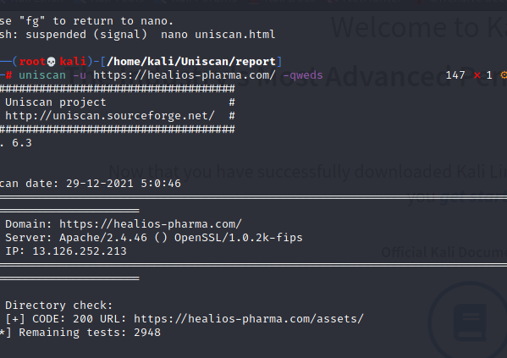
Figure 2: Coding of full information on this website.
project (Source: Self-created)

After writing this code, then a piece of full detailed information has been opened.
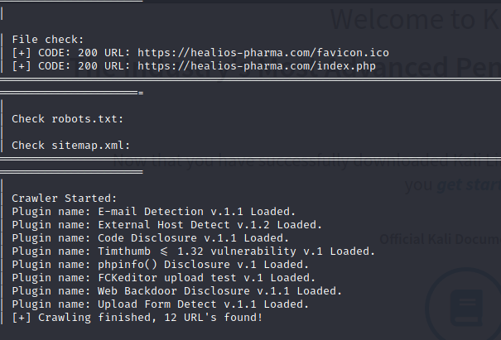
Figure 3: Check file of this website
(Source: Self-created)
This figure mainly means how many emails and the external host has been used here. Php and web backdoor have not to been shown here.
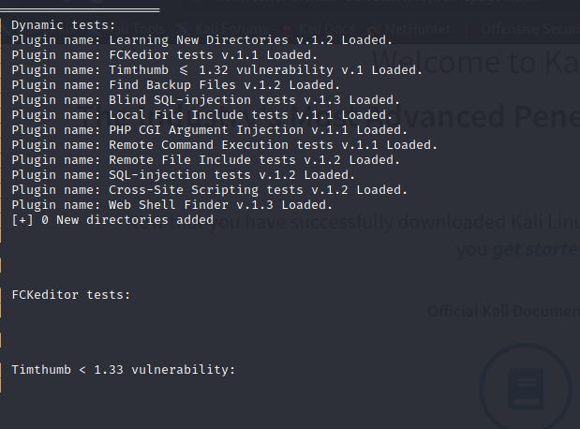
Figure 4: Dynamic test
(Source: Self-created)

This figure has been showing the Php CGI version and SQL injection test.
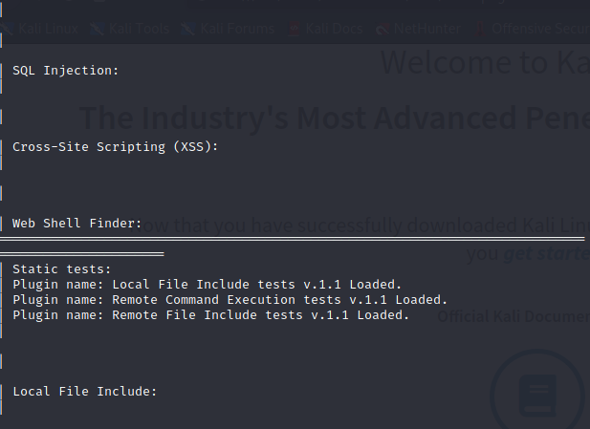

Figure 5: Static test
(Source: Self-created)

This figure has is showing some static names on this website.
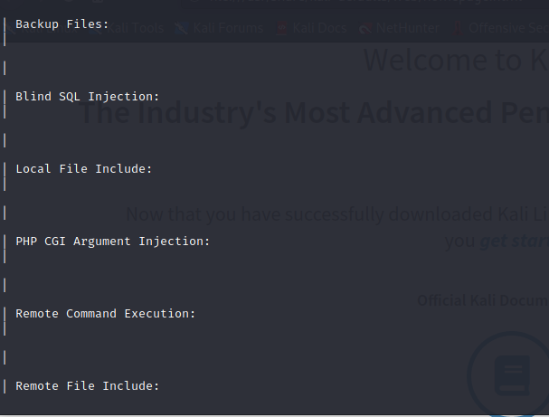
Figure 6: Check SQL and PHP
(Source: Self-created)

Part B

1.0 Introduction
Healios Pharmaceutical Company (HPC) is currently working to develop the vaccine for the Covid-19 pandemic. And in the present scenario, they are very close to developing the vaccine and for this purpose, they are developing a website where they are storing all the necessary data gathered in the R&D process. This is the reason that this pharmaceutical company is hiring an ethical hacker so that the hacker can hack their website and then find vulnerabilities in their website. After the hacker finds those vulnerabilities in this company's website, then the hacker would be giving this company a series of procedures by which they can upgrade their website from security issues, risks, and chances of hacking. Furthermore, it needs to be highlighted that HPC has hired Ceac Cybersecurity and Forensics Ltd (CCFL) to conduct a REAL life hacking on their company official website. In this study, the key theme is to discuss how black box penetration can be done on their website, identify weaknesses that can be exploited, use OWASP, and then provide a systematic technical report.

2.0 Black box penetration testing
In terms of doing a black-box penetration testing assignment, firstly, the tester needs to be placed in the job role of a moderate hacker, with no specific internal knowledge regarding the targeted website. For this process the tester will not be provided with any source code or architecture of diagrams that are not generally available (Moniruzzaman, et al. 2019). Furthermore, it needs to be highlighted that the black box penetration test is capable of determining vulnerabilities in the official website of HPC which are exploitable from an external network. It can be said that the black box penetration test heavily relies on various analyses of perfectly running programs within the company official website of HPC and the overall system of the HPC network.
The hacker, who has performed the hacking of this company’s official website, was aware of various tools for doing hacking, such as the automated scanning tool, and methods for doing manual hacking and penetration testing. On the other hand, the hacker was capable of generating a self-made road map and the way to penetrate the official website by observing the traffic inflow and outflow, as there was no diagram provided to perform the ethical hacking (Sveikauskas, 2021). Furthermore, it needs to be highlighted that the restricted knowledge given to penetrate makes the black box penetration test much quicker than other hacking methods. However, the duration of the penetration depends on the knowledge and ability of the tester to find and exploit vulnerabilities in the official website of HPC. However, if the tester was unable to perform the penetration test, then it wouldn't have been possible to identify those vulnerabilities and then provide solutions and recommendations to this company.

3.0 Vulnerabilities identified and ways to exploit weaknesses
There are 10 most common website vulnerabilities presented by the OWASP. However, after conducting the black box penetration test on the official website of this company, the ethical hacker found some serious issues and vulnerabilities and all the vulnerabilities are presented in the below section.
- Injection Flaws: It was easy to hack the official website of the HPC just by using unfiltered and malicious data, and data linked to the official website. Firstly, SQL injection was helpful to penetrate and then LDAP injection was also helpful. Injection had been done using input fields with databases and directories of the company official website. These include passwords, databases, and other areas. It needs to be highlighted that all these fields are left vulnerable because of the lack of input filters in the process of developing a directory or website database (Appiah, et al. 2017). Therefore, adding various filters to the company website can be helpful to protect this company website from injection flaws. With the help of SQL injection, the official website of HPC can be upgraded more effectively. Using the LDAP injection, IT officials of this company can use escape variables protocol to prevent attacks from hackers.
- Security Misconfiguration: After conducting the penetration test it was clear that the security configuration of this company was not properly done in the first palace, and this is the reason that it was easy for the hacker to penetrate the official website within just a short span of time. As there was a lack of security management on the official website, it left a series of vulnerabilities for hackers to manipulate this website. The security misconfigured issues of this official website are unprotected directories, unprotected files, unused files, unpatched flaws, outdated software, and software running in debug mode (Elisa, 2017).
Furthermore, it needs to be highlighted that preventing all these vulnerabilities is quite simple. One of the best ways to prevent these vulnerabilities is the deployment of protocol to develop updates within this website to establish a secure website environment. Automatic deployment of these updates would also be helpful to keep the official website up to date and secure this website from external threats (Vumo, et al. 2017).
- XSS Vulnerabilities: After performing the penetration test it has been found that the official website of his company can be hacked using malicious code injected into the website. The penetration was performed by inserting the code in the official website through a link, and along with social engineering. Furthermore, it needs to be highlighted that the hacker was able to penetrate through the website using JavaScript and after a successful hacking, the hacker was able to access the user's location, webcam, and other critical functions and data (Williams, 2021). All these XSS vulnerabilities are pretty general where the input of any website is sanitized.
On the other hand, using this process the hacker was able to steal user cookies from their browsers and also access the history of their browsers. There are many steps by which all these attacks can be prevented. One of the best ways to prevent these types of attacks from a company website is by sanitizing the input. Sanitizing input can be helpful for the users of this website from online hackers and it can also protect the privacy of the users by not allowing the hackers to steal browsing history and various sensitive data (Khandelwal, and Srivastava, 2017).
- Exposure of Sensitive Data: From the penetration of their official website it was found that the website is vulnerable in terms of protecting sensitive data, which is a serious matter of concern. The website is lacking encryption and decryption code, and other protection. And this is the reason that the website is prone to cyber-attacks leaving sensitive information exposed to various attacks from online hackers. There are 2 types of issues that can be found on their official website, one is data transportation from the client or user end, and data storage issues.
It needs to be highlighted that all these vulnerabilities need to be removed from the website to upgrade the security of this website. For upgrading the performance of the website and protecting it from hackers, PFS (perfect forward secrecy) and HTTPS need to be implemented in this website to protect all the official data on this website. Furthermore, disabling data caching is another method by which this type of vulnerability can be officially removed (Debebe, 2019).
- CSRF (Cross-Site Request Forgery): CSRF was another security vulnerability that has been found on this website. Hackers use social engineering to penetrate any website and steal data. Websites and applications of this company, without any proper authentication method, will always be vulnerable to security issues like CSRF. However, there are several measures by which all these issues can be prevented. One of the best ways to prevent this type of security theft is using cookies or secret tokens, as these processes can be helpful to authenticate real users versus malicious users. Also, removing GET requests and utilizing POST requests can be helpful to keep the official URL safe from hackers (Milić, et al. n.d).

4.0 OWASP top 10 security risk

a. List of vulnerabilities
OWASP is also defined as an Open web application security project which could be defined as a non-profit enterprise that specifically concerns software security. The project includes a number of open-source development software toolkits and programs, conferences, and local chapters. In recent years, it became an all-new graphic design and helps everyone to improve their security on web applications (Softwaretestinghelp.com 2021). Materials offered are tools, videos, documentation and other forums. OWASP is based on a regularly-updated report which outlines security concerns, which focus on 10 critical risks. Technological developments would be improving the quality of life and would help in changing social norms (Swarupet al. 2021). RL, also known as Reinforcement learning, has been applied for penetration testing with the use of attack graphs.
No | Risks
M1. | Injection
M2 | Broken Authentication
M3 | Sensitive Data Exposure
M4 | XML External Entities
M5 | Broken Access Control
M6 | Security Misconfiguration
M7 | Cross-site Scripting
M8 | Insecure Deserialization
M9 | Using components with known vulnerabilities
M10 | Insufficient Logging and Monitoring
Table 4.1: OWASP Top 10 Website Risks, 2021
(Source: Self-made)

b. Attack tool
Therefore, for analysing security of Websites, a penetration test has been conducted from the above list. These risks get updated over years, and penetration risk tests have been conducted with the help of updated lists, and it has been studied through scientific perspectives (Singh, 2021). The work analyses practice for software development, which is being followed for creating secure websites. However it provides authentication, password-section management, and obfuscation techniques, and many other effective recommendations to build tough security (Caraguayet al. 2016). The fact is because of digitization, the situation is becoming more challenging for companies to keep their data secure. CVE, also known as Common Vulnerability and exposure, is the name which is given to known vulnerabilities. The principle of CVE is to facilitate shared information over different databases, and it needs to be made available through a common platform for evaluating security tools (Veracode.com, 2021). CVE consists of three stages; fixed CVE, year of release and Serial number.

c. Protocols which are involved in the attack
This is the most significant section of the project, and here different elements have been used for performing security analysis, and the risks that have been looked into while performing penetration tests. For any pharmaceutical company, hacking and phishing could be dreadful not just for sale, but also its existence in the market. Penetration testing is also known as pen testing, security testing and security-pen testing, which could be defined as ethical hacking (Putra et al. 2021). Penetration test could be defined as intentional launching of some cyberattacks, and here to test the same, virtual Lab has been used, which consists of SAP Litmos, Talent LMS and Moodle. Moodle can be defined as open-source Learning MS, and it is one of the oldest LMS, and more than 190 million users have been using this application according to 2020 (Jalbani et al. 2021). The situation is becoming more challenging, as the majority of people have been using digitization to overcome such risks. Penetration testing is a border part for vulnerability detection, with the help of static analysis. Models for these tests have taken the form of either attack tree or hypothesis model. The Hypothesis model, states a general process to gather information about a certain system that helps to determine a specific list for hypothetical flaws, like domain expert-brainstorming. Therefore, penetration testing could be defined as a systematic process to identify security vulnerabilities and eventually evaluate systems through different malicious techniques.

d. Attack launch process
It mostly occurs whenever an attacker exploits some insecure code for inserting a different code into their program. Pharmaceutical companies are undergoing serious challenges and in recent years, injection flaws are becoming more challenging in recent years. Injection flaw is a serious vulnerability and it comprises backed systems and other clients which are being connected with vulnerable applications. The moment a web application passes, and analyses to hijack sessions. Therefore, the tree model has been used for analysing other risks. Here, in this case, it could be analysed that it would help the attacker to execute operating systems over a target machine. Therefore, RL test methods help to address multiple challenges, and out of which a single tool for penetration would not be enough. However, RL helps in detecting bypassing security, which would be applicable to blind and internal testings.
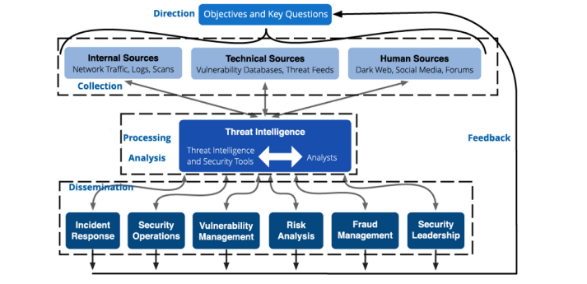
Figure 4.2: Framework for Threat intelligence
(Source: Cascavillaet al. 2021)

e. Success and failure
The above picture is a scientific framework for threat intelligence. According to analysts of threat intelligence and cyber security, criminal activity over the online sectors are increasing exponentially, and for detecting such crimes, mostly AI and ML are being used, and other techniques by engineers are being applied. Here, the company is a pharmaceutical company, and through that, detectable crimes are being analysed in depth. Therefore, these tests include; source code reviews, threat modelling and penetration testing (Lakovakiset al. 2021). SQL injection test checks the possibility for injecting data into an application so that it might execute user-controlled SQL mostly in the database.
First step is to detect injection with the use of DB Server, for ordering some accessible data. Which includes, Search engines, and authentication forms (Dzidic and Mbonyimana, 2021). Authentication is being performed, with the use of web form, and consists of certain datasets i.e. password, username. The next is the use of search engines that help in the extraction of relevant records from databases. The first test is conducted through, with the addition of a single quote or maybe a semicolon; to the parameter of the field under test. There is the first use of single terminator, and if it is not filtered with any application, it might lead to an incorrect query. The second is, SQL statement, which should be filtered, otherwise, it might be generating errors. Injection occurs due to input invalidation. Another reason is the sanitisation of data that is being used by website applications.

Risk | Problems Found | Security recommendations
M1- Injection | - Input invalidation  - Sanitisation of data  - Attackers are exploiting insecure code to inject their personal code into the website  - SQL injections  - Unauthorised action has been detected | - Remediation techniques  - Stripping of special characters  - Parameterised writings of SQL queries  - Implementation of TLS protocols  - BIG-IP ASM system would help to detect requests from clients, and eventually respond to severe cyber attacks
M6- Security Misconfiguration | - Information is being left insecure  - Data and system is at risk  - Attack caused due to misconfiguration  - Passwords are not being secured  - Directories and files are unprotected  - Forceful browsing | - There is a need to configure BIG-IP ASM policy to build up strong security  - All systems need to be protected against malware, and it is necessary to use regular soft wares  - There is a necessity for modifying password policy after setting certain durations  - BIG-IP ASM policy would be securing its policies for safeguarding the features of new application
M4- XML External Entities | - Attract against the web application, which is phrased as XML inputs  - There seen a presence of an external entity  - exploited DTDs, also known as Document Type Definitions  - Port scanning | - Implementation of a new method that would be disallowing DTDs.  - With the implementation of BIG-IP 15X, it was necessary to detect clients and their interactions and especially their negative mind-set that might harm the system  - With the implementation of BIG-IP, 14X, it would be detecting attack XXE signatures that would also help in detecting clients.
Table 4.2: Detection of Risks for Penetration tests
(Source: Self-created)

5.0 Findings

a. Changes in configuration
From the above analysis, it could be estimated that there are serious injection flaws in the website application. The website application market is growing, and security problems are becoming more serious along with the increased use of website applications. Security is becoming more concerned among developers, security experts, cyber researchers and users of these websites. Website applications handle sensitive information, which is misused on a daily basis, and criminals are finding or have been analysing a new method to get unauthorized actions (Support.f5.com, 2021). From the above analysis of OWASP Risk methodology, risks are being determined. Here, injection, security misconfiguration and external ethics are being identified as high risks.

b. New hardware and software
Among the majority of security cyber researchers, injection flaws are one kind of vulnerability in every sector, and it mostly occurs on a daily basis. Here to identify risks, penetration testing or pen-testing has been conducted among 10 OWASP Risks from 2021. Their risks are being justified, and with the help of penetration, it could be justified the breaches the website has been facing and connectivity is also being determined. The above list focuses on the list of risks that are being faced by the website, and implementation of BIG_IP would help to maintain confidentiality from cybercriminals (Jansson, 2021). Using UNIX or Linux file system can be helpful as these are the most famous software.

c. Defence strategy
However, cyber threats are becoming riskier, and due to that multiple factors have been determined above, which means SaaS is not being deployed fully secure. PaaS and IaaS would help to control the application’s structure. Overall, the penetration system was very helpful to conduct this test, as it helped to identify standard vulnerabilities that are present in the application. Research into cybersecurity, would not just be beneficial for the company but also for people who will be using the web application.

6.0 Cost of Solution

a. Cost of Hardware and Software Replacement
Cost of Hardware- There are various hardware which can be helpful in terms of improving the cyber security of the official website of the Healios Pharmaceutical Company (HPC). One of the many hardware is Encrypted Flash Storage. This hardware can be helpful in terms of storing encrypted data more securely. The cost of these hardware varies, however it cost 40 cents/gigabytes (CIO, 202). 32GB flash drive of Kingston costs around 430$ (Amazon.com, 2021). On the other hand USB fingerprint reader cost around 22-24 British pounds (Amazon.co.uk, 2021).
Cost of Software- Adding SSL Certificate and HTTPS can be helpful for them to improve their website security. Cost of SSL Certificate starts at 14.21$ per year (Gogetssl.com, 2021). It needs to be highlighted that these costs vary from region to region.

b. Cost of Fix Implementation
The cost of fixing all the bugs may require a huge amount of money as there can be observed a series of bugs present in their website. It is estimated that the overall costs to fix all the bugs might require more than 15,000$, as there is a need to upgrade both software and hardware for this company.

7.0 Timetable
SSL Certificate | 3-5 business days (Portswigger.net, 2021)
HTTPSCertificate | 5-6 business days
Fixation of Injection flaws | 1-2 business days
Fixation of misconfiguration | 7-8 hours
Fixation of XSS vulnerabilities | 3-4 business days
Table 7.1: Timetable for fixation
(Source: Self-created)

Part 2: Research into cyber security incidents and defensive techniques

1.0 introduction
The present case study is regarding a case of employee sabotage where Nera star, an employee of HPC (Helios Pharmaceutical Company), has deleted all the critical research documents of the company as she has not been rewarded for the work she has done before leaving the company. The IT department has failed to recover those deleted files and hence they need to hire a Computer Forensics investigator to help them in recovering those deleted files as it contains very sensitive documents and the loss of which could cost the company a loss of around 3 million us dollars. Various security analysis techniques will be used by the investigator to restore those deleted files. Apart from the study, it will also include a detailed report regarding the actions taken to restore data and also it will contain the invoice to the company for service taken which will include costs like replacement cost for hardware or software, cost of consultancy etc.

2.0 Forensics report
Brief software analysis has been done to assess the present case study as it is very important to recover those deleted files. Since Nera star has deleted those files in such a way that the IT department was unable to recover those files, therefore, the investigator has done a security analysis to gain sufficient knowledge about the case. The purpose of the security analysis includes the following:
- One of the main objectives of security analysis is to identify the area of weakness which may be exploited by a malicious programmer.
- To identify any sleeper this may be already present in the computer system.
- To analyze sensitive information.
- The corruption of vital information
- The miscalculation of data which has been done deliberately
Out of the above objectives the main purpose of the security analysis in the present analysis has been done to check the corruption of vital information as it was deleted permanently by Nera star an ex-employee of the company (Karahasanovicet al. 2017). From the analysis, it has been found by the investigator that the majority of the computer systems there in the company have no or very few security layers which could be easily exploited by a computer programmer. The quality assurance of the company relied on the sampling techniques on the basis of if one of the programmers has performed adequately with respect to a sample therefore it can be assumed that all the other work of that programmer will be satisfactory.

2.1 Risk considerations:
Various risks have been taken into consideration that could arise if performing the task to recover those deleted files. The risks can be assessed in the below points:
Threat
The threat to a computer system as it could get attacked by a malicious agent as a number of programs will need to run on the computer system to recover files.
Vulnerability
The vulnerability in the case of a computer system lies where it lies in the extent to which it could be exploited by those malicious agents.
Therefore the purpose of the system analysis has been to reduce the risk while recovering the data of the company. Therefore a number of steps have been followed in the security analysis that has been important in the present case and which can be observed in the following points:

2.2 Threat Modeling
A threat modelling has been used in the present case which includes the following steps:
Step 1: identification of use case for the assessment of system
The first step in the modelling is the identification of a use case which is a device or a system in which the assessment needs to be performed which helps in getting the idea that what device or system needs to be performed further. It is a very important step as an attacker may attack to steal sensitive data from the systems or device (Shevchenko et al. 2018) It is essential to assess which device or system consists of essential information. By performing the assessment task it has been found that the computer system of Nera star contained sensitive information which she had already deleted.
Step 2: identification of potential advisories, trust zones and threats
In this step, the investigator has performed threat modelling to recognize the trust zones and the corresponding entry-exit points. This approach has helped the investigator in preparing a data flow diagram along with privilege boundaries which has helped in defining the approach for input data validation and error handling etc.
Step 3: determination of the high level of security goals
In this step, the investigator has performed the threat modelling approach on the rest of the computer system that might be attacked in near future. The modelling, therefore, includes the security elements like confidentiality, integrity, authenticity and other main security elements.
Step 4: Explanation of Security Requirement for each objective
In this step, the investigator has explained in detail to the management of the company the requirements that are needed to accomplish each of the objectives such as recruitment of candidates who are skilled computer programmers, a robust communication channel, setting of failure threshold limit and secure remote management etc.
Step 5: Creation of document to store relevant information
This step generally consists of the creation of a document known as a threat modelling document which will consist of all the information such as a separate table which will consist of assets that need to be protected, security requirements, threats and potential advisories etc.

2.3 data recovery perform without the third party software
After setting the security objectives and requirements for the company so that no such future incidents will cause loss of important data and files, the investigator has performed the recovery task without any third-party software (Al-Sabaawiet al. 2019). Therefore he has performed various tasks which can be assessed as follows:
Data recovery using command prompt
Step 1
Click on the start menu and type cmd and select run as administrator
Step 2
Type chkdsk x: / and enter. Here replace x with the hard drive which you want to recover like drive d or drive e.
Step 3
Type ATTRIB -H -R -S /S /Dx: *.* again replace x with the desired drive
However, the above recovery process has failed to recover the deleted files as it seems that Nera star has deleted those files which are very difficult to recover.
Therefore the investigator has suggested to the management that software will be required to install in the computer system to recover those data. Since the data loss is very large files, no free software would be able to recover those files as free data recovery software are able to recover only a certain amount of data.

2.4 Data recovery through a third-party software
Importance of a data recovery software
Data recovery software is a valuable tool that is very important nowadays as many cyber attackers try to steal confidential data from profitable organizations to sell them for profit motive. This has led companies to have data coverage software to protect the important files of the organization from loss of data. Though this software does not guarantee to recover 100% of the data recovered, most of the data can be recovered from those files.
Function of a recovery software
Since every file system has a specific process for deleting files such as in the FAT file system the file directory is marked as unused and file allocation information is deleted. Apart from that, the NTFS system marks those deleted files and spaces as unused. In the UNIX or Linux file system, the file type, size and locations are deleted and the disk is marked as free.
Therefore the data recovery software helps in recovering those deleted files by analyzing the storage that has been marked as unused or frees (Surbakti and K, 2019). Therefore a file recovery tool consists of various features:
- File recovery software is able to recover deleted, corrupted and lost files.
- Some of the recovery software is also able to recover lost data and files from a range of storage media and also from ssd drives, memory cards and optical drives etc.
- Advanced data recovery tools are also able to recover data that are inaccessible
The investigator, therefore, suggests the management with a number of data recovery software that might be implemented by the company which are as follows:
- Ease US
- Recuva
- Wonder share Recoverit
- Undeletable 360
Apart from the above suggestions, there are more software available to be used as a data recovery tool.
However, out of the above, the investigator has suggested using WondershareRecoverit as it is cost-effective and the user interface of the software is not much complicated. Some of the main features of the software are as follows:
- It supports more than 1000 files types to be recovered
- Not much technical skill is required to use this software
- It does not require much time to start the process as all it needs is to download and start the recovery process.
- Apart from the data recovery the software also provides data security and services.
The investigator has performed the following process to recover the deleted files from the computer system of Nera Star:
Step 1
- Downloaded and launched the software
- Scanned the disk to restore files from the system
- Previewed the recovered files and got them back in the system.
The recovery process has been successfully done and all the files and data related to Covid-19 which have been deleted by Nera Star recovered in a few minutes.

3.0. Ethical Process of Hacking
From this project, the coding part has been created help of Kali Linux. It is a basic ethical hacking concept. Basically, ethical hacking has been used for the security of websites, and misuse or hack for the website. A good ethical hacker has found errors in this website and again recorrect this error of this website also more secure this site [2]. But a black hack hacker has been misusing this error and hack in this website for harm. with the help of the Uniscan tool can easily see where is an error or mistake on our website. Uniscan is a web vulnerabilities scanner and power full tool. During this project, have gained a lot of knowledge on ethical hacking. The help of this Uniscan this project has been easy. In this project apply on this uniscan code can easily scan this website. The help of this uniscan and their option can comfortably have been found details information of this website. After finishing this step, a lot of information has been gained. Now can easily be investigated deleted file, error, directory for this website, robot. text for full details of this website like how much page has here, the frequency for this website with dynamics and static check. Apply on this project here can investigate and remove harm or error this website.

4.0 Analysis of findings
From analyzing the findings of the results it has been found that the data recovery process has been successful which has saved the company from a loss of 3 million US dollars as the non-recovery of data would cost it. From the analysis, it has been found that normal data recovery has failed to recover data that has been deleted from the computer system by Nera Star, an ex-employee of the organization by normal recovery process using command prompt option (CAMPOS et al. 2018). The investigator also uses free recovery software to recover files but those recovery software were able to recover only a small size of data and the data deleted by Nora Star were too large. Hence a paid application needed to buy which was WondershareRecoverit which is data recovery software used to recover almost all types of files with ease. The reason behind the selection of this software out of the available ones are that this software has a friendly user interface and the recovery process is much easier as anyone could perform it. The storage devices that the software supports to recover data are hard disk, memory card, computer, camera, flash drive and other storage media. Considering the file types and formats, it supports almost 1000 file formats and types to recover data. Furthermore, this software also provides security to existing data in the software as it has been based on a non-destructive mechanism.
Apart from WorkshareRecoverit, there are many software available which can be used for data recovery but this particular software avails an easy process as just install and can the storage device whose data a company want to recover and when it recovered get a preview of the data and save it back into the desired location (Carrillo Vinuezaet al. 2019). Hence anyone from the organization can run the process if it happens again in near future and the company doesn't need to hire a professional every time for data recovery. Apart from the recovery process, some risk assessment tasks have also been performed by the investigator which suggests that the company's security system regarding their sensitive data and information needs an upgrade.
Considering the normal recovery, a command prompt has been performed but was unsuccessful in recovering the data. However, the normal recovery process is able to recover data most of the time but in case data have been deleted using advanced options it sometimes fails to recover those deleted files which were in the following case.

5.0 Discussion on the whole Coding Process Mechanism
After finishing the coding part have been getting lots of information from this website. Already know how many folders, images, E-mail have been used on this website [3]. In this process can be known host of the website and which programming language has been used in this website. From part 1, there have been already pasted all document and coding parts in this website. The help of this full information in this website can easily modify this website as well as more secure it. Through the process of libraries, Kali Linux has distributed the potential service resources and re there to enable the coding security which serves the vital effectiveness [4]. Commonly, it has been evidenced that OpenSSL/HEALIUS 1.0 -Kbps. 213.321.412 source coding that serves the whole information on the whole. Based on the resource company that has been implemented under this cognitive application of Kali Linux [5]
The security enhances the potential growth of CGI and SQL injection test on which it detects the whole traffic system. It vitally serves the misuse of security, potential form of hacking, misusing of source code, and working on the fundamental error detection process. With the removal of the dynamism and checking of fundamental statistical views, it has been evidenced that projects need to follow certain regulations methods that serve a wide role [6]. Moreover, Kali Linux is vital there to creating the prototypical form of security for the leading run.

6.0 Invoice for the professional service taken
Considering the charge that the investigator has taken for his service was a fee of $2000 which includes a software cost of $99 for using the software on a yearly basis plan and which can be used to recover data of 2 computers. Apart from these expenses the company also incurred costs related to the staff based on their hourly rates. Furthermore, a timetable has also been included in the study to assess the total time taken to resolve the issue and it has been recorded that it takes 2 days and 4 hours for conducting the whole process (Abd Rahman et al. 2020). The results which the investigator has gained from the process needed for the computer forensic examination will be needed in the near future if the same issues arise and also the information gathered in the whole process has been needed to be organized so that anyone could understand it without the need of resources and references.

7.0 Conclusion
Computer and network security have been briefly focused on in the whole study, which signifies the related things that vitally play a crucial role. Considering all things, it had been focused on the key intriguing things that are typically provided by Kali Linux. The process and the mechanism of customization vitally can generate a strong form of anxiety and enable the source code to serve the leading effectiveness. Moreover, on a concluding note, it is too focused on the level of certain key things that can briefly play a key role. Ethical hacking is most important for a secure website. The help of this ethical hacking can easily protect the leading website on the wide spectrum.

References
Abd Rahman, N.A. and Suki, N.N.A.N., 2020, December. A Customized Data Recovery Tool. In Journal of Physics: Conference Series (Vol. 1712, No. 1, p. 012019). IOP Publishing.
Al-Sabaawi, A. and Foo, E., 2019. A comparison study of android mobile forensics for retrieving files system. International Journal of Computer Science and Security (IJCSS), 13(4), pp.148-166.
Appiah, V., Nti, I.K. and Nyarko-Boateng, O., 2017. Investigating websites and web application vulnerabilities: Webmaster’s perspective. International Journal of Applied Information Systems (IJAIS)–ISSN, pp.2249-0868.
CAMPOS, J.P.M., 2018. COMPUTAÇÃO FORENSE: ANÁLISE E COMPARAÇÃO DE DESEMPENHO DAS FERRAMENTAS FORENSIC TOOLKIT 4 E RECOVERIT 6.
Caraguay, Á.L.V. and López, L.I.B., 2021. Risk Analysis and Android Application Penetration Testing Based on OWASP 2016. Information Technology and Systems: ICITS 2021, Volume 1, 1, p.461.
Carrillo Vinueza, D.J. and Cortez Oviedo, D.K., 2019. Desarrollo de unapropuesta para la implementación de un laboratorio de informáticaforensedentro del centro de procesamientos de datos (CPD) de la Carrera de Ingeniería de Ciencias de la Computación de la Universidad PolitécnicaSalesiana Campus Sur (Bachelor's thesis).
Cascavilla, G., Tamburri, D.A. and Van Den Heuvel, W.J., 2021. Cybercrime Threat Intelligence: a Systematic Multi-Vocal Literature Review. Computers & Security, p.102258.
Debebe, H.G., 2019. Security Testing Of Ethiopian E-Governmental Websites Using Penetration Testing Tools. Master's Thesis). Near East University. Turkish Republic of Northern Cyprus.
Dzidic, E. and JanssonMbonyimana, B., 2021. Penetration Testinga Saia Unit: A Control System for Water, Ventilation, and Heating in Smart Buildings.
Elisa, N., 2020. Usability, accessibility and web security assessment of e-government websites in tanzania. arXiv preprint arXiv:2006.14245.
Gogetssl.com, (2021). Cheap SSL Certificates - Starting at 14.21$ per year. Retrieved From: https://www.googleadservices.com/pagead/aclk?sa=L&ai=DChcSEwjA0bnF94X1AhUSV2AKHdjvAawYABADGgJ0bQ&ae=2&ohost=www.google.com&cid=CAESQOD2AEn_rxC3mKzPjwqSkuFQBUcnUba10_Sre8SOMlIZe0mMf8uCDG2Wp8YJMqICxCf3u2l7AcFXiyMsIrrpWlY&sig=AOD64_3gEngMVs66meLIrJIcvO25hGvNkA&q&nis=1&adurl&ved=2ahUKEwiX37HF94X1AhXIDd4KHbEKA8wQ0Qx6BAgFEAE [Accessed on: 26.12.21]
Harman Singh. Available at: https://thecyphere.com/blog/owasp-top-10-application-security-risks/ [Accessed on: 26.12.21]
Iakovakis, G., Xarhoulacos, C.G., Giovas, K. and Gritzalis, D., 2021. Analysis and Classification of Mitigation Tools against Cyberattacks in COVID-19 Era. Security and Communication Networks, 2021.
Jalbani, K.B., Yousaf, M., Sarfraz, M.S., JamiliOskouei, R., Hussain, A. and Memon, Z., 2021. Poor Coding Leads to DoS Attack and Security Issues in Web Applications for Sensors. Security and Communication Networks, 2021.
Jansson, D., 2021. Generic Quality Assurance in Software Projects.
Karahasanovic, A., Kleberger, P. and Almgren, M., 2017, November. Adapting threat modeling methods for the automotive industry. In Proceedings of the 15th ESCAR Conference (pp. 1-10).
Khandelwal, P. and Srivastava, K., 2017. Security Vulnerabilities of Websites and Challenges in Combating these Threats. IITM Journal of Management and IT, 8(1), pp.32-36.
Maceira-Elvira, P., Timmermann, J.E., Popa, T., Schmid, A., Krakauer, J.W., Morishita, T., Wessel, M.J., Hummel, F.C., Hummel, F. and Biotech, R., 2021. Black-box testing in motor sequence learning.
Milić, P., Kuk, K., Mišić, J. and Kartunov, S., SECURITY ASSESSMENT OF UNIVERSITY WEBSITES IN SERBIA BY USING AUTOMATED BLACK BOX TESTING. DANI ARČIBALDA RAJSA ARCHIBALD REISS DAYS, p.211.
Moniruzzaman, M., Chowdhury, F. and Ferdous, M.S., 2019, February. Measuring vulnerabilities of bangladeshi websites. In 2019 International Conference on Electrical, Computer and Communication Engineering (ECCE) (pp. 1-7). IEEE.
Portswigger.net, (2021). OS command injection. Retrieved From: https://portswigger.net/web-security/os-command-injection[Accessed on: 26.12.21]
Putra, I.H., Darusalam, U. and Sari, R.T.K., 2021. E-Voting Information System for the General Election of the Head of the Community with Black Box Testing and Dummy Variable Regression Analysis. JurnalMantik, 5(2), pp.661-669.
Shevchenko, N., Chick, T.A., O'Riordan, P., Scanlon, T.P. and Woody, C., 2018. Threat modeling: a summary of available methods. Carnegie Mellon University Software Engineering Institute Pittsburgh United States.
Singh, 2021. OWASP Top 10 Vulnerabilities, Application Security Attack Examples (With Recommendations)
Softwaretestinghelp.com 2021. Penetration Testing Available at: https://www.softwaretestinghelp.com/penetration-testing-guide/ [Accessed on: 26.12.21]
Support.f5.com, 2021. Injection attacks. Available at: https://support.f5.com/csp/article/K51836239 [[[Accessed on: 26.12.21]
Surbakti, K., 2019. KajianMengenaiPentingnya Basis Data BagiSekolahSaatIni. JURNAL CURERE, 2(2).
Sveikauskas. D. 2021. How Do People Hack Websites? The Most Common Website Hacking Techniques. Retrieved From: https://patchstack.com/website-hacking-techniques/
Swarup, Y., Kumar, A., Tyagi, A. and Kumar, V., 2021, August. Prevention of SQL Injection Attacks using Query Hashing Technique. In 2021 2nd International Conference on Range Technology (ICORT) (pp. 1-5). IEEE.
Veracode.com, 2021.OWASP Top 10 Vulnerabilities. Available at: https://www.veracode.com/security/owasp-top-10[Accessed on: 26.12.21]
Vumo, A.P., Spillner, J. and Köpsell, S., 2017, August. Analysis of Mozambican websites: How do they protect their users?. In 2017 Information Security for South Africa (ISSA) (pp. 90-97). IEEE.
Williams. L. 2021. 10 Most Common Web Security Vulnerabilities. Retrieved From: https://www.guru99.com/web-security-vulnerabilities.html
Cisar, P. and Pinter, R., 2019. Some ethical hacking possibilities in Kali Linux environment. Journal of Applied Technical and Educational Sciences, 9(4), pp.129-149.
Deviarinda, J.P., Budiyono, A. and Almaarif, A., 2020. ANALYSIS OF POTENTIAL SECURITY ISSUES IN REGIONAL GOVERNMENT X WEBSITE USING SCANNING METHOD IN KALI LINUX. FoITIC, pp.169-174.
Jeremiah, J., 2019. Awareness Case Study for Understanding and Preventing Social Engineering Threats using Kali Linux Penetration Testing Toolkit. echInsig, p.43.
White, G.B., Fisch, E.A. and Pooch, U.W., 2017. Computer system and network security. CRC press.
Lin, H., Yan, Z., Chen, Y. and Zhang, L., 2018. A survey on network security-related data collection technologies. IEEE Access, 6, pp.18345-18365.
Rathore, S., Sharma, P.K., Loia, V., Jeong, Y.S. and Park, J.H., 2017. Social network security: Issues, challenges, threats, and solutions. Information sciences, 421, pp.43-69.
Lopez, D., Lopez, E., Dunbar, L., Strassner, J. and Kumar, R., 2018. Framework for interface to network security functions. draft-ietf-i2nsfframework-04. pdf, IETF I2NSF WG.

marking criteria and Student FEEDBACK

This section details the assessment criteria. The extent to which these are demonstrated by you determines your mark. The marks available for each criterion are shown. Lecturers will use the space provided to comment on the achievement of the task(s), including those areas in which you have performed well and areas that would benefit from development/improvement.

Common Assessment Criteria Applied (Assignment 1) | Marks available | Marks  awarded
1. Engagement with Literature Skills
Extent of research and/or own reading, selection of credible sources, application of appropriate referencing conventions.
You have done basic research. You need to do more in-depth research. You have used the wrong referencing style. You need to use IEEE number convention. More referencing content need to be done. (Grade mark: 33.33%) | 15 | 5
2. Knowledge and Understanding Skills
Extent of knowledge and understanding of concepts and underlying principles associated with the discipline.
Did not demonstrated relevant knowledge and understanding. Seems you did not understand the module and content delivered. (Grade mark: 33.33%) | 15 | 5
3. Cognitive and Intellectual Skills
Analysis, evaluation and synthesis; logic, argument and judgement; analytical reflection; organisation of ideas and evidence
Your introduction needs to be improved. Your introduction should give a background to the work along with some general research information of the subject areas, followed by what the rest of the report will include. You have provided screen shot of basic pen test but no discussion analysis and findings. You have not done any cost solutions and timetable for the execution of solutions. You have not done task 2, the forensics aspect. Your report demonstrated that you did not engage with the module. Your conclusion needs to be improved, it should summarised your key areas of the report. (Grade mark: 37.50%) | 40 | 15
4. Practical Application Skills
Deployment of methods, materials, tools and techniques; application of concepts; formulation of innovative and creative solutions to solve problems.
Basic screenshots showing access to the website. Fig 4 is not from the website. (Grade mark: 20.00%) | 25 | 5
5. Transferable Skills for Life and Professional Practice
Attributes in professional practice: individual and collaborative working; deployment of appropriate media; presentation and organisation.
A presentable work (Grade mark: 50.00%) | 5 | 2.5

Assignment Mark (Assessment marks are subject to ratification at the Exam Board. These comments and marks are to give feedback on module work and are for guidance only until they are confirmed. ) | Late Submission Penalties (tick if appropriate) |  | 33%
 | Up to four weeks late |  | 33%
 | First Attempt? |  | 33%

