SOIL REMEDIATION TECHNIQUES
by Joshua Benger

Environmental Monitoring and Remediation
University of Wales Trinity Saint David
Swansea
15/12/17

CONTENTS PAGE

- Introduction……………………………………………………………1
- Soil Remediation Technologies…………………………………….….1
2.1 Air Sparging and Soil Vapour Extraction……………………….2
2.2 Excavation……………………………………………...……….2
2.3 Thermal Soil Remediation………………………………………3
2.4 Bioremediation...………………………………………………..3
2.5 Phytoremediation………………………………………………..3
- Advantages and Disadvantages of Different Technologies………….4
3.1 Air Sparging and Soil Vapour Extraction……………………….4
3.2 Excavation…………………………………………………….....5
3.3 Thermal Soil Remediation…………………………………....….5
3.4 Bioremediation…………………………………………………..6
3.5 Phytoremediation………………………………………………...7
3.6 Cost Comparison of Different Techniques……………………....7
- Conclusion………………………………………………………………8

Soil Remediation Techniques
- Introduction

Soil is a vital natural resource that is essential to all forms of life. It provides a habitat for living organisms, while regulating the flow of gases and water flow through infiltration. Without soil, landscapes would be without water, meaning that there would be no chance for plants to grow and animal life could not exist (Kutilek & Nielsen, 2015). Soils contain a variety of naturally occurring compounds including metals, phosphates, carbonates, nitrates and hydrocarbons that are produced by microbiological activity of indigenous microorganisms found within the soil, and the decomposition of organisms, such as plants and animals (Chen et al, 2003).

However, soils also contain many unnaturally derived compounds that have entered the soil via wind, groundwater or a range of anthropogenic activities. Once the quantities of these soil contaminants exceed natural levels, soil pollution is generated, and the concentrations of toxic chemicals present in the soil become high enough to pose a risk to the ecosystem, as well as human health (EPC, 2017). Consumption of fruits and vegetables that have been grown in contaminated soil pose a clear risk to human health once consumed. In addition to this, the groundwater which runs through these contaminated soils also becomes contaminated, before ultimately ending up in our water systems as drinking water.

The most common soil and groundwater contaminants are mineral oils and chlorinated hydrocarbons, as well as lead and other heavy metals (EEA, 2010) that have derived through industrial production and large-scale use of fertilisers and fossil fuels (Meuser, 2013). Due to the vast increase in soil pollution, as well as research into the potential negative impact on present and future human and environmental health, many new technologies have been created in an attempt to prevent, or minimise, the potential risks carried by soil pollution.

- Soil Remediation Technologies
With ever increasing quantities of waste materials being derived from industrial activities, soil pollution has become a serious problem regarding sustainability, by endangering the health of future populations and the environment. Many soil remediation techniques have been developed in an attempt to clean and improve the quality of soil and groundwater, in order to prevent further negative effects on the natural environment. There are many soil washing technologies used in current industry that have proven effective in remediating contaminated soils. These technologies can be split into ex situ methods, such as excavation and off-site treatment or disposal, or in situ methods such as air sparging, soil vapour extraction, thermal soil remediation, bioremediation and phytoremediation. The remediation technique most applicable to the particular soil being treated depends on the types of contaminants present, the location of the site and the properties of the soil being treated, such as its permeability and moisture content. Each method possesses a number of advantages and disadvantages, so an assessment of the applicability of each remediation technique, as well as the overall costs involved, must be carried out.

  - Air Sparging and Soil Vapour Extraction
Air sparging involves injecting large volumes of air into aquifers within soils that are contaminated with volatile organic compounds (VOCs), such as Benzene and MTBE. VOCs are one of the most frequent contaminants of soil, due to the huge quantities of petroleum used worldwide (Thompson, 2003). The process of air sparging forces the contaminants out of the saturated zone, and up into the unsaturated zone above, through a process known as volatilization (EPA, 1996). This allows for the contaminants to be extracted via another soil remediation technique known as Soil Vapour Extraction. Soil Vapour Extraction involves the application of a vacuum to a contaminated soil, in order to create a flow of air through the soil that transports the contaminants towards extraction wells for removal (Suthersan, 1999). When the two methods are used in conjunction with one another, they provide one of the most effective remedies for treatment of VOC-contaminated soils, and at a relatively low cost (DOD, 1994).
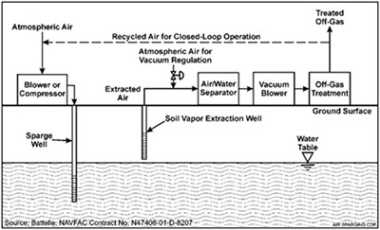
Fig. 1- General Diagram of an Air Sparging System (Smith, 1995)

  - Excavation
The process of excavation as a soil remediation technique involves physically extracting contaminated soil from a site using mechanical machinery such as excavators and dumpers. The removed soil can either be treated in situ at an alternative area of the site, or it can be transported away to be disposed of (Suer and Andersson-Skold, 2010), or to be treated ex situ using alternative soil remediation techniques. The applicability of excavation as a method of soil remediation relies primarily on the location and makeup of the soil requiring excavation. Often, excavation is an impractical solution, for example when contaminants have spread to undermine structures such as buildings that remain in use. However, on the contrary, excavation may also be the only applicable solution. This holds, for example, when underground structures have been identified as a source of contamination and the removal of said structures is the only feasible option that can provide total decontamination.

  - Thermal Soil Remediation
Thermal Soil Remediation is the process of removing contaminants from a soil through heating. A network of pipes are installed into the soil, in which high temperature gases circulate through and heat the soil by conduction. Once the soil reaches high enough temperatures, its organic pollutants become volatile and isolate from the contaminated soil through evaporation (Saadaoui et al, 2008). Thermal remediation has many advantages, with it being a fast process that is adaptable to a wide range of pollutants and applicable for the majority of soil types (Li et al, 2015). However, thermal soil remediation works most efficiently at higher temperatures, and so in order to be effective, the energy inputs required are high, meaning raised costs as well the requirement of burning fossil fuels.

  - Bioremediation
Bioremediation is the treatment of polluted soils using indigenous microorganisms to break down and destroy contaminants present within the soil. This method offers an environmentally friendly alternative to many other soil remediation techniques, with minimal energy requirements and lower costs when the site conditions are well suited to this type of remediation (Sharma, 2012). The rate at which degradation occurs depends on the microbial population present within the contaminated soil, and so for bioremediation to be successful, the environmental conditions must promote microbial growth (Vidali, 2001). There is therefore a requirement of optimal temperatures and moisture contents within the soil, along with the need for sufficient nutrient availability.

  - Phytoremediation
Phytoremediation is a soil remediation method that utilizes plants to extract contaminants from soils through use of their ability to evapotranspire groundwater and act as hyperaccumulators of contaminants (Prasad, 2003). Phytoremediation is effective in treating soil contaminated with organic pollutants and xenobiotics, such as heavy metals and agricultural and industrial chemicals, providing a cheaper and exceptionally more environmentally friendly solution to site restoration than many other physical or chemical approaches (Schroder, 2003).
Through evolution, plants have gained the potential to deal with toxic compounds present in their environment. They can extract contaminants from the ground, sequester them in their cell walls and metabolize them, degrading them into non-toxic substances that may even be useful to the plants as sources of carbon, phosphorus, nitrogen and sulphur (Saier and Trevors, 2010).

- Advantages and Disadvantages of Different Technologies
  - Air Sparging and Soil Vapour Extraction
Air sparging and Soil Vapour Extraction have proven to be effective in the removal of several types of contaminants from soils, including lighter petroleum compounds and chlorinated solvents (Reddy et al, 1995). However, the cost and effectiveness of this method depends significantly on the conditions and properties of the soil undergoing treatment. Low-permeable soils are difficult to treat, as they slow down the movement of vapours, while air sparging has proven to be ineffective on extracting contaminants with low Henry’s law constants (Di Julio & Drucker, 2002).
Depending on the permeability of the soil and its water content (Schubert et al, 2011), as well as the contaminants present and the actual area of land being treated, the amount of time taken to successfully remediate contaminated land through air sparging can range greatly. A review of case studies carried out by Bass et al (2000) showed that the average time taken for successful air sparging systems to operate was 16 months, however the remediation times in successful systems ranged up to as long as 4 years. Therefore, the capacity of air sparging as a choice of remediation technique on a soil must be analysed beforehand to ensure that it is the most applicable method.
Fig.2 below shows how general factors may be taken into account when determining the applicability of air sparging on remediating a particular contaminated soil.
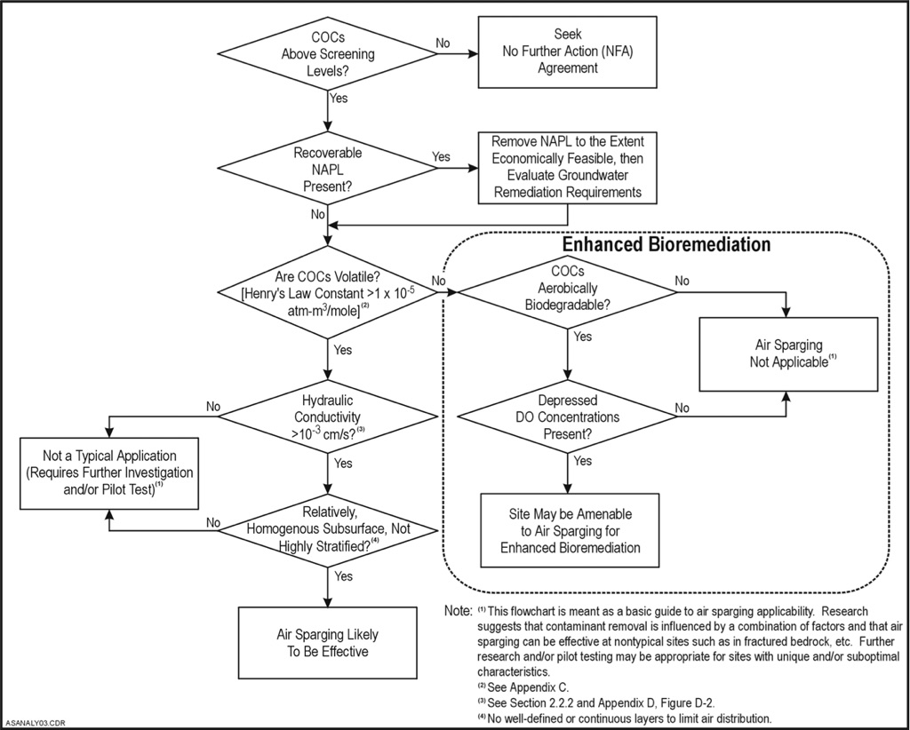
Fig.2- diagram indicating how general factors can be used to determine the applicability of air sparging (NFESC, 2001)
  - Excavation
Although excavation and off-site treatment is one of the most efficient and least time-consuming solutions for soil remediation (Kuppusamy et al, 2016), the key issue regarding excavation lies in the overall costs involved. The operation requires costly excavation work, as well as transportation costs, while ex situ remediation costs must be accounted for also. In addition to the high costs involved, excavation results in high levels of emissions, through both on site activities and transportation. The majority of emissions released when using excavation as a method of soil remediation contain carbon dioxide, which has proven to cause global warming and damage human health (Sakaguchi et al, 2015). Excavation also possesses the risk of causing a spread of contaminants to clean soil, either during excavation or during transit to off site remediation facilities. Transportation of contaminated soil through populated areas may also upset communities (Pavel and Gavrilescu, 2008).
  - Thermal Remediation
As mentioned in Chapter 2.3, the efficiency of thermal remediation in the removal of contaminants from a soil is dependent on the temperatures being reached. Fig. 3 below shows how different temperatures effected the removal rate of PBDEs found in a particular soil during research thermal soil remediation experiments carried out by Tan et al, 2015.
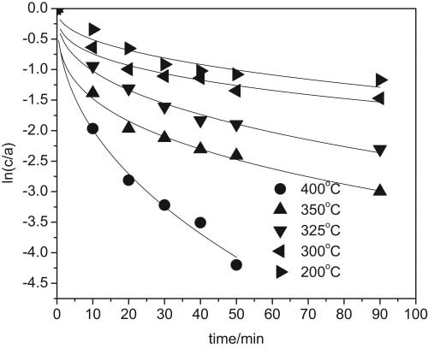
Fig. 3- Curve Graph comparing the removal rates of PBDEs in a particular soil under different desorption temperatures (Tan et al, 2015)
As can be seen in the graph, the time taken for the contaminant to erase is greatly influenced by the temperatures used. Higher temperatures require more energy input through burning fossil fuels. However, modern thermal soil remediation technologies, such as Thermopile, use as much as 10 times less energy than many traditional thermal systems, by re-using gases and using desorbed contaminants that are captured by the gas streams as fuel (Cappuyns, 2013).
A case study carried out by Bouckenooghe et al (2011) on a former industrial site in Flanders, Belgium, compared the overall environmental impact between soil treatment through thermal soil remediation compared to excavation with off-site treatment. The site in question had been contaminated through the use of several solvents over the past 4 decades, including Exxsol, an aliphatic hydrocarbon with a boiling point between 200°C and 240°C that had formed a light non-aqueous phase liquid (LNAPL) layer on the groundwater within the soil. The case study used two analytical methods, namely the REC method and the BATNEEC method, which concluded that the environmental impacts of the thermal remediation technology were lower than that of excavation and off-site treatment, primarily due to the overall emissions produced when transporting to off-site treatment facilities.
  - Bioremediation
Many soil remediation techniques leave behind, or use as a means of enhancement, daughter compounds that are potentially toxic to the environment. Bioremediation, however, results in the complete removal of contaminants, therefore removing the possibility of future issues that may arise from alternative methods. The graph shown in Fig.4 below gives an example of how the number of microorganisms present within a particular soil relates to the amount of nitrogen available as a source of nutrient. An increase in the number of microorganisms results in a period of nitrogen depletion, which in turn results in a drop in the microorganism population. Bioremediation works in a similar way to this, in that once the microbes used during Bioremediation have completely degraded the contaminants, and the presence of these contaminants has been removed, the microbes simply die off, leaving only residues that are generally harmless to the environment, such as carbon dioxide, water and cell biomass (Kensa, 2011)
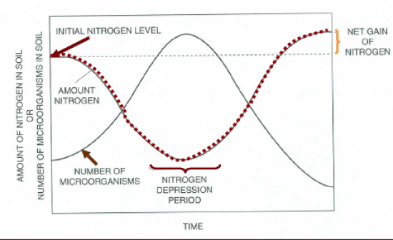
Fig.4- The relationship between amounts of nitrogen and number of microorganisms present within a particular soil (Vokes, 2013)
In order to be an effective solution to soil remediation, bioremediation requires optimal temperatures and moisture contents within the soil. If achieving these conditions is not possible, two techniques that may be utilised to enhance bioremediation of contaminated soils are biostimulation and bioaugmentation. Biostimulation involves the addition of nutrients, via fertilisers, into a contaminated soil, in order to stimulate the growth of indigenous microorganisms that have the ability to degrade the pollutants (Thieman and Palladino, 2009). Bioaugmentation on the other hand involves adding exogenous biodegrading microorganisms into the contaminated soil, in order to assist the indigenous microorganisms, which are already present within the soil, in degrading the pollutants (Li et al, 2017).
In addition to the requirement of specific conditions for bioremediation to be effective, there is also concern regarding the effect of this method on the microorganisms. When these microorganisms are exposed to high concentrations of metal, it may have a detrimental effect on them. Therefore, bioremediation of heavy metal contaminated soil through use of microorganisms is only effective when the concentration of metals in the soil is low (Kumar and Gopal, 2015).

  - Phytoremediation
Phytoremediation, like all soil remediation techniques, has its advantages as well as disadvantages. It can take several years for complete soil treatment through phytoremediation (Palmroth et al, 2006). This means that the land in question may not be available for use for a long period of time and so if there is a requirement for the soil to be treated quickly, other remediation techniques must be considered instead. Phytoremediation is also greatly influenced by the soil and climate conditions of the site, and it is only effective for moderately hydrophobic compounds (Kamath et al, 2004). However, if phytoremediation is an applicable option and is suitable to the site in question, it carries many benefits including reduced costs and a greatly reduced negative impact on the environment. It requires no consumption of fossil fuels, while the plants absorb carbon dioxide from the air. If the climate in the location being treated is suitable to the plant species being used, the cost and maintenance required for this remediation technique is minimal (Schwitzguebel et al, 2011)

  - Cost comparison of different techniques
Due to the fact that site conditions present on different contaminated areas will always vary, cost estimates for one site will differ to that of other sites, and so establishing cost data for remediation technologies can be difficult. Additional information will always be required to obtain accurate cost comparisons on the suitability of different soil remediation techniques on a particular site, however we can use a number of general factors that provide sufficient data that allows us to derive an estimated evaluation of the costs of different methods, with patterns in unit cost (EPA, 2000).
Table 1 shows an example of general parameters for eight different types of template sites that are critical elements for comparing costs of ground water remediation techniques.

Template Number | Depth to Water Table (m) | Aquifer Thickness (m) | Aquifer Permeability (cm/sec) | Ground Water Flow Rate (m/year)
1 | 4.6 (15 ft) | 7.6 (25 ft) | 5.0 x 10⁴ | 3 (10 ft/yr)
2 | 4.6 (15 ft) | 7.6 (25 ft) | 2.5 x 10² | 150 (500 ft/yr)
3 | 4.6 (15 ft) | 21 (70 ft) | 5.0 x 10⁴ | 3 (10 ft/yr)
4 | 4.6 (15 ft) | 21 (70 ft) | 2.5 x 10² | 150 (500 ft/yr)
5 | 30 (100 ft) | 7.6 (25 ft) | 5.0 x 10⁴ | 3 (10 ft/yr)
6 | 30 (100 ft) | 7.6 (25 ft) | 2.5 x 10² | 150 (500 ft/yr)
7 | 30 (100 ft) | 21 (70 ft) | 5.0 x 10⁴ | 3 (10 ft/yr)
8 | 30 (100 ft) | 21 (70 ft) | 2.5 x 10² | 150 (500 ft/yr)
Table 1- General Parameters for Comparing Costs of Ground Water Remediation Technolgies (National Research Council, 1997)

- Conclusion
The Industrial Revolution, together with the continuous development of new technologies and the ever-increasing human population, has led to an enormous rise in atmospheric emissions, and an increased amount of potentially harmful chemicals polluting the earth’s soils. As of June 2016, there was an estimated 340,000 sites in the United Kingdom that were expected to be contaminated and requiring remediation (EEA, 2016. Soil Contamination Widespread in Europe). Due to this, the requirement of soil remediation techniques already being used, and indeed the requirements for new, more advanced technologies is clear. Soil remediation technologies have proven successful in remediating contaminated with soil, however there is a requirement to switch to more sustainable methods. As can be seen in the above assessment, there are a number of contributing factors limiting our choice of remediation methods, however it is clear that some methods, when applicable, hold many advantages over others.
The energy demands required for air sparging, soil vapour extraction and excavation mean that these techniques have a negative impact on the environment, despite their key aim to reduce the impact of contaminants within the soil. Additionally, Thermal remediation requires energy inputs to provide high temperatures, although modern techniques have become more energy efficient (Cappuyns, 2013). Another issue in regards to the use of thermal remediation is the risk of altering soil properties. The high temperatures have been proven to diminish nutrients available in the soil, creating poor conditions for plants and microorganisms (O’Brien et al, 2017).
Bioremediation offers a potential environmentally-friendly solution to contaminated soil treatment, however it requires specific conditions in order to do so without the addition of environment-modifying techniques, such as biostimulation and bioremediation. Biostimulation requires the use of potentially harmful fertilisers to enhance biodegradation, while the addition of exogenous microbes into a soil through bioaugmentation may alter the ecology of the soil, potentially causing post-remediation risk to environmental health (Abioye, 2011)
Plants have the potential to convert harmful contaminants found within soil into useful sources of nutrition (Yadav et al, 2015) . Therefore, phytoremediation does not require the use of, or result in the production of, harmful substances that may be as, or even more, toxic than the contaminants being removed. This means that, when applicable and suitable to the particular contaminated soil, phytoremediation is a desirable solution with minimal impact on human health and the environment.
Soil remediation techniques were created in order to reduce the potential harm posed on human health and the environment, so it is clearly of interest to switch to methods that use less energy and do not leave behind alternative toxic substances. Further research and investment is vital in order to create new environmentally-friendly technologies to provide sustainable soil remediation options.

References
- Abioye, O.P. (2011). Biological Remediation of Hydrocarbons and Heavy Metals Contaminated Soil. Soil Contamination, Chapter 7, p.131. Pascucci, S. (Ed.).
- Bass, D.H. ; Hastings, N.A. ; Brown, R.A. (2000). Performance Of Air Sparging Systems: A Review Of Case Studies. Journal Of Hazardous Materials, Volume 72, pp.101-119.
- Cappuyns, V. (2013). Environmental Impacts of soil remediation activities: quantitive and qualitative tools applied on three case studies. Journal of Cleaner Production, Volume 52, pp145-154.
- Bouckenooghe, D. ; van Breuseghem, L. ; Cappuyns, V. ; van Herreweghe, S. (2011). Can Thermal Soil Remediation Be Sustainable? A Case Study Of The Environemental Merit Of The Remediation Of A Site Contaminated By A Light Non-Aqueous Phase Liquid (LNAPL). Journal of Integrative Environmental Sciences, Volume 8, Issue 2, pp.103-121.
- Chen, G. ; Zhu, H. ; Zhang, Y. (2003). Soil microbial activities and carbon and nitrogen fixation. Research in Microbiology, Volume 154, Issue 6, pp.393-398.
- Di Julio, S.S. ; Drucker, A.S. (2002). Air-Sparging Remediation: A Study On Heterogeneity And Air Mobility Reduction. Journal of Hazardous Substance Research, Volume 3, Chapter 7, pp.1-18.
- DOD Environmental Technology Transfer Committee (1994). Remediation Technologies Screening Matrix and Reference Guide, Second Edition, p.11.
- EEA (2007). Europe’s Environment- The Fourth Assessment. Chapter 2: Environment and Health and the Quality of Life, p. 441.
- EEA (2016). Soil Contamination Widespread in Europe. URL: https://www.eea.europa.eu/highlights/soil-contamination-widespread-in-europe [Accessed 14/11/17].
- EPA (Environmental Protection Agency) (1996). A Citizen’s Guide to Soil Vapor Extraction and Air Sparging. The Citizen’s Guide Factsheet.
- EPA (Environmental Protection Agency) (2000). Remediation Technology Cost Compendium- Year 2000, Section 1, p.1.
- EPC (2017). What Is Soil Pollution? URL: https://www.environmentalpollutioncenters.org/soil/ [Accessed 01/12/17].
- Kamath, R. ; Rentz, J.A. ; Schnoor, J.L. ; Alvarez, P.J.J. (2004). Phytoremediation of hydrocarbon-contaminated soils: principles and applications. Studies in Surface Science and Catalysis, Volume 151, Chapter 16, p.450.
- Kensa, V.M. (2011). Bioremediation- An Overview. Journal of Industrial Pollution Control, Volume 27, Issue 2, pp.161-168.
- Kuppusamy, S. ; Palanisami, T. ; Megharaj, M. ; Venkateswarlu, K. ; Naidu, R. (2016). Ex-Situ Remediation Technologies for Environmental Pollutants: A Critical Perspective. Reviews of Environmental Contamination and Toxicology, Volume 236, p.124.
- Kutilek, M. ; Nielsen, D.R. (2015). Soil Regulates Circulation of Water on the Planet Earth. Soil: The Skin of the Planet Earth, pp. 137-158.
- Li, Y. ; Pan, L. ; Li, A. (2015). Suitability evaluation of remediation technology for polluted farmland. International Journal of Agricultural and Biological Engineering, Volume 8, Issue 2, p.40.
- Li, Y. ; Zhang, Y. ; Sun, Y. ; Wu, S. ; Kong, X. ; Yuan, Z. ; Dong, R. (2017). The performance efficiency of bioaugmentation to prevent anaerobic digestion failure from ammonia and propionate inhibition. Bioresource Technology, Volume 231, pp. 94-100.
- Meuser, H. (2013). Soil Remediation and Rehabilitation: Treatment of Contaminated and Disturbed Land. Environmental Pollution, Volume 23, p.1.
- National Research Council (1997). Innovations in Ground Water and Soil Cleanup: From Concept to Commercialization. Chapter 6, p.255.
- NFESC (2001). Air Sparging Guidance Document. NFESC Technical Report, p.8.
- Kumar, B.L. ; Gopal, D.V.R.S. (2015). Effective Role of Indigenous Microorganisms for Sustainable Environment. 3 Biotech (Journal), Volume 5, Issue 6, pp.867-876.
- O’Brien, P.L. ; DeSutter, T.M. ; Casey, F.X.M. ; Khan, E. ; Wick, A.F. (2017). Thermal Remediation Alters Soil Properties- A Review. Journal of Environmental Management, Volume 206, pp.826-835.
- Palmroth, M.R.T. ; Koskinen, P.E.P. ; Pichtel, J. ; Vaajasaari, K. ; Joutti, A. ; Tuhkanen, A.T. ; Puhakka, A.J. (2006). Field-Scale Assessment of Phytotreatment of Soil Contaminated with Weathered Hydrocarbons and Heavy Metals. Journal of Soils and Sediments, Volume 6, Issue 3, p.128.
- Pavel, L.V. ; Gavrilescu, M. (2008). Overview of Ex Situ Decontamination Techniques for Soil Cleanup. Environmental Engineering and Management Journal, Volume 7, Issue 6, p.832.
- Prasad, M.N.V. (2003). Phytoremediation of Metal-Polluted Ecosystems: Hype for Commercialization. Russian Journal of Plant Physiology, Volume 50, Issue 5, p.686.
- Vokes, C. (2013). Soils Midterm. URL: https://www.proprofs.com/flashcards/story.php?title=soils-midterm [Accessed 26/11/17].
- Reddy, K.R. ; Kosgi, S. ; Zhou, J. (1995). A Review of In-Situ Air Sparging for the Remediation of VOC-Contaminated Saturated Soils and Groundwater. Hazardous Waste and Hazardous Materials, Volume 12, Issue 2, pp.97-118.
- Saadaoui, H. ; Jourdain, S. ; Falcinelli, U. ; Haemers, J. (2008). Mathematical Modeling of Thermal Conduction in Soil in Presence of Non-Aqueous Phase Liquids For The Thermopile Process Description. 10th International Conference on Soil-Water System, pp.106-115.
- Saier, M. ; Trevors, J. (2010). Phytoremediation. Water, Air and Soil Pollution, Volume 205, pp.61-63.
- Sakaguchi, I. ; Inoue, Y. ; Nakamura, S. ; Kojima, Y. ; Sasai, R. ; Sawada, K. ; Suzuki, K. ; Takenaka, C. ; Katayama, A. (2015). Assessment of soil remediation technologies by comparing health risk reduction and potential impacts using unified index, disability-adjusted life years. Clean Technologies and Environmental Policy, Volume 17, Issue 6, pp.1663-1670.
- Schroder, P. (2003). Phytoremediation. Journal of Soils and Sediments, p.228.
- Schubert, M. ; Schmidt, A. ; Muller, K. ; Weiss, H. (2011). Using Radon-222 As Indicator For The Evaluation Of The Efficiency Of Groundwater Remediation By In Situ Air Sparging. Journal of Environmental Radioactivity, Volume 102, pp.193-199.
- Schwitzguebel, J. ; Comino, E. ; Plata, N. ; Khalvati, M. (2011). Is Phytoremediation a Sustainable and Reliable Approach to Clean-up Contaminated Water and Soil in Alpine Areas? Environmental Science and Pollution Research International, Volume 18, Issue 6, p. 843.
- Sharma, S. (2012). Bioremediation: Features, Strategies and Applications. Asian Journal of Pharmacy and Life Science, Volume 2, Issue 2, pp. 203-208.
- Smith, S.J. (1995). Evaluating the Effective Zone for an Air Sparging System. HGC Gradient. URL: hgcinc.com/novdec95.htm [Accessed 01/12/17].
- Suer, P. ; Andersson-Skold, Y. (2010). Biofuel or excavation? Life cycle assessment (LCA) of soil remediation options. Biomass and Bioenergy, Volume 35, p. 970.
- Suthersan, S.S. (1999). Soil Vapour Extraction, in Remediation of Sandy Soils Contaminated with Hydrocarbons and Halogenated Hydrocarbons by Soil Vapour Extraction. Journal of Environmental Management, Volume 104, p.195.
- Tan, Z. ; Feng, W. ; Ai, P. ; Xiong, H. (2015). Effect of Different Work Conditions on the Thermal Desorption Remediation Model of Contaminated Soil. Soil and Sediment Contamination: An International Journal, Volume 24, Issue 7, p.774.
- Thieman, W.J. and Palladino, M.A. (2009). Introduction to Biotechnology,2nd Edition. p. 1.
- Thompson, C. and Nathanail, P., eds. (2003). Chemical Analysis of Contaminated Land p.178.
- Vidali, M. (2001). Bioremediation. An Overview; Pure and Applied Chemistry, Volume 73, No. 7, pp.1166-1167.
- Yadav, B.K. ; Akhtar, M.S. ; Panwar, J. (2015). Rhizospheric Plant-Microbe Interactions: Key Factors to Soil Fertility and Plant Nutrition. Plant Microbes Symbiosis: Applied Facets, pp.134-136. Arora, N.V. (Ed.).

