Module: Learning in the Digital Era
Module code: BMPS4009 & BMPL4007
Lecturer: Sadie France
Assignment Title: Evidence of Learning (E-Portfolio)
Student Name: Ionel Florin Nicolae
Student ID: 2246428
Table of Contents
Written Summary 3
Mind Map 5
Power Point Presentation 6
Self-Reflection 14
Personal Development plan 19
References 36

Written Summary
The planning for higher education is transformative and goes through definite pathways which include several skills. For the preparation of higher education, there are several requirements for soft skills which the learners must imbibe to accommodate themselves in the learning career. The soft skills include team-making, planning, time management and leadership skills (Barana and Marchisio, 2021). Learners preparing for higher education must plan carefully and consciously keeping in mind the necessary constraints that might lead to separate consequences. The learner must first research properly and choose the colleges and schools they want to apply to and whatever program the concerned college is providing. The learner must be aware of the location, culture and reputation of the concerned college along with the learner's individual goals (Paudel, 2021). The learner must also evaluate his or her academic faults and strengths to avoid gaps and negate possibilities. Higher education will enable the learner's personal development and encourage their growth while promoting cultural balance and critical thinking capabilities. Moreover, higher education enables networking which in turn will lead to exposure, engagement and promote communication abilities. Learners must ensure proper research and decide on their passion and goals along with that they must work on their extracurricular activities to foster better growth (Alexander et al., 2019).

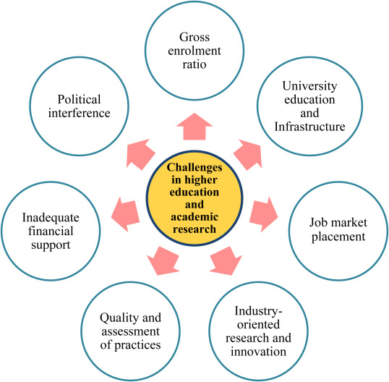

Figure: Challenges of Preparation of Higher Education
Source: (Ramísio et al., 2019)
Planning for higher education often invites certain challenges that act as a hindrance in front of the learner's goals. There are standardised tests that check the amplitude of the learner's and therefore failing which will create a hindrance for the learner. Financial planning is of utmost importance as that decides the learner's capability to fund his goals. Learners must also be aware of the prevailing scholarships that can fund his or her study. Application procedures often get tedious and can cause a hindrance in learning goals along with problems related to accommodation and well-being. Although these days online learning facilities have lessened up much of the problems and have been serving the needs. Therefore, learners must have sound technical skills to navigate through it and be self-disciplined.

Mind Map
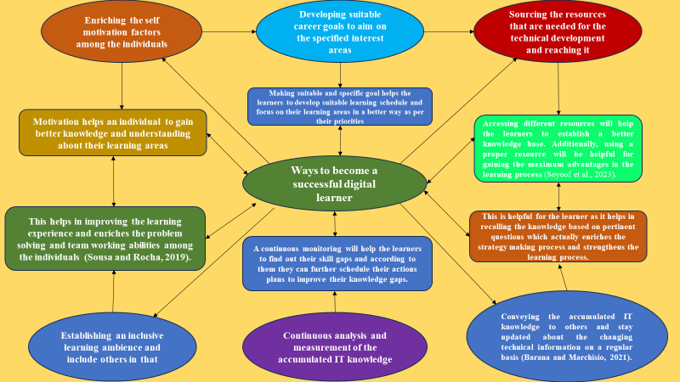

Figure: Mind Map

Power Point Presentation

https://www.youtube.com/watch?v=Tt4xLKThURg
Slide One
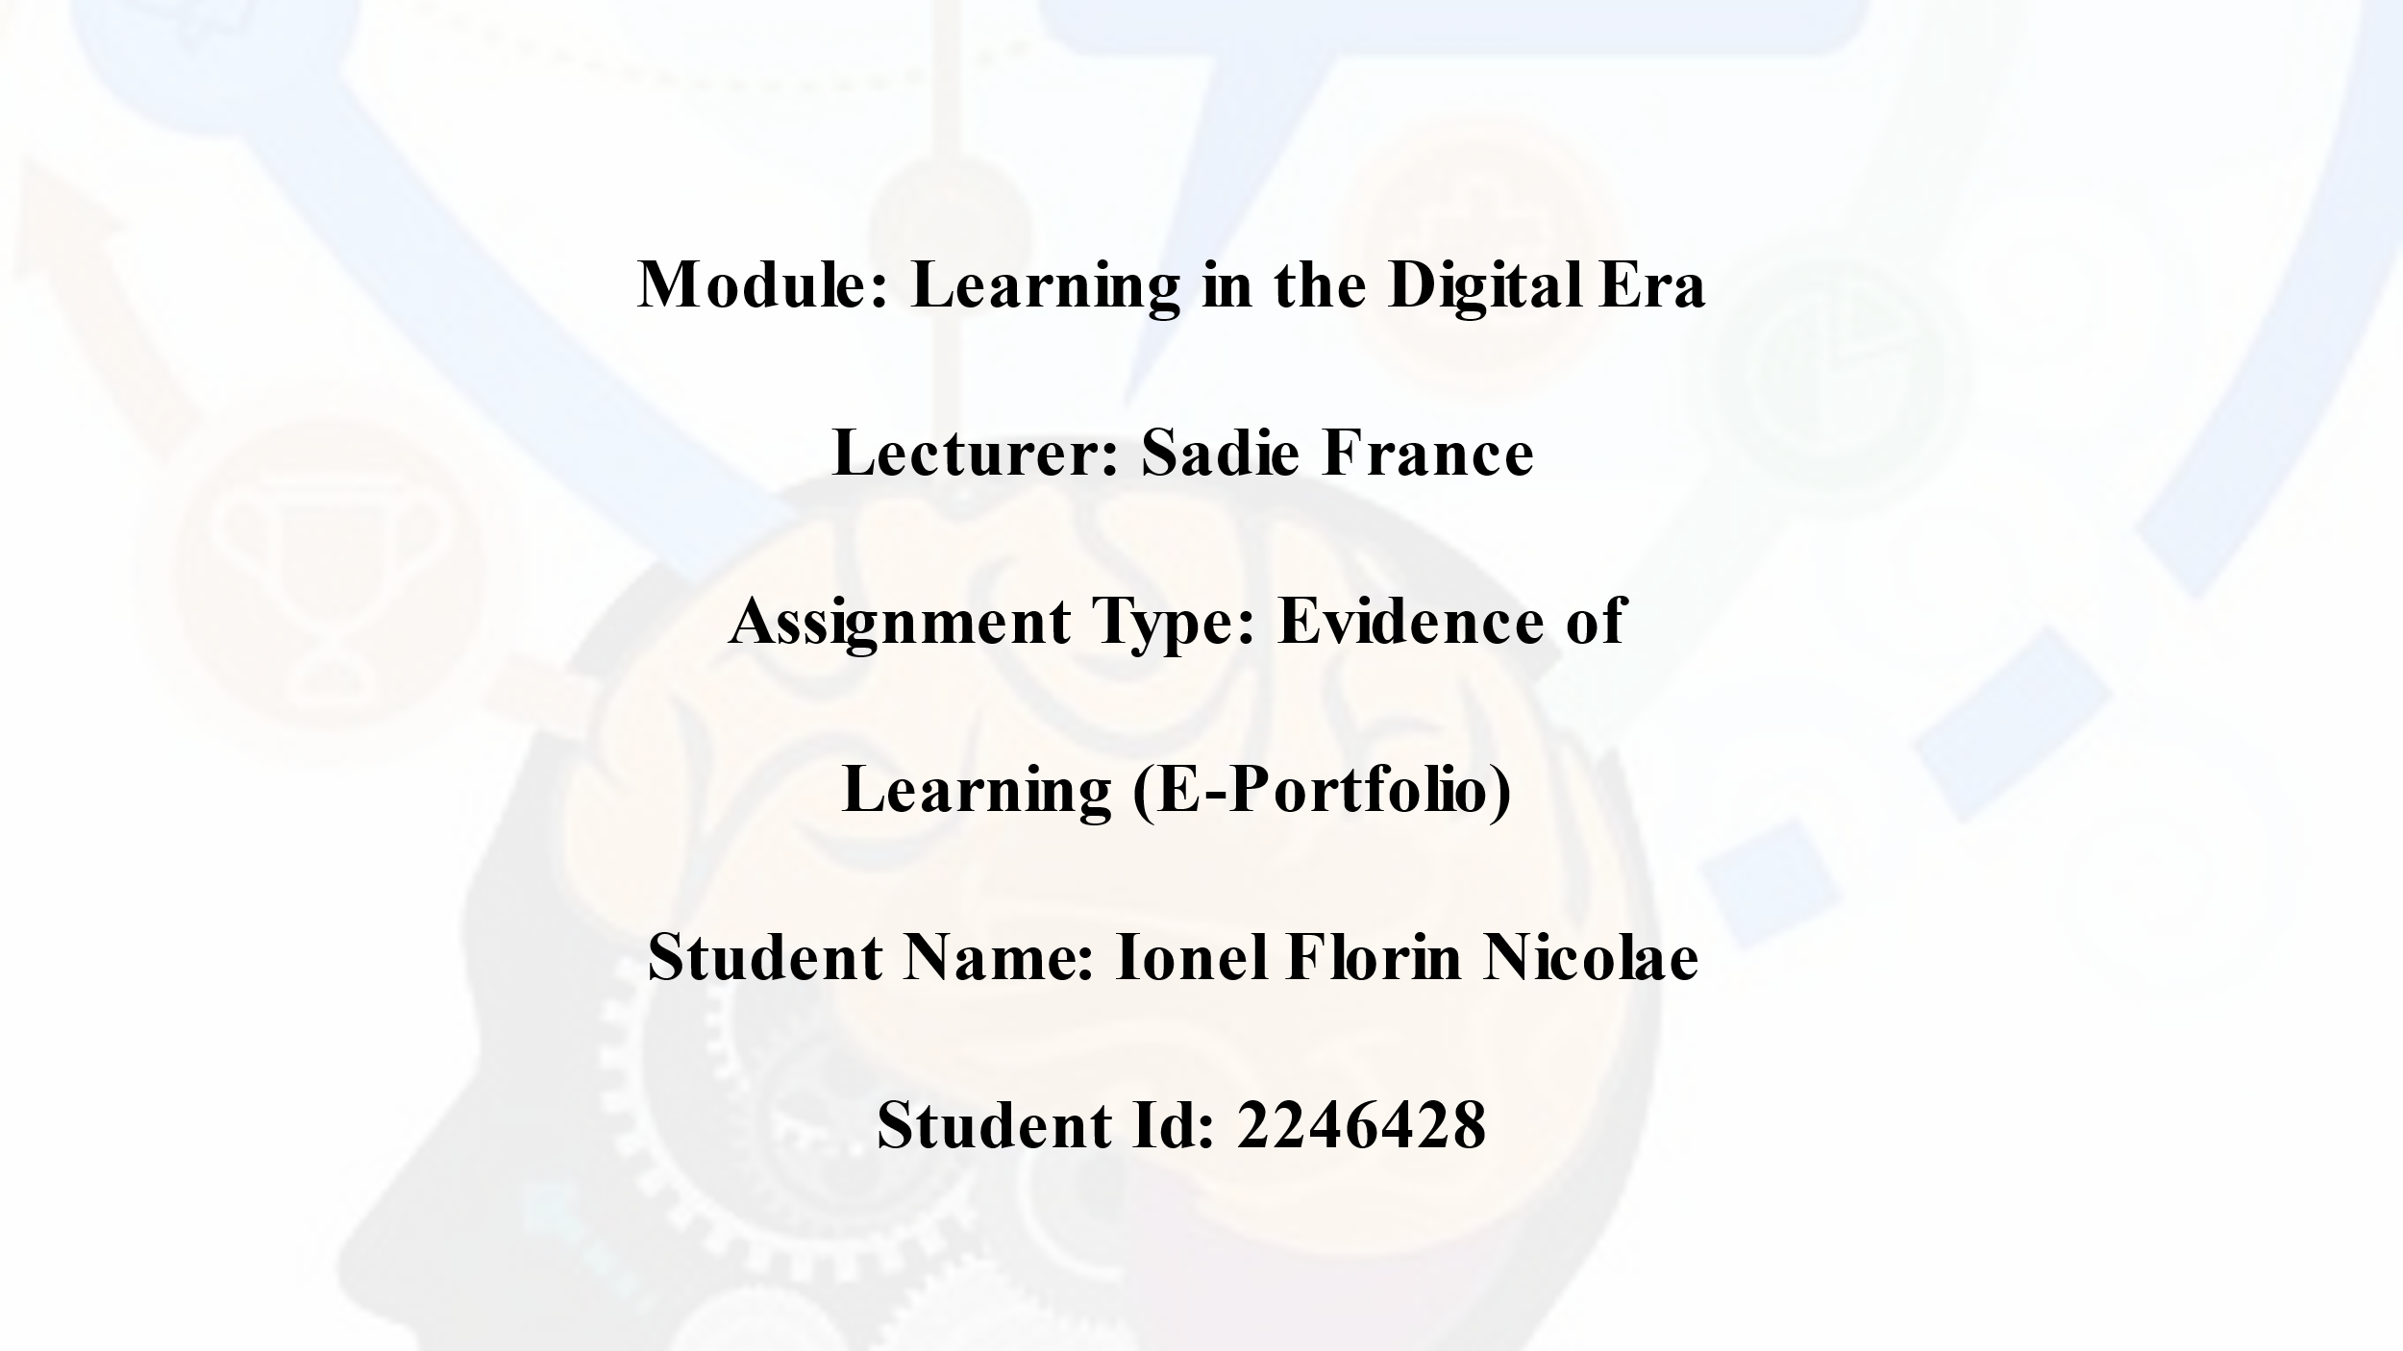

Slide Two
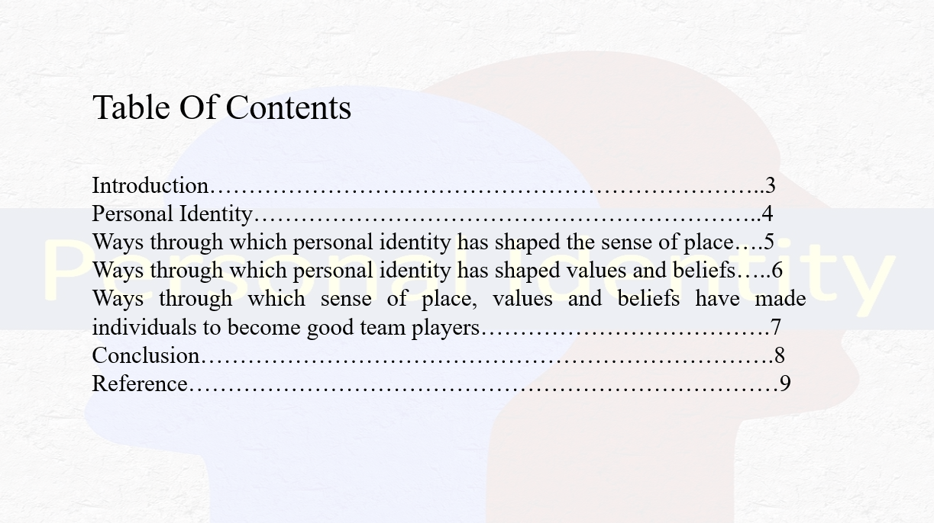
Introduction
Slide three
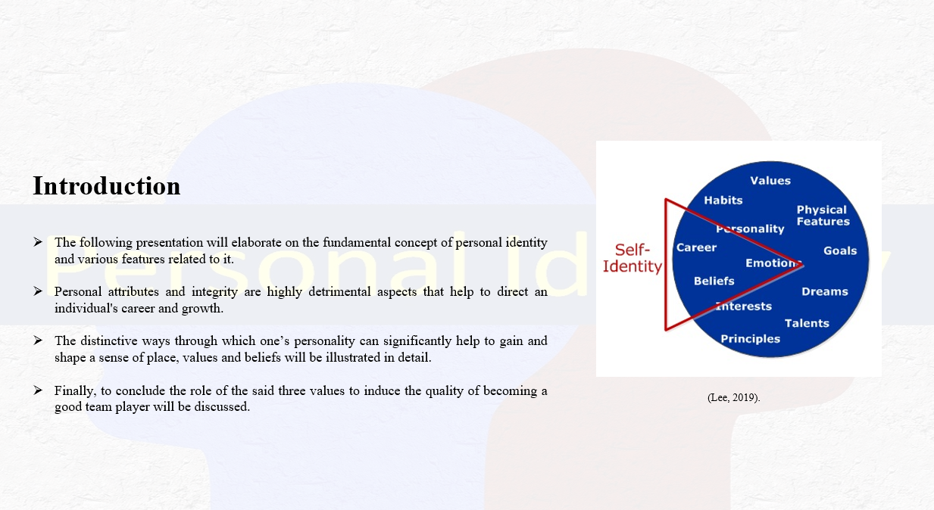
Notes
The following presentation will elaborate on the fundamental concept of personal identity and various features related to it. Personal attributes and integrity are highly detrimental aspects that help to direct an individual's career and growth. Initially, the discourse will provide an overview of the definition of personal identity that will further outline the author’s reflection on personal progress. Afterwards, the distinctive ways through which one’s personality can significantly help to gain and shape a sense of place, values and beliefs will be illustrated in detail. Finally, to conclude the role of the said three values to induce the quality of becoming a good team player will be discussed.
Personal Identity
Slide four
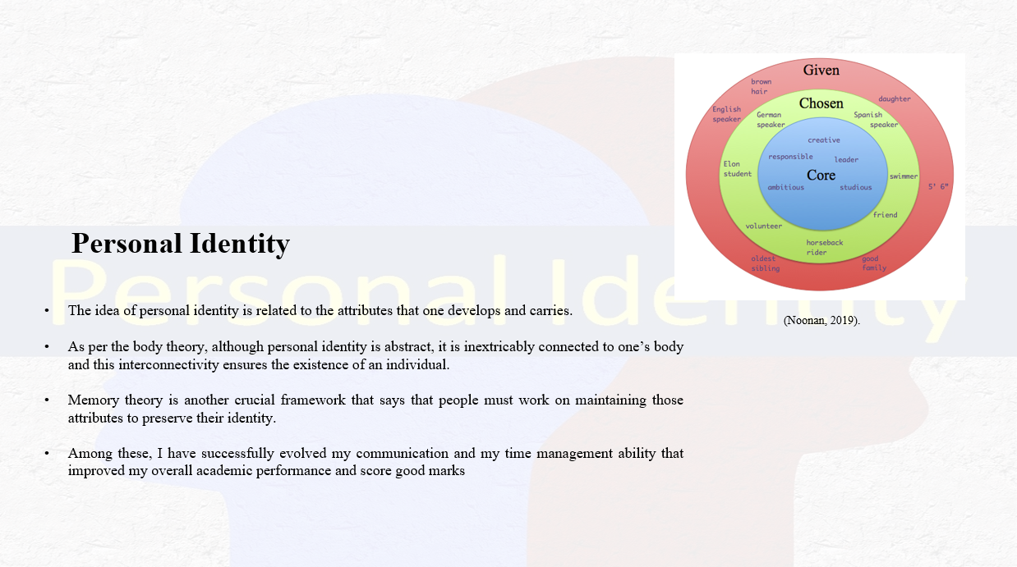
Notes
The idea of personal identity is related to the attributes that one develops and carries. However, to reflect upon my skills and experiences, I have applied the two most relevant theories to come up with the correct definition of the complicated idea. As per the body theory, although personal identity is abstract, it is inextricably connected to one’s body and this interconnectivity ensures the existence of an individual (Noonan, 2019). Memory theory is another crucial framework that says that people must work on maintaining those attributes to preserve their identity. Therefore, I realised that I have developed and cultivated many skills that can widen my future career prospects. Among these, I have successfully evolved my communication and my time management ability that improved my overall academic performance and score good marks (Shoemaker and Tobia, 2019).
Ways through which personal identity has shaped the sense of place
Slide five
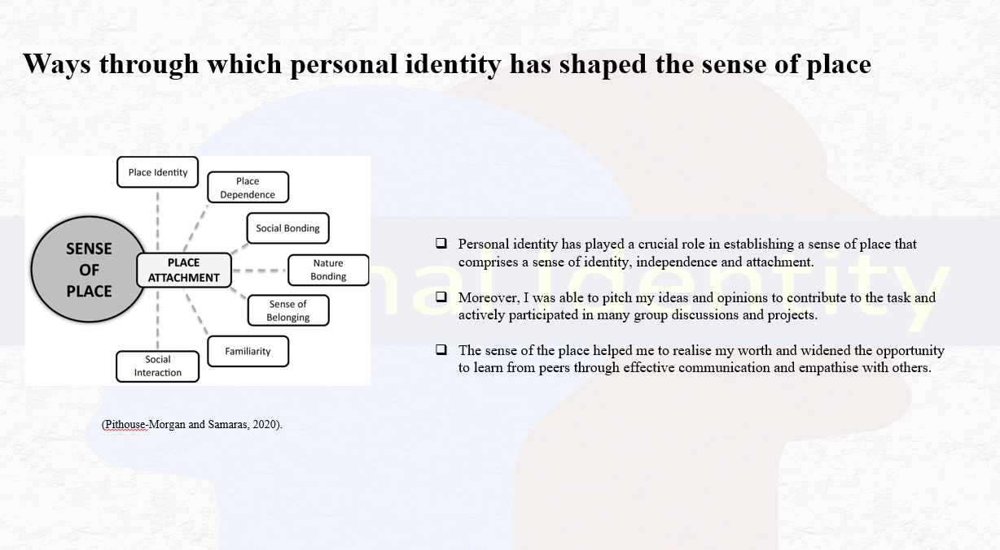
Notes
Personal identity has played a crucial role in establishing a sense of place that comprises a sense of identity, independence and attachment. Once I have determined my position and place, I have efficiently worked and that boosted my confidence immensely. Moreover, I was able to pitch my ideas and opinions to contribute to the task and actively participated in many group discussions and projects. The sense of the place helped me to realise my worth and widened the opportunity to learn from peers through effective communication and empathise with others (Pithouse-Morgan and Samaras, 2020).
Ways through which personal identity has shaped the sense of values and beliefs
Slide six
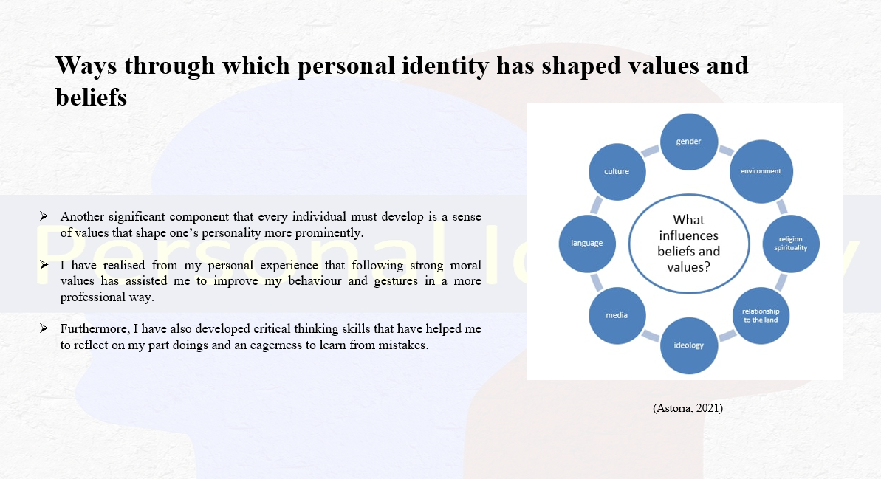
Notes
Another significant component that every individual must develop is a sense of values that shape one’s personality more prominently. While growing a strong personality, it is imperative to formulate fundamental ethics, perspectives and characteristics. I have realised from my personal experience that following strong moral values has assisted me to improve my behaviour and gestures in a more professional way. My experiences, cultural and communal background and social conventions have enabled me to adapt to change and accept diversity. Furthermore, I have also developed critical thinking skills that have helped me to reflect on my part doings and an eagerness to learn from mistakes (Astoria, 2021).
Ways through which sense of place, values and beliefs have made individuals become good team players
Slide seven
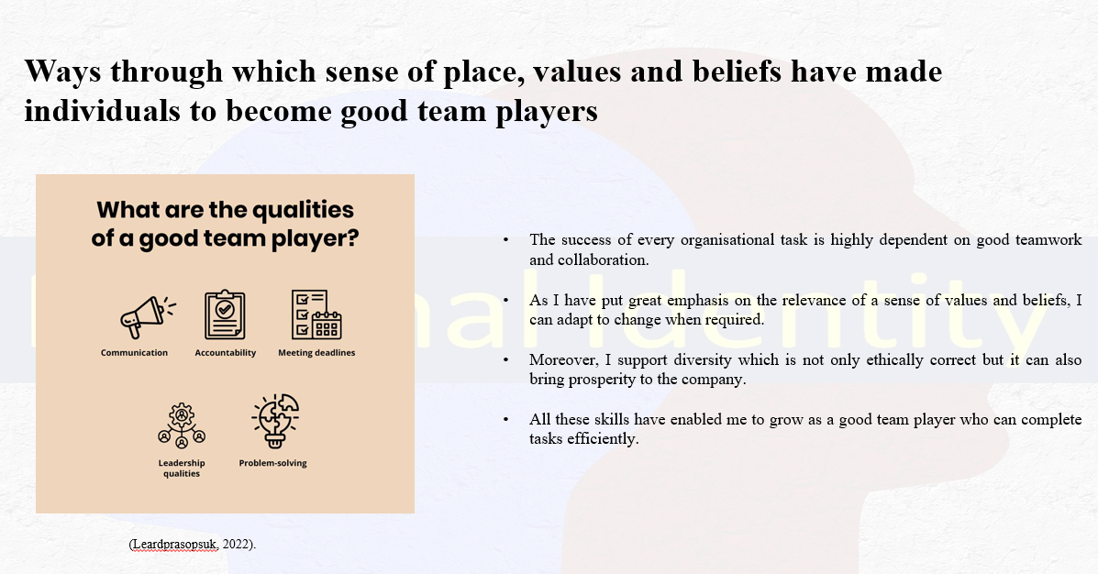
Notes
The success of every organisational task is highly dependent on good teamwork and collaboration. Thus, it is important that every group member is highly skilled and can efficiently complete the operations without arising any additional hazards. As I have put great emphasis on the relevance of a sense of values and beliefs, I can adapt to change when required. Moreover, I support diversity which is not only ethically correct but it can also bring prosperity to the company. One of the most important skills that a team requires is leadership and problem-solving skills (Morgan, 2021). During my academic sessions, I have actively taken participation in many group assignments and worked as a team. While working on the project I realised how important it is to consider everyone’s opinion and share empathy with each other. Furthermore, it is also important to foster a positive work environment so each member feels included. My beliefs shaped my values and that further created a sense of mutual respect for each other that helped to mitigate the communication gap. All these skills have enabled me to grow as a good team player who can complete tasks efficiently (Leardprasopsuk, 2022).
Conclusion
Slide eight
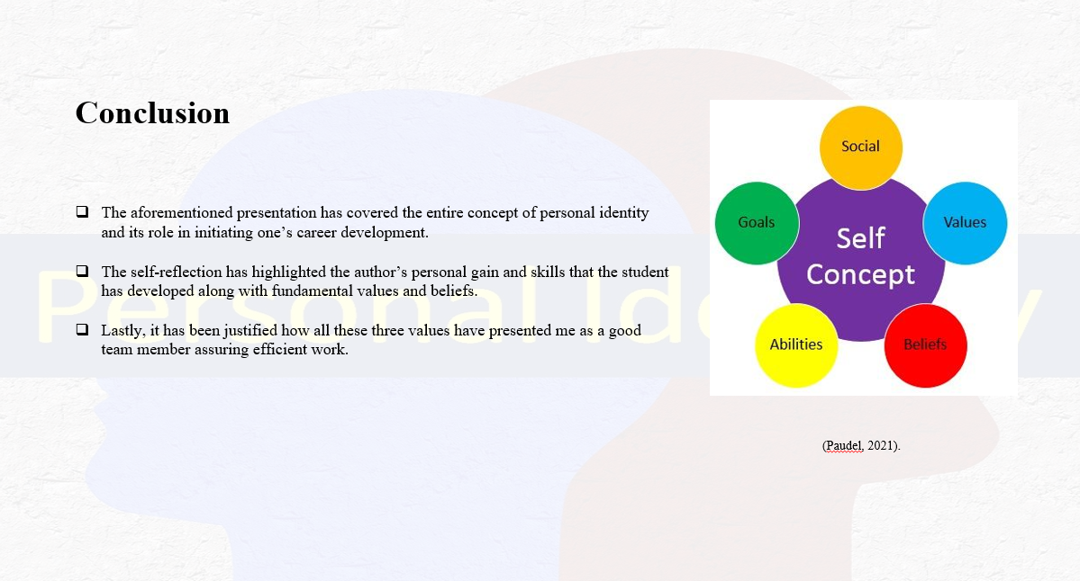
Notes
The aforementioned presentation has covered the entire concept of personal identity and its role in initiating one’s career development. However, the discourse has displayed how a sense of place, values and belief can be achieved by developing personal integrity. The self-reflection has highlighted the author’s personal gain and skills that the student has developed along with fundamental values and beliefs. Lastly, it has been justified how all these three values have presented me as a good team member assuring efficient work.
Slide nine
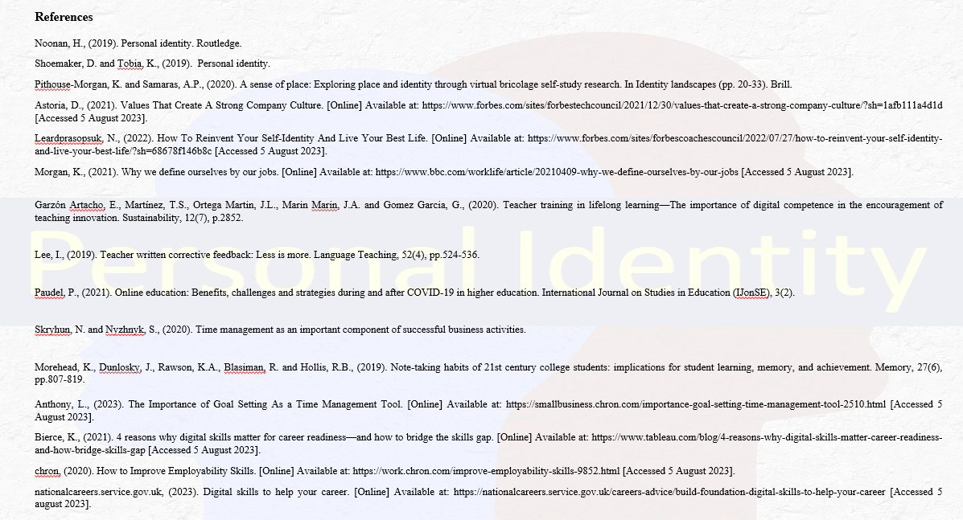

Self-Reflection
The Gibbs model of the reflective cycle was developed by Graham Gibb in the year 1988. This model allows the individual to self-reflect on the different experiences learnt by them during the course of the study. There are 6 stages of the model which help to give a detailed view of the entire experience in the form of a self-reflection.

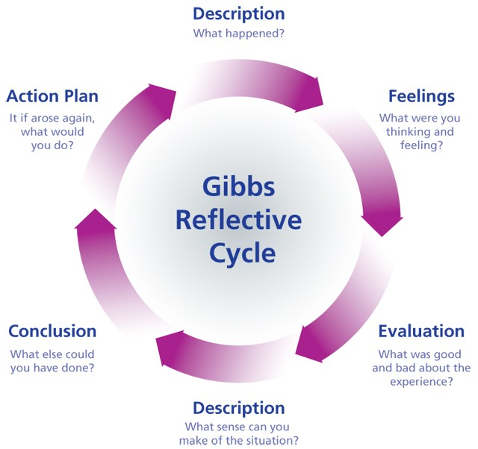

Source: (Müller and Mildenberger, 2021).

Description
Online learning is one of the new additions to the field of education which allows the students to carry out their learning process from distant areas (Müller and Mildenberger, 2021). Different online methods are also available which helps to procure additional information related to the subject of study. During my initial days of starting my activities as a student of online learning, I thought that I only had to go through the available sources to get the information. The first thing that I was taught was to identify the different types of online learning tools and methods which are available. Different ways in which the different online methods are used during the learning process were also introduced in the classes to learn about their uses. The various ethical considerations while using online sources of information were also taught to me to make the online learning process free from any errors.

Feelings
During the initial days of starting my classes as a student, I felt very much confident about the different online learning resources and the tools available. I thought that online learning materials can be collected from any general source or website and this will allow me to learn very easily. The different information can just be copied from different sources to gather the information from the internet and this thought made me very happy. After the start of the classes, I came to know that there are certain considerations which need to be followed to carry out online learning methods (lexology, 2021). After knowing about the different rules and regulations I came to know that I had a completely false idea about the online learning methods and practices. The different rules and regulations and the ways to gather the information and cite the appropriate references also made me realise that the online learning process is not as easy as it looks. Thus, I felt that the idea which was present within me about the online learning process was not fully correct and many things needed to be learnt by me.
Evaluation
After attending a few lessons about the different online learning methods and doing a few assignments I learnt the basics about this subject. I had a basic idea about the different ways to search for information using different digital tools. This knowledge allowed me to gather information related to the different online learning methods much more easily than the others. While doing the different group assignments I came across the other students who helped me to complete the projects within the stipulated time with the help of different online resources. The process of citing the references for the collected academic sources did not go well during the overall process (Rethlefsen et al., 2021). This reduced my working efficiency during the process of doing the assignments and I had to take the help of my classmates and of my educators (Lattanzi et al., 2020). Overall, the initial days of my lesson made me realise that many things needed to be learnt as a student although it might seem easy in the beginning.
Analysis
Digital learning has made much of online learning easier and has saved time while providing specific tools that are important for efficient learning outcomes. With the use of online learning, I have gathered a lot of educational information and have been able to access much of the knowledge that is present in the outside world. Digital learning has helped me to access various kinds of information and had a huge impact during the pandemic. While preparing for my assignments I have referred to the various kinds of online lectures, which helped me to prepare as per the recent trends in the education system. Recorded lectures from trained individuals have helped me to prepare my assignment explicitly. Besides, preparing through various blogs and hourly resources has helped me to revise my schedule according to my preferred time. Besides, digital learning is interactive and has often enhanced my experience while making it more unique and interesting. Moreover, the methods used in digital learning are unique and do not cover conventional patterns which makes it easier for learners like me who are inclined towards critical learning. While preparing for my first assignment digital learning has made resources accessible and saved time while making course preparations convenient and flexible (lexology, 2021).
Conclusion
Online learning has brought the world together and helped students and teachers from various places to connect and facilitate a safe learning environment. I can connect with a diverse range of students and share my ideas and views with them through virtual classes and various other forums. Through online discussion boards and virtual classes, I have made friends with other students, exchanged ideas, and learnt a lot. These connections have improved my educational experience while also broadening my thinking by exposing me to different approaches and points of view. The Gibbs reflective tool of 1988 has highlighted the significance of internet-based education and resources for academic assignments. The learning process has been transformed by internet-based technologies and resources that enable better educational outcomes, giving access to vast knowledge repositories, and promoting the growth of crucial skills. We must utilise these technological advancements to the best extent feasible as learners. These enable us to achieve academic success, widen our horizons, and prepare for the challenges of a continuously changing world. Further, as a learner, I have implemented the necessary advantages of digital learning in my academic pursuits to prepare an academically rich assignment, covering a diverse range of information (Rethlefsen et al., 2021).
Action Plan
I have discovered how much the tools and potential of virtual learning have for enhancing my academic performance as a student. My options to enhance my knowledge and abilities have been expanded by the accessibility and simplicity of the digital world. I will be researching a variety of online learning settings to determine which ones best meet my academic needs and learning preferences. By selecting platforms that provide a variety of engaging content, such as instructional videos, online tests, and discussion forums, I will work on my understanding of the subject. For organising the materials for my online courses, I will develop a system that broadens my perspectives and enhances my growth. I will further create an organised system of learning which will help me to be more organised and accountable. As a student preparing for higher education, I will carefully save my resources, projects and articles to create a specialised directory on my laptop stop storage. I will choose my lectures and modules carefully and check whether they are suitable for my course of study and my subsequent projects. I will also work on my quality of work and emphasis on details by emphasising details. I aspire to make the best out of my education endeavour and give more time to research to fulfil my experience and write better assignments in future

Personal Development plan
Student Name | Student Number |  | Module | Code
Ionel Florin Nicolae | 2246428 |  | Learning in the Digital Era | BMPL4007  BMPS4009
What goals do I want to achieve? | How will I measure my progress? | What resources or support will I need? | How is the objective relevant to my personal aspirations? | What is the timeframe for the achievement of my goals?
Specific | Measurable | Achievable | Relevant | Timebound
Digital Skills | - During my course, I have understood that measuring digital abilities necessitates being creative and analytical (nationalcareers.service.gov.uk, 2023).  - With the goal to assess my total advancement, I will initially decide on a computer skill to examine, such as of different computer programming, statistical analysis, or digital advertising.  - Activities for self-evaluation such as real-world tasks, distance learning courses, and practice workouts, will be quite beneficial in exposing skill levels.  - Getting feedback from peers, coaches, or strangers online can bring a completely different viewpoint (Lee, 2019).  - As a result, if they are to evaluate and improve my of technological skills, I have to establish targets on a regular schedule, evaluate my success, and look for opportunities for further learning. | - Improving digital abilities demands the use of various important resources.  - During the development of these skills, I required access to a dependable internet connection for online instruction and practice.  - I also need structured advice provided by high-quality platforms for learning, instructions, and programmes.  - Using technology and programmes that are related to desired abilities promotes practical training (Garzón Artacho et al., 2020).  - I also need to participate in online groups and forums to promote information exchange and solve issues.  - I also required regular practice, diligence, and an evolving mentality that are valuable personal assets.  - Furthermore, electronic gadgets such as laptops or cell phones, combined with basic programs will help me to allow for practical training. | - The general objective of mastering these talents will be extremely beneficial for my upcoming career advancement (Bierce, 2021).  - Gaining technological abilities will enable me to pursue worldwide employment prospects in the scientific, firm, and educational fields .  . | Two months
Time management skills | - Self-reflection and monitoring can be used to assess time management ability.  - I can determine whether I prioritise successfully by analysing my daily activities, duties, and objectives.  - Reviewing finished work against timeframes allows me to assess my abilities to manage my time effectively.  - Monitoring distractions and delays indicate potential areas for development.  - My ability to balance employment, leisure, and private time is demonstrated by my ability to manage my free time.  - A frequent examination of levels of efficiency and future accomplishment reveals how well I manage my time (Paudel, 2021). | - I will require tracking time tools and applications to aid in the monitoring of everyday activities and the identification of areas for development.  - The Pomodoro Technique can help me to provide regular work times (Skryhun and Nyzhnyk,2020).  - I also need different motivational books on the importance of scheduling time and online programmes to provide useful ideas and insights.  - Schedules can be better organised with the help of electronic calendars and job administration software.  - Setting straightforward objectives and prioritising work can help me with good time management.  - I Seek coaching or guidance and can offer tailored advice and frequent self-evaluation and discussion aid in tracking development.  - A friendly workplace, few distractions, and frequent practice are also important resources for effectively honing scheduling abilities. | - The aforementioned objective related to the importance of time management is extremely relevant to my overall productivity related to my further higher education as well as future career accomplishment (Anthony, 2023).  - These skills will surely help me to schedule my tasks according to the level of difficulty.  - My chance of engaging in the corporate field will also increase. | One month
Effective studying skills | - I will thoroughly examine study patterns, record information techniques, and understand the levels that aid in determining the level of knowledge.  - I will also concentrate on skills measured by monitoring the capacity to stay concentrated and avoid interruptions.  - I will track educational time allotment and project completion displays of organisational ability.  - I will also assess the use of methods of active learning and request clarification as necessary demonstrating flexibility and ingenuity.  - I will improve exam scores, enhance data retention, and have the capacity to communicate topics to others to reflect knowledge of efficient studying strategies.  - Ongoing progress in this crucial skill is ensured by evaluation and requesting criticism. | I will require extensive learning materials provided through high-quality educational materials, virtual classes, and instructional websites.  - I also need Cornell or that mind mapping taking notes tools and procedures that aid in organised knowledge storage (Morehead et al., 2019).  - I will use effective time management tools and approaches to aid in the organisation of study periods.  - I will Seek assistance from professors, tutors, or group studies that encourages an atmosphere of cooperative learning.  - According to me, practice tests and quizzes can help to reinforce knowledge and increase conviction.  - Educational stress can be reduced by practising mindfulness and relaxation techniques and finally setting up clear goals, perseverance, and building an attitude of growth are important personal tools for developing successful study techniques. | - The aforementioned skills will help me to understand different topics related to my educational field as well as from the other areas (chron, 2020).  - This can increase my knowledge and increase my chance of getting a job in various areas. | Two month

References
Alexander, B., Ashford-Rowe, K., Barajas-Murph, N., Dobbin, G., Knott, J., McCormack, M., Pomerantz, J., Seilhamer, R. and Weber, N., (2019). Horizon Report 2019 higher education edition (pp. 3-41). EDU19.
Anthony, L., (2023). The Importance of Goal Setting As a Time Management Tool. [Online] Available at: https://smallbusiness.chron.com/importance-goal-setting-time-management-tool-2510.html [Accessed 5 August 2023].
Astoria, D., (2021). Values That Create A Strong Company Culture. [Online] Available at: https://www.forbes.com/sites/forbestechcouncil/2021/12/30/values-that-create-a-strong-company-culture/?sh=1afb111a4d1d [Accessed 5 August 2023].
Barana, A. and Marchisio, M., (2021). Analyzing interactions in automatic formative assessment activities for mathematics in digital learning environments.
Bierce, K., (2021). 4 reasons why digital skills matter for career readiness—and how to bridge the skills gap. [Online] Available at: https://www.tableau.com/blog/4-reasons-why-digital-skills-matter-career-readiness-and-how-bridge-skills-gap [Accessed 5 August 2023].
chron, (2020). How to Improve Employability Skills. [Online] Available at: https://work.chron.com/improve-employability-skills-9852.html [Accessed 5 August 2023].
Garzón Artacho, E., Martínez, T.S., Ortega Martin, J.L., Marin Marin, J.A. and Gomez Garcia, G., (2020). Teacher training in lifelong learning—The importance of digital competence in the encouragement of teaching innovation. Sustainability, 12(7), p.2852.
Lattanzi, S., Lavastida, T., Moseley, B. and Vassilvitskii, S., (2020). Online scheduling via learned weights. In Proceedings of the Fourteenth Annual ACM-SIAM Symposium on Discrete Algorithms (pp. 1859-1877). Society for Industrial and Applied Mathematics.
Leardprasopsuk, N., (2022). How To Reinvent Your Self-Identity And Live Your Best Life. [Online] Available at: https://www.forbes.com/sites/forbescoachescouncil/2022/07/27/how-to-reinvent-your-self-identity-and-live-your-best-life/?sh=68678f146b8c [Accessed 5 August 2023].
Lee, I., (2019). Teacher written corrective feedback: Less is more. Language Teaching, 52(4), pp.524-536.
lexology, (2021). Legal issues about collecting and using the customer’s information. [Online] Available at: https://www.lexology.com/library/detail.aspx?g=24461e6e-0281-4bc3-8283-6f991ac31d63 [Accessed 5 August 2023].
Morehead, K., Dunlosky, J., Rawson, K.A., Blasiman, R. and Hollis, R.B., (2019). Note-taking habits of 21st century college students: implications for student learning, memory, and achievement. Memory, 27(6), pp.807-819.
Morgan, K., (2021). Why we define ourselves by our jobs. [Online] Available at: https://www.bbc.com/worklife/article/20210409-why-we-define-ourselves-by-our-jobs [Accessed 5 August 2023].
Müller, C. and Mildenberger, T., (2021). Facilitating flexible learning by replacing classroom time with an online learning environment: A systematic review of blended learning in higher education. Educational Research Review, 34, p.100394.
nationalcareers.service.gov.uk, (2023). Digital skills to help your career. [Online] Available at: https://nationalcareers.service.gov.uk/careers-advice/build-foundation-digital-skills-to-help-your-career [Accessed 5 august 2023].
Noonan, H., (2019). Personal identity. Routledge.
Paudel, P., (2021). Online education: Benefits, challenges and strategies during and after COVID-19 in higher education. International Journal on Studies in Education (IJonSE), 3(2).
Paudel, P., (2021). Online education: Benefits, challenges and strategies during and after COVID-19 in higher education. International Journal on Studies in Education (IJonSE), 3(2).
Pithouse-Morgan, K. and Samaras, A.P., (2020). A sense of place: Exploring place and identity through virtual bricolage self-study research. In Identity landscapes (pp. 20-33). Brill.
Ramísio, P.J., Pinto, L.M.C., Gouveia, N., Costa, H. and Arezes, D., (2019). Sustainability Strategy in Higher Education Institutions: Lessons learned from a nine-year case study. Journal of Cleaner Production, 222, pp.300-309.
Rethlefsen, M.L., Kirtley, S., Waffenschmidt, S., Ayala, A.P., Moher, D., Page, M.J. and Koffel, J.B., (2021). PRISMA-S: an extension to the PRISMA statement for reporting literature searches in systematic reviews. Systematic reviews, 10(1), pp.1-19.
Shoemaker, D. and Tobia, K., (2019). Personal identity.
Skryhun, N. and Nyzhnyk, S., (2020). Time management as an important component of successful business activities.
Sousa, M.J. and Rocha, Á., (2019). Digital learning: Developing skills for the digital transformation of organisations. Future Generation Computer Systems, 91, pp.327-334.
Soyoof, A., Reynolds, B.L., Vazquez-Calvo, B. and McLay, K., (2023). Informal digital learning of English (IDLE): A scoping review of what has been done and a look towards what is to come. Computer Assisted Language Learning, 36(4), pp.608-640.

