Wider connections and meanings of Ivory Boxes in Cyprus
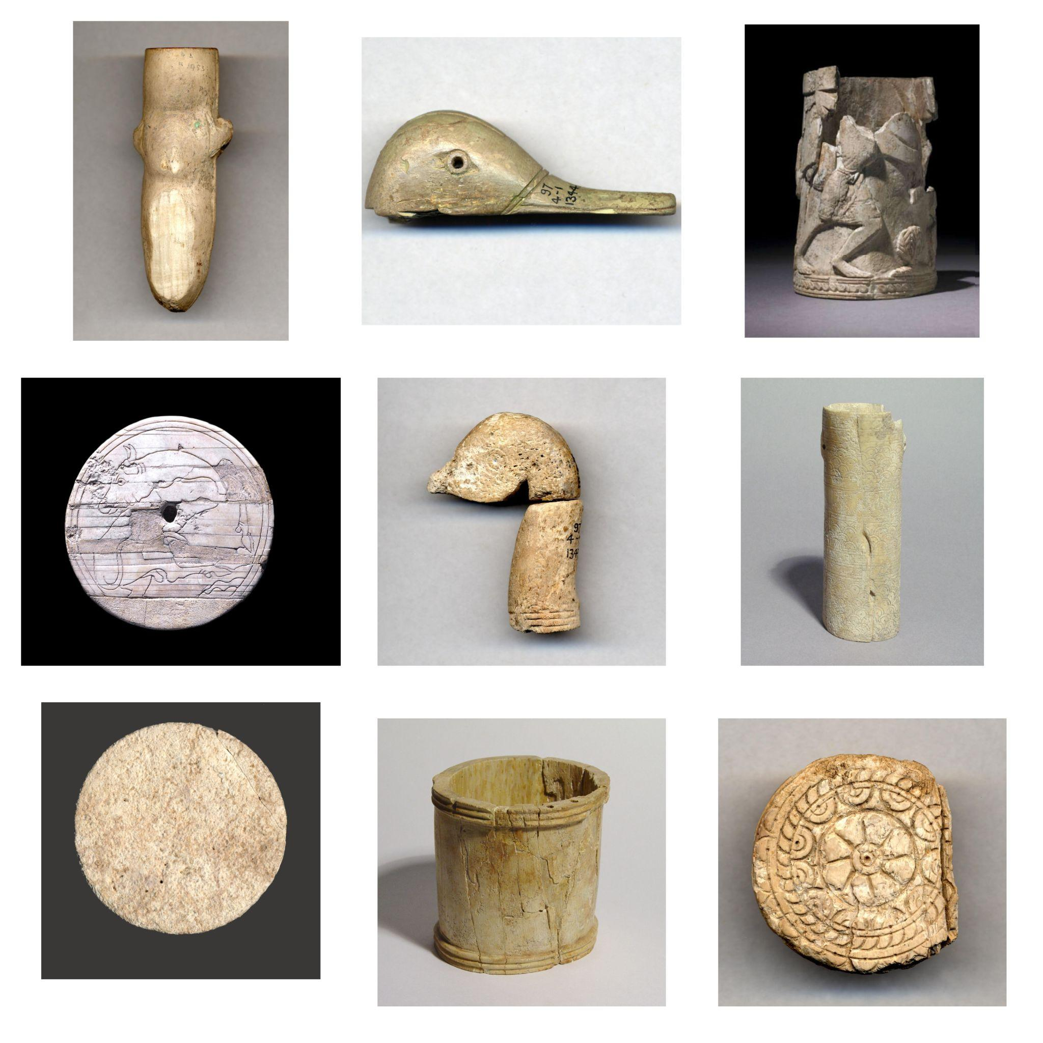
Figure one: Ivory Boxes found in Enkomi and Hala Sultan Tekke (British Museum, 2022)

Saskia Judd (1900292)

Abstract:
The aim of this report is to explore evidence of connections and culture contact in the Bronze Age Near East. The focus of this report is ivory boxes which were discovered on Cyprus in the late 1800s and early 1900s. The items raise many questions regarding, style, form and materials used as well as origins. There is much evidence for the sharing and wide ranging existence of similar iconographies throughout the region. Evidence suggests that it is not only iconography which has travelled and been assimilated across cultures but also beliefs and concepts. The ivory boxes found in the graves demonstrate the emerging narrative of a trade network of not only materials and products but of artistic styles, ideas and beliefs.

Contents:

Introduction: 3
Sites: 4
Ivory Provenance: 5
Enkomi: 6
Hala Sultan Tekke: 9
Conclusion: 10
Bibliography: 11
Image Bibliography: 12
Appendix: 13

Introduction:
Many sites in the Near East have been excavated over the past century. Some of the most material rich excavations have been in Cyprus. This report focuses on two sites from Cyprus, Enkomi and Hala Sultan Tekke, in regard to the finds of ivory boxes and a bone box which are now housed in the British Museum. These boxes have a range of forms and vary in size and quality. There were many more discovered at Enkomi with only two of the boxes in this report being discovered in Hala Sultan Tekke. These items show culture contact throughout the Bronze Age Near East through materials and the assimilation of ideology. These archaeological finds can be used to partially decipher and explore the interconnected world of the ancient Near East.

One of the key contentions surrounding this report is why were there ivory workshops in Cyprus if there were no hippopotami or elephants? (Lafrenz, 2004). Ivory appears to be used primarily in the manufacture of luxury objects. The presence of workshops suggests a well-established market for such luxury items, that requires materials to be sourced from distant continents. Boxes could conceivably have been made from local materials, such as wood or ceramics, however ivory was chosen, why? What was it about ivory that made it the preferred material for this form of Bronze Age production? The fact that ivory workshops were present on Cyprus does lend itself to the idea of an interconnected world where raw products were shipped in to be made into objects before being traded or gifted.

Sites:
Enkomi and Hala Sultan Tekke are both sites in Cyprus in which archaeological excavation has taken place. The geographical location of both sites can be seen in figure two Both sites are coastal which offers opportunities for greater trade and item variety as these coastal regions have the better connections to the rest of the Near East. Hala Sultan Tekke was at the height of its golden age from about 1650 BC and 1150 BC (Wild, et.al., 2019). As for Enkomi, it was flourishing during the 17th to 15th centuries BC, which is a bit earlier than Hala Sultan Tekke and the items seen in this report (New Cyprus Guide, 2021). During the British and Swedish excavations in and prior to the 1920s the site was discovered to hold 120 graves of the wealthy (Schaeffer, 1949). With this wealth came much material goods and evidence.

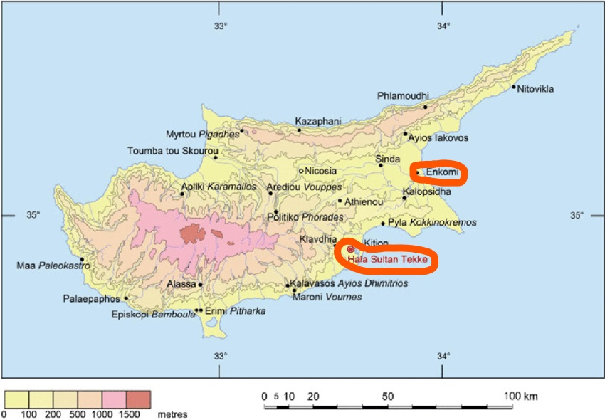
Figure Two: Map of Cyprus with key sites listed (Wild, 2019)

Ivory Provenance:
Ivory was an imported material to Bronze Age Cyprus. The boxes which are examined in this report were all carved from Ivory. Only one example is explicitly listed as Hippopotamus ivory and the rest are not specified. Before people colonised the island there was the presence of Pygmy hippopotami, but these died out, because of interactions with the human populous. Due to the lack of ivory baring animals in Cyprus, the ivory was most likely imported from Syro - Palestine or Egypt (Lafrenz, 2004). The origins of the specific boxes are not located. This is likely due to the difficulty of pinpointing the location. Tests such as Strontium Isotope analysis could be conducted on the items but as can be seen in Lafrenz’s 2004 book Tracing the Source of the Elephant and Hippopotamus Ivory from the 14th Century B.C. Uluburun Shipwreck: The Archaeological, Historical, and Isotopic Evidence This form of test does not always garner results. Granted, the book was written in 2004 but the test is still problematic and may not be as helpful as desired. Due to the advances in archaeological science, in particular strontium isotope analysis more may be able to be found out about the origins of the materials. If such information could be worked out it could give a more accurate depiction of the links that Cyprus and Cypriot crafts people had with the rest of the globe and Near East. What is useful about the ivory boxes is that, as stated above, there were probably few places which could have traded such goods so even without the scientific analysis a general idea of movement and contact is visible.

Identifying locations can also be problematic as not as much is known about the trade of hippopotamus ivory, compared to that of elephants (Lefranz, 2004). As stated above the hippopotamus ivory is most likely from Syro - Palestine or Egypt due to hippopotamus depictions and the landscape and ecology at the time (Lefrenz, 2004). Even though more is known about the trade of elephant ivory in the near east in the Bronze Age the origins are still blurry due to Egypt sometimes sourcing elephant ivory from further south in Africa so it cannot always be known if it is from Egypt or whether Egypt is an intermediary in the trade (Lefrenz, 2004).

Enkomi:
One of the more common yet unusual forms of box from Enkomi on the British Museum website are those in the form of a duck. Throughout the Bronze Age Near East and Aegean ducks appear in a widespread area and have many meanings. The imagery itself probably came from the domesticated and wild ducks which migrated yearly. Mallards were abundant in Cyprus especially as winter visitors. There were two other species of ducks which were seen, the tufted duck and the White-headed duck but these were a lot less common and again were only migrationary winter visitors. The importance of ducks, especially in Cyprus, is suggested through the incorporation of duck imagery and products such as eggs into many social practices of life and death. Duck related items such as eggs have been found in tombs alongside duck shaped boxes and other duck shaped items such as jugs.

Duck iconography is not restricted to Cyprus but rather there is an assimilation of knowledge and ideas in Cyprus that is also evident in the wider Near East and Aegean. In Egypt the duck is thought to be an ‘enemy of the dead’ (Dissinger, 2017) and was also said to be a metaphor for the journey to the afterlife (Dissinger, 2017). This idea may have come from the migratory patterns of such birds. Ducks migrated to the Nile twice a year and this may have created an association with life after death to the people of ancient Egypt (Dissinger, 2017). Ducks are mentioned in the book of the dead. As part of burial rites, the serving family would offer roast duck and worship Ra, this spell is supposed to help the dead triumph over their enemies (Ancient Egypt Online, 2022). The spell, therefore, showcases another meaning for ducks and partially explains why they are seen as enemies of the dead even in life. Finally, ducks were a symbol of fertility, as suggested by Dissinger, 2017. This could link to the connotations of the Nile since the Nile is a source of nutrients for the country so ducks being part of that landscape could assimilate some of that meaning.

In Greece the iconography was also clear. Some of the best examples of ducks were found in Greece with sauce boats designed as ducks looking over their backs (Binnberg, 2019). Furthermore, the duck form gives libation vessels a greater link to the liquids contained as ducks had an active role in distribution due to the links that ducks have to water (Binnberg, 2019). Binnberg, 2019, explains this by stating that ‘if the spout is in the tail or the beak of the bird, it directly mediates the flow of liquid’ (Binnberg, 2019). In other words, the action of passing through the beak reinforces the connection between the duck and the liquid, with the duck as a mediator. This would not be the case if the duck imagery was simply inscribed on the side of the vessel. Due to the natural appearance of the vessels the boundaries were dissolved between the real and the manmade. Even after the collapse of palaces the iconographical importance of the duck did not wane because of a very strong belief system and the duck's intrinsic link to water and the supply of water (Binnberg, 2019). Duck iconography is evident.

Imagery in Crete and the Cyclades was very similar with askos in the shape of the duck as well as the duck’s more common representation on wall paintings. This can clearly be seen in Akrotiri. In Xeste the Potnia’s necklace has ducks as beads in the painting as well as ducks seen throughout the frieze (Vlachopoulos, 2008). ‘Potnia’ was the word for ‘mistress’ or ‘lady’ as well as a title of a goddess (Greek Boston, 1998). The connotations of the Potnia, as a young woman, could include fertility which links to the idea that ducks are a symbol of fertility throughout the ancient Near East. The mutually connected ideas about fertility assimilate through each other. Vlachopoulos, 2008 offers the idea that ducks were a symbol of fertility in the Cyclades. This again shows the transmission of ideas as Egypt also had similar meanings for ducks. If the idea was not fully drawn from Egyptian Culture there may be a different reason as to why the duck symbolises fertility in Crete and the Cyclades in the absence of the Nile. Rather the idea more likely has some influence again from the migrationary patterns of birds. The Cyclades also had ideological associations about ducks similar to those found in other parts of Greece (Binnberg, 2019).

In the Aegean the ducks represented much the same as Egypt, with ideas of fertility being thought to be one of the main symbolisms (Yasur- Landur, 2010). A further idea brought forward by Yasur - Landur is that the Aegean used duck bowed ships which have been interpreted as European symbols of travel in the Near East in the Bronze Age.

The multiple, often overlapping, ideas about ducks and duck iconography in the Bronze Age Near East show the interconnectedness of the past. Ideas were assimilated and the esoteric knowledge learnt from travellers could have played a role in the shared imagery. Helms, 1988, says ‘Knowledge of geographically distant phenomena, whether acquired directly or indirectly, may be expected to form part of the corpus of esoteric knowledge’ (Helms, 1988, pp.5). Travel and trade are the means by which these ideas are shared.

Even within Cyprus duck iconography has differentiation. Half of the finds are the bottom halves of duck boxes; the ducks which do depict the head have some differences. The more common one is a simple duck's head but there is also item 1897,0401.1345 which has a protruding neck and is formed differently. This duck is more stylized than the other examples which are more naturalistic. The beak is also much shorter, but this may be due to damage after the initial creation. Furthermore, the head is much more curved in this example than the others, which may infer that it was styled on a different species of duck, or it is not actually a duck at all, but rather perhaps a goose or a swan as speculated by Dissinger, 2017.

There are also varying qualities of duck carving. The current state of the finds reflects a mixture of varied craftsmanship, different burial environments and most likely inconsistent quality of ivory. The best example (Item 1897,0401.1344) looks as if it has been made with much more skill than some of the other examples and has survived much better. Item 1897,0401.1350 Is considerably more broken down and fragmented to the point where it is only inferred that it is a duck. The form of such damaged items is more ambiguous so the evidence of the more eroded examples must be questioned.
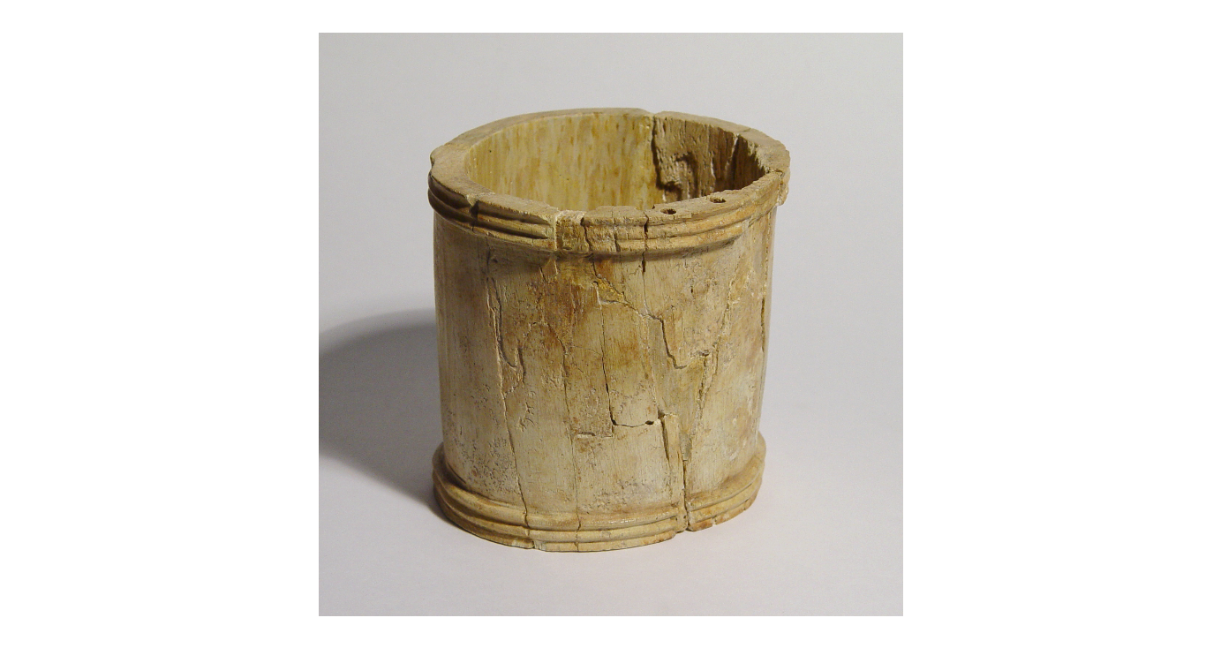
Figure Three: Item 1897,0401.1445 (British Museum, 2022)
Besides the duck boxes there are several ivory boxes from Enkomi which are much plainer. One such item is a very simple cylindrical box (See figure three). This item appears to be much simpler than the other items and may have had less prestige than some of the other designs. With the plain banding around the outside framing the main box there seems to have been less craftsmanship going into the item. Due to the less attractive nature, It is likely that this box would have been less prized than a duck box and could have also been more of a commodity rather than a delicate box with transmitted symbolism. Another explanation for this box is that the size and quantity may be what is prized about this piece. This box is the largest find, especially in diameter, as the second largest diameter is around 6cm compared to the 10cm of this find (British Museum, 2022). This cannot be taken for face value, however, as the duck boxes are missing most of their sections so they may have included more ivory in life.

There are also other ivory boxes which were found in Enkomi. The circular box lid is reminiscent of the Hala Sultan Tekke box base and has the same form as they are both circular disks. This example is decorated with a floral design which can be seen on a couple of the examples. Flower patterns or ‘rosettes’ is another form of imagery which is present around the Near east. Flowers are also natural flora which indicates the importance of nature.

The most unusual example of a box is one of the simplest. Item 1897,0401.1362 is not made from ivory but rather bovine bone. This is the only item that is an anomaly from the trend. There was a bovine presence in Cyprus but whether the bone was from a Cypriot bovine may likely stay unsolved. If the bone was Cypriot, then this would be the one item out of the many boxes found in the two tombs which may say nothing about international links. It may have been sourced, made, and buried in Cyprus. The one thing which does hint at external influence is the pattern. Even with a simpler carved pattern of semicircles and lines there could be a hint of minoanisation due to their use of ‘swirls’ in their work (Mallin, 1996). On the other hand, this design is very natural and may just be a specific design choice of a creator. One thought which is not easy to prove is where did the idea of the box come from in the first place? If it was not from Cyprus but rather learnt from somewhere else, then the very idea of a box is the sharing of knowledge and international style.

For some of the boxes from Enkomi there seems to be a question about where the items were made. Item 1897,0401.853 is thought to have been made in Cyprus, but the provenance is questioned. There is a chance that the item was made on Cyprus because of the presence of Ivory workshops in the Bronze Age but if this item was to have been made elsewhere then it could be an example of International style which has been postulated as common throughout the Near East during this period (Rehak and Younger,1997). International style comes from the sustained interaction of different cultures (Steel, 2013). The sustained interaction can blur the origins of items, which may be sourced from a mixture of different nations' ideas but also can be assimilated into another's culture so the origins may be difficult to pinpoint.

Hala Sultan Tekke:
In comparison to the quantity of boxes found in Enkomi there are only a small number of ivory boxes from Hala Sultan Tekke. The lesser quantity of ivory boxes at Hala Sultan Tekke could show that these graves were poorer. There are two examples of such ivory artefacts. The first is detailed with a carving of a bull with concentric circles framing the edge of the box. The second example is much simpler and is plain with no details and is suggested as being a box base. As with the duck iconography (see appendix) , the bull representation on the box is likely to have some meaning.

Bulls were quite common in the Bronze Age Near East. In many wall paintings across the Near east and Aegean bulls can be seen. As McInerney, 2011, states ‘the bull is everywhere’ (McInerney, 2011). This was in relation to Crete and sums up the importance of such iconography. Much like the ducks the imagery gives the items a clear link to a wider network of ideas. Bull iconography was also oftentimes seen in temples and palaces offering the connotations of power, wealth, and importance. The presence of bull iconography at Hala Sultan Tekke could have been in relation to the deceased, or the deceased’s family, as a way of showing their status. Yerner, 2009, also comments on the frequency of bull iconography in the Minoan world stating that many Minoan Kraters which have been found in the past two decades have had further imagery of leaping bulls.

Having such evidence from the tombs shows the links to other cultures at the time. There is an idea of a ‘cult of cattle’ which emerged and was present in the Bronze Age throughout Europe and Asia. Recht, 2021, states that cattle were not successfully bred on Cyprus till the beginning of the Bronze age at which point they become key parts of life as can be seen in other parts of the Near East through the sculptural evidence of bulls (Recht, 2021).

As for the other example of a box from Hala Sultan Tekke, item 1898,1201.271, there is much less information that archaeologists can use. Due to it being relatively plain and unsure even of its use. The only evidence which can infer culture contact is the material which raises a number of important questions, from where did the ivory originate? Was it imported as a ready-made object? or was it fashioned in a workshop in Cyprus?

Duck boxes and other ivory boxes are most likely prized in Cyprus to the point where they are placed in tombs because they were traded with the Egyptian elites and pharaohs (Dissinger, 2017). Their association with royalty and the elites of a far-off exotic nation is likely to have enhanced their value to the people of Cyprus. The enhanced status could also come from the fact that ivory was pale and ‘exotic’ which were also highly prized features of material in the ancient Near East.

Conclusion:
Many aspects of the items (See Appendix) can be used to develop a narrative of culture contact in the Bronze Age Near East. Connections become clear through the consideration of the materials and iconography presented. Excavations at Enkomi and Hala Sultan Tekke have revealed imported ivory in Bronze Age Cyprus. A relative lack of knowledge of Hippopotamus ivory makes it difficult to identify the exact origin of the material within Syro - Palestine or Egypt. The duck iconography is common in Bronze Age Cyprus but also evident in the wider Near East, mainland Greece and Aegean, suggesting the spread and assimilation of knowledge and ideas. Duck imagery appears in several forms including duck shaped askos, wall paints, beads and sauce boats, as well as boxes. While the iconography is shared culturally there is also evidence of a sharing of ideas and symbolism associated with ducks. Ideas connecting ducks to fertility, funerary practices and water are found across the regions where ducks are represented. This suggests a sharing of knowledge, ideas, and other cultural concepts within a connected world. While duck iconography is the subject of this report, it was not the only iconography shared between the wider regions. Bull iconography, for instance, is also found. The use of ivory also highlights connections within the Bronze Age Near East and Aegean. Workshops manufacturing luxury products from an imported exotic material demonstrates that there was trade and established stable connections. The value of ivory resides in its connection to royalty and the exotic. Differences in the artefacts recovered may suggest that not all items were made in Cyprus but were traded from further afield.

Overall, the evidence of the boxes from Enkomi and Hala Sultan Tekke is illustrative of travel and trade connections across the area and including the wider Near East, Aegean, and Egypt in the Bronze Age.

Bibliography:
Ancient Egypt Online (2022) The Book of the Dead. Available at: https://www.ancient-egypt-online.com/book-of-the-dead.html (Accessed on: 2nd March 2022)
Binnberg. J. (2019) ‘LIKE A DUCK TO WATER – BIRDS AND LIQUIDS IN THE AEGEAN
BRONZE AGE ‘, The Annual of the British School at Athens, 114, pp. 41-78
British Museum (2022) Enkomi and Hala Sultan Tekke
Christofis. N. (2019) ‘World-Systems Theory’. In Romaniuk. S (ed.) The Palgrave Encyclopedia of Global Security Studies. London: Palgrave, pp. 1-6
Dissinger. A.M. (2017) Cypro-Archaic Bird Iconography: Types, Uses, and Meanings. : Virginia: University of Virginia
Gilbert. A.S (2001) The Native Fauna of the Near East. Edited by Collins. B.J., ‘A History of the Animal World in the Ancient Near East’, Koln:Brill
Greek Boston (1998) About Potnia - Early Goddess of Ancient Greece. Available at: https://www.greekboston.com/culture/mythology/potnia/ (Accessed on: 8th March 2022)
Helms, M.W. (1988) Ulysses’ sail : an ethnographic odyssey of power, knowledge, and geographical distance. Princeton: Princeton University Press.
Lafrenz. K. (2004) Tracing the Source of the Elephant and Hippopotamus Ivory from the 14th Century B.C. Uluburun Shipwreck: The Archaeological, Historical, and Isotopic Evidence. Florida: University of Florida
Mallin. S.B. (1996) ‘Swirling Beyond Our Time: Along Minoan and Nazcan Lines’ in Mallin Art Line Thought. Kluwer Academic Publishers: The Netherlands. Pp. 133-155
McInerney. J. (2011) ‘BULLS AND BULL-LEAPING IN THE MINOAN WORLD’ Penn Museum Expedition. 53(3).
New Cyprus Guide (2021) Enkommi Ruins. Available at: https://newcyprusguide.com/listings/enkomi-ruins/ (Accessed on: 2nd March 2022)
Recht. L. (2021) ‘The cult of cattle in Bronze Age Cyprus: Base Ring ‘bull’ rhyta in context’
Rehak. P and Younger (1997) ‘International Styles in Ivory Carving in the Bronze Age. In Cline. E and Harris-Cline. D. (ed.) in The Aegean and Orient in the Second Millennium. 50th anniversary Symposium: Cincinnati
Schaeffer. C.F.A. (1949) ‘Enkomi’ American Journal of Archaeology. 52(1).
Steel, L. (2013) Materiality and consumption in the Bronze Age Mediterranean. New York: Routledge
Vlachopoulos, A.G., (2008) The wall paintings from the Xeste 3 building at Akrotiri: towards an interpretation of the iconographic programme, inHorizon: a Colloquium on the Prehistory of the Cyclades. Editors N. Brodie, J. Doole, G. Gavalas & C. Renfrew. (McDonald Institute Monographs.) Cambridge:McDonald Institute for Archaeological Research, 451–65
Wild.E.M. et.al (2019) ‘14 C-Dating of the Late Bronze Age City of Hala Sultan Tekke, Cyprus: Status Report’ Arizona Board of Regent. 61(5), pp.1-12
Yasur- Landur. A. (2010) ‘On Birds and Dragons: A Note of the Sea Peoples and Mycenaean Ships’ in Cohen. Y, Gilan. A, Singer. I, Miller, J.L. (eds) Pax Hethitica: Studies on the Hittites and Their Neighbours in Honour of Itamar Singer. Germany: Hubert & Co.

Image Bibliography:
British Museum (2022) Enkomi and Hala Sultan Tekke
Wild.E.M. et.al (2019) ‘14 C-Dating of the Late Bronze Age City of Hala Sultan Tekke, Cyprus: Status Report’ Arizona Board of Regent. 61(5), pp.1-12

Appendix:
Items: Table showing ivory and bone boxes excavated in Enkomi and Hala Sultan Tekke.
The table below shows items selected from Enkomi and Hala Sultan Tekke, all of which were discovered as grave goods. The items are all boxes made of ivory, with one exception. There is a range of designs but a recurring imagery of ducks. This collection of items is the focus of this report.
Museum Number | Picture | Manufacture Location | Period | Material | Link:
1897,0401.853 | 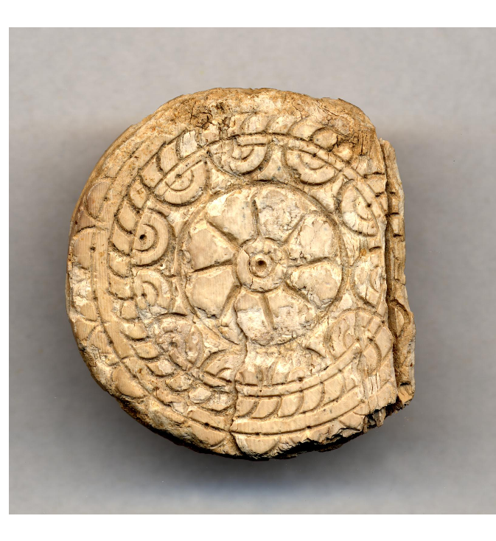 | Cyprus? | Late Cypriot IIC (?)  Late Cypriot III (?)  1340 BC-1050 BC | Ivory | https://www.britishmuseum.org/collection/object/G_1897-0401-853
1897,0401.1345 | 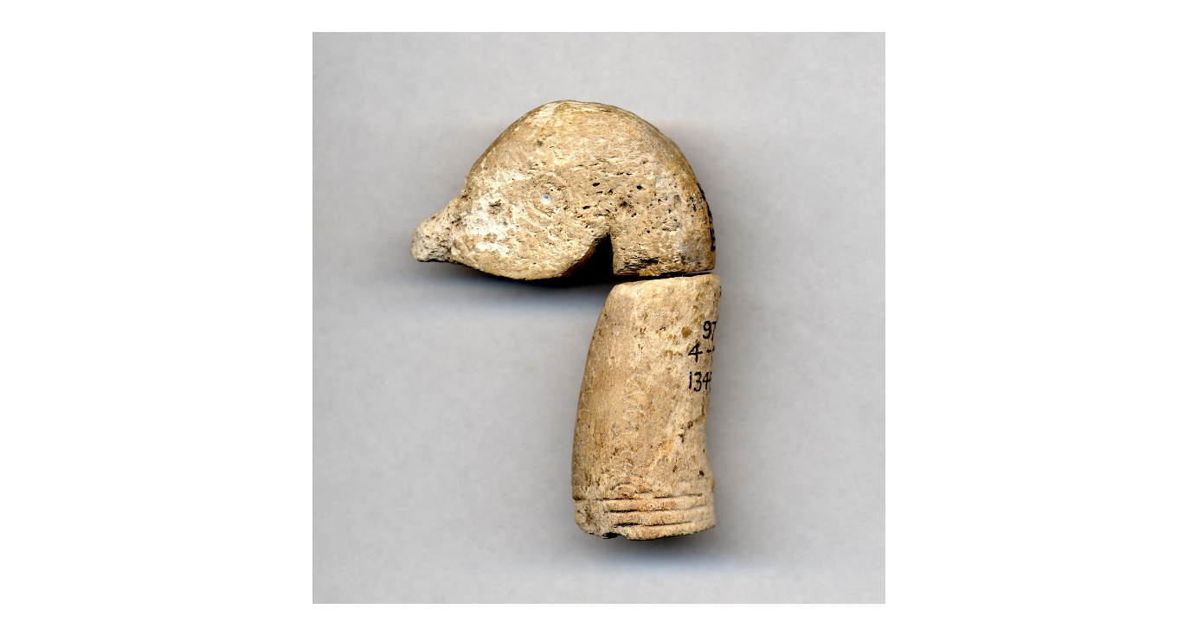 |  | LBA  1400 BC-1050 BC | Ivory/ Bone? | https://www.britishmuseum.org/collection/object/G_1897-0401-1345
1897,0401.1362 | 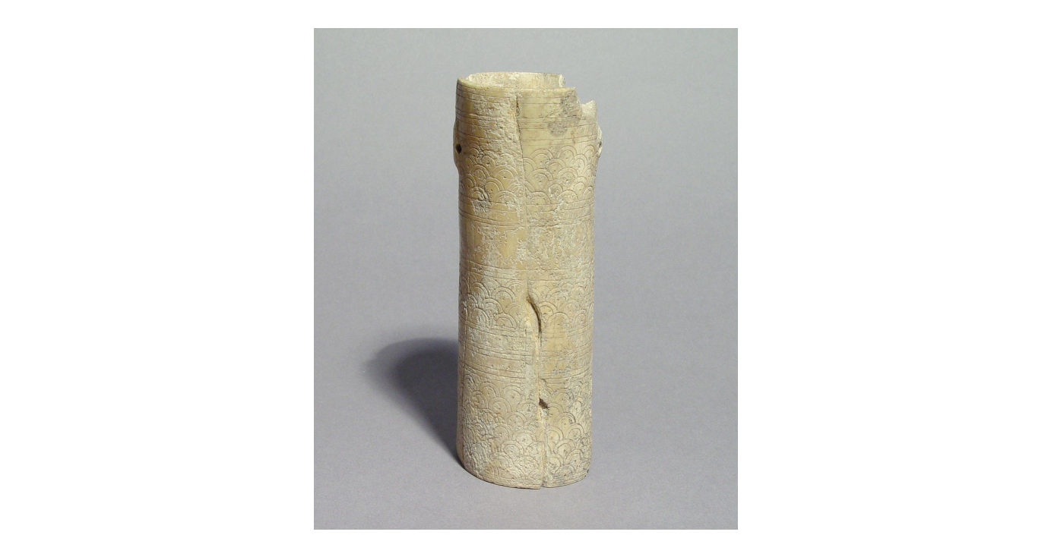 | Cyprus | Late Cypriot IIC (?)  Late Cypriot III (?)  1340 BC-1050 BC | Bone (Bovine) | https://www.britishmuseum.org/collection/object/G_1897-0401-1362
1897,0401.1453 | 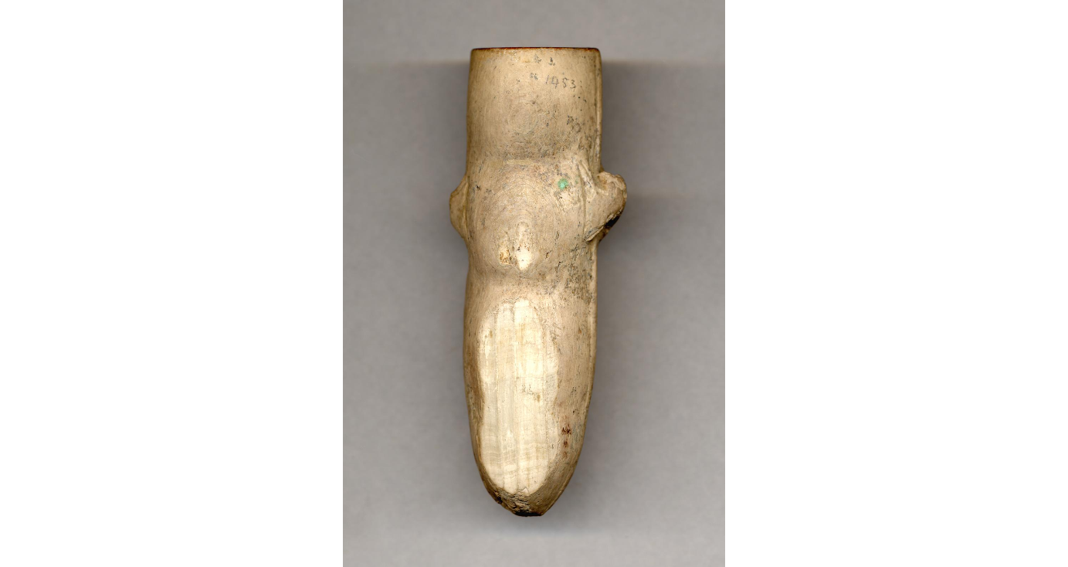 | Cyprus | Late Cypriot IIC (?)  Late Cypriot III (?)  1340 BC-1050 BC | Ivory | https://www.britishmuseum.org/collection/object/G_1897-0401-1453
1897,0401.882 | 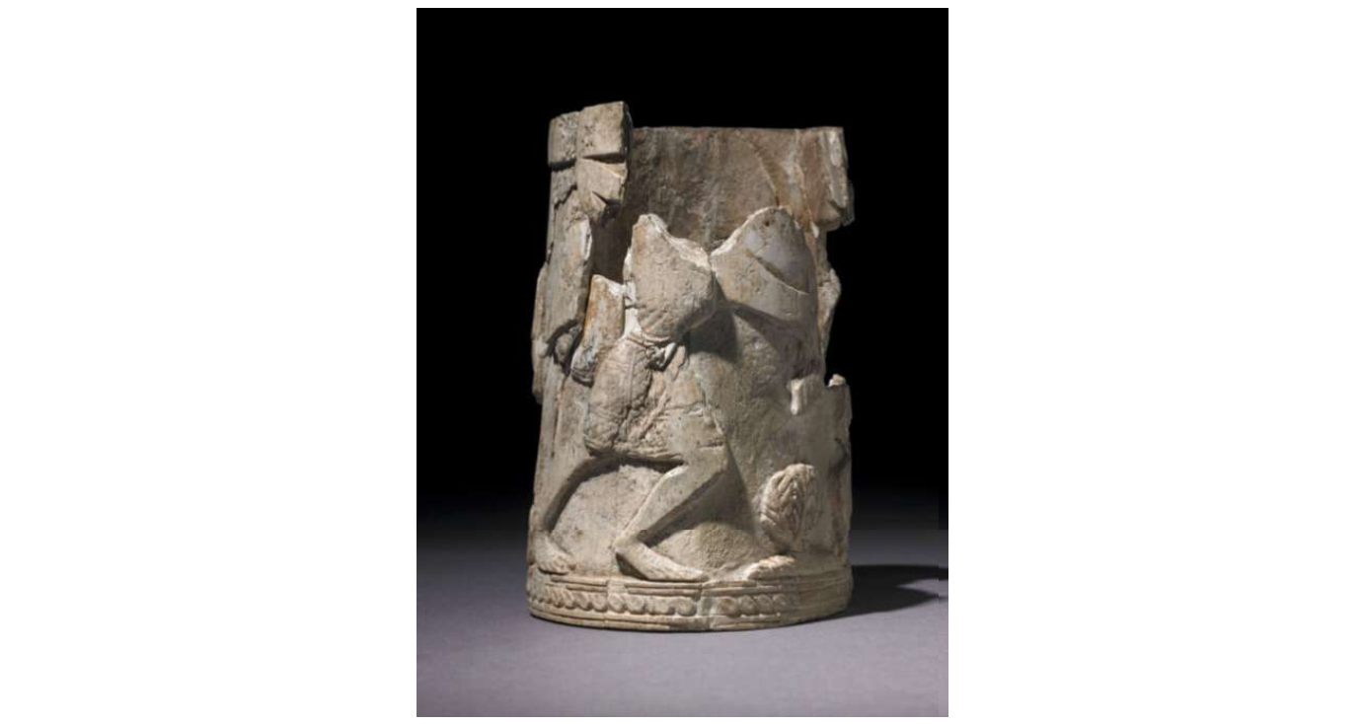 | Cyprus | Late Cypriot IIC (? Late)  Late Cypriot III (?)  1340 BC-1050 BC | Ivory | https://www.britishmuseum.org/collection/object/G_1897-0401-882
1897,0401.1445 |  | Cyprus | Late Cypriot IIC (?)  Late Cypriot III (?)  1350 BC-1050 BC | Ivory | https://www.britishmuseum.org/collection/object/G_1897-0401-1445
1897,0401.1380 | 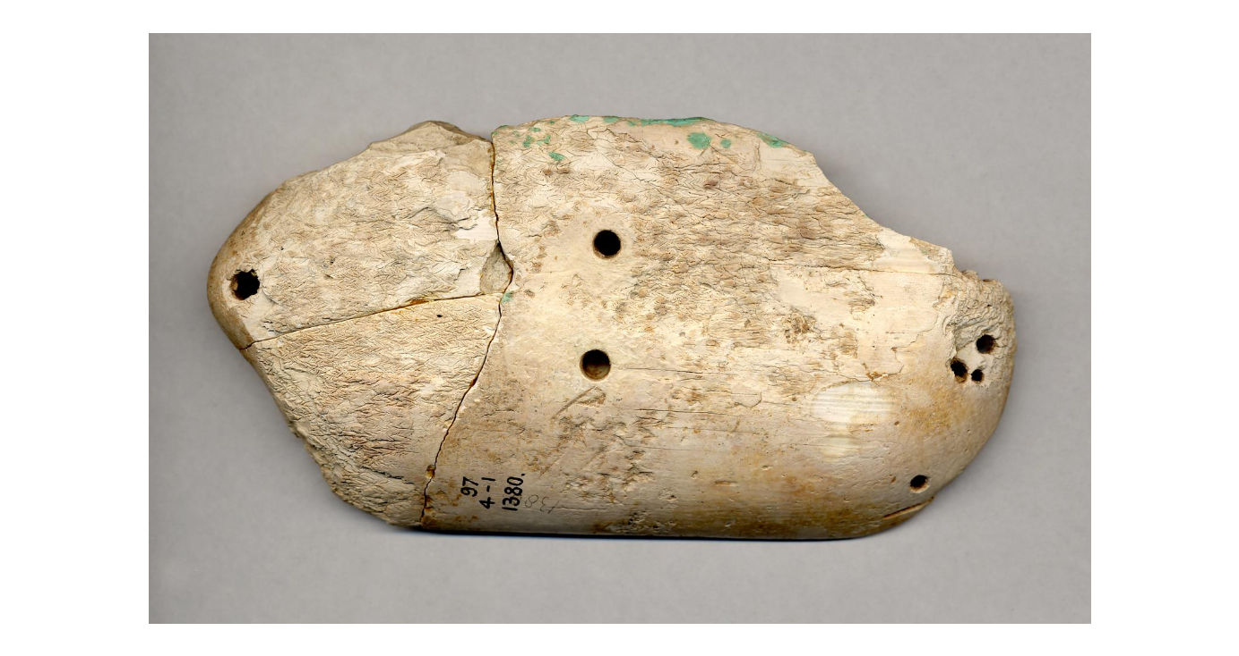 | Cyprus | LBA  1400 BC-1050 BC | Ivory | https://www.britishmuseum.org/collection/object/G_1897-0401-1380
1897,0401.1353 | 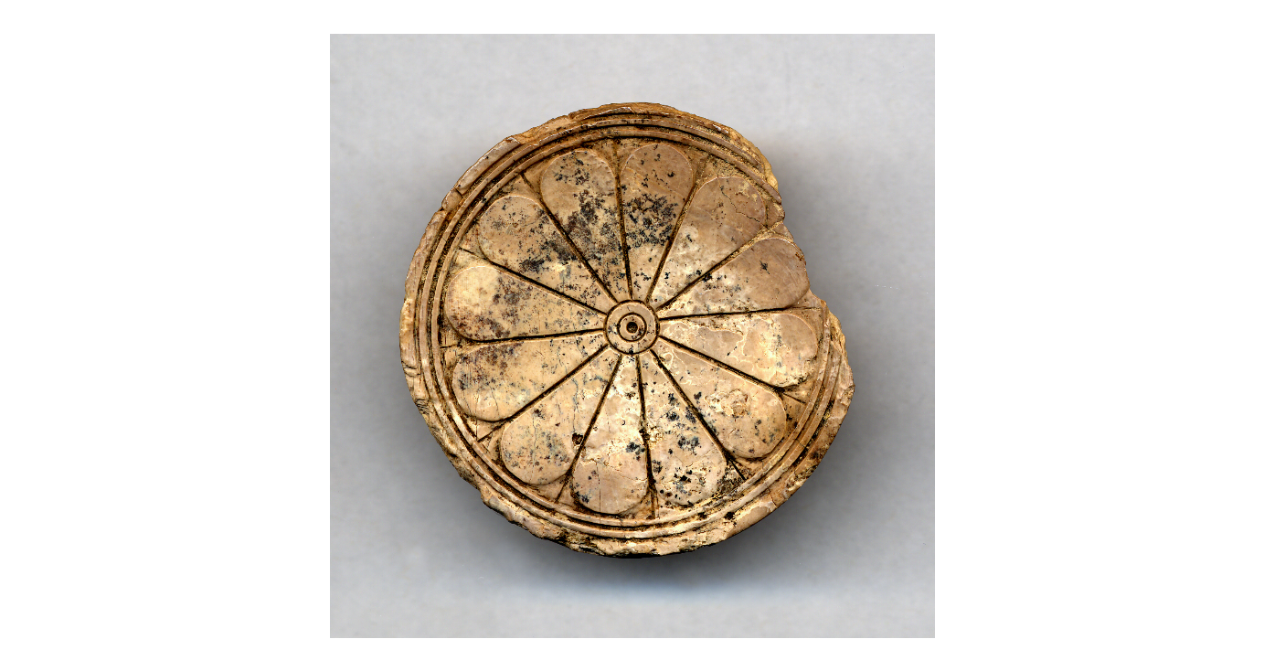 | Cyprus | Late Cypriot IIC (?)  Late Cypriot III (?)  1340 BC-1050 BC | Ivory | https://www.britishmuseum.org/collection/object/G_1897-0401-1353
1897,0401.884 | 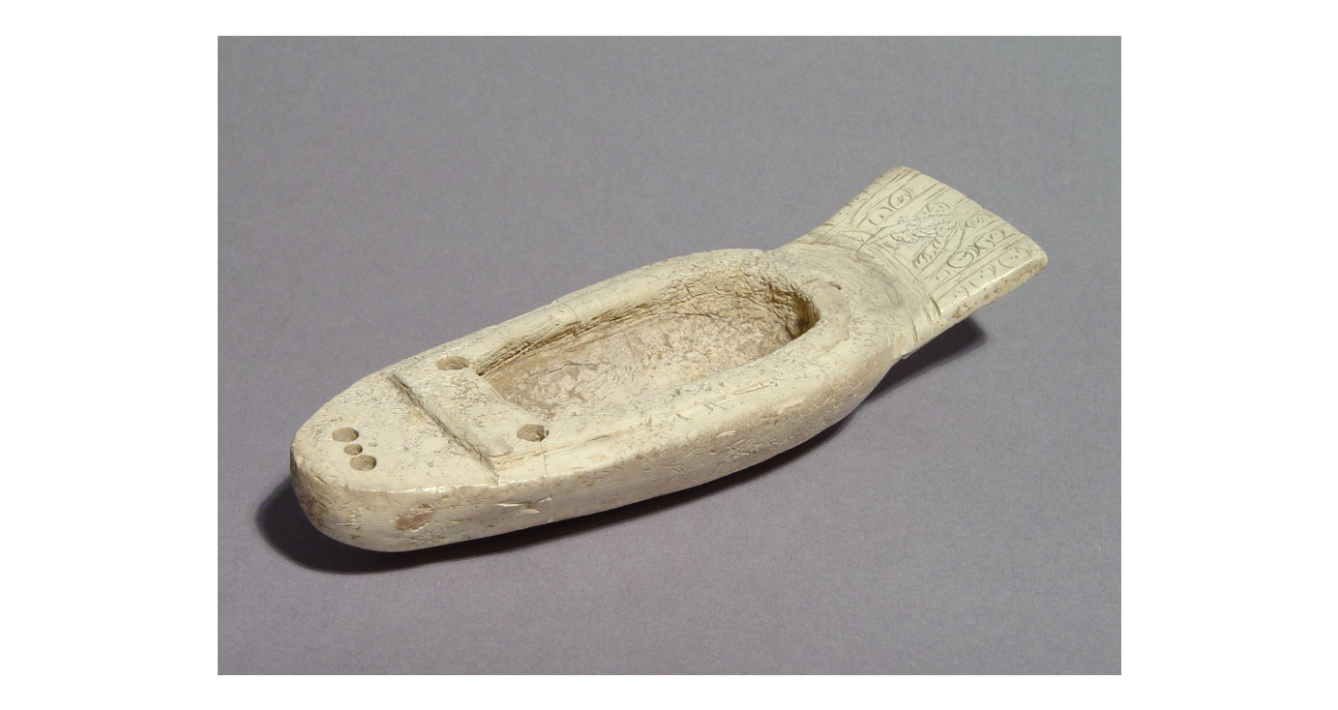 |  | LBA  1400 BC-1050 BC | Ivory | https://www.britishmuseum.org/collection/object/G_1897-0401-884
1897,0401.1350 | 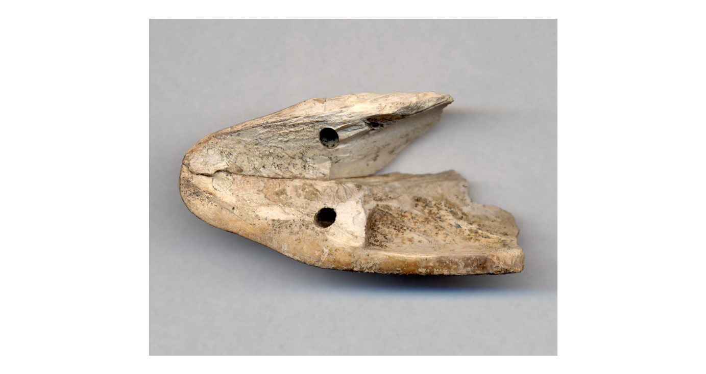 |  | LBA  1400 BC-1050 BC | Ivory | https://www.britishmuseum.org/collection/object/G_1897-0401-1350
1897,0401.1379 | 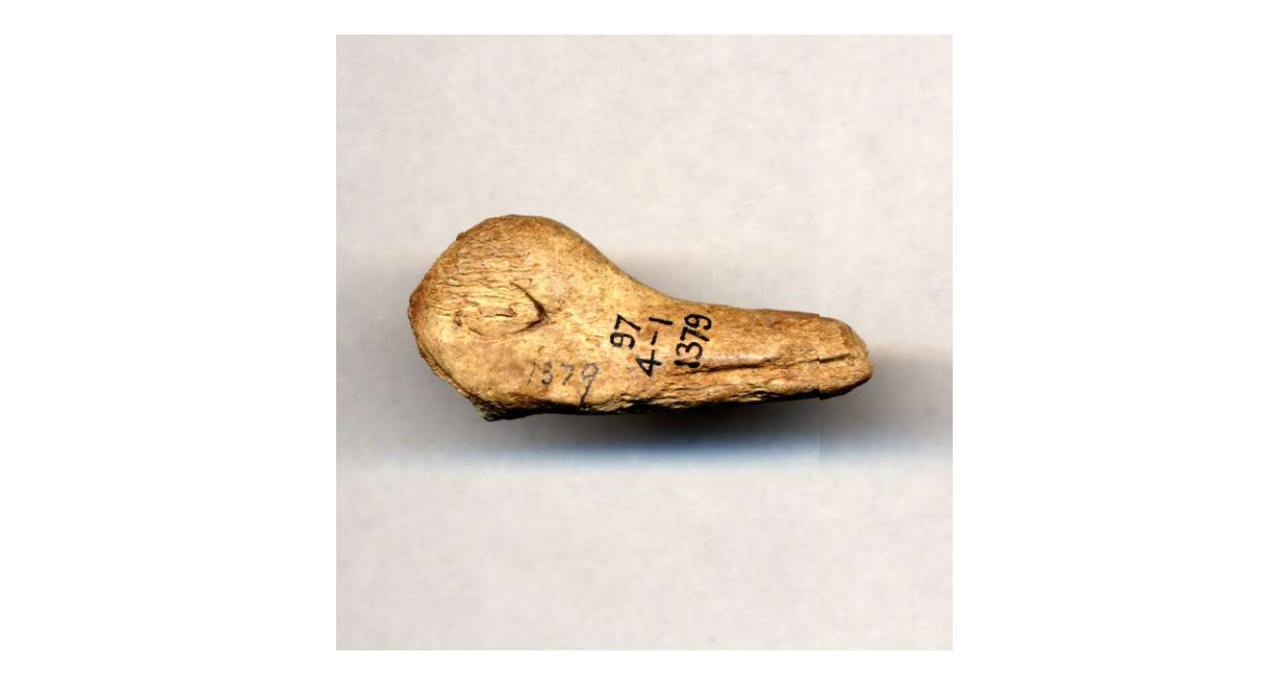 |  | LBA  1400 BC-1050 BC | Ivory | https://www.britishmuseum.org/collection/object/G_1897-0401-1379
1897,0401.1344 | 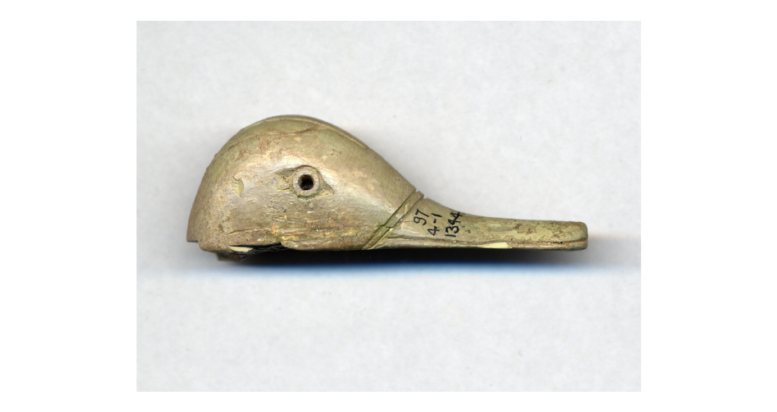 |  | LBA  1400 BC-1050 BC | Hippopotamus Ivory | https://www.britishmuseum.org/collection/object/G_1897-0401-1344
1897,0401.884 |  |  | LBA  1400 BC-1050 BC | Ivory | https://www.britishmuseum.org/collection/object/G_1897-0401-884
1897,0401.851 | 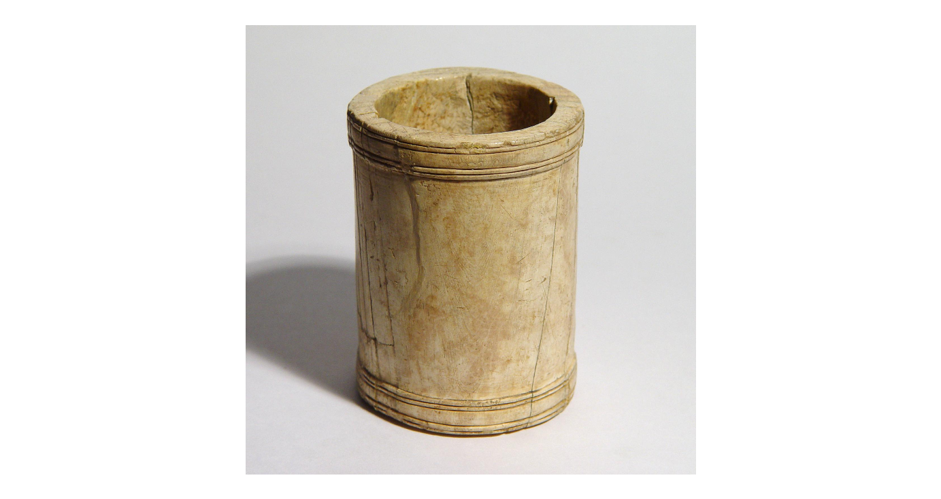 | Cyprus | Late Cypriot IIC (?)  Late Cypriot III (?)  1350 BC-1050 BC | Ivory | https://www.britishmuseum.org/collection/object/G_1897-0401-851
Hala Sultan Tekke
1898,1201.271 | 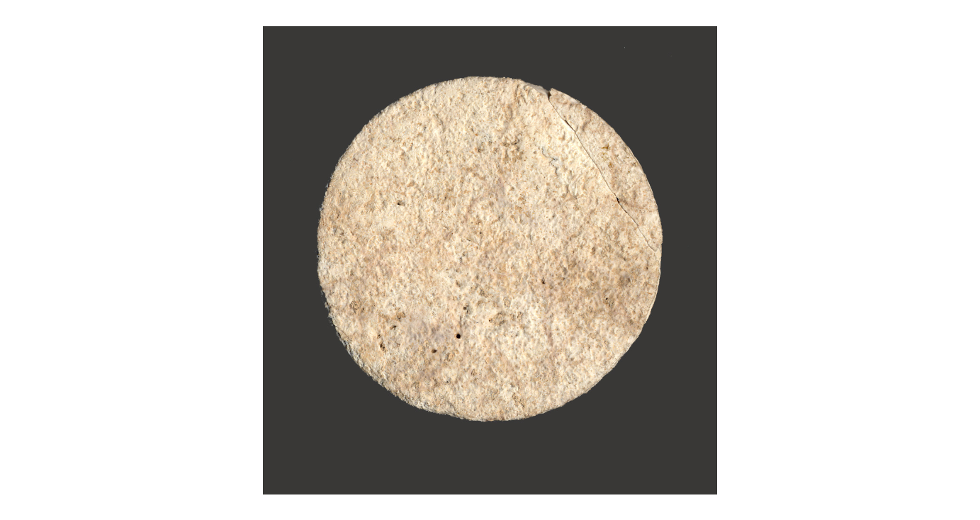 | Cyprus | Late Cypriot II (?)  Late Cypriot III  1450 BC-1050 BC  50BC-300 | Ivory | https://www.britishmuseum.org/collection/object/G_1898-1201-271
1898,1201.203 | 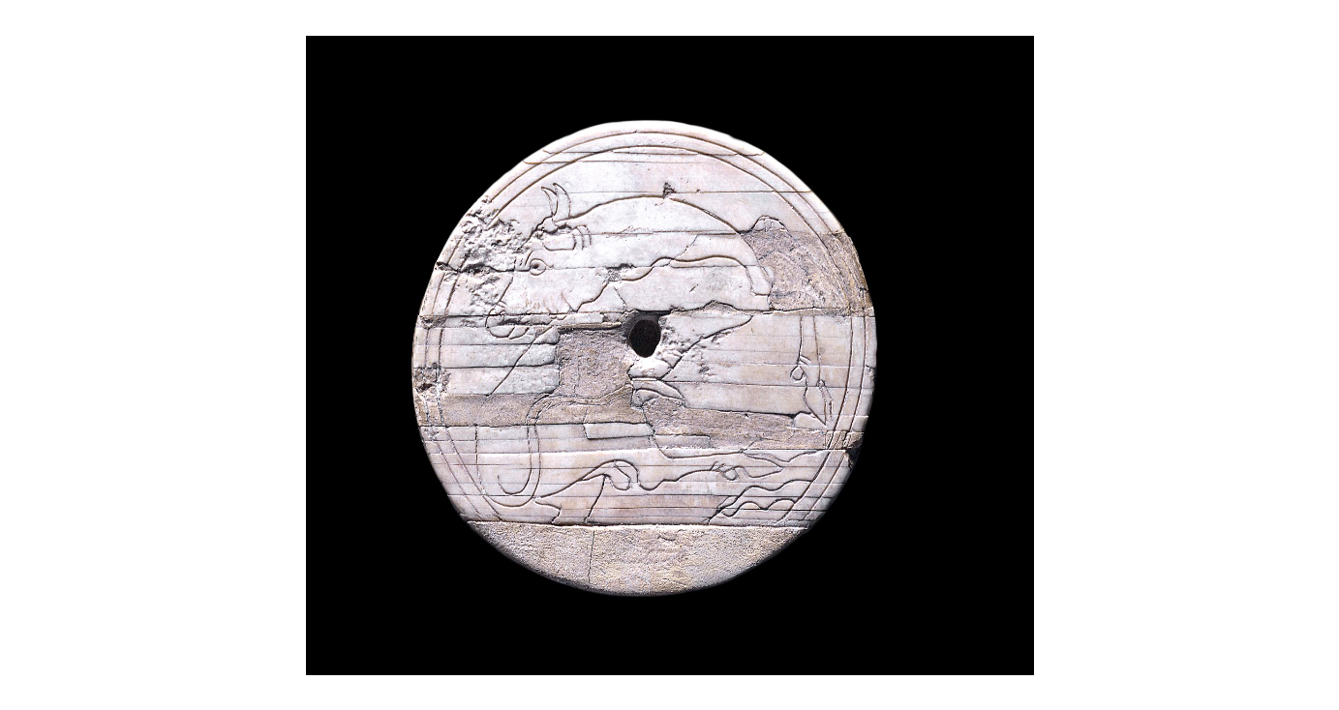 | Cyprus | Late Cypriot IIC (?)  Late Cypriot IIIA (?)  1340 BC-1100 BC (circa) | Ivory | https://www.britishmuseum.org/collection/object/G_1898-1201-203

