University of Wales Trinity St David

DR Engineering
ACMA5007 – L5 - Management Innovation and Sustainability

BEng Energy & Environment Engineering
Andrew Thorn

By Antony Wingate (1904205)

Executive summary

This report examines the various issues of relocating an expanding engineering business, DR Engineering. First, a SWOT analysis was used to determine the current status of DR Engineering and what its strengths, weaknesses, opportunities, and threats were. The SWOT analysis identified factors that the business should consider when looking for a suitable new location. These Include the location, environmental and pollution issues, legal considerations, and transport amongst others.
Suggestions were made as to what steps the business could take to keep the business running as usual during the move, minimising losses and impact on customers.

Table of Contents
Executive summary 2
2. Table of Contents 3
3. Table of Figures 3
Introduction 4
Questions 1 - SWOT analysis 5
Question 2 – Considerations 6
Question 3 – moving steps 9
Recommendations 10
Conclusion 11
Bibliography 12

Table of Figures

Figure 1 DR Engineering SWOT analysis 4

Introduction

It is a common theme for successful businesses to expand and, when this happens, there is a need to potentially relocate to different premises.
The timing of the relocation of a business is of critical importance. It can enable a business to take advantage of opportunities, which in turn will allow it to grow substantially, if done correctly. Various factors must be considered in relation to the businesses needs when relocating, including the company’s market, transportation methods, supply chain and available work force. Mistakes and errors can be costly, leading to loss of customers, higher expenditure, loss of trusted workforce and increased debt. In a worst-case scenario, it could have the opposite effect on the business, reducing the business’s success.
This assignment will examine DR Engineering, one company that has found the need to relocate, after outgrowing its current premises.
In order to do this, a SWOT analysis, a common tool used in business, will be used to determine the strengths, weaknesses, opportunities, and threats that will affect DR Engineering. This will help identify the various factors considered when relocating, including the ethical, environmental, and legal. Once these factors have been identified and considered, the appropriate steps the company needs to take in order relocate successfully can be implemented. This will ensure minimal disruption to the operation of the business.

Questions 1 - SWOT analysis

A SWOT analysis was used to identify the Strengths, Weaknesses, Opportunities, and Threats relating to DR Engineering. This technique is easy to understand by users and provides a good structure for sorting ideas for future development, and how to take advantage of them (Piercy and Giles, 1989).

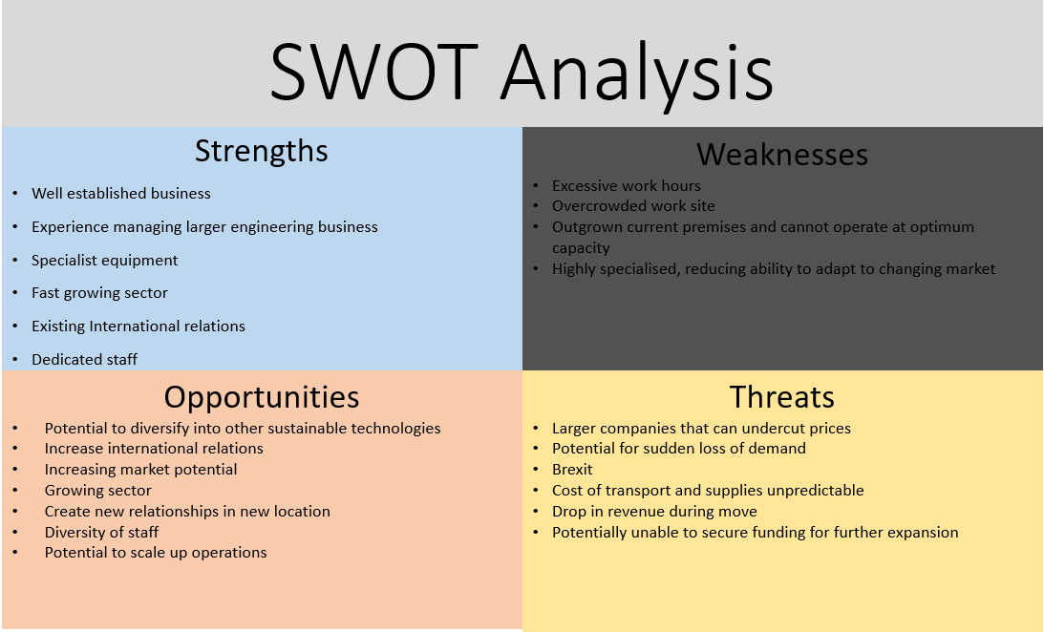
Figure 1 DR Engineering SWOT analysis

Question 2 – Considerations

Following the results of the SWOT analysis, the following issues were identified and discussed.
Give notice to staff – All staff must be given sufficient notice of the relocation. A possibility exists that not all staff will choose to relocate. Giving sufficient notice, will allow the company to be aware of how many staff members, if any, they will lose by relocating. If there is a significant loss of employees, it could leave the company short staffed, with the result that the company will not be able to function at optimum capacity, leading to loss of revenue. Even a small number of key employees leaving could jeopardise the company. Legally, companies must offer members of staff redundancy if employees do not wish to remain with the company. For a company of this size, which would have not more than 20-99 redundancies, the company must give 30 days' notice before the first redundancy (Best, 2015).
Personal preference – When considering a new location, personal preference from members of staff and directors should not be taken into account. It could be easy for a senior member of staff to attempt to influence a decision regarding the location in order to benefit themselves. For example, If the company were established closer to their home, a shorter commute would be of benefit. Another possible scenario would be purchasing a building off a friend to do them a favour (Weber, 1990).
Future growth - Depending on the company's budget and future growth predictions, it must be decided whether the new site will be leased or bought. Leased premises could offer the advantage of a potential relocation to even larger premises in the future relatively easily. However, this solution may prove to be more expensive in the long term. If the company decides to purchase a new premises, it should be considered whether a greenfield, brownfield, or already developed site is acquired. Being able to develop the site to the company’s specific needs would be a bonus, but it would be more expensive as well as taking longer to be fully functioning (Pynford, 2018).
Environmental - The foundations of the new site would need to be able to support substantial weight in terms of machinery and materials. If the terrain were soft or prone to subsidence, it would pose substantial difficulties, which would be costly to rectify (Weber, 1990). A check should also be carried out to determine if the site is located in an area that is prone to flooding, as this would necessitate investment in flood protection. Given the potential of rising sea levels due to climate change (currently sea levels are rising by 3cm per decade), a low-lying site should be avoided (Ortega and Taṣpınar, 2018). Checks should be carried out to ensure the site has not previously been polluted. Issues such as the ones mentioned above may result in the company experiencing difficulties in obtaining suitable insurance cover or may result in high premium costs.

Infrastructure – The infrastructure must be able to support the increased size of the business, there must be adequate water supply, sewage service, electric supply, and internet line.
Security - The site should ideally be in a location with low crime rates, and have the space to install security measures such as security fencing, CCTV
Ease of access - Disability access should be considered, which would require ramps for entering and exiting the premises, and disabled parking spaces
Location/accessibility – When choosing a new location, it should be considered where the supplies are sourced, and where customers are located. Relocating too far from the material suppliers will increase transport costs, or if the distance is too great, new suppliers may have to be found. These may be more expensive or unreliable. The long term location of the business should be considered, it may be tempting to relocate to an area just because it has low wage rates, rent reductions or tax grants, even though other factors make it unsuitable in the long term (Catalin and Oana, 2019). Low cost usually equals low productivity.
It must also be considered what kind of transport will be used to bring supplies to the site. If the majority of the supplies arrive by sea, then it would reduce costs being located close to a dock yard. The business should be aware of where their competition is located. Moving closer could lead to loss of business if they are a larger firm. If moving to a different region or even country, it must be known whether there are different laws and regulations to those where the business is currently located. The cost of being further from customer versus further from a supplier must be weighed up. The surrounding area to the location should be studied, taking note of any universities or other academic facilities that are related to engineering. This may facilitate potential new employees with a good attitude to work. Some of the products being produced, such as the wind turbines, are very large and will likely require special transportation methods. The new location should take this into account and have good accessibility and transport routes.
The company also likely has specialist machinery that will require maintenance, spare parts, or software management by specialists. It should be checked that the new location is within the area that is supported by these companies.
The company should seek advice of a local expert in the sector in the area they wish to move, acquiring data from several sources may be beneficial.
Waste management – The business operates within a sector that produces various types of waste that are classed as hazardous, and must be disposed of in a responsible manner, according to the Hazardous Waste regulations 2005 (The Hazardous Waste Regulations 2005, 2021). The location of the nearest waste carrier or disposal site relative to the potential site location should be considered.
Marketing – relocating could provide an opportunity for the business to advertise themselves and show that they are successful and increasing in size.
Legal – The new premises should have business use and carry the correct certification for the business to operate at that location. The length of the current lease should be considered, breaking the contract early could have legal implications and fines place (Best, 2015). The new contract, if there is one, should not be signed until there is an agreement to end the lease contract for the current location.
Pollution - Due to the nature of the business, there will be a certain level pollution, including noise, light, air and environmental. Therefore, the new site should not be located close to any residential areas which could be impacted by pollution produced by the business. It should also not be located close to any waterways, as run off could enter the waterway and pose significant threat to the surrounding wildlife and environment. An example of the residential business is that of Port Talbot, which is currently one of the highest polluted residential areas in the UK, which has shown to increase the incidence of health conditions and has been associated with a shortened lifespan in local residents (Moreno et al., 2004).
Layout - The layout of the new premises should be considered carefully; a poorly planned site could cause not only safety issues but wasted time and investment.
Storage/size - The size of the new premises should allow for future expansion. Ample storage space would be needed if the company were to undertake an increased amount of work, resulting in a need increased amounts of materials and machinery. Wind turbine components are often very large, and it must be ensured that there will be enough room for not only producing them, but also storing stock. More office space would also be needed if staff numbers were to increase.
Budget – All associated costs of moving and possible increased rent must be considered. It is easy to overlook relatively small costs which, once added up, can become significant. The company has secured funding previously, and whether further applications for grants/loans are required should be investigated. The company should have a clear budget for each department. When a business expands, there is a potential to lose track of finances, and thus the company may benefit by investing in a finance director. Cash flow should be considered as the business could run into financial difficulty if there were a lack of cash flow during the move.
Moving machinery to new location. The cost of transporting heavy machinery can be significant. It may not be possible to transport existing machinery to the new site, and evaluations should be made as to value of the equipment in the current market, if sold, and the cost to purchase replacements. In particular, the furnace is a very large plant and it may not be economical to relocate due to its size. However, relocating could provide an opportunity to upgrade the company’s equipment.
Skills sets. If the location of the new site is too far away from current employees, the business could lose part of its workforce and must employ new staff whose ability/skillset is not known. The work ethic of any potential new employees should be considered, such as whether they will represent the company in a good way, have a positive attitude to work and show a willingness to learn (if training is required).
Quality – Once the business has moved, it must ensure that the quality of service and product manufactured is maintained at the current level. There is a potential for a deterioration of quality as a result taking on too larger workload and rushing jobs.
Sustainability - Relocating could give the opportunity for the company to become more sustainable. This could be achieved by using more recycled material, reducing the use of environmentally damaging production methods, or switching to greener methods of transportation, such as electric vehicles.
Creating new relationships - This should be a priority, both before and after the business relocates. Ensuring the business has adequate connections can help secure contracts and reduce costs.

Finally, the business should not expand too rapidly, as this could lead to diminished quality of service and products, creating pressure on customer services, and difficulties in recruiting sufficient numbers of new staff.

Question 3 – Moving Steps

The business should aim to operate a “business as usual” policy during the move. Transferring departments gradually will enable the business to operate as usual. The cost of running two premises concurrently for a certain period of time may be high, but it would allow the business to maintain its workflow and meet deadlines while various departments are moved to the new location individually.
Inform authorities and all other contacts - All service suppliers, such as water, electric, gas, etc should be informed of the business relocating to avoid contracts carrying on at the current premises after the move. The authorities should be informed as they will be able to inform any contacts that might be missed.

Management – It would constitute good practice to appoint a project manager who oversees the entire relocation process, creating a project plan with a timescale of tasks and personnel responsible.
The company would need sufficient time to advertise for new employees and evaluate each candidate after the move.
Safety checks - The new site and equipment must undergo safety checks before the site becomes active. This may include fire safety checks and evacuation plans. A fire drill and updated fire safety information should be given to all staff once the move has taken place (Best, 2015).

Insurance – It is vital that the correct insurance is taken out before the relocation date, as well as ensuring that the insurance cover for the old premises remains active until the company is fully moved to the new premises. It must be noted that there are significant fines on a daily basis for uninsured companies. Insurance covering material and machinery during the move should also be taken out, as it is possible goods may be damaged in transit.

Communication - A key part of relocating is communication with the company’s customer base. If customers are not fully informed of the intended move, they could potentially take their business to the competition. In order to plan ahead, advertisements and business cards should be updated before the relocation takes place.

Recommendations

An alternative to acquiring a new and larger site, would be to expand to an additional location, rather than relocate from the current site. This would allow the company to acquire newer machinery, while continuing production at the current site. The downside of remaining at the current location is that if the layout is not optimal, then it may be complicated, costly and time consuming to modify it. Remaining in the existing location would allow the company to keep all its current customers, yet also gaining additional clients. This option may result in being more costly in rent and running costs compared to operating from one single location.

Conclusion

In the report, a SWOT analysis was used to determine the various strengths, weaknesses, opportunities, and threats to the company. Although there are many other evaluation methods, a SWOT analysis is easy for the user to understand and is concise. Once the different elements had been evaluated, the various requirements for the new business location became clearer. Requirements evaluated for the new location were the advantages and disadvantages of being closer to a supply chain as opposed to being close to the customer base, budget limitations, legal and ethical considerations, and environmental issues. It was found that, although it is appealing for a business to relocate to an area where costs are low, this may not prove to be beneficial to the company in the long term.
Suggestions were made as to what actions the company could take during the relocation to help maintain a steady workflow and keep the business running as usual.

Bibliography

Best, D., 2015. Legal Considerations When Relocating A Business. [online] Savoystewart.co.uk. Available at: <https://www.savoystewart.co.uk/blog/legal-considerations-when-moving-your-business> [Accessed 15 November 2021].
Piercy, N. and Giles, W., 1989. Making SWOT Analysis Work. Marketing Intelligence & Planning, [online] 7(5/6), pp.5-7. Available at: <https://www.emerald.com/insight/content/doi/10.1108/EUM0000000001042/full/html> [Accessed 19 November 2021].
Pynford, A., 2018. Brownfield vs Greenfield construction – which is better?. [online] pbctoday. Available at: <https://www.pbctoday.co.uk/news/planning-construction-news/brownfield-vs-greenfield-construction/48170/> [Accessed 16 November 2021].
Weber, F., 1990. Locating Or Relocating Your Business. [online] pp.1-5. Available at: <https://books.google.co.uk/books?hl=en&lr=&id=25C13Hf0OsQC&oi=fnd&pg=IA1&dq=relocating+business&ots=ZVTl-UtK3h&sig=OJthn_XXSCUNktmrzA-yE5_-370&redir_esc=y#v=onepage&q=relocating%20business&f=false> [Accessed 19 November 2021].
Moreno, T., Merolla, L., Gibbons, W., Greenwell, L., Jones, T. and Richards, R., 2004. Variations in the source, metal content and bioreactivity of technogenic aerosols: a case study from Port Talbot, Wales, UK. Science of The Total Environment, [online] 333(1-3), pp.59-73. Available at: <https://www.sciencedirect.com/science/article/abs/pii/S0048969704003298> [Accessed 19 November 2021].
Ortega, F. and Taṣpınar, S., 2018. Rising sea levels and sinking property values: Hurricane Sandy and New York’s housing market. Journal of Urban Economics, [online] 106, pp.81-100. Available at: <https://www.sciencedirect.com/science/article/pii/S0094119018300354> [Accessed 22 November 2021].
Gheorghe Catalin, Panazan Oana. 2019. Decisional Model of Relocating a Business in the Context of Current Economic Challenges. International Journal of Economics and Management Systems, 4, 98-102. Available at: <iaras.org/iaras/home/caijems/decisional-model-of-relocating-a-business-in-the-context-of-current-economic-challenges> [Accessed 24 November 2021].
Legislation.gov.uk. 2021. The Hazardous Waste (England and Wales)Regulations 2005. [online] Available at: <https://www.legislation.gov.uk/uksi/2005/894/contents/made> [Accessed 19 November 2021].

