

Student Name: krishkumar bhalala

Student ID:2505003

Module Name: HUMAN CAPITAL MANAGEMENT

Module Code: LCMB7023

Lecturer’s Name: DR. GLADIUS KULOTHUNGAN

Work Count:2601

Term 1

Executive Summary
This report has discussed the influence of globalisation, technology and changing demographics on the labour markets and human resource management practises. It assessed how artificial intelligence, automation, and the digital transformation affected job creation, job displacement, and skills of the workforce. It was found that automation made things more efficient but demanded some fresh skills including digital literacy and flexibility. Additional factors that affected talent mobility and global workforce strategies are geopolitical tensions, the ageing population, and migration patterns. The build, buy, borrow, and bind strategic HRM models were also addressed to face the increasing skills gaps and facilitate the agility of the workforce. Sector-specific responses were also discussed in the report, but the author presented the ways technology, healthcare, and hospitality industries adapted to the situation and employed specific reskilling, recruitment, and retention programmes. Lastly, reflective self-reflection showed that I developed the most important competencies of MBA such as leadership, teamwork, digital skills, and self-directed learning. The findings in general were that, globally adaptive, ethically inspired and technologically apprehensive professionals are critical in maintaining organisational competitiveness in a business environment which is more digital and interconnected.
Table of Contents
Introduction 4
Context 4
Impact of Global and Technological Forces 4
Purpose 4
1.0 Question 1: Technology & Labour Markets 5
1.1 The Reshaping of Labour Markets 5
1.2 The Gig Economy and Digital Platforms 5
1.3 Skills Churn and the Half-Life of Skills 6
1.4 Implications for HRM and IHRM Strategies 6
2.0 Question 2: Demographic & Geopolitical Factors 8
2.1 Key Demographic Factors 8
2.2 Key Geopolitical Factors 9
2.3 Challenges for HR Professionals 10
3.0 Question 3: Skills Gaps & Strategic HRM 11
3.1 Understanding the Causes of Skills Gaps 11
3.2 Strategic HRM Approaches 12
3.3 Sector-Specific Examples 12
4.0 Question 4: Reflective Report on Capabilities 14
4.1 Introduction 14
4.2 Self-Assessment(Gibbs Reflective Cycle) 14
4.3 Development Plan 16
Conclusion 17
References 18
Appendix 23

Introduction
Context
The present globalised world is rapidly transforming labour markets and the human resource management practises (HRM) because of the rapid globalisation and digitalisation.

Impact of Global and Technological Forces
The use of new technologies, including artificial intelligence, automation, and the tools of remote collaboration, has reconsidered the question of how, where, and when work is done.

Purpose
This report focuses on the role of such transformative forces in the structuring of workforce, skills requirements, and human resource management in national and international settings that instigates the necessity of having adaptive and strategic human capital management.

1.0 Question 1: Technology & Labour Markets

1.1 The Reshaping of Labour Markets
AI and digital technology threaten 25% of OECD jobs (OECD, 2023). Automation produces jobs by increasing productivity and modifying task needs, notwithstanding displacement. Brynjolfsson and McAfee (2014) claim that this “second machine age” increases efficiency and separates routine and creative work. This graph shows Austria, Germany, and Spain having automation exposure above 70% (OECD, 2024b).
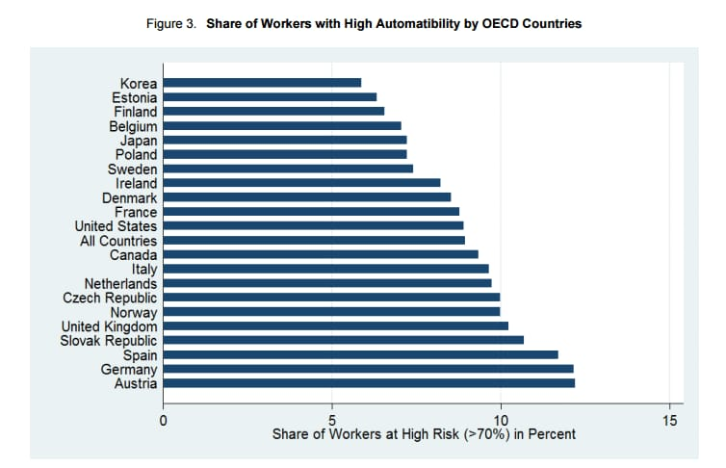
Figure 01: Share of Workers with High Automatability by OECD Countries
Source: (Altexsoft, 2025)
Emerging roles – With the transformation of work provided by AI, new positions, like the AI ethics officer, the automation engineer, and the data trust manager, are in demand. As an example, job openings that demand emotional, cognitive, or digital abilities in the jobs that are exposed to AI have grown by 8 percentage points.

1.2 The Gig Economy and Digital Platforms
The gig economy has reached its peak, and 25-43 percent of the American workforce is involved in non-regular or gig employment since 2025 (Gig Economy Data, 2025). The digital platforms are at the centre, driving the market that is estimated to rise at a CAGR of approximately 15-17 per cent across the world in the period between 2024 and 2031 (Cognitive Market Research, 2022). The graph below illustrates gig-based work is 15.79% global growth from USD 582.2 billion in 2025 to USD 2,178.4 billion by 2034 (Business Research Insight, 2025).
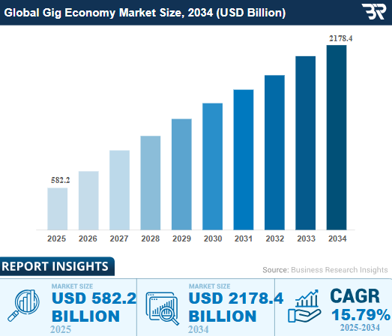
Figure 02: Global Gig Economy Market Size Forecast (2025 – 2034)
Source: (Business Research Insight, 2025)

1.3 Skills Churn and the Half-Life of Skills
Skills half-life predicts how long job skills last before switching or becoming ineffective. Due to rapid digital revolution, UK job skills are depleting after 4 years (Chris, 2025). The OECD concluded that high-exposure professions needed at least one management skill and 67 business-process skills in 2024, while digital and social/emotional skills increased by 5-8 percentage points. STEM, digital literacy, and ever-changing skills are in demand due to these trends.

1.4 Implications for HRM and IHRM Strategies
Talent acquisition using AI tools: By 2024, over 70 percent of HR functions indicated that they utilise AI to hire and 60 percent of organisations claimed that AI enhanced the accuracy of candidate-job matching (BCG Global, 2025). Digital credentialing and micro-learning improve hybrid workforce engagement and skills recognition transparency, according CIPD (2024).
Learning and development: micro-learning, reskilling: In 2024, 47% of L&D departments aim to introduce micro-learning programs, and 74% value skills-building for organisational success (Trisca, 2024). The global digital badge industry will grow 20.4% from USD 214 million in 2023 to USD 1.1 billion in 2032 (Global Market Insights Inc, 2024). The World Economic Forum (2025) ranks upskilling as the top global workforce strategy, with 85% of organisations adopting continuous learning by 2030, highlighting the importance of lifelong learning to HR sustainability.
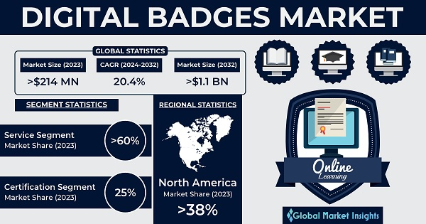
Figure 03: Global Digital Badges Market Growth and Segment Insights (2023–2032)
Source: (Global Market Insights Inc, 2024)
Strategic HR planning for blended workforce: As digital and remote jobs increase, strategic HR planning would have to consider full-time, contract, and gig workers, allowing the organisation to utilise agile pools of talent and deploy workers flexibly.
IHRM challenges in managing global digital workforces (GDPR, compliance): With the growth of international digital workforce, global HR should find the way to address the laws of data protection, employment regulation across borders, tax/residency of a remote worker, and so on, and compliance is one of the strategic HR concerns.

2.0 Question 2: Demographic & Geopolitical Factors

2.1 Key Demographic Factors
Ageing populations and multi-generational workforce management:
In the world alone, the 60+ population has grown to 1.2 billion in 2024, and it is expected to be 2 billion in 2050 (Pereira, 2024). By 2030, it will have one in every three workers over 50 years old in the UK ( State of Ageing, 2024). This population change requires age-based HRM practises focused on tacit knowledge based on recruiting, flexible retirement, and never-ending reskilling to take advantage of the older generation to retain the tacit knowledge of older employees and remain productive in the workforce.
Migration patterns: brain drain vs brain gain
As over 600,000 Indians emigrated to work in 2024, high-skilled emigration in developing countries reached record highs (Varun, 2025). HRM should improve global mobility, allow knowledge diffusion across boundaries, and return employees home to maintain vital skills to balance brain drain and brain gain.
Workforce diversity and inclusion strategies:
In 2024, when women were joining the workforce at record rates, just 29% of C-suite positions were held by women worldwide (McKinsey and Company, 2024). HR directors must include bias-conscious hiring, inclusive leadership training, dynamic data-based D&I measurements, and inclusion-aligned performance data in their organisational plan to address disparities.
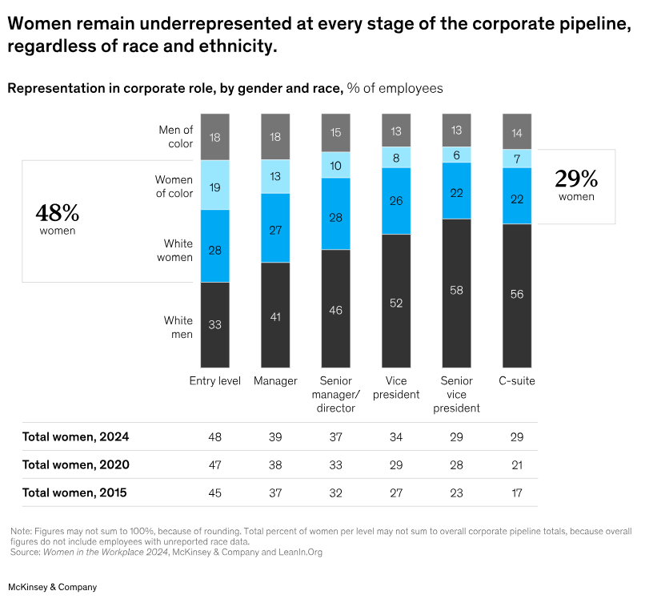
Figure 04: Representation in corporate roles by gender and race, percentage of employees
Source: (McKinsey & Company, 2024).

2.2 Key Geopolitical Factors
Trade wars, protectionism, and global supply chain disruption: The World Trade Organisation 2024 study found that rising tariffs and protectionist measures have forced companies reevaluate trade cooperation and supply-chain resilience (Ruzicka, 2024). In 2024, developed-country enterprises report 34% supply-chain risk, up from 22% in 2022 (Mishra, 2025). Global corporations are localising production due to geopolitical tensions and reshoring, shifting talent mobility, cost structures, and HR deployment, according to The Economist (2025).

Political instability, sanctions, and international HR risks: Political instability, sanctions, and cross-border job disruptions plague global organisations (World Economic Forum, 2024). HR managers must comply with penalty regimes, site closures, and expatriate repatriation for global talent deployment. Dowling et al. (2017) recommend prioritising risk management, legal compliance, and employee well-being in international HRM for unexpected geopolitical conditions.
Pandemics and health crises: remote work and safety policies: In 2024, 14% of full-time workers worldwide were remote and 29% hybrid (Ahmed, 2024). HR must develop excellent health-safety, remote-work, and cross-national employment procedures because many teams have embraced remote models due to the pandemic.

2.3 Challenges for HR Professionals
Challenge | Details
Talent mobility and complex visa regulations | The 2024 Ernst & Young Mobility Reimagined study indicated that 71% of firms expected higher cross-border regulatory concerns than in 2022, limiting global deployment and project timelines (Moss, 2024a).
Risk management and duty of care | Only 25% of multinationals have full mobility functions, even though 64% of international assignees feel overseas postings increase retention and engagement, underscoring the HRM gap in global risk preparedness (Moss, 2024b).
Global compliance and cultural integration | The 2024 Cartus Global Talent Mobility survey found that 34% of businesses view immigration and compliance issues as important barriers to international team integration and cross-cultural staff cohesion (Cartus, 2024).

3.0 Question 3: Skills Gaps & Strategic HRM

3.1 Understanding the Causes of Skills Gaps
Rapid technological change: Over 50 percent of IT leaders indicated the lack of AI talent in 2024, which was 28 percent in 2023 (Torres, 2025). This is increasing the pace of AI and automation and existing skillsets are becoming obsolete more rapidly than organisations are reskilling.
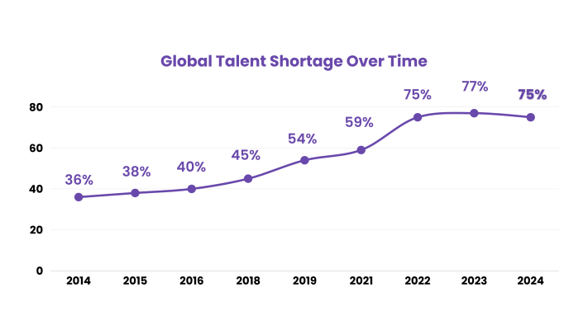
Figure 05: Global Talent Shortage Trends (2014–2024)
Source: (UPC, 2024)
Education–industry misalignment: The Organisation for Economic Cooperation and Development (OECD) indicates that 41 percent of companies in manufacturing are on the list of skills gaps, 32 percent in services, which is important evidence of the lack of correspondence between academic outputs and technical requirements (OECD, 2024c).
Insufficient investment in lifelong learning: In 2024, a survey of business leaders in the United Kingdom concluded that 84 percent of organisations experience a shortage of IT/tech skills and 31 percent of respondents cited inadequate training or applicant supply by academic institutions as a major source of the problem (Hyve, 2024).

3.2 Strategic HRM Approaches
Build Strategies- Internal Development: Higher-level apprenticeships (Level 6 and 7) increased by 10.9 per cent to 25,490 higher-level apprenticeships in the UK during the 2023/24 academic year and represents an indication of organisations investing in upskilling their workforce (Skills for Health, 2025). Cappelli (2008)'s make-versus-buy talent management model balances internal development with external hiring to optimise worker potential, which aligns with strategic solutions to skills shortages.
Buy Strategies- Strategic Recruitment: The 2024 study of employer branding NOW suggests that 68% of talent leaders believe that employer branding is a key device to recruit hard-to-find talent in the coming 12 months (Univer Sum, 2024). Also, two-thirds of businesses have widened their talent-analytics candidate pool in the recruitment (Symphony Talent, 2024).
Borrow Strategies- Accessing External Talent: Companies are turning to the temporary use of gig workers and specialist consultants to address temporary skills shortages with no long-term binding a flexible borrow-like approach to assume the position of build and buy.
Bind Strategies: Companies that have well-established internal career structures and mentoring initiatives experience reduced turnover of developed talent. Employer-branding studies report that there is a 28 percent retention improvement in case of fascinating learning culture (Skowronski, 2024). Standardising HR analytical abilities improves evidence-based decision-making and data-driven workforce strategies, according to Kulikowski (2024).

3.3 Sector-Specific Examples
Sector | Example
Technology | In 2024, companies' “Build” spending on internal training to quickly upskill staff drove the global coding boot-camp sector to USD 661.8 million (Group, 2024).
Healthcare | In March 2024, the UK nursing registry reported 778,340 nurses, emphasising “Buy” overseas recruitment to meet urgent needs (Cucumber Recruitment, 2025).
Hospitality | In 2024, 7% of UK jobs were in hospitality, which increasingly relies on “Build” (internal management training) and “Buy” (strong employer branding) to attract and retain people (Institute of Hospitality, 2024).

4.0 Question 4: Reflective Report on Capabilities

4.1 Introduction
MBA graduates can operate in turbulent multicultural and technology-driven environments due to global and adaptive competencies. They instil agility, ethical decision-making, and cross-cultural collaboration major qualities of successful leadership, innovation, and strategic adaptability in the modern-day globalised business environment.

4.2 Self-Assessment(Gibbs Reflective Cycle)
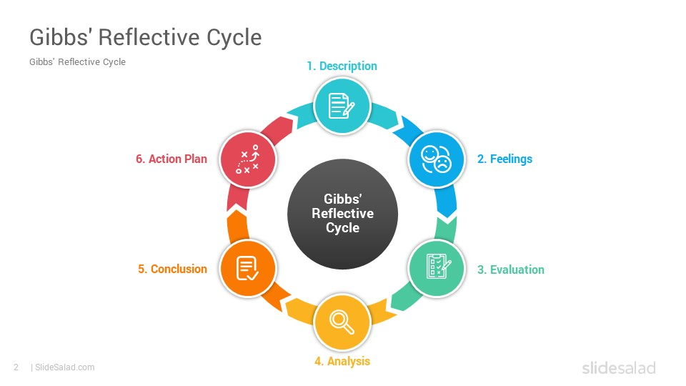
Figure 06: Gibbs Reflective Cycle
Source: (Slide Salad, 2025)
Description:
In this MBA module, I gained several professional skills, which included group work, information-based tasks, and using digital learning technologies. The experience of cross-cultural collaboration and analytics software use activities enhanced my knowledge of the global HRM practise.
Feelings:
First, I was confused with dealing with high-level software and different viewpoints but through reflective practice I gained confidence, flexibility, and value of collective problem-solving. Feng et al.(2025) say action learning and layered reflection in HRM education increase emotional awareness and self-efficacy, helping students turn uncertainty into professional growth.
Evaluation
My level of tech expertise also increased by using MS Teams, excel dashboards, and applying AI technologies to synthesise the research. My level of tech expertise also increased by using MS Teams, excel dashboards, and applying AI technologies to synthesise the research. The social skills were enhanced by the positive feedback in presentation and the succinct writing in academics. Teamwork facilitated fair allocation of tasks and successful management of conflicts. Leadership was created by mentoring the peers on analysis of HR data. Independent research of OECD and CIPD reports outside of module content was a manifestation of self-directed learning.
Analysis
The model by Gibbs helped understand that the primary MBA skills are adaptability, digital literacy, and intercultural competence. Reflection was used to determine regularity of patterns of initiative and collaboration to be my major strengths (Gibbs, 1988).
Conclusion
With the help of the repetitive reflection, I realised that I need to balance analytical and interpersonal competencies to become a whole-self leader.
Action Plan
Action Plan | Timeline
Enrol in Coursera’s Leading Global Teams course to improve cross-cultural leadership | By May 2026
Attend public-speaking workshops to strengthen presentation confidence | Ongoing (quarterly)
Complete LinkedIn Learning certification in HR analytics and Power BI | By August 2026

4.3 Development Plan
Leveraging Strengths for Employability
Through providing the opportunity to make evidence-based decisions and plan the workforce based on the data, possessing a competent knowledge of the data analytics and AI-driven data analysis tools enhances employability in the strategic human resource management sector. With good communication and collaboration skills, the ability to interact effectively with stakeholders and integrate with other business functional areas is another support in digitally adaptive businesses.
Addressing Weaknesses with Actionable Steps:
To enhance leadership in multi-cultural backgrounds, one should seize chances of leading global projects teams and implementing cross-cultural management model. The ability to talk to people can be trained during the professional communication workshop, whereas the reliance on digital collaboration tools can be compensated by attending on-site networking events to strengthen the interpersonal and leadership presence.

Conclusion
This report has critically looked at how global labour markets and the management of human resources is being redefined by technological innovation, demographic changes, and geopolitical forces. The results have indicated that automation and AI are changing the nature of jobs and necessitate the constant reskilling and the hybrid approach to the labour force, ageing populations and the problem of international movement demand flexible HR policies. The strategic management of HRM including build-buy-borrow-bind is important in closing any skills knowledge gaps by using data-based planning of the workforce. The reflection showed that to be a successful leader in the rapidly changing world, future managers should have global and adaptive competencies such as digital literacy, leadership, and intercultural collaboration.

References
Ahmed, N. (2024). Recent Trends and Statistics of Remote Work in 2024 - Interloop. [online] Interloop. Available at: https://inlps-production.azurewebsites.net/recent-trends-and-statistics-of-remote-work-in-2024/ [Accessed 1 Nov. 2025].
Altexsoft (2025). [online] Altexsoft.com. Available at: https://www.altexsoft.com/static/blog-post/2024/1/848fad12-bd06-4c3d-856e-87c3d4410c96.jpg [Accessed 5 Nov. 2025].
BCG Global (2025). How AI Is Changing Recruitment. [online] BCG Global. Available at: https://www.bcg.com/publications/2025/ai-changing-recruitment.
Brynjolfsson, E., &amp; McAfee, A. (2014). The Second Machine Age: Work, Progress, and Prosperity in a Time of Brilliant Technologies. W. W. Norton &amp; Company. (A foundational text on the economic impact of technology).
Business Research Insight (2025). Healthcare M2M Market 2025-2033 | Size, Share, Growth, Trend. [online] Businessresearchinsights.com. Available at: https://www.businessresearchinsights.com/market-reports/healthcare-m2m-market-100162 [Accessed 4 Nov. 2025].
Cappelli, P. H. (2008). Talent on Demand: Managing Talent in an Age of Uncertainty. Harvard Business Press. (The classic &quot;Make vs. Buy&quot; framework for talent management).
Cartus (2024). the great balancing act: optimizing the employee experience while controlling costs global talent mobility survey 2024. [online] Available at: https://assets.ctfassets.net/2czxzrwels61/2DKMvHMfomwEmQmM4iiYjU/fa605e1f1372afce09d3506ab9180242/Cartus_Global-Talent-Mobility-Full-Report_2024-03.pdf [Accessed 2 Nov. 2025].
Chris (2025). Lack of digital skills in workforce costing UK over £23 BILLION per year - FutureDotNow. [online] FutureDotNow. Available at: https://futuredotnow.uk/lack-of-digital-skills-in-workforce-costing-uk-over-23-billion-per-year/ [Accessed 8 Nov. 2025].
CIPD (2024). CIPD Good Work Index 2024. [online] Available at: https://www.cipd.org/globalassets/media/knowledge/knowledge-hub/reports/2024-pdfs/8625-good-work-index-2024-survey-report-1-web.pdf.
Cognitive Market Research (2022). Global Gig Economy Market Report 2024 Edition, Market Size, Share, CAGR, Forecast, Revenue. [online] Cognitive Market Research. Available at: https://www.cognitivemarketresearch.com/gig-economy-market-report.
Cucumber Recruitment (2025). NHS Nurse Employment Statistics 2024. [online] Cucumber Recruitment. Available at: https://www.cucumber-recruitment.co.uk/resources/insights/nhs-nurse-employment-statistics-2024 [Accessed 30 Oct. 2025].
Dowling, P. J., Festing, M., &amp; Engle, A. D. (2017). International Human Resource Management. Cengage Learning. (A core IHRM textbook with chapters dedicated to the global context).
Feng, L., Barry, P. and Eldridge, D., 2025. Applying action learning in democratic educational practices: using a triple-layered reflective approach in an MSc HRM Enhancement Programme (HRMEP). Action Learning: Research and Practice, pp.1-11.
Gibbs, G. (1988) Learning by Doing: A Guide to Teaching and Learning Methods. Oxford: Oxford Polytechnic, Further Education Unit.
Gig Economy Data (2025). How many gig workers are there? [online] GigEconomyData.org. Available at: https://gigeconomydata.org/basics/how-many-gig-workers-are-there.html.
Global Market Insights Inc (2024). Digital Badges Market Statistics| Global Analysis Report, 2032. [online] Global Market Insights Inc. Available at: https://www.gminsights.com/industry-analysis/digital-badges-market.
Group, I. (2024). Coding Bootcamp Market Size, Share, Growth and Industry Report. [online] Imarcgroup.com. Available at: https://www.imarcgroup.com/coding-bootcamp-market [Accessed 6Nov. 2025].
Hyve (2024). IT and Tech Skills Gap Report 2024 | Hyve Managed Hosting. [online] Hyve Managed Hosting. Available at: https://www.hyve.com/insights/downloads/it-and-tech-skills-gap-report/.
Institute of Hospitality (2024). Labour and skills market in the UK economy. [online] Available at: https://www.instituteofhospitality.org/wp-content/uploads/2024/04/MarketIntelligenceApril2024.pdf.
Kulikowski, K. (2024). Defining analytical skills for human resources analytics: A call for standardization. Journal of Entrepreneurship Management and Innovation, 20(4), pp.88–103. doi:https://doi.org/10.7341/20242045.
McKinsey & Company (2024). Women in the Workplace. [online] McKinsey. Available at: https://www.mckinsey.com/featured-insights/diversity-and-inclusion/women-in-the-workplace.
Mishra, V. (2025). Global Supply Chain Shocks and Trade Resilience: A Review Post-Covid and Ukraine Crisis. Journal of Marketing & Social Research, [online] 2(5), pp.336–348. doi:https://doi.org/10.61336/jmsr/25-05-38.
Moss, R. (2024a). Global mobility failures risk loss of talent. [online] Personnel Today. Available at: https://www.personneltoday.com/hr/global-mobility-ey-survey-2024/ [Accessed 2 Nov. 2025].
Moss, R. (2024b). Global mobility failures risk loss of talent. [online] Personnel Today. Available at: https://www.personneltoday.com/hr/global-mobility-ey-survey-2024/ [Accessed 1 Nov. 2025].
OECD (2023). OECD Employment Outlook 2023. [online] OECD. Available at: https://www.oecd.org/en/publications/oecd-employment-outlook-2023_08785bba-en.html.
OECD (2024a). ARTIFICIAL INTELLIGENCE AND THE CHANGING DEMAND FOR SKILLS IN THE LABOUR MARKET OECD ARTIFICIAL INTELLIGENCE PAPERS. [online] Available at: https://www.oecd.org/content/dam/oecd/en/publications/reports/2024/04/artificial-intelligence-and-the-changing-demand-for-skills-in-the-labour-market_861a23ea/88684e36-en.pdf.
OECD (2024b). Employment. [online] OECD. Available at: https://www.oecd.org/en/topics/employment.html.
OECD (2024c). Understanding Skill Gaps in Firms. [online] OECD. Available at: https://www.oecd.org/en/publications/understanding-skill-gaps-in-firms_b388d1da-en.html.
Pereira, R. (2024). Improving the visibility of older people in global statistics | National Statistical. [online] Ons.gov.uk. Available at: https://blog.ons.gov.uk/2024/10/01/improving-the-visibility-of-older-people-in-global-statistics/.
Ruzicka, J. (2024). Rethinking trade and cooperation to navigate global shocks. [online] World Economic Forum. Available at: https://www.weforum.org/stories/2024/11/rethinking-trade-cooperation-navigate-global-shocks/.
Skills for Health (2025). HASO | Skills for Health. [online] Skills for Health. Available at: https://www.skillsforhealth.org.uk/haso/.
Skowronski, B. (2024). How to Turn Acquisitions into Real Growth. [online] Red Caffeine. Available at: https://www.redcaffeine.com/uncategorized/how-your-employer-brand-influences-recruitment-and-employee-retention/ [Accessed 5 Nov. 2025].
Slide Salad (2025). [online] Slidesalad.com. Available at: https://www.slidesalad.com/wp-content/uploads/2020/10/Gibbs-Reflective-Cycle-PowerPoint-Templates-Diagrams-0001.jpg [Accessed 2 Nov. 2025].
State of Ageing (2024). Work | The State of Ageing 2023-24 | Centre for Ageing Better. [online] ageing-better.org.uk. Available at: https://ageing-better.org.uk/work-state-ageing-2023-4.
Symphony Talent (2024). The State of Recruitment Marketing in 2024 - Symphony Talent. [online] Symphony Talent. Available at: https://www.symphonytalent.com/resources/reports/the-state-of-recruitment-marketing-in-2024/ [Accessed 1 Nov. 2025].
The Economist (2025). Trade in Transition 2025 Global Report. [online] Available at: https://impact.economist.com/projects/trade-in-transition/pdfs/Trade_in_Transition_Global_Report_2025.pdf.
Torres, R. (2025). AI skills shortage surpasses big data, cybersecurity. [online] CIO Dive. Available at: https://www.ciodive.com/news/AI-skill-shortage-adoption-enterprise/750106/.
Trisca, L. (2024). Employee Development Statistics You Need to Know in 2024. [online] www.deel.com. Available at: https://www.deel.com/blog/employee-development-statistics/.
Universum (2024). Employer Branding NOW 2024 | Universum. [online] Universumglobal.com. Available at: https://universumglobal.com/resources/news-press/employer-branding-now-2024/.
UPC (2024). [online] Linkedin.com. Available at: https://www.linkedin.com/pulse/global-talent-trends-navigating-through-shortage-qrrce/ [Accessed 2 Nov. 2025].
varun (2025). Brain Drain: How many People Left India from 1960 to 2025 - FactoData. [online] FactoData. Available at: https://factodata.com/brain-drain-how-many-people-left-india-from-1960-to-2025/.
World Economic Forum (2025). The Future of Jobs Report 2025. [online] World Economic Forum. Available at: https://www.weforum.org/publications/the-future-of-jobs-report-2025/in-full/4-workforce-strategies/.
World Economic Forum. 2024. The Global Risks Report 2024. Geneva: World Economic Forum. Available at: https://www3.weforum.org/docs/WEF_The_Global_Risks_Report_2024.pdf (Accessed: 7 November 2025).

Appendix
SWOT Analysis
Strengths | Weaknesses | Opportunities | Threats
• Proficient in AI tools, MS Teams, and data analytics  • Strong written and verbal communication  •Effective teamwork and conflict management | •Limited multicultural leadership experience  •Occasional overreliance on digital tools  •Public-speaking confidence needs development | • Global networking through professional associations  • Advanced certifications in HR analytics and leadership  • Expanding job markets in data-driven HRM | • Rapid AI evolution outpacing current skills  • Economic uncertainty in international markets  • High competition within management consulting and HR sectors

