Essay – The past and present of Japanese art

Abstract
For the purpose of this assignment, I have decided to compare and contrast two Japanese artists, one contemporary and one from the Edo period namely Yoshitaka Amano and Katsushika Hokusai. I have chosen these particular artists to try and highlight how the style of one may have influenced the other but also to pinpoint their obvious differences. Some aspects that will be analysed in both artist’s work are the materials that they use, the colours that are seen in their paintings and the conceptual thinking behind some of their paintings. Through this research, it is hoped that the way that artists from the past can inform and influence contemporary practitioners can be discussed.
Illustrations
Amano
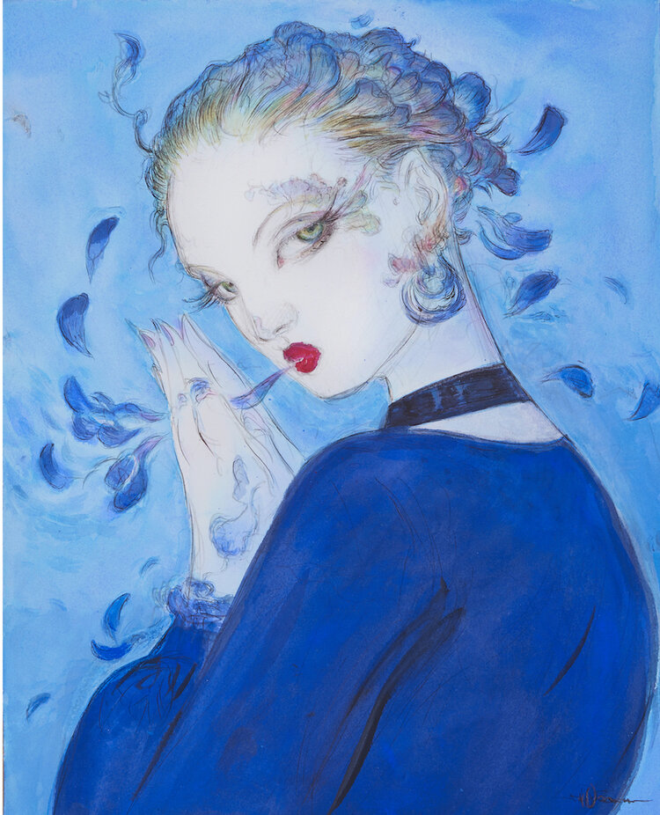
Fig. 1: Vogue Italia

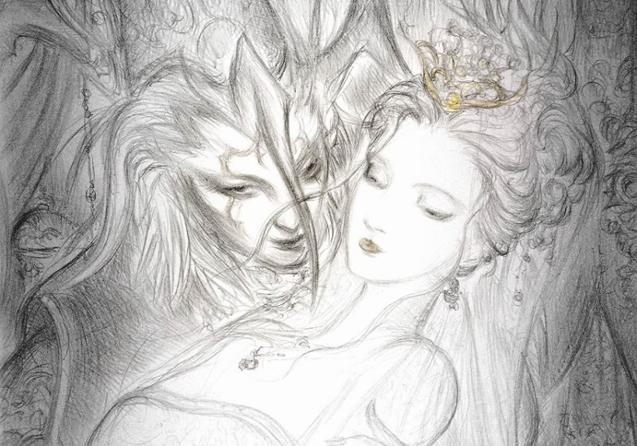
Fig. 2: Noir
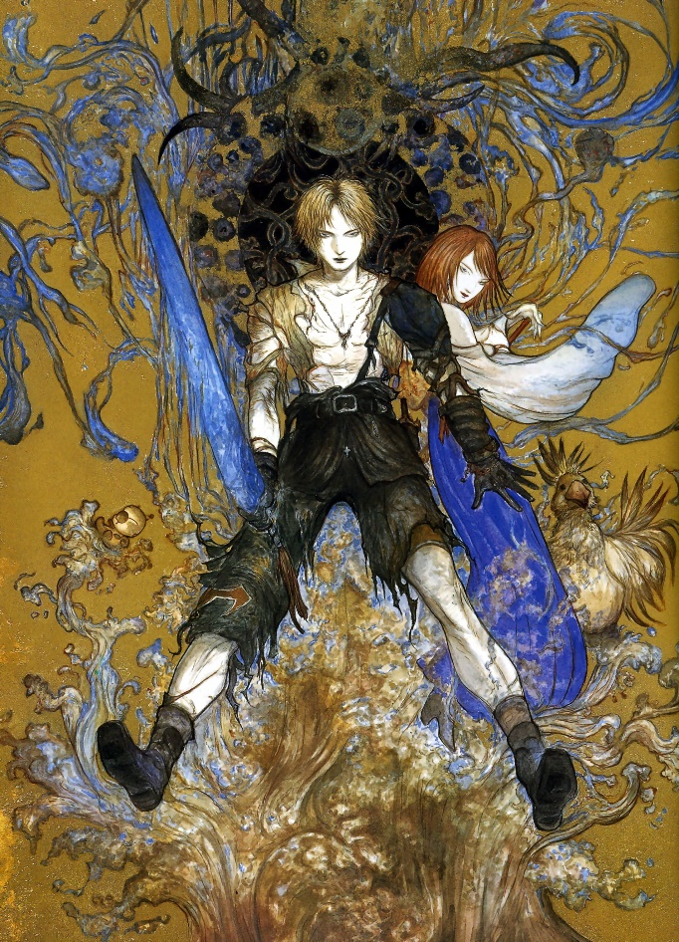
Fig. 3: Tidus and Yuna

Hokusai
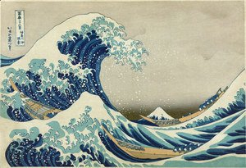
Fig. 4: The Great Wave of Kanagawa
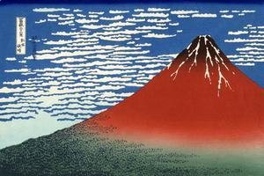
Fig. 5: South Wind at Clear Dawn
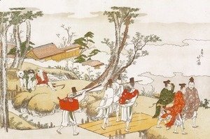
Fig. 6: Courtiers Crossing a Bridge
Body
Amano is a Japanese artist, costume designer, concept art, illustrator and a contemporary practitioner that has worked with different business. Furthermore, his art style has influences, such as “early Western comic books, art noveau, and Japanese woodblock prints” (Amano, 2021). Looking at his artwork that he has produced during his career, his art style displays the different elements of his influences. In January 2020, Amano was invited to collaborate with Vogue Italia (Fig. 1) to design covers for a special issue magazine (Vogue, 2020). According to an article by ‘Game Fragger’, they claim that Amano was able to invoke the “image of model Lindsey Wixson wearing Gucci” (Game Fragger, 2020) in his art style. The piece uses a colour palette consisting of mostly blue with a few warm colours in small areas. The way that Amano has illustrated Lindsey Wixson resembles a fantasy character from a game, or a story as stated on a post by Yoshitaka Amano that he “takes inspiration from fantasy but focuses on a single character” (Amano, 2020). An example of a fantasy character that resembles Amano’s illustration of Wixson is Yuna from Final fantasy 10 who is a character that Amano has illustrated for the purpose of “promotional artwork” (Fig. 2 and Fig. 3) (Fandom, 2019). The correlation between these two illustrations is the shade of blue that Amano has used for both pieces which stand out to the other colours around them (Fig.1 and Fig. 3). This could show how his influences and experience through his career have helped him develop his conceptual thinking and his pieces. Furthermore, his influences come from both eastern and western backgrounds which is reflected in his art style such as the subjects of his illustrations, the colours that he uses and the way that he creates his delicate lines.
Compared to Amano, Hokusai is an artist in the Edo period of Japanese history and was claimed to be “Japan’s leading expert on Chinese painting” stated by his biography website (Hokusai, 2021). In addition, it also mentions about Hokusai’s “woodblock print series Thirty-six Views of Mount Fuji” is what he is “best-known” for (Hokusai, 2021). One famous print “The Great Wave of Kanagawa” (Fig. 4) is part of this series and has become a notable piece to this day. The art size was done by 26cmx38cm and the medium used to create it was ink with the woodblock printing process. Furthermore, this piece was created in multiple locations as it was part of a series which as it title suggests, displays thirty-six different views of Mount Fuji. The way that Hokusai has drawn the waves almost consuming the boats depicts the duality of the water with it being “Enchanting but treacherous” (Potter, 2005) and it can also reflect nature itself on how it can appear to be beautiful yet still a threat to humanity. Furthermore, considering that Hokusai’s work focuses on realism with nature and people’s lives, the piece also depicts the many difficulties and risks that most people in that time would have encountered for them to continue living as the boats in the painting were “light boats carrying fish to market on a workday” (Potter, 2005).
In Hokusai’s work, he would place a signature with a different name instead of using only one name. One example of the names that he used to sign some of his later works was “The old man mad about painting” (Potter, 2005), which implies that Hokusai’s passion for his art gave his life meaning. According to the Hokusai biography, “Hokusai was known by at least 30 names during his lifetime.” (Hokusai, 2021), the purpose behind the many different names is due to the “changes in his artistic production and style” (Hokusai,2021) which helps him to separate and organise his different pieces of work and “life up into periods” (Hokusai,2021). This can show the amount of work and development that Hokusai has gone through in his art career and his dedication to his work.

Argument
From the research, Amano and Hokusai’s work contain several elements that are like one another, but still branch out with their differences. For example, both artists draw with a delicate use of line, but they use different materials to complete their images. Hokusai uses several techniques from Ukiyo-e which is a style of woodblock print that captures “pictures of the floating world” (Breedlove, 2016). The process for woodblock printing involves carving the design of the print into the woodblock, preparing the ink for the block to place on, then placing the block with ink onto paper to transfer the design. Whereas Amano uses a variety of media to illustrate his designs. These media might include ink, watercolour, acrylic and sometimes automotive paint on aluminium panels.
Both artists use a similar tonal palette in their work. The colour palette contains several muted/soft colours that appear peaceful in their pieces and common colour theme is the use of blues, greens and browns with some hints of other colours. With Amano’s Vogue Italia and Tidus and Yuna (Fig. 1 and Fig. 3) as well as Hokusai’s The Great Wave of Kanagawa and South Wind at Clear Dawn (Fig. 4 and Fig. 5), all these pieces contain various shades of blue that stand out from other colours used in them. In comparison to Hokusai’s colours, Amano’s colours appear to be slightly brighter in tone which does make them feel more contemporary as the materials that he uses are easier to acquire compared to older times.
However, both practitioners avoid using bold colour schemes with some of their pieces and would mostly use pale greys and browns accompanied with a few other colours. For example, with Amano’s Noir illustration (Fig. 2), he has used different shades of grey and a pale yellow. What is interesting about the colours is that the greys are applied in a way that creates a gradient across the whole canvas which creates an ominous feeling from the characters, especially the male character on the left is expressing a malevolent smile. In addition, the pale yellow could have been used to highlight the significance of the object.
As for Hokusai, with his woodblock print Courtiers Crossing a Bridge (Fig. 6), the natural landscape has been coloured with pale colours and light greys instead of the bold, mute colours such as the ones used in South Wind at Clear Dawn and The Great Wave of Kanagawa (Fig. 5 and Fig. 6). However, the light grey colours in the sea or the top part of the sky could have come from the paper material that was used to print the design onto.
The Great Wave of Kanagawa was a woodblock print that depicted a giant, monstrous wave in the foreground engulfing three “light boats” (Potter, 2005). This is set against the image of Mount Fuji in the background using geometric laws such as the inclusion of a vanishing point to balance the composition and provides scale to compare the mountain with the wave to exaggerate its power compared to the weakness of mankind. Hokusai’s prints always had nature as the focus and with some of his prints, they depict nature overwhelming humanity with its beautiful presence.
On the other hand, Amano’s illustrations focus more on being imaginative with his character designs and making them look visually interesting and unique. During his interview with Archipel, Amano stated himself that “Even though I’m Japanese, I like western fantasy a lot. I wanted to draw knights, etc.” (Archipel, 2020). This shows that Amano’s inspirations and interests from outside areas has had some impact on his conceptual thinking with his illustrations. Furthermore, this also depicts that contemporary artists have access to a wider range of resources that they can use for inspiration and reference such as Google.
Conclusion
After analysing and comparing the work of both artists, it is clear that both have a fairly broad colour palette. The fact that Hokusai is depicting landscape in his work clearly leads to the use of blue in many of his prints, whereas Amano uses it as part of a variety of colours to depict human figures and characters. In the Vogue cover in particular, he has used blue to suggest cool and subtle tones which highlights the red of the model’s lips. Furthermore, both artists create blocks of colour and the way that the colours form from the brush strokes creates texture which creates uneven tones of a single colour. In addition, both artists create small, delicate lines to outline their pieces which shows their dedication and patience for their work. Lastly, the composition of Amano’s illustrations resembles print work which can be related to Hokusai’s prints.
In conclusion, from the research that was gathered for this essay, it is believed that Amano’s work is influenced by Hokusai and Japanese prints because as stated by his own website that one of his influences is Japanese woodblock prints. Another reason is that as previously mentioned, there are aspects of Amano’s art style that are similar to Hokusai’s art style.
List of Illustrations
Figure 1. Amano, Y. (2020) Vogue Italia. [Magazine cover] Available at: https://www.yoshitakaamano.com/ (Accessed: 9th March 2021)
Figure 2. Amano, Y. (2001) Noir. Final Fantasy Ultimania Archive, 3. United States: Dark Horse [Mixed media on paper]
Figure 3. Amano, Y. (2001) Tidus and Yuna. [Mixed media on paper] Available at: https://finalfantasy.fandom.com/wiki/Yoshitaka_Amano (Accessed: 9th March 2021)
Figure 4. Hokusai, K. (1820-1831) The Great Wave of Kanagawa. [Ink on canvas], 26cm x 38cm Available at: https://www.katsushikahokusai.org/ (Accessed: 9th March 2021)
Figure 5. Hokusai, K. (1820-1831) South Wind at Clear Dawn (Gaifu kaisei). [Ink on canvas] Available at: https://www.katsushikahokusai.org/ (Accessed: 9th March 2021)
Figure 6. Hokusai, K. (1820-1831) Courtiers Crossing a Bridge. [Ink on canvas] Available at: https://www.katsushikahokusai.org/ (Accessed: 9th March 2021)
Bibliography
Amano, Y. (2021) Yoshitaka Amano [online] Available at: https://www.yoshitakaamano.com/ (Accessed: 8th March 2021)
Farneti, E. (2020) Vogue, (7), pp. 5. [online] Available at: https://www.instagram.com/p/B602zKSHRft/ (Accessed: 8th March 2021)
Hokusai, K. (2021) Katsushika Hokusai [online] Available at: https://www.katsushikahokusai.org/ (Accessed: 8th March 2021)
Potter, P. (2005) ‘Of Tidal Waves and Human Frailty’, EID Journal 11(10) [online] Available at: https://wwwnc.cdc.gov/eid/article/11/10/ac-1110_article (Accessed: 9th March 2021)
Breedlove. B (2016) ‘Perspective and Surprise in the Floating World’, EID Journal, 22 [online] Available at: https://wwwnc.cdc.gov/eid/article/22/6/AC-2206_article (Accessed: 9th March 2021)
Gigazine (2017) Documentary film that said that Yoshitaka Amano known for FF series character deza says "What is Amano Amity" is worth a visit Available at: https://gigazine.net/gsc_news/en/20171115-amano-yoshitaka/ (Accessed: 9th March 2021)
Kuittinen, P. (2006) ‘Very Important Game People in the History of Computer and Video Games’, University of Art and Design Helsinki, pp. 142-151. [online] Available at: https://aaltodoc.aalto.fi/bitstream/handle/123456789/12544/optika_id_1037_kuittinen_petri_2006.pdf?sequence=1#page=143 (Accessed: 7th March 2021)
Game Fragger (2020) FINAL FANTASY Artist Yoshitaka Amano Contributes To VOGUE ITALIA'S 'No Photoshoot' Issue Available at: https://gamefragger.com/multiplatform/role-playing/final-fantasy-artist-yoshitaka-amano-contributes-to-vogue-italias-no-photoshoot-issue-a18192#gs.uqngco (Accessed: 9th March 2021)
Amano, Y. (2020) yoshitaka_amano [online] Available at: https://www.instagram.com/p/B9fab7MjiTW/ (Accessed: 7th March 2021)
Archipel. (2020) Yoshitaka Amano - his universe, on paper [Video] Available at: https://www.youtube.com/watch?v=PJEPhBL77lk&t=5s (Accessed at: 8th March 2021)
Ebay. (2020) VOGUE Italy 833 7 issue Yoshitaka Amano, Salle Beecroft Namoda, Manara, Desane. [online] Available at: https://www.ebay.co.uk/itm/VOGUE-Italy-833-7-issue-Yoshitaka-Amano-Salle-Beecroft-Namoda-Manara-Desane-/124055798611 (Accessed: 8th March 2021)
Harris, L. (2015) ‘Hokusai, Under the Wave off Kanagawa’, Khan Academy [online] Available at: https://www.khanacademy.org/humanities/ap-art-history/south-east-se-asia/japan-art/a/hokusai-under-the-wave-off-kanagawa-the-great-wave (Accessed: 9th March 2021)
Victoria and Albert Museum. (2020) Japanese woodblock print (ukiyo-e) Available at: https://www.vam.ac.uk/articles/japanese-woodblock-prints-ukiyo-e (Accessed: 9th March 2021)
Richardson, M. (1986) Dark Horse Comics [online] Available at: https://www.darkhorse.com/
The Collector (2020) The Great Wave Off Kanagawa: 5 Little Known Facts About Hokusai’s Masterpiece Available at: https://www.thecollector.com/the-great-wave-off-kanagawa/ (Accessed: 8th March 2021)
Fandom (2019) Yoshitaka Amano Available at: https://finalfantasy.fandom.com/wiki/Yoshitaka_Amano (Accessed: 7th March 2021)

