The impact of product recalls on businesses and projects
Darren Thomas
Student ID 2117577
MSc Engineering Project Management, University of Wales Trinity of Saint David
ACEA 7012: Quality Management in an Operational Environment
Lecturer: Andrew Thorn
29th November, 2022

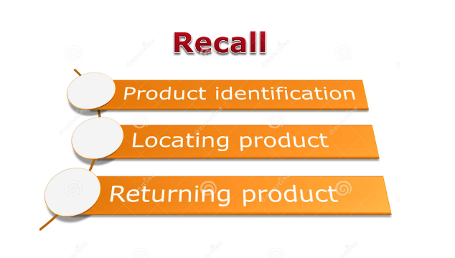

Contents page

Contents page 2
Introduction 3
Product recall process Flow Chart 4
The Product Recall Process 5
Classification of Recall: 6
Class I: 6
Class II: 6
Class III: 6
Justifications for recalls Examples 6
Lack of testing 6
Manufacturing mistakes 6
Substitutions 6
Product recall procedure: 7
Product Recall Costs and how to Manage them: 8
Cost implications of product recall 8
Damage limitation 8
Regulatory Recalls 9
Ascertain the Scale of the Fault/Defect 9
Decide the Suitable Reaction 9
Product Return 9
Repair option 9
Notification 9
Inform Your Insurer 9
Stakeholders and Customers Communication 10
How to manage a product recall procedure to reduce harm to the company 11
Consequence of poor quality 12
Ethical Product Manufacture 12
Failure Mode Effect Analysis (FMEA) 13
Supply Chain Complexities 13
Conclusion 13
References 14

Figure 1. Product Recall Flow Diagram 4
Figure 2. United States Vehicle Recalls 8

Introduction

A product recall is a process a company should follow if a product is faulty, the product may be faulty due to manufacturing issues, quality, contamination, or safety concerns. The customers and consumers who have purchased the item should be contacted and informed of the recall and the item taken off the market

Companies will usually compensate or convince the customers to trade in their products to ensure the safety of the customers, usually recalls are at the company’s discretion undertaken for customer satisfaction and to ensure repeat sales and to build and keep trust in the company, on the other hand the Government bodies or HSE may intervene and issue a mandatory recall to protect the consumers depending on the severity of the issues.

Companies are aware that recalls should be managed properly as not to effect brand and customer health. The quick communication and recall process is essential to ensure customer and product safety. For example a washing machine company has recalled up to 21 models due to issues with the door mechanism and heating element on their machines which may pose a risk of fire, no serious injuries reported. Since the recall in early 2020 over 210,000 customers have registered their appliances for the recall (over 40% of affected customers, above industry average for a recall) (Whirlpool Corporation, 2020)

Product recall process Flow Chart

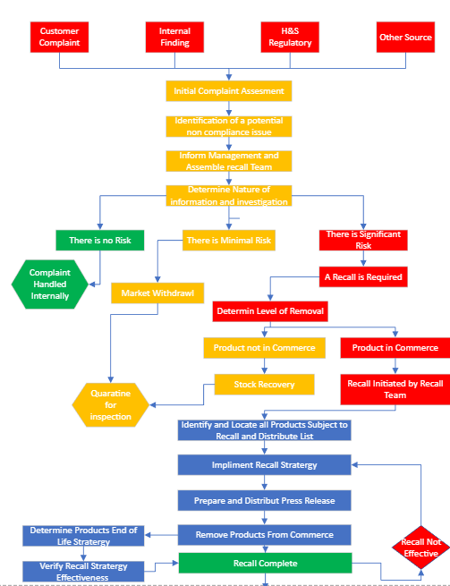

Figure 1. Product Recall Flow Diagram

https://pharmablog.in/product-recall-sop/

The Product Recall Flow Diagram Fig 1. appropriate for the recall of dispatched products, if believed to be defective or that they have been detected that the products are defective.

The Product Recall Process

The Quality Assurance Manager (Q.A.) is to initiate the recall process, monitor the process and close out the recall on completion. These actions can only be initiated after a team of people called the Product recall team has made the final decision to implement the process of a recall. (PharmaBlog, 2022)

The Technical Head role within the company is responsible for carrying out the review of the Complaint, Investigation of documents and after consultation with Q.A. and the recall team recommendations are given to the higher management for the recall of the product.

A Recall is defined as the removal or return of specific batch or batches of a product in circulation and a Withdrawal is the removal of the product from the consumer and customer market.

A recall of marketed product will be started in following conditions.

- If a product is expected or recognized to be defective based on consumer and customer complaints, and an assessment of likelihood of occurrence of the hazard is seen to be true.

- If the local Health / Regulatory authorities have issued a complaint or notice.

- If advised by the Key company for which the product is produced.

From the initial complaint a Product Recall Team should be formed. (ASQ.ORG, 2022)

The Product recall team should consist of following members or similar depending on the company management set up.

Director
Technical Head
Quality Assurance Head
Quality Control Head
Production Head

The product recall is to be initiated by the Q.A. Head and tailored to suit depending on the nature of the complaint and investigation.

Classification of Recall:

There are several types of Product recall:

Class I:
The most critical of recalls, consequences to health are serious harm or likely hood of Death to the user and customer. The recall would be initiated within a short period of time after the recall team put forward its recommendations.
Examples are: wrong product, wrong strength, chemical contamination all with serious health consequences.

Class II:
Product recalls are for defective or poor-quality products but do not present a danger or serious health risk. The recall is started within 7 working days from the recommendation of product recall team.
Examples are incorrect labelling or mis information, contamination of products, wrong product or out of spec.

Class III:
Recalls are for products that are unlikely to cause health issues but are below manufacturing regulations and compliance.
Example would be Faulty packaging, contamination, missing leaflets or information on the product etc.

Justifications for recalls Examples
Companies would normally recall a product to make sure the safety of their customers and the integrity of their brand. There are numerous reasons why a product would be recalled, including:

Lack of testing
If a product is on the market without having thorough tests and inspections, there may be defects or side effects that have been missed. Including stress tests to measure their strength and ductility to simulate life cycle of the product where premature failure may be the result. For example, a company might recall a car with seat belt issues if they didn't test their effectiveness enough in a crash or hard breaking simulation. 2022 Hyundai recall 239,000 vehicles with similar issues. (Wile, 2022)

Manufacturing mistakes
A common cause for companies to recall a item is manufacturing errors. This can involve errors in production such as missing an ingredient or tainting a product with another ingredient. For example, a cat food product accidentally didn't include the chicken in the formula.

Substitutions
Substitutions are an additional mistake that can prompt a product recall. If a manufacturer substitutes ingredients for costs or availability. When companies haven’t approved these substitutes, a product recall may be issued.
For example, if a product that normally uses organically obtained ingredients and a manufacturer substituted for artificial ingredient, the recall process may be followed to protect the integrity of their brand name.

Product recall procedure:

Recall commencement: warning is given to the warehouse, distribution departments and the executives of the company, to inform them that a recall of a product is to commence within a specific time period as above classification.

On receipt of the recall notification all concerned distributors and stockists are to be contacted by phone or mail, requesting them to stop sales of product and withdraw items from the market.
Q.A. and the Directors will collate all documents, Quantities affected, costs, and customers concerned, all information will be reviewed before initialising the Recall.

Product recall Team meeting to evaluate the risk associated with the complaints and how to minimise customer dissatisfaction.

All returned goods to be marked as Recalled goods and quarantined and local regulatory body notified regarding the recall schedule.

Director / Marketing head will send a product recall email where the product has been shifted abroad and inform to the customer of the type of recall and it’s likely hood to cause harm or its hazards. A request to return the product back at the earliest opportunity or the arrangement to destroy the product in the country if unable to ship. The progress of the recall is closely monitored by Q.A. Head.
On completion of the recall, the warehouse team and Q.A. to perform a stock take and document all findings to cross reference outgoings with returns, including any certifications for destroyed stock. All stock to be kept separate and under lock and key until final decisions by the product recall team.

The Q.A. will complete the Product recall, recording the Recall completed and closed.

Q.A. and director to complete a root cause analysis and communicate with the teams to prevent reoccurrence.

Higher management to complete a product recall report approved by the Director

Conclusion to be documented and stock either destroyed in the presence of the Q.A. Head or appropriate steps taken for stock to be re-entered into the supply chain with the modifications required.

Evaluation of all recall incidents should be completed annually and documented for future reference.

Product Recall Costs and how to Manage them:

Modern manufacturers over the past 10 years have seen a jump in product recalls with significant costs to their companies. An OMEP article (Kelly, 2022) highlights the best way to protect their customers and reduce risk is to initiate a product recall.
In the united states over the past 20 years this is evident and in 2016 the market was seeing up to 1000 vehicle recalls and on average over 3 vehicles per 1 sold where being recalled. Figure 2 shows this steady climb up to 2017. (Adriana Aragon, 2019)

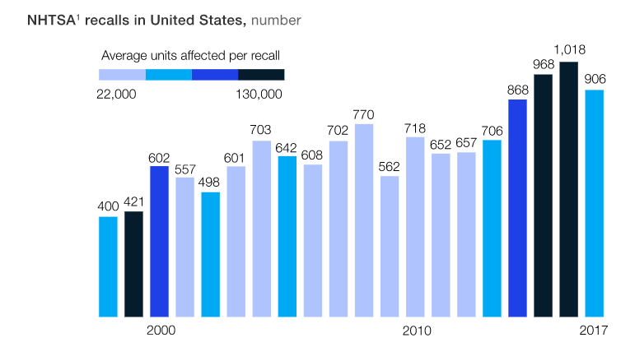

Figure 2. United States Vehicle Recalls

Cost implications of product recall
Obvious Costs for a product recall are the inspection costs, repair costs, replacement, and disposal costs, as well as personnel to deal with the recall, the reduction in sales due to loss of customer purchases and loss of trust in the company and products.

Damage limitation
The first thing to do in any recall is to verify the presence of a defect. For example, the fault may be due to damage or tampering in this case there would be no need for a recall. Initiating a recall prematurely places the company in unnecessary risk with unwarranted costs and loss of customer trust. Customers may choose to claim damage and compensation even if there are no issues if a recall has been authorized. On the other hand, if there is an issue or fault with the product and a recall is not raised, legal and regulatory enforcement and exposure may cost the company a great deal more.

Regulatory Recalls
Certain industry recalls are regulated by government bodies and departments. These departments have specific recall requirements and should be consulted with directly when a product defect is found. Failure to comply with regulatory requirements can expose an organization to civil, or even criminal, penalties.

Ascertain the Scale of the Fault/Defect
If a fault exists, identifying the faulty part of the product, or conditions that generate the fault, may remove, or reduce the scale of the recall. For example, if something has been changed recently, suppliers, materials, manufacturers, and the issues have only been seen since, only the products within this time period need to be recalled, or if the issue is only with certain batch or serial numbers the issue can be narrowed down and only recall the specific serial numbers of the batch. Lessoning the costs needed to be outlaid by the company and decrease the loss of trust to the customers.
Largely reducing the burden of the recall.

Decide the Suitable Reaction
Every recall is different and should be customised to the defect. There are several types of recall that may be appropriate under different circumstances:

Product Return
where the customers are asked to return the product with certain serial numbers, generally the most expensive, but is regularly essential if the defect is not easily fixable.

Repair option
If the defect can be simply fixed and completed in a cost-effective way, the company will ask the customers to return the merchandise for repair. For large items, the company may send personnel to the customers site to complete the repairs.

Notification
Notification of the defect to Customers can be an effective response In certain circumstances, This option can be successful if the problem arises under specific conditions for example excessive temperatures or when used incorrectly. Reducing or negating a recall action.

Inform Your Insurer
Before starting a recall, your insurer should be contacted to understand what your company’s insurance policy covers. Costs of a recall are often excluded from general policies.so it may be worth a company adding recall insurance to existing policies in case this event arises. This would pay for the inspection costs, repairs and replacement costs.

Stakeholders and Customers Communication
Communication is required to be given to all key stakeholders regarding the recall, involving the customers, end-users, employees, sales partners, and suppliers. All communications must be consistent – misunderstandings regarding the defect can hurt consumer confidence and trust.

Having a mock recall plan in place and rehearsing it will help the company and team understand the roles required and what is required to protect customers whilst minimising the risks and costs to the company. A good communication strategy is key to the success of a product recall.

As well as a recall plan, the company can review contracts with clients and suppliers to establish how recall costs will be distributed. Improving product tracking systems can assist with locating specific products for the recall process, having the correct policies and procedures in place will reduce disruption caused by the recall process.

How to manage a product recall procedure to reduce harm to the company

The company must react quickly if there is an issue with a product which could potentially affect the health and safety of the customer or to cause displeasure, it's essential to react swiftly. Quick reaction shows the consumer that the company is committed to their responsibilities and proactive into dealing with any safety issues that arise, building trust.

After the initial investigation and the company understands the fault with the product the appropriate authorities should be notified, this is a legal requirement, as they may well have a specific recall procedure to follow to be compliant.

Customers will be expecting an explanation for the recall. An option is to share this information in a press release and or on social media accounts, brief and truthful description for the recall safeguards the customers understand of the issue. This will again help to build trust and have an advantage towards the customers to accept a product swap or full reimbursement at a later date. Limiting the damage to the company’s relationship is then to offer refunds and or an exchange for similar product. Taking responsibility for the fault will increase customer satisfaction.

After declaring a product recall, ensure communication pathways are open for customer concerns and questions. Open dialog and customer complaints contact details should be made readily available, Transparency is one of the 13 high trust behaviours (Covey, 2008) and can improve reputation of the company.

Using Product recall insurance can protect companies from the recall costs these costs can include shipping, disposal and advertising.

Consequence of poor quality
Quality is crucial in business, poor quality leads to negative outcomes such as lost customers, operational issues, diminished profits, and even closure of the company.

Substandard quality products or services can lead to displeased customers, resulting in lost profits and reduced customer loyalty. As well as customers taking their business elsewhere, causing job losses and a reduction in company productivity.

The operational associated concerns of poor quality can contain lost time, wasted resources, and decreased efficiency. These could lead to increased production costs and also will lead to a higher cost of repairing items or products.

poor quality can also lead to product liability claims. In some cases, poor quality can also lead to legal action against the manufacturer or supplier.

Some other outcomes of poor quality contain:

- Increased insurance premiums
- Increased legal fees
- Decreased reputation
- Loss of goodwill
- Increased product liability claims
- Increased product recalls
- Increased warranty costs

Quality is important aspects of the business. It is vital to have a quality management system to guarantee that all products and services are of the highest standard.

Ethical Product Manufacture
Ethics plays a big part in obligations to the consumer.
The contract view, Due care view and the social cost’s view are examples by Manuel Velaquez. (Velasquez, 1992)
- The contract is the duty to provide the customer safe products and is a contract held by to manufacturer and the purchaser.
- The Due care view a Manufacturer has a duty to exercise due care to prevent others from being injured by the product.
- Social view is that the manufacturer should pay the costs of any injury sustained through defects in the design and manufacture of the of the product. Even when the manufacturer has taken all reasonable precautions to warn users of every foreseen danger.

All the above are good reason to implement a recall process and act with haste when identified.

Failure Mode Effect Analysis (FMEA)
Generally speaking, an FMEA should be completed at the design stage of a new product, when a change in the use of a product or process is to be implemented, when a goal is to improve quality or when we need to understand and improve the failures of a process. The desired outcome would be to improve the quality, reliability, and performance of a product. (Quality One, 2022)
Understanding the issues from a product recall by implementing an FMEA and tackling the recommended actions from the process can avoid future costs to the company. (Durivage, 2017)

Supply Chain Complexities
In the modern day supply chain complexities are challenging with customers and consumers expecting faster lead times, expanded products and services, as well as internal complexities, specialist suppliers can often restrict, slow down and make the process less responsive. (O'Handley, 2017) A recall would require returns, repairs, re deliveries, all need to be taken into account.
Having Product Quality to meet the user’s standards is essential. (Business.com, 2022)

Conclusion
In conclusion over recent years there has been a sharp rise in product recalls, companies are required to act quickly and decisively on ethical grounds as well for customer and consumer health and wellbeing, including in the interest of the company’s profits, customer relations, brand name and the company’s future. Product quality is essential to reduce recalls, there is always room for improvement on quality whether it is through manufacturing, supply chain or the tracking of products to the end user.

References

Adriana Aragon, U. H. T. M. H. N., 2019. Resolving the automotive-recall resurgence. [Online]
Available at: https://www.mckinsey.com/industries/automotive-and-assembly/our-insights/return-to-sender-resolving-the-automotive-recall-resurgence
[Accessed 19 November 2022].
ASQ.ORG, 2022. WHAT IS A PRODUCT RECALL?. [Online]
Available at: https://asq.org/quality-resources/recalls
[Accessed 26 November 2022].
Business.com, 2022. Elevating Expectations: 6 Ways Product Quality Affects Your Brand. [Online]
Available at: https://www.business.com/articles/5-reasons-why-product-quality-matters/
[Accessed 26 November 2022].
Covey, S. M. R., 2008. The Speed of Trust: The One Thing that Changes Everything. United Kingdom: Simon & Schuster UK..
Durivage, M. A., 2017. The Certified Reliability Engineer Handbook.. United States: ASQ Quality Press..
Kelly, K. E. E., 2022. Product Recall: A Quick Guide for Manufacturers. [Online]
Available at: https://www.omep.org/product-recall-a-quick-guide-for-manufacturers/#:~:text=In%202015%2C%20almost%20three%20times%20more%20vehicles%20were,have%20doubled%20since%202002%2C%20according%20to%20the%20article.
[Accessed 19 November 2022].
O'Handley, C., 2017. 3 Main Sources of Supply Chain Complexity. [Online]
Available at: https://www.inboundlogistics.com/articles/main-sources-of-supply-chain-complexity/
[Accessed 26 November 2022].
PharmaBlog, 2022. Product Recall SOP. [Online]
Available at: https://pharmablog.in/product-recall-sop/
[Accessed 26 Novemeber 2022].
Quality One, 2022. Failure Mode and Effects Analysis (FMEA). [Online]
Available at: https://quality-one.com/fmea/
[Accessed 26 November 2022].
Velasquez, M., 1992. Buisness Ethics: Concepts and Cases. 3rd ed. Englewood Cliffs: Prentice Hall.
Whirlpool Corporation, 2020. Washing machine Recall. [Online]
Available at: https://washingmachinerecall.whirlpool.co.uk/about_issue.jsp?lang=en
[Accessed 12 November 2022].
Wile, R., 2022. NBC News Hyundai recalls 239,000 cars over exploding seat belt parts. [Online]
Available at: https://www.nbcnews.com/business/consumer/hyundai-recalls-cars-exploding-seat-belt-parts-rcna30361
[Accessed 26 November 2022].

