

‘Does group work promote engagement of primary school children within a lesson?’
 | Targed/Target | What I have done in this assignment.
Targed/Target 1 | Longer paragraphs linking together | Ensure that the assignment flows using longer paragraphs and link points together
Targed/Target 2 | Contemporary literatur | Ensure that the references used are contemporary no older than 1990
Targed/Target 3 | Develop critical thinking | Ensure to consider other perspectives of points made
1902865
PGCE Primary with QTS
ECAD7004: Professional and Pedagogic Studies: Researching the Learning: What, How and Why am I teaching?
Level 7
Yr Athrofa
2019-2020’

Introduction & Literature Review
At times during my placement, I found that discussions in class among teacher and pupils were especially effective in order to raise new questions that would gain a deeper understanding and knowledge of pupils. I found that such discussions sometimes lead to myself researching with the children to find answers to questions considered during the lesson. This resulted in a deeper understanding of a topic with answers to questions that I did not think of myself. Watkins et al (2007) suggests that discussion creates a deeper and richer meaning for a learner. Through this observation, my research partner and I suggested ways in order to promote discussion and engagement within a classroom, which lead us to decide on group work. Group work is a simple way that children are able to engage in discussion and learning from one another (Welsh Assembly Government (WAG), 2010).
There are many factors that influence one’s learning including an individual’s engagement. Engagement has a vital effect on an individual’s learning (Scager et al, 2016). Therefore, my research partner and I chose to focus our project on a particular approach that could promote engagement. As a result, we determined on a question ‘Does group work promote engagement of primary school children within a lesson?’
The reflection on our lesson study in hindsight shows that the focus was on collaboration rather than cooperation. Collaboration is when a group of individuals work together on a shared task to reach a single outcome (Watkins et al, 2007). Collaboration encourages learners to take greater educational risks and take their learning forward (WAG, 2010).
As a pair we devised a lesson that would support collaboration, discussion and higher-level thinking skills by creating a single mind map in a group. This lesson required all the above skills in order to suggest solutions to an open-ended question, with no right or wrong answers. In a year 2 class we believe that this was simpler than a question that supported children to share opinions and personal reasoning at this young age. Supporting this, Piaget stated that young children cannot provide reasoning for their beliefs. Piaget’s Cognitive Development theory suggests that children are categorised in the ‘pre-operational stage’ until they are 7 years old. This means that they are unable to process information to form personal opinions and others’ perspectives (McLeod, 2018). According to this, only children over the age of 7 in the ‘intuitive stage’ are able to express opinions whilst giving reasons.
‘It is essential that the curriculum is designed in ways that will engage the interest of all children and young people and enable them to achieve’ (Donaldson, 2015:10).
Following this quote, my research partner and I believed a sensible way to engage interest was by including collaboration and working together with peers, that henceforth, promotes achievement and successful learning (Baines et al, 2015).
The commonly used term ‘peers’ in a classroom implies that it is of a social environment where friendships are built. As well as this, a typical classroom structure has shifted from rows to tables in groups, facilitating group discussion (Grigg, 2010). As suggested, to support collaboration and discussions during work. However, Watkins et al (2007) states that much of the learning that takes place within a classroom is individual, and therefore, lacks in communication and socialisation among peers. I found this statement true from my experience so far in PTE1, where work in schoolbooks included a very limited representation of group work and collaboration taking place. Watkins et al (2007) research findings also indicates that teachers prioritise social aspects when asked about life goals of the classroom, which appears contradicting. Baines et al (2015) believed that the majority of group work taken place in a primary classroom were for reasons excluding effective learning. Teachers use group work in order for organisational benefits such as ensuring ‘free’ time for marking, reflecting and observing (Ibid, 2015). This suggests that it is not used with the children’s needs at mind and therefore not planned to facilitate learning. Raidal & Volet (2009) discovered in their research that there was a significant amount of pupils that preferred individual form of learning. This could be due to the lack of familiarity and/ or a lack of confidence.
When constructing our lesson, Donaldson (2015) ‘Successful Futures’ was a priority of ours to meet the new curriculum links. Collaboration is a common theme along with discussion, building relationships, confidence and respect. It is also a key pedagogical principle ‘Good teaching and learning encourages collaboration’ (Ibid, 2015: 70) which is believed to present more of a “family” or “community” atmosphere” (Hattie, 2009). Particularly important in lower socio-economic communities.
Although studies could argue that communication through language is not essential within a learning process, such as animals’ learning (Shuell, 1986). It is believed to have a significant effect on humans’ learning. Collaboration and discussing ideas not only develop conceptual understanding, Mauro & Cohen (1992) suggests that it is also increases conceptual understanding and social skills such as respect. Furthermore, working together in a mixed ability group improves the level of achievement (Baines et al, 2015) and therefore confidence. Peer collaboration and feedback can provide a safe environment to articulate and test ideas (Donaldson, 2015) which can again lead to building confidence, a trait beneficial to discussion and sharing ideas. Reid et al (1982) argue that there are also beneficial social, emotional and cognitive outcomes.
It is important to consider other benefits towards peer collaboration within a primary setting. An example of this is a child’s explanation. I often found myself repeating instructions or explanations several times for children to grasp the instruction or context. However, it has been proved that when one child explains a task, another child can benefit and is seen as a more efficient way of learning (Black et al, 2006). Pupils’ learning is more productive when collaborating as it could lead to children taking responsibility of their own learning (Ibid, 2009). Children interpret information in different ways, and who best to explain that information to a child, than another child? This is because of the language used, perspectives perceived as well as the child’s prior knowledge and experience that can be linked in order to retain new information.
Collaborative learning is also an ideal situation to develop self and peer motivation. Studies show that collaborative learning stimulates an individual’s drive to succeed (the Social Pedagogic Research into Group-work (SPRinG), no date). Although, it is important to consider one’s personality as self-motivation can differ from one person to another.
From a psychology perspective, personality is a great factor when it comes to working with others. According to Eysneck’s Personality trait theory, personality traits are categorised into four personality types (McLeod, 2017). As seen in figure 1 below:
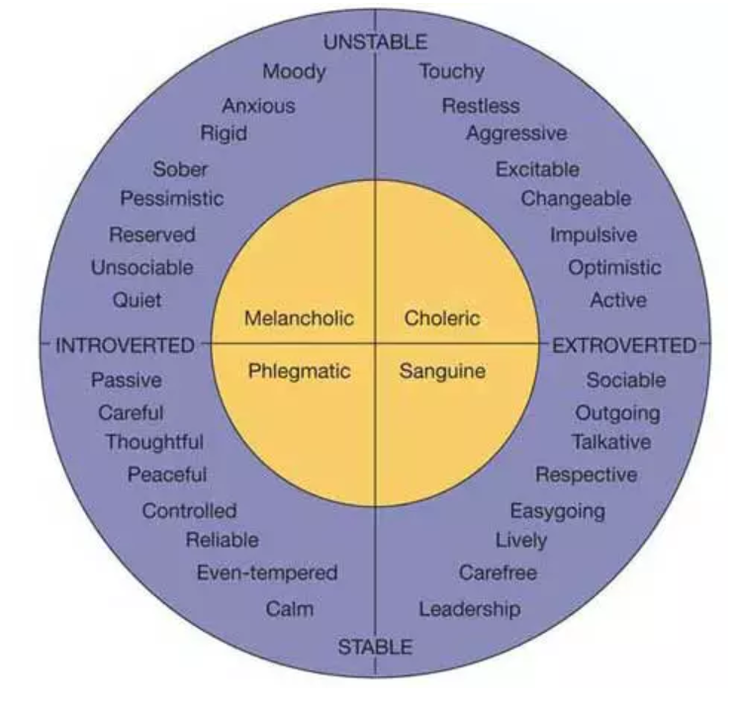
[Figure 1: Eysneck’s Personality theory]
This figure suggests that situations such as group work will affect an individual’s engagement and participation, as well as motivation; depending on the traits the participants have, such as talkative, leadership and reserved. Such qualities that could affect engagement in discussion and group work in positive and/ or negative way. If participants lean towards extrovert tendencies, this suggests that they could engage well when working with others. However, the stability of the individual’s personality will then affect how controlled they are working with others. Henceforth, if an individual leans towards an introvert personality, they could lack in contribution given during the task and could be taken over by an individual with more extrovert tendencies. As well as this, some will take advantage of working in a group and let other members complete the task. Hall & Buzwell (2012) found that many children are hesitant about group work because of these reasons of ‘free riders’ as well as conflicts. This, therefore, is important to ensure that every individual has some participation in the task.
Although literature suggests that collaborative work has a positive impact on one’s learning, there are limitations towards this method. Individual assessment is one that is clear due to the single, shared outcome. ‘Collaborative work is very important in everyday life but is forbidden by current norms of formal testing’ Black & Wiliam (1998:12). This is due to the lack of certainty of individuals work and therefore does not give a true reflection on an individual’s participation as well as ability. When concerning verbal discussions, it is difficult to monitor the engagement of every pupil and can appear unrealistic without digital support, which could raise cost issues. Additionally, individuals’ strengths are unique, and those that may not meet expectations in written work could excel verbally. Henceforth, if collaborative assessment does develop, it would be an ideal opportunity for children who are better verbally to gain confidence and raise expectations of the teacher. However, as suggested by Hall & Buzwell (2012) this can also be a frustrating experience if every member has the same mark and the contribution is not equally distributed.
Methodology
My research partner and I undertook a lesson study in order to gather information that build an answer to a shared, focussed question. Lesson study is beneficial to us as student-teachers as it is an opportunity to recognise ways to improve our teaching (Cordingley et al, 2004) through the observation of children’s learning and progress (Hopkins, 2014). Additionally, the opportunity to be actively involved in research through practice.
The process of a lesson study involves collaboration through planning, observation, discussions and reflections. As seen in figure 2 below:
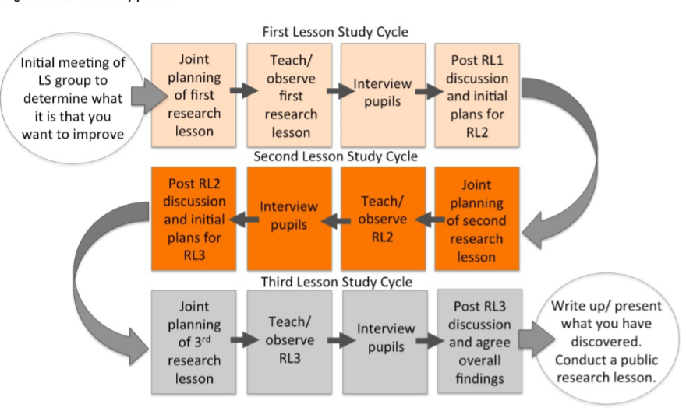
[Figure 2: Dudley’s Lesson Study Process]
Dudley (2014) indicates that the process consists of three cycles. However, as a pair of researchers, we were only able to undertake two cycles. This could be a limitation as the discussion after the second lesson study generated ideas that would have been beneficial to investigate further. Henceforth, would result in a more detailed and understood results. As suggested by Hopkins (2015) there is more progress when there are a number of study lesson in a series; however, the information gathered within the two conducted does identify progress.
The lesson study consisted of three pupils from two different Year 2 classes. In order to identify our focussed group, we used an online randomiser. This ensured that there were no bias or personal reasons to choose the participants.
For the observation, we chose to adopt a non-participant approach. This method ensured that there was limited influence from the observer and ensured that the lesson was as authentic as possible. The Hawthorne effect suggests that any observation taking place will inevitably affects the performance of the pupils due to their awareness and natural response of having an onlooker (Cosser, 1998). The observer could be a distraction for children therefore they will pay less attention to the teacher and the task, which is a significant factor to consider as the focus is on pupil engagement. Ideally to avoid such effect, the observer would appear ‘invisible’ (Taber, 2007). Arguably, there could be ethical issues that could arise if the observer attempts to hide or be of absence in a classroom (Ibid, 2007).
To record the observation on our focussed children, we used the Leuven scale as seen in appendices (page 22). We adapted the Leuven scale to suit what we required. This adaptation allowed us to be able to gather both qualitative and quantitative data. One part using the distinct categories of engagement on the Leuven scale, which ensured that both observers could follow the identical description of each level (as seen in figure 2): avoiding personal perceptions. The second part allowed observers to take notes in order to support the grade given on the Leuven scale.
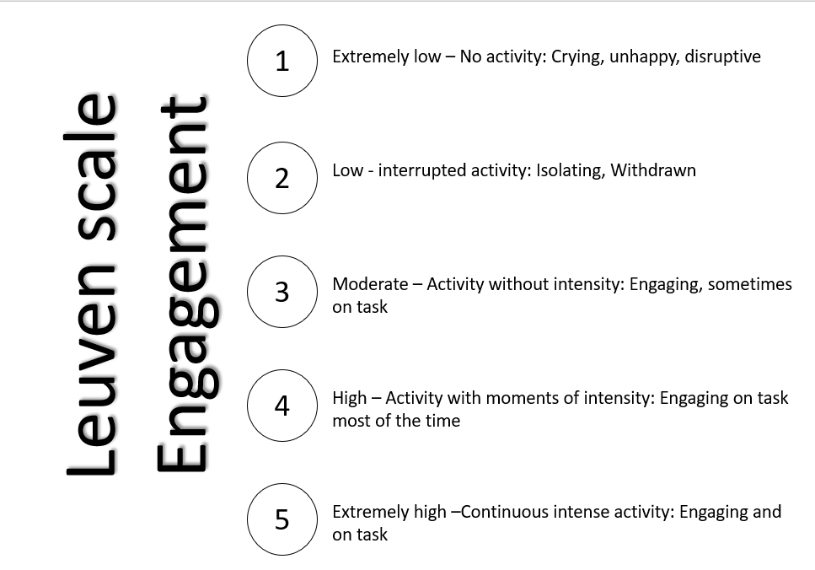
[Figure 2: Adapted Leuven Scale created and practiced by researchers]
Alongside this, we had constructed an observation schedule (as seen in appendices page 19).
Continuing to follow Dudley’s process, we promptly interviewed the children after the lesson. We undertook this as soon as possible to ensure that the experience was ‘fresh’ in their young minds. We conducted a structured interview in order to gather more qualitative data. However, while designing this, we had some considerations to acknowledge such as removing ambiguity, using language the children will be able to understand and avoiding offering desired answers when asking questions. We noticed that the interview was a little extensive and could result in a loss in interest and/ or fatigue. Therefore, we actively altered the interview and condensed the number of questions. Although this decision could mean that the information preferred wasn’t all gathered, it could also have been beneficial to ensure that the answers given was of higher quality.
Following the observations and interviews, my research partner and I used Gibbs Reflective Cycle to plan our reflection (Kolb, 1984). This has six distinctive stages, leading from a description of the event through to conclusions and considerations for future progression, as seen in figure 3 below:
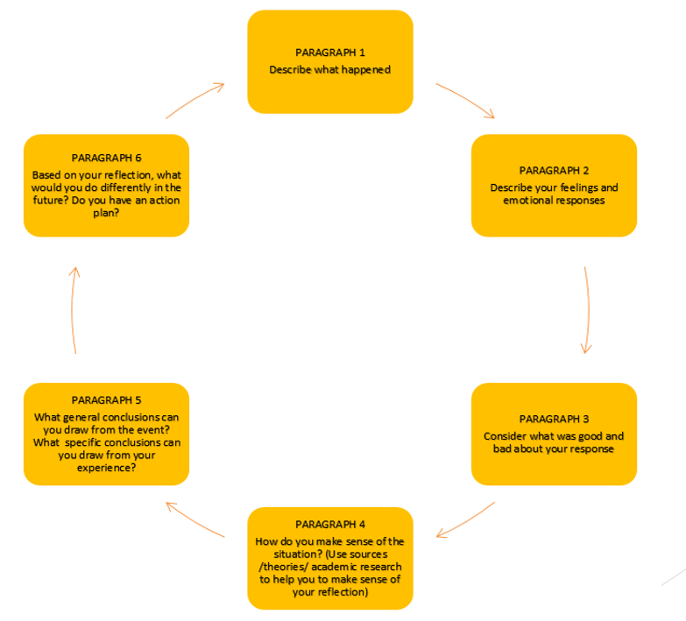
[Figure 3: Models of reflective practice: Gibbs, 1988]
Tripp (2012) outlines the importance of reflective practice. Reflection promotes and maintains awareness of professional development and acknowledge new actions and strategies that henceforth, maximising successes in successful teaching and learning.
We closely followed the BERA (2018) guidelines while acknowledging the ethical considerations. Prior to any formal research, parents of the focus group pupils received an information sheet and a consent form to return to us as researchers. Pupils will then had a assent form to complete to show willingness to participate in the project (as seen in appendices pages 6-18). We have ensured that the participants are anonymised and will refer to each pupil as Pupil 1-6, as well as giving limited personal information about the child in order to keep their identity anonymous. All raw data were kept in a locked cupboard and online data was stored in a password protected file to ensure confidentiality. When the records are no longer needed, they will be disposed and destroyed. One parent has requested the findings of this research, therefore it is important to limit the information to ensure that any identity is kept anonymous and that there is no bias throughout the research.
Lesson Study
Lesson study 1 and 2 followed the same lesson plan and resources; and presented to the same age group. This therefore had minimal changes to have a more realistic comparison with each lesson study. The more elements in a research project that is kept the same the more reliable the observations, comparisons and results will be.
This lesson required the children to work in mixed-ability groups of around 5 to respond to a story book by thinking of ideas of ways to help the local wildlife as a class and as a school. This consisted of completing a mind map as a group through discussion. As the teacher in the first lesson study, I found that this went well; all the children understood what was expected of them and achieved the lesson objective. However, this was identified through one piece of work therefore an equal input from each group member would be unlikely.
As a student-teacher, prior learning is not always clear. Therefore, I particularly found the research prior to the lesson useful, where I shared the ‘rules’ or expectations effective before setting the task (as seen in appendices page 4). Grigg (2010) states that in order for group work to be successful, ground rules must be recognised and understood.
It was clear from this that the class were familiar with group work. However, it was less evident that the children would work in mixed ability through the frequent exclaim ‘I’m not in that group, Miss.’ This was clear that the majority of group work the children had experienced were in ability groups and that working in a mixed ability group was a new and unfamiliar opportunity.
Before sending the class to their groups and undertake the task given. I allowed the opportunity to discuss ideas as a class in order to activate ideas, in hope to subsequently provide confidence to discuss within their peer groups during the task.
During the task, Pupil 1 showed a lack of confidence when discussing within their group, however it was evident that this child was on task by engaging through listening to group members. They wrote down their ideas on the mind map but did not wish to share with the group verbally. This child showed a considerable amount of understanding of the task from written work however did not feel confident verbally to discuss ideas, although reassured by the teacher and Pupil 2 that the ideas were good and could be very effective. Pupil 1 appeared uncertain with spelling when writing but did not ask for any help from another group member and continued to misspell a word. This supports that it requires confidence to request help and learn from a more knowledgeable other.
Pupil 2 presented a great deal of interest within the topic and enthusiastic to complete the task. This pupil shared a series of ideas as well as providing comments on others’ ideas, displaying active listening and valuable engagement. Pupil 2 showed true empathy through their ideas to help the wildlife. They also showed a considerable amount of confidence by contributing several ideas verbally and leading the majority of the discussions. This child showed willingness to help other group members. Towards the end of the lesson, Pupil 2 showed a lack of concentration and disengaged a couple of times. While Pupils 2 was disengaged, the group appeared to all be off task or silent which suggested that the ‘glue’ to the group was pupil 2. This disengagement of pupil 2 could be because they shared all their ideas and therefore went off task or that they noticed that the ideas were mostly conducted through themselves therefore chose to step back. However, much of this discussion was aimed at the Teaching Assistant.
Whilst observing Pupil 3, it was evident that there was a lack of interest in the theme of the task which lead to no engagement or contribution to the learning. There was no evidence of any discussion skills practiced such as sharing ideas, or active listening. This child payed more attention to other groups and gazing around the classroom. The teaching assistant repeatedly attempted to ensure engagement through asking questions and prompts, reinforcing the task and eliminating the distractions by positioning herself appropriately.
At the end of the lesson for the plenary I provided the opportunity for ‘magpie’. This is when each group shared one idea with the class, which henceforth would help groups that did not complete the mind map by ‘borrowing’ others’ ideas in order to complete the task. Pupil 3 showed confidence to participate in this part of the lesson but said an idea that had already been shared by another group to the class. This could show that there is an understanding of the task and a possible lack of interest in other’s ideas and therefore, listening. Following this, Pupil 2 showed further confidence by volunteering to share an idea in a larger group. They described in detail with no prompting or hesitance to expand on other children’s understanding of the idea.
Following the lesson, we conducted an interview with the focussed children to gain a greater understanding of their thoughts throughout the lesson. We interviewed all three children together. One particular response stood out, when asked ‘how does group work make you feel?’ These responses varied from ‘its hard to concentrate because it is noisy when everyone is talking at the same time’ to ‘I enjoy it because my friends can help me’. Pupil 3’s response reflected on his behaviour throughout the lesson stating, ‘I like group work because it is less work’. This suggests that his lack of engagement was due to his perspective that other group members will complete the majority of the work and means that the input is distributed and therefore less work for Pupil 3.
Grigg (2010) suggests that student-teachers need to learn and balance the skills of ‘questioning, promoting, probing and elaborating’ with taking a ‘back seat’ and allowing the children to lead discussion. From the observation of the first lesson study, we were confident that the level of challenge in this task was suitable for each group as a mixed ability. As student-teachers, a priority of ours when reflecting on a lesson is next learning steps of the pupils and how we can improve as teachers. Therefore, we decided that an adaptation we would like to observe would be withdraw any adult intervention such as asking questions to prompt answers as well as intervene in order to maintain pupils’ engagement. This subsequently would give us a more authentic pupil discussion and true representation of pupil motivation and engagement.
As discussed earlier, the approach to the task was identical but tested on a different class. Overall, there was more evidence of pupil engagement and motivation, however a sense of collaboration and teamwork was limited. Each child appeared to want ownership of their ideas and did not see the completion of the task as a collaboration or one single final piece of work with shared ownership and responsibility.
Pupil 4 had the highest mark on the Leuven scale which shows that this child was engaged and on-task throughout. This pupil showed leadership within the discussion and gathered everyone’s attention before sharing ideas as well as taking charge of the writing involved in the task. However, this child did not like to share responsibility of writing which lead to disagreements with Pupil 6. Pupil 4 also showed teamwork by involving other members in discussion, through asking other members questions such as ‘do you have any ideas?’ and encouragement when required. Pupil 4 exclaimed ‘we need to catch up!’ which showed competitiveness against other groups within the class, as well as activating other group members motivation. Additionally, this pupil showed good listening skills and added reassuring feedback to others’ ideas demonstrating support and empathy.
Pupil 5 announced ideas with ownership, they did not wish to discuss any further and believed that their participation to the task was complete. This child showed great confidence and interest in leadership but appeared to be dominated by Pupil 4. This led to a disagreement between Pupil 4 and 5 of whom was to write. This child showed an understanding to the rules presented when suggesting taking turns in the written task. Pupil 5 showed interest during his turn to speak but disengaged almost instantly when another group member was talking. They did not show any listening skills or participate in active discussion.
Lastly, Pupil 6 appeared to lack in confidence and comfort when working within a group that included domineering members. Although this pupil suggested a well thought out idea showing great understanding of the task; this was only shared with the group when prompted by Pupil 4. Their response furthered the evidence of uncertainty and a lack of confidence, ‘I only have one idea’. This child did not show any interest in leading the discussion nor mind having a turn writing.
The interview following lesson study two proved that the children understood the task and did not require any adult intervention or help. When asked whether they preferred to work within a group or on their own there were two contradicting answers.
Pupil 4 and 5: ‘It is lonely working alone and you don’t have friends to help you.’
Pupil 6: ‘I don’t like working in a group because I am shy, I prefer to work on my own because there is not as much noise.’
These responses determine that social skills and comfortability has a great influence on an individuals’ opinion of group work. Additionally, it shows that children differ in learning styles and what ways work best for them.
Discussion of research findings in relation to related literature and research.
Although there are similarities between the focus pupils’ engagement according to the Leuven scale, it is clear through the analysis that the reasoning behind the amount of engagement varies. I believe that this research question has endless amount of answers as there are numerous factors that could be considered from pupil to pupil, lesson to lesson, day to day. Such factors include confidence, interest, group members, and thoughts and feelings of the pupils. ‘High levels of involvement, coupled with high levels of well-being – that’s the perfect recipe for deep learning and development.’ (Arenich, 2018:1).
There are common themes surfacing when gathering literature and raw data, such as personality traits, confidence and interest within the topic.
Feelings and interest towards the topic in this lesson study was essential in order to get a response of ways to help. This means that in order to come up with ideas the individual must show true passion and willingness to help the wildlife. As presented by Pupil 3, there was no interest in the topic or helping peers with completing the work. Referring back to Hall & Buzwell (2012) this could be a disadvantage for the other group members as the work was complete without Pupil 3’s contribution.
On the other hand, Pupil 4 showed great enthusiasm towards helping wildlife which lead to the majority of the task produced by this child. However, Pupil 4 did show some leadership and dominating features which resulted in other group members not having an equal amount of contribution, whether it was against their wish or not. Pupil 4 is a male participant, and through research, males tend to adopt a more dominating and directive role during collaboration than females (Hattie, 2009). Considering this to be true from the literature is reliable, however, in the lesson study there was only one female selected through the randomiser and therefore is not a true representation to compare this statement.
This shows the importance of working as a part of a team and that the ground rules should be followed. Grigg (2010) suggests that group members should have roles within their team to avoid any conflicts or dominancy.
Referring to appendices (page 18), there are clear signs of engagement from the work produced was complete. However, supporting Hall & Buzwell (2012), there is no evidence on the discussion or contributions made by each individual. Through the observation there were many personality traits evident across Eysneck’s diagram, as well as a variety in one’s confidence. I believe that this had a great impact on the engagement in group work.
During the interview, children showed confidence within each other through saying that they can help one another with the task. This was proven when the participants helped each other with spellings in both lesson studies. During individual work this is a situation that is less common to see, and therefore is understood why teachers often see this as a ‘free’ time. As well as this, it supports that children can help facilitate each other’s learning (Watkins et al, 2007).
Overall, group work appears to be a successful strategy to engage pupils in the task but as individuals, everyone will have their own preferences, as suggested by Pupil 6 in the interview. This is reinforced by Raidal & Volet (2009) where preferences vary between everyone on how they like to learn and work.
Evaluation
There are many factors that I would consider changing for any future research to ensure validity and a better representation of all types of primary school children.
Firstly, as the randomiser used only chose one female during this project, I will ensure that the randomiser used can determine how many of each gender we would like to participate. This henceforth, will give a better representation of each gender and which can link to the vast amount of literature on primary school aged boys and girls and their learning types to compare.
For future research, it would be beneficial to have the opportunity and time to interview the focussed pupils individually in order to eliminate any influence on the answers given by peers. Additionally, this method would provide the opportunity for each participant to have a contribution to the answer of every question.
The engagement of schools and teachers on a broader scale is an apparent way that would also provide further evidence, analysis and greater understanding of the impact on a greater variety of pupils (Rahardjanto, 2019). Henceforth, this will help improve the use of group work and collaboration to improve engagement and therefore efficient learning.
Recommendations
In my next placement, I would continue to use collaborative learning to take full advantage of the layout of the classroom and the evidence of its positive impact on this contemporary way of learning. However, I will consider changes when using collaborative learning. I would use a ‘talking object’ so that primary aged children have a visual feel of taking turns and listening to the group member holding the object. I would also like to introduce a timer to ensure that the children all have an equal amount of contribution within discussions which henceforth will benefit any assessment for learning. With older children, I would like to introduce roles for the group members to have a greater sense of a multidisciplinary team and responsibilities of each role.
Next time, I would like to focus on providing opportunities that could build children’s confidence. This will then help individuals to express ideas through increase the number of members in a collaborative group slowly. For example, allow children to work in pairs then slowly increase group number along with their confidence. I will ensure to avoid any anxiety or negative feelings and show a welcoming and open mind when discussing opinions and ideas.
Eventually, I would like to introduce reasoning and argumentative skills for children. I would do this using debate or a controversial scenario where the pupils will be able to express their opinions as well as practice Piaget’s theory as referred to in the literature review.
To avoid any assessment limitations, I could overcome this by using learning through a cooperative approach, as suggested by Watkins et al (2007). This is when children can continue to work and discuss in groups while completing individual tasks.
Conclusion
There are many other contributary factors that we must consider that can affect one’s engagement in group work, such as the environment, confidence and an individual’s wellbeing. However, there was a clear interest and engagement with pupils with high interest and confidence in discussion and contribution to the work.
To conclude, as with many approaches with teaching it is all dependant on each individual. It appears very difficult to use the best approach for each individual and therefore is extremely important to have a good balance of a variety of teaching and learning techniques and strategies as suggested by Donaldson (2015). What works for one pupil does not necessarily work for another and this is down to preferences, needs, experiences and personalities.

References
Arnerich, M. (2018) How to Apply The Leuven Scales in Practice. Available at: https://famly.co/blog/management/leuven-scales/ (Accessed on: 6th February 2020)
Baines, E., Blatchford, P. & Webster, R. (2015) ‘The challenges of implementing group work in primary school classrooms and including pupils with special educational needs’, International Journal of Primary, Elementary and Early Years Education, 43(1), pp. 15 – 29.
BERA (2018) Ethical Guidelines for Educational Research. Available at: https://www.bera.ac.uk/publication/ethical-guidelines-for-educational-research-2018online#community (Accessed on: 5th February 2020).
Black, P. & Wiliam, D. (2001) Inside the Black Box: Raising Standards through Classroom Assessment. Department of Education & Professional Studies.
Cordingley, P., Bell, M. and Rundell, B. (2004). How does CPD affect teaching and learning? Paper presented at the British Education Research Conference, 18 September 2004, UMIST, Manchester.
Cosser, M (1998) ‘Towards the Design of a System of Peer-Review of Teaching for the Advancement of the Individual within the university’, Higher Education, 35(2), pp. 143-162.
Dillon, J. T. (1994) Using Discussion in Classrooms, Buckingham: Open University Press.
Donaldson, D. (2015) Successful Futures. Cardiff. Available at: http://gov.wales/docs/dcells/publications/150317-successful-futures-en.pdf (Accessed on: 1st February 2020).
Dudley, P. (2014) Lesson Study: A Handbook. Available at: http://lessonstudy.co.uk/wp-content/uploads/2012/03/new-handbook-revisedMay14.pdf (Accessed on: 20th February 2020)
Grigg (2010) Becoming
Grigg, R. (2010) Becoming an Outstanding Primary School Teacher. Essex: Pearson Education Limited.
Hall D, Buzwell S. The problem of free-riding in group projects: looking beyond social loafing as reason for non-contribution. Active Learning in Higher Education, 14(1) pp. 37–49.
Hattie, J (2009) Visible Learning: A Synthesis of Over 800 Meta-analyses Relating to Achievement. London: Routledge.
Hopkins, D. (2014) A Teacher’s Guide to Classroom Research. 5th ed. Berkshire: Open University Press.
McLeod, S. (2017) Theories of Personality. Available at: https://www.simplypsychology.org/personality-theories.html (Accessed on: 6th February 2020).
McLeod, S. (2018) The Preoperational Stage of Cognitive Development. Available at: https://www.simplypsychology.org/preoperational.html (Accessed on: 3rd February 2020).
Rahardjanto, A. (2019) ‘Impact of Implementation Crashes between Lesson Study and K-13 Curriculum in Educational Services at School: A Case study in Batu, East Java, Indonesia’, Advances in Social Science, Education and Humanities Research, 349, pp. 627-631.
Raidal, S.L. & Volet, S. E. (2009) ‘Preclinical students’ predispositions towards social forms of instruction and self-directed learning: a challenge for the development of autonomous and collaborative learners’, Higher Education, 57(1), pp. 577–596
Reid, G., Eggemeier, T. & Nygren, T. (1982) ‘An individual differences approach to SWAT scale development, Proceedings of the Human Factors Society Annual Meeting, 26(7), pp. 639-642.
Scrager, K., Boonstra, J., Peeters, T., Vulperhorst, J. & Wiegant, F. (2016) ‘Collaborative Learning in Higher Education: Evoking Positive Interdependence’, CBE Life Sciences Education, 15(4) article 69.
Shuell, T. J. (1986) ‘Cognitive conceptions of learning’, Review of Educational Research, 56(4), pp. 411-36.
Social Pedagogic Research into Group-work (no date) SPRinG Project: Improving the effectiveness of pupil-group-work in classrooms. Available at: https://www.spring-project.org.uk/ (Accessed on: 20th February 2020)
Taber, K. S. (2007) Classroom Research and Evidence-based Practice: A Guide for Teachers. London: SAGE Publications ltd.
Tripp, D. (2012) Critical incidents in teaching: Developing Professional Judgment. London: Routledge.
Watkins, C., Carnell, E. & Lodge, C. (2007) Effective Learning in Classrooms, London: SAGE Publications Ltd.
Welsh Assembly Government (2010) Why develop thinking and assessment for learning in the classroom? Available at: https://hwb.gov.wales/storage/2d2b99cd-5431-421e-ac8b-8608fe0edf05/why-develop-thinking-and-assessment-for-learning-in-the-classroom.pdf (Accessed 2nd February 2020)

