  Plaza Hotel, New York | Nicodav consult ltd  delivery date: 11/11/2024  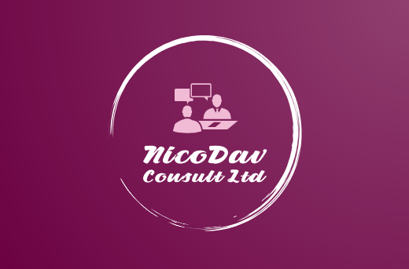  Ana-Maria Savulescu  2208665

1. CONTENT TABLE

- CONTENT TABLE…………………………………………………………………..1
- EXECUTIVE SUMMARY…………………………………………………………...2
- INTRODUCTION………………………………………………………………..…..5
- ANALYSIS ………………………………………………………………………...…7
  - Issues That Affect the Hotel on a Larger Scale…………………………..7
  - PESTEL Analysis………………………………………………..…………10
  - Positive Performance and SWOT Analysis…………………...…………11
    - Positive Performance…………………………………………..………11
    - SWOT Analysis…………………………………………………………12
  - TOWS Analysis……………………………………………………………..13
    - TOWS Matrix……………………………………………………………13
    - Strength-Opportunity Strategies……………………………………...13
    - Strength-Threats Strategies…………………………………………..14
    - Weakness-Opportunity Strategies……………………………………14
    - Weakness-Threats Strategies………………………………………...14
- RECOMMENDATIONS……………………………………………………………15
  - Implement Smart Room Technology……………………………………..15
  - Design mobile check-in and Keyless Entry……………………………..16
  - Enhance Wi-Fi Infrastructure……………………………………………..16
  - Develop and Institute a centralized smart Guest Experience Management system………………………………………………………17
  - Utilise Technologies that will employ Efficient use of Energy………….17
  - Integrated real-time feedback tools………………………………………18
  - Organize Training Sessions for the Staff on New Technologies………19
  - Manage Online Identity……………………………………………………19
  - Develop a Loyalty Program with incorporated Technology……………20
  - Redesign website and reservations platform……………………………20
  - Provide Virtual Tours of the Hotel………………………………………...21
  - Augmented reality experience should be embedded…………………..21
  - Eco-friendly Initiatives……………………………………………………..22
  - AI for Personalised Marketing…………………………………………….23
- ACTION PLAN……………………………………………………………………..24
- CONCLUSION……………………………………………………………………..26
- REFERENCES……………………………………………………………………..28

2. Executive Summary

The Plaza Hotel is an internationally recognized, five-star luxury hotel whose operational circumstances have become critical to threaten its status in the competitive hospitality markets. With a reputation for fabulous service, a prime location, and rich heritage, in a sense, the hotel has fallen behind at the aspects regarding what today's guests, through the influence of technology, increasingly expect from even high-end hotels. This lag in innovation is leading to a decline in guest satisfaction, thus impacting on the hotel's financial performance and overall standing. No modern digital services, such as smart room technology or mobile check-in options, is going to be a critical issue for The Plaza, considering these features are now common among its competitors. The result in the failure on the part of the hotel to upgrade is directly proportional to the decrease in repeat business since guest turnout has fallen over the last years.
Those days are gone when people are traveling to a very fancy resort and are satisfied with just a view and basic amenities, but today's guests desire flawless digital experiences to complement the best amenities money can buy.
With a reluctance to invest in new technologies, The Plaza has created in the minds of guests a perception of itself as something antiquated and less convenient than other luxury options. This is particularly damaging because, in this current day and age, online reviews and word-of-mouth recommendations from travelers collectively have the greatest influence on consumer decisions. The hotel has also been subject to growing disgruntlement on sites like TripAdvisor, as many guests have voiced complaints about the general lack of technology and digital amenities in-room that have come to be expected from the luxury segment of the market. Negative comments have resulted in a significant downtrend in the hotel's reputation, translating into a drop in repeated bookings. Also, there are concerns that the management of the hotel has also resisted changing key business processes, which might have slowed the pace at which some other technological upgrades have been put in place.
The analysis identifies several root causes of the hotel's current problems. Probably, the most significant disturbing factors would be the management's resistance to change due to uncertainty about modernization costs and a loss of the hotel's classic image.
While the upkeep of tradition is important for a historic brand like The Plaza, the inability to balance heritage with innovation has resulted in considerable losses regarding its market competitiveness. This investment in smart technologies, mobile services, and digital personalization tools will be quite costly. However, the long-term benefits that come with improving guest satisfaction and loyalty could often offset the initial investment. Besides, the luxury hospitality industry worldwide is faced with a new reality that is increasingly tech-savvy, dictated by the demands of younger, more affluent travelers desiring convenience and customization. The Plaza has refused to move along these trends in the industry, therefore it is dying appeal-especially for millennial and Gen Z travelers who expect luxury to be synonymous with both comfort and the most advanced technology.
Based on the findings, there are a few recommendations that could bring back The Plaza Hotel to its competitive position in the market. For starters, the hotel needs to invest in updating its infrastructure with smart rooms, mobile check-in services, and personalization systems using data analytics. In so doing, the hotel will be able to give its guests a more modern and full-of-convenience experience that is very critical for retaining existing customers and gaining new ones. Moreover, a continuous development of the online reputation of the hotel through implementing guest-focused processes must be engaged, including engaging with guests actively through digital means, responding to reviews, enhancing its digital visibility through social media and ensuring customer feedback flows into further improvements in service and technology. It is also recommended that the management team be trained in changing management practices as well, so they may better understand how to integrate technologies of today without compromising the hotel's classic brand.
These strategies, if put into place, will bring impactful benefits to The Plaza Hotel. Firstly, the development of the technological infrastructure will provide increased satisfaction for guests and expedite operations. For example, mobile check-ins minimize queueing at the front desk, and smart room features mechanize energy-saving processes, which will eventually lead to cost savings. Moreover, since The Plaza will be able to address the root causes of dissatisfaction for the guests, it will have begun rebuilding its reputation as a leading luxury hotel-a key driver of profitability in the long run. More key performance indicators to accompany successful results for these initiatives are increased guest satisfaction scores, higher occupancy rates and improved profit figures. If well-planned and properly executed, the opportunity exists for The Plaza Hotel to once again join the echelons of the very finest luxury destinations, integrating historic charm with the needs of the modern traveler. In essence, The Plaza Hotel has reached that pivotal juncture where failure to push out innovation might mean unabated financial decline and loss of relevance within the marketplace. This status quo approach can be shifted, however, as the hotel embraces its modern technological investment and change process, continuing to regain its reputation and secure further success in the years to come. These recommendations are purposed to enable The Plaza to meet the evolving expectations of luxury travelers while perpetuating its legacy as a destination for high-end accommodations.

3. Introduction
This consultancy report investigates a major impact problem that is faced by The Plaza Hotel-a five-star hotel in New York. The Plaza Hotel was opened in 1907 and has 282 luxurious rooms, of which 102 are suites and include not only classic elegance but also all modern amenities. It is, however, still struggling to integrate technology despite its historic importance and reputation for luxury (Turkel, 2024). Because of this, customer satisfaction has been on the decline, hence affecting competitiveness against other technologically viable hotels, especially for the younger and more tech-savvy guests.
The lack of in-room technology upgrades and limited automation have resulted in negative online reviews and reduced repeat business. Because customer experience is the most important thing in the hospitality industry, failure to adapt to current trends in technology poses a very serious threat to the long-term competitiveness of the hotel and the loyalty of its guests (Booking.com, 2024). The report provides an expert recommendation for resolving the issue at hand by newer technological enhancement hospitality solutions, a consultancy firm with expertise in the fields of hospitality and technological innovation. With great experience, the firm has been capable of taking the opportunities of luxurious hotels to the most advanced technologies in a way that enhances the guest experience, facilitates seamless back-of-house operations and fosters brand prestige. In this assignment, the consultation report will be leveraging modernization through brand preservation, presenting a strategic solution adapted to the unique needs of The Plaza Hotel.
The subsequent section shall present a detailed problem examination along with recommendations that can be acted upon, using various strategic management frameworks. First, the PESTEL analysis will be used to discuss external factors influencing the technological failures of The Plaza Hotel. This model further explores Political, Economic, Social, Technological, Environmental and Legal elements for insight into how the reasons could be influenced by potential external pressures for the hotel's current slow technological adoption, such as regulations within the industry and the expectations of guests for service luxury (Carlo, 2021).
A SWOT analysis will also be done to review the hotel's internal strengths and weaknesses, coupled with opportunities and threats from the external environment. This will reveal how the reputation, location, and heritage of The Plaza Hotel can be used in order to take care of its weaknesses in the technological infrastructure and provide possible threats such as competitive pressures to serve as an opportunity for growth (Citra Birru et al., 2022).
Finally, the TOWS analysis will be built upon the SWOT findings by providing a more in-depth approach towards strategy. The report will also map up a road to technological upgrades for improving the guest experience at The Plaza while maintaining alignment with its luxury brand identity by matching strengths with external opportunities and dealing with weaknesses via strategic actions. In short, this report analyzes in depth the problem of using key business frameworks toward actionable, financially responsible and guest-centric recommendations to address declining guest satisfaction at The Plaza Hotel through the integration of modern technologies.

4. Analysis
The historic Plaza Hotel is well known for its five-star amenities yet is suffering from an extreme decline in customer satisfaction. The problem is straightforward-the hotel has fallen behind the curve when it comes to offering technology that today's hospitality industry considers non-negotiable. Sure, it stands as a symbol of affluence-but failing simultaneously to update its facilities, especially in-room technology and online services, is limiting its efficiency, brand engagement, guest experience and true bottom line (Chang et al., 2023).
-

4.1. Issues That Affect the Hotel on a Larger Scale
- Technological Lag: The absence of intelligent room facilities such as mobile check-in, voice assistant, VR room tour, AI for process automation and digital room controls is seriously impacting customer satisfaction (Das, 2023). Competition provides refreshing services to the current, tech-savvy traveler. The inability to meet such expectations leads to the creation of a perception that the hotel is outdated, thereby discouraging return visits and reducing customer loyalty (Domanski, 2020).
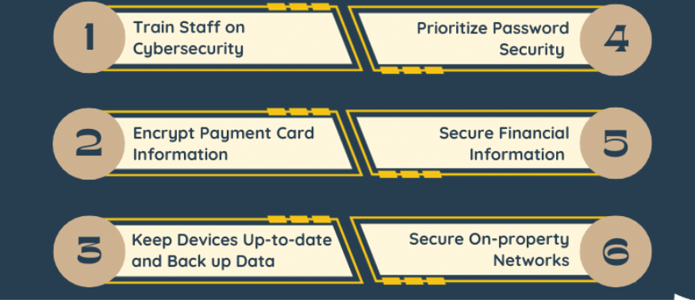
Figure 2: Strategies of data safety in the hospitality sector

- Loss of Guest Satisfaction: Guest reviews, obtained via TripAdvisor and Google Reviews, show a growing dissatisfaction by hotel guests with the older technological infrastructure of the hotel. For example, regarding bookings and room controls, guests expect smooth digital experiences when booking luxury hotels (Tripadvisor, 2023). It is well accepted that newer generation and luxury hotel guests held modern technology as one of the major determinants in booking a hotel, The Plaza's failure to live up to such standards has meant a decline in their sales for repeat bookings.
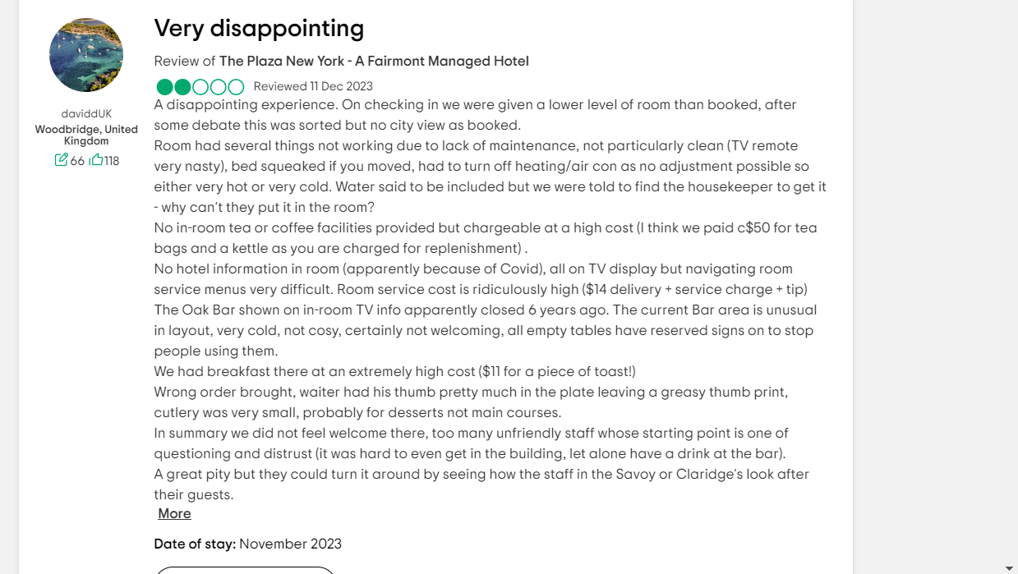
Figure 3: TripAdvisor negative comment related to The Plaza, NY

- Reputation Damage: Online complaints are diluting the Plaza Hotel's reputation as one of the best places of luxury since most of those complaints have expressed dissatisfaction with the amenities. In this light, word-of-mouth and online reviews are what will make or break the hotel industry (Kim & Kim, 2022). Adding to this, the increased competition with newer hotels that offer more modern experiences chips away at The Plaza's standing. With so many competitors on the market, travelers check reviews before booking-even slight dips in reputation can have massive effects on revenue.
- Income Decline: The technological deficiency of the hotel and its resultant impact on reputation have translated into a drop in occupancy. Recent financial data indicate on a global basis of hospitality that the hotel has suffered from a drop in RevPAR over the last 12 months due to its diminished capacity to attract and retain high-end customers (Khan et al., 2020).
The technology gap is pushing some guests toward its competition for a better balance between luxury and innovation.
- Causes of the Problem Resistant to Modernization: With the management seemingly cautious with the new technologies, probably out of fear of losing that classic and timeless brand identity, the Plaza Hotel has somewhat declined a key demographic in today's travelers and technology-savvy customers looking forward to blending technological conveniences with sheer luxury (Han et al., 2021).
- High Implementation Costs: Inhibitive costs of implementing technology upgrade initiatives present a challenge for the hotel. Technologies that involve investments in smart room systems, mobile applications, IoT devices, RFID and other digital enhancements are often expensive. However, reluctance by the hotel management to invest in these initiatives is proving more costly with the resultant deterioration in guest satisfaction and revenues (Ganapathi, 2023).
- Guest Expectations and Industry Trends: The modern guest expects digital convenience. Those luxury hotels that have already seamlessly integrated modern technologies such as keyless entry, smart TVs and voice-controlled devices into their operations are those that find it easier to thrive in an industry molded increasingly by personalization and automated services (Sharma & Gupta, 2021). Millennials and then Generation Z are increasingly going to hotels, and their expectations regarding technology are higher than in the case of past generations (Barone & Stagno, 2023).
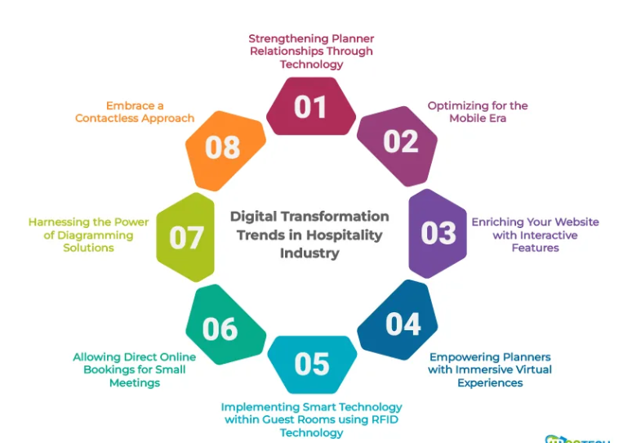
Figure 4: Benefits of using Digital enhancements in the Hospitality sector

4.2. PESTEL ANALYSIS
A PESTEL analysis would uncover the external factors contributing to the problem. This framework determines the Political, Economic, Social, Technological, Environmental, and Legal factors that affect The Plaza Hotel's challenges (Wood, 2024). The issues are presented on the table below.
Factor | Description
Political | New York’s regulations on data privacy and customer protection provide stringent guidelines on how hotels must manage guest data using advanced analytical tools like big data making the integration of digital services more complex (Cryan, 2024).
Economic | The hospitality market is resilient but more prone to economic variabilities, such as inflation and recession which can limit discretionary expenditure on high-end services like The Plaza's (Grussu, 2021).
Social | The shift towards experiential travel and the rising demand for personalization puts emphasis on hotels to give unique and tech-enhanced experiences that cater to modern travellers (Hargreaves, 2024).
Technological | Competitors are implementing AI-powered guest services, mobile apps and smart room systems to enrich the guest experience, while The Plaza’s failure to adopt these trends has left it behind (Singh, 2023).
Environmental | Growing issues over sustainability have pushed hotels to get energy-saving technologies such as solar power, low power consuming devices, etc. a field where The Plaza lags due to its old infrastructure (Mansour & El Shafey, 2024).
Legal | Stringent GDPR-style laws governing the management of guest data have pushed hotels to invest heavily in secure technology systems like encryption of data and other data safety measures which is a challenge The Plaza has yet to address effectively (Saft, 2024).

It has resulted in a scenario where the excellent reputation of The Plaza Hotel not only suffered several issues but also reeled under many severe jolts related to guest satisfaction and revenue generation. The problematic scenario is magnified further due to the external environment consisting of rapid change in the technological setup within the industry and emerging expectations of guests while internal resistance toward change and constrained financial resources are also major causes. Such challenges can be overcome only with strategic investments in technology for The Plaza to get back its glory of competitiveness in the luxury hospitality market segment (Bucher, 2016).

4.3. Positive Performance and SWOT Analysis

While The Plaza Hotel may have issues with its infrastructure being technologically outdated, the company is still very healthy in many areas of its business. Showing an awareness of these strengths is part of giving a fair discussion and perhaps finding the main reasons that could help solve this problem at hand.
4.3.1. Positive Performance
- Heritage and Brand Reputation: The Plaza has a history of luxury and a rather prestigious reputation around the world. Through its long history and still consistent branding, the hotel has managed to take in very wealthy travellers and retain customers-older guests, who treasure tradition over modern amenities (Elshaer, Azazz and Fayyad, 2022). Its heritage becomes a competitive advantage in the luxury market for those guests who seek exclusivity and class.
- Prime Location: Located in a historic location in New York City, The Plaza enjoys proximity to Broadway, Central Park, Fifth Avenue and even the Museum of Modern Art, making the hotel prime as people, both tourists and businessmen alike, will easily get attracted to its centrality (Plaza LLC, 2024).
- Excellent Service Standards: It is outstanding in providing the best services through well-trained and courteous staff and the provision of personalized services. Every guest at the hotel comments on the customer service at all touchpoints, right from concierge support to housekeeping, saying how attentive the staff is and committed to ensuring an excellent guest experience (Sakovska et al., 2021). This has been one strength that has helped in securing positive guest feedback and high ratings for its excellent service.
- Exclusive Offerings: Special offers include the culinary variety, customized choice of hospitality and beautiful designs among many exclusive event venues at The Plaza, for which no competitor can boast. Such special features help The Plaza carve a niche in the already congested luxury hotel market (Planet Lux, 2023).

4.3.2. SWOT Analysis

SWOT Factor | Details
Strengths | - Strong heritage and global significance.  - Prime location in New York City.  - Exceptional consumer service and exclusive offerings.
Weaknesses | - Technological lag, specifically in-room digital services.  - Increasing costs of modernization.  - Reluctance to change from management.
Opportunities | - Modernization of technology to satisfy guest expectations such as IoT, automation in check-ins, etc.  - Expansion of eco-friendly initiatives to appeal to sustainability-conscious guests.
Threats | - Rising competition from tech-integrated luxury hotels.  - Economic downturns impacting luxury spending.  - Possible legal issues due to outdated data privacy processes.

The Plaza Hotel still represents a symbol of luxury and heritage, and its prime location along with great service is still considered major strengths. Various shortages regarding technology need to be improved in order to exploit the market opportunities that eco-friendly innovations and modernization bring while minimizing outside threats and internal weaknesses (BusinessDojo, 2024).

4.4. TOWS analysis
The TOWS analysis will now translate the findings from the SWOT analysis into actionable strategies that turn The Plaza Hotel's challenges into opportunities. This framework will help in developing solutions by matching the hotel's strengths with opportunities and managing weaknesses against external threats (Dillingham, 2024).
4.4.1. TOWS Matrix
 | Opportunities (O) | Threats (T)
Strengths (S) | S1. Strong heritage and global reputation  S2. Central location  S3. Exceptional consumer service | T1. Other competent hotel chains.  T2. Inefficiency in the technological adoption.
Weaknesses (W) | W1. Technological lag  W2. High modernization costs  W3. Reluctance to change from management | W1. Technological issue  W2. High technical integration costs  W3. Resistance to change from management

4.4.2. Strength-Opportunity Strategies
- Heritage-Powered Technology Modernization: Drawing from the strong brand positional value of Plaza, modernizing technology facilitation the historical charm well to traditional and modern guests alike and involves flawless integration between luxury and technology for smart automation of the services in the hotel (Wu et al., 2023).
- Sustainability Leadership: It can also use its prime location by directing more toward green initiatives that could help attract an increasingly ecologically conscious traveler. Simultaneously, the hotel can avail itself of eco-friendliness due to which it can attract a rapidly growing sustainability market by building an environmentally friendly hotel using energy-efficient systems.

4.4.3. Strengths-Threats Strategies
- Brand promotion against business rivals: The hotel should be promoted based on its rich heritage, thus giving it an edge over other competitors. It should highlight its decades-earned reputation and luxurious service in order to beat the competition by technology-based hotels and by using efficient social media marketing channels for good digital visibility (Aydin, 2020).
- Enhance local partnerships: Partnerships with high-end brands or cultural hotspots close to the pivotal location buffer them from any revenue decline due to economic shocks as they generate high-end customer traffic.

4.4.4. Weakness-Opportunity Strategies
- Phased Tech Upgrade: The Plaza can pursue a phase-like investment pattern to cope with the technological gap in focused areas of high impact such as digital check-in and enhancement of guest experiences within well-managed costs (Wynn & Jones, 2022).
- Government Grants for Sustainability: The Plaza can offset the economic costs of modernizing through government funding allocated for the promotion of digital innovation and sustainability in historic properties.

4.4.5. Weaknesses-Threats Strategies
- Targeted Tech Investments: The Plaza Hotel will entrust resources only to critical upgrades like mobile apps for efficient booking and in-room experience.
- Change Management: Change management programs overcome the resistance to change by aligning leadership with modernization and sustainability goals through change management (Rabiul et al., 2023).
This TOWS analysis develops a comprehensive, actionable strategy for The Plaza Hotel in its struggle to balance the demands of its heritage with modern needs through innovative solutions.

5. Recommendations

5.1. Implement Smart Room Technology
- Description: Smart technology entails installing IoT gadgets/ appliances that enhance the independent operations of lighting, heating, AC, and entertainment gadgets of the guest rooms with the use of applications or voice commands from the guests (Luxury Hotels, 2024). While much attention is paid to complete house interoperability, the smart transformation may for instance consist of a smart thermostat, smart lighting system, or connected entertainment devices.
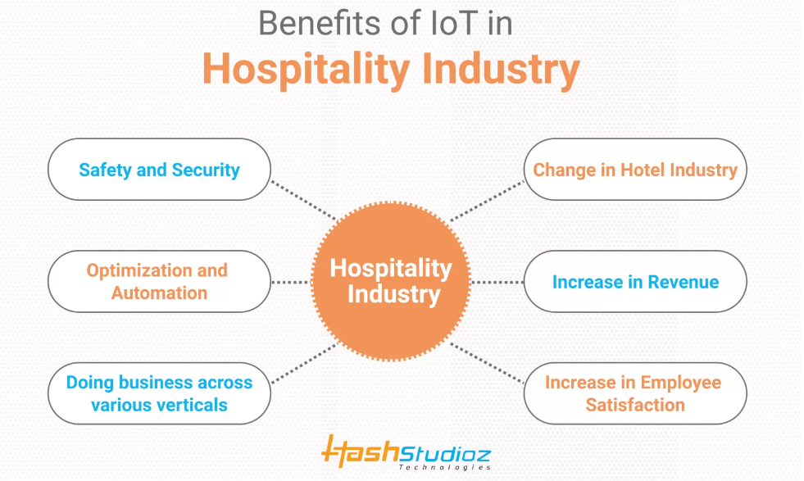
Figure 5: Merits of using IoT in the hospitality sector
- Rationale: Modern business travellers, and still more so those in the premium segment, expect technology to make their lives easier. Given the fact that guests are expected to have control over the internal environment of the hotel room, Plaza can build a relationship with technical-savvy individuals in line with innovation. Smart room technology impacts both the guests by enhancing the quality of services and making the hotel attractive and relevant to customers (Deri et al., 2024).
- Expected Outcome: The guest is also pleased when the environment that he or she is in is fully controlled by an individual therefore the introduction of the smart room technology will help make the guests pleased. It can produce positive feedback on the web page, helping to create more bookings and guest loyalty. But it also has the potential to come up with a unique selling proposition that sets it apart from other similar facilities like The Plaza (Karagiannis, 2024).

5.2. Design mobile check-in and Keyless Entry
- Description: The use of m-check in system allows guests to check in in advance and to open their room doors through their mobile phones. This system can be completed free from physical keys by using secure QR codes or Bluetooth technology.
- Rationale: As the world continues to turn, mobile check-in and keyless entry reduce times at the front desk and therefore improve the experience of the guests. This technology relates to the current popularity of touch-free interactions in hospitality, especially due to the current public health issues (Pego et al., 2024).
- Expected Outcome: It is in this line that The Plaza Hotel can enhance guests’ satisfaction level and organizational performance through check-in optimization. Direct access is enjoyed by guests as they do not congest in the lobby, especially during busy Check-in times. This system also can release front desk personnel for other guest-related services and thereby improve the corporation’s guest relations (Park et al., 2021).

5.3. Enhance Wi-Fi Infrastructure
- Description: Improving Wi-Fi in the given hotel means increasing connection speed and reach with high-speed internet inside the building, in rooms, in the lobby, and in meeting rooms.
- Rationale: A fast, and reliable internet connection is now a necessity in this generation for any traveller or businessperson. Not only do these improved Wi-Fi standards address these requirements but also the diverse use of guests including streaming services or video conferencing (Alrawadieh et al., 2020).
- Expected Outcome: An upgrade of the Wi-Fi is expected to increase guest satisfaction and return business from businesspeople and the youth. On the same note, a strong internet offering can position The Plaza as an attractive candidate for conferences and all events hence maximizing the revenue capacity (Blueprint, 2024).

5.4. Develop and Institute a centralized smart Guest Experience Management system
- Description: The concept of having a central hub for guests from which to gather, organize, and evaluate information about guests, their behaviour, and preferences contributes to a personalized guest experience. This system may also encompass features, which allow capturing information about conversations with guests, as well as services they have used previously (Gupta et al, 2022).
- Rationale: A guest experience management system also makes it easier for The Plaza Hotel to cater to guests’ needs since they are well anticipated. Consumers decide where to stay using experience, by giving analysis of data collected from previous stays, the hotel can make recommendations and offer special promotions to the consumers making the experience an interesting one.
- Expected Outcome: With the help of better personalization, it will be easier to retain guests and in turn, bring more of them as well. By meeting the needs and expectations of the consumers, they are more likely to repeat their stay with that hotel, hence potential long-term associations (Gelbrich et al., 2021).

5.5. Utilise Technologies that will employ Efficient use of Energy
- Description: Adopting several energy-conserving measures like intelligent lighting, energy-efficient heating systems, and solar power will go a long way in decreasing the amount of energy consumed by The Plaza Hotel together with the negative effects on the environment (Chan et al. 2020).
- Rationale: Many individuals and organizations seeking traveling services are nowadays placing a lot of importance on sustainability. In addition, with The Plaza Hotel investing in and implementing energy-efficient technologies, it is aligning itself not only for the benefit of economic revenues, but is positioning itself to appeal to such guests, improve its brand image, and help support the global fight against climate change and variability impacts.
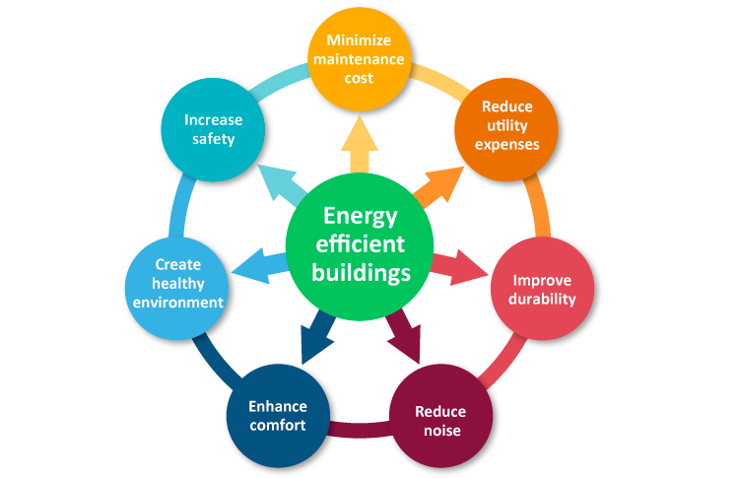
Figure 6: Merits of using energy efficient elements in the hotels
- Expected Outcome: By deploying these technologies, the hotel’s operating costs, especially energy costs will be cut, and the hotel will be perceived as an environmentally conscious and innovative company (Franco, 2021). This leads to an increase in the number of tourists who are sensitive to the environment, as well as loyalty among its clients.

5.6. Integrated real-time feedback tools
- Description: It is possible to use feedback kiosks in guests’ rooms and create applications for receiving surveys from guests during and after their stay.
- Rationale: Feedback systems ensure customers’ grievances are corrected in real-time and enhance service delivery thus the satisfaction level of customers is checked by the hotel. The ability to engage the staff in immediate feedback decisions empowers the staff to make correctors instantly which in turn improves the guest experience.
- Expected Outcome: This sustainable competitive advantage benefits guests and helps The Plaza Hotel to improve guest satisfaction and its image. What people like is to have their complaints heard and resolved promptly and this will enhance positive recommendations (Ghouri, 2021).

5.7. Organize Training Sessions for the Staff on New Technologies
- Description: Seminars for employees of the hotels will enable them to understand new technologies of hospitality and serve their customers. This initiative can comprise workshops, e-learning modules, and hands-on training sessions effectively (Vatan & Dogan, 2021).
- Rationale: Making certain that all the staff are conversant with the new technologies that go into making a guest comfortable is important. Skilled employees can therefore use technology to help deliver better services and interact with the guests.
- Expected Outcome: The standard of service delivery will be enhanced, and the guests will be more than content with service delivery by staff who are able to employ resources to deliver the best to guests (Truong et al. 2020). From the above analysis, it can be concluded that this training can enhance the level of personalized service and at the same time increase operational effectiveness.

5.8. Manage Online Identity
- Description: Part of reputation management entails constantly tracking guests’ reviews and, also participating in their social media interactions (Ahmed et al. 2022). Such a system can include means for tracking the sentiment expressed and overall feedback trends.
- Rationale: Effective ORM for The Plaza Hotel enables combating negative comments, and thus improving the online reputation of the company. It is also more effective to engage the guests because it reflects that the hotel is willing to listen to the views of its customers and is willing to change for the better (Allard et al. 2020).
- Expected Outcome: The subsequent sections will focus on the following objectives: By e-reputation management, The Plaza Hotel can foster guest loyalty and the number of stars on the travel websites. That is because more people are willing to go with a hotel that has been positively reviewed by other users than going to an unknown hotel (Alfarisyi & Ferdian, 2023).

5.9. Develop a Loyalty Program with incorporated Technology
- Description: When future-oriented, guest engagement could be advanced by implementing a loyalty program using a digital approach where the guest gains points each time they make a visit to the hotel and receives additional points each time they select a product from the list of their choices. The program can help monitor spending and individual preferences by offering special bonuses (Moghimi, 2024).
- Rationale: Due to this, a tech-integrated loyalty program will compel the guests to return by providing the items that they would be interested in. Personalization in experiences improves the client’s engagement and satisfaction (Chetty, 2020).
- Expected Outcome: Guest satisfaction will be enhanced by tailored rewards to compensate their return visits with improved revenues. Correctly built and implemented, the existing loyalty program also has the potential to improve The Plaza's competitive position in the luxury segment.

5.10. Redesign website and reservations platform
- Description: Among them is the redesign of the sites of the Plaza Hotel, which is the project of developing the mobile version of The Plaza Hotel’s sites and the booking system. This may involve, simplifying the simplicity of the booking process, beautifying the look, and including the option of real-time availability (LLC, 2024).
- Rationale: Presenting a modern and efficient website is important as it is the first point of contact for a guest. An optimized booking system also helps to reduce drop off rates to the lowest level and thus patrons are encouraged to book directly to the hotel the type of booking is more lucrative than using third-party bookings.
- Expected Outcome: A renewed website usually increases conversion rates since clean lines and easy booking are important to guest acquisition. Gastronomic and scenic upgrades will make the customer experience at The Plaza better, thereby boosting their perception of the place as a luxury joint and overall satisfaction (Abdel‐Hamid et al. 2022).

5.11. Provide Virtual Tours of the Hotel
- Description: The creation of VR tours will enable potential visitors to visit and tour The Plaza Hotel before making their bookings. Since such virtual tours are created electronically these can draw a focus on the hotels’ facilities including guest rooms as well as on the surrounding sights and attractions (Syahidi et al., 2022).
- Rationale: Virtual tours provide value to bookings by showcasing the real-life experience once clients make their reservations. To the targeted technical savvy customers, this technology can virtually paint the picture to the potential clients, contributing to enhanced sales conversion (Buhalis & Moldavska, 2021).
- Expected Outcome: Providing virtual tours may improve the number of tourists arriving at the hotel because customers are more confident when deciding. It can also help The Plaza stand out from competitors who might not include as interesting activities in the menu.
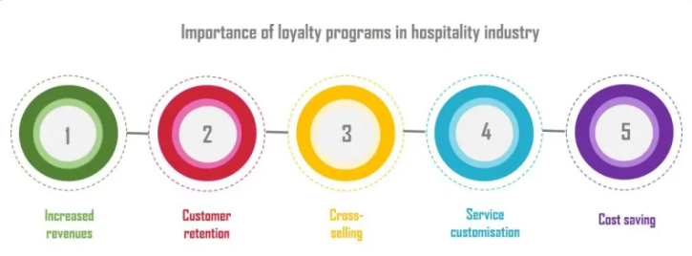
Figure 7: Significance of using loyalty programs in the hospitality sector

5.12. Augmented reality experience should be embedded
- Description: Augmented Reality (AR) used in advertising contexts and as applied to in-room entertainment contextualizes the physical surface of the hotel in ways that have not been done with previous media or advertisements. This could include AR maps, info layers, or active information objects in a room for example.
- Rationale: AR can help in constructing potentially more appealing and meaningful guest experiences that allow the guest to interact with the environment in smarter ways. It acts like a marketing strategy that can capture the eyes of the guests looking for new techniques to be offered (Balasubramanian et al., 2022).
- Expected Outcome: The AR operation can bring a higher level of guest satisfaction and enhanced marketing reach in the social media platforms in which the guests will share their experiences (Theocharidis et al., 2020).

5.13. Eco-friendly Initiatives
- Description: Organizational initiatives for the protection of the environment including prohibiting the use of plastics, introducing the recycling policy, and procuring products sourced locally will improve The Plaza’s sustainability (Nuong et al., 2024).
- Rationale: Today’s travellers are more conscious of the environment, and the sustainable practices enforced by a hotel will be preferred most of the time. The organization should make an appearance that conforms to environmentally friendly policies to align itself with this segment and improve its image (CBRE, 2023).
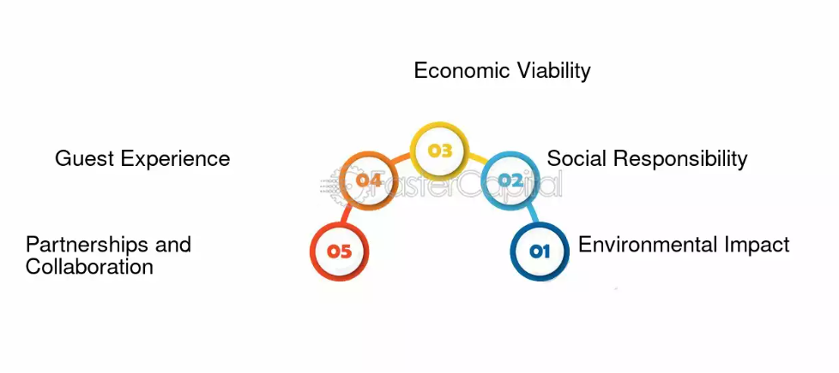
Figure 8: Sustainability in the hospitality sector
- Expected Outcome: Having environmentally friendly programs will also help to create a new image that shows The Plaza as an environmentally friendly place that guests should visit. This can in turn go a long way in improving the number of bookings by guests who decide to exclusively patronize environmentally friendly accommodation facilities (Kuo et al., 2021).

5.14. AI for Personalised Marketing
- Description: AI can help personalize the data collected on the guests to fashion-specific and individual marketing strategies. This includes electronic direct mailers, reports on special charges presented after a guest’s stay, and advertisements.
- Rationale: Personalised marketing increases guest touch points as they get presented with offers that they can appreciate. Marketing: AI can assist in breaking the data into smaller chunks to find out trends that can be associated with the future behaviour of one or another client.
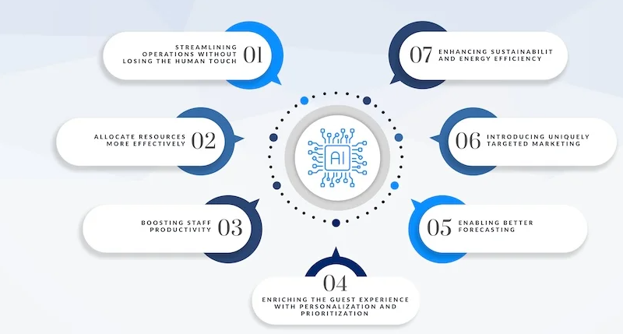
Figure 9: Use of AI in the hospitality sector
- Expected Outcome: Adopting the use of AI in marketing, The Plaza can increase bookings and, therefore, get a better marketing return on investment. Individual target communication with the guests will trigger the feeling of loyalty and repeat visitation among the guests (Aguiar-Castillo et al. 2021).
These recommendations shall seek to increase guest entertainment, improve efficiency as well as maintain the sustainability levels of The Plaza Hotel in the luxury hospitality industry. All are aimed at the use of technology to enhance organizational performance, customer experience, and company image.

6. Action Plan

Number | Problem | Solution | Desired Outcome | Time Scale | Completion Date | Planned Budget
1 | Technological Lag | Apply smart room technology, mobile check-in, digital key cards and upgraded Wi-Fi infrastructure (Thakur, 2022). | Enrich guest experience and get tech-savvy travellers, with rising occupancy rates. | 6 weeks | 12/11/2024 | £50,000
2 | Inefficiency of Staff Training on New Tech | Give staff training on novel technologies and consumer service best practices (Jawabreh et al., 2022). | Enhanced staff competence and guest service leading to better reviews and guest retention. | 3 weeks | 22/10/2024 | £40,000
3 | Damaged Reputation | Launch reputation management campaigns and tactics including real-time feedback monitoring with the help of enhanced analytics and collaborations with influencers for targeted marketing campaigns using social media platforms (Veloso et al., 2023). | Enhanced public image, increased positive reviews and improved guest loyalty. | 5 weeks | 05/11/2024 | £30,000
4 | Poor Guest Feedback Collection | Setting up digital feedback kiosks and post-stay surveys for real-time guest feedback. | Real-time data gathering on guest satisfaction to inform ongoing enhancements. | 4 weeks | 29/10/2024 | £25,000
5 | High Energy Consumption | Apply energy-efficient solutions such as smart lighting, thermostats and solar panels (Salehi et al., 2021). | Limited energy costs and improved sustainability will increase attraction to eco-conscious guests. | 6 weeks | 12/11/2024 | £60,000

7. Conclusion

This report tailors the analysis and recommendations that will help The Plaza Hotel surmount some of the existing challenges it faces, especially regarding the decline in satisfaction among its guests due to a lack of technological modernization. It is expected that The Plaza-true to its iconic picture of luxury will be able to mold into the expectations of the modern-day traveler appreciating tradition and innovation within hotel experiences. The issues identified included lag in technology, decline in guest satisfaction, reputational damage and income loss, which were fundamental issues the hotel needed to address if it was going to sustain its competitive standing in the luxury hospitality market. The key findings that have emerged pinpointed a few main issues. First, the antiquated technological infrastructure of the hotel was unable to deliver according to the expectations of its technology-savvy guests, who then became dissatisfied and filed complaints. Technology is one of the prime focuses that luxury travelers look for in their destinations today, and ignorance on the part of The Plaza in implementing modern amenities has led to lowering repeat bookings. Because of this, the revenue continued falling. Moreover, due to online reviews against it for not modernizing itself, its reputation suffered further, making it incapable of luring and retaining high-end customers.
The critical external factors in the PESTEL analysis that could be considered to have caused the problem of the hotel included an ever-changing face of technology, an expectation among guests for more digital options to be available and an increased concern for lack of digital integration in the hospitality sector. While these external factors have helped to outline the need for The Plaza to innovate technologically and keep up with modern trends in the hospitality industry, other issues instigated these concerns about resistance to change or an inability of the hotel to maintain its classic features.
The recommendations within the report include updating the hotel's technological infrastructure, developing better training for staff members, improving feedback solicited from guests, and adopting energy-efficient solutions. If implemented properly, this will allow The Plaza to regain its competitive standing through the delivery of a more modern and luxurious experience for guests. These suggested changed management strategies will lead to an easy transition by both the new and old systems for employees and customers, reducing disruption as much as possible while maximizing the benefits of the new upgrades.
With these adjustments, The Plaza Hotel can be confident that the satisfaction of its guests, its occupancy rate, and the bottom line will follow an upward course. Modern technology will enhance customer experience and make this hotel once more, as it was in the past, a progressive leader in the luxury category. Also, energy-efficient solutions will significantly reduce operational expenses and make it possible to appeal to ecologically conscious travelers, creating new opportunities for the hotel within a constantly growing competitive travel market. The report has shed light on a bright future for various ways The Plaza Hotel will overcome its most worrisome issues. Its strategic implications raise guest satisfaction, protect the hotel's brand reputation and assure revenue generation. With these modifications, The Plaza will also position itself in the future as a superior hostel of luxury, able to meet the needs of traditional and modern guests. It is continuing in such a great way that it will remain in an excellent position to always adapt to the changing demands of the hospitality industry.

8. References
Abdel‐Hamid, T.A. et al. (2022) ‘The role of digital transformation in improving customer satisfaction: An empirical study on Egyptian hotels’, THE ELECTRONIC JOURNAL OF INFORMATION SYSTEMS IN DEVELOPING COUNTRIES, 88(6), p. 12234.
Aguiar-Castillo, L. et al. (2021) ‘Survey on optical wireless communications-based services applied to the tourism industry: Potentials and challenges’, Sensors, 21(18), p. 6282.
Ahmed, M. et al. (2022) ‘Rating-based recommender system based on textual reviews using IOT smart devices’, Mobile Information Systems, 2022, pp. 1–18.
Alfarisyi, M. and Ferdian, F. (2023) ‘Guest decision to book a hotel room through social media: the mediation effect of behavioural intention’, Gemawisata: Jurnal Ilmiah Pariwisata, 19(2), pp. 01–18.
Allard, T., Dunn, L.H. and White, K. (2020) ‘Negative reviews, positive impact: Consumer empathetic responding to unfair word of mouth’, Journal of Marketing, 84(4), pp. 86–108.
Alrawadieh, Ziad, Alrawadieh, Zaid and Cetin, G. (2020) ‘Digital Transformation and Revenue Management: Evidence from the Hotel Industry’, Tourism Economics, 27(2), pp. 328–345.
Aydin, G. (2020) ‘Social Media Engagement and Organic Post Effectiveness: A roadmap for increasing the effectiveness of social media use in hospitality industry’, Journal of Hospitality Marketing &amp; Management, 29(1), pp. 1–21.
Balasubramanian, K. et al. (2022) ‘Integration of Augmented Reality (AR) and virtual reality (VR) as marketing communications channels in the hospitality and Tourism Service Sector’, Palgrave Studies of Marketing in Emerging Economies, pp. 55–79.
Barone, A.M. and Stagno, E. (2023) ‘Voice assistants’, Artificial Intelligence along the Customer Journey, pp. 55–69.
Blueprint (2024) Discover the future of WIFI Technology & Standards in hospitality, Blueprint RF. Available at: https://www.blueprintrf.com/future-of-hospitality-wifi-technology/ (Accessed: 05 November 2024).
Booking.com (2024) The largest selection of hotels, homes, and vacation rentals - The Plaza, Booking.com. Available at: https://www.booking.com/ (Accessed: 05 November 2024).
Bucher, C. (2016) A case study on the Plaza Hotel, A Case Study on The Plaza Hotel. Available at: https://siuarchitecture.blogspot.com/2016/04/a-case-study-on-plaza-hotel.html (Accessed: 05 November 2024).
Buhalis, D. and Moldavska, I. (2021) ‘Voice assistants in hospitality: Using artificial intelligence for customer service’, Journal of Hospitality and Tourism Technology, 13(3), pp. 386–403.
BusinessDojo (2024) The SWOT analysis of a hotel (with examples), BusinessDojo. Available at: https://dojobusiness.com/blogs/news/hotel-swot (Accessed: 05 November 2024).
Carlo, C. (2021) ‘Critical success factors in hotel companies: A managerial perspective’, Journal of Tourism and Hospitality Management, 9(2), pp. 1–7.
CBRE (2023) Sustainability and ESG adoption in the Hotel Industry: A Global Status Update, Creating Resilience. Available at: https://www.cbre.com/insights/reports/sustainability-and-esg-adoption-in-the-hotel-industry (Accessed: 05 November 2024).
Chan, E.S.W., Okumus, F. and Chan, W. (2020) ‘What Hinders Hotels’ adoption of Environmental Technologies: A quantitative study’, International Journal of Hospitality Management, 84, p. 102324.
Chang, V. et al. (2023) ‘An improved model for sentiment analysis on Luxury Hotel Review’, Expert Systems, 40(2), p. 12580.
Chetty, P. (2020) Importance of customer loyalty programs in the hospitality industry, Knowledge Tank. Available at: https://www.projectguru.in/importance-of-customer-loyalty-programs-in-the-hospitality-industry/ (Accessed: 05 November 2024).
Citra Birru, A., Sudarmiatin, S. and Hermawan, A. (2022) ‘Competitive strategies in the lodging service sector: Five porter analyses and case study swot analysis’, Journal of Business and Management Review, 3(1), pp. 1–17.
Cryan, E. (2024) City Council passes controversial hotel licensing bill, The Real Deal. Available at: https://therealdeal.com/new-york/2024/10/23/new-york-city-council-passes-controversial-hotel-licensing-bill/ (Accessed: 05 November 2024).
Das, M.P. (2023) ‘Technology and Guest experience: innovations reshaping hotel management’, International Journal for Multidimensional Research Perspectives, 1(3), pp. 76–95.
Deri, M.N., Zaazie, P. and Singh, A. (2024) ‘Digital Future of the hospitality industry and Hospitality Education globally’, Springer International Handbooks of Education, pp. 221–243.
Dillingham, J. (2024) Is The Plaza Hotel Worth it? an honest review of New York icon, Jared’s Detours. Available at: https://www.jaredsdetours.com/plaza-hotel/ (Accessed: 24 October 2024).
Domanski, M. (2020) The concept of a smart hotel and its impact on guests’ satisfaction, privacy and the perception of the service quality. Södertörns högskola, Turismvetenskap.
Elshaer, I.A., Azazz, A.M. and Fayyad, S. (2022) ‘Authenticity, involvement, and nostalgia in Heritage Hotels in the era of digital technology: A moderated meditation model’, International Journal of Environmental Research and Public Health, 19(10), p. 5784.
Franco, M.A. (2021) ‘Buyer-supplier collaboration for eco-innovations in a circular economy’, Sustainable Innovation, pp. 79–92.
Ganapathi, V. (2023) ‘Digital transformation in Cluster Management: A study on the hotel industry’, International Journal of Science and Research (IJSR), 12(6), pp. 2176–2182.
Ganapathi, V.S. (2023) ‘Digital transformation in Cluster Management: A study on the hotel industry’, International Journal of Science and Research (IJSR), 12(6), pp. 2176–2182.
Gelbrich, K., Hagel, J. and Orsingher, C. (2021) ‘Emotional support from a digital assistant in technology-mediated services: Effects on customer satisfaction and behavioral persistence’, International Journal of Research in Marketing, 38(1), pp. 176–193.
Ghouri, A.M. (2021) An empirical study of real-time information-receiving using industry 4.0 technologies in downstream operations. S.l.: SSRN.
Grussu, R. (2021) Plaza Hotel: Its Rise, Splendor and Decline From the Great Gatsby to Trump’s Betrayals, La Voce di New York. Available at: https://lavocedinewyork.com/en/2021/09/19/plaza-hotel-its-rise-splendor-and-decline-from-the-great-gatsby-to-trumps-betrayals/ (Accessed: 05 November 2024).
Gupta, S. et al. (2022) ‘Artificial intelligence enabled robots for stay experience in the hospitality industry in a Smart City’, Industrial Management &amp; Data Systems, 122(10), pp. 2331–2350.
Han, D. et al. (2021) ‘Modelling tourists’ acceptance of Hotel Experience-Enhancement Smart Technologies’, Sustainability, 13(8), p. 4462.
Hargreaves, E. (2024) Inside the real plaza suites: A tale of grandeur, romance and cinematic legacy in the heart of New York, Tatler. Available at: https://www.tatler.com/article/plaza-hotel-new-york-review (Accessed: 05 November 2024).
Jawabreh, O., Fayoumi, T.A. and Bareya, A. (2022) ‘Customer satisfaction towards communication skills of front office staff at the Hotel (Case Study Five Stars hotels in Aqaba)’, GeoJournal of Tourism and Geosites, 44(4), pp. 1312–1318.
Karagiannis, M. (2024) How do smart rooms improve the hotel experience, Medium. Available at: https://medium.com/hotel-tech/how-do-smart-rooms-improve-the-hotel-experience-9048983e12c7 (Accessed: 05 November 2024).
Khan, N. et al. (2020) ‘Factors affecting tourism industry and its impacts on global economy of the world’, SSRN Electronic Journal, pp. 1–29.
Kim, Y.-J. and Kim, H.-S. (2022) ‘The impact of Hotel Customer Experience on customer satisfaction through online reviews’, Sustainability, 14(2), p. 848.
Kuo, F.-I., Fang, W.-T. and LePage, B.A. (2021) ‘Proactive Environmental Strategies in the hotel industry: Eco-innovation, Green Competitive Advantage, and Green Core Competence’, Journal of Sustainable Tourism, 30(6), pp. 1240–1261.
LLC (2024) The plaza new york, Love & War. Available at: https://loveandwar.com/projects/the-plaza-new-york/ (Accessed: 05 November 2024).
Looka (2024) Free logo maker - create a unique logo online | looka. Available at: https://looka.com/logo-maker/ (Accessed: 05 November 2024).
Luxury Hotels (2024) Redefining the stay: How smart room technology is Shaping Luxury Hotels in NYC? Redefining the Stay: How Smart Room Technology Is Shaping Lu. Available at: https://www.luxury-hotel-new-york.com/en/blog/redefining-the-stay-how-smart-room-technology-is-shaping-luxury-hotels-in-nyc (Accessed: 05 November 2024).
Mansour, H.A. and El Shafey, H.M. (2024) ‘How green HRM drives hospitality organizations towards a sustainable future? moderation effect of environmental proactivity’, Journal of Tourism, Hotels and Heritage, 8(1), pp. 1–16.
Moghimi, B. (2024) ‘EXPLORING THE INFLUENCE OF ECO-FRIENDLY PRACTICES ON GENERATION Z’S PERCEPTIONS AND LOYALTY (CASE STUDY OF MARRIOT INTERNATIONAL HOTEL IN GEORGIA) ’, The International Journal of Interdisciplinary Organizational Studies, 19(1), pp. 1747–1757.
Nuong, M. et al. (2024) ‘Solid waste management for the hotel industry’, Advances in Hospitality, Tourism, and the Services Industry, pp. 231–246.
Park, S. et al. (2021) ‘Service quality dimensions in hotel service delivery options: Comparison between Human Interaction Service and self-service technology’, International Journal of Hospitality &amp; Tourism Administration, 23(5), pp. 931–958.
Pego, A., Talukder, M.B. and Kumar, S. (2024) ‘Utilizing Smart Technology and AI in hybrid tourism and hospitality’, Advances in Hospitality, Tourism, and the Services Industry [Preprint].
Planet Lux (2023) The Plaza Hotel, New York City [video], YouTube. Available at: https://www.bing.com/videos/riverview/relatedvideo?q=exclusive%2Bofferings%2Bat%2Bplaza%2Bhotel%2Bnew%2Byork&mid=EF838F9C5913703AEF04EF838F9C5913703AEF04&FORM=VIRE (Accessed: 05 November 2024).
Plaza LLC (2024) Luxury Hotel near Central Park: 5 Star Hotel in NYC: The Plaza Hotel, The Plaza. Available at: https://www.theplazany.com/ (Accessed: 05 November 2024).
Rabiul, M.K. et al. (2023) ‘An investigation of the interrelationships of leadership styles, psychological safety, thriving at work, and work engagement in the hotel industry: A sequential mediation model’, International Journal of Hospitality Management, 113, p. 103508.
Saft, S.M. (2024) Proposed New York City legislation could negatively impact the hotel industry: Insights, Holland & Knight. Available at: https://www.hklaw.com/en/insights/publications/2024/08/proposed-new-york-city-legislation-could-negatively-impact (Accessed: 05 November 2024).
Sakovska, O. et al. (2022) ‘Improvement of the marketing management system of tourism and hospitality industry enterprises on the basis of Innovations’, Lecture Notes in Networks and Systems, pp. 881–895.
Salehi, M. et al. (2021) ‘Energy conservation in large-sized hotels: Insights from a developing country’, International Journal of Hospitality Management, 99, p. 103061.
Sharma, U. and Gupta, D. (2021) ‘Analyzing the applications of internet of things in Hotel Industry’, Journal of Physics: Conference Series, 1969(1), p. 012041.
Singh, C. (2023) The Plaza New York Review: Still the city’s most iconic stay, Boss Hunting. Available at: https://www.bosshunting.com.au/travel/stay/the-plaza-new-york-review-still-the-citys-most-iconic-stay/ (Accessed: 05 November 2024).
Syahidi, A.A. et al. (2022) ‘Tour experience with interactive map simulation based on mobile augmented reality for tourist attractions in Banjarmasin City’, The IJICS (International Journal of Informatics and Computer Science), 6(1), p. 22.
Thakur, A. (2022) ‘Sensor-based technology in the hospitality industry’, Advances in Hospitality, Tourism, and the Services Industry, pp. 24–43.
Theocharidis, A.-I. et al. (2020) ‘An approach towards investigating factors affecting intention to book a hotel room through social media’, Sustainability, 12(21), p. 8973.
Tripadvisor (2023) Very disappointing - review of the plaza new york - A fairmont managed hotel, New York City, Tripadvisor. Available at: https://www.tripadvisor.in/ShowUserReviews-g60763-d675616-r929157512-The_Plaza_New_York_A_Fairmont_Managed_Hotel-New_York_City_New_York.html (Accessed: 05 November 2024).
Truong, N. et al. (2020) ‘Exploring the impact of innovativeness of Hospitality Service operation on customer satisfaction’, Operations and Supply Chain Management: An International Journal, pp. 307–319.
Turkel, S. (2024) The Plaza Hotel History: Historic Hotels in New York, Historic Hotels Worldwide. Available at: https://www.historichotels.org/us/hotels-resorts/the-plaza/history.php (Accessed: 05 November 2024).
Vatan, A. and Dogan, S. (2021) ‘What do hotel employees think about service robots? A qualitative study in Turkey’, Tourism Management Perspectives, 37, p. 100775.
Veloso, M., Ieva, M. and Gómez-Suárez, M. (2023) ‘Social Media Content Strategy in hospitality: The impact of experiential posts and response congruence on engagement, hotel image, and booking intention’, Journal of Hospitality Marketing &amp; Management, 33(1), pp. 57–77.
Wood, A. (2024) What is a pestle analysis? why do I need it?, OnStrategy. Available at: https://onstrategyhq.com/resources/pestle-analysis/ (Accessed: 05 November 2024).
Wu, F., Sorokina, N. and Putra, E.D. (2023) ‘Customers satisfaction on robots, Artificial Intelligence and Service Automation (Raisa) in the hotel industry: A comprehensive review’, Open Journal of Business and Management, 11(03), pp. 1227–1247.
Wynn, M. and Jones, P. (2022) ‘It strategy in the hotel industry in the Digital Era’, Sustainability, 14(17), p. 10705.

