
Data HANDLING & Business intelligence
Assignment 2 – Part One & Part Two

May 1, 2019
Jessica Rees
1703037

Contents Page

1.0 Introduction ………………………………………………………………………………….PAGE 2

PART ONE – Excel PAGE 3

2.0 Microsoft Excel Functions

2.1 IF Statement ………………………………………………………….PAGE 4

2.2 Lookup …………………………………………………………………….PAGE 4

2.3 Pivot Tables – Charts and Graphs …………………………….PAGE 5

2.4 Strengths and Weaknesses of using Excel for pre-processing, analysing and visualising and why Sarn Helen should use it ………………….PAGE 6

PART TWO – Weka PAGE 8

3.0 Data mining approaches

3.1 Prediction – Sarn Helen …………………………………………….PAGE 9

3.2 Association – Sarn Helen …………………………………………..PAGE 10

3.3 Clustering – Sarn Helen ……………………………………………..PAGE 11

3.4 How prediction, association and clustering are used to understand data ……………………………………………………………………………………………………PAGE 12

4.0 Conclusion …………………………………………………………………………….PAGE 13

5.0 References …………………………………………………………………………….PAGE 14

1.0 Introduction

This report will analyse Sarn Helen Office Supplies’ data set using software such as Weka and Excel. This report will also highlight the functions used through Excel that presents the data such as Pivot tables, IF statements, charts and graphs and so forth, as well as assessing the strengths and weaknesses of using Excel for pre-processing, analysing and visualising which will help Sarn Helen understand how Excel can be useful for decision making purposes. Alongside this, the report will also explain the data mining approaches of prediction, clustering and association which will aid Sarn Helen in understanding the data.

PART ONE

2.0 Microsoft Excel Functions

2.1 IF Statement

An if statement is a programming conditional statement that, if proved true, performs a function or displays information. (computerhope.com, 2019) Using the Sarn Helen data set on Excel, the spreadsheet looked at profit loss, using IF. The following formula: =IF(I2=I1640,"Profit","Loss") was used to analyse if there was a profit loss.

2.2 Lookup

“VLOOKUP is an Excel function to lookup and retrieve data from a specific column in table. VLOOKUP supports approximate and exact matching, and wildcards (* ?) for partial matches. The "V" stands for "vertical". Lookup values must appear in the first column of the table, with lookup columns to the right.” (exceljet.net, 2019) VLOOKUP is used through a formulae, for example: =VLOOKUP(F2,I2:J2,4,FALSE)

2.3 Pivot Table – Charts and Graphs

Row Labels | Sum of Profit | Sum of Sales
Dyfed | 154350.54 | 1311925.846
Mid Glamorgan | 305323.93 | 2927266.446
South Glamorgan | 93819.72 | 717288.6535
West Glamorgan | 188410.01 | 1362802.103
Grand Total | 741904.2 | 6319283.048

“Pivot table reports is a powerful data summarisation tool. It summarises the columns of information in a database in relationship to each other.” (Courter, 2002) Pivot tables build a collective list of unique values, summarising data which makes it easy to find unique values. Other inconsistencies can also be found as a result of this, due to the extraction from a significant detailed data set.
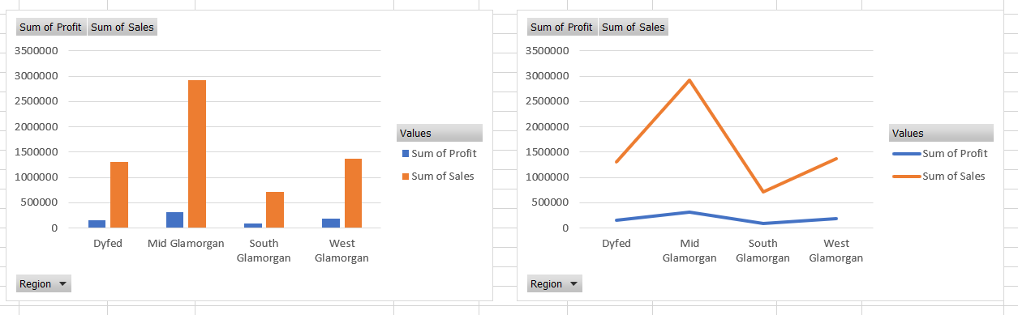

Graphs and charts are fewer complex visualisations of data. Through Excel, graphs and charts can be made once a desired pivot table has been created. From then, all elements added to the table will be more vividly assessed.

2.4 Strengths and Weaknesses of using Excel for pre-processing, analysing and visualising and why Sarn Helen should use it

Microsoft Excel is a software program included in the Microsoft Office suite. It is used to create spreadsheets, which are documents in which data is laid out in rows and columns — like a big table. Due to its extreme versatility and power, Excel has become one of the most-used software programs in the business world since its launch in 1985. Indeed, the personal computing renaissance of the 1980s and 1990s was largely driven by the many uses of Excel and another spreadsheet software. What are spreadsheets used for? Almost everything. Spreadsheets are extraordinarily powerful tools and are used frequently in the business world to store and manipulate data.” (deskbright.com, 2019)

“Data pre-processing describes any type of processing performed on raw data to prepare it for another processing procedure. Commonly used as a preliminary data mining practice, data pre-processing transforms the data into a format that will be more effectively processed for the purpose of the user.” (searchsqlserver.techtarget.com, 2019) The advantage of using excel for pre-processing is that a lot of data found in public datasets can often be referred to as ‘dirty’, and needs cleaning up to then be analysed. Data quality is also essential to get good results and pre-processing is the only technique that will ensure this. This term is commonly referred to as ‘Garbage In, Garbage Out’ (GIGO). Another advantage of this technique is the importance of the characteristics it looks out for such as missing values, ‘noisy data’, incorrect type of data or even incomplete data. If an analytical person from the company was to conduct a spreadsheet and they were to accidentally miss out a value that results in a column not adding up, pre-processing would pick this up which brings the additional advantage of giving anyone carrying out this analysis a piece of mind that their spreadsheets will be proof read before putting it through the next stage of a machine learning algorithm software such as Weka. An example of pre-processing regarding using Weka would be apostrophes. Since they don’t read in Weka, by carrying out this pre-processing technique, the company can be sure that the algorithms will not be interrupted. Pre-processing can also be time consuming as this is the first step before being able to analyse the data and if not done correctly, this can cause issues when the data is being processed through software.

“The ability to analyse data is a powerful skill that helps you make better decisions. Microsoft Excel is one of the top tools for data analysis and the built-in pivot tables are arguably the most popular analytic tool.” (edx.org, 2019) Overall, using excel for data analysis is easy to use, especially since it acts as an all-in-one data management tool, giving the user ease to import, explore, clean and analyse as well as visualise the data all in one place. (quora.com, 2019) With relative ease, you can look at each data point, field or line using the graphic interface, as well as excel making it even easier to build table relations by inputting an equal sign. Although Excel is used to analyse the data Sarn Helen provides, businesses often find it a task in itself to select the right analytics tool and there is always the risk of the information obtained being misused, especially with an external company but upon selecting a company to perform this task, business to business trust is essential at point of meeting.

“Data visualization is the presentation of data in a pictorial or graphical format. It enables decision makers to see analytics presented visually, so they can grasp difficult concepts or identify new patterns. With interactive visualization, you can take the concept a step further by using technology to drill down into charts and graphs for more detail, interactively changing what data you see and how it’s processed.” (sas.com, 2019) Data visualisation is known to be a preference to the human brain as we process more information visually through charts or graphs rather than complex spreadsheets and reports. A benefit of data visualisation is that it highlights key areas that need attention or improvement which is useful for the company to identify this quickly and effectively. Not only this, but Sarn Helen would also use this to predict sales volume, which again helps predict the near future of the company. Pinpointing emerging trends is also something data visualisation can discover. This can give the company an edge over competition, as it addresses issues before they become larger. Although, the disadvantages of visualisation is that it cam be time consuming meaning data isn’t interpreted really quickly. Another disadvantage is that skills are needed to complete the task, which is why Sarn Helen has employed an external company to compose this which on top is costly. Graphical displays of data are also extremely useful. Excel offers a chart section of which the user can present data within a chart or graph, which allows better visualisation and better presented communication. Within a business environment, this is practical for informing future planning decisions.

PART TWO

3.0 Data Mining Approaches

3.1 Prediction – Sarn Helen
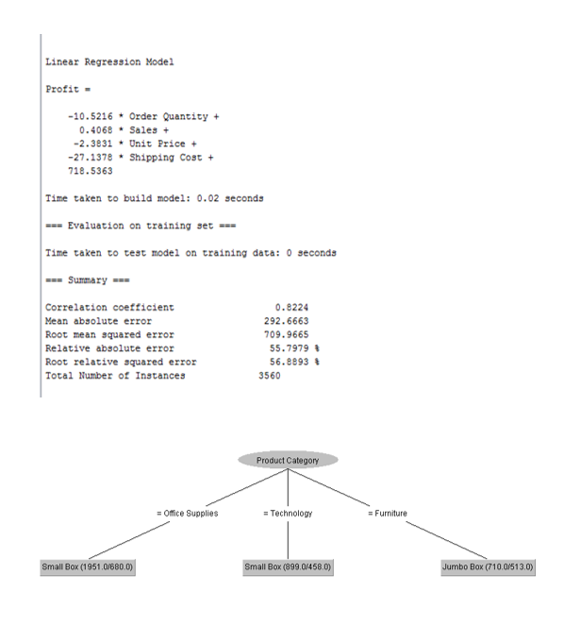

“Numeric prediction is the task of predicting continuous or ordered values for given input. By far, the most widely used approach for numeric prediction is regression.” (Han, 2006) such as the above image. This regression analysis can be interpreted to model the relationship of one or more independent or variable or even a dependent or variable. This modelling is one of the simplest approaches to statistical modelling and is useful to look if there is any relationship between 2 variables, how strong that relationship is, how accurately can the target be predicted and is the relationship linear. In the prediction model created from Weka, it indicates that its correlation coefficient was significant from zero as the negative figure shows that there was perhaps an inverse relationship between each of the factors. Although it can look complex, the model can help Sarn Helen to understand relationships between data points, using them to make better decisions from predicting a sales forecast to looking more closely at inventory levels, referring more towards supply and demand. For example, Sarn Helen can use this prediction model to understand why a specific promotion would work better than another or what sales could look like over an upcoming 6-month period.

3.2 Association – Sarn Helen

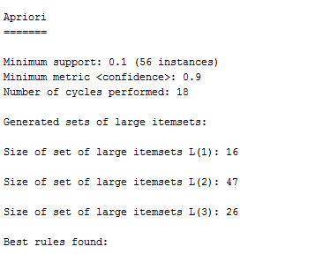

“Association is a data mining function that discovers the probability of the co-occurrence of items in a collection. The relationships between co-occurring items are expressed as association rules. Association rules are often used to analyse sales transactions. For example, it might be noted that customers who buy cereal at the grocery store often buy milk at the same time. In fact, association analysis might find that 85% of the checkout sessions that include cereal also include milk. This relationship could be formulated as the following rule.” (docs.oracle.com, 2019) “Apriori algorithm, a classic algorithm, is useful in mining frequent itemsets and relevant association rules. Usually, you operate this algorithm on a database containing many transactions. One such example is the items customers buy at a supermarket.” (digitalvidya.com, 2019) The starting point for the Apriori algorthim is the collection of transactions, which in this case looks at large itemsets. From here it analyses patterns or occurrences in the database, and if it does, these are referred to as association rules.

3.3 Clustering – Sarn Helen

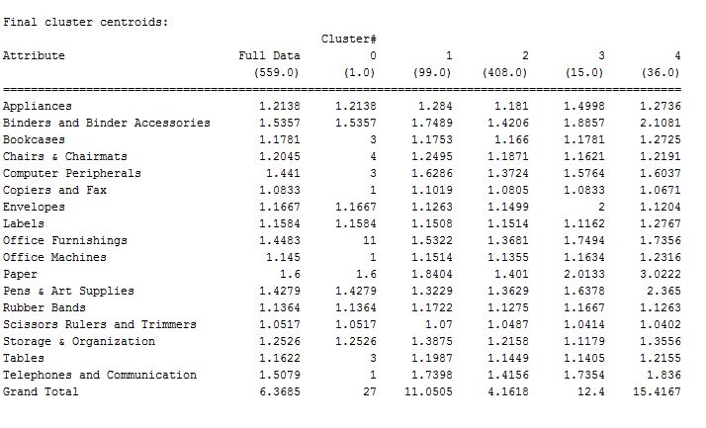

“Clustering is a method in which like records are grouped together. Usually this is done to give the end user a high-level view of what is going on in the database.” (Berson, 1997) “It is also the grouping of a set of objects based on their characteristics, aggregating them according to their similarities. Regarding data mining, this methodology partitions the data implementing a specific join algorithm, most suitable for the desired information analysis.” (bigdata-madesimple.com, 2019)
In the above image, it is shown that the list of products is not only listed in alphabetical order but also regarding similar characteristics and uses. Using Weka, this function is done using the ‘SimpleK-means’ algorithm. So, for this cluster, a group of centroids which are the beginning points for the cluster of which then Weka performs repetitive calculations to begin optimising the centroids positioning. Only when the centroids have finalised meaning there is no other change in their values and when the targeted number of replications have been made.

3.4 How prediction, association and clustering are used to understand data

Predictive analysation uses previous data to predict future events, building a model to capture these important trends that set these predictions. Sarn Helen greatly benefits from this as predicting possible future outcomes for any business will help understand what needs to be set in place to create a definite outcome or if there are any threats that could be defeated before the company reaches that point. By continuing to use this algorithm regularly and effectively, Sarn Helen will have no problem in putting their success in their corner. Association rules is also useful for finding patterns within a database. By using these association rules, Sarn Helen can identify the most important relationships between variables and can continuing searching for frequent patterns within the elements they input into the software. These relationships will give the company a better view on how elements are working, for example, the profit received when selling tables. If the company continues to look for these trends, it will give a better understanding of what is working and what isn’t. Since clustering refers to the grouping of variables with similar characteristics, by carrying out this function, Sarn Helen will be able to assess a set of measured variables into a number of differentiating groups, which helps the company see what samples, meaning products, are working at relatively the same pace and what isn’t and why.

4.0 Conclusion

To conclude, Excel spreadsheets are very useful for a company such as Sarn Helen looking at analysing their data. This can be done using certain functions such as IF statements, Pivot Tables, charts and graphs. With the right skills, these can be done easily. Pre-processing, analysing and visulaing data are also other functions used in Excel, done mainly before input to software such as Weka. Although these bring many advantages, these also bring disadvantages. Using Weka, data mining is also has approaches of prediction, association and clustering that are performed to understand the data. These functions bring many benefits to Sarn Helen such as predicting future elements to the business and looking for trends. Overall, Sarn Helen will greatly benefit from this software.

5.0 References

