
Student name: Corneliu Ovidiu Dinica
Student number:1918442
Tutor name: David Jenkins
Module: Management Economics (LCBB5003_BIRM)

Contents
INTRODUCTION 3
MAIN BODY 3
An overview of the business and how its strategies have unfolded in the above time-period 3
A five-year macroeconomic data comparison between the three countries, to include growth, inflation, currency fluctuations, interest rates, unemployment, and current account balance 4
An evaluation of the firm’s business performance over the five years, and how its operations in the UK compare with its activities in the other two countries 14
Highlight the changes, if any, in the company’s overall performance in the three countries, and discuss the extent to which the UK government’s trade policies may, or may not, have impacted on this 16
CONCLUSION 16
REFERENCES 18

INTRODUCTION
Managerial economics is a related to the data method. Because managerial economics and judgment procedures are intertwined, this occurs. This method can assist a business in taking better efficient and productive actions to achieve its goals. This management approach is utilized in the business world to help businesses run their business, such as risk assessment, economic evaluation, price norms, related legislation, and business investments (Gössling and Higham, 2021). This report based on the FTSE 100 listed transnational companies Vodafone. In this report consist of strategies consider by the company and compare company data between three countries for company. Along with highlight the changes in business performance from the year 2016 to 2020.

MAIN BODY

An overview of the business and how its strategies have unfolded in the above time-period
Vodafone Group Plc is a telecommunication conglomerate headquartered in the United Kingdom. Newbury, Berkshire, England is the company's head offices and headquarter. Asia, Africa, Europe, and Oceania are the main destinations for its services. Vodafone currently operates infrastructure in 22 countries as of November 2020, with partner organizations in another 48. Vodafone Global Corporate serves business clients in 150 countries with telephony and IT solutions. Vodafone is a member of the FTSE 100 Index and has its principal registration on the London Stock Exchange. On Nasdaq, the firm has a better prospect.
Vodafone Idea's goal to maintain its market leadership relies around streamlined pricing plans, speedier integrating, and improving its financial statement, according to its CEO, who also stated that present "unviable" prices "will mend" as the industry consolidates. Vodafone's company's current plan aims to expand geographically, acquire new consumers, build customer loyalty, and increase consumption via technological advances (Kliestik and et.al, 2020). As seen by Vodafone's performance in the United Kingdom, this is a very winning approach. The business plan of Vodafone and its involve implementing are inextricably linked. Meeting society's requirements opens up a plethora of economic prospects. Vodafone's objective is to establish and look for areas wherein their actions may most solve complex environmental challenges while also providing an appealing financial benefit to their investors.
Developing Vodafone's corporate strategy in developing markets like Africa and India is increasing telecommunication availability and the socioeconomic advantages that come with it.

A five-year macroeconomic data comparison between the three countries, to include growth, inflation, currency fluctuations, interest rates, unemployment, and current account balance
Australia
Growth:
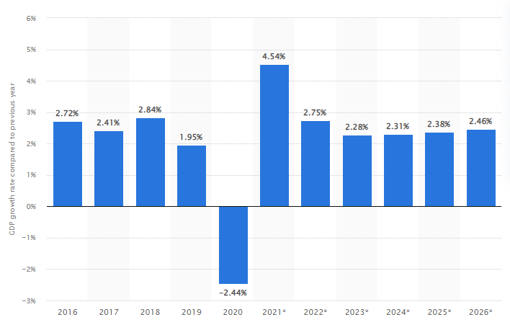

The graph depicts Australia's real GDP growth rate from 2016 to 2020, with predictions through 2026. Australia's GDP is expected to fall by 2.44 percent in 2020 comparison to the prior decade. In a country with such a huge number, maintaining a reliable telecommunications network is critical. Generations of continuous progress have culminated in a vast mobile and fixed broadband network. Fiber, towers, cables, sensors, spacecraft, radio airwaves, and cloud services are included. Although most areas are controlled by a few corporations, the market is reasonably free to competitors for operators and network operators (TRAN and et.al, 2020).
Inflation:
- Inflation in Australia was 0.85 percent in 2020, down 0.76 percent from 2019.
- Inflation in Australia in 2019 was 1.61 percent, down 0.3 percent from 2018.
- Inflation in Australia in 2018 was 1.91 percent, down 0.04 percent from 2017.
- In 2017, Australia's inflation rate was 1.95 percent, up 0.67 percent from 2016.
Currency fluctuations:
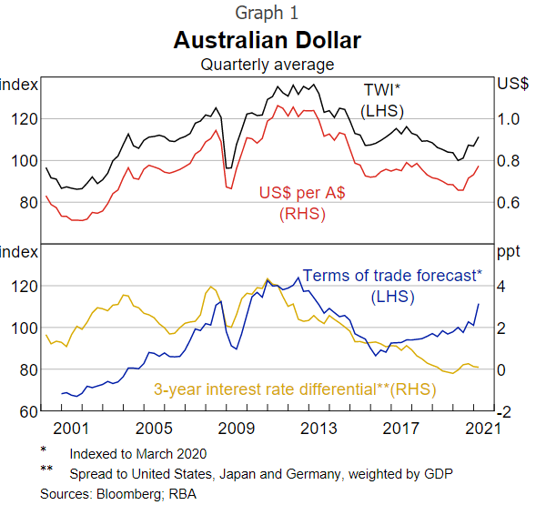
Over the mid to long term, economies of trade and interest rates are important drivers of the Australian dollar. These drivers give insight into the projected sales for Australian dollars. The interest rate difference, for instance, represents assumptions about yields on Australian dollar - denominated assets versus equivalent assets somewhere else in the globe, influencing market for Australian dollars (Ahluwalia, Mahto and Guerrero, 2020).
Interest rates:
- In May 2021, the Australian Government Bond Yield: 10 Years was announced at 1.62 percent per year, down from 1.65 percent per annum the prior month.
- Future Interest Rate data for Australia is regularly updated and is accessible from July 1969 to May 2021.
- The statistics peaked in August 1982 at 16.50 percent per year and peaked in October 2020 at 0.82 percent per year.
- The Reserve Bank of Australia publishes the Longer - term Interest Rate.
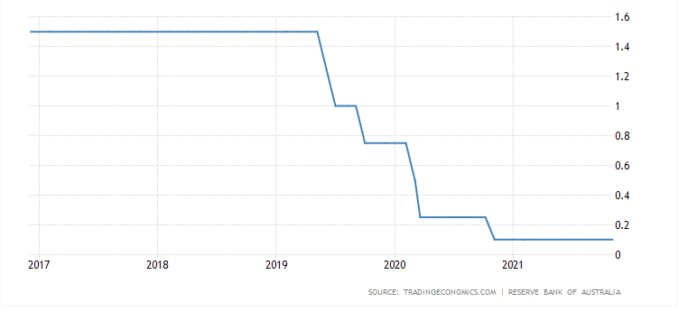
Unemployment: This graph shows Australia's unemployment rate from 2016 to 2020, with forecasts until 2026. Unemployment, often referred as underemployment, arises when consumers are unable to find work. To calculate the frequency of unemployment, dividing the total number of jobless people by the total number of people in the labour force, which provides a percentage rate. Around 6.49 % of the Australian population was jobless in 2020.
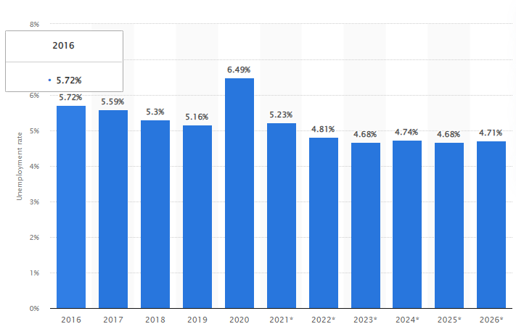
Current account balance: Australia's budget deficit was 33.9 billion dollars in 2020. Australia's current account balance increased at an average annual rate per annum of 18.30 percent from -8.5 billion dollars in 2001 to 33.9 billion dollars in 2020. In the second quarter of 2021, the account numbers deficit grew $9.6 billion to $24.2 billion. As a consequence of a more favorable worldwide financial forecast and better equities market circumstances elsewhere, Australian pension and investment funds have resumed their offshore investing activities (Sánchez-García and et.al, 2021).
New Zeland:
Growth: The growth rate of New Zealand's GDP in 2020 was 0.98 percent, down 0.65 percent from 2019. The growth rate of New Zealand's GDP in 2019 was 1.63 percent, down from 1.57 percent in 2018. The rate of growth of New Zealand's GDP in 2018 was 3.21 percent, down 0.41 percent from 2017. The growth rate of New Zealand's GDP in 2017 was 3.61 percent, down 0.12 percent from 2016.
Inflation: In 2020, prices in New Zealand increased by 1.72 percent. The Reserve Bank of New Zealand's financial institutions must have been glad to see the comeback from the uncomfortably low. In 2015, inflation was 29%. Whenever a nation's budget deficit is in the domestic currency, inflation aids the country by allowing it to pay back the debt with coming dollars, that are lower.
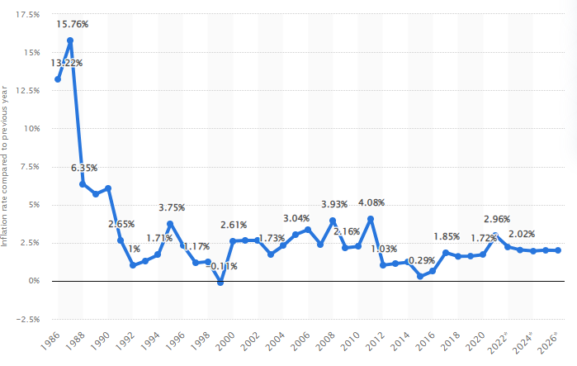
Currency fluctuations:
In March 2021, the New Zealand Dollar to US Dollar exchange rate averaging 1.401 (NZD/USD), compares to 1.380 NZD/USD the prior session.
Information on the New Zealand Dollar Exchange Rate is constantly updated and is accessible from January 1957 to March 2021.
The statistics ranged from a peak of 2.506 in November 2000 to a low of 0.673 in October 1973.
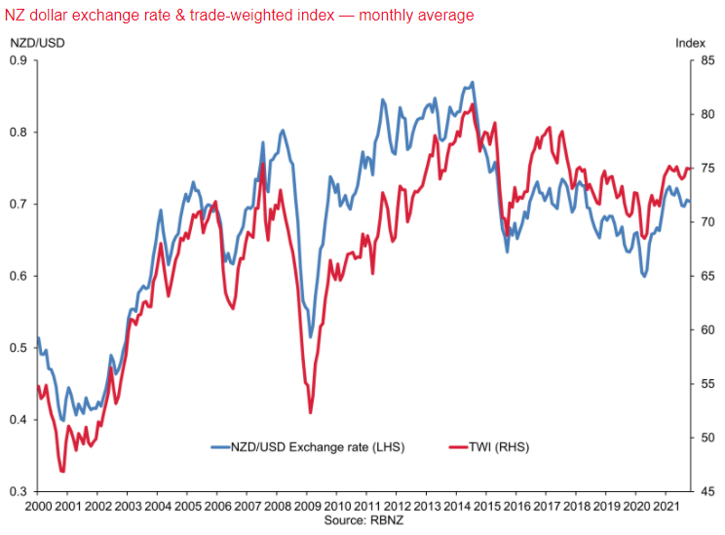
Interest rates: From 1985 to 2021, the interest rate in New Zealand averaging 6.90 percent, with a peak of 67.32 percent in March 1985 and a low of 0.25 percent in March 2020.
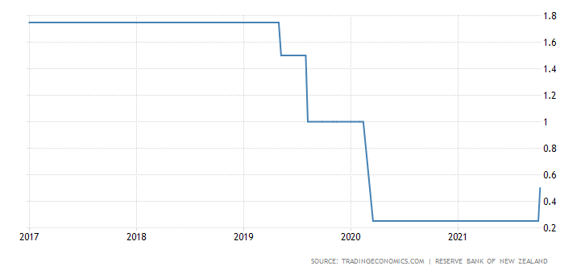
Unemployment: From 1999 until 2020, this graph depicts New Zealand's unemployment rate. New Zealand's unemployment rate was estimated to be at 4.55 % in 2020.
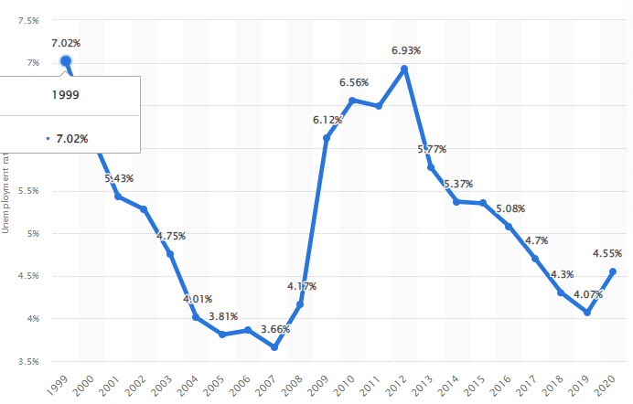
Current account balance:
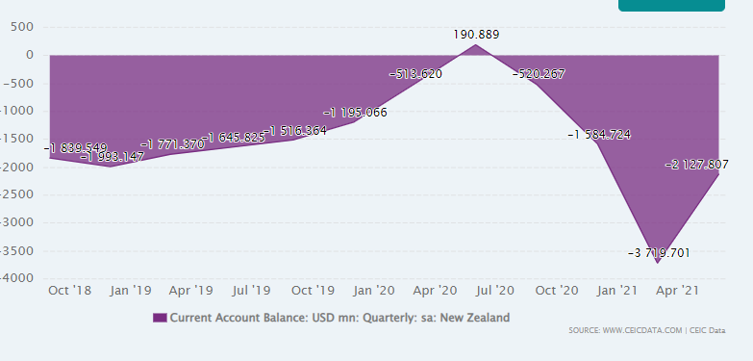
United Kingdom
Growth: In 2021, the UK economy is forecast to increase by 4%, with an even faster pace of 7.3 percent projected in 2022. These projections are clearly predicated on the United Kingdom's ability to recover from the Coronavirus epidemic and return to some semblance of normalcy in the nearest term. There have been some indications that this may be the reality as of year 2021, with the United Kingdom having one of the world's greatest immunization programmers. In April 2021, the British economy posted a moderate quarterly growth rate of 2.3 percent, showing that the economy is steadily improving.
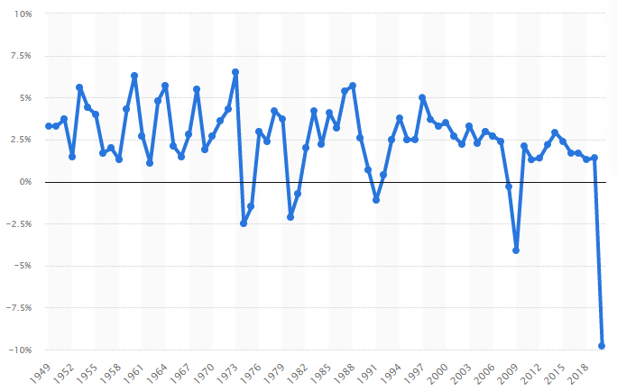
Inflation: The graph depicts the United Kingdom's inflation rate from 1986 to 2020, with estimates until 2026. The rise in prices of a specific product basket is used to determine the inflation rate. This item basket includes items and services that the average customer purchases during the year. Foods, clothing, rent, electricity, telephones, leisure activities, and natural resources (e.g., gas, oil), as well as government charges and costs, are all included. In comparison to earlier years, the annual inflation rate in the United Kingdom in 2020 was around 0.85 percent. In contrast, unemployment in India in the same year was 6.2 percent.
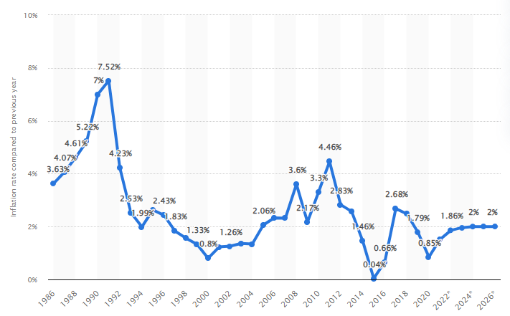
Currency fluctuations:
- In March 2021, the United Kingdom exchange rate versus the US dollar reached 0.721 (GBP/USD), comparing to 0.721 GBP/USD the prior month.
- Data on the UK exchange rate versus the US dollar is regularly updated and ranges from January 1957 to March 2021.
Interest rates: Great Britain In September 2021, the Longer - term Interest Rate: Month Avg: United Kingdom: ECB Harmonised was announced at 0.81 percent pa, up from 0.57 percent pa the monthly before.
Information on UK Longer - term Interest Rates is accessible from January 1993 through September 2021, and it is refreshed weekly.
The statistics peaked in September 1994 at 8.99 percent per year and peaked in July 2020 at 0.15 percent per year.
CEIC Data provides information on the Long Term Rate Of interest.
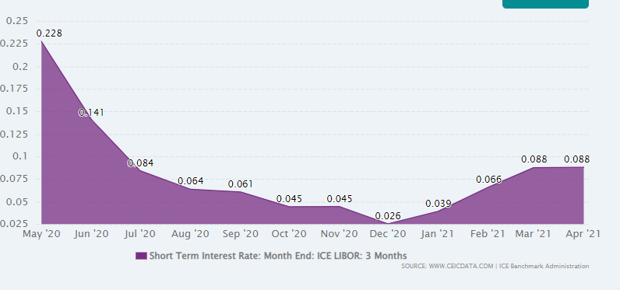
Unemployment: From 1999 through 2020, the unemployment number in the United Kingdom is shown. In 2020, the unemployment rate in the United Kingdom fell to 4.34 %.
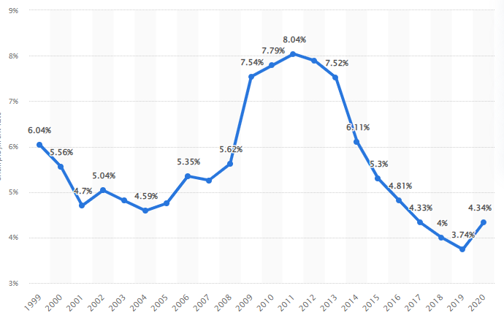
Current account balance: The United Kingdom's current account balance was -106.5 billion US dollars in 2020. Though the current account balance of the United Kingdom has varied considerably in recent decades, it has tended to drop from 2001 to 2020, finishing at -106.5 billion US dollars in 2020.

An evaluation of the firm’s business performance over the five years, and how its operations in the UK compare with its activities in the other two countries
From 2014 to 2021, Vodafone's revenues in the United Kingdom (UK) fell generally. This is notwithstanding the firm's all-time high of 8.43 billion Euros in the UK in 2016. Vodafone is among the most well-known telecommunication businesses in the world, with revenues of 43.7 million euros in the fiscal year that ended March 31, 2021, coming from a variety of regions comprising Europe, Africa, the Middle East, and Asia Pacific. Vodafone's most profitable region is Germany, where the firm generated 13 billion euros in revenue in the fiscal year ending March 31, 2021 (Khan and 2021).
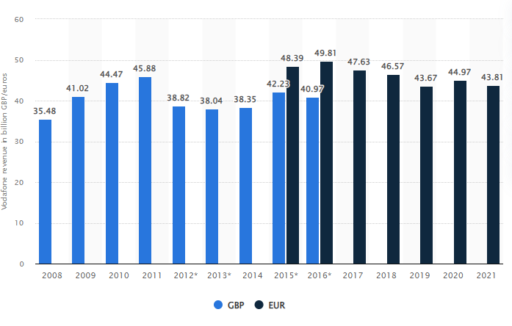
According to Reading Material, Vodafone UK, the global telecom's domestic market provider, has significantly decreased staff in its systems integration centers (NOCs) as a result of the adoption of digital technologies to aid management. As per Vodafone CTO Scott Petty, the number of staff at these sites has decreased from 1,500 to the "low thousands" as a consequence of NOC automation systems. Vodafone UK is relying on the use of digital technologies to cut expenses and automating tasks that were previously performed directly by workers.
Whenever it came to streaming video through a Smartphone, the Australian operators delivered an awesome time for our consumers. On our 0-100 point system, all three operators received Excellent ratings (75 and above). In this area, there was a statistical tie, with Telstra scoring 75.8 and Vodafone getting 75.7. With such a rating of 75.3, Optus was just marginally behind other two. Vodafone performance is good in United Kingdom and also takes good position in Australia and New Zealand (Urinov, 2020).
With such a rating of 75.6 out of 100, Vodafone wins our Video Quality category by 1.4 points over Telstra's 74.2. In our previous two assessments, Telstra and Vodafone were virtually tied for this accolade, but owing to a 1.2 point increase in its score, Vodafone was capable of breaking the tie. When researchers began included it in our Australian mobile service satisfaction assessments in April 2019, it's the first occasion the Video Experience category has been won uncontested. Vodafone is perhaps the only Australian provider to receive an Exceptional (75 or above) score, with both of its competitors receiving a Really Excellent (65-75).
There really is no lack of communication alternatives in a society where there are more cell phones than people. Despite functioning in the face of severe opposition from both conventional competitors and innovators, Vodafone New Zealand confronts the issue of simplifying these customization options. Vodafone New Zealand must completely restructure processes and allow teams to perform perfectly at breakneck speed in order to keep up with the competition (Sierra, 2020).
Thus, from the overall analysis it is saying that Vodafone performance in UK is good as compare of other two countries. In other two countries company do not able to establish leading position and face various problems. So it is saying that company performance is good in UK not in other two countries.

Highlight the changes, if any, in the company’s overall performance in the three countries, and discuss the extent to which the UK government’s trade policies may, or may not, have impacted on this
Vodafone has been seeking to downsize its operations in Australia and New Zealand in order to concentrate on Eu countries, and it is challenging authorities who last week blocked a A$15 billion ($10.4 billion) merger with TPG Telecom. In a release, Vodafone Group CEO Nick Read stated, "An essential component of our approach is aggressive asset management and government debt, which this deal significantly underlines."
The purchase is a minor investment into a comparatively recent market for Brookfield, that will founder the firm with Infratil in equal 49 percent ownership. The deal might be expanded in other countries. "This is a once-in-a-lifetime chance for Brookfield," said Stewart Upson, Asia Pacific CEO of Brookfield. "Data is one of the worlds largest most rapidly expanding products. They anticipate this fast expansion to continue for some time, fueled by increased smartphone ownership, rising video usage, the introduction of 5G networks, and new and emerging uses." As of December 31, 2018, Vodafone New Zealand, one of the state's leading wireless carriers, had around two million subscribers, compared to nearly 700 million for holding company Vodafone (Strielkowski and et.al, 2020).
UK trade policies: There are no substantial trade or investment restrictions in the United Kingdom, and there are no limitations on public finance or income return. We don't anticipate any big changes in how firms operate inside the telecommunications regulatory regime or in how telecommunications service users are safeguarded.
Although subsidiary legislation underneath the EU Withdrawal Act 2018 will address EU-derived laws applying to participate in the global and guiding the way Ofcom supervises telecommunications industries, this is the case. The regulations governing spectral efficiency and reassignment would also be modified, but the method Ofcom performs these responsibilities would remain largely intact (Yarovenko and et.al, 2021).

CONCLUSION
As per the above report it has been concluded that Managerial economics is the study of how macroeconomics is applied to corporate leadership. It discusses how to make economic decisions using economics concepts and methods. Managerial Economics has replaced the phrase "Business Economics." Business Analysis is the examination of economic ideas, reasoning, and methods used to solve key challenges.

REFERENCES
Books and journal
Gössling, S. and Higham, J., 2021. The low-carbon imperative: Destination management under urgent climate change. Journal of Travel Research. 60(6). pp.1167-1179.
Kliestik, T. and et.al, 2020. Networked, smart, and responsive devices in industry 4.0 manufacturing systems. Economics, Management and Financial Markets. 15(3). pp.23-29.
TRAN, T. Q. and et.al, 2020. Relationship between ownership structures and earnings management behavior in Vietnamese commercial banks. The Journal of Asian Finance, Economics, and Business. 7(9). pp.401-407.
Ahluwalia, S., Mahto, R. V. and Guerrero, M., 2020. Blockchain technology and startup financing: A transaction cost economics perspective. Technological Forecasting and Social Change. 151. p.119854.
Sánchez-García, C. and et.al, 2021. Evaluation of the economics of sport hunting in Spain through regional surveys. International Journal of Environmental Studies. 78(3). pp.517-531.
Khan, M. K. and 2021. Stock market reaction to macroeconomic variables: An assessment with dynamic autoregressive distributed lag simulations. International Journal of Finance & Economics.
Urinov, B. N., 2020. Theoretical aspects of organizational behavior and corporate culture. Economics and Innovative Technologies. 2020(2). p.15.
Sierra, J., 2020. The importance of simulation in teaching and learning economics: The students’ perspective. Innovations in Education and Teaching International. 57(5). pp.521-531.
Strielkowski, W. and et.al, 2020. Leadership and Effective Institutional Economics Design in the Context of Education Reforms. Economies. 8(2). p.27.
Yarovenko, H. and et.al, 2021. Methodology for assessing the risk associated with information and knowledge loss management. Journal of Business Economics and Management. 22(2). pp.369-387.
Online
Exchange rate in Australia, 2021. [Online]. Available through; <https://www.rba.gov.au/publications/bulletin/2021/mar/determinants-of-the-australian-dollar-over-recent-years.html>

