`
Name: Naheed Rehman
ID number: 1714919
Module: Introduction to Physiology
Module code: (BMHP5003_BIRM)
Lecture: Mumtaz Goolam

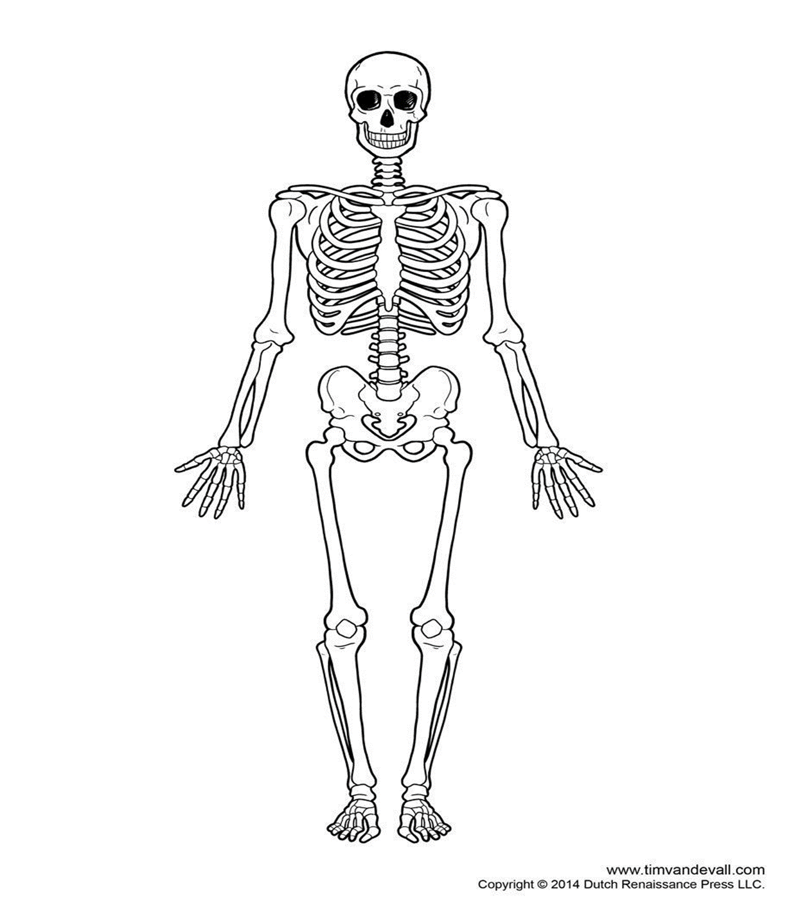
The Appendicular Skeletal System Poster
9.Phalanges
8.Metacarpals
7.Carpals
6.Ulna
4.Elbow
5.Radius
3.Humerus
2.Scapula
1.clavicle

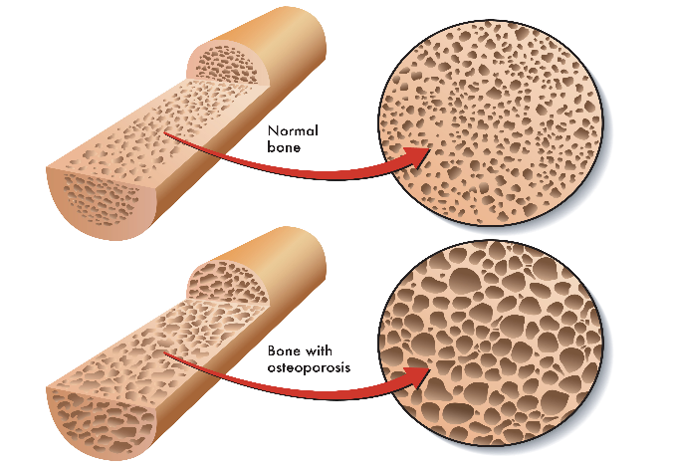
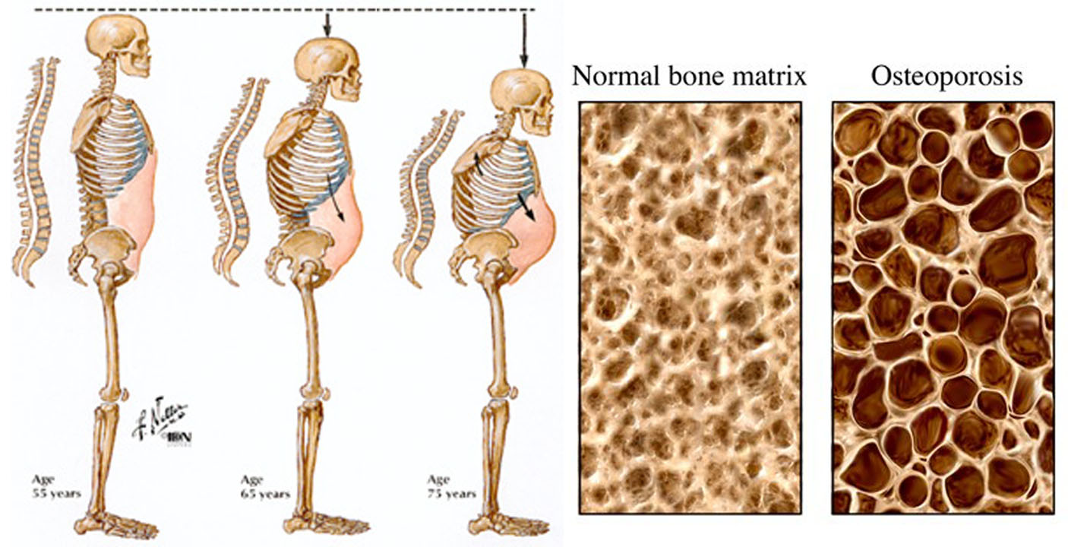
https://www.bing.com/images/search?view=detailV2&ccid=1YjPrKcJ&id=EE704FE5DAE4426A12AE76E414BD9856D501712C&thid=OIP.1YjPrKcJa85XxgFsJIoLvQHaFj&mediaurl=http%3A%2F%2Fpittsburgh-dietitian.com%2Fwp-content%2Fuploads%2F2015%2F07%2Fosteoporosis-bone
9. Phalanges
These are tiny, long bones to form the fingers of both hands and feet. There are 14 phalanges in each limb and 56 in total. Each finger has three phalanges: proximal, intermediate, and distal but the thumb has only two phalanges because intermediate phalanges accreted with distal ones during the development (Martini, 2006).
8. Metacarpals
The metacarpal bones in the palm of the hand joint closely with the adjacent carpal bones in the distal row and these carpometacarpal joints are capable of bending movements and radial and ulnar deviation. The five metacarpophalangeal joints are common joints capable of both flexion/ extension movements away from and towards the midline of the hand (Jones and Lederman, 2006).

7. Carpals
The wrist and base of hand developed by eight small carpal bones. These bones are assembled in two rows, proximal and distal each of them has four carpal bones. The carpal bones and the four proximal bones are bringing together by muscles to create a group. Only scaphoid, lunate, and triquetrum three of them contribute to the radiocarpal joint. The scaphoid, and lunate bones hinged directly with the distal end of the radius, while the triquetrum bone jointed with a fibrocartilaginous pad that covers the radius and styloid route of the ulna (Betts et al, 2017).

6. Ulna
The ulna is a long bone in the forearm and parallel to the radius. It acts as stabilising bone with the radius pivoting to create movement. Proximally, the ulna articulates with the humerus at the elbow joint it also articulates with the radius to create distal radio- ulnar joint (Jones, 2020).
5. Radius
The forearm contains two major bones which are ulna and radius. These two bones play an essential role in the forearm rotation. The ulna primarily connects with the humerus at the elbow joint while the radius attached with the carpal bones of the hand at the wrist joint. the radius is an insertion point for few muscles (Healthline, 2018).
4. Elbow
The elbow is a hinged joint which made up of humerus, radius and ulna. These bones are covered from cartilage from their ends, ligaments, tendons, and companion larger muscles. The humerus is a large bone of the upper arm, forms the top of the elbow joint. Radius is the bone of the forearm that distance the elbow to the wrist and located on the side of the forearm where the thumb is located. It also the channel to important nerve and blood vessel network (BRMC, 2017).

3.Humerus
The humerus is the largest bone in the whole upper arm. The head articulates with the glenoid cavity of the scapula to create the shoulder joint. The bottom of the humerus touches the top of the radius and ulna which joins the upper arm with the lower arm. These bones meeting allows for the wide range of motion, which is possible at the shoulder joint, along with the movement at the elbow. The humerus bone has two large knobs at the top which are called greater and lesser tubercles and When the tendons surrounding the humerus it becomes inflamed and irritated which called tendonitis or bursitis (Ferri, 2020). Osteoporosis, avascular necrosis (lacking blood vessels) and bone cancer are the bone diseases that lead the bone to break or collapse. In United States there are 2 million fracture each year in which 1.3 million are caused by osteoporosis, but avascular necrosis and bone cancers are rare. The bones become weaker in osteoporosis and gets more fragile (Reiley et al, 1998). Osteoporosis can affect men and women but more common in older people although young people can affect too. When women reach at the age where menopause start the hormone oestrogen levels fall this can lead to a rapid decrease in bone density. In men when they grow in old age, they are producing hormone testosterone if it is in low level then the risk of osteoporosis is increased in men. Hormone related disorders are overactive thyroid gland, Cushing’s syndrome, reducing of oestrogen and testosterone, pituitary gland disorders, overactivity of the parathyroid glands. The diagnosis of osteoporosis is based on the results of the patient’s bone density scan and the treatment will be decided according to the age, sex, risk of breaking a bone, and previous injury history. If someone diagnose with osteoporosis due to broken bone, then to reduce the risk of further broken bone they should receive treatment. Calcium is an important mineral found in bone, and having balanced diet is important for maintaining healthy bones. Vitamin D helps the body absorb calcium. Balanced diet and good sunlight are very helpful to take enough vitamin D but some countries have not enough sunlight every needs to take daily supplement during autumn and winter (NHS, 2019).
.

2.Scapula
The scapula is flat triangular shaped bone lying on the next to chest wall shallow to the ribs and separated from them by muscles. At the horizontal angle is a low articulatory surface, the glenoid cavity, and head of humerus forms the shoulder joint. The next surface runs a rough ridge called spine which goes beyond the lateral border of the scapula and extends the glenoid cavity (Waugh and Grant, 2014).

1.Clavicle
The clavicle bone known as collar bone and form as a double arch, in the middle half its convex forward and in the cross half is concave forward. It is a long bone in appendicular skeleton. The clavicle bone is different in size and shape in male and female all over the period of life. The clavicle is linked posteriorly to the vessels passing from the thoracic operculum into the base of the neck and upper limb. The roots of the cervical nerves and thoracic nerves pass posteriorly to the clavicle into the upper limb (Moseley, 1968).

Poster references with numbers

- Moseley, H.F., 1968. 3 The Clavicle: Its Anatomy and Function. Clinical Orthopaedics and Related Research®, 58, pp.17-28 [Accessed on 29th October 2020].
- Waugh, A and Grant, A (2014). Ross and Wilson Anatomy and physiology in health and illness. 12th ed. London: Elsevier. P. 407. Chapter 16. [Accessed on 15th October 2020].
- Ferry. B (2020). The Anatomy of the Humerus. Very well health. Available at: https://www.verywellhealth.com/humerus-anatomy-4628463. 3(a) [Accessed on 26th October 2020].
- Reiley, M.A., Scholten, A. and Talmadge, K.D., Medtronic Spine LLC (1998). Inflatable device for use in surgical protocols relating to treatment of fractured or diseased bones. U.S. Patent 5,827,289. (3b) [ Accessed on 2nd November 2020]
- NHS (2019). Osteoporosis causes. Available at: https://www.nhs.uk/conditions/osteoporosis/causes. [Accessed on 3rd November 2020]. 3c.

- Baxter Regional Medical Centre. Anatomy of the elbow (2017). Available at: https://www.baxterregional.org/medical-services/orthopaedics/upper-body/elbow/anatomy-of-the-elbow/. [Accessed on 27th October 2020]
- Healthline Editorial Team (2018). The Healthline Medical Network. Available at: https://www.healthline.com/human-body-maps/radius-bone#1. [Accessed on 28th October 2020]
- Jones. O (2020). Teach me Anatomy. Available at:
https://teachmeanatomy.info/upper-limb/bones/ulna/#:~:text=The%20ulna%20is%20a%20long,humerus%20at%20the%20elbow%20joint. [Accessed on 10th October 2020]
- Betts. G J, Desaix. P, Johnson. E, Johnson. E J, Korol. O, Kruse. D, Poe. B, Wise. A J, Womble. M, Young. A K (2017). Anatomy and Physiology. OpenStax Rice University. Chapter 8, P. 316. Available at:
https://anatomytool.org/content/openstax-book-anatomy-physiology. [Accessed on 29th October 2020].
- Jones, L. A, and Lederman, S.J (2006). Human hand function. Oxford University Press. [Accessed on 29th October 2020]
- Martini, F (2006). Anatomy and Physiology'2007 Ed. Rex Bookstore, Inc. Chapter no 7. P.178. [Accessed on 30th October 2020]
Howard References
- Baxter Regional Medical Centre. Anatomy of the elbow (2017). Available at: https://www.baxterregional.org/medical-services/orthopaedics/upper-body/elbow/anatomy-of-the-elbow/. [Accessed on 27th October 2020]
- Betts. G J, Desaix. P, Johnson. E, Johnson. E J, Korol. O, Kruse. D, Poe. B, Wise. A J, Womble. M, Young. A K (2017). Anatomy and Physiology. OpenStax Rice University. Chapter 8, P. 316. Available at:
https://anatomytool.org/content/openstax-book-anatomy-physiology. [Accessed on 29th October 2020].
- Ferry. B (2020). The Anatomy of the Humerus. Very well health. Available at: https://www.verywellhealth.com/humerus-anatomy-4628463. [Accessed on 26th October 2020].
- Healthline Editorial Team (2018). The Healthline Medical Network. Available at: https://www.healthline.com/human-body-maps/radius-bone#1. [Accessed on 28th October 2020]
- Jones. O (2020). Teach me Anatomy. Available at:
https://teachmeanatomy.info/upper-limb/bones/ulna/#:~:text=The%20ulna%20is%20a%20long,humerus%20at%20the%20elbow%20joint. [Accessed on 10tth October 2020]
- Jones, L. A, and Lederman, S.J (2006). Human hand function. Oxford University Press. [Accessed on 29th October 2020]

- Moseley, H.F., 1968. 3 The Clavicle: Its Anatomy and Function. Clinical Orthopaedics and Related Research®, 58, pp.17-28 [Accessed on 29 October 2020].
- Martini, F (2006). Anatomy and Physiology'2007 Ed. Rex Bookstore, Inc. Chapter no 7. P.178. [Accessed on 30th October 2020].
- NHS (2019). Osteoporosis Causes NHS. Available at: https://www.nhs.uk/conditions/osteoporosis/treatment/. [Accessed on 3rd november].

- Reiley, M.A., Scholten, A. and Talmadge, K.D., Medtronic Spine LLC (1998). Inflatable device for use in surgical protocols relating to treatment of fractured or diseased bones. U.S. Patent 5,827,289 [ Accessed on 2nd October 2020]
- Waugh, A and Grant, A (2014). Ross and Wilson Anatomy and physiology in health and illness. 12th ed. London: Elsevier. P. 407. Chapter 16. [Accessed on 15th October 2020].

