Overall assessment

Freya Marshall

Contents

Contents 2
Coaching Session Plan Group 2
In class test 1 7
Individual session plan 11
Academic Journal Review 1 19
Academic Journal Review 2 20
Coaching Observation Competence Assessment 21
In class test 2 24
References: 30

Coaching Session Plan Group
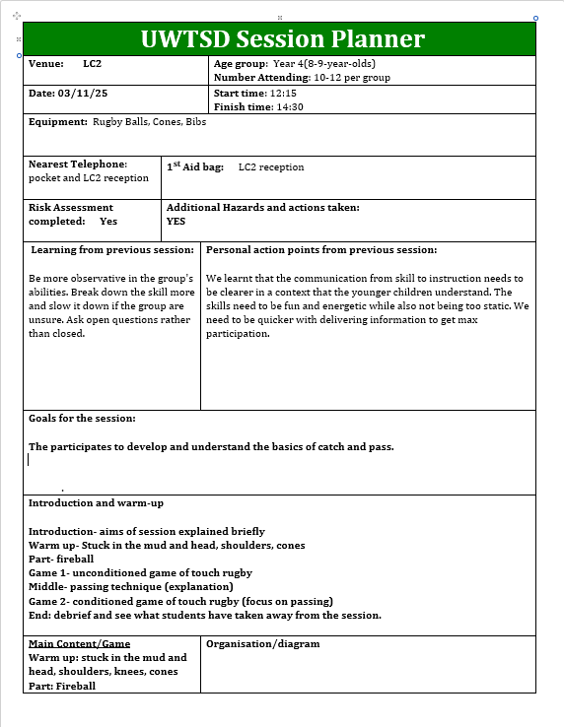
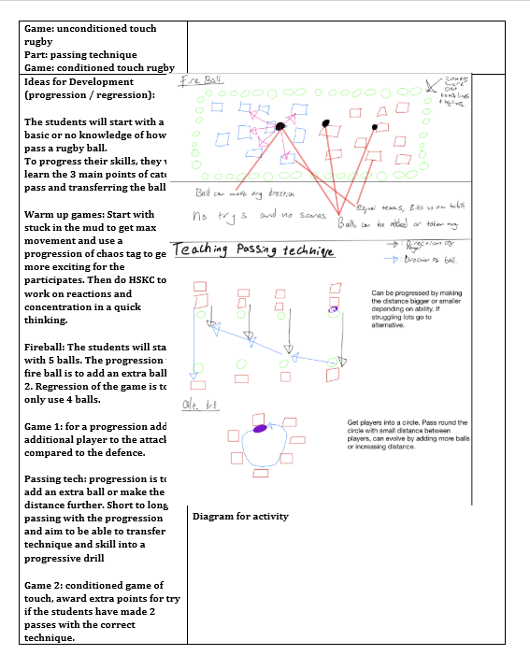
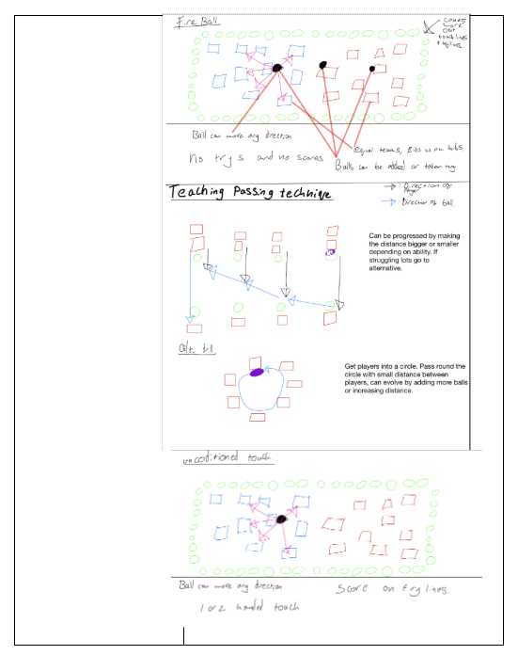
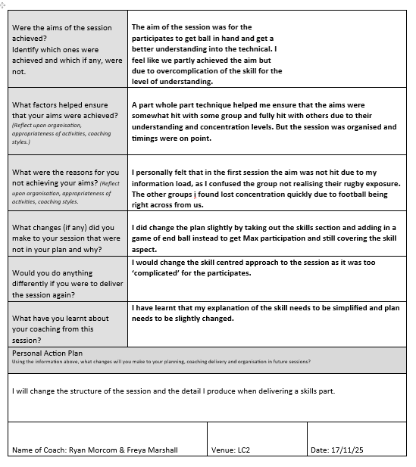

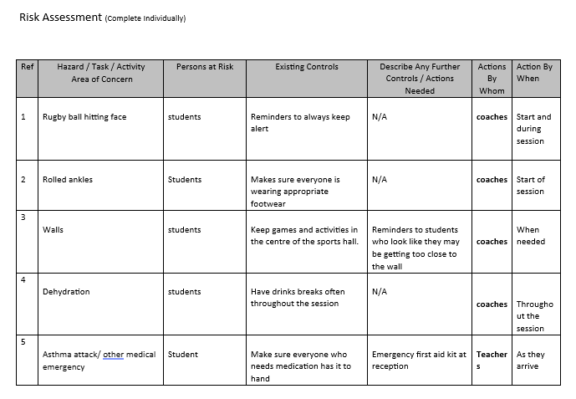

In class test 1

Management of the coaching process- Freya

1. Generalization in childhood sports development refers to a child participating in multiple sports such as football, swimming, and rugby. This allows the child to develop their fundamental movement patterns and their motor skills to make them a well-rounded athlete. They can then choose one sport to specialise in life. By doing multiple sports at a young age rather than limiting themselves to one, they will be able to draw on skills developed across other sports to further their performance in their chosen sport. For example, they may develop situational awareness in football to pick the most advantageous pass which can also be applied to rugby.
1.1 Specialisation in childhood sports development refers to a child solely participating in one sport. This means they will build up their sporting hours within one sport such as football. They may be training within school, for multiple teams outside of school as well as doing individual practise. This will allow them to build up their 10,000 hours faster than a child that generalises seemly giving the impression that they may be uniquely “talented” or developmentally above their peers. However, in the long run because their developmental scope was limited to one sport, they may be overtaken by a child that generalised before specialising.
1.2 Generalisation and specialisation can be linked to athletes Roger and Tiger. Roger is a famous tennis player who grew up participating in many different sports therefore he generalised in his childhood sports development. Roger was a keen sportsman throughout his childhood participating in as much sport as he could which allowed him to develop his all-round sporting ability before he then chose tennis to specialise in. Conversely Tiger is a famous golf player who grew up playing golf therefore he specialised in his childhood sport development. Tiger was given a golf club by his father at a very young age and when he displayed early signs of “talent” his father guided him down the route of being a professional golfer meaning he only trained golf and specialised in it through his childhood development.
1.3 The Polgar sisters are significant to this theme because they specialised in chess. Their father wanted to prove that anyone could achieve high levels in a sport if they had enough training and put enough hours into it from a young age. As a result, he taught all his daughters how to play chess as early as possible and encouraged them to dedicate themselves to the sport throughout their childhood. This resulted in them specialising in chess and building up their 10,000 much earlier than other chess players. One of the sisters became a grandmaster at 14 which is much earlier than most players. This sole focus on chess allowed all 3 sisters to become successful chess players at a relatively young age because they had dedicated themselves to the sport all throughout their youth.
1.4 Chunking is a method of memorisation/ learning. It involves grouping together information with a similar theme or that can be linked so that the overall information is broken down into smaller sections. For example, you might use a mnemonic as a way of remembering a group of words. This can trigger your brain to remember better than if you just looked at the words and tried to remember them. This skill can be applied to chess as one of the Polgar sisters was tested in memorising pieces on a chessboard. She did this successfully multiple times, however when the pieces were put in places on the board that are not legal within the game, she was unable to. This is because her brain used familiar patterns to memorise these pieces before, but when it was changed her brain did not have the familiar hints to trigger her memory as it was unnatural for the pieces to be where they were and wouldn't occur in a real game.
2.1 Three outcomes parents may want in addition to technical player development from my coaching session is to develop confidence, game-based knowledge and player fitness.
2.3 If I were taking an U8s session and a child wasn't engaging and distracting other children I would assess what is causing the child to misbehave. It could be that there is too much standing around in the drill, I’m asking them to do focused practise for too long, they are finding the drill/ skill too difficult and are acting out in frustration etc. Once I have identified what the problem is either by observation or asking the child I would either adapt the drill to fix the problem, offer a drink break to allow the children to leave the drill and reset offering them a mental break and giving me time to solve the problem or move onto the next drill. Alternatively, I could give the child that is not engaging another “job” so that they are still participating but in a slightly different way. For example, if we were doing a game of football, I could ask them to help me referee e.g. it's their job to say which team gets the throw in etc. This allows them to be engaged in the same activity as the other children but participate in a different way that keeps them engaged.
2.4 If I were taking an U5s session and the child hasn't participated in 3 weeks due to claiming they have a bad leg I would initially encourage them to stay involved in the session. I would then observe them for signs of discomfort and if I think the child is experiencing discomfort, I would let the child sit out as not to cause them further discomfort. After the session speak to the parents about their child’s discomfort to gauge whether the child has an ongoing issue or it's something they should get checked. If there seemed to be nothing wrong with the child, I would take them aside and speak to them to try and discover the route problem and find a solution to engage them based of the child’s feedback.
2.6 If I were coaching an U21s session and an adult started swearing and shouting at players I would immediately tell them to stop as there is no place for that behaviour in a sporting environment. If they continued, I would ask them to take a break from the session to calm down e.g. go and have some water. After the session I would take them aside and explain the behaviour is not appropriate and try to ascertain whether its due to a deeper issue that the player is experiencing. If that were the case, I would then try to support the player and solve the issue.
3. The coaching process refers to a way of teaching a sport to an athlete. It differs depending on the coach and there are multiple different approaches that can be used. For example, a coach could take a democratic approach where they encourage feedback from players and include players in decisions. It involves planning a session, delivering a session and afterwards reflecting on that session.
3.1
Instruction and explanation:

Demonstrations:
Could be done in football by the coach taking the football and dribbling through the cones as a visual of what they have just explained.
They could show a clip of a professional athlete correctly doing a skill in a game to show players what correct delivery of a skill within a game context would look like.
Observation and analysis:

Provide feedback:
Feedback could be given nonverbally for example clapping when a player does something well.
It can be given positively or negatively for example a coach may take a player aside after a game if they gave away unnecessary fouls and tell them they are not happy with the player doing so.

3.2 WRU coaching process
P= Performance
D= Development
R=

4 Technique is defined as a way of moving in a sport. It is how you correctly perform a movement. You need correct technique to perform a skill well.

4.1 An exmaple of a technique in sport is an athlete’s form when running. For example, keeping their head facing forwards, not striking the ground with their heels.

4.2 A skill is defined as a specific movement pattern.

4.3 An example of a skill in football is a step over.

4.6 The benefits of a skill practise session are that the player can work on their sport specific movement in a self-paced environment so that they are confidence transferring them into a game situation. A player being skilful is advantageous because they will be able to perform the more difficult movements well that other players may not and it give them an edge e.g. in a 1v1. They can also be done alone or with small numbers.

4.7 The limitations of a skill practise session are it does not practise real game like scenarios. For example, a football player may excel in a skill practise session and be able to do lots of skills but then on the pitch is not able to perform it under pressure, have good awareness to pick out passes, be able to read the game etc.
4.8 The benefits of using a whole/part/whole approaching during a coaching session are that it allows the coach to identify weak areas within the group which can then inform their skill-based practise in the part section. They can identify team weaknesses and specifically target improving them in the session. It also allows them to track progress and their own success within the coaching drill. If the team was weak at passing in the first game and the coach then does specific passing drills, they would then want to see an improvement in passing within the game at the end. If this is the case, they will know their coaching drill was successful and the players took the information on board. The limitations are that it may not be as effective for elite players when they are technically already skilled and don't need small breakdowns or have small individual areas they need to improve.

Individual session plan

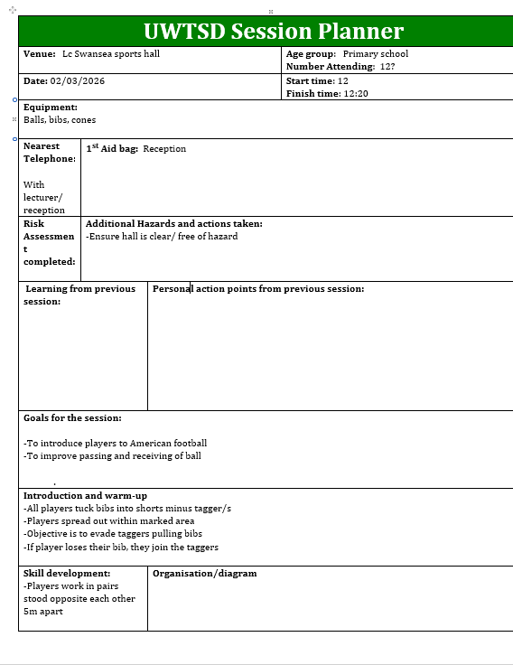
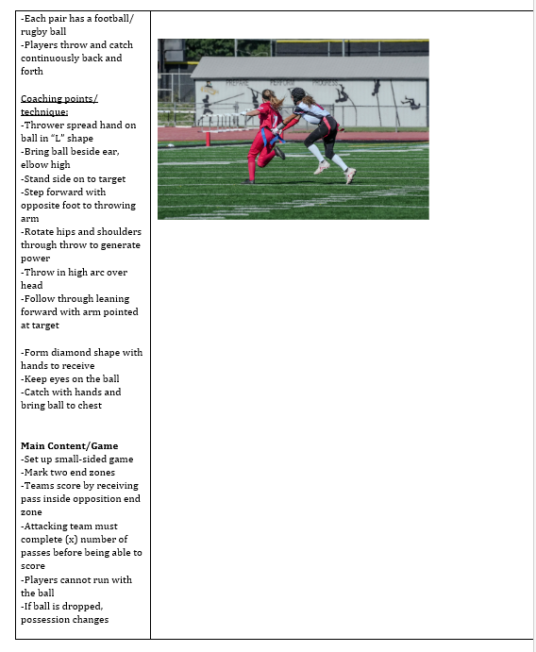
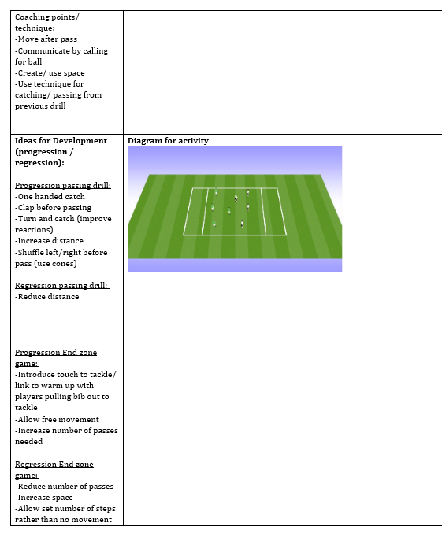
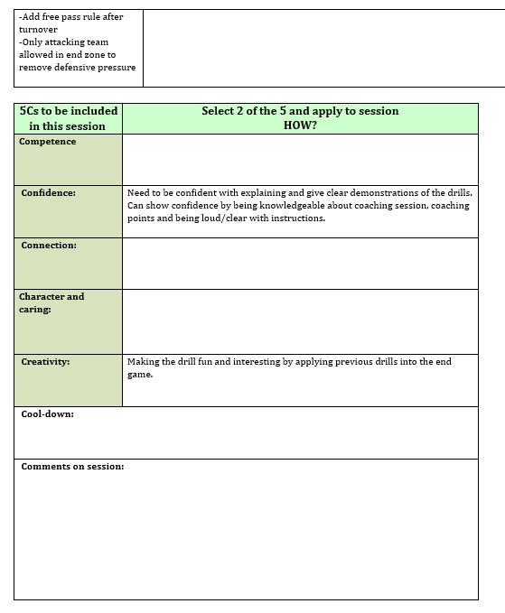

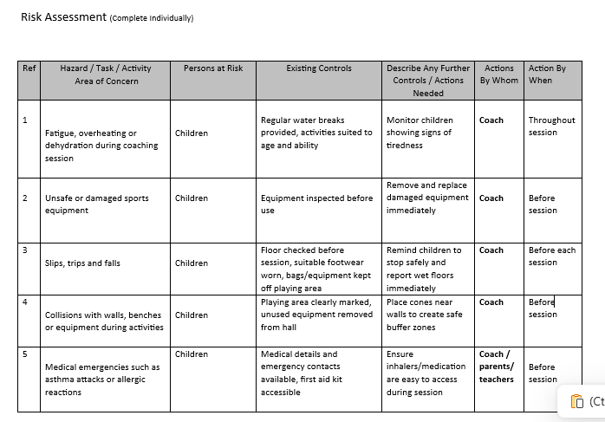

Academic Journal Review 1
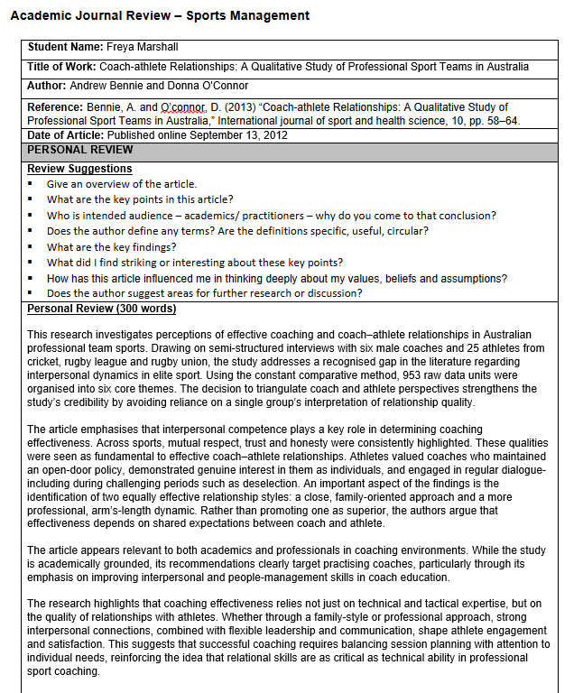

Academic Journal Review 2
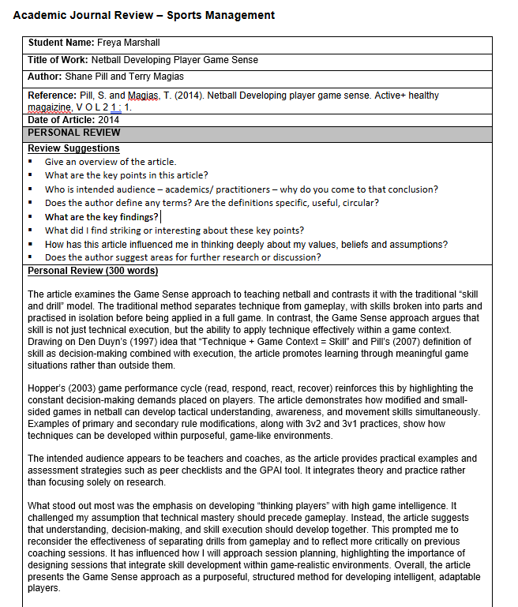

Coaching Observation Competence Assessment

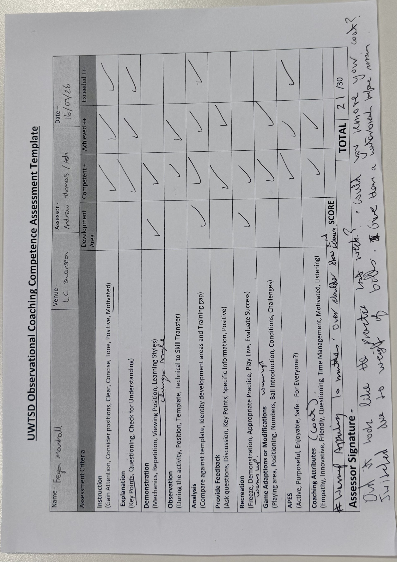

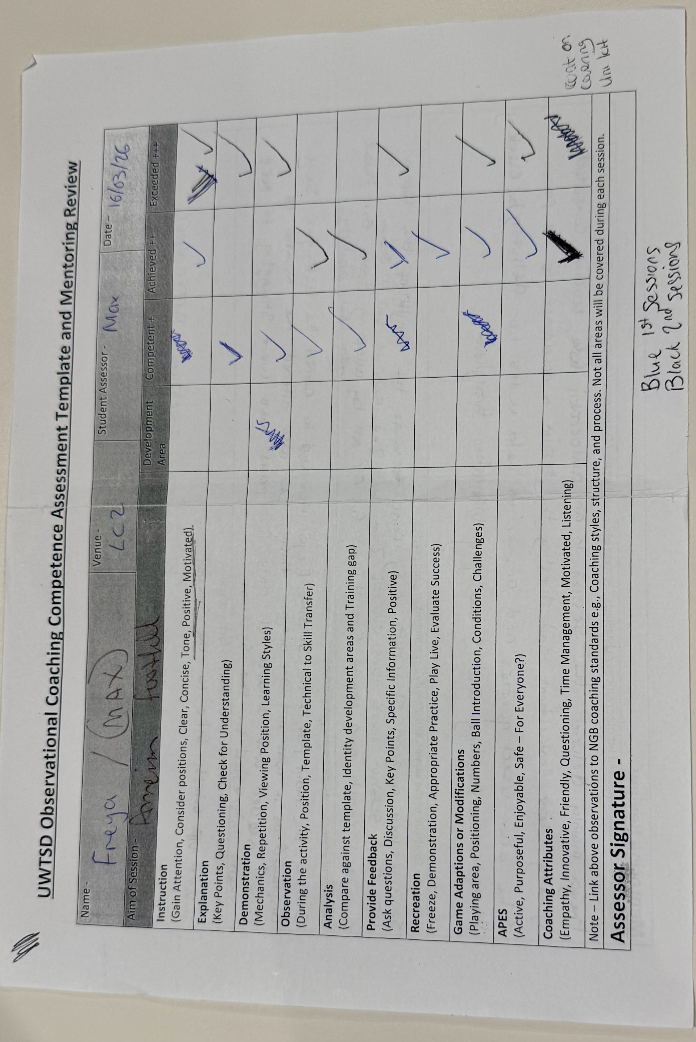

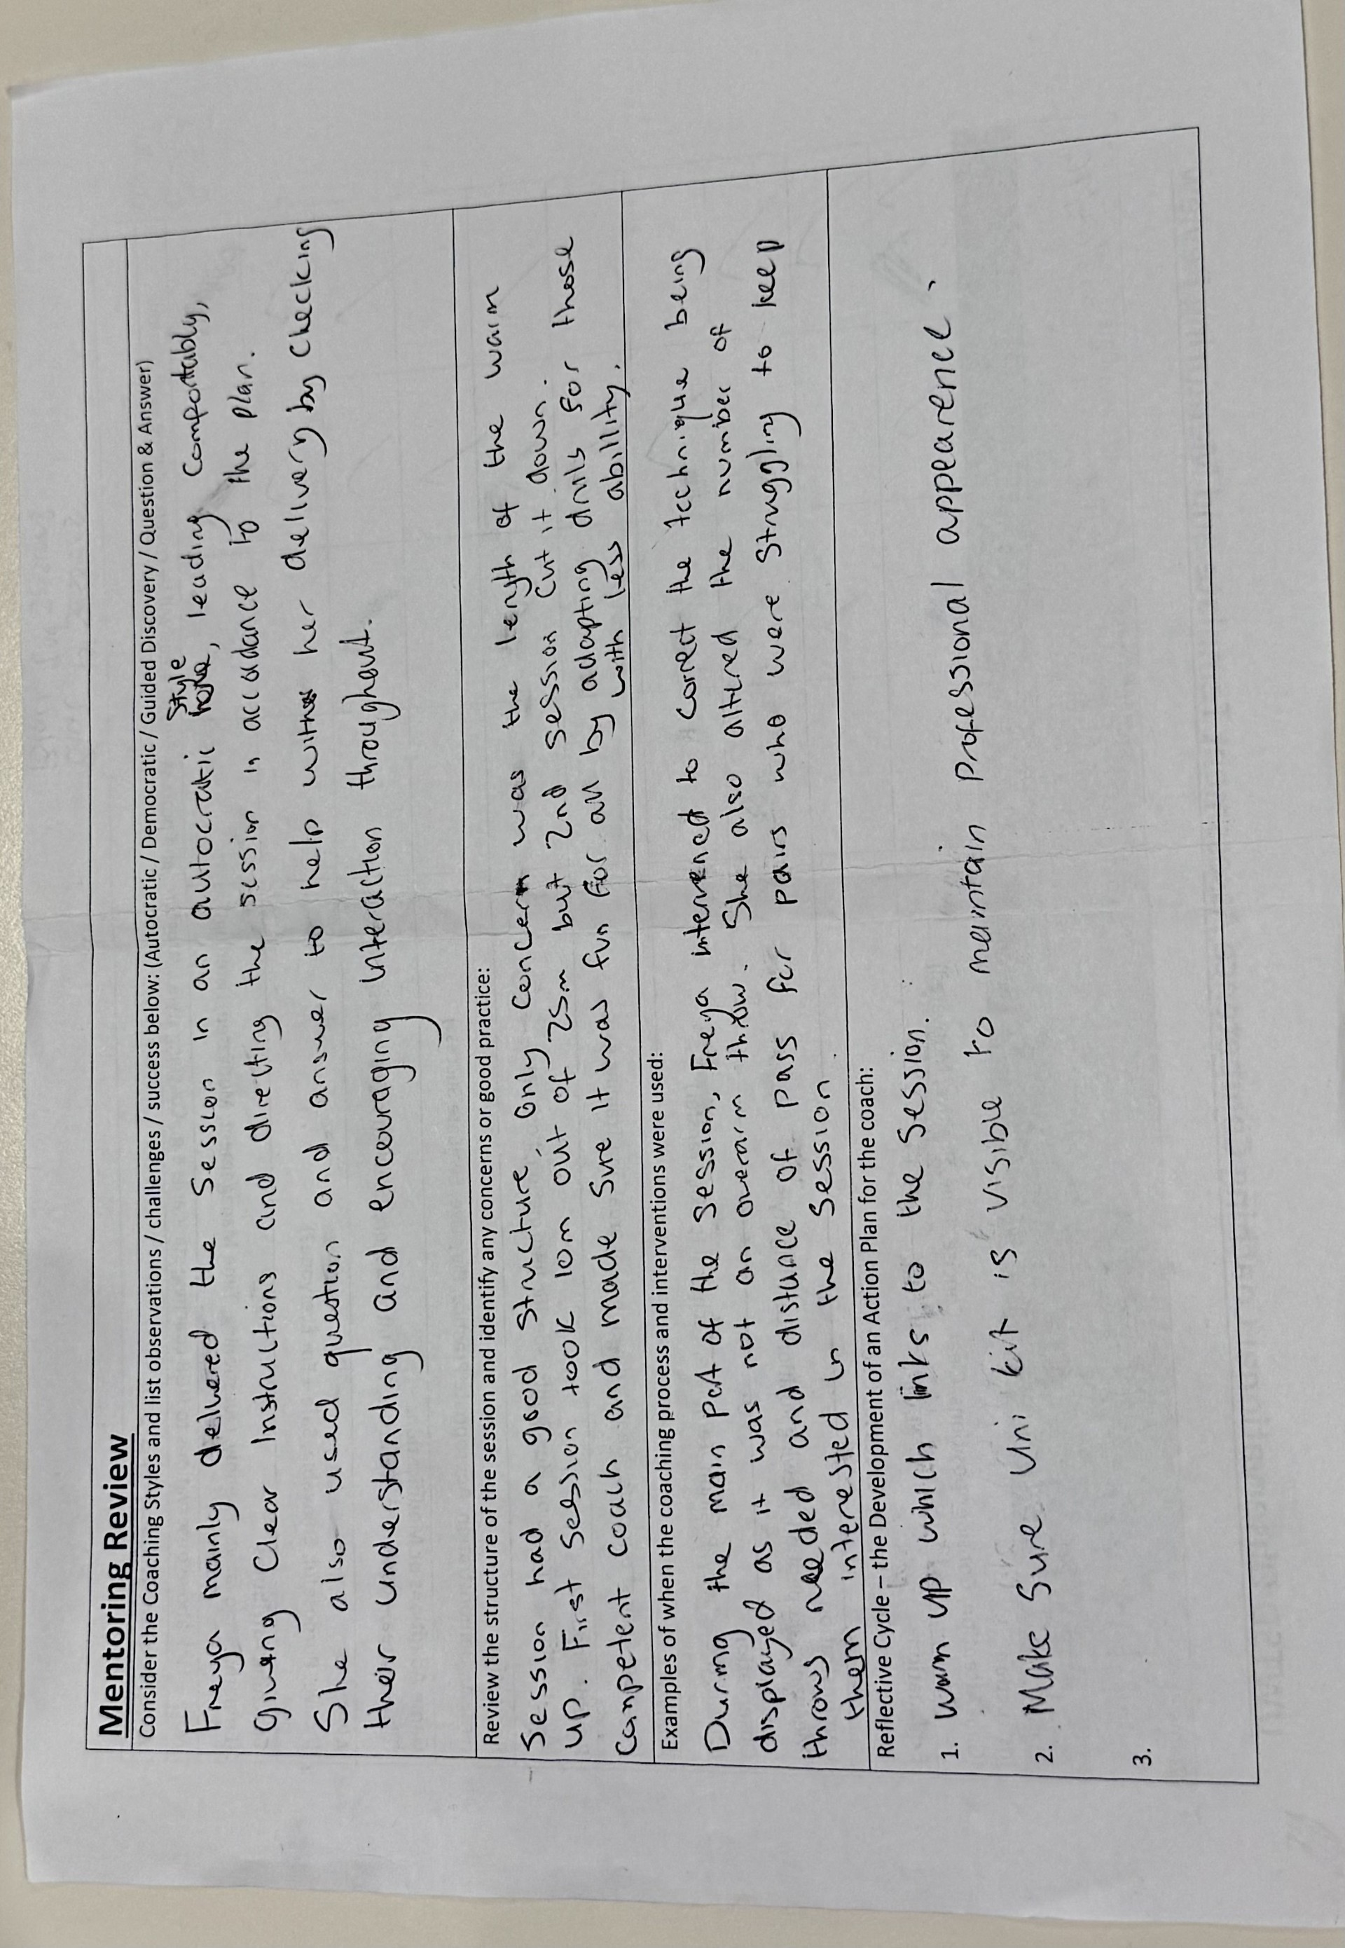

In class test 2

Competency scale
1= Unable to perform skill
2= Performs with difficulty
3= Performs with some consistency
4= Performs effectively and independently
5= Performs with high level of skill and consistency

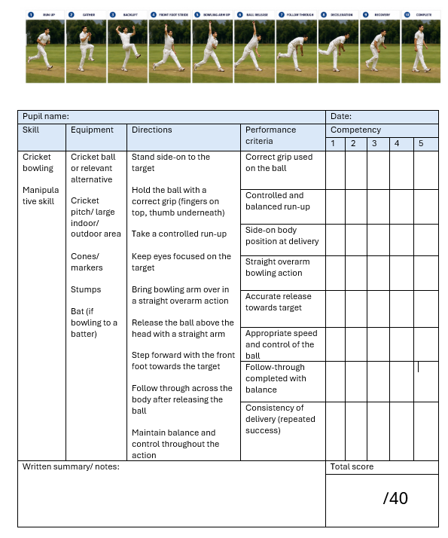

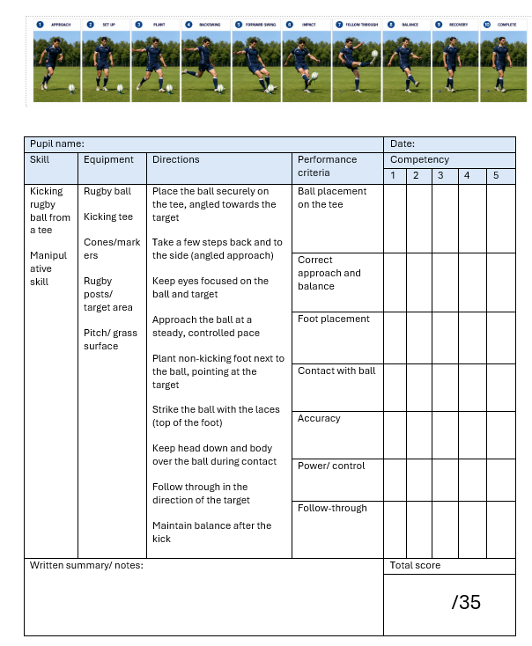
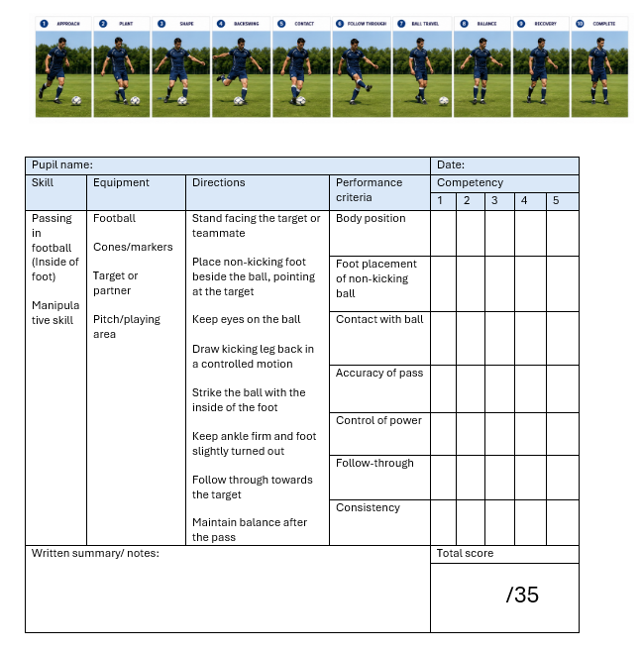
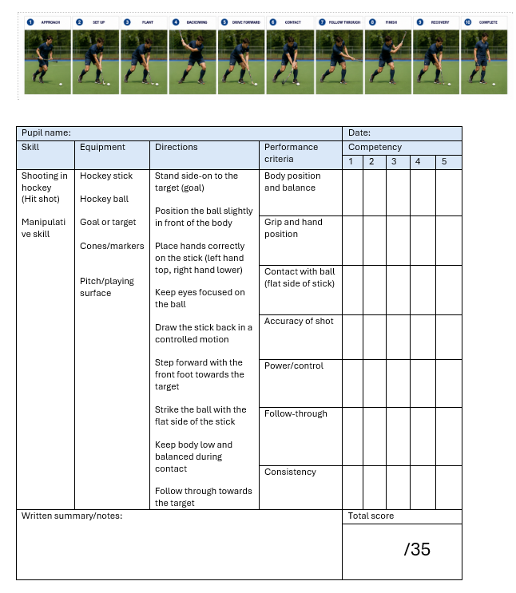

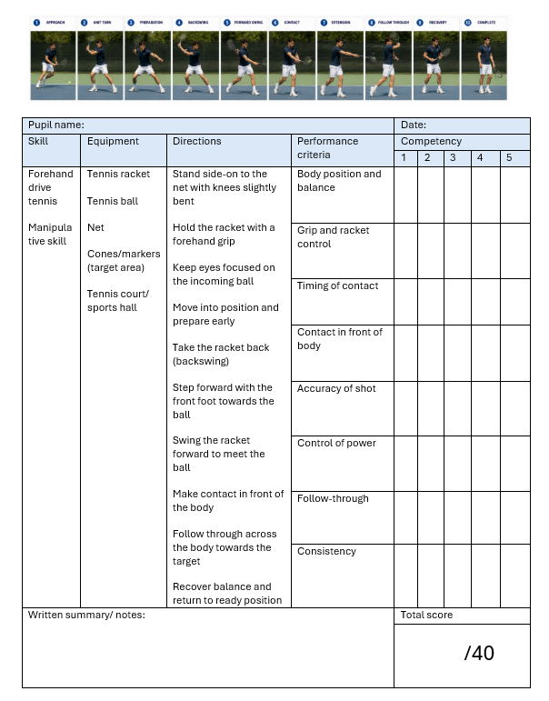

References:
Bennie, A. and O’connor, D. (2013) “Coach-athlete Relationships: A Qualitative Study of Professional Sport Teams in Australia,” International journal of sport and health science, 10, pp. 58–64.
den Duyn, N. (1997b). Game Sense: Developing Thinking Players – A Presenter’s Guide and Workbook. Belconnen, ACT: Australian Sports Commission.
Hopper, T. (2002) Teaching Games for Understanding: The Importance of Student Emphasis over Content Emphasis. Journal of Physical Education, Recreation & Dance, 73(7), pp. 44–48.
Pill, S. (2007) Play with Purpose: Game Sense to Sport Literacy. Adelaide: ACHPER Australia.
Pill, S. and Magias, T. (2014). Netball Developing player game sense. Active+ healthy magaizine, V O L 2 1 : 1.

