

The Regeneration of Swansea: What can be learnt from the greening of Copenhagen?

School of Architecture, Built and Natural Environment
Course: BSc Architecture

Name: Ben Alan Brandon
Student Number: 1804289
Module code: M6X01986
Word count: 10,987
Date: 5 May 2023


Author’s Declaration
I declare that the work in this dissertation was carried out in accordance with the regulations of the University of Wales, Trinity Saint David. The work is original except where indicated by special references in the text and no part of the dissertation has been submitted for any other degree.
Any views expressed in the dissertation are those of the author and in no way represent those of the University of Wales, Trinity Saint David.
The dissertation has not been presented to any other University for examination either in the United Kingdom or overseas.
I hereby give permission for my work, if accepted, to be available for photocopying and inter-library loan, and for the title and summary to be made available to outside organisations.

Signed: | Ben Alan Brandon
Date: | 5th May 2023

Copyright statement

The copyright of this dissertation rests with the University of Wales, Trinity Saint David. No information derived from this dissertation shall be published without the prior written consent of the University.

Signed: | Ben Alan Brandon
Date: | 5th May 2023

Abstract

In today’s society, ‘Urban Regeneration’ has become increasingly important for cities around the world, as they aim to revitalise their communities, attract investments for the future and improve the overall quality of life within the area. This dissertation will examine the case of the greening of Copenhagen and investigate the potential lessons that can be applied during the regeneration of Swansea, Wales.
The study begins by analysing Copenhagen as a city, examining the key policies and legislation put in place by the local and national governments that were important in the greening of the city, such as the development of Copenhagen’s carbon neutral 2025 plan. The dissertation then moves on to discuss the energy policies within the city and how these benefit Copenhagen in their carbon neutral initiative. Furthermore, the transportation system within Copenhagen will be analysed and examined, to further understand how a city’s transportation system can have such an impact on the city’s carbon footprint.
After analysis of Copenhagen, the dissertation moves on to examining Swansea as a city, again examining the key policies and legislation put in place by the local and national governments that have sustainable initiatives and help Swansea strive towards its 2050 carbon neutrality goal. Following on from this, an analysis of Swansea’s ‘Bay City Deal’ will be conducted, exploring the different sustainable objectives of the plan including energy usage, future investments and infrastructural improvements. Finally, Swansea’s transportation system is examined to understand what the current transportation situation is within the city, and where possible improvements can be made.
Following on from the analysis of both cities, a case study of two key sustainable architectural projects from both cities will be carried out. The purpose of this is to understand and examine the environmental impact of the two projects within the city, as well as further understand the different support from the local and national governments on sustainable projects such as these, and understand how they have affected the local community as well as analyse the overall success of the two buildings.
Finally, a conclusion will be formed as to what lessons, if any, there are to be learnt from Copenhagen during the regeneration of Swansea. This will outline a brief overview of the key differences between the two cities and the author of the dissertation will make some suggestions of what should be done after examining the findings of the dissertation.

Acknowledgements

I would firstly like to acknowledge Dr Elizabeth Walder FRSA for her significant contributions to this dissertation, assisting with various research routes and asking key questions that led me to the research that I have conducted for the paper.
I would also like to acknowledge Mr Ryan Stuckey for his guidance and assistance throughout the research, development and writing process of this dissertation, he helped me come to a clear and direct strategy to answer my dissertation question.
I finally would like to thank Mr Ian Standen for his assistance in gathering valuable information on Swansea and the regeneration plans. He provided me access to information that I otherwise may not have been able to have found myself which gave a key insight into the strategic thinking of the Swansea government and their plans for the city.

Table of Contents

PAGE TITLE | PAGE NO
Author’s Declaration | 2
Copyright statement | 3
Abstract | 4
Acknowledgments | 5
List of Illustrations | 7
List of Tables | 8
Introduction | 9
Methodology | 9
Selection of case studies | 11
Chapter 1: Why Copenhagen? | 13
Chapter 2: An Introduction to Swansea | 22
Chapter 3 Case Study 1 – Copenhill | 32
Last chapter: Case Study 2: Active Classroom and Active Office | 41
Conclusion | 50
Bibliography: Published Works | 52

List of Illustrations

CHAPTER 1: WHY COPENHAGEN? | PAGE NO
Figure 1: Graph Showing Energy Consumption in Copenhagen compared to CO2 emissions | 14
Figure 2: Graph showing the estimated energy split of Copenhagen 2011 | 15
Figure 3: Image of Anholt Wind Farm | 16
Figure 4: Graph showing Copenhagen’s Green House Gas Emissions from 2005 to 2020 | 17
Figure 5 showing a map of Copenhagen via cycling routes | 20
Figure 6 showing a map of Copenhagen’s Metro lines | 21
CHAPTER 2: AN INTRODUCTION TO SWANSEA
Figure 7: Image of Swansea Bay University’s green spaces | 24
Figure 8: The 3,500-capacity indoor arena at a site adjacent to the LC in Swansea city centre | 25
Figure 9: A state-of-the-art office development on The Kingsway in Swansea city centre | 26
Figure 10: Graph showing the estimated regional renewable energy production of Wales | 28
Figure 11: Active Travel Network Map for Swansea | 30
CHAPTER 3: CASE STUDY 1 – COPENHILL
Figure 12: Image of Copenhill | 31
Figure 13: Image showing a design of the Copenhill Ski Slope | 32
Figure 14:Image of the Copenhill Climbing Wall | 33
Figure 15: Image of Copenhill under construction | 34
Figure 16: Showing the Steel Frame Construction of Copenhill | 35
Figure 17: Showing the hollow-core roof slabs in the construction phases of the project | 35
Figure 18: Showing the Aluminium façade with the translucent panels | 36
Figure 19: Image of the ski slope of Copenhill in use | 37
CHAPTER 4: CASE STUDY 2: ACTIVE CLASSROOM AND ACTIVE OFFICE
Figure 20: Swansea’s Active Classroom and Office | 40
Figure 21: Showing Swansea’s Active Classroom | 42
Figure 22: Showing Swansea’s Active Office | 44
Figure 23: Showing The Active Classroom’s Steel Frame substructure | 45
Figure 24: Showing The Active Office’s Concrete Pad Substructure | 46

List of Tables

CHAPTER 2: AN INTRODUCTION TO SWANSEA | PAGE NO
Figure A: Table 1: Table showing the top 10 UK cities in which to bring up children | 22

Introduction

Methodology
While researching material for this dissertation, the author engaged in four different strategies:
- Library research and documentary sources
- Fieldwork with site visits to conduct first-hand research
- Government and legislative data
- In depth case study analysis

Following on from the recent Covid-19 pandemic, this has meant that a lot of information is now easily accessible online. However, I was still able to conduct my site visits as required and gain valuable first-hand information to coincide with my online research.

- Library research and documentary sources
At the beginning of the period of study, a desktop research was conducted into the ‘greenest’ cities in the world, which revealed that in order to futureproof a city, it simply must become more sustainable. Through the literature research, the researcher used historical books on the topic of sustainability in order to gain a wider understanding of the topic to utilise when analysing the case studies later on in the dissertation. There were also several government-published documents that were analysed by the researcher in order to gain a sense of how the two comparative cities have arrived at their current positions when it comes to sustainability and discover what has already been implemented in regards to sustainability.

- Site visits to conduct first-hand research
The researcher of this dissertation carried out constant site visits throughout the research process to various locations throughout Swansea. Ranging from visiting the location of one of the case studies analysed later in the dissertation, to visiting local transportation hubs and gaining first-hand experience of the sustainable transport options throughout Swansea. The researcher also conducted a visit to the Swansea Museum and the National Waterfront Museum in order to gain a wider understanding of how the transport of Swansea has developed throughout history.

- Government and legislative data
Both the Swansea and Copenhagen Governments have produced a number of significant reports that have been read and referred to as part of the literature review for this dissertation. It has also been useful to collect and analyse comparative data from other notable bodies such as the Welsh Government and the Danish Government as this has helped to provide a wider knowledge of the position of the two cities when compared to on a national scale.

- In depth case study analysis
The author of this dissertation carried out an in depth case study analysis into two key pieces of sustainable architecture from both cities. There were also case studies already carried out on both buildings by various architects and architectural critics around the world, these documents helped to gain a wider understanding of the two buildings and how they are viewed by others. Some of these case studies proved to be key pieces of literature that were referred to throughout this dissertation and helped the author gain a wider knowledge on the buildings in question.

Aims & Objectives
Dissertation question:
The regeneration of Swansea: What can be learnt from the greening of Copenhagen?

Aim
To analyse the greening of Copenhagen and understand how the regeneration of Swansea can learn from this.

Specific Objectives
- To understand how Copenhagen has become a green city.
- To understand what is currently being done in Swansea to become a green city.
- To examine and analyse key sustainable architectural projects in both cities.
- To consider if any lessons can be learnt from Copenhagen and utilised in the regeneration of Swansea to improve its sustainable position.
Key Words
Regeneration – The investment of public and/or private funds to improve/enhance an urban landscape socially, economically and environmentally (Schurig, 2018).
Green City – A city which puts special consideration on energy production/consumption, green space, sustainable transport and renewable energy generation (Anderson, 2022).
Carbon Neutral – The making of or resulting in no net release of carbon dioxide into the atmosphere (Wollerton, 2021).
Carbon Footprint – A measure of how much carbon dioxide is released into the atmosphere as a result of the activities of a particular organisation, city or community (Selin, 2023).

Introduction to Case Studies
The author has chosen Swansea and Copenhagen as the two main focal points of this dissertation, along with two key examples of sustainable architecture within the two cities; Copenhill and The Active Classroom and Office. Swansea was chosen due to being the hometown of the author, and therefore being easily accessible for site visits and first-hand research. Swansea has a population of approximately 314,000 which is on the upwards trend, increasing around 0.64% per year (Macro Trends, 2023). With the population on the rise and the regeneration of Swansea in the near future, the author will be exploring what can be done to make Swansea a green city. Copenhagen was chosen by the author as the initial investigation into exemplar green cities revealed that Copenhagen is seen as one of the greenest cities in the world. It has a population of approximately 644,000 which similarly to Swansea, is on the upwards trend, increasing at a faster rate of around 0.97% per year (Statista Research Department, 2022). Copenhagen is quite obviously a larger city than Swansea, with just over double the population, however due to its progress towards becoming a carbon neutral city, the author has chosen to examine Copenhagen and analyse what factors have contributed to its success.

Literature Review
Within the literature review, the author has used significant reports during the research of the dissertation such as the Danish Energy Agency’s 2021 Energy Statistics Report, the European Environmental Agency’s Renewable Energy in Europe 2017 Report, the Welsh Government’s Energy Generation in Wales 2020 Report and Swansea Council’s Climate Change and Nature Strategy 2022 Report. Significant government legislation such as the Copenhagen 2025 Climate Plan (2012) and the Swansea Bay City Deal (2017) were thoroughly examined by the author of this dissertation when analysing both cities comparatively.
Furthermore, significant publications which the author referred to within the literature review include various architectural publications such as the Architects Journal, Dezeen, RIBA Journal and Archdaily. Similarly, news companies such as Wales Online and The Guardian were also used to compare the opinions of the public with those in the architectural publications. In addition to this, a thorough examination of Joanna Clarke’s in depth case studies; Active Classroom Case Study (2020) and Active Office Case Study (2020) were analysed to supplement the findings from various web pages. All of the above was then further supplemented with various research visits to the Active Classroom and Office, as well as the Swansea Museum and the National Waterfront Museum by the author.

Chapter 1: Why Copenhagen?

There are various reasons why Copenhagen has been chosen as a comparative model to Swansea which this chapter will explore. According to C40 Cities Climate Leadership Group over the past 50 years Copenhagen has earned itself the title of the ‘Greenest city in the world’ (Co, 2022).
Furthermore, Copenhagen has won a number of international awards and titles including the European Green Capital in 2014 (European Commission, 2012) to the International Climate Prize in 2017 awarded at the C40 Cities Awards in Chicago (Heiburg, 2017). These awards are only won by cities who take significant steps to become carbon neutral or a sustainable. For example, to be awarded the International Climate Prize by the C40 Cities Commission in 2017, Copenhagen implemented an impressive energy surveillance plan across a two-year span which began in 2015 with 100 pilot buildings converted to 550 (450% increase) municipal buildings in 2017 with the purpose of monitoring and optimising energy consumption, thereby reducing energy and water consumption in public buildings by 25% by 2025 (Heiburg, 2017).

The first Carbon Neutral Capital?
According to the Carbon Neutral Cities Alliance (CNCA), which is a collaboration of leading global cities working towards achieving carbon neutrality, Copenhagen aims to be the first carbon neutral capital by 2025 (CNCA, 2020). In order to achieve this goal, Copenhagen adopted the Copenhagen (CPH) 2025 Climate Plan in 2012 which, contains four pillars:
- Energy Consumption
- Energy Production
- Mobility
- City Administration Initiatives.

Energy consumption within Copenhagen has dropped considerably since adopting the CPH 2025 Climate Plan in 2012 as shown in the graph in Figure 1 which shows that energy consumption dropped from an index of 100 in 2012, to around 90 in 2021 as well as demonstrating a general downwards trend in the overall consumption.
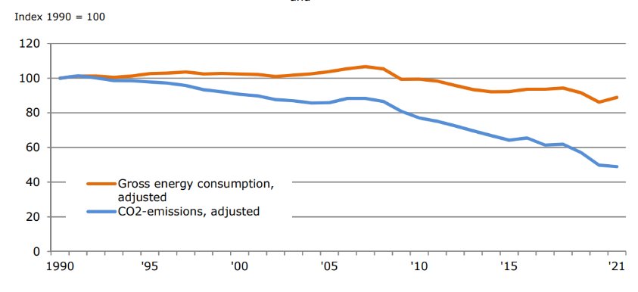
Figure 1: Graph Showing Energy Consumption in Copenhagen compared to CO2 emissions (Photo credit: Danish Energy Agency)

The slight spike in 2021 is most likely to be as a result of the global Covid-19 pandemic, which if taken into consideration, created an increase in energy usage within the homes of the public (Danish Energy Agency, 2020). Energy consumption is a major factor in becoming a green city and carbon neutral as it is now estimated that around two thirds of the global greenhouse gas emissions are linked to the burning of fossil fuels for energy used for heating, electricity, transport and industry (European Environmental Agency, 2017). In 2012, when Copenhagen adopted the CPH 2025 Climate Plan, it was estimated that around 43% of total energy consumption was attributed to heating, about 29% to electricity and 28% to transport (see Figure 2). In response to these statistics, Copenhagen developed a large scale district heating network which covers roughly 98% of the city and acts as damage limitations for the 43% of energy consumption that the heating accounts for in Copenhagen. The district heating system contributes significantly to the EU and national energy targets through a reduction in carbon emissions and a greater increase in renewable energy usage, all of which are factors that the Danish Government considered when introducing the system to the capital (Interreg, 2020). Not only is this an environmental benefit to Copenhagen, but it also helps boosts the city’s economic profile, creating more green jobs within the city as well as increasing the energy ratings of any new building developments (Interreg, 2020).
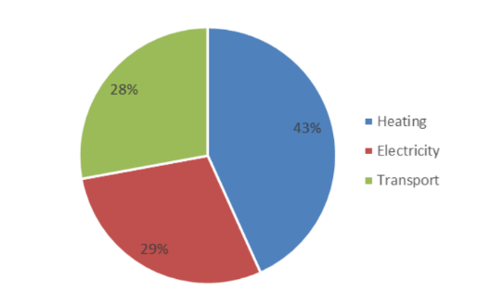
Figure 2: Graph showing the estimated energy split of Copenhagen 2011 (Photo credit: Mathisen et al 2015)

Energy production
As well as the energy consumption, Copenhagen has attempted to develop its energy production systems to further decrease its carbon footprint with the use of combined heat and power (CHP) plants and renewable energy sources (Gerdes, 2013). As Copenhagen has focused on renewable energy production by implementing strategies such as wind farming and biomass energy production throughout the city, this has allowed for approximately 67% of Copenhagen’s electricity to be produced from (up to) 46% from wind farms and (up to) 11% from the biomass farming (Braff, 2023).

One of Denmark’s most efficient wind farms powering Copenhagen is known as Anholt Offshore Wind Farm (see Figure 3) and consists of 111 wind turbines contributing to the 46% of electricity produced for Copenhagen. The wind energy produced by Anholt Offshore Wind Farm alone is enough carbon-free power to cover the annual consumption of up to 400,000 homes, totalling to approximately 4% of Denmark’s total power consumption as a nation (Orsted CDN, 2016).
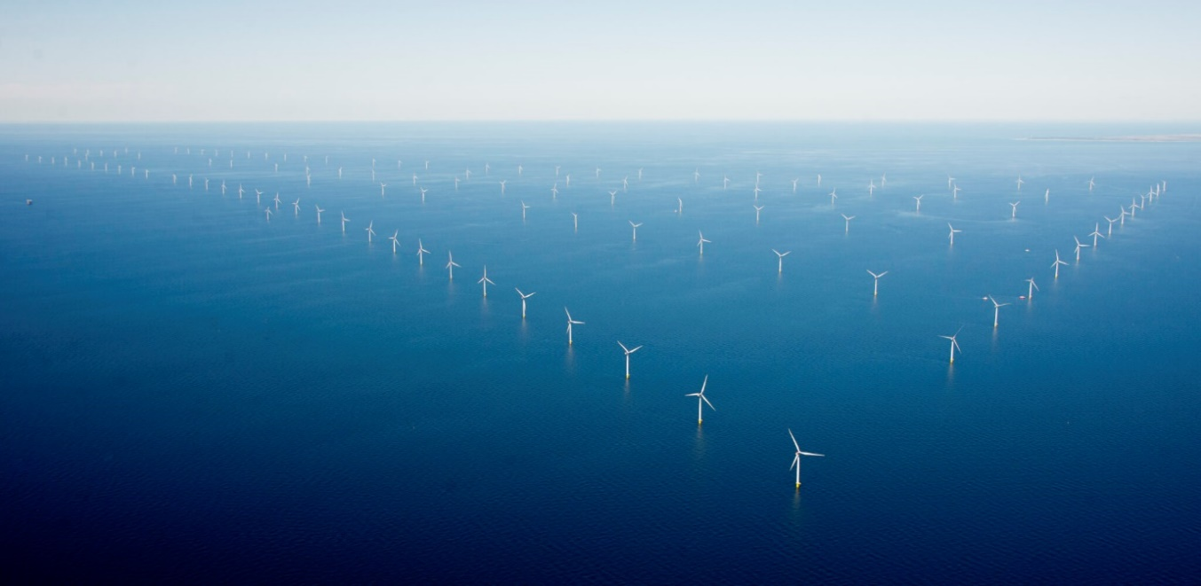
Figure 3: Image of Anholt Wind Farm (Photo credit: Orsted, 2022)

Not only does Copenhagen make use of wind farming to produce energy, but it also places emphasis on biomass farming, and trying to replace fossil fuels with biomass fuels wherever possible.

The world’s largest district heating network covers approximately 98% of Copenhagen (Interreg, 2020) and is part of a 15-year decarbonisation plan put in place by HOFOR, Greater Copenhagen Utility company. HOFOR plans to make the system completely carbon neutral by 2025, transitioning from using fossil fuels such as gas, oil and coal to being powered solely with sustainable biomass energy, being reliant on the Copenhill power plant (Johansen, 2022).

The heating system currently utilises combined heat and power (CHP), a highly efficient method of using both heat and electricity from a single fuel source, where any waste heat from the electricity production is then fed back into the district heating network to heat water for the city, thereby reducing the system’s energy waste (Copenhagen Infrastructure Partners, 2023). According to Orsted, Biomass energy use as a whole is a key factor in Copenhagen’s mission of becoming Carbon Neutral by 2025 (2020). Biomass energy is not only a renewable method of energy production, but it is also an efficient technique that allows for the re-use of any waste energy production, such as from producing electricity for the city, putting this to use in other sectors for the city such as the heating of water, reducing the demand for more fuel.

The main driver of the sustainability legislation would be the previously mentioned CPH 2025 Climate Plan, which is being delivered in three main phases, the first of which was completed in 2016, the second phase took place from 2017-2020 and the final phase is 2021-2025 (Climate Chance, 2018). The main objective of the first phase introduced in 2013, was to convert the city’s energy production into a more sustainable method, which, in turn lowered Copenhagen’s Green House Gas (GHG) emissions. In January 2012 the annual GHG emissions for Copenhagen was approximately 1.9 million tonnes of CO2, already a considerable decrease from the previous 2.4 million tonnes in 2005 (see Figure 4).

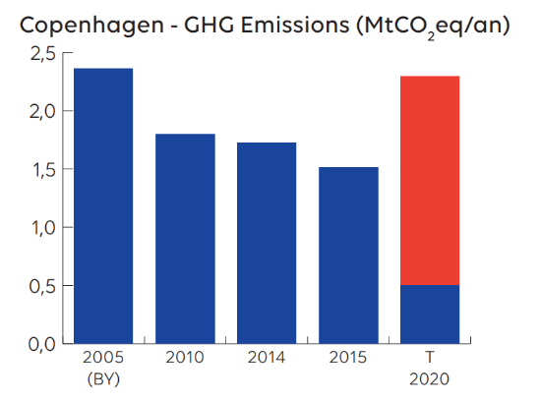
Figure 4: Graph showing Copenhagen’s Green House Gas Emissions from 2005 to 2020 (Photo credit: Climate Chance, 2018)

Legislation
This initial decrease was a direct result of the legislation established after the 2009 UN Climate Change Conference, which set a target of a 20% reduction in the baseline emissions from 2005 which was actually met in 2011 ahead of schedule (WWF, 2014). Following the conference, three main policies out of the five implemented worldwide influenced the reduction in Copenhagen’s emissions reduction, and these were:
- The 2010 Cancun Agreements which set out a framework for addressing climate change and established a goal of limiting global warming to two degrees Celsius. This framework consisted of a mitigation pledge, a new Green Climate Fund for developing countries and a system to help verify the action of any country when reducing global warming (C2ES, 2017).
- The Paris agreement of 2015, brought together 195 countries to commit to reducing greenhouse gas emissions with a clear framework for monitoring and reporting the progress (UNFCCC,2021).
- The Renewable energy incentive encouraged any country to implement subsidies and other incentives for the development of renewable energy sources such as solar and wind power.
Participation in these policies allowed Copenhagen to benefit from a range of new funding in the renewable energy sector (Bundgaard & Lexner, 2011).

The second and third phases of the CPH 2025 Climate Plan share similar initiatives. The C40 Cities knowledge hub states that approximately 80% of the reduction in Copenhagen’s greenhouse gases will come from switching over to sustainable fuels wherever possible, replacing coal powered plants with biomass-fired power plants and utilising the wind farms such as Anholt Farm.

Copenhagen has also implemented a focus on retrofitting, as many of the existing buildings need to be updated in order to help reduce the energy consumption (Jacobson, 2014). Retrofitting is the upgrading of existing buildings to improve their energy efficiency. Utilising retrofitting would prove crucial in lowering the energy consumption of the capital as it allows Copenhagen to maintain the architectural prowess of the historic buildings, while utilising modern energy efficient technologies such as triple glazing or modern insulation methods (Dyrbøl, 2020). According to The Copenhagen Adaptation Plan (2014), Copenhagen aims to reduce electricity usage by 10% and heating consumption by 20% by utilising these technologies in the newly retro-fitted buildings. Other technologies used includes visual monitors that can track overall water and energy usage of the buildings and indicate how much heat is lost from each building (City of Copenhagen, 2014).

The Danish and local Copenhagen government have introduced several city administrative and legal initiatives to support Copenhagen’s carbon neutrality charge and these initiatives have played a key part in the greening of Copenhagen. According to ‘The European Green Capital’ document section 3: Green urban areas, it is now municipal policy that all residents of Copenhagen must “have the ability to access a park within 15 minutes walking distance of their home” (2015), informally referred to as the ‘Park-policy’. Such policies have a profound effect on the everyday lives of Copenhagen residents, which in turn, can improve the health and well-being of the city’s population (Douglas & Douglas, 2021). Another example of these initiatives is the introduction of the 2009 action plan which focuses on integrating public spaces within the urban landscape of the city, called ‘Pocket parks, trees and green areas’ (Trimon, 2014). This policy recommended that developers focus on incorporating more green space within their developments. Further initiatives have been taken within the city to aid in water use and handling, including the drainage with the recommendation that every new development has a Sustainable Urban Drainage System (SUDS) in order to reduce water waste and the carbon footprint (Kaye, 2015). This innovative outlook on new development requirements within the city are key drivers in Copenhagen’s sustainability push.

Transport
Copenhagen has a range of public transport and sustainable travel options available to the residents. Thoem (2023) states that approximately 49% of all trips to either work or school in Copenhagen are via bicycle, which has increased by (about) 14% from 10 years ago (VisitCopenhagen, 2023). This increase in cycling is mainly due to the developments in infrastructure, where the streets are now more accessible and safer for cyclists. There are four main options offered for cyclists, all of which are interlinked across the city (Ariza, 2020):
- traffic calmed streets
- painted bike lanes
- separated cycle tracks
- green routes

The map of Copenhagen shown in Figure 5 demonstrates how well the cycle routes across the city are interlinked, with the cycle routes shown in red (Heward, 2022).

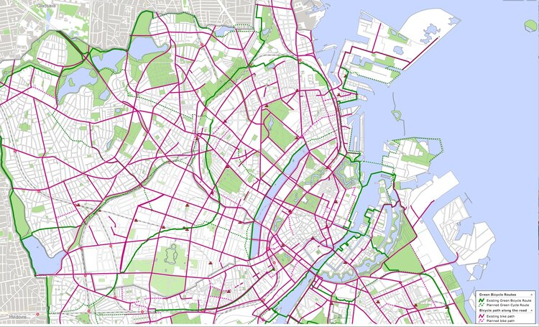
Figure 5 showing a map of Copenhagen via cycling routes (Photo credit: Heward, 2022)

Looking at Figure 5, one can understand the attraction for the bicycle in Copenhagen, with the city itself almost designed with the bicycle in mind, whereas in many other cities, cycle routes often feel like an after-thought. According to Andrew Edwards and Max Leonard, the authors of City Cycling – Copenhagen “one can access near enough everything you would need for everyday life within the city, from supermarkets to coffee shops, and work places to hardware stores, all are of ease access with bicycle, and it can be argued that access via bicycle is easier than the car” (2014).

Furthermore, Copenhagen is well known for the range of public transport options such as the harbour buses (ferries), metro lines, and train travel (Rasmussen, 2022). According to DIS Copenhagen (2022), travel by harbour bus is one of the most sustainable options of travel through the city and is available for both tourists and locals. The harbour bus network has been run on green electricity since 2020, meaning that any energy consumed by the ferries is renewable energy that is produced in a sustainable way (Rasmussen, 2022).

The light rapid transit system of the Copenhagen Metro is also considered to be sustainable travel and accessible, and are shown in Figure 6.

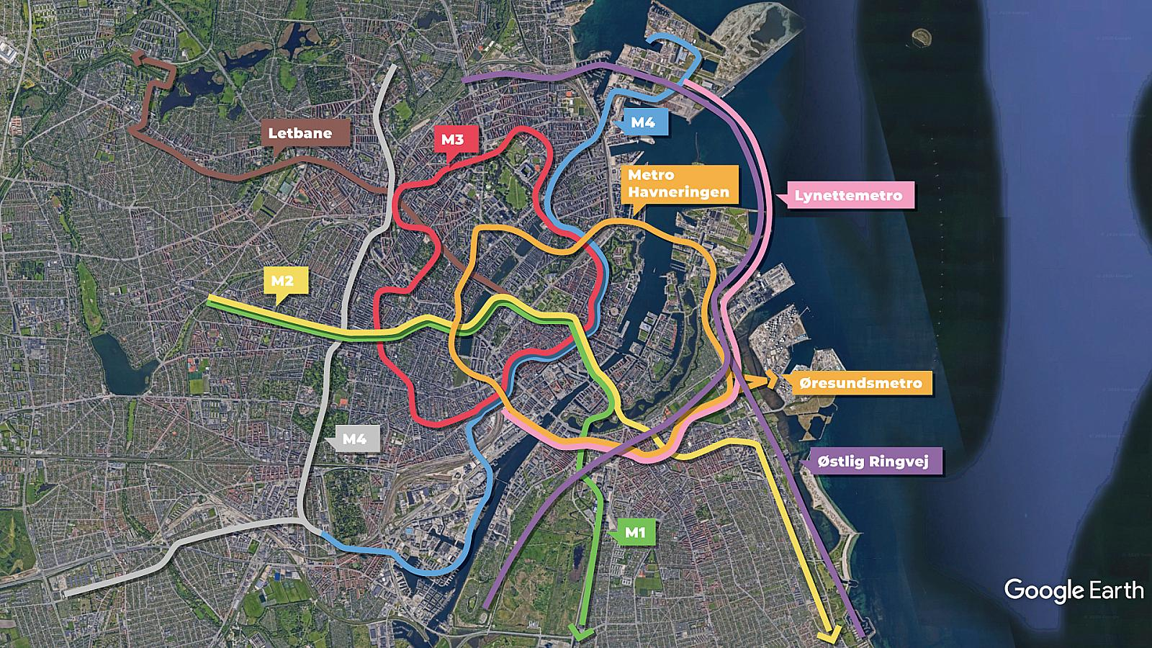
Figure 6 showing a map of Copenhagen’s Metro lines. (Photo credit: Google Earth, 2023)

According to Nexus.org (2023), metro travel helps cut carbon emissions by two thirds when compared to travelling by car.

Copenhagen is leading the way in providing options for its residents and travellers to reduce their carbon footprint through the availability of carbon-free and sustainable travel options. With the interconnectivity of the city and the design of its infrastructure the average citizen is being softly encouraged to step away from carbon heavy methods such as car and air travel. According to Mark Stratton of National Geographic this is a key factor in Copenhagen’s efforts to becoming the first carbon neutral city (Stratton, 2020).

Chapter 2: An Introduction to Swansea

Swansea is often overlooked as a major city in Wales and in comparison to Cardiff the capital of the country, Swansea is often referred to as the ‘Second city’ of Wales (Kennedy, 2020). According to Business News Wales Ltd, the coastal city of South of Wales has already embraced the sustainability crisis, becoming a hub for renewable energy, eco-tourism and sustainable transportation (2022). Despite the city’s humble reputation both nationally and internationally, Swansea was voted ‘The third best city in which to bring up children in the UK’ (McEntee, 2023). This title was awarded based on five main factors shown in Table 1 below, demonstrating the ranking system used by ‘Comparethemarket’ and their life insurance team (McEntee, 2023).

Rank | City/Town | Average rent for a 3-bed property (£) | Average property price per m2 (£) | Pollution Index (out of 100) | Crime Index (out of 100) | Quality of life score (out of 240)
1 | Middlesbrough | 600 | 2,300 | 20 | 44 | 197
2 | Aberdeen | 827 | 2,171 | 27 | 33 | 195
3 | Swansea | 1,000 | 1,395 | 24 | 34 | 187
4 | Stoke-on-Trent | 723 | 850 | 43 | 44 | 182
5 | Norwich | 1,157 | 2,350 | 37 | 26 | 184
6 | Leicester | 900 | 1,900 | 34 | 44 | 182
7 | Edinburgh | 1,188 | 3,231 | 28 | 30 | 183
8 | Milton Keynes | 1,320 | 3,000 | 18 | 50 | 201
9 | Cardiff | 1,070 | 2,200 | 33 | 37 | 174
10 | Newcastle upon Tyne | 933 | 2,228 | 33 | 38 | 179
Table 1: Table showing the top 10 UK cities in which to bring up children (Source: McEntee 2023)
Upon closer examination of Table 1, the key column of interest is the ‘Pollution Index’. Swansea is relatively low in pollution when compared to the rest of the cities in the list. This is an interesting perspective as it would lead the reader to believe that Swansea has already implemented certain strategies to reduce the pollution levels in the city, and in turn, the carbon footprint. According to ‘Business News Wales’, Swansea has been named as one of the ‘Top five green cities to invest in’ in 2022 (Business News Wales Ltd) and scored particularly well in the number of environmentally friendly office buildings within the City. Other factors considered included CO2 emissions and roadside pollutants by the international banking group BNP Paribas as part of their study named ‘Real Estate Next X’ that, in short, was a study conducted to assess the most investable sustainable cities for the future. Swansea Council Leader, Rob Stewart commented, “We need to create a greener Swansea to attract more private sector investment and employment which include zero carbon office developments, more greenery across the city, and the installation of more electric car charging points” (Swansea Council, 2022). Stewart later explained that these actions would help to cut Swansea’s carbon footprint and make the city more biodiverse and help take the necessary steps towards carbon neutrality (Swansea Council, 2022).

Swansea’s Carbon Neutral Journey
Swansea shares a similar aspiration to Copenhagen in becoming a carbon neutral city, however the timeline for Swansea is approximately 25 years behind Copenhagen (Swansea Council, 2022f). According to Swansea.Gov, the city had initial plans to achieve net zero emissions by 2030, however, the official carbon neutral target of 2050 was agreed during the Paris Agreement of 2015. Despite Swansea ranking higher in terms of sustainability within the UK, there is still a difference when comparing the sustainability agenda for both Swansea and Copenhagen. The 25-year gap between the two cities enables Swansea to learn from best practice in and ask questions of Copenhagen, such as ‘What is Copenhagen doing different?’ or ‘What can Swansea learn from Copenhagen?’

Despite being behind Copenhagen for carbon neutrality, Swansea has won a number of sustainability awards including the ‘Green Flag Award’, given in recognition of creating outstanding publicly accessible green spaces and parks, which are of the highest standard (Green Flag Award, 2023). Factors considered when judging this award for green spaces include cleanliness, community involvement and environmental management (Owens, 2018). In 2018, the Swansea Bay University Campus, shown in Figure 7 below, won the Green Flag Award for its outstanding areas of green space and parks, which the students and members of the public can access with ease, in which a built up city is very much a luxury (Owens, 2018).

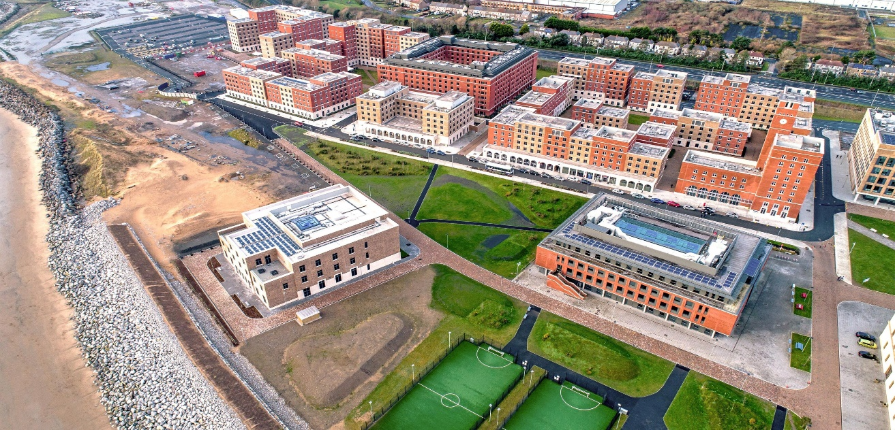
Figure 7: Image of Swansea Bay University’s green spaces (photo credit: Glancy Nicholls, 2022)

Swansea has also won a range of smaller sustainability awards and accolades that are more specifically designed to encourage sustainability throughout the city and recognise small-scale businesses and individuals (McDonnell, 2021). Such smaller awards schemes and initiatives are extremely important for individuals and businesses to contribute to the carbon neutral journey of Swansea.

The Swansea Bay City Deal
In addition, there is the new £1.3 billion project set to transform the city (Phillips, 2022). The ‘Swansea Bay City Deal’ is a major new development to improve the city’s infrastructure and develop new opportunities within the city, with funding from both the UK and Welsh Governments (Swansea.Gov, 2021). The first phase of the deal is to create a digital district village which will contain three major elements; the first element (Figure 8) not only provides a new cultural arena for the city, but also creates new green spaces in the surrounding area and greater pedestrian access through the city as the development is raised above and over the road below, further encouraging greener travel options (Welsh Government, 2021).

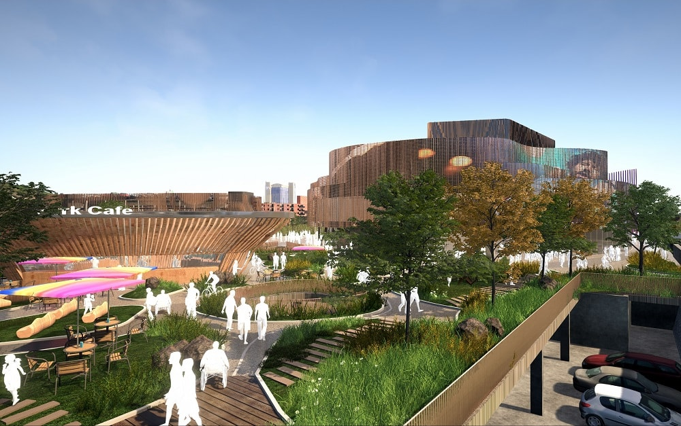
Figure 8: The 3,500-capacity indoor arena at a site adjacent to the LC in Swansea city centre (Photo credit: Swanseabaycitydeal.wales, 2021)

The second element of the project (Figure 9) is providing around 110,000ft² of low cost, shared office spaces with high speed digital connectivity. The building has been designed to accommodate Swansea’s growing digital technology businesses and provide a shared working environment for multiple businesses which can reduce the energy consumption for each individual business operating in their own space (Welsh Government, 2021). This stage of the project is currently in the tender process for construction and is set to be complete by summer 2023 (Swansea.Gov, 2022).

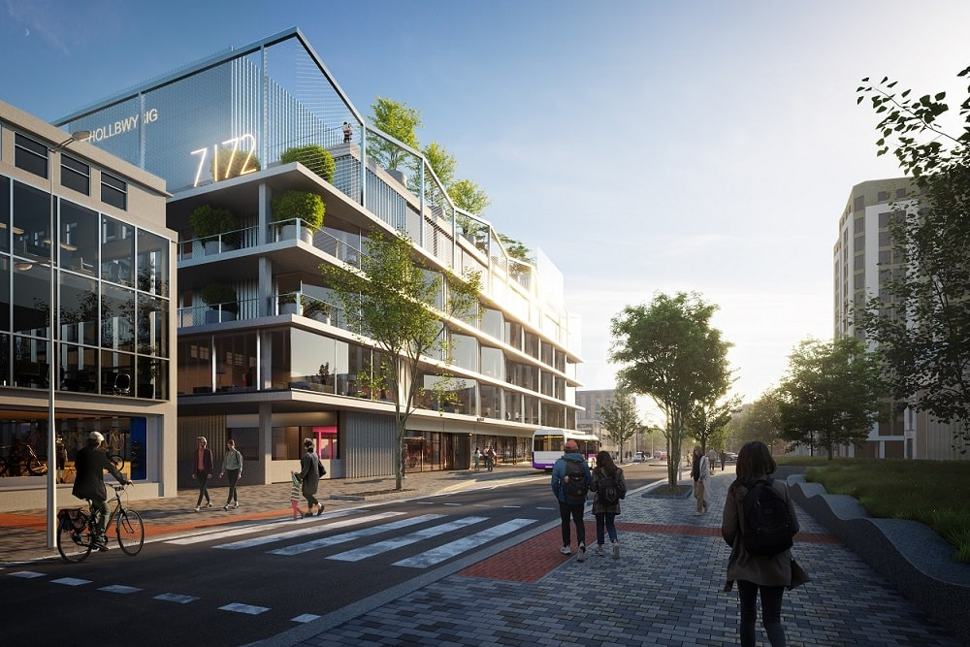
Figure 9: A state-of-the-art office development on The Kingsway in Swansea city centre (Photo credit: Swanseabaycitydeal.wales, 2021)

The final element of the project, is set to be built on the University of Wales Trinity St David’s SA1 waterfront campus and will provide a space for start-up businesses and entrepreneurs to develop their ideas in a positive environment (Welsh Government, 2021).

Another project taking place in Swansea as part of the ‘City Deal’ is a development planned for a ‘box village’ within the University of Wales Trinity St David, the purpose of which is to provide a cheap, flexible space for start-up companies to utilise (Barry, 2017). This project will be built from recycled shipping containers across a 23-acre site next to the university campus in order to allow the start-up companies ease of access to the university’s facilities and expertise (Welsh Government, 2021). Utilising recycled shipping containers in construction gives many benefits ranging from cost efficiency, to speed of construction, but the obvious factor for choosing to build with recycled containers would be the sustainability of the method (Welch, 2022). Such a development, and the planning approval of similar projects in the future, will open the door for more developments with sustainability at the heart, helping to take the necessary steps needed to get closer to the carbon neutral vision of 2050.

The final project of the ‘City Deal’ significant in Swansea’s carbon neutrality push, is the ‘Homes as Power Stations Project’. Here, the brief is to introduce new state-of-the-art design and energy efficient technologies into thousands of properties across the city, facilitating the integration of renewable energy technology into both new build and retrofit programmes (Swansea Bay City Region Deal, 2021). The project aims to facilitate the renewable technology into approximately 10,300 homes within five years, split between 7000 retrofit and 3300 new build, with the aim of improving the residents’ health and well-being by further reducing the carbon footprint (Pearce, 2020). The Homes as Power Stations Project aligns with the ‘Well-being of Future Generations Act 2015’ in Wales, another key piece of legislation created by the Welsh Government to help develop the country. The Act has seven main criteria to satisfy which are as follows:
- Create a Prosperous Wales
- Create a Resilient Wales
- Create a Healthier Wales
- Create a More Equal Wales
- Create a Cohesive Community
- Promote Vibrant Culture and the Welsh Language
- Satisfy Wales’ Global Responsibilities

According to Pearce (2020), the ‘Homes as Power Stations Project’ will satisfy all seven goals of the Well-being Act criteria. The project is reducing the carbon footprint of the new-builds and retrofitted properties that are within the scheme, helping to battle the global crisis of climate change and fossil fuel implications (Pearce, 2020).

Green Energy
It is recognised that Swansea also has huge potential when it comes to green energy production and has begun in recent years to take the necessary steps needed in order replicate a greener energy system (Youle, 2023). According to the Welsh Government, 2020 was the first year that Wales had zero electricity generated from coal, and that approximately 33% of total electricity generated was via renewable energy (Gov Wales 2022). In the ‘Energy Generation in Wales’ report (2020), it is stated that Swansea Bay generates the most renewable energy in Wales, joint with the North Wales region as shown in Figure 10.

The North Wales region has comparable renewable energy output as the Swansea Bay City region, yet there is one key difference between the two regions: The Conwy Tidal Lagoon will be constructed between Prestatyn and Llandudno and will provide substantial renewable energy for the region (Moore, 2022). In 2018, there were similar plans to construct a tidal lagoon in Swansea Bay. After considerable consultation, the UK and Welsh Governments at the time advised that the Swansea Bay tidal lagoon was too expensive and that alternative routes to generate renewable energy such as nuclear power or offshore wind farming should be considered (Vaughan & Morris, 2018). The proposed Swansea Bay tidal lagoon was more detailed in its approach than the Conwy Tidal Lagoon as it consisted of a floating solar farm, tidal energy plant and more green space, all of which would play key roles in the development of Swansea as a Green City (Youle, 2023).
.
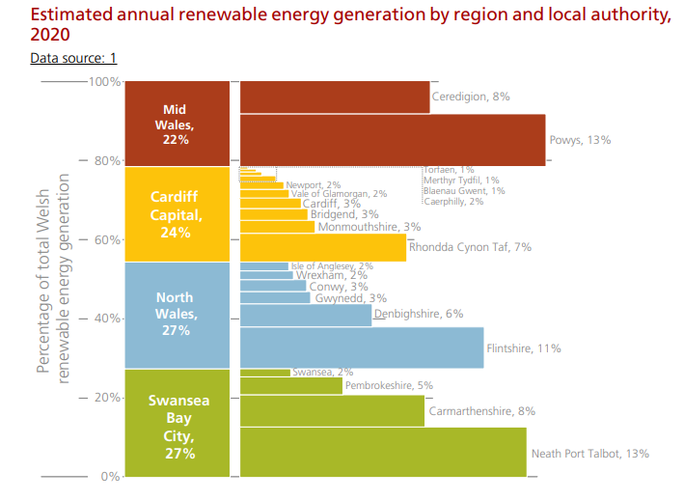
Figure 10: Graph showing the estimated regional renewable energy production of Wales (photo credit: Gov.Wales, 2022)

Transport
By June 2022 there were 164,600 licensed vehicles in Swansea, which included 127,500 cars (Swansea Council, 2023b). In recent years Swansea has taken positive steps to develop a sustainable travel and transportation strategy (Swansea Council, 2022c). The strategy includes the continued promotion of active travel, the development of sustainable public transport systems in the region, the installation of electric vehicle charge points across the city and the replacement of fossil fuel to electric for the council fleet vehicles. By 2022 Swansea achieved progress in their transportation strategy together with progress towards their Net Zero 2050 pledge via actions that included the growth of the cycle network by 25%, installation of electric vehicle charge points in council car parks and improvements to the council’s fleet of vehicles with a steady conversion to electric vehicles (Swansea Council, 2022c).

Swansea promotes cycling as a means of sustainable transportation and the council has developed a comprehensive network of cycle paths and lanes across the city. In 2018 Swansea City Council implemented a bicycle sharing scheme in conjunction with Santander and Swansea University, allowing individuals to rent bicycles around the city. By June 2022 the scheme had reached 100,000 rentals (Swansea Bay News, 2022). Swansea Council received more than £8M of funding from the Welsh Government to fund the design and construction of new walking and cycle routes to further promote active travel (Swansea Council, 2022e). The active travel network in Swansea has over 120km of on- and off-road cycle and walking routes which means Swansea is with the Welsh Government Active Travel Act 2013. Figure 11 shows the active travel network map for the Swansea area detailing the existing and the potential future walking and cycle routes (Welsh Government, 2023).

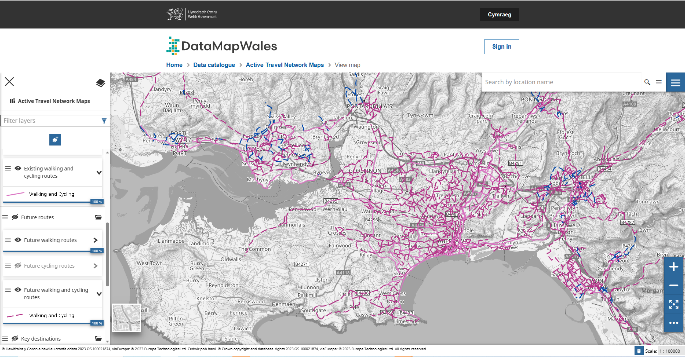
Figure 11: Active Travel Network Map for Swansea (Welsh Government, 2023)

A further initiative of the sustainable travel and transportation strategy is the development of a bus rapid transit (BRT) system in Swansea and the Swansea Metro, which aims to reduce congestion and improve public transport services. The BRT operates on dedicated lanes, and passengers benefit from reduced travel times, increased reliability, and improved air quality (FirstBus (North) Limited and FirstBus (South) Limited, 2023). The rail network in and around the city of Swansea is currently part of the South Wales Metro development which aims to transform transport for people in the area. The project was confirmed in 2018 with an initial investment of £738M to develop the rail network to improve connectivity and sustainable travel across South Wales, including Swansea (Transport for Wales, 2023).

In summary, Swansea is clearly already taking significant steps towards the aim of being Carbon Neutral by 2050 and following in Copenhagen’s footsteps to become a green city. However, there are still a number of opportunities that are not recognised as attainable to achieve the Carbon Neutral goal, and close the gap between Swansea and Copenhagen.

Chapter 3: Case Study 1 – Copenhill

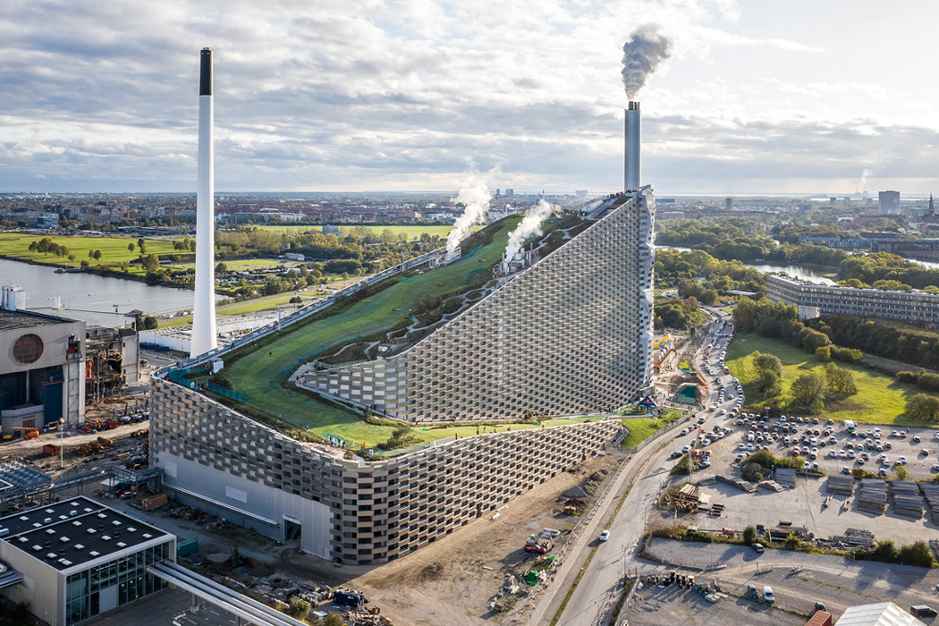
Figure 12: Image of Copenhill (Photo credit: Bernas, 2020)

Project Name: | Copenhill
Project Location: | Amager, Copenhagen (Ijeh, 2019)
Designed by: | Bjarke Ingles Group (Ijeh, 2019)
Budget: | 3.5 billion DKK (£415 million) (Ijeh, 2019)
Completion Date: | 30th March, 2017 (Stevens, 2021)

Introducing Copenhill
Copenhagen has many outstanding pieces of architecture that play a huge part in the city’s push for carbon neutrality, perhaps one of the most significant is pictured above; Copenhill (Baldwin, 2020). Copenhill began as an idea/concept developed from an ever-growing effort to decrease the landfill and waste within the city and increase recycling within Copenhagen and Denmark as a whole, further decreasing the City’s carbon footprint (Cooper, 2018). In Denmark it has been prohibited to landfill any organic waste since 1997, whilst in Copenhagen, this prohibition dates back even further to 1990 (Europa,2012). Following on from these prohibitions, the idea of Copenhill was actually coined in 2002, when an analysis of the existing waste-to-energy plant was conducted, the Danish Government came to the conclusion that the existing facility was substandard to the requirements needed to align with Copenhagen’s carbon neutrality push (Greenroof, 2022). In 2011 Bjarke Ingles Group won the international design competition put out by the client, Amager Resource Centre (ARC), to reimagine Copenhagen’s waste-to-energy plant and begin designing the facility of Copenhill (Baldwin, 2019).

At the early stages of development, the brief for Copenhill was simple; ‘To create a state-of-the-art waste-to-energy plant that would be environmentally friendly and provide space for public recreation’ (Mairs, 2022). The building needed to be able to process the waste from the city of Copenhagen and turn it into renewable energy whilst also being a visually striking building that would engage the public both visually and physically (Baldwin, 2019).

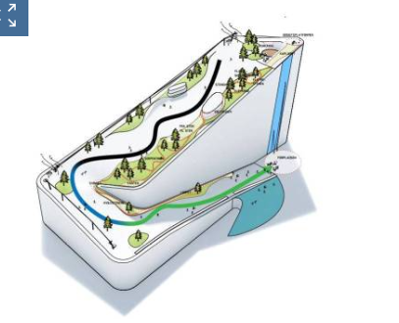
Figure 13: Image showing a design of the Copenhill Ski Slope(Credit: Ski Resort, 2022)

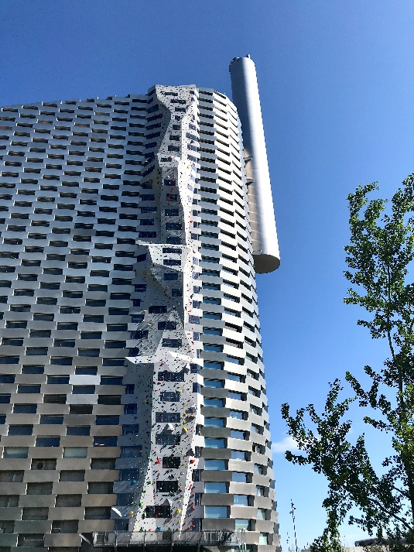
Figure 14:Image of the Copenhill Climbing Wall. (Photo credit: CopenHill, 2022)

The Planning Stage of Copenhill
As the project developed, it became apparent that the building needed to have certain facilities to attract the public and make it a success. Firstly, it was decided that the building was to house an outdoor ski slope on the roof for public use, as well as an observation deck that provided a view over the city (Crook, 2019). Next, the idea of a hiking trail alongside the ski slope was developed, stretching approximately 450m, according to the Copenhill website, as it ascends the sloped roof to reveal a view of the city. Finally, a climbing wall, the largest artificial climbing wall in the world, ascending approximately 85 metres was to be another key element of the building that would attract the interaction of the public (Slavsky, 2020).
During the planning stage of the project, there were a few concerns raised by the Danish Government. There were questions on the motive for designing such a large scale waste-fired plant, as ARC (Amarger Resource Centre), a public non-profit, energy firm, were the developers of this project alongside Bjarke Ingles, started to highlight the potential profitable side of the development, something that was not originally discussed in the early plans (Kohl, 2019). According to Kohl’s research, questions were asked as to if the building was still purely being planned and designed with the ethical and sustainable aspects at the heart of the project, or if it had slowly started to be seen as somewhat of a profitable opportunity for the ‘non-profit’ organisation which caused serious tension during the planning stages (Kohl, 2019). Another problem that was faced in the development of Copenhill was regarding the sheer scale of the energy plant and the amount of fuel needed to power it. There were worries initially that Denmark as a whole simply would not produce enough waste to incinerate within the facility, and would need to import waste from other countries to power the plant (Gurzu, 2019). This would then present another factor that would have to be considered within the proposal, would the carbon footprint of the transportation of said imported waste counteract the benefit of burning the waste in the power plant? There were also concerns that it would send a message to the people of Copenhagen that it was acceptable to burn otherwise recyclable materials (Zero Waste Europa, 2021).

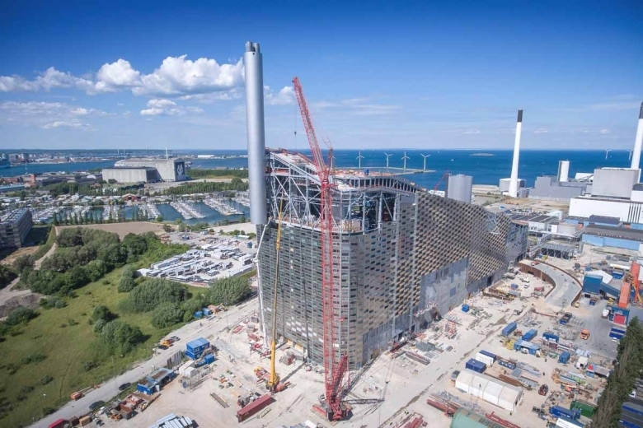
Figure 15: Image of Copenhill under construction. (Photo credit: Jeremy Williams, 2017)

The Construction of Copenhill
One of the biggest tasks facing Ingles when designing Copenhill was the challenge of creating such a large scale energy plant that was structurally sound, yet built sustainably (Architect Magazine, 2019). The building, as per the brief, had to ‘blend in’ seamlessly with the surrounding urban context, which for an 85m tall energy plant, could prove to be difficult (Architect Magazine, 2019). Ingles opted to go for an entirely steel framed construction as shown in Figure 16 which, when analysing the benefits of steel frame construction, appears to make sense for a project of this scale (Ijeh, 2019). Steel frame construction provides excellent longevity and durability when compared with other materials such as timber frame or masonry, as well as having the ability to withstand high loads with little material (Baker, 2023). Steel is also a recyclable material, meaning that it can be reused exponentially without losing any of its core durability (Baker, 2023). Furthermore, the energy required to produce raw steel has decreased significantly over the years. Carbon Dioxide by-products can be recaptured and reused in other areas, further decreasing the carbon footprint of this construction method (Baker, 2023). Copenhill also utilised concrete within the construction of the building, mainly in the foundations, however as can be seen in Figure 16, the concrete was also used in elements of the walls that required extra support (Elematic.com, 2023). Concrete was also the element of choice for the roof of the structure, which required a solid base as it was also acting as a floor for the ski slope above.
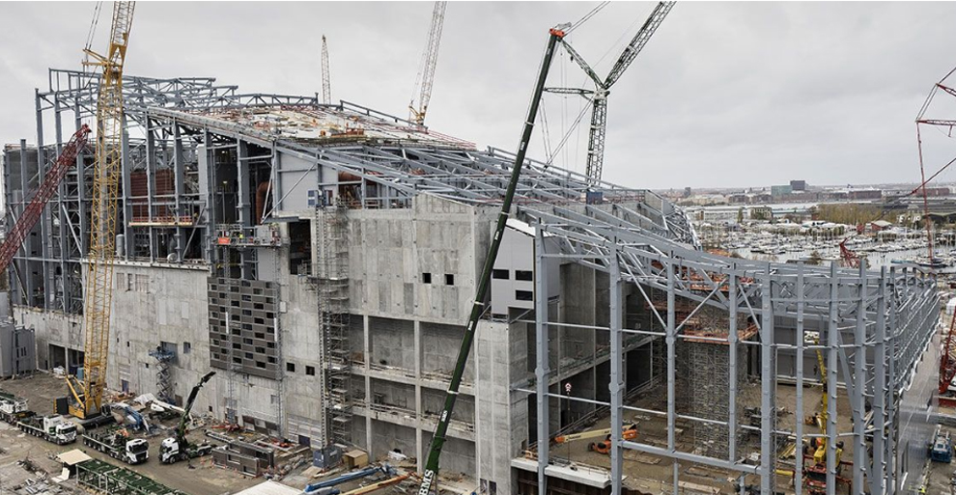
Figure 16: The Steel Frame Construction of Copenhill. (Photo credit: De La Paz, 2020)

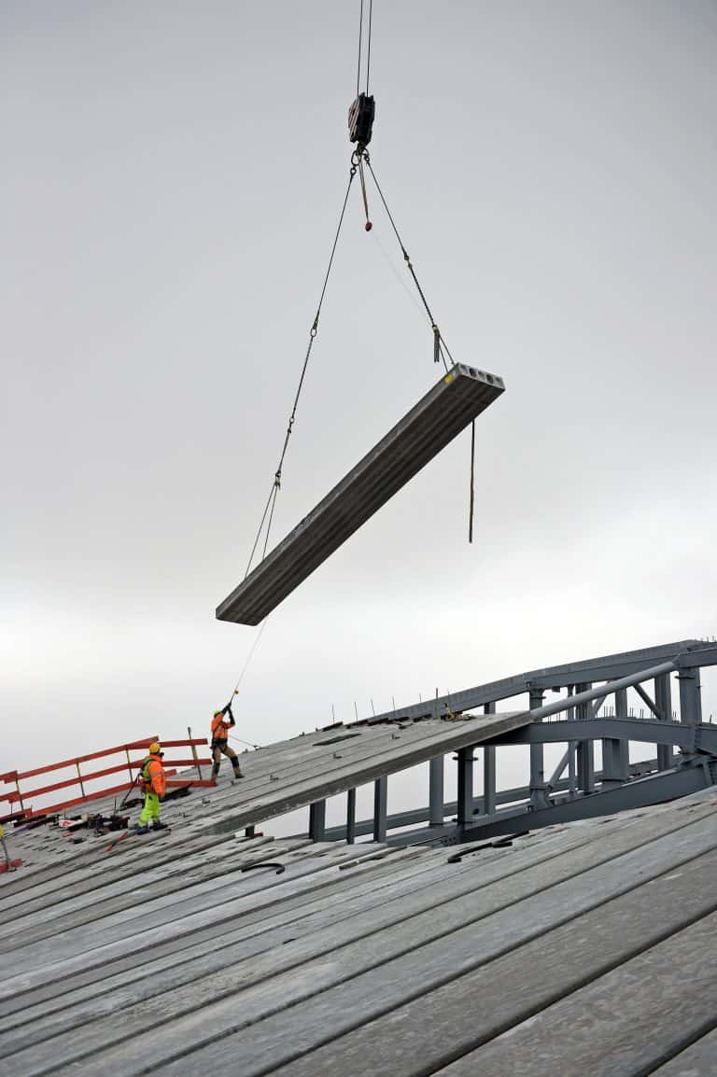
Figure 17: Showing the hollow-core roof slabs in the construction phases of the project. (Photo credit: Mestour, 2018)

Another element used in the construction of Copenhill, was the aluminium façade as shown in Figure 18, which is the main visual element that can be seen on the completed building today. The façade is actually a dual layered structure, where the inside layer consists of a concrete fibre reinforced polymer with ventilation breaks and the outer layer being the 1.2m by 3.3m aluminium brick façade in a checked pattern (Kolnaar, 2021). What is particularly innovative about this façade, is the fact that the aluminium ‘bricks’ double up as planters which are used to encourage the biodiversity and wildlife in the area by providing a place for various wildlife and vegetation to inhabit in the vertical garden (Bernas, 2020). As well as the encouragement of biodiversity, the aluminium bricks themselves are a sustainable material choice. Aluminium is “one of the most environmentally friendly metals on the planet” according to Alexandra Giles of origin-global.com and in fact is 100% recyclable and around 75% of the 1 billion tons of aluminium produced in the last 100 years is still in use today (Fbsprofilati, 2020). In between the aluminium façade bricks, there is a layer of translucent glazing that is designed to both let natural daylight into the facility, as well as illuminate the building at night (Bernas, 2020). Overall, the material choices for Copenhill can be seen as a balance between sustainable, practical and visually pleasing.
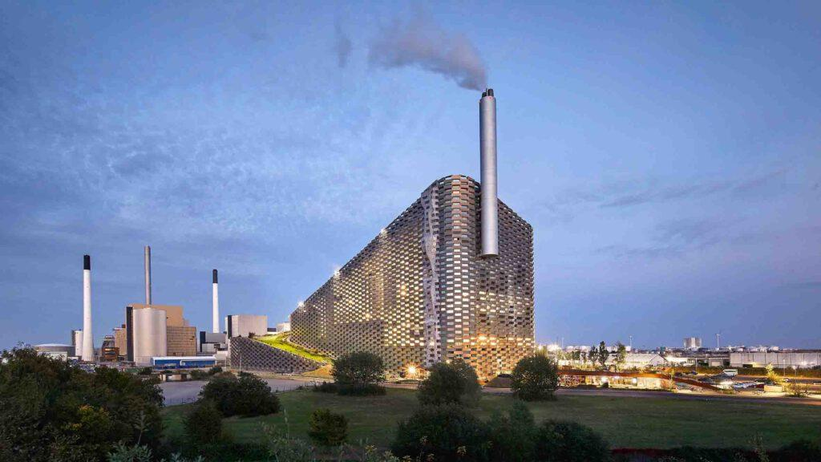
Figure 18: Showing the Aluminium façade with the translucent panels. (Photo cCredit: Hufton & Crow, 2020)

The Success of Copenhill
Moving on from the materiality of Copenhill, one can begin to analyse the performance of the building now it has been in operation for approximately six years (Stevens, 2021). The main purpose of the building is to incinerate the waste of Copenhagen and convert this into energy to be used throughout the city (Crook, 2019). The first full year the facility was open, 2018, it was reported to have processed approximately 450,000 tonnes of waste, converting this into district heating for around 72,000 homes and electricity for a further 30,000 homes (Hartman, 2019). Concerns were raised about the waste demands of the facility as during this period it was reported that around 30,000 tonnes of waste was shipped to the plant from the UK and Ireland, meaning that Denmark alone were not producing enough waste to power the plant (Hartman, 2019). Hartman goes on to explain that the plant was intended to serve five municipal areas around Copenhagen, however it ended up being too large to be solely powered by these five municipals. When questioned about the oversized facility, Amager Resource Centre (ARC) director Jacob Hartvig Simonsen justified this as a “climate win” as he explained the benefits of importing waste to be burnt in the facility outweigh the negatives, even when transportation of the waste was considered (Hartman, 2019).

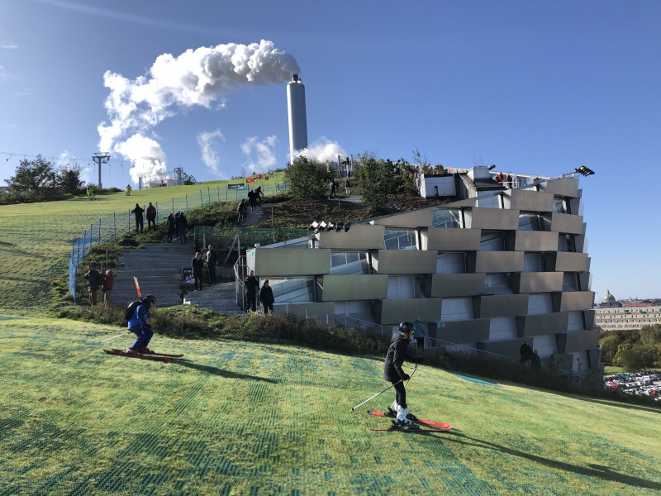
Figure 19: Image of the ski slope of Copenhill in use. (Credit: Saalbach, 2020)

Copenhill does far more than just incinerate waste to convert to energy, the integrated leisure facilities of the building have a huge part to play in the significance of the development (Grasmus, 2020). According to Hartman from the Architect’s Journals, the building was expected to have approximately 300,000 annual visitors each year to make use of the leisure facilities available at the plant (Hartman, 2019). The leisure facilities available include a 400m ski slope, an 85m climbing wall and a hiking trail that ascends alongside the ski slope to the top of the building (Crook, 2019). These leisure facilities are what makes Copenhill so unique, as the people of Copenhagen would usually have to leave the city or even Denmark to go skiing or go for a mountainous hike, as the city itself is very flat and densely populated (The Style Mate, 2021). Finally, the waste-to-energy plant also has its educational purposes, intended to educate the public on the procedure of waste-to-energy and spark some curiosity into the subject (Crook, 2019). Copenhill has become one of Copenhagen’s most renowned tourist attractions that boasts the ‘best view of the city’ according to the Copenhill website and hosts hundreds of thousands of tourists each year.

After the above analysis of Copenhill, one question remains to be answered, how successful was the project? One can begin to determine the success of the project purely from an architectural point of view by analysing the impact of the development after completion. When the head architect of the development, Bjarke Ingles, was questioned about the success of the project, he stated that Copenhill was a “blatant architectural expression of something that would otherwise have remained invisible: that is the cleanest waste-to-energy power plant in the world…” Ingles then went on to say that he believed Copenhill was an excellent example of “Hedonistic Sustainability” and demonstrated that a sustainable city can be better for both the environment and the people living in it (Hartman, 2019). According to Brooke Kaz of architectural digest, Ingles explained that he believed the project to be “economically, environmentally and socially profitable” due to its impact on both the tourism and economy of the city, the carbon footprint of the city’s energy production and the recreational opportunities it creates for the people of Copenhagen to take advantage of (Katz, 2018). Copenhill was also viewed as a success in the eyes of architects all around the world, winning multiple prestigious awards such as ‘ArchDaily 2020 Building of the Year award’ and ‘Building of the Year 2021’ at the fourteenth annual World Architecture Festival (World Achitecture, 2021). The client of the project, ARC, have also expressed their gratitude and satisfaction when asked their opinion on the development stating that they are “very proud to have built the most energy efficient waste-to-energy plant in the world.” (Hartman, 2019). ARC highlighted the fact that the energy plant has such minimal environmental emissions, allows it to have members of the public living within 200m of the establishment and really makes the building feel a part of the city (Pintos, 2019). Finally, one can look at Copenhill from the viewpoint of those who inhabit the city, both Government and general public. In the Governments eyes, Copenhill aligns with their plan of becoming the first carbon neutral city by 2025 as it has helped take a huge step towards Copenhagen becoming a completely renewably powered city (Urban Next, 2019). However, there is still an argument that the energy plant is too large due to the need for imported waste every year, however as previously mentioned, this is labelled as a “climate win” by the director of ARC (Gurzu, 2019). In regards to the people of Copenhagen, they too see the benefits of Copenhill as they have access to facilities such as the ski slope and mountainous hiking path (The Style Mate, 2021). Not to mention the benefits seen for the local businesses in and around the surrounding area to Copenhill, as it attracts around 300,000 visitors each year, some of which will be venturing out into the city and surrounding area spending money in the local business (Valence, 2019). Therefore, overall it can be said that Copenhill as a project was a huge success and continues to have a significant impact on the city of Copenhagen today, providing the residents with leisure and the city with energy, the energy plant can be looked at as an exemplar piece of hedonistic architecture and demonstrates the vital steps that architects can take to tackle the sustainability issues of today’s society (Hartman, 2019).

Chapter 4 – Case Study 2: Active Classroom and Active Office

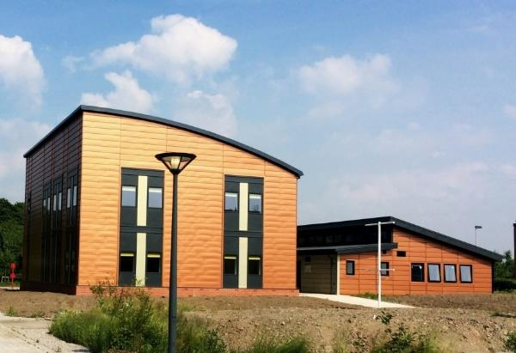
Figure 20: Swansea’s Active Classroom and Office. (Credit: Sullivan, 2018)

Project Name: | Active Classroom and Active Office
Project Location: | Swansea University Bay Campus, Swansea (Jones, 2017)
Designed by: | Joanna Clarke (Education Buildings.Wales, 2022)
Budget: | £1.2million (10.1 million DKK) (Gov UK, 2017)
Completion Date: | September 2016 / June 2018 (Specific, 2023)

Introducing Active Classroom and Active Office
Swansea as a city has taken huge steps in the sustainability crisis in recent years with various plans for future developments and improving infrastructure all to help tackle today’s issues of climate change (Youle, 2020). Swansea University has been a leading force at the forefront of the sustainability crisis trying to find new, innovative ways to help tackle the issue, and their latest efforts have produced what is known as the ‘Active Classroom and Office’ (Sullivan, 2017). Swansea’s Active Classroom and Office are two separate buildings that have a positive energy impact, meaning they both produce more energy than they use (Sullivan, 2017). The Active Classroom was the first of the two building projects to be complete in September 2016, followed by the Active Office in June 2018 (Specific, 2023a). SPECIFIC, a UK innovation and knowledge centre who are currently one of the leading companies in energy technology research and full-scale development, were one of the key forces behind the planning and development of the two projects and played a huge role in securing financial and government support (Swansea University, 2022). The industrial partners of SPECIFIC. were a crucial aid in seeing the Active Classroom and Office come to fruition as they provided expert industrial knowledge and access to key elements such as Tata Steel’s ‘Colorcoat Urban’ Steel cladding system, a lightweight, strong cladding system that has very low carbon production (Tata Steel, 2012).

What is an Active Building?
An active building is described as “a building that supports the wider grid network by intelligently integrating renewable energy technologies for heat, power and transport” (Clarke, 2023). The concept of ‘Active Buildings’ was initially developed by the Active Building Centre (ABC) who have now made it their mission to ‘deliver transformational change in the construction and energy sectors’ (Trade and Invest.Wales, 2021). Clarke (2023) advises that there are six main principles to follow when designing an ‘active building’ which are:
  - Building Fabric and Passive Design – Making use of architectural tools and techniques in order to provide comfort for the occupant at a low level of energy expenditure e.g. Natural lighting, natural ventilation.
  - Energy Efficient Systems with Performance Monitoring - Intelligently monitored and controlled energy systems that are designed to be as efficient as possible while using real-time data of the occupant’s usage habits.
  - On-site Renewable Energy Generation – Integration of renewable energy sources where possible, for example installation of solar panels.
  - Energy Storage – Thermal and electrical storage utilised in order to ensure there is minimal energy wastage and possibility to transport energy back to local infrastructure.
  - Electric Vehicle Integration – Integration where possible to encourage a switch over to electric vehicles at a faster rate.
  - Intelligently Manage Integration with Micro-Grids and National Energy Network – Manage the on-site demand of energy required from the wider national energy network and limit the uncontrolled import/export of energy where possible

These principles were the driving force behind the research and innovation that was being carried out within the early stages of SPECIFIC’s projects (Clarke, 2019). In the United Kingdom alone, buildings account for approximately 40% of energy consumption as well approximately 40% of greenhouse gas emissions (Neos Networks, 2023) which quite clearly offers a massive opportunity for improvement. The Active Classroom and Active Office projects were developed as a direct response to this statistic, as Swansea University and SPECIFIC wanted to demonstrate that with the use of various technologies, steps can be taken in the construction of new builds and the retrofitting of existing buildings in order to help tackle this and reduce not just Swansea, but the carbon footprint of the UK (Clarke, 2021a).

The Active Classroom

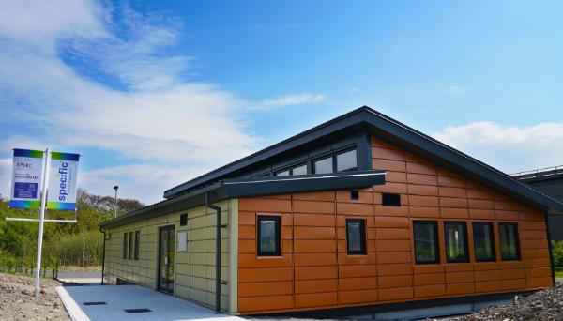
Figure 21: Showing Swansea’s Active Classroom. (Photo credit: Sullivan, 2017)

The official brief for Swansea’s Active Classroom was to serve as a demonstration/trial of SPECIFIC and Joanna Clarke’s concept of creating an ‘Active Building’ (Clarke, 2020a). The main purposes of the building outlined in the brief were;
- To act as a showcase for SPECIFIC and their industrial partner’s new innovative technologies (Clarke, 2020a).
- To be energy positive and produce more energy than what is required in its annual cycle (Clarke, 2020a).
- To be designed with net zero considerations such as the use of low carbon materials and recycled materials where possible (Clarke, 2020a).
- To act as a tool to educate the government, companies, students etc. about the ‘Active Building’ concept (Clarke, 2020a).
- To be used as a teaching facility for the University, to be used as a ‘test bed’ for new technologies that are being trialled which could be retrofitted in large scale across the city (Clarke, 2020a).
- To be used to generate and analyse data on energy usage of the facility and how it can be manipulated (Clarke, 2020a).

Clarke also goes on to highlight the fact that the project was to serve as a demonstration to a concept. While the technologies on display at the time of completion in 2016 were the latest and greatest at the time, she recognises that technology is evolving rapidly and hopes that the concept on display within the building can be adapted/improved with the technology (Clarke, 2020a).

The Active Office

The Active Office was designed and built around two years after the completion of the Active Classroom.
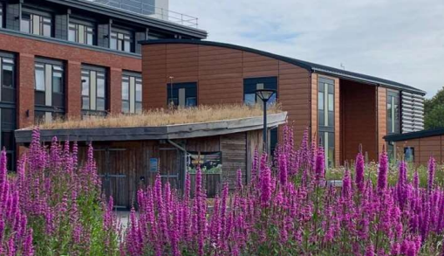
Figure 22: Showing Swansea’s Active Office. (Photo credit: Clarke, 2020b)

While the project had an identical brief to the Active Classroom, there were some unique requirements asked of the Active Office which were;

- To use commercially available technologies that could be utilised easily by other companies/developers (Clarke, 2020b).
- To be repeatable, therefore offer a solution that could be repeatable by other companies and implemented within their businesses (Clarke, 2020b).
- To have integrated electric vehicle charging points (Clarke, 2020b).
- To be used as its intended purpose, as an office building (Clarke, 2020b).

Similarly, Clarke states that this development was to serve as an example of the concept of an ‘Active Building’ and recognises that the technologies available at the time of construction in 2018 could be improved/evolved in years to come (Clarke, 2020b). Overall, both buildings were specifically designed for the sole purpose of evoking thoughts of change within the construction industry and demonstrating that these types of renewable technologies can be utilised in the ‘Active Building’ concept and help tackle the carbon footprint of the building industry. (Sullivan, 2020).

Innovative Materials Used in the Projects

As previously stated in the brief of Swansea’s Active Buildings, a major part of SPECIFIC’s concept of an ‘Active Building’ is the use of new and innovative materials to construct the buildings that have low embodied carbon (Passive House Plus, 2017). The Active Classroom takes advantage of its lightweight nature and is sat upon a steel frame sub structure as shown in figure 23 (Clarke, 2020a). The steel was supplied by one of SPECIFIC’s industry partners, Tata Steel, and is 100% recyclable and reusable as they are truly committed to align with the Carbon Neutral 2050 goal (Tata Steel Europe, 2023). The substructure of the classroom has minimal implications to the surrounding environment according to Clarke’s case study on the building, in which she outlined that she opted for this method of construction due to its minimalistic demand for resources and environmental impact (Clarke, 2020a).

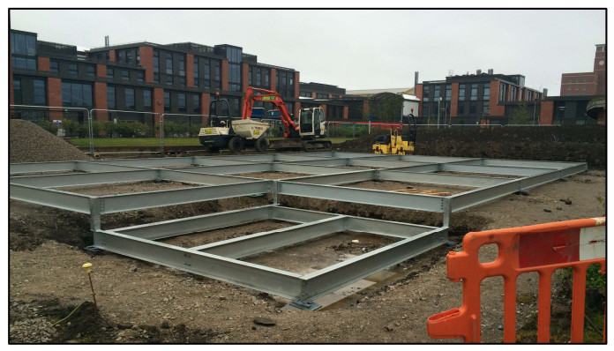
Figure 23: Showing The Active Classroom’s Steel Frame substructure. (Photo credit: Clarke,2020a)

In comparison, the Active Office that was constructed two years later opted for a different approach when it came to the substructure of the building. The office is a lot larger than the classroom, and therefore is lot heavier so the construction methods of choice had to be adapted to suit. The office sits on top of a concrete pad foundation as shown in Figure 24, which then supports the steel frame construction of the building above, approximately 12 steel frame modules that were constructed off site were used to create the structure of the building (Clarke, 2020b). Wernick, the supplier, claimed that all waste steel, aluminium and timber is recycled resulting in “next to no landfill” (Fennell, 2019). It is also stated that there are environmental benefits to opting to go with Wernick’s offsite modular construction as it greatly decreases the construction programme resulting in less environmental implications on the surrounding site (Fennell, 2019). Lastly, Fennell goes on to state that where possible, Wernick seek labour and materials locally, to reduce travel implications and support local businesses and communities, all of which is beneficial in Swansea’s carbon neutrality push.

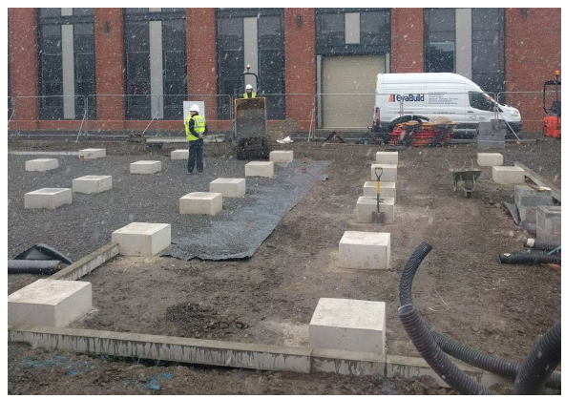
Figure 24: Showing The Active Office’s Concrete Pad Substructure. (Photo credit: Clarke, 2020b)

Both buildings also make substantial use of the various products that SPECIFIC’s partners have available to them and in fact developed specifically for the concept of an ‘Active Building’. Firstly, NSG group’s glazing manufacturers, Pilkington UK, provided two of their patented products for both projects; The Pilkington Sunplus BIPV Glass and The Pilkington EnergiKare Advantage Glass (Brit Glass, 2023). The ‘Sunplus BIPV Glass’ is Pilkington’s innovative approach to architectural glazing. The glass is essentially a renewable energy generator, as it uses the solar energy from the sun to produce and store energy to be used within the building (Pilkington, 2023). The main factors that made Clarke opt for type of glass during the development of the Active Classroom and Office was the durability, ease of construction and of course the sustainability benefits from the production of renewable energy (Brit Glass, 2023). The ‘EnergiKare Advantage Glass’ is another innovative product that Clarke opted for in the design. The glass is known as Pilkington’s ‘most optimal’ glazing for thermal efficiency as, according to archiexpo.com, it provides triple glazing performance with only two panels of glass (Archi Expo, 2023) allowing for less heat loss and more solar gain, resulting in greater energy efficiency (Brit Glass, 2023).

Tata Steel contributed significantly to both projects, the key elements being; ‘Tata Steel Colorcoat Prisma pre-finished steel’ and ‘Tata Steel transpired solar collectors’ (Tata Steel Europe, 2023). The ‘Tata Steel Colorcoat Prisma pre-finished steel’ is described as a pre-fabricated cladding system that has an extensive aesthetic guarantee (Tata Steel Europe, 2019). The prefinished cladding was coated with Tata Steel’s ‘clear coat technology’ which enhances the UV protection and life span of the cladding system, the total lifecycle is boosted up to a 40-year span with promised weathering protection for the duration (Tata Steel Europe, 2019). When explaining her choice to opt for Tata Steel’s ‘Colorcoat Prisma’, Clarke explained that the prefinished cladding had a range of colours that matched the contextual surroundings of the existing buildings, and the clear coat technology attracted her to the material as it had the guarantee that the finish would last, therefore needing less maintenance in the long run keeping the operating cost of the buildings to a minimal (Clarke, 2020b). Finally, Tata Steel’s ‘Transpired Solar Collectors’ were utilised in both projects, this element is essentially an active solar air heating solution that provides a renewable ‘pre-heating’ option for space heating (Brown, 2014). The system captures solar energy from the sun and pulls it into the building by using the collectors that are on the exterior of the building, this then heats the fresh air that is in the cavity of the walls and is used to ‘pre-heat’ the main system, resulting in far less energy consumption by the main heating system (Erhlich, 2016). Clarke explained that the use of this system in the active buildings has been an essential part of lowering the energy consumption of the buildings, and believes it plays a crucial role in the success of the buildings (Clarke, 2021b).

The Success of the Active Buildings
Finally, it can be argued that both the ‘Active Classroom’ and ‘Active Office’ were successful projects by SPECIFIC and Joanna Clarke as they both demonstrated the concept of an ‘Active Building’ extremely well (Bevan, 2022). The ‘Active Classroom’ has been utilised extensively since its construction in 2016, ranging from being used as an actual classroom, to being used as an educational centre on SPECIFIC’s ambitions and projects (Bevan, 2022). The classroom has acted as a focal point for SPECIFIC’s research and has enabled them to demonstrate, monitor and validate new innovative technologies that could be taken to the larger scale industry (Bevan, 2022). Despite being a small scale project, it has sparked conversations within the wider industry as the building has proved that a lot of the sustainable technologies from SPECIFIC’s partners have worked extremely well and produced unarguable data (Bevan, 2022).

Since completion, the ‘Active Classroom’ has produced 1.6 times the amount of energy its consumed, which is essentially what Clarke set out to achieve with the building, creating an energy positive piece of architecture (Specific, 2020). The ‘Active Office’ has been used on a day to day for the university staff, students as well as local businesses who wish to learn more about sustainable solutions within the construction industry. In its first year of operation, the office energy use came down by around 12% and the average operational costs were around 43% lower than offices of a similar size (Greaves, 2021). Overall the office is said to produce more solar energy than it consumes which, again, was the original target from Clarke to demonstrate the renewable energy strategies of SPECIFIC. The office saves around 1.2 tonnes of CO2 annually and has been recognised with numerous awards such as ‘The Most Innovative Building Project’ and ‘The Most Innovative Public Sector Project’ at the 2021 Buildings Innovation Centre (Naked Energy, 2022). Overall, both projects achieved what they set out to achieve in demonstrating the renewable technologies of the time, and therefore showing the concept of an ‘Active Building’ has a place in society moving forward.

Conclusion
After careful analysis of both Copenhagen and Swansea, including Copenhill and the Active Classroom and Office, one can begin to draw comparison between the two cities and explore what, if anything, Swansea can learn from Copenhagen. It is clear that both cities have made significant efforts to creating a more sustainable future, however there are some notable differences.
It can be argued that Copenhagen is around 25 years ahead of Swansea in its push for carbon neutrality as both cities share the same vision of becoming carbon neutral, only Copenhagen aims to achieve this by 2025, while Swansea by 2050 (Nikel, 2019). Copenhagen’s sustainability push dates back to around 1973 (Rudiger, 2014) and since then it is obvious that the Danish government have consistently introduced more legislation/infrastructural developments with sustainability at the core. Copenhagen has had a clear sustainability strategy set in place with the adoption of the 2025 climate plan back in 2012, and this has led to some of the most significant steps in Copenhagen’s carbon neutral push (Srivastava, 2022). From the introduction of Copenhagen’s district heating system, to the investment in off shore wind farms, it is apparent that the Danish government and other stakeholders in the city understand the significance of renewable energy production and consumption in becoming carbon neutral. Renewable energy production has increased during the greening of Copenhagen, now being at a point where approximately 50% of the total energy produced in the city is from renewable sources such as wind farms or biomass plants (State of Green, 2021).
When comparing this to Swansea, it becomes clear that renewable energy production is an area for improvement if Swansea is to begin closing the 25-year gap between the two cities. According to the ‘Energy generation in Wales’ report by the Welsh Government in 2020, Swansea produces approximately 27% renewable energy, nearly half of Copenhagen. One could argue that this represents the first opportunity for Swansea to learn from Copenhagen as clearly there is a vast difference between the two cities. Swansea has the potential to produce more renewable energy with projects such as the ‘Swansea Tidal Lagoon’ yet to come to fruition (Hinson, 2018). The lack of ambition to support sustainable projects like this from both the Swansea and UK governments is one of the major differences between the two cities and part of the reason why Copenhagen is so far ahead of Swansea in its carbon neutrality push. Copenhagen has had a clear objective since the adoption of the 2025 climate plan which Swansea could learn from, as it is evident that the guidelines in place, Copenhagen really has put sustainability at the heart of the majority of its major developments in recent years, which leads one to believe that Swansea would benefit massively from a similar action plan, not just a carbon neutral goal date.
Finally, upon analysis of Copenhagen’s sustainable transport options, it becomes apparent that this is perhaps another learning opportunity for Swansea. Copenhagen demonstrates an exemplar sustainable transport network throughout the city, boasting over 200 miles of curb segregated cycle lanes (Davis, 2023) and an extremely well interlinked public transport systems including the metro bus and train (Duggan et al., 2022). According to the ‘Carbon Neutral Cities’ website, Copenhagen has successfully managed to lower its transport emissions by approximately 42% since 2005, and this is mainly due to the transportation infrastructure of the city. Swansea on the other hand has a more limited sustainable transport network, with more focus on leisure cycling rather than integrating cycling into everyday transportation. The city does have small initiatives like the Santander bike sharing programme, and slowly installing more electric car charging points across the city, but these initiatives are yet to gain real traction and car is still very much the preferred method of transport in the city (Swansea Bay News, 2022). This presents another opportunity in the regeneration of Swansea to perhaps work to encourage the use of sustainable travel options more throughout the city. Learn from Copenhagen’s dedication to integrating sustainable travel in everyday life with the use of infrastructural developments like dedicated cycle lanes through the city, this could shift the preference of the people of Swansea from the car, and opt more for bike or public transport.
Overall, the three main lessons to be learnt from Copenhagen in the regeneration of Swansea are as follows;
- To develop a clear strategic plan to follow, like Copenhagen’s 2025 climate plan, in order to achieve the carbon neutral vision of 2050.
- To invest more into renewable energy projects throughout the city on a larger scale, one of the biggest drivers of a green city is its renewable energy generation.
- To continue to develop the city’s sustainable transport routes further, with the eventual goal of making sustainable travel more appealing than car travel etc.
If Swansea take these three lessons away from the Danish capital, then it could be argued that this would benefit the city massively in their carbon neutrality push and perhaps speed up the process to a pace that is more similar to that of Copenhagen, future-proofing the city and improving the lives of its inhabitants all while helping tackle the ever-growing issue of global warming on the planet.

Bibliography: Published Works Arial 16 Bold
Bibliography – Published Works
A Danish fiasco: The Copenhagen Incineration Plant (2021) Zero Waste Europe. Available at: https://zerowasteeurope.eu/2019/11/copenhagen-incineration-plant/#:~:text=A%20controversial%20background&text=In%20January%202012%2C%20the%20Amager,focus%20on%20recycling%20and%20reuse. (Accessed: 20 April, 2023).
A record year: Wind and solar supplied more than half of Denmark's electricity in 2020 (2021) State of Green. Available at: https://stateofgreen.com/en/news/a-record-year-wind-and-solar-supplied-more-than-half-of-denmarks-electricity-in-2020/ (Accessed: 29 April 2023).
Active classroom - specific (2020) Active Classroom Web Case Study. Available at: https://www.specific.eu.com/assets/downloads/casestudy/Active_Classroom_Web_Case_Study.pdf (Accessed: 28 April 2023).
Anderson, M. (2022) Green City: What is a sustainable city and why is it important?, Green City: What Is a Sustainable City and Why Is It Important? Milwaukee Tool. Available at: https://onekeyresources.milwaukeetool.com/en/green-city (Accessed: 1 May 2023).
Ariza, M.C., Quintero, M.C., and Alfaro, K.E., (2019) Sustainable urban transport: What can we learn from Copenhagen? Available at: https://blogs.iadb.org/ciudades-sostenibles/en/sustainable-urban-transport-what-can-we-learn-from-copenhagen/ (Accessed: 29 March 2023).
Baldwin, E. (2019) Copenhill: The story of big's iconic waste-to-energy plant, Archdaily. Available at: https://www.archdaily.com/925966/copenhill-the-story-of-bigs-iconic-waste-to-energy-plant (Accessed: 19 April, 2023).
Baldwin, E. (2020) Exploring big's Copenhill, the clean energy plant with its own ski slope - architizer journal, Architzer. Available at: https://architizer.com/blog/practice/details/bjarke-ingels-group-copenhill/ (Accessed: 20 January, 2023).
Baker, T. (2023) 06 Jan is structural steel a sustainable material?, Baker Steel Trading. Available at: https://www.bakersteeltrading.co.uk/is-structural-steel-sustainable/ (Accessed: 21 April, 2023).
Barry, S. (2017) Plans to create 'box village' for Swansea built from shipping containers. Available at: https://www.walesonline.co.uk/business/business-news/plans-create-new-innovation-village-12393546 (Accessed: 17 April 2023).
Bernas, F. (2020) Copenhill: A waste to energy plant with a ski slope, DirectIndustry News. Available at: https://emag.directindustry.com/2020/11/30/copenhill-a-waste-to-energy-plant-with-a-ski-slope/ (Accessed: 21 April, 2023).
Bevan, G. (2022) The future of the active classroom: Deconstructability of buildings for a circular economy, Specific. Available at: https://www.specific.eu.com/future-of-the-active-classroom/?utm_source=rss&utm_medium=rss&utm_campaign=future-of-the-active-classroom (Accessed: 28 April 2023).
Bjerke, C. (2019) Big's skiable Copenhill Power Plant is a contradictory landmark, The Architect's Newspaper. Available at: https://www.archpaper.com/2019/10/big-skiable-copenhill-powerplant-crit/ (Accessed: 20 April, 2023).
Big-designed Copenhill / Amager Bakke Wins World Building of the Year Award for 2021 (2021) World Architecture Community. World Architecture Community. Available at: https://worldarchitecture.org/article-links/emcpe/big-designed-copenhill-amager-bakke-wins-world-building-of-the-year-award-for-2021.html (Accessed: 22 April, 2023).
Braff, D. (2023) Green City: Copenhagen, Denmark, Green City Times. Green City Times LLC. Available at: https://www.greencitytimes.com/copenhagen/#:~:text=Energy%20from%20wind%20farms%20(such,needs%2C%20on%20particularly%20windy%20days. (Accessed: 29 March, 2023).
Brown, C. (2014) Transpired solar collector installations in Wales and England, Science Direct. Elsevier. Available at: https://www.sciencedirect.com/science/article/pii/S1876610214002665 (Accessed: 28 April 2023).
Brown, E. (2019) The world’s first combination ski slope-power plant is finally open, Fast Company. Fast Company & Inc. Available at: https://www.fastcompany.com/90414117/the-worlds-first-combination-ski-slope-power-plant-is-finally-open (Accessed: 30 April 2023).
Bundgaard, J. and Lexner, K. (2011) ‘Denmark’s Tax Incentives to Promote Renewable Energy’, Tax notes international. Available at: https://corit-advisory.com/wp-content/uploads/2011/12/61TI0515-Bundgaard_Lexner1.pdf (Accessed: 17 April 2023).
Business News Wales Ltd. (2022) Swansea named one of UK's most investable Green Cities. Available at: https://businessnewswales.com/swansea-named-one-of-uks-most-investable-green-cities/ (Accessed: 06 April 2023).
CNCA Carbon Neutral Cities Alliance (2020) Copenhagen. Available at: https://carbonneutralcities.org/cities/copenhagen/ (Accessed: 21 March 2023).
Centre for Climate and Energy Solutions, (2017). COP 16 Cancun. Available at: https://www.c2es.org/content/cop-16-cancun/ (Accessed: 29 March 2023).
C40 Cities Climate Leadership Group, (2015) Cities100: Copenhagen - Carbon Neutral District Heating. Available at: https://www.c40.org/case-studies/cities100-copenhagen-carbon-neutral-district-heating/ (Accessed: 29 March 2023).
Clarke, J. (2019) Designing active buildings, Active Building Centre. Available at: https://www.activebuildingcentre.com/designing-active-buildings/ (Accessed: 25 April, 2023).
Clarke, J. (2020a) Active Classroom Case Study, Specific.eu.com. Available at: https://specific.eu.com/uploads/Active_Classroom_Case_Study.pdf (Accessed: 26 April, 2023).
Clarke, J. (2020b) Active Office Case Study, Specifc.eu.com. Available at: https://www.specific.eu.com/uploads/Active_Office_Case_Study.pdf (Accessed: 26 April, 2023).
Clarke, J. (2021a) Active building demonstrators: Specific: Swansea University: Sustainable Buildings, Carbon Copy. Available at: https://carboncopy.eco/initiatives/active-building-demonstrators (Accessed: 26 April, 2023).
Clarke, J. (2021b) How the low-carbon active building works, RICS. Royal Institution of Chartered Surveyors (RICS). Available at: https://ww3.rics.org/uk/en/journals/built-environment-journal/how-the-low-carbon-active-building-works.html (Accessed: 28 April 2023).
Clarke J (2022) Education Buildings Wales. Available at: https://www.educationbuildings.wales/speaker/joanna-clarke/ (Accessed: 25 April, 2023).
Clarke, J. (2023) What are active buildings and their core principles?, Specific. Available at: https://www.specific.eu.com/what-are-active-buildings/ (Accessed: 25 April, 2023).
Climate Chance (2018) Annual Report – Global Observatory on Non-State Climate Action. Denmark Copenhagen to become the first carbon neutral city. Available at: synthesis-report-2018-local-action-book-case-copenhague_denmark-p67.pdf (climate-chance.org) (Accessed: 29 March 2023)
Cities Territories Governance, (2018) Copenhagen - Becoming the first carbon neutral city. Available at: https://www.citego.org/bdf_fiche-document-1869_en.html (Accessed: 29 March 2023).
Co, G., (2022) Green City Goals: 8 reasons why Copenhagen is the world's Greenest City. Available at: https://www.8shades.com/green-city-goals-copenhagen-sustainability/ (Accessed: 21 March 2023)
Colorcoat Prisma® (2019) Tata Steel in Europe. Available at: https://www.tatasteeleurope.com/construction/products/coil-flat-sheet/prefinished-steel-cladding/colorcoat-prisma (Accessed: 28 April, 2023).
Concrete for energy- efficient buildings - the concrete initiative (2007) theconcreteinitiative.eu. Available at: https://www.theconcreteinitiative.eu/images/ECP_Documents/ConcreteForEnergyEfficientBuildings_EN.pdf (Accessed: 21 April, 2023).
Cooper, J. (2018) Copenhagen – will its waste be wonderful?, letsrecycle.com. Available at: https://www.letsrecycle.com/news/copenhagen-waste-wonderful/ (Accessed: 20 January, 2023).
Copenhagen by Bike, (2022) Cycle City Copenhagen. Available at: http://danishdesignreview.com/copenhagen-by-bike/category/planning (Accessed: 01 April 2023
Copenhill (2022) Greenroofs.com. Available at: https://www.greenroofs.com/projects/copenhill/ (Accessed: 20 January, 2023).
Copenhill, by Bjarke Ingles Group | architect magazine (2019) Architectmagazine.com. Available at: https://www.architectmagazine.com/project-gallery/copenhill_o (Accessed: 20 April, 2023).
Copenhill: Copenhagen's Center for Urban Mountain Sport (2021) THE Stylemate. Available at: https://www.thestylemate.com/copenhill-denmark-copenhagens-epicenter-for-urban-mountain-sport-architecture/?lang=en (Accessed: 22 April, 2023).
Copenhill: Hedonistic sustainability – urbannext (2019) Urban Next. Available at: https://urbannext.net/copenhill/ (Accessed: 22 April, 2023).
Crook, L. (2019) Big opens copenhill power plant in Copenhagen with rooftop ski slope, Dezeen. Available at: https://www.dezeen.com/2019/10/08/big-copenhill-power-plant-ski-slope-copenhagen/ (Accessed: 19 April, 2023).
Danish Energy Agency, (2022) 2021 Data, tables, statistics and maps: Energy Statistics 2021. Available at: https://ens.dk/sites/ens.dk/files/Statistik/energy_statistics_2021.pdf (Accessed: 21 March 2023).
Davis, R. (2023) The Best Bike Lanes in the world: 12 cities doing it right, Discerning Cyclist. Available at: https://discerningcyclist.com/best-bike-lanes-in-the-world/ (Accessed: 30 April 2023).
DIS Study Abroad in Scandinavia, (2022) Taking the Harbour Bus (Ferry). Available at: https://disabroad.org/copenhagen/student-resource/how-to-get-around-copenhagen/taking-the-harbor-bus-ferry/ (Accessed: 01 April 2023).
Douglas, K. and Douglas, J. (2021) ‘Green spaces aren't just for nature - they boost our mental health too’, NewScientist, 24 March. Available at: https://www.newscientist.com/article/mg24933270-800-green-spaces-arent-just-for-nature-they-boost-our-mental-health-too/ (Accessed: 21 March 2023).
Duggan, A. et al. (2022) Public transportation in Copenhagen, ArcGIS StoryMaps. Esri. Available at: https://storymaps.arcgis.com/stories/a55f8e424bb249b5ae7ccba79c4e485b (Accessed: 30 April 2023).
Dyrbøl, S. (2020) Driving innovation through renovation in Copenhagen, Fire and Soundproofing Insulation. Available at: https://www.rockwool.com/group/advice-and-inspiration/blog/driving-innovation-through-renovation-in-copenhagen/ (Accessed: 06 April 2023).
Elsman, P. (2009) System of the year award, System of the Year Award - International District Energy Association. Available at: https://www.districtenergy.org/membership-services/awards-scholarships/system-year-award (Accessed: 06 April 2023).
ENERGIKARE™ advantage - low-e glass panel by Pilkington: ArchiExpo (2023) The B2B marketplace for architecture and design. Available at: https://www.archiexpo.com/prod/pilkington/product-5773-1560107.html (Accessed: 27 April, 2023).
Erhlich, B. (2016) Transpired solar collector performance: More than hot air, BuildingGreen. Available at: https://www.buildinggreen.com/news-article/transpired-solar-collector-performance-more-hot-air (Accessed: 28 April 2023).
European Commission, (2012) Copenhagen European Green Capital 2014. Available at: https://ec.europa.eu/environment/europeangreencapital/copenhagen-european-green-capital-2014/ (Accessed: 21 March 2023)
European Environment Agency, (2017) Shaping the future of energy in Europe: Clean, smart and renewable. Available at: https://www.eea.europa.eu/publications/signals-2017 (Accessed: 21 March 2023).
Fbs (2020) The world's most sustainable building material? aluminium, Fbs Profilati. Available at: https://fbsprofilati.it/sustainable-products/#:~:text=Aluminium%20is%20arguably%20the%20most,takes%20to%20create%20primary%20aluminum. (Accessed: 21 April, 2023).
Fennell, L. (2019) New Wernick Modular Building System, Wernick. Available at: https://www.wernick.co.uk/new-wernick-modular-building-system/ (Accessed: 26 April, 2023).
FirstBus (North) Limited and FirstBus (South) Limited (2023) Our history. Available at: https://www.firstbus.co.uk/south-west-wales/about-us/our-history (Accessed: 24 April 2023).
Future Generations Commissioner for Wales, (2020) Well-being of Future Generations (Wales) Act 2015. Available at: https://www.futuregenerations.wales/about-us/future-generations-act/ (Accessed: 18 April 2023).
Gerdes, J. (2013) Copenhagen's ambitious push to be carbon neutral by 2025, Yale E360. Available at: https://e360.yale.edu/features/copenhagens_ambitious_push_to_be_carbon_neutral_by_2025 (Accessed: 24 April 2023).
Glancy Nicholls Architects (2022) Swansea University Bay Campus. Available at: https://www.glancynicholls.com/work/swansea-bay-campus (Accessed: 12 April 2023).
GOV.WALES (2022) Energy Generation in Wales Report 2020. Available at: https://www.gov.wales/sites/default/files/publications/2022-06/energy-generation-in-wales-2020.pdf (Accessed: 12 April 2023).
Grasmus (2020) Copenhill Recreation Center, Unusual Places. Available at: https://unusualplaces.org/copenhill-recreation-center/#:~:text=Copenhill%20is%20a%20multi%2Duse,far%20into%20the%20sky%20above. (Accessed: 22 April, 2023).
Greaves, M. (2021) Transforming construction, Active Office – Transforming Construction. Available at: https://tc-catalogue.strongerstories.org/stories/active-office/ (Accessed: 28 April 2023).
Green City Times, (2023) Copenhagen – A Sustainable City. Available at: https://www.greencitytimes.com/copenhagen/ (Accessed: 29 March 2023).
Green Flag Award (2023) Green Flag Award. Available at: https://www.greenflagaward.org/ (Accessed: 07 April 2023).
Gurzu, A. (2019) Not enough's rotten in the state of Denmark, POLITICO. POLITICO. Available at: https://www.politico.eu/article/denmark-garbage-gamble-amager-bakke-plant-waste/ (Accessed: 20 April, 2023).
Hartman, H. (2019) Big's copenhill waste-to-energy plant-cum-ski slope opens in Copenhagen, The Architects' Journal. Available at: https://www.architectsjournal.co.uk/buildings/bigs-copenhill-waste-to-energy-plant-cum-ski-slope-opens-in-copenhagen (Accessed: 21 April, 2023).
Hinson, S. (2018) Tidal Lagoons - House of Commons Library, House of Commons Library. Available at: https://commonslibrary.parliament.uk/research-briefings/cbp-7940/ (Accessed: 30 April 2023).
Ijeh, I. (2019) Projects: Copenhill Ski Slope and energy-from-waste plant, Copenhagen, Building. Available at: https://www.building.co.uk/buildings/projects-copenhill-ski-slope-and-energy-from-waste-plant-copenhagen/5102285.article (Accessed: 20 January, 2023).
Interreg North-West Europe HeatNet NWE (2020) Benefits of district heating. Available at: https://guidetodistrictheating.eu/about/benefits-of-district-heating/ (Accessed: 21 March 2023).
Jacobson, M. (2014) Copenhagen Climate Plan, WWF. Available at: https://wwf.panda.org/wwf_news/?229197%2FCopenhagen-climate-plan (Accessed: 29 March 2023).
Johansen, K. and Werner, S. (2022) ‘Something is sustainable in the state of Denmark: A review of the Danish district heating sector’, Renewable and Sustainable Energy Reviews, Volume 158, April, 112117. Available at: https://www.sciencedirect.com/science/article/pii/S1364032122000466 (Accessed: 29 March 2023).
Jones, R. (2017) Swansea University's 'Buildings as power stations' project backed by UK Government funding, Business News Wales. Available at: https://businessnewswales.com/swansea-universitys-buildings-power-stations-project-backed-uk-government-funding/ (Accessed: 25 April, 2023).
Katz, B. (2018) Big's Bjarke Ingels on his singular vision for Copenhill-the power plant–ski slope, Architectural Digest. Architectural Digest. Available at: https://www.architecturaldigest.com/story/big-bjarke-ingels-copenhill (Accessed: 22 April, 2023).
Kaye, L. (2015) Copenhagen reveals world's first neighbourhood adapted for climate change. Available at: https://www.triplepundit.com/story/2015/copenhagen-reveals-worlds-first-neighborhood-adapted-climate-change/37506 (Accessed: 29 March 2023).
Kennedy, P. (2020) Swansea - Wales's Second City. Available at: https://www.propeterra.com/resource-center/swansea-waless-second-city (Accessed: 02 April 2023).
Kolnaar, T. (2021) Specification case study: Amager Bakke / copenhill by big, Archello. Available at: https://archello.com/news/specification-case-study-amager-bakke-copenhill-by-big (Accessed: 21 April, 2023).
Leonard, M. and Edwards, A. (2014) In City Cycling Copenhagen. London: Thames & Hudson, pp. 10–18.
McDonnell, P. (2016) Swansea Environmental Forum. Available at: https://slideplayer.com/slide/12999916/ (Accessed: 12 April 2023).
McDonnell, P. (2021) Discover Swansea & The World, RISW. Available at: http://www.risw.org/events-and-activities.htm?id=86 (Accessed: 12 April 2023).
McEntee, A. (2023) Comparethemarket - the top locations to raise a family in the UK and Europe, The top cities for raising a family in the UK and Europe. Available at: https://www.comparethemarket.com/life-insurance/content/best-locations-to-raise-a-family/ (Accessed: 12 April 2023).
Mairs, J. (2022) Copenhill named WAF World Building of the Year, Architecture Today. Available at: https://architecturetoday.co.uk/copenhill-big-world-building-of-the-year-world-architecture-festival-2021/ (Accessed: 19 April, 2023).
Mathiesan, B. et al. (2015) Copenhagen Energy Vision: A sustainable vision for bringing a Capital to 100% renewable energy. Early version. Available at: https://vbn.aau.dk/ws/portalfiles/portal/209592938/Copenhagen_Energy_Vision_2050_report.pdf (Accessed: 18 April 2023).
Medea, R. (2018) Copenhill: Waste plant to become a Copenhagen tourist spot with Rooftop Entertainment Park, Life & Soul Magazine. Available at: https://lifeandsoulmagazine.com/2018/09/14/copenhill-waste-plant-aims-to-become-copenhagens-tourist-spot-with-new-rooftop-entertainment-park/ (Accessed: 22 April, 2023).
Metro - a greener form of travel | nexus.org.uk (2023) Metro - A Greener Form of Travel. Available at: https://www.nexus.org.uk/metro-greener-form-travel (Accessed: 24 April 2023).
Moore, C. (2022) North Wales £7bn tidal lagoon gets thumbs up from council. Available at: https://www.geplus.co.uk/news/north-wales-7bn-tidal-lagoon-gets-thumbs-up-from-council-03-03-2022/ (Accessed: 18 April 2023).
Nikel, D. (2019) Copenhagen aims to be world's first carbon neutral capital by 2025, Forbes. Forbes Magazine. Available at: https://www.forbes.com/sites/davidnikel/2019/08/22/copenhagen-aims-to-be-worlds-first-carbon-neutral-capital-by-2025/?sh=440c88a77fb3 (Accessed: 29 April 2023).
Ørsted to become carbon neutral by 2025 (2020) Leading the Transition to Renewable Energy. Orsted. Available at: https://orsted.com/en/media/newsroom/news/2020/01/373943464489368 (Accessed: 18 April 2023).
Our innovative Active Buildings are generating, storing and releasing their own energy (2022) Swansea University. Available at: https://www.swansea.ac.uk/research/research-highlights/steel-innovation/active-buildings/ (Accessed: 25 April, 2023).
Owens, S. (2018) It's been a record-breaking year for the Green Flag Awards in Wales. Available at: https://www.walesonline.co.uk/special-features/more-green-flags-been-awarded-14921555 (Accessed: 07 April 2023).
Phillips, L. (2022) What is the £1.3bn Swansea Bay City Deal and its nine projects? Available at: https://www.walesonline.co.uk/news/wales-news/what-13bn-swansea-bay-city-23627622 (Accessed: 15 April 2023).
Pilkington UK supports ground-breaking energy-positive office project (2023) Britglass.org. Available at: https://www.britglass.org.uk/news-comment/pilkington-uk-supports-ground-breaking-energy-positive-office-project (Accessed: 26 April, 2023).
Pilkington Sunplus™ bipv (2023) Pilkington Sunplus™ BIPV. Available at: https://www.pilkington.com/en/global/products/product-categories/solar-energy/pilkington-sunplus-bipv#benefits (Accessed: 27 April, 2023).
Pintos, P. (2019) Copenhill Energy Plant and Urban Recreation Center / Big, ArchDaily. ArchDaily. Available at: https://www.archdaily.com/925970/copenhill-energy-plant-and-urban-recreation-center-big (Accessed: 22 April, 2023).
Published by Statista Research Department and 1, J. (2022) Copenhagen: Total population 2022, Statista. Available at: https://www.statista.com/statistics/1303909/population-copenhagen/ (Accessed: 1 May 2023).
Rüdiger, M., (2014) ‘The 1973 Oil Crisis and the Designing of a Danish Energy Policy’, Historical Social Research / Historische Sozialforschung, vol. 39, no. 4 (150), 2014, pp. 94–112. Available at: http://www.jstor.org/stable/24145529. (Accessed 21 March 2023).
Schurig, S. (2018) Regenerative cities - an urban concept whose time has come!, Medium. TheBeamMagazine. Available at: https://medium.com/thebeammagazine/regenerative-cities-an-urban-concept-whose-time-has-come-e08b5271ccf8 (Accessed: 1 May 2023).
Selin, N. (2023) Carbon footprint, Encyclopædia Britannica. Encyclopædia Britannica, inc. Available at: https://www.britannica.com/science/carbon-footprint (Accessed: 1 May 2023).
Slavsky, B. (2020) World’s tallest climbing wall built on Copenhagen Power Plant, Climbing.com. Available at: https://www.climbing.com/news/worlds-tallest-climbing-wall-built-on-copenhagen-power-plant/ (Accessed: 19 April, 2023).
Solver, C. (2022) Copenhagen is easy to get around – here’s how. Available at: https://www.lonelyplanet.com/articles/getting-around-copenhagen (Accessed: 06 April 2023).
Specific IKC – the active office (2022) Naked Energy. Naked Energy. Available at: https://nakedenergy.com/case-studies/specific-ikc (Accessed: 28 April 2023).
Srivastava, S. (2022) The sustainable city: Learning from Copenhagen's plan for Zero carbon, SPUR. Available at: https://www.spur.org/news/2022-08-31/sustainable-city-learning-copenhagens-plan-zero-carbon (Accessed: 30 April 2023).
Stratton, M. (2020) ‘Carbon-free Copenhagen: how the Danish capital is setting a green standard for cities worldwide’, National Geographic. Available at: https://www.nationalgeographic.co.uk/travel/2020/03/carbon-free-copenhagen-how-danish-capital-setting-green-standard-cities-worldwide (Accessed: 01 April 2023).
Stevens, P. (2021) Bjarke Ingels Group's Copenhill Power Plant opens in Copenhagen, designboom. Available at: https://www.designboom.com/architecture/bjarke-ingels-group-copenhill-power-plant-copenhagen-10-04-2019/ (Accessed: 20 January, 2023).
Sullivan, K. (2017) Tomorrow’s office, today – Uk’s first energy-positive office opens in Swansea, Swansea.ac.uk. Available at: https://www-2018.swansea.ac.uk/press-office/news-archive/2018/tomorrowsofficetoday-uksfirstenergy-positiveofficeopensinswansea.php#:~:text=This%20new%20building%2C%20known%20as,Centre%20led%20by%20Swansea%20University. (Accessed: 25 April 2023).
Sullivan, K. (2020) Designing low carbon buildings: Swansea team's know-how gathered in new toolkit for others to use, Swansea University. Swansea University. Available at: https://www.swansea.ac.uk/press-office/news-events/news/2020/11/designing-low-carbon-buildings-swansea-teams-know-how-gathered-in-new-toolkit-for-others-to-use.php#:~:text=The%20Active%20Building%20design%20principle,for%20heat%2C%20power%20and%20transport. (Accessed: 26 April 2023).
Sustainability (2023) Copenhagen Infrastructure Partners. Copenhagen Infrastructure Partners. Available at: https://cipartners.dk/sustainability/ (Accessed: 29 March 2023).
Sustainable Construction in Steel (no date) Tata Steel in Europe. Available at: https://www.tatasteeleurope.com/construction/sustainability/sustainable-construction-in-steel (Accessed: 26 April, 2023).
Swansea, UK metro area population 1950-2023 (2023) MacroTrends. Macro Trends LLC. Available at: https://www.macrotrends.net/cities/22882/swansea/population#:~:text=The%20metro%20area%20population%20of,a%200.64%25%20increase%20from%202020. (Accessed: 1 May 2023).
Swansea Bay News (2022) Swansea Bike Share cyclists hit 100,000 mark. Available at: https://swanseabaynews.com/2022/06/09/swansea-bike-share-cyclists-hit-100000-mark/ (Accessed: 23 April 2023).
Swansea Bay News, (2023) Swansea ranks as the third-best UK city for raising children. Available at: https://swanseabaynews.com/2023/03/21/swansea-ranks-as-the-third-best-uk-city-for-raising-children/ (Accessed: 03 April 2023).
Swansea Bay City deal (2021) Swansea. Available at: https://www.swansea.gov.uk/article/9586/Swansea-Bay-City-Deal (Accessed: 17 April 2023).
Swansea Bay City Region Deal (2021) Green light for multi-million pound Homes as Power Stations project. Available at: https://www.swanseabaycitydeal.wales/news/green-light-for-multi-million-pound-homes-as-power-stations-project/ (Accessed: 18 April 2023).
Swansea Council (2021) City parks flying the Green Flag for Excellence. Available at: https://www.swansea.gov.uk/article/11385/City-parks-flying-the-green-flag-for-excellence (Accessed: 07 April 2023).
Swansea Council (2022a) Swansea named one of UK's most investable green cities. Available at: https://swansea.gov.uk/article/17382/ (Accessed: 07 April 2023).
Swansea Council (2022b) Coastal route upgrade in Gower keeps walkers on the right path. Available at: https://www.swansea.gov.uk/article/17742/Coastal-route-upgrade-in-Gower-keeps-walkers-on-the-right-path (Accessed: 23 April 2023).
Swansea Council (2022c) Climate action - sustainable transport. Available at: https://swansea.gov.uk/climateactiontransport?lang=en (Accessed: 23 April 2023).
Swansea Council (2022d) 71 and 72 the Kingsway. Available at: https://www.swansea.gov.uk/article/7645/71-and-72-The-Kingsway (Accessed: 17 April 2023).
Swansea Council (2022e) New walking and cycling routes approved for Swansea. Available at: https://www.swansea.gov.uk/article/16816/New-walking-and-cycling-routes-approved-for-Swansea (Accessed: 23 April 2023).
Swansea Council (2022f) Net Zero 2030. Available at: https://www.swansea.gov.uk/article/9488/Net-Zero-2030 (Accessed: 23 April 2023).
Swansea Council (2023a) Active Travel (Wales) Act 2013. Available at: https://www.swansea.gov.uk/activetravelact (Accessed: 23 April 2023).
Swansea Council, (2023b) Key facts about Swansea. Available at: https://www.swansea.gov.uk/article/14192/Key-facts-about-Swansea (Accessed: 24 April 2023).
The Active Office (2023a) Specific. Available at: https://www.specific.eu.com/the-active-office/ (Accessed: 25 April, 2023).
The Active Classroom (2023b) Specific. Available at: https://www.specific.eu.com/the-active-classroom/ (Accessed: 26 April, 2023).
The lifespan & recyclability of aluminium and steel (2021) Metals Warehouse. Available at: https://www.metalswarehouse.co.uk/lifespan-recyclability-aluminium-steel/ (Accessed: 21 April, 2023).
The Public Building 'Energy Efficiency' report: Where can improvements be made to meet net-zero decarbonisation targets? (2023). Available at: https://neosnetworks.com/resources/blog/the-public-building-energy-efficiency-report-where-can-improvements-be-made-to-meet-net-zero-decarbonisation-targets/ (Accessed: 25 April, 2023).
Thoem, J. (2023) What makes Copenhagen the world's most bicycle friendly capital?, VisitCopenhagen. Available at: https://www.visitcopenhagen.com/copenhagen/activities/what-makes-copenhagen-worlds-most-bicycle-friendly-capital (Accessed: 24 April 2023).
Tradeandinvest.wales (2021) The Active Building Centre. Welsh Government. Available at: https://tradeandinvest.wales/regional-strengths/active-building-centre#:~:text=The%20Active%20Building%20design%20principle,Knowledge%20Centre%20at%20Swansea%20University. (Accessed: 25 April, 2023).
Transport for Wales, (2023) South Wales Metro final cost re-evaluation. Available at: https://news.tfw.wales/blog/south-wales-metro-final-cost-re-evaluation (Accessed: 24 April 2023).
Triman, J. (2014) Pocket parks research: Small public urban green spaces (SPUGS) in Copenhagen, Denmark. Available at: https://www.biophiliccities.org/pocket-parks-research-small-public-urban-green-spaces-spugs-in-copenhagen-denmark (Accessed: 29 March 2023).
UK's first energy-positive classroom opens its doors (2017) passivehouseplus.ie. Available at: https://passivehouseplus.ie/news/projects/uk-s-first-energy-positive-classroom-opens-its-doors (Accessed: 26 April, 2023).
United Nations Climate Change, (2021) The Paris Agreement. Available at: https://unfccc.int/process-and-meetings/the-paris-agreement (Accessed: 29 March 2023).
Vaughan, A. and Morris, S., (2018) Government rejects plan for £1.3bn tidal lagoon in Swansea. Available at: https://www.theguardian.com/business/2018/jun/25/government-rejects-plan-for-tidal-lagoon-in-swansea (Accessed: 18 April 2023).
Urban skiing on top of a waste management plant (2023) Elematic precast technology. Available at: https://www.elematic.com/concrete-issues/urban-skiing-on-top-of-a-waste-management-plant/ (Accessed: 21 April, 2023).
Valence, S.D. (2019) The slopes are green at Copenhagen's first ski hill. really., The New York Times. The New York Times. Available at: https://www.nytimes.com/2019/10/23/travel/copenhagen-ski-hill-powerplant.html (Accessed: 22 April, 2023).
VisitDenmark, (2023) How to get around Denmark with public transport. Available at: https://www.visitdenmark.com/denmark/plan-your-trip/public-transport (Accessed: 01 April 2023).
Waste and recycling (2012) environment.ec.europa.eu. Available at: https://environment.ec.europa.eu/topics/waste-and-recycling_en (Accessed: 20 January, 2023).
Welch, A. (2022) Can shipping containers be used in construction industry? Available at: https://www.e-architect.com/articles/can-shipping-containers-be-used-in-construction-industry (Accessed: 18 April 2023).
Welsh Government (2021) Swansea Digital Waterfront District. Available at: https://tradeandinvest.wales/regional-strengths/swansea-digital-waterfront-district (Accessed: 17 April 2023).
Welsh Government (2023) Data Maps Wales. Available at: https://datamap.gov.wales/maps/active-travel-network-maps/view?center=-4.068101620116004,51.629440659455454&amp;zoom=6#/ (Accessed: 24 April 2023).
Welsh Secretary: UK Government is investing in Swansea's infrastructure for the long term (2017) GOV.UK. Available at: https://www.gov.uk/government/news/welsh-secretary-uk-government-is-investing-in-swanseas-infrastructure-for-the-long-term (Accessed: 25 April, 2023).
Williams, J. (2017) Building of the week: Copenhill Power Plant, The Earthbound Report. Available at: https://earthbound.report/2017/10/27/building-of-the-week-copenhill-power-plant/ (Accessed: 21 April, 2023).
Wollerton, M. (2021) What does carbon neutral mean?, CNET. CNET. Available at: https://www.cnet.com/home/energy-and-utilities/what-does-carbon-neutral-mean/ (Accessed: 1 May 2023).
Wonderful Copenhagen, (2017) Copenhagen wins International Climate Prize. Available at: https://www.wonderfulcopenhagen.com/convention-bureau/copenhagen/copenhagen-wins-international-climate-prize (Accessed: 21 March 2023).
Youle, R. (2020) What Swansea is doing to become a Greener City, WalesOnline. Available at: https://www.walesonline.co.uk/news/wales-news/swansea-climate-change-environment-council-17601030 (Accessed: 25 April, 2023).
Youle, R. (2023) Tidal lagoon, floating solar farm and Battery Plant 'will be delivered'. Available at: https://www.walesonline.co.uk/news/wales-news/swansea-council-blue-eden-lagoon-25956956 (Accessed: 18 April 2023).

CNCA, 2017
Mathiesan et al., 2015
Located in the Kattegat, between Djursland and Anholt island, the Anholt Offshore Wind Farm is one of the largest offshore wind farm in the world and was the largest in Denmark from 2013-2019.
The 2009 United Nations Climate Change Conference, commonly known as the Copenhagen Summit, was held at the Bella Centre in Copenhagen, Denmark, in December 2009, and according to the Bali Road Map (adopted at the 2007 United Nations Climate Change Conference hosted in Bali, Indonesia), a framework for climate change mitigation beyond 2012 was to be agreed in Copenhagen.
Councillor Rob Stewart represents Labour in the Morriston ward, a position he has held since 2003. Stewart has been Leader City and County of Swansea since 2014 and Chair of Swansea Bay City Region since 2016.
The Paris Agreement is a legally binding international treaty on climate change. It was adopted by 196 Parties at the UN Climate Change Conference (COP21) in Paris, France, on 12 December 2015.
Awards won include the ‘Sustainable Business Award’, the ‘Environmental Champion Award’, the ‘Green Innovation Award’ and the ‘Young Environmentalist Award’ (McDonnell, 2021)
Future Generations Commissioner for Wales, 2020
SPECIFIC are a research company that is led by Swansea University and funded by UK Research and Innovation (UKRI). SPECIFIC has industrial partners that are committed to helping the research and development of innovative energy strategies, these companies include Tata Steel, Akzo Nobel and NSG Group (Specific, 2023a)

