

A study to recommend the most effective approaches that South Wales Police should adopt to address the effect of social media on policing incidents of serious disorder.

Simon Belcher
Student Number : 2116972

MSc Policing (Operational & Strategic Leadership)

June 2024

Word count: 15755

Dissertation Declarations

Declarations

1 | This work has not previously been accepted in substance for any degree and is not being concurrently submitted in candidature for any degree.  Signed: SA Belcher  Date: 18th June 2024
2 | This dissertation is being submitted in partial fulfilment of the requirements for the degree of MSc Policing (Operational & Strategic Leadership)  Signed: SA Belcher  Date: 18th June 2024
3 | This dissertation is the result of my own independent work/investigation, except where otherwise stated.  Other sources are acknowledged by footnotes giving explicit references. A bibliography/reference list is appended.  Signed: SA Belcher  Date: 18th June 2024
4 | I hereby give consent for my dissertation, if accepted, to be available for photocopying and for interlibrary loan, and for the title and summary to be made available to outside organisations.  Signed: SA Belcher  Date: 18th June 2024
5 | I hereby give consent for my dissertation, if accepted, to be available on the University’s IT system to those who have consent to use the system.  Signed: SA Belcher  Date: 18th June 2024

Acknowledgements

I am indebted to my supervisor Alison Cooke, who has been invaluable in assisting me throughout this journey. Alison’s superb knowledge, positivity and patience has ensured that I have remained calm and focussed throughout. She has fully understood the pressures that I have faced in work alongside completing this dissertation, and I would not have been able to complete the study without her support and guidance.
I am also grateful to all the lecturers and guest speakers who have been involved in the MSc programme over the last three years, who given up their time to assist my development.
A special thanks goes to my wife, children and mother in law, who have given me the time and space to study when needed, as well as plenty of coffee.
I also really appreciate senior leaders in South Wales Police supporting myself to undertake the MSc and also my colleagues, who have not only shown interest in my study, but have also ensured that I have stayed positive throughout .

Abbreviations
BBM - Blackberry Messenger
POPSA - Public Order Public Safety Adviser
SM - Social media
Tac Ad - Tactical Adviser

Contents
Declarations Page 1
Acknowledgements 2
Abbreviations 3
Contents 4
List of Illustrations,charts and graphs 7
Abstract 8
Chapter One Introduction 10
1.0 Research Question 11
1.1 Rationale 11
1.2 Context for South Wales Police 11
1.3 Research Aim 14
1.4 Research Objectives 14
1. 5 Anticipated Outcomes 15
1.6 How will the Outcomes be achieved 16
Chapter Two Literature Review 17
2.0 Chapter Introduction 18
2.1 Social Media and Policing 19
2.2 Social Media and Riots 20
2.3 Police use of Social Media in a Riot 21
2.4 The 2011 Riots 23
2.5 The Ely Riot 25
2.6 Chapter Conclusion and Impact on Police 25
Chapter Three Research Methodology 27
3.0 Chapter Introduction 28
3.1 Research Strategy 28
3.2 Philosphy 29
3.3 Approach 30
3.4 Methodological Choice 30
3.5 Strategies 30
3.6 Time Horizon 31
3.7 Techniques and Procedure- Data Collection and Data Analysis 31
3.8 Ethical Issues 33
3.9 Limitations 34
Chapter Four Analysis of Results 35
4.0 Chapter Introduction 36
4.1 Current Use of Social Media 36
4.2 Social Media and Legitimacy 38
4.3 Social Media as an effective option 38
4.4 Personal Impact 40
4.5 Effectiveness of use by Commanders 41
4.6 Qualitative Comments 42
4.7 Case Study Ely 44
4.8 Chapter Conclusion 47
Chapter Five Conclusion and Recommendations 48
5.0 Chapter Introduction 49
5.1 Objectives and Findings 49
5.1.1 Objective One: Establish the content and volume of social media posts in
relation to the Ely riot and how did South Wales Police respond to these posts in
relation to their policing approach and communications strategy. 49
5.1.2 Objective Two: Evaluate the effectiveness of the police response to the social
media commentary and their own use of social media during times of disorder. 50
5.1.3 Objective Three: Examine and assess approaches by policing in England and
Wales to responding to social media, in order to apply lessons learnt to policing
future incident of disorder. 51
5.2 New Knowledge 52
5.3 Objective Four and Recommendations: Recommend effective approaches that
South Wales Police and other forces should undertake in order to ensure that they
maintain the confidence of the communities when dealing with incidents of s
serious disorder, where social media activity is significant. 53
5.3.1 Training and guidance to be put into place for public order commanders in
relation to the use of social media to assist with policing serious disorder. 53
5.3.2 Guidance and procedures to be amended to ensure that communications staff
are in contact with the gold or silver public order commander at the earliest
opportunity in a riot situation and to be embedded in the command room and
structure. 53
5.3.3 A ‘common operating picture’ document to be produced at regular intervals
during the riot by the intelligence function.. 54
5.3.4 The occupational health department to consider the impact of social media on commanders and those involved in managing the riot and put appropriate support
measures in place. 54
5.4 Chapter Conclusion 55
Bibliography 56
Appendicies 62
Appendix A - Survey with Responses 62
Appendix B - Participant Information Sheet 74

List of illustrations, Charts and Graphs

Image 1.1 BBC website showing photograph from the 2022 Mayhill Riots, Swansea
Image 1.2 Collation of news and media websites in relation to the Ely Riot 2023
Figure 3.1 The Research Onion
Diagram 4.1 - Survey Question. ‘How frequently do you view social media platforms to gather intelligence and information in public order situations ?’
Diagram 4.2 - Survey Question. ‘ How frequently do you view social media platforms to gather intelligence and information in public order situations?’
Diagram 4.3 - Survey Question. ‘Social media platforms are impactive on legitimacy trust and confidence for the police during times of riot and disorder’
Diagram 4.4 - Survey Question. ‘Use of social media by the police is one of the first options that should be considered to de-escalate tensions’
Diagram 4.5 - Survey Question ‘ Social media comments are impactive on my own personal wellbeing during times of riots and public disorder’

Abstract
This dissertation examines the impact of social media in relation to policing of a riot or serious disorder. The purpose is to recommend effective approaches for South Wales Police to implement, in order to improve how it manages social media during such challenging incidents. The study and recommendations will also be relevant for other police forces in England and Wales. The research objectives include assessing the effectiveness of methods adopted by police forces to manage social media, during riots, including a study of the recent riot in Ely, Cardiff in 2023.

Policing in Wales and England relies on the public having trust in their police forces. There have been a number of incidents of serious disorder in recent years, which are challenging for police commanders to manage, due to their dynamic nature ,risk to the public’s and officer’s safety and there will always be differing views on how the police have responded. The considerable growth of social media means that footage filmed by members of the public can be spread across the country quickly, with anybody able to comment , regardless of their knowledge of the circumstances. This study seeks to assist policing in their response to these challenges, as both on their own, a riot and social media can impact significantly on the public’s trust of the police, together they are a powerful influence.

This study commences with a literature review that examines scholarly works on the subject matter, mainly focussed on 2011 onwards, when significant riots occurred in England, also coinciding with the first noticeable impact of social media during times of serious disorder. To take the research further, the methodology of primary research was utilised in the form of a survey with South Wales Police public order commanders, and other key staff involved in the management of disorder. This survey was used to examine if practitioners views aligned to that of academia, as well as seeking to address gaps found in the literature review, for instance, around the impact of social media on the wellbeing of commanders. The primary research also included the interview of three commanders involved in the Ely riot of last year, in order to gain more insight into the challenges that they faced, ascertain best practice and if their practical experiences aligned to the literature review.

A number of findings were established as a result of the analysis of the research. These included
- A lack of case studies and academic research into social media and the management of policing riots since 2011, including utilising the perspectives of police commanders.
- All public order commanders that participated in the survey, stated that they required support and training in relation to the management of social media during these incidents.
- The need to ensure that communications specialists are embedded into the command structure as soon as possible, after the start of a riot.
- Good practice was identified in the management of the Ely riot, including early use of social media messaging to inform the public of police action and the use of a “common operating picture” document to filter out disinformation.
- The need to consider the impact of social media on the wellbeing of police officers and staff overseeing the response.

These findings led to four recommendations in this study, in order to help maintain public safety and confidence during these events. In summary, these were to put in place training and support for public order commanders and for the wellbeing of senior leaders to be considered as part of the welfare processes. Also South Wales Police should ensure that communication specialists are embedded in the command structure as soon as possible and preferably co located with the relevant commander and that the “ common operating picture” report should be used on all incidents of serious disorder.

Chapter One Introduction

1.0 Research Question
What are the most effective approaches that South Wales Police should adopt to address the effect of social media on policing incidents of serious disorder.

1.1 Rationale
Policing in the United Kingdom faces many present and future challenges. One of the most difficult areas is that of policing disorder.
It is an area of policing where forces and commanders will invariably face criticism, as protests and disorder polarises opinions. On a regular basis, video footage is circulated on social media platforms regarding police actions in dealing with public order incidents, encouraging commentary from the public, politicians and high profile figures. It may be in a planned protest or in a spontaneous event, but one isolated incident that is filmed and distributed immediately across platforms, can instantly undermine public trust that has been built up over years (Ellis, 2021).
Extensive research has shown the impact that social media has had on policing in general terms and the need for effective social media management to be in place by police forces to ensure legitimacy and retain the confidence of the public. Media acts as a key bystander, influencing the public with how they interpret actions of the police or those causing disorder (Redekop and Paré, 2010), and whereas traditional media will usually seek to be objective, those on social media with certain mind sets will look to sway the public (Redekop and Paré, 2010). Social media users can also read comments on platforms before they read the actual article, resulting in them making judgements before they even have the story or facts presented to them (Gearhart, Moe and Zhang, 2020).

1.2 Context for South Wales Police
South Wales Police oversees the capital city of Wales , as well as the second biggest city of Swansea. Cardiff, as the capital, sees a number of protests weekly being held in it’s area and has also been the subject of a number of incidents of disorder in recent years , attracting social media attention.
In particular there have been two riots within the South Wales area. The first being in Mayhill in Swansea in 2022, which occurred spontaneously after a vigil for a teenager who had passed away. The serious disorder was filmed by those taking part and included cars being set alight, houses being damaged and officers attacked with missiles. Impactful footage
( Image 1.1) was circulated around social media of residents fearing for their safety and asking where the police were. There was criticism from many in relation to the police response to the riot. Members of the public, no matter if they lived within the community or hundred miles away, were able to see the full extent of what occurred and perceived lack of police action by some, via the social media footage and commentary. Judge Thomas , whilst sentencing some of those involved described it as the ‘worst outbreak of mass violence that has occurred here in my lifetime’ and addressing one of the defendants stated ‘You filmed what was going on, you celebrated and exulted in what was happening’ (BBC News, 2022).
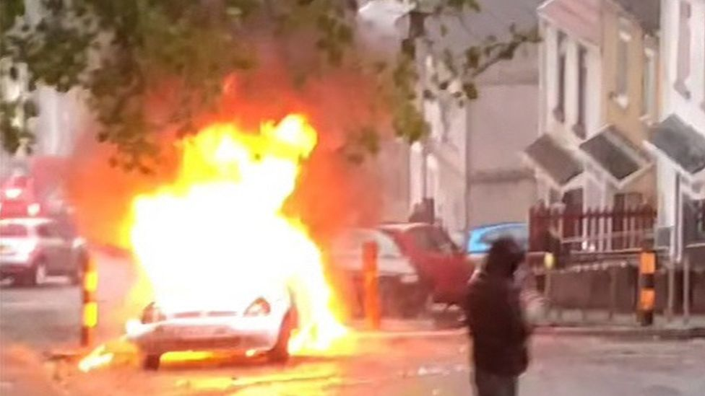
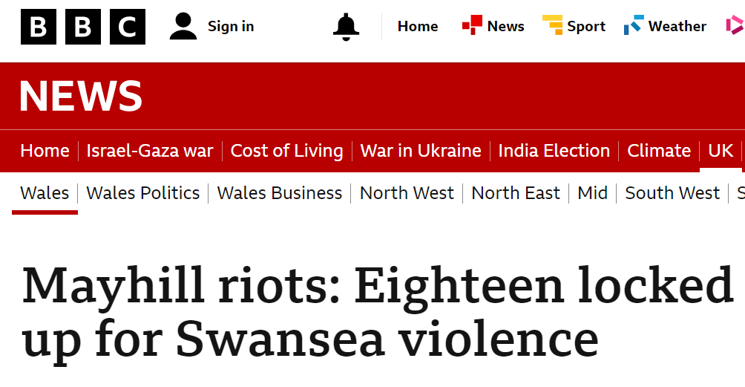

Image 1.1 BBC website showing photograph from the 2022 Mayhill Riots, Swansea,. (BBC News, 2022).
On the 22nd May 2023, a riot occurred in Ely, Cardiff that saw a number of police officers injured, a number of cars damaged, resulting in many arrests. The disorder started after the deaths of two teenagers who had been riding an e bike. Rumours spread quickly across social media that the e bike was being pursued by police officers with the incident receiving national media attention. The Police and Crime Commissioner for South Wales Police, Alun Michael, informed the media that the e- bike was not being pursued but then had to defend his statement, as a result of criticism that officers may have been following the vehicle at some point. Senior police officers were then subject to intense questioning from the media and there was much debate online by social media users, around the police actions leading up to the riot. Traditional media articles subsequently focused on the link of the use of social media platforms by communities and those involved in the disorder, causing escalations in tensions. Many of these articles featured opinions from academic subject matter experts. There was also much focus on the use of social media by the commissioner and commentary on the need for clear and unambiguous messaging .
Image 1.2 summarises some of these articles to underline the scrutiny and links made between the riot and the role of social media.
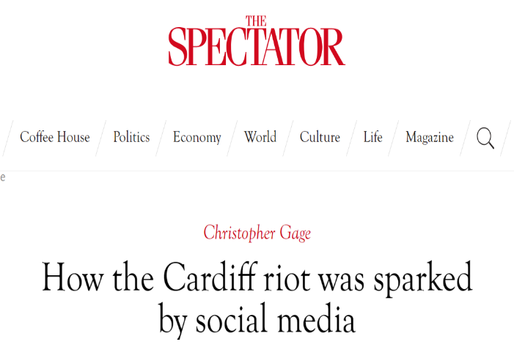
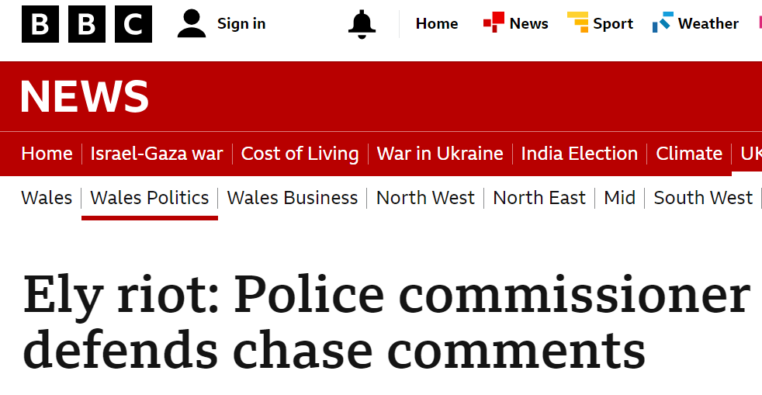
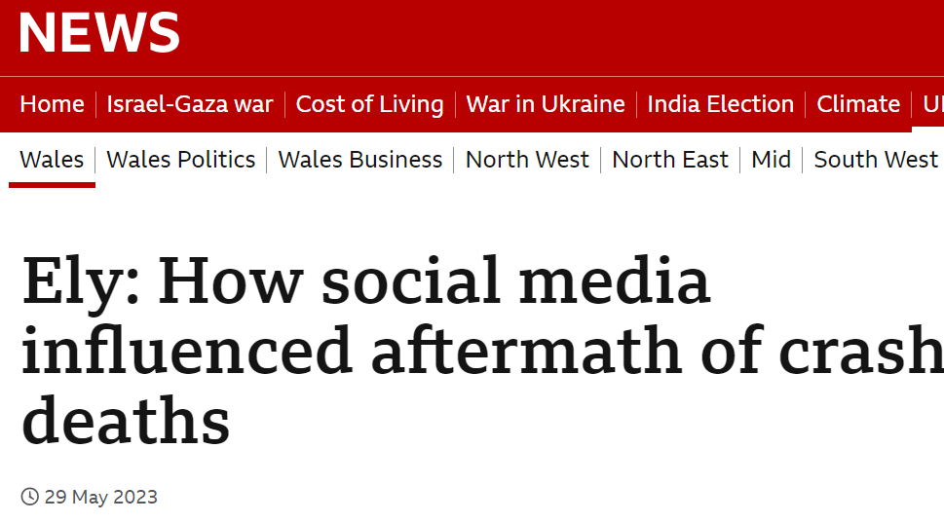
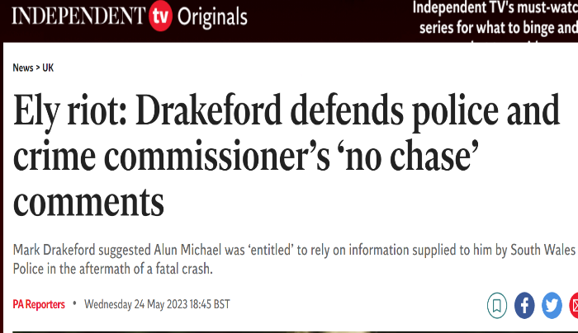

Image 1.2 Collation of news and media websites in relation to the Ely Riot 2023 (BBC News, 2023) (The Independent, 2023) (Gage, 2023) (BBC News Wales, 2023).
Ely is a recent, clear example of the issues that social media poses when dealing with riots , and makes an ideal case study. For the purpose of this research, it is important to note that there will be no reference or examination into the investigation or circumstances leading up to the tragic deaths of the two teenagers. There is an ongoing investigation by the Independent Office for Police Conduct and this research is purely focused on social media and the policing of public order.
Scholars and police officers and staff acknowledge the importance of effectively managing social media during these serious incidents. Assistance and guidance needs to be given to those involved in managing the disorder and understanding their considerations, when in the middle of dealing with the many demands and challenges that are involved. This undoubtedly applies to South Wales Police, as a force that has and will continue to deal with serious public order.

1.3 Research Aim
This study seeks to research the nature and trends of social media posts on sites such as Twitter and Facebook in relation to serious incidents of disorder in South Wales, including a case study on the riot in Ely, Cardiff in 2023. This will identify the impact that social media has had on commanders and others involved in managing disorder and the Ely riot , including the use of social media platforms by the police themselves. The final critical aim will then be to identify the methods that South Wales Police and other police forces should use in the future, in relation to responding to social media commentary linked to events of significant disorder.

1.4 Research Objectives
- Establish the content and volume of social media posts in relation to the Ely riot and how did South Wales Police respond to these posts in relation to their policing approach and communications strategy.
- Evaluate the effectiveness of the police response to the social media commentary and their own use of social media during times of disorder.
- Examine and assess approaches by policing in England and Wales to responding to social media, in order to apply lessons learnt to policing future incident of disorder.
- Recommend effective approaches that South Wales Police and other forces should undertake in order to ensure that they maintain the confidence of the communities when dealing with incidents of serious disorder, where social media activity is significant.

1.5 Anticipated Outcomes
This research will assist South Wales Police in shaping future guidance for public order commanders, media managers and other key staff who will be involved in policing riots. It is seeking to produce clear recommendations on what approaches should be considered by South Wales Police in relation to how to manage social media in relation to dealing with serious public disorder. The aim, is that this work will produce evidence based guidance, available to social media teams and police public order commanders, that they can utilise as part of their strategies or tactical options.

Any recommendations resulting from the analysis of the research will be practicable and relevant , as they will be shaped by those who can give recent and operational perspectives. It is hoped that findings will not only be used within South Wales Police and presented to relevant internal stakeholders but can also be disseminated to other forces, the College of Policing and national policing public order oversight bodies where appropriate.

1.6 How will the Outcomes be achieved
Chapter two critically examines existing literature regarding social media and policing generally, before moving onto focussing specifically on its impact on policing disorder. It will review research and commentary on the 2011 riots in London and England, the first time that social media played a prominent part in such an event. The chapter will also review scholarly observations on the links that social media may have with ensuring police legitimacy is maintained, during the challenges of a riot.
Chapter three describes and rationalises the methodology that is used, which is predominantly a pragmatic philosophy. This is best suited to the research, as there are operational issues being addressed, resulting in recommendations that are looking to impact on real and complex events (Saunders,Lewis, and Thornhill, 2019). A mixed method approach of combining qualitative and quantitative method will support an inductive approach (Saunders, Lewis, and Thornhill, 2019). The methodology used for the primary research will look to provide evidence and analysis in areas that the secondary research used in the literature review identified was lacking or needed further exploration.
The chapter will also detail the different methods taken in relation to researching the issues linked to commanding public disorder and riots generally in South Wales and a case study of Ely, which will be qualitative focused, using interviews as opposed to more quantitative based surveys .

Chapter four presents analysis as a result of the primary research findings specifically for South Wales Police, in addition to reinforcing issues that have been identified in chapter two. The contribution of officers and staff from different roles will give a fresh perspective to how the challenges should be addressed going forward.

Chapter five will detail recommendations and conclusions based on the outputs from the analysis chapter , and will be specifically aimed at assisting police senior officers, public order commanders and communications staff in managing future riots.
The research will commence with a critical review of relevant literature.

Chapter Two Literature Review

2.0 Chapter Introduction
This chapter will review and evaluate academic literature relating to the use of social media by policing in relation to managing public disorder. It will seek to provide a background and context for the research in this paper and assist in identifying gaps in theories and knowledge and their application in the operational policing environment, that the research study can examine and address.
This review will commence by examining the wider use and challenges of such communication platforms in relation to policing in general, before then looking specifically at social media and policing riots. Due to the narrow focus of this research study, there was concern that there may be a lack of volume of academic literature to review. However as highlighted by Adorjan and Ricciardelli (2021), there are a number of scholars who have examined use of social media during riots, with particular focus on the riots in 2011 that occurred in England.
In relation to defining the two main components of this research, namely social media and a riot. Social media encompasses a wide selection of online platforms, including blogs, forums and sharing photographs and videos that all contribute to providing online communities (Aichner et al, 2021). The sheer quantity and variety of social media platforms ,functions and interdependencies makes the defining of social media extremely difficult. Currently, social media platforms are seen as Web 2.0 applications that have turned users into participants (Obar and Wildman, 2015). Examples of social media include Instagram, Facebook and X. The latter was formerly known as Twitter and due to the recent change of name, both ‘Twitter’ and ‘X’ will be referred to in this paper but are in effect the same. Facebook and Twitter have been the most used social media platforms, where the ‘technology has shrunk the world. The distances look closer and sharing information looks easier’ (Salloum, 2017, p. 27). For policing, these platforms allow the public and police, with a very quick glance, to be able to read the views of protestors, traditional media and the public: ‘Twitter does not just allow you to peer through a window; it allows you to look through man-ifold windows at once.’ (Bonilla, and Rosa, 2015, p. 7).
A riot is more straight forward to define and in the United Kingdom it is :
Where 12 or more persons who are present together use or threaten unlawful violence for a common purpose and the conduct of them (taken together) is such as would cause a person of reasonable firmness present at the scene to fear for his personal safety (Public Order Act,1986).
Riots have occurred in the United Kingdom for centuries. In 1749 there were riots in London regarding taxes on gin, right through to the present day, and they can be a response to perceived government persecution and tyranny, or anger against the state or personal opportunity to gain financially (Hernon, 2015). There have been riots in London, Bristol , Manchester and other major cities since 2011 in England, and recently in Wales: Swansea and Cardiff had a riot in each city.

2.1 Social Media and Policing
Policing in England and Wales is based on Robert Peel’s principles of 1829 with the key one being ‘the ability of the police to perform their duties is dependent upon public approval of police actions’ (Williams, 2003).
Neighbourhood or community policing underpins this, and revolves around the police being part of the community and in turn the community feels part of policing and they feel safer working together towards the same outcome (Ericson and Haggerty, 2018). Community based policing in the England and Wales is centred around the public feeling empowered and involved. Following on from this, Lieberman, Koetzle and Sakiyama (2013) summarise why proficient use of social media by policing is important, as it empowers the public and gathers support in tackling crime and disorder, forming strong relationships between the police and the public. The police look to retain public confidence around public safety by effectively communicating with them, using methods that the public relate to and use (Lieberman, Koetzle and Sakiyama, 2013). Social media platforms, on many occasions, replace the formal press releases and have been used as two-way communication during times of crisis or critical incidents to both receive and give information in order to reassure communities and resolve the situation (Information Resources Management Association, 2019).

With the prevalence of social media in modern society, policing has to have a social media presence. The public expect policing to adapt , be readily available with information and react effectively and rapidly to events and situations (Akhgar, Bayerl and Leventakis, 2019). This is reinforced by Fyfe and Crookall (2012) who state that social media has led to far more expectations of the public wanting to be connected and police forces now have to make sure they are focused on the needs of the communities. This new kind of media management, as opposed to the traditional methods, can be more complicated, and the police are having to manage a number of stakeholders, with different perspectives, who are using and viewing social media through their own lens (Greer and McLaughlin, 2010). Effective social media is also important for the police for detecting crime , as they rely heavily on the public for giving and receiving information, so ensuring that the use of social media is right ,is crucial, for instance, in identifying offenders (Lee and McGovern, 2016). Edlins and Brainard (2016) advise police forces that they need to do more than use the platforms to just give information, but need to listen, engage and connect with the public (Edlins and Brainard, 2016).

Scholars point out the risks that social media can pose for legitimacy for police forces, such as Adorjan and Ricciardelli (2021) who articulate that many of the online communities are hard to categorise, as they are large in numbers, diverse and many are anonymous accounts. This could lead to lack of trust, as a video could be swifty and extensively circulated, with a particular narrative attached or without context provided, that can undermine confidence in the police and their operational effectiveness and impartiality. Going further than this, misinformation on social media causes significant concerns for democratic establishments and bodies such as the police (Allcott, Gentzkow and Yu , 2019). Bullock (2018) gives a balanced view of Twitter, as a platform that can provide a solid and steady connection between police force accounts and its followers but also has more unpredictable and uncontrollable connections, as can be seen with the use of ‘hashtags’, which are harder to influence and counter views once momentum has built.

It is clear that academic literature views social media as a key tool for police forces to use, but there is a consistent and cautionary tone found throughout the research, around not making mistakes in relation it’s use. Bayerl et al (2014) for instance reinforce what some of the research previously mentioned, in that the platforms provide excellent mechanisms for true two way engagement with the police and the public, but the information given by the police has to be reliable to ensure the trust of the public is maintained. Livingstone (2022) notes that police communication should be based on giving the confidence to the public around their actions being legitimate, and police forces are improving in their use of social media but the environment is challenging, crowded and there will always be criticism around any messages given out by the police.

2.2 Social Media and Riots
Waddington’s (2010) Flashpoints Model of Public Disorder states that the cause of a riot cannot be put down to one variable, but instead is caused by one or more of six interdependent reasons, some of which are very relevant when discussing social media and riots. Despite the model being designed before the introduction of social media, Waddington identified that the quality of relations and communication between police and the public can turn a flashpoint into a riot, as can rumours or misinformation if not properly dealt with. Waddington reinforces that this is only one of several factors that will instigate serious disorder, and will at times be outweighed by some of the other variables of his model, such as the collective view of grievance or social exclusion (Waddington, 2010).
However the last fourteen years has seen the unprecedented growth of social media. Van Dijck and Poell (2013) cite the Haren riots in the Netherlands in 2012 that arose after a birthday party was advertised on Facebook by a teenager and escalated significantly, with large numbers of youths attending. This they state, was due to the multiple connections of people created by social media platforms. Connecting people in different locations with a common cause has been made easier by platforms like Twitter, which can suggest people to follow and tweets to view (Pond and Lewis, 2019). This enables more effective coordination by organisers of disorder. Social media and the associated technology also helps to mobilise protestors and mass groups as they are cheap to use (Pond and Lewis, 2019).
Waddington’s disorder model (2010) still provides a strong theory around the causes of public disorder but as Van Dijck and Poell (2013) and Pond and Lewis (2019) evidence, social media platforms have created un precented fast connectivity between people that can cause tensions in a community to rise very rapidly from normality to public disorder. Greer and McLaughlin (2010) note that public disorder provides impactive footage for news agencies and can be presented in a way that is different to the reality on the ground. This footage is often provided by members of the public unexpectedly caught up in the event or by those actively involved and will often be viewed as being authentic despite their motives or narrative being unknown.
As such, although rumours and misinformation would still be just one factor that escalates tensions, it has become a more significant factor because of the evolvement of social media

2.3 Police use of Social Media in a Riot
In relation to the use of social media by policing during a riot, which in the modern age will be one of the tools used by the police to deal with such disorder, Newburn (2016) emphasises that the overall police initial response, tactics and role are critical as to whether the public disorder increases or reduces. Waddington (2007) states the main challenge when policing public order is for the police to be seen as neutral. They will be seen by many as biased towards the state and instruments of the government and will never please everyone in these situations. Cronin and Reicher (2009) emphasise how commanders need to put in place effective communication strategies in order to effectively show the difficult conditions and complexity that officers are operating in, when dealing with a riot situation. A clear and no surprises communication policy is important (Waddington, 2017). Procter et al (2013) highlight that the relationship between the media and policing has always been a complicated one, with the police needing to be transparent and ethical throughout. Policing a riot, whilst dealing with and making full use of social media, makes this even more complex.

Chermak, McGarrell and Gruenewald (2006) agree but believe that in times of normality the police service has become adept at producing positive stories, enhancing their reputation and confidence with the public. However Chermak, McGarrell and Gruenewald (2006) state crises and serious disorder can significantly undermine this confidence, as the narrative is harder to control. The dynamic nature of social media has created difficulties for police in maintaining legitimacy and public confidence, which has resulted in considerable investment in their media departments (Chermak,McGarrell and Gruenewald, 2006). Therefore there is a need for the police to communicate , via the use of social media, during spontaneous and challenging events such as riots, to not just give messages to the public but to properly interact and engage with their communities (Gascó et al, 2017).

Czudnochowski and Ludewig (2023) are more positive and believe that police forces are becoming well versed in the use of social media platforms when dealing with times of crisis or challenging time. They argue that the police are utilising the benefits that the platforms give and are able to give out accurate information quickly and directly to the public that the police can control. This has helped to show the transparent actions of the police and assist with their legitimacy. Czudnochowski and Ludewig ( 2023) however reinforce the viewpoint of Chermak, McGarrell and Gruenewald (2006) and highlight concerns, that with the speed that tensions can escalate, police forces can be reactive and can hastily post messages to try and de-escalate situations. They state then that there is a need to ensure that the information is accurate and ensure that there is a balance between communicating at pace and giving out the right information. This is a consistent theme, which others such as Goldsmith (2015) raise, in that social media is one of the tools that police can use to control or manage the information. There is also the need to distinguish between information given out to show openness by the police, with the actual need for the public to know some of the information, reinforcing the point raised by Bayerl et al (2014) earlier in the chapter, around ensuring accuracy of information in order to maintain public trust.

During a critical incident, like a riot, it is vitally important that there is good, clear communication by the police with the public to not only reassure them, around their safety but also confirm that the police response is needed and proportionate (Gascó et al, 2017). Policing is centred around reassuring the public that risk and security is being appropriately managed (Ericson, and Haggerty, 2018). Poor communication or lack of it can lead to further unrest and public disorder, as was seen after Hurricane Katrina where the New Orleans Police Department amongst other things, did not communicate effectively with their communities (Sims, 2007). Goldsmith (2015) highlights that there are now twenty four hours a day media demands on policing, as well as the public’s expectations around being given information, with police leaders being asked to comment or to be interviewed ever more increasingly.
O’Connor and Zaidi (2021) state that the consensus of commentators and academia is that the police do not appear to be effectively using social media and that they are failing to properly engage and respond to the public and not using the full capabilities of the platforms to show that the police response to an event is transparent, proportionate and effective. However this review has shown that scholars do acknowledge the complexities of social media during times of riots and times of crisis, and the need for the police to carefully consider their social media output with pressures of timescales and expectations from the public.
There is much focus from academia on engagement with the public but not as much attention is paid to the use of social media by police as an information and intelligence tool. Dencik, Hintz and Carey (2018) do highlight that police should be looking to identify ‘influencers’, who could be not physically near the disturbances at all and taking a more proactive stance before and during the event in analysing social media , in order to perform effective ‘pre-emptive’ tactics (Dencik, Hintz and Carey,2018).

2.4 The 2011 Riots
The 2011 riots that originated in London but spread throughout England, saw forces using social media as communication channels for the first time during serious disorder. As a result of it being a relatively new phenomenon, much of the research in relation to social media and policing riots has been focussed on these events in 2011. According to Baker (2011),the instantaneous nature of social networking and the tempo that images and videos are released, with the subsequent volume of comments from platform users, fosters a collective spirit that can embolden people to take action at what they see as an injustice ,such as what occurred after the Mark Duggan shooting in London.
Moran and Waddington (2014) also articulate that 2011 showed the speed that social media could speculate or circulate videos, such as rumours regarding a young girl being attacked by police officers, where no such actual evidence existed. This contributed to a quick escalation of tensions and violence. There was a new unstable communications environment on social media , such as users of the forums being able to watch video footage of where the police appeared to be outnumbered, not being able to prevent some of the disorder, which emboldened rioters to continue with disorder. Social media meant that many could participate in riots and encourage disorder without actually being physically there (Moran and Waddington, 2014).
There is some positive commentary around the police use of social media during the riots, for example, Denef et al (2012) highlights Greater Manchester Police. The force had asked for public feedback after the 2011 riots after they had put out some controversial tweets and although some disagreed with the messages, they were widely praised for their engaging style that they had updated the public with during these challenging times. It was clear that the force had embraced the platform and were looking at where they could improve with their engagement (Gascó et al, 2017). The Police Foundation (2014) in a briefing on the use of social media, also highlighted effective use of social media in the 2011 riots to correct misinformation and reduce tensions. The report showed different styles and approaches used by forces on social media, comparing the engaging stye of Greater Manchester Police with the more regimented tweets of the Metropolitan Police. The latter did not achieve the same kind of engagement as other more informal and open tweeting from other forces, however there was a clear professional line of what information was being tweeted, which aligned to the need to ensure accurate material was communicated on the platforms to ensure public trust, as Bayerl et al ( 2014) has highlighted.

However, on the whole it is acknowledged that the police use of and reaction to social media in these riots was not effective. Crump (2011) highlights the fact that the influential impact of social media had not been fully understood by the police in 2011, and was used by the forces to show a police presence and their operational response, as opposed to engaging with the public. An effective social media strategy can dispel misinformation, and impactively show an effective operational police response to a riot. In relation to 2011 ,and other similar events, the consensus of academia is that police did not use twitter and other platforms as effectively as they could have (Procter et al, 2013). The Police Foundation briefing (2014) also highlighted that the police structures in 2011 could not cope with the amount of information and intelligence that was being put on social media and could have been acted upon.

Research of current academic literature is lacking in relation to whether the structures have now improved since 2011 for policing in England and Wales. As such this study will seek to ascertain if the systems and knowledge have improved and are now in place to effectively manage the information that social media gives , with a focus on South Wales Police.

2.5 The Ely Riot
In relation to the 2023 Ely riot, this research could only find commentary on this event in a few news articles. BBC News (2023) quoted Professor Matthew Williams ,chair of criminology at Cardiff University's School of Social Sciences as saying, ‘The immediacy of the riot might be a key part of social media's influence’ (Williams, 2023). In the article he states that there a number of factors that cause a riot, including deprivation and lack of trust in the police, and social media did not start the riot but it gave it impetus and narrowed the time frame in which the police needed to communicate with the public. This viewpoint was also reinforced by Christopher Gage writing in the Spectator, where he states that the ‘power of social media cannot be understated’ (Gage, 2023) with rumours, live streaming of the riot and false information all being put on social media causing an escalation of the disorder.
Although the riot only took place a year ago, it is surprising that further research and study has not been undertaken in relation to the impact of social media on the Ely riot. As shown in this chapter, the briefing from the Police Foundation (2014) highlighted the ineffectiveness of policing to deal with social media during the 2011 riots, as has other studies (Crump, 2011) (Procter et al, 2013), and the 2023 Ely riot is an appropriate event to compare how policing has progressed in this area, over the last decade. This study will look to address this. Although limited in current academic commentary, it is clear from the above articles around Ely, that social media continues to be an impactful factor in tensions escalating into a riot.
2.6 Chapter Conclusion and Impact On police
The academic literature makes it clear that policing is now scrutinised twenty fours a day via media platforms ,not just by official news agencies but by ‘citizen journalists’ and the public (Mawby, 2010).
During a riot, this scrutiny on the actions of public order commanders and police forces is intense. If the police response or engagement is insufficient , they will lose the confidence of the wider public. It is also clear that the police service in England and Wales needs to build capacity and capability to read, analyse and respond to the sheer volume of social media posts during a riot, to ensure an effective policing response.

Academic research has focussed heavily on the corporate stance and approach that police forces need to approach in relation to their use of social media, during times of disorder, and on the impact of social media of inflaming tensions and increasing disorder. There is also a theme of the police use of social media needing improvement, and the risks in relation to getting its use wrong, which also links into public confidence.

Where there is a gap in academia, is the direct impact on those police commanders, officers and staff who are actually dealing with the riots themselves. There appears to be a lack of recommendations in regard to specific improvements that forces could implement , at both tactical and strategic levels, and there should be more research on how police could proactively use social media to assist with information and intelligence collection. A question posed by the Economist (2011) regarding the riots thirteen years ago, relating to the BlackBerry Messenger(BBM) service was ‘The rioters use BBM against the police. But can the police use it against the rioters?’ (The Economist, 2011). Academic literature appears to say yes, but there needs to be more focus on the ‘how’ to use it by police, albeit the BBM has been replaced by the platforms mentioned in the paper.

The 2011 riots have provided significant material but more recent riots, such as Ely, need to be reviewed, as social media has been developing at an unprecedented rate in the last decade. A public order commander dealing with serious public disorder faces many challenges and will be under intense pressure during the time of commanding a riot, not least knowing that one wrong decision could increase tensions further, with lasting community impact. A commander will, in these situations make a number of spontaneous decisions, without articulating the reasons, other than to police colleagues who will have a similar mindset (Cronin and Reicher, 2006). It is clear, that social media can assist in explaining these decisions to the public, and this research intends to aid those police decision makers and address some of the concerns cited by scholars within this review and other areas, such as the impact on the commanders themselves ,by understanding their viewpoints and issues that they face.

Chapter Three Research Methodology
3.0 Chapter Introduction
This chapter will outline the research approach and methodology to collate data in order to achieve the objectives articulated in chapter one. The Economic and Social Research Council (2024) defines research as ‘as any form of disciplined inquiry that aims to contribute to a body of knowledge or theory’, and as such the research strategy and design must be focused on the set objectives of this study and consideration of evidence or gaps found in the literature review.
The purpose of conducting this research will be to evaluate the effectiveness of the police management of social media during serious disorder, have a clear understanding of the impact of social media posts in relation to the Ely riot and then recommending best practice for South Wales Police and policing going forward.
The literature review conducted has shown that it has been acknowledged that police need to improve their management of social media during major disorder and that there is a lack of the study in relation to the impact of social media on those dealing with the incident as it is occurring. This research will seek to understand the challenges, risks and issues that they face in making critical decisions, in order to give evidence based advice on best practice or a range of options to use in future events.

3.1 Research Strategy
Strategy is ‘a plan of action designed to achieve a series of objectives or a particular goal’ (College of Policing, 2024). In relation to this study, the research strategy will detail the structure and overall plan as to how the research will be conducted and ensure a cohesive approach to collating and analysing the data in order to answer the research question.
The framework that will be used for the strategy is the widely respected ‘research onion’ (figure 3.1) as described by Saunders, Lewis and Thornhill (2019).
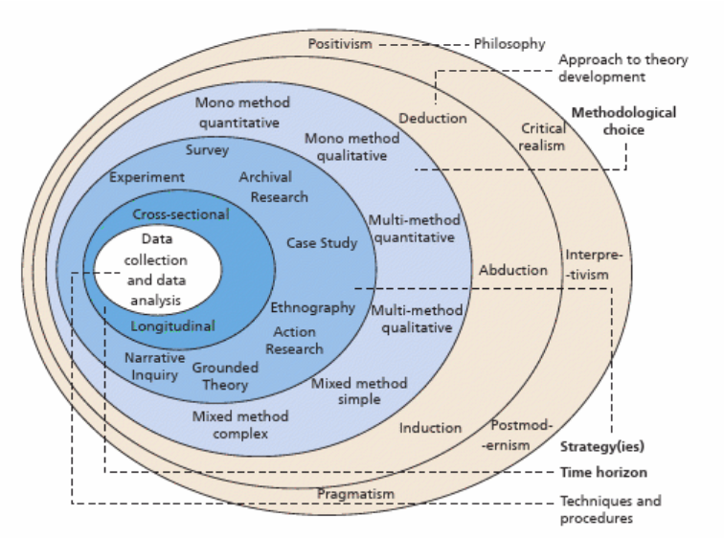
Figure 3.1 The Research Onion (Saunders, Lewis and Thornhill , 2019)

The onion will be adopted as the blueprint for the strategy as it is ‘an all-inclusive framework, it forces researchers and academia to address all relevant research dimensions in their research endeavours in a simple, clear and logical way’ (Steenkamp and Haydam, 2020, p. 313).

3.2 Philosophy
The overriding philosophy will be one of pragmatism. Saunders, Lewis and Thornhill (2019) define this philosophy as one that is grounded in reality and where theories and research are viewed as tools for thinking and action as opposed to more abstract considerations.
With social media networks, users and their perceptions being at the core of this research, then adopting a philosophy of interpretivism was a genuine consideration, as it is a way of thinking that would effectively look at relationships, language and viewpoints (Kincaid and Bouwel, 2023). However, the pragmatic approach revolves around intervention as opposed to observation and using knowledge to recommend actions that will lead to change on organisations (Goldkuhl, 2012). This approach is more suited to the area of research, that deals with challenging, dynamic events resulting in serious consequences if the right decisions are not made. There will be elements of interpretivism, but the overriding philosophy of pragmatism aligns appropriately with the research aim.

3.3 Approach
Two approaches were considered for this study. A deductive approach involves going from ‘general to the particular’ (Locke, 2007, p. 868). It starts with a theory and a hypothesis with a view then to collating data to test whether the theory is accurate (Schwester, 2015). This approach is well established and highly regarded but it can constrain innovative thinking and development of new ideas (Jebb, Parrigon and Woo, 2017).

The other approach is an inductive one, which Schwester (2015) states is one where the data is collected first and a hypothesis is formed on patterns identified in the data, that then guides the research’s final theory .The inductive approach does not start entirely with the data collection, it commences when an issue of interest is identified or observed, in this case the impact of social media on policing riots due to recent occurrences ,accompanied by a review of existing literature where data and research analysis can assist in addressing gaps in knowledge or theory (Yom, 2015).

The area of this research is still relatively new and the aim is to deliver recommendations ,based on experiences of those who deal directly with the challenges faced. The study needs to be open to what the findings and proposal may be ,as opposed to starting with a fixed view and as such an inductive approach will be adopted.

3.4 Methodological Choice
The study will employ a mixed method technique. This aligns with the pragmatist philosophy and blends qualitative and quantitative methods to address practical issues in an evolving arena, and takes account of the dynamic environment that the research is studying (Denscombe, 2008), which as previously noted, is applicable to policing riots and social media impact.

There is a danger that in using the method ,that the quantitative approach could prevail over the qualitative approach (Baran, 2020), but this was considered and mitigated by ensuring that an appropriate research question was constructed. A mixed method is motivated by a pragmatic view of events and the world, that minimises deficits in using singular methods (Ngulube, 2022 ).

3.5 Strategies
A survey strategy was adopted to support this study, alongside a case study of the 2023 Ely riot. As Saunders, Lewis and Thornhill (2019) reinforce, a survey strategy is well respected as it allows the collation of standardised data from a large number of participants ,is inexpensive, and easy to analyse and compare responses.

Kelly et al (2003) when looking at disadvantages of using surveys, states that they can lack the detail and depth required by the researcher. This has been taken into consideration and the questionnaires included two qualitative questions, that allowed the participants to provide context to the quantitative questions but also to raise any pertinent points that the researcher had not considered.

The survey strategy was undertaken alongside a case study, conducted using interviews with key police participants. The case study provides compelling realism, that other methods, such as experiments could not provide (Dul and Hak, 2008). Saunders, Lewis and Thornhill (2019) note that there are many approaches that can be taken when conducting a case study , and interviews were utilised as the approach for this research.

The survey and case study will complement each other and Saunders, Lewis and Thornhill (2019) emphasise that no one strategy should be mutually exclusive. It is also recognised that survey strategies are usually aligned with a deductive approach , however a survey strategy can be undertaken to support an inductive approach, as the data is being used to develop recommendations and theory (Saunders, Lewis and Thornhill, 2019).

3.6 Time Horizon
A cross sectional time approach has been adopted not only because of time constraints attached to the research but because this is a study of social media and policing riots that have occurred recently and will continue to occur spontaneously. There is sufficient time to collate evidence and conduct the research over the shorter period of time.
The cross sectional approach also captures the current feelings and experiences effectively during a time when social media and public order is prevalent .After taking time to critically review the relevant literature, the data collection phase was undertaken in a four week time frame before the analysis.
3.7 Techniques and Procedure- Data Collection and Data Analysis
Two methods were used to collate data for this research that supported the survey strategy. The first of these was a questionnaire that was sent online using Microsoft forms. This platform was used for creating surveys as it integrates effectively with Microsoft excel, which in turn has a number of beneficial functions that assist with data analysis. Microsoft forms is also well regarded in relation to its ease of use and security functions, which would encourage a higher percentage of replies.
The questionnaires were sent to all public order commanders in South Wales Police, representing the strategic, tactical and operational decision makers in riot situations. They were also sent to public order tactical advisers, who are at constable or sergeant ranks and provide guidance and advice to the commanders. In addition the questionnaires were sent to members of the communications and intelligence departments. As a result 51 officers and staff were sent the questionnaires in April 2024 with an ask to return within two weeks. 38 persons completed the questionnaire.
The questionnaire established role and experience of the respondents and then consisted of a further 20 questions ( Appendix A ),of which 18 were quantitative. The last two questions were qualitative in nature, in order to allow respondents to clarify any points that the quantitative questions could not cover. This adds more depth to any answers or to raise points not covered in the survey. Questionnaires proved effective as the reassurance around anonymity, resulted in honest views being expressed, in addition to ease of use for the respondents and the researcher.
The second method of data collection was via semi structured interviews with two public order commanders and the intelligence lead commander, who were all directly involved in the Ely riot. The interviews were conducted via Microsoft teams and were recorded. This platform is also used extensively within South Wales Police, so again gave confidence around security and ease of use. The participants were provided with an information sheet ( Appendix B ) which reassured them around no comments being directly attributed to them, encouraging honest reflections. The interviews were qualitative based, in order to gain a fuller understanding of the impact that social media had on officers who have recently faced dealing with a riot. The interviews gave the researcher a deeper insight into the emotional effect on the individuals and what drove their thought process. This could not be captured as effectively in the survey ,although the latter allowed wider views to be collated in a larger quantity at pace.
The sampling method used was nonprobability based, due to the study topic being focussed on specific areas, where participants needed the required specialist knowledge. The interviews were focussed on the Ely riot and as such, there are only a small number of individuals, who were involved in the command of the incident. The surveys were sent to a wider group, again kept within South Wales Police, however due to policing a capital city, it does have a wide pool of those involved in command of public order policing. The advantages of using South Wales Police only staff was a willingness to participate in the study, due to the relevance of the research to their role and recent events in the force area, including two riots. The surveys and interviews could also be easily managed and coordinated by the researcher.

3.8 Ethical Issues
‘Research ethics are concerned with moral behaviour in research contexts’ (Wiles, 2012, p. 15). Research whilst looking to produce valid conclusions based on trusted methodology that obtains authentic data, needs to be based on ethical behaviour from the researcher in relation to the principles and manner with which the data is collected and analysed (Bos, 2020).
This research is guided by the University Of Wales Trinity Saint David’s research ethics and integrity codes of practice (University of Wales Trinity Saint David, 2022) and ethical approval was sought by the university and researcher’s supervisor before commencement of the study. The relevant senior chief officer in South Wales Police also gave approval that participants in the force could be approached to take part, on a voluntary basis, for the research.
An ethical consideration was to ensure that impartiality was maintained throughout the research .The researcher is also a public commander within South Wales Police. Saunders, Lewis and Thornhill (2019) address the implications of being an ‘insider researcher’ throughout their guidance on research methods. There are clear advantages in relation to the ease of access to participants and a sound knowledge of the subject area allowing easier interpretation of data. However there was a need to ensure with vigour that the research remained objective , and that the researcher did ‘stand back’ and ‘not take things for granted’ (Saunders, Lewis and Thornhill, 2019, p. 360).
Linked to this issue of the ‘insider researcher’, was ensuring that all participants felt comfortable taking part in the research and that they were fully aware that their involvement was voluntary throughout and they did not feel pressurised to take part. Participant information sheets (Appendix B ) and a verbal briefing to those being interviewed emphasised this.
The study did revolve around some sensitive areas, in particular the Ely riots , which had only occurred in 2023. The surveys were completed anonymously and with a high return rate, there was a clear trust and support of the study. The case study into Ely became more problematic during the research, as there was still an independent inquiry ongoing and additional staff within South Wales Police were being asked to account for their decisions in relation to the incident. Ethical considerations were the primary thought of the researcher, in relation to interviewing this small pool of commanders. It was emphasised, using the information sheets and requests for interview, that their role was entirely voluntary, it was not focussing on the actual events that led to the riots and that they were free to withdraw at any stage. Being involved in any such inquiry places significant pressures on those involved and their welfare was considered throughout , and as such if any interview would add to their concerns, then the interview would not take place. As a result only three officers were interviewed .A smaller pool of commanders involved in the case study meant that it was more challenging to ensure the anonymity of the interviewees, but the research took great care to ensure no individual comment could be attributed to a specific individual.
The pressures linked to managing such a challenging and scrutinised event was also taken into account with the contingency that any individual during the study , who showed signs of requiring welfare support, could be referred to South Wales Police occupational health department, if they consented.

3.9 Limitations
Linked to the previous focus on research ethics, the limited number of commanders involved in the Ely riot and the time scales of the study , meant that inquiries linked to the riot were still ongoing during the research. This resulted in only three interviews being completed. The interviews though, gave impactful context and insights that reinforced the survey findings.
The surveys which were mainly quantitative in nature, contained two qualitative questions , that the researcher had underestimated about how much information would be given in these replies. The survey respondents embraced the qualitative questions, which compensated for the reduction in interviews around Ely, that the researcher originally intended to undertake.
The research was conducted within South Wales Police only. This had advantages over conducting researching externally, such as ease of access, trust from respondents and participants and contextual knowledge of the subject areas (Saunders, Lewis and Thornhill Thornhill, 2019). Utilising the views and experiences of police commanders and staff throughout the United Kingdom would have provided richer and more plentiful data. This was a consideration, but utilising South Wales Police staff only, meant that there was a real focus on the aims of the research and was a proportionate method with the timescales attached to the research.
Chapter Four Analysis of results

4.0 Chapter Introduction
There were 38 respondents to the survey, conducted using an online questionnaire. All of the respondents work for South Wales Police in either public order command , intelligence or the communications department. 46% are public order commanders and 23% are Public Order Public Safety Advisers(POPSAs), who are police officers that work alongside commanders during events to provide specialist advice to the commanders. Communications staff, managers and operational staff (15%) and Intelligence officers(5%) were smaller in numbers, but there is only a small pool of staff who assist with these functions during serious disorder. The remaining respondents are frontline public order supervisors. The respondents have considerable experience , with 70% of those surveyed having over 15 years experience in their relevant roles. At least 37 respondents replied to each of the questions.
In addition to the questionnaire, three commanders were interviewed in relation to their role in the Ely riot of 2023. Their roles are explained towards the end of this chapter.

4.1 Current Use of Social Media
The results showed that within South Wales Police, during serious disorder, social media is viewed to gather information and intelligence and to gauge the wider public’s views on an incident but consistent proactive engagement is limited to the communications department.
89% of respondents stated that they looked at the platforms to gather information and intelligence at least sometimes, of which over half of this number stated that they viewed social media for this purpose either often or always.
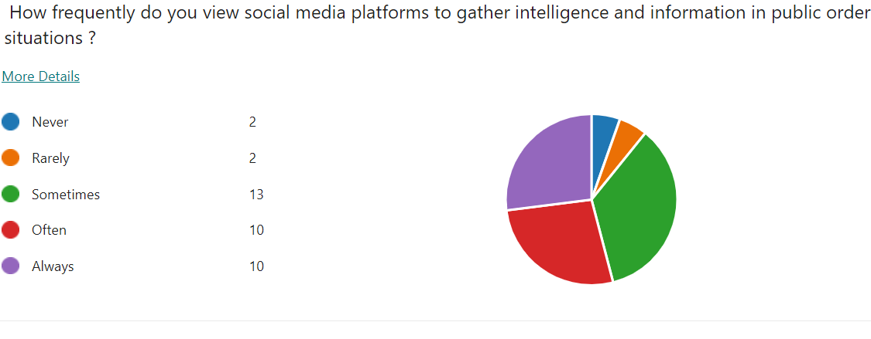Diagram 4.1 - Survey Question. ‘How frequently do you view social media platforms to gather intelligence and information in public order situations ?’

Even more so , it is clear that the respondents view social media to gather the views and sentiments of the public during these serious incidents, with 62% stating that they do this often.

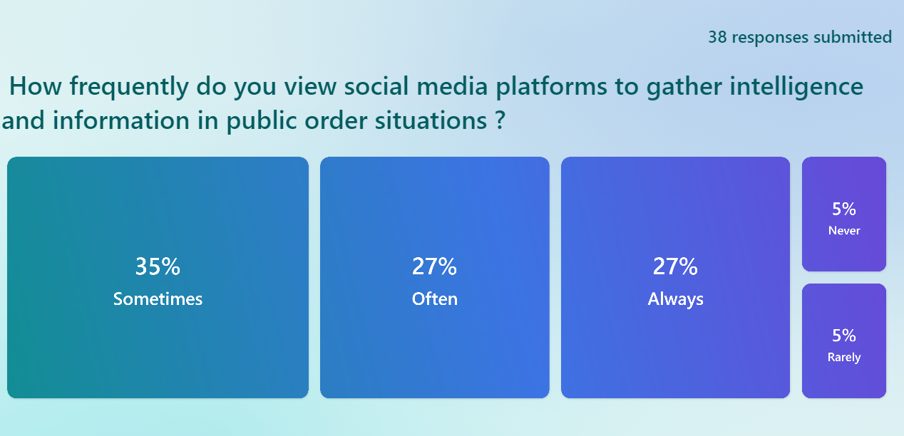
Diagram 4.2 - Survey Question. ‘ How frequently do you view social media platforms to gather intelligence and information in public order situations?’
However, the commanders do not take it the step further from viewing social media to engaging with the public to explain the ongoing situation and rationalise their actions. Out of the 18 Gold, Silver and Bronze commanders , seven said they do engage sometimes but over half of the commanders rarely or never engage. As expected, 83% in the communications department replied that they always engage. This is their core role and they have the experience and knowledge to use the platforms representing the commanders. The fact that eight of the 18 commanders, do use social media for this purpose, at least sometimes, does show it is a consideration, and also could show a balanced consideration in that they only use it when appropriate.
However just over half of the commanders do not feel the need to use it, or rarely use it, and as will be shown in their qualitative comments, they believe that their communications colleagues are in the best roles to carry this out. The literature review reinforced the need to effectively engage with the public and not to just use social media to collect information (Edlins and Brainard, 2016) (Gascó et al, 2017). The communications staff are the trained specialists in this area. However, if commanders became more proactive in directly interacting with the public, this may well have benefits in building trust and provide that quality of engagement ,with a clear and no surprises style that Waddington (2010) states will help to reduce tensions.

4.2 Social Media and Legitimacy
94% of respondents agreed or strongly agreed that social media shapes the public perception of the policing response during serious disorder. 82% agreed or strongly agreed that social media is impactive on legitimacy and trust and confidence.
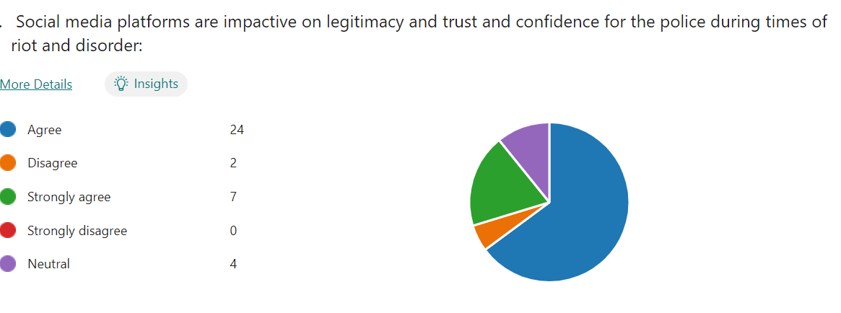
Diagram 4.3 - Survey Question. ‘Social media platforms are impactive on legitimacy trust and confidence for the police during times of riot and disorder’
Previously in this paper, it has been shown that scholars such as Adorjan and Ricciardelli (2021) underline the importance of the link between activity on social media and police legitimacy, which the respondents also clearly agree with and understand.
92% of all those taking part stated that they had seen misinformation and disinformation in relation to a riot or serious disorder, with 45% saying they had seen it often, confirming that it is prevalent, as highlighted by Greer and McLaughlin (2010) and other scholars in the literature review.

4.3 Social Media as an effective option
88% of replies stated that social media was an effective or very effective tool for providing information and intelligence during disorder, reinforcing findings in the literature review, that social media allows ‘police to gather a sense of who and how many people will be attending an event and how militant it might be’ (Dencik, Hintz and Carey, 2018, p. 1441). Out of the 18 Gold, Silver, Bronze commanders, 16 believed that social media should be utilised as one of the first options to deescalate tensions, supporting Cronin and Reicher’s (2009) emphasis of the need for an effective communications strategy to show the issues that the police are dealing with.
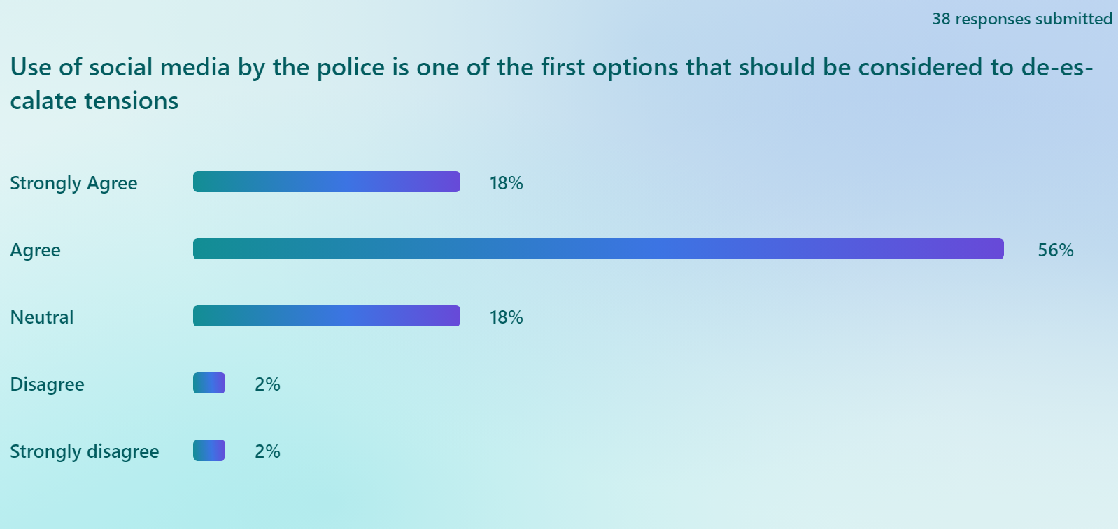
Diagram 4.4 - Survey Question. ‘Use of social media by the police is one of the first options that should be considered to de-escalate tensions’
34% of respondents did not believe that it should be the police commanders themselves engaging with the public on the platforms, to provide explanations of their actions. Although the majority did believe that there should be engagement by those in command, over a third of those surveyed disagreeing, is a significant number. A third of the police commanders themselves expressed this sentiment. However those working in the communications department agreed that commanders should engage, with five out of six replying that they should.
This is interesting, as there may be an expectation that communications officers saw such engagement as their own domain and protective of their role. However it is clear that they see the benefits of proactivity from commanders on social media, and a number of commanders need convincing that this is the case. The literature review aligns with this and shows that academia supports the communications department views around a more committed approach to social media, with the belief that the police need to do more than just send messages out on social media, but effectively engage with the public (Gascó et al, 2017), which O’Connor and Zaidi (2021) endorsed. What the scholars have not specifically commented on, is whether it should be the commanders or the communications departments directly undertaking the engagement.

4.4 Personal Impact
The literature review highlighted a lack of consideration around the impact of social media on those commanding and managing the public order situations. When asked about impact on their own wellbeing , there was a fair balance between those saying it did impact; 45% and those who said it did not; 37 %. However this is still a significant number of officers and staff who say social media affects their wellbeing in these situations. Further scrutiny of those impacted, showed no pattern in relation to roles that they performed, there was much the same balance of commanders, intelligence staff, communications staff, who either felt impacted or not affected by social media.
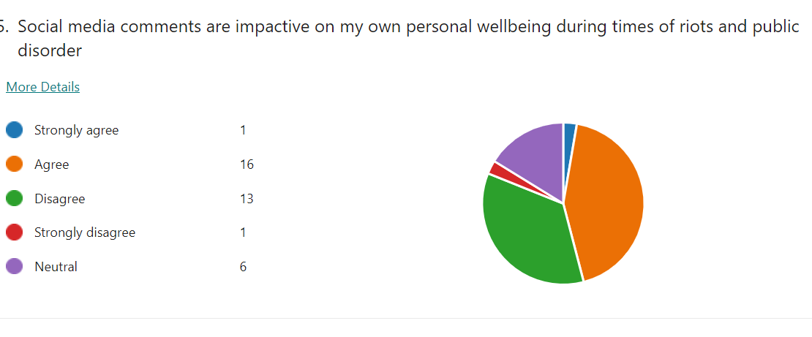

.
Diagram 4.5 - Survey Question ‘ Social media comments are impactive on my own personal wellbeing during times of riots and public disorder’
In relation to whether social media impacted on the respondents own decision making during riots, 43% agreed or strongly agreed that it did. 83% of the communications staff respondents thought it was impactive but only 33% of the public order commanders believe it affected their decision making. This suggests that public order commanders will be less likely to be impacted by what is being said or shown on platforms, as they will likely be focussing on protecting the public and officers, whilst those in communication departments directly dealing with social media engagement ,will be paying attention to how their replies and messaging will be received. However, as previously highlighted in chapter two, scholars place heavy emphasis on policing understanding the social media environment during a riot, in order to garner the public’s support in tackling disorder (Lieberman, Koetzle and Sakiyama, 2013 ) and gain their confidence (Livingstone, 2022) but it appears that commanders in this survey are more focussed on delivering the tactics, diverting their attention away from social media.

4.5 Effectiveness of use by Commanders
70% of respondents felt that police public order commanders should receive training in relation to the use of social media during riot situations, with 24% strongly agreeing that this was needed. 59% of all respondents did not believe that they received the right guidance or support to use the platforms during these incidents and more telling, is that not one of the commanders felt that they received the correct level of guidance or support.
This also links in to two questions around effectiveness of both the police and themselves using social media during times of riot. In relation to policing in general ,45% of all respondents did not believe it’s use was effective , with only 18% agreeing it was. However ,only two out of the 18 commanders believed this was the case. In relation to their own effectiveness , only 24% of all respondents said that they were very effective or somewhat effective at using social media during times of disorder. As could be expected though, due to their roles, every communications or intelligence officer replied that they were effective, as opposed to just one out of the 18 commanders. This is most likely due to the fact that social media use is part of the daily role of an intelligence or communication officers, whereas a public order commander also has their daily function to perform, such as an operational superintendent , who commands riots and public disorder when the needs arise and their use of social media is limited outside of these events.
The literature review demonstrated that academia supports the views of the commanders around a lack of effectiveness of the police in their use of social media in such situations (Crump, 2011) (Procter et al, 2013) and there would be a reasonable expectation that since the 2011 London riots, such support and training would have been put in place as the use of social media has accelerated. Czudnochowski and Ludewig (2023) did acknowledge that policing has become more effective at the use of social media during times of crisis, with the development of a more proactive approach by communications departments in critical incidents being cited as a primary reason (Czudnochowski and Ludewig, 2023). This corresponds with the views of communications officers in this survey but the results show that the commanders felt ineffective at dealing with social media and need more support ,which if given, would assist policing further in maintaining legitimacy during a riot.

4.6 Qualitative Comments
At the end of the survey, participants were asked to comment qualitatively on
- The improvements that policing could make in order to support their use of social media during times of a riot or disorder and
- Anything further that they wanted to observe in relation to the impact of riots on themselves personally or in their role.

These were included in order to gain a greater insight from the respondents who are directly involved in managing such events. This proved to be beneficial with a number of impactful remarks, that clearly demonstrated this subject is of interest to public order commanders and managers.
Some common themes arose in the comments which reinforced some of the quantitative findings. Training was one such subject, where commanders wanted inputs on how to deal with disinformation and examine case studies, as one respondents states: ‘as PO ( Public Order) commanders you may be responding to situations fuelled / caused by disinformation’ (Respondent 4).
Communications managers and staff emphasised the increasing reliance that the public place on social media, as opposed to traditional media and the speed at which disinformation and a particular narrative can spread during such a dynamic incident, as evidenced by Van Dijck and Poell (2013) and Pond and Lewis (2019) previously in the paper. The respondents believe that policing needs to respond more quickly on social media themselves, as one respondent summarised.
Social media allows for false rumours and other misleading information to spread quickly, so policing should be on the front foot to look out for these and correct it where possible and appropriate. It can be tricky when things are fast-moving, so comms social media experts should be trusted to be closely integrated within command rooms or equivalents. ( Respondent 13)
It is clear in examining the statements, that communications officers want to have an improved joined up approach with commanders, in order to provide updates on social media at a faster pace, to ensure that the facts are relayed to the public. Respondents cited a number of barriers to this including a lack of a ‘consistent approach to social media between commanders’ (Respondent 14) and lack of early involvement and engagement with the communications department by the commanders.
Academia, as shown in the literature review, are consistent in their view that the current operating environment means that police need to react more quickly in a public disorder situation (Goldsmith, 2015) and to demonstrate the complex situation and dilemmas that they are facing (Cronin, 2006). Scholars support the need for police to move at this more rapid pace, but the literature review could not find evidence of research exploring the relationship between commanders and their communications departments, that has been cited in the survey by some respondents as an area for improvement.
There was no clear consensus on whether it should be commanders directly engaging on social media , with one respondent stating that senior officers should be ‘fronting up’ (Respondent 19) and taking part in interactive sessions with members of the public to explain their decisions, whilst another said there was no need for them to be involved , but that they should have an appreciation of the importance of social media in such situations. What was clear and emphasised, was that the information that is disseminated on platforms by South Wales Police needs to be accurate, reinforcing the views of scholars such as Bayerl et al (2014) who stated that the public need to trust the information that police provide for legitimacy, and thus if found to be incorrect will impact on public confidence. ,
The Strategic commanders have views aligned with communications staff, although from a different viewpoint. They agreed that a more proactive and faster approach to social media is an issue that needs to be addressed in such situations. The consistent theme throughout was that the commanders wanted more engagement at an earlier stage from communications colleagues, with social media experts located in the command room or at least better integrated into the command structure. Two examples of comments are :
Better availability of PRO ( Public Relations Officer) to come into command room for spontaneous incidents( Respondent 13).
And
Better access to Comms particularly out of hours, it is too slow and we are allowing SM to describe the narrative, often incorrectly( Respondent 5).
However, as described, those in the communications department want commanders to involve them more from an earlier stage, so both sets of functions actually agree with the sentiment but there appears to be a disconnect between the commanders and the communication staff. It was notable in the commanders response that there appears no desire for themselves to be more actively engaged on the platforms but instead they wanted a properly embedded social media communications specialist in their command room. The Police Foundation (2014), as shown in chapter two, commended Greater Manchester Police for their engaging style on social media during the 2011 riots, as opposed to more guarded tweets from other forces. Commanders being more active on social media assist engagement and authenticity albeit the demands on a public order commander are significant during a riot and as one commander stated:
We have a comms team and they are the Subject matter experts so we should leave it to them and any commanders comments should be managed by comms team as tac ads ( tactical adviser) (Respondent 7).
Another commander raised a very pertinent point, in that those in the communications department are not trained in public order legislation or necessary experienced in public order, which could make it harder for them to put a response onto social media . This is a gap that again should be straightforward to assess and resolve. The same commander continues with a powerful statement reinforcing the findings in the literature review chapter:
The inability to fill the police silence in social media leads to others filling that space and taking any narrative away from policing (Respondent 16).

4.7 Case Study Ely
Interviews were conducted with three commanders involved in the 2023 Ely riot, all of which played key functions in relation to the event. One was the silver public order commander who assumed tactical command immediately, another was a gold public order commander who took on the strategic command of the incident and a third was the intelligence lead for the riot, who also performs a senior intelligence role in their daily business. All agreed that social media had a significant part in the policing of the event.
Commander B considered the use of social media very early upon taking tactical command of the incident, with it being referred to early on in their plan and one of their first contacts was with the on call communications police staff member. The commander requested that an initial message on social media was to be disseminated quickly on social media, to explain to the community the brief background and the purpose of police involvement, in that they were there to investigate a tragic event. This was aimed at reducing tensions, with a view also to reducing the numbers that were attending. A second social media message was put out shortly after that, with a more direct intent of asking the crowd to move away and disperse, due to the start of public disorder and to avoid having to use proportionate force. Newburn (2016) emphasised the importance of the initial police response which the commander fully understood.

Commander B saw their use of social media as being important: ‘Also in terms of transparency about what we're trying to achieve and explaining what we're doing and why we're doing it. So I think that feeds into legitimacy as well’ ( Commander B).
This statement reinforced the emphasis, as shown in the literature review, that academia places on social media and its impact on police legitimacy as Bayerl et al states: ‘The success of police work therefore relies on the support and participation of citizens. Social media can here provide important new channels for linking police forces with the public’ (2014, p. 43).

The commander felt that they had good support from the communications officer who was trusted to actually craft the wording and place on social media, as due to the dynamic nature of events, the commander had to concentrate on delivering tactics on the ground. Commander B did comment it would have been beneficial to have the communications officer in the command room as the incident progressed and they had more time and space, but nevertheless the commander was very complimentary of communications colleagues.

Commander C took up the role as gold commander on the morning after the initial public disorder and was responsible for the policing of the incident for the following week. The commander reinforced the need to have a specialist communications officers located with the silver commander, which assisted in the management of the Ely disorder. The commander stated that they had used the lessons learnt from the Mayhill ( Swansea) riot in 2021, where the police response was heavily criticised, and as such they put early messaging out to the public on social media and proactively monitored and assessed what was being shown or said on the platforms to gauge tensions.

Due to the communications officer being embedded in the command room, there were effective links with the intelligence function to assist with the collation of intelligence. Again the commander expected the communications officer, to then write the posts and monitor ,trusting their expertise. In supporting the comments of communication officers in the survey, the commander emphasised the caution that they took around the wording of any police social media messages, and ensuring anything communicated was factual, in order to avoid inflaming tensions, again supporting Bayerl et al (2014) and Bullock(2018).The commander highlighted the issue of misinformation on social media in relation to the riot and the volume of comments by those who were actually living outside of Wales but basing their opinions on the footage and views by what they saw on the various platforms, issues that were raised by Pond and Lewis (2019) and Allcott, Gentzkow and Yu (2019).

Commander A, who was in charge of the intelligence structure dealing with the riot, stated that monitoring of the platforms was a key part of his intelligence strategy to gain information and assess tensions. The challenges ,in particular for the intelligence officers, was bringing the sheer quantity of information and footage that social media was displaying at a fast pace into one place, to be assessed and evaluated. It was difficult to evaluate what was fact and they had to ensure that the team did not make assumptions that a particular piece of footage or comment was accurate, without some verification. Good practice identified by the commander was the production of a ‘common operating picture’ document that was produced regularly for the commanders, in order to have verified intelligence and a summary of social media activity on one coordinated document, that they could refer to and use to base decisions on .

However capturing all of the information on social media was a struggle, again highlighting issues raised by scholars in a previous chapter and the Police Foundation, who reported that police structures in the 2011 riots ‘were not always sufficient to cope with the demand to process it rapidly enough to usefully inform strategies and tactics’ (2014, p. 8). Commander A highlighted a significant lesson to be learnt from Ely which appears to show a lack of progression from the 2014 Police Foundation report (Foundation, 2014):

We didn't put in place sufficient procedures to capture what that was telling us at that time because that would have informed us about the ongoing risk and may have given us opportunities around investigative lines of inquiry ( Commander A).

This also included not having enough resources dedicated to collating the information on social media, at an early stage of the riot. When asked whether all the intelligence officers had the necessary skills to monitor and effectively utilise the information that social media can offer, the commander admitted that there were varying skills to do this amongst the officers, and there is a need to upskill a number of persons involved in this work.

One commander did state that what was posted on social media did affect their own wellbeing, as the commander read some criticism online of the police. The commander had been trying hard to keep the communities safe, but started to over analyse their own decision making after the event, due to the amount of commentary. More impactive was how social media weighed heavily on the commander’s mind in relation to how they thought their family and friends would view the social media posts and affect their views of how it was policed. As highlighted, academic literature has not studied this impact, and the words of the commander here are very powerful, and reinforces the gap in studies in this area.

The commanders all stated that senior stakeholders , such as the chief officers in the force, did not react to social media posts in a disproportionate way or place undue pressure on them as a result of what they read or saw. Commanders were left to command, with social media not impacting on the trust that the executive had in their officers.

4.8 Chapter Conclusion
The results reinforce the themes of existing literature in that operational and strategic police officers and staff acknowledge the impact of social media on police legitimacy in policing a riot, and associated threats of misinformation, pace of footage being circulated and the need to have a strong communications strategy, ensuring accuracy of output. There is a consistent view in the reviewed literature that police should be engaging more effectively and commanders in this research admitted that they lack and would like more support and training in how to use social media as an effective tactic to help manage a riot. It has been highlighted that there appears to be a gap in relation to looking at issues discussed in this paper from the viewpoint of practitioners and examining whether social media has an impact on commanders decision making and wellbeing. Certainly in relation to the latter, a significant amount of respondents stated it did impact on their wellbeing.
There also appears to be a need for a consistent joined up approach between the commanders and their communications colleagues, as both functions agreed that there should be early co location or involvement in the command structure of the communications department, but this does not always occur. When it does happen, as the interviews in relation to Ely show, early connectivity between the functions seems to be effective. The surveys and interviews however highlighted that many issues raised in the literature review are indeed issues for the practitioners but solutions have not been put in place, such as dealing with the sheer volume of social media in an effective way, that prioritises intelligence collection and identifies tension indicators.
The next chapter of this study will present findings and recommendations. based on the analysis of the primary and secondary research that has been presented in this paper.

Chapter Five Conclusion and Recommendations

5.0 Chapter Introduction
The aim of this paper is to examine the impact of social media on policing serious disorder, with a view of recommending effective approaches for South Wales Police to adopt. To achieve this, four research objectives were laid out in chapter one. This chapter will deliver findings for each of those objectives ,utilising the primary and secondary research that is evidenced in previous chapters, specifically the literature review, questionnaire and interviews. Recommendations will be presented, based on the findings and although the primary research has been focused on South Wales Police, the findings will be of relevance to other police forces in England and Wales.

5.1 Objectives and findings

5.1.1 Objective One :
Establish the content and volume of social media posts in relation to the Ely riot and how did South Wales Police respond to these posts in relation to their policing approach and communications strategy.
Primary research was utilised, with interviews undertaken with three commanders from South Wales Police. The limitations of this research were documented in chapter three and due to unforeseen ongoing inquiries in relation to the build up of the riot, the research had to be sensitive around the examination of specific social media posts. Secondary research was also applied, in the form of the literature review, which showed a lack of analysis from academia on the Ely riot, apart from some media publications that highlighted the role that social media had played in escalating tensions. This is a missed opportunity, as the 2023 riot is a good comparator to the riots in England and Wales in 2011, where a number of studies such as Williams et al (2013) showed that the police response to social media during the events required improvement: ‘The police were ill-equipped to make use of the intelligence emerging from these non-terrestrial networks’ (Williams et al, 2013, p. 461).

The literature review highlighted that the perspective of public order commanders is lacking in scholarly research. The interviews conducted in this study, gave impactful insight into the pressures faced by commanders during the Ely riot, as well as directly addressing this objective. The interviews showed good practice by the commanders reinforcing the findings of the literature review, where scholars such as Lieberman, Koetzle and Sakiyama (2013) showed that early, effective communication builds public confidence and trust. The initial response to the social media posts was to swiftly respond with two messages on the South Wales Police platforms ,the first aimed at reducing tensions and the second, a more direct one, aimed at dispersing the crowd. The commanders used the specialist knowledge of the communications department early on in the event, in addition to ensuring that they were embedded in the command room, when time allowed. The riot did not escalate beyond the first day, and the commanders clearly acknowledged the importance of effective social media management from the very early stages of the riot. Although Ely is only one example, it does show a different viewpoint to O’Connor and Zaidi (2021) in the literature review, who state that the police are still not effectively using social media.

The researcher believes that this reinforces the need for a number of further case studies by scholars, to ensure good practice is acknowledged and disseminated.

The interviews regarding Ely evidenced that the sheer volume of posts made it extremely difficult to monitor and differentiate between fact and misinformation, which also is reinforced by scholars in Chapter 2, such as Pond and Lewis (2019) and Van Dijck and Poell (2013), who emphasise the impact of the speed of connectivity of social media on incorrect narratives being disseminated. An innovative approach was found when interviewing Commander ‘C’, regarding the production of a ‘common operating picture document’ for commanders by intelligence officers, where social media outputs had been analysed and verified. This resulted in a trusted report, that commanders utilised to decide their next response, based on accurate information.

The interviews with commanders showed that there is good practice for other commanders and forces to learn from and that there is a need for a refresh of studies by academia in relation to recent riots.

5.1.2 Objective Two :
Evaluate the effectiveness of the police response to the social media commentary and their own use of social media during times of disorder.
A combination of primary and secondary research was examined to achieve this objective. The literature review demonstrated the consistent view that the police were ineffective in relation to utilising social media, to properly engage with the public and explain their actions, impacting on public confidence (O’Connor and Zaidi, 2021). However there was some literature found, such as Czudnochowski and Ludewig (2023) who do believe that the police have improved in relation to their use of social media and also Greater Manchester Police’s engaging style was praised during the 2011 riots (Gascó et al, 2017) but the overriding theme is that the police are not effective in relation to this area.

The questionnaire and the interviews, looked to address the gap that was identified around assessing how police had dealt with recent serious disorder. The respondents in the survey acknowledged the link between social media and legitimacy but the public order commanders believed that policing and indeed themselves were not effective at using social media during such events. This supported the views of scholars in chapter two.

An interesting finding was that both the communications department and commanders believe that communication staff should be embedded in the command rooms and utilised by the commanders at an earlier time, however the questionnaire shows that this does not happen every time. The commanders cited that delayed access to communications staff was an issue whereas some communication staff stated that the commanders do not utilise them as quickly as they should. This leads the researcher to conclude that a more joined up approach is required in relation to processes and dialogue, as both functions actually agree on this area for improvement.

The interviews of the three commanders showed that this early collaboration between the two functions did occur in the Ely riot, assisting with dealing with the sheer volume of commentary and posts in a positive way and helping to contain the riot.

The questionnaire focussed on other areas that chapter two evidences have not been scrutinised by academia, in particular focussing on the needs and thoughts of those commanding the riots. It was found that one reason for commanders feeling that their use of social media is ineffective, is that they lack support and guidance and they require training in relation to its use. Another finding, was that a significant number of commanders highlighted the impact of social media posts on their own wellbeing, showing that police forces need to consider impact of social media on their leaders, in their welfare processes.

5.1.3 Objective Three :
Examine and assess approaches by policing in England and Wales to responding to social media, in order to apply lessons learnt to policing future incident of disorder.
The secondary research conducted using the literature review showed detailed attention has been spent on analysis of the 2011 riots, and subsequently what police forces should be doing in order to manage social media during such events. The contrasting communication styles of the more informal Greater Manchester Police and the more regimented London Metropolitan Police showed the benefits in relation to public engagement for the former but ensured accuracy of information given out by the latter (Denef et al, 2012) (Gascó et al, 2017). The Police Foundation (2014) commented that the police structures were not in place to deal with volume of information on social media during these riots.
The Ely Riot of 2023 provides a good indicator to see if policing has developed its approach to social media and this aspect of policing. Chapter two showed a lack of investigation into riots since 2011, and although literature evidences the need for police to improve their management of social media, the question of ‘how they can do this?’ has not been addressed in depth. The primary research, using interviews with the key commanders involved in 2023, showed early consideration of social media and the immediate use of communication specialists by the commanders. Social media was seen as a tactical option to reduce tensions and measures were put in place, as articulated earlier under objective one in this chapter, to differentiate between fact and misinformation.
5.2 New Knowledge
Before articulating recommendations as part of objective four, the researcher would like to convey some key new information found as part of this research.
Despite the focus on the issue of social media and effectively policing disorder by academia and police leaders themselves, this research has found training and support for such commanders in South Wales Police is inadequate. This is also likely to reflect policing in England and Wales, as these commanders undertake the same training and continued professional development programmes as other forces. Commanders in this research did not believe that themselves or policing were effective at using social media to deal with a riot, although good practice was found in the management of the Ely riot.
Many commanders and those involved in leading a police response to a riot in South Wales Police, see social media as directly impacting on their own wellbeing . Again this is likely to be replicated in other forces.
The literature review shows that both of these impactive issues appear to not have been addressed in other studies. This new knowledge will be considered in the recommendations that are presented next.

5.3 Objective Four and Recommendations :
Recommend effective approaches that South Wales Police and other forces should undertake in order to ensure that they maintain the confidence of the communities when dealing with incidents of serious disorder, where social media activity is significant.

The following recommendations relate to future approaches for South Wales Police to adopt and directly address the research question of ‘What are the most effective approaches that South Wales Police should adopt to address the effect of social media on policing incidents of serious disorder’.
These recommendations are also applicable to other police forces:

5.3.1 Recommendation One
Training and guidance to be put into place for public order commanders in relation to the use of social media to assist with policing serious disorder.
This should include an input on initial courses that commanders attend, but also be part of their annual continuous development. Use of case studies, such as Ely, must form part of this proposal, to learn lessons from previous riots. The College of Policing, which is responsible for the professionalism of the police service, should consider how guidance and training is improved nationally.

This recommendation could be achieved within a medium term time scale – six months to one year.

    - Recommendation Two
Guidance and procedures to be amended to ensure that communications staff are in contact with the gold or silver public order commander at the earliest opportunity in a riot situation and to be embedded in the command room and structure.
The paper has shown that there is a need for the police to ensure that the initial communications, in such a challenging situation is effective, (Newburn, 2016). Commanders and communication staff agreed that they should be joined up more effectively and co located, using the expertise of the specialists to monitor and craft the messaging. There appears to be a disconnect in ensuring this happens and as such it should be agreed that this takes place as part of procedural guidance. Gold commanders are responsible for the overall policing of a riot and must ensure communication specialists are fully integrated in the command formation. The interviews conducted in this research showed that this proved effective in relation to the Ely riot. Communications officers should also attend public order development days to gain more insight into public order legislation and challenges faced by commanders, as well as assisting in building stronger relationships with them.

The survey showed a difference in opinions of how proactive commanders should be themselves on social media, with some communications officers believing this will show a more engaging style, as opposed to many commanders stating this is the role of communications experts. However an improved joined up approach will assist with ensuring the most appropriate resource communicates on social media, with an accurate and appropriate style.

This recommendation could be achieved within a short term time scale – two months.

    - Recommendation Three
A ‘common operating picture’ document to be produced at regular intervals during the riot by the intelligence function.
The survey and interviews with the commanders, reinforced an issue in the literature review regarding the scale of social media and differentiating between fact and disinformation. For Ely, a regularly produced report detailing the facts based on analysis of social media, assisted commanders in dealing with the right threats and risks. This is good practice and should be produced in all serious public order matters. There is a need for the force to ensure that there is the required capacity and capability of resources to undertake this work.

This recommendation could be achieved within a medium term time scale – six months to one year. The mandate to produce the document for incidents can be undertaken within a month, the review of capability and capacity will take longer.

    - Recommendation Four
The occupational health department to consider the impact of social media on commanders and those involved in managing the riot and put appropriate support measures in place.
The literature review showed that impact on the commander’s own wellbeing had not been studied. The questionnaires and interviews demonstrated that social media did have a significant impact on the wellbeing of many of those involved in dealing with public order and the Ely riot. The occupational health department need to consider the impact on commanders and managers, as senior leaders can often be missed from wellbeing considerations after such events. From a strategic force perspective ,this will assist in keeping experienced commanders healthy, and ready to command the next riot, bearing in mind a public order commander is a voluntary role.

This recommendation could be achieved within a short term time scale – two months.

5.4 Chapter Conclusion
Waddington’s Flashpoints Model of Public Disorder (2010) cites good communication and engagement with the public as being one of the key variables that will prevent disorder intensifying. The increasing complexity of social media has made this variable more important to manage. The implementation of the recommendations in this study will assist South Wales Police and other forces in managing the impact of social media on policing a riot. Taking this further, if academia were to study recent incidents of disorder combined with commanders disseminating learning from their own incidents, this would support policing significantly. There will always be lessons to be learnt after any incident in relation to the policing response to social media but as the successful American Football coach Vince Lombardi said, ‘Perfection is not attainable, but if we chase perfection we can catch excellence’ (Lombardi)

Bibliography
Adorjan, M. and Ricciardelli, R., 2021. Synoptic Prudentialism: The police, social media, and bureaucratic resistance. Canadian journal of sociology, 46(1), pp. 59-84.
Aichner, T., Grünfelder, M., Maurer, O. and Jegeni, D., 2021. Twenty-five years of social media: a review of social media applications and definitions from 1994 to 2019. Cyberpsychology, behavior, and social networking, 24(4), pp. 215-222..
Akhgar, Babak., Bayerl, P.Saskia. and Leventakis, George., 2019. Social Media Strategy in Policing From Cultural Intelligence to Community Policing. First ed.Springer International.
Allcott, H., Gentzkow, M. and Yu, C 2019. Trends in the diffusion of misinformation on social media,. Research & politics, 6(2).
Baker, S., 2011. 'The Mediated Crowd: New Social Media and New Forms of Rioting.' Sociological research online, 16(4), pp.1-5.
Baran, M., 2020. Applied social science approaches to mixed methods research. Pennsylvania: IGI Global.
Bayerl, P.S., Horton, K., Jacobs, G. and Akhgar, B., 2014. Who wants police on social media. In Proceedings of the 1st European Conference on Social Media, pp. 42-49.
BBC News Wales, 2023. Ely: How social media influenced aftermath of crash deaths. (Online).Available at: https://www.bbc.co.uk/news/uk-wales-65726839.(Accessed 20 April 2024).
BBC News, 19th December 2022. Mayhill riots: Eighteen locked up for Swansea violence. (Online) Available at: Mayhill%20riots_%20Eighteen%20locked%20up%20for%20Swansea%20violence%20-%20BBC%20News.html. (Accessed 20th April 2024).
BBC News, 2023. Ely riot: Police commissioner defends chase comments. (Online). Available at: https://www.bbc.co.uk/news/uk-wales-politics-67357823.(Accessed 20 April 2024).
Bickman, L. , 2009. The SAGE handbook of applied social research methods. 2nd ed. Los Angeles : Sage.
Bonilla, Y. and Rosa, J, 2015. “Ferguson: Digital protest, hashtag ethnography, and the racial politics of social media in the United States,. American ethnologist, 42(1), pp. 4-17.
Bos, J., 2020. Research ethics for students in the social sciences.. First ed. Cham: Springer Nature.
Brendon Williams, 2023. BBC News, Ely: How social media influenced aftermath of crash deaths.(Online). Available at: https://www.bbc.co.uk/news/uk-wales-65726839.(Accessed 31st May 2024).
Bullock, K. (2018)(Re)presenting ‘order’ online: the construction of police presentational strategies on social media,. Policing & society, 28(3), pp. 345-359.
Chermak, S., McGarrell, E. and Gruenewald , J.(2006) Media coverage of police misconduct and attitudes toward police.. Policing, 29(2), pp. 261-281.
College of Policing (2024) College of Policing- Strategic Planning. (Online)Available at: https://www.college.police.uk/app/operations/operational-planning/strategic-planning. (Accessed 21 April 2024).
ESCR Council ( 2024) UK Research and Innovation Council. (Online). Available at: https://www.ukri.org/councils/esrc/guidance-for-applicants/research-ethics-guidance/useful-resources/key-terms-glossary.(Accessed 21 April 2024).
Cronin, P. and Reicher, S.( 2009) Accountability processes and group dynamics: a SIDE perspective on the policing of an anti-capitalist riot. European journal of social psychology, 39(2), pp. 237-254.
Cronin, P. and Reicher S. (2006) A study of the factors that influence how senior officers police crowd events: On SIDE outside the laboratory. British journal of social psychology, 45(1), pp. 175-196.
Crump, J. (2011) What Are the Police Doing on Twitter? Social Media, the Police and the Public. Policy and internet, 3(3), p. 1–27.
Czudnochowski, D. and Ludewig, F. (2023) A driving force, a driven force? Social media and police self-legitimacy. International journal of police science & management, 25(3), p. 226–236.
Dencik, L., Hintz, A. and Carey, Z.( 2018) Prediction, pre-emption and limits to dissent: Social media and big data uses for policing protests in the United Kingdom.. New media & society, 20(4), pp. 1433-1450.
Denef, S., Kaptein, N., Bayerl, S. and Ramirez, L. (2012) Best practice in police social media adaptation., Rotterdam.
Denscombe, M. (2008) Communities of Practice: A Research Paradigm for the Mixed Methods Approach. Journal of mixed methods research, 2(3), p. 270–283.
Dul, J. and Hak, T. (2008) Case study methodology in business research. Oxford: Butterworth-Heinemann.
Edlins, M. and Brainard, L.A. (2016) Pursuing the promises of social media? Changes in adoption and usage of social media by the top 10 U.S. police departments. Information Polity, 21(2), pp. 171-188.
Ellis, J. (2021) More than a trivial pursuit: Public order policing narratives and the ‘social media test'. Crime, media, culture, 17(2), pp. 185-207.
Ericson, R. and Haggerty, K. (2018.) Policing the Risk Society.. Toronto: University of Toronto Press.
The Police Foundation (2014) The briefing-Police use of social media--Police Foundation Social Media Briefing. Police-foundation.org.uk.
Fyfe, T. & Crookall, P.( 2012) Social Media vs. the Public Sector: Irresistible Force, Immovable Object. Public Service, Governance and Web 2.0 Technologies: Future Trends in Social Media. IGI Global, pp. 34-46.
Gage, C. (2023) The Spectator: How the Cardiff riot was sparked by a social media rumour (Online)The Spectator Available at: https://www.spectator.co.uk/article/how-the-cardiff-riot-was-sparked-by-a-social-media-rumour/ .(Accessed 31st May 2024).
Gascó, M., Bayerl, P. S., Denef, S., & Akhgar, B. ( 2017) What do citizens communicate about during crises? Analyzing twitter use during the 2011 UK riots. Government information quarterly, 34(4), pp. 635-645.
Gearhart, S., Moe, A. and Zhang, B (2020) Hostile media bias on social media: Testing the effect of user comments on perceptions of news bias and credibility. Human behavior and emerging technologies, 2(2), pp. 140-148.
Goldkuhl, G. (2012) Pragmatism vs interpretivism in qualitative information systems research. European journal of information systems, 21(2), pp. 135-146.
Goldsmith, A. ( 2015) Disgracebook policing: social media and the rise of police indiscretion. Policing & society, 25(3), p. 249–267.
Greer, C. and McLaughlin, E. (2010) We predict a riot?: Public Order Policing, New Media Environments and the Rise of the Citizen Journalist. British journal of criminology, 50(6), pp. 1041-1059.
Hernon, I.( 2015). Riot: Civil Insurrection From Peterloo to the Present Day.s.l.:Pluto Press.
Information Resources Management Association.( 2019) Police science : breakthroughs in research and practice (2019). Pennsylvania: IGI Global.
Jebb, A.T., Parrigon, S. and Woo, S.E. (2017) Exploratory data analysis as a foundation of inductive research,. Human resource management review, 27(2), pp. 265-276.
Kaplan, A. and Haenlein, M. (2020 ) Rulers of the world, unite! The challenges and opportunities of artificial intelligence. Business horizons, 63(1), p. 37.
Kincaid, H. and Bouwel, J. van.( 2023) The Oxford handbook of philosophy of political science- Chapter 11. New York,: Oxford University Press..
Lee, M. and McGovern, A. (2016) Logics of risk: police communications in an age of uncertainty. Journal of risk research, 19(10), pp. 1291-1302.
Lieberman, J.D., Koetzle, D. and Sakiyama, M.( 2013) Police Departments’ Use of Facebook: Patterns and Policy Issues. Police quarterly, 16(4), pp. 438-462.
Livingstone, R.( 2022) Public relations and public service: police departments on Facebook. Policing & society, 32(5), pp. 598-610.
Locke, E. (2007). The Case for Inductive Theory Building. Journal of management, 33(6), pp. 867-890.
Lombardi, V. No Date. (Online) Available at: https://www.jtcvs.org/article/S0022-5223(21)01000-X/fulltext. (Accessed 13 June 2024).
Mawby, R. (2010) Chibnall Revisited: Crime Reporters, the Police and Law-and-Order News. British journal of criminology, 50(6), pp. 1060-1076.
Moran, M. and Waddington, D.(2014) Recent Riots in the United Kingdom and France. Contention ,Brooklyn, 2(2).
Newburn, T. (2016) The 2011 England riots in European context: A framework for understanding the ‘life-cycle’ of riots,. European journal of criminology, 13(5), pp. 540-555.
Ngulube, P. ( 2022) Handbook of research on mixed methods research in information science. Hershey, Pennsylvania: Information Science Reference.
O’Connor, C.D. and Zaidi, H.(2021) Communicating with purpose: Image work, social media, and policing. Police Journal, 94(3), pp. 333-352.
Obar, J.A. and Wildman, S.( 2015). Social media definition and the governance challenge: An introduction to the special issue. Telecommunications policy, 39(9), pp. 745-750.
Pond, P. and Lewis, J. (2019 )Riots and Twitter: connective politics, social media and framing discourses in the digital public sphere. Information, communication & society, 22(2), pp. 213-231.
Procter, R, Crump, J, Karstedt, S, Voss, A & Cantijoch, M.( 2013) Reading the riots: what were the police doing on Twitter. Policing & society, 23(4), p. 413–436.
Public Order Act.1986 (1986) . www.legislation.gov.uk. (Online) .Available at:https://www.legislation.gov.uk/ukpga/1986/64/section/1.(Accessed 6th April 2024).
Redekop, V.N. and Paré, S. ( 2010) . Beyond control : a mutual respect approach to protest crowd-police relations. London: Bloomsbury Academic..
Salloum, S.A., Al-Emran, M., Monem, A.A. and Shaalan, K. (2017). A survey of text mining in social media: Facebook and Twitter perspectives.. Advances in Science, Technology and Engineering Systems Journal, 2(1), pp. 127-133.
Saunders, M.N.K., Lewis, P. and Thornhill, A. ( 2019) Research methods for business students. Eighth ed. Harlow: Pearson.
Schwester, R. (2015) Teaching research methods in public administration. Pennsylvania: Hershey.
Sims, B. ( 2007) The Day after the Hurricane: Infrastructure, Order, and the New Orleans Police Department’s Response to Hurricane Katrina. Social studies of science, 37(1), pp. 111-118.
Steenkamp, P and Haydam, N.( 2020) A Methodological Blueprint for Social Sciences Research – The Social Sciences Research Methodology Framework. The International Conference ‘The European Integration - Realities and Perspectives, 15(1), pp. 304-325.
The Economist. (2011) Britain: The BlackBerry riots; Technology and disorder. The Economist, 400(8746), p. 52.
The Independent.( 2023). Ely riot: Drakeford defends police and crime commissioner’s ‘no chase’ comments. [Online] Available at: https://www.independent.co.uk/news/uk/mark-drakeford-ely-south-wales-police-first-minister-south-wales-b2345163.html.[Accessed 20th April 2024)

University of Wales Trinity Saint David.( 2022). Research Ethics and Integrity Code of Practice. (Online).Available at: University of Wales Trinity Saint David.(Accessed 6th May 2024).
Van Dijck, J . and Poell, T. (2013) Understanding Social Media Logic. Media and Communication, 1(1), pp. 2-14.
Waddington, D.( 2010) Applying the Flashpoints Model of Public Disorder to the 2001 Bradford Riot. British journal of criminology, 50(2), pp. 342-359.
Waddington, D.( 2017) Police liaison approaches to managing political protest: A critical analysis of a prominent UK example. Community Policing-A European Perspective: Strategies, Best Practices and Guidelines, pp. 83-97.
Waddington, P. (2007) Policing of Public Order. Policing : a journal of policy and practice, 1(4), p. 375–377.
Wiles, R. (2012 What are qualitative research ethics? s.l :Bloomsbury Academic.
Williams, K. (2003) Peel’s Principles and Their Acceptance by American Police: Ending 175 Years of Reinvention. Police journal, 76(2), p. 100.
Williams, M. L., Edwards, A., Housley, W., Burnap, P., Rana, O., Avis, N., Sloan, L.( 2013) Policing cyber-neighbourhoods: tension monitoring and social media networks. Policing & society, 23(4), pp. 461-481.
Yom, S. (2015) From Methodology to Practice: Inductive Iteration in Comparative Research. Comparative political studies, 48(5), pp. 616-6

Appendices
Appendix A – Survey with responses

1.
What is your role?
More Details
 | Gold POPs Commander | 3
 | Silver POPS Commander ( if dual with Bronze, please reply as Silver) | 10
 | Bronze POPs Commander | 5
 | PSU Commander | 1
 | POPSA | 9
 | Serial Sergeant | 1
 | Communications (Manager) | 4
 | Communications ( Operational) | 2
 | Intelligence | 2
 | Other | 1
2.
Experience in Public order or in your Intelligence/Communications role
More Details
 | Under 5 years | 4
 | 5-10 Years | 4
 | 10-15 years | 3
 | 15 years plus | 26
3.
How frequently do you view social media platforms to gather intelligence and information in public order situations ?
More Details
 | Never | 2
 | Rarely | 2
 | Sometimes | 13
 | Often | 10
 | Always | 10
4.
How effective do you find social media platforms in providing intelligence and information to yourself or police colleagues, during the time of the disorder ?
More Details
 | Very effective | 7
 | Somewhat effective | 26
 | Neither effective nor ineffective | 4
 | Somewhat ineffective | 0
 | Very ineffective | 0
5.
How often do you encounter misinformation or disinformation on social media during riots or public disorder events ?
More Details
Insights
 | Never | 0
 | Rarely | 2
 | Sometimes | 14
 | Often | 17
 | Always | 4
6.
It is important for police commanders to receive training in using social media during riot situations:
More Details
Insights
 | Strongly agree | 10
 | Agree | 16
 | Neutral | 7
 | Disagree | 4
 | Strongly disagree | 0
7.
To what extent do you believe that social media shapes the public perception of the policing response to dealing with a riot:
More Details
 | Strongly agree | 26
 | Agree | 9
 | Neutral | 2
 | Disagree | 0
 | Strongly disagree | 0
8.
I am given the required level of guidance and support in relation to the use of social media during challenging events like riots:
More Details
 | Strongly Agree | 1
 | Agree | 5
 | Neutral | 9
 | Disagree | 20
 | Strongly Disagree | 2
9.
How often do you engage with the public through social media in order to convey policing updates or reduce tensions, during times of serious disorder ?
More Details
Insights
 | Always | 7
 | Sometimes | 9
 | Rarely | 10
 | Never | 11
10.
How much do you believe social media reinforces the need for accountability and transparency for police officers and decision makers during riots and public disorder ?
More Details
 | Completely | 9
 | Very Much | 20
 | Moderately | 6
 | Slightly | 2
 | Not all | 0
11.
How frequently do you view social media platforms to view the sentiments of the wider public in relation to their views on the riot/public order situation ?
More Details
 | Always | 6
 | Often | 23
 | Sometimes | 5
 | Rarely | 2
 | Never | 1
12.
I believe that police commanders should be engaging on social media with the public providing explanations of action , during times of riot/serious disorder :
More Details
 | Strongly agree | 6
 | Agree | 16
 | Disagree | 9
 | Strongly disagree | 4
 | Neutral | 2
13.
Use of social media by the police is one of the first options that should be considered to de-escalate tensions
More Details
 | Strongly Agree | 7
 | Agree | 21
 | Neutral | 7
 | Disagree | 1
 | Strongly disagree | 1
14.
Social media comments are impactive on my own decision making during times of riots and public disorder:
More Details
 | Strongly Agree | 3
 | Agree | 13
 | Neutral | 14
 | Disagree | 7
 | Strongly disagree | 0
15.
Social media comments are impactive on my own personal wellbeing during times of riots and public disorder
More Details
 | Strongly agree | 1
 | Agree | 16
 | Disagree | 13
 | Strongly disagree | 1
 | Neutral | 6
16.
Which social media platforms would you view during times of riots and public disorder:? Can answer more than one
More Details
 | X ( previously Twitter) | 27
 | Face | 31
 | Instagram | 21
 | Tik Tok | 15
 | Other | 7
17
The potential risks of use of social media by police during riots/ serious public disorder outweigh the benefits
More Details
 | Strongly Agree | 1
 | Agree | 5
 | Neutral | 18
 | Disagree | 11
 | Strongly disagree | 2
18.
Social media platforms are impactive on legitimacy and trust and confidence for the police during times of riot and disorder:
More Details
Insights
 | Agree | 24
 | Disagree | 2
 | Strongly agree | 7
 | Strongly disagree | 0
 | Neutral | 4
19.
Policing is effective at using social media during times or riot and disorder:
More Details
 | Strongly agree | 1
 | Agree | 6
 | Neutral | 13
 | Disagree | 15
 | Strongly disagree | 2
20.
How effective do you believe that you are at using social media during times of riot and disorder:
More Details
 | Very effective | 3
 | Somewhat effective | 6
 | Neither effective nor ineffective | 16
 | Somewhat ineffective | 9
 | Very ineffective | 3
21.
Please comment on what improvements policing could make to support you in the use of social media during times of riots and disorder:
anonymous Whilst media bronze is a separate role under the GSB structure, there is a missed opportunity for Bronze Media to report updates in Bronze Intel on comments received as a result of police proactive press releases
2 anonymous Training on various platforms, support from SWP media team
3 anonymous More training for Officers, social media is so popular in todays society.
4 anonymous Delineation between Gold Strategic Comms and Tactical Comms on SM - these are different and seek different operational effects and this should be reflected in the development of a command structure and tac plan (i.e more specific consideration of SM as a tactical option and what it would look like). Maybe even development of specific training. The evolution of the Metropolitan Police' comms during the pro-Palestinian protests is noteworthy in this regard. Improved training on disinformation and the fact that as PO commanders you may be responding to situations fuelled / caused by disinformation therefore the primary role in countering this is creation of a counter narrative / version of the truth. Us of SM not just on the day - this links in to creating Police channels as trusted sources that need to be built over time. i.e the role of POPS, use on day to day basis in response to operational activity - providing commentary on policing and building trust that can be called upon in a time of crisis / riot
5 anonymous Better access to Comms particularly out of hours, it is too slow and we are allowing SM to describe the narrative, often incorrectly.
6 anonymous Police should have the ability to stop the use of Social media by some users, especially those who organise and cordinate people to a particular area during a riot
7 anonymous I think that it would be beneficial if the media officer was sat in the command room with silver so that they can pass up to date and concise messages to the public. The messages need to be checked by silver to make sure it is the correct message they want to get across to the public.
8 anonymous If your are a commander on the ground, it may not be practical to give social media updates, however updates of the actual situation fed through to Silver Command may give a real time perspective of the issues and hostilities the Police are facing, this may lend legitimacy to Police tactics.
9 anonymous During the initial spontaneous phase of disorder/riot as a commander it is unlikely that I would have the capacity to consider the social media aspect. Early briefing from comms on apparent public perception and response to the situation, including an info/intel grab of relevant information.
10 anonymous As a serial Sgt I would not want to have to use social media during times of disorder as I feel it is more important to focus my attention on the well being of my team and dealing with the incident in hand.
11 anonymous The management of misinformation, where possible sharing factual information to negate any potential unrest.
12 anonymous include in CPD and initial Command training
13 anonymous Better availability of PRO to come into command room for spontaneous incidents
14 anonymous Consistent approach to social media between commanders, the comms tasking / approach can often vary between commander which gives an inconsistent approach to the public. Social media commentary, sentiment should be treated the same way as a media enquiry.
15 anonymous Offering guidance and advice to all staff regarding viewing and commenting on all aspects of Social Media commentary with an emphasis on warning all untrained staff to abstain from any commenting during any PO event
16 anonymous As a Bronze commander I do not feel I would be in a position to effectively use social media during a riot simply due to the nature of my role. I feel there is a need for SWP to be better in the way in which we react on social media platforms during times of unrest as we are very often slow to put anything out in the public domain through fear of escalating the situation.
17 anonymous consideration for fast, accurate information for release to the public via social media made a priority and included on action cards fact checking officer assigned to incident to validate information before release quick time
18 anonymous Further training/course completed to be able to evidence what is located by more officers within the department.
19 anonymous Intelligence and social media concerns that is raised by comms to be taken seriously. Social media being considered at an early stage, rather than waiting for 'traditional' media to get involved. Consideration always to be given to proactive media/social media statements, rather than reactive. The need to be able to refute inaccuracies quickly. Senior officers being available to front up and explain what has happened and why. Consideration to be given to interactive sessions, such as Facebook Live Q+As, to allow the public to ask their questions directly to decision makers (via the police comms team)
20 anonymous Better links between mainstream media providers, social media and police media teams could help ensure that information being provided is truthful and not fabricated to enflame situations. During the Ely riot we saw mainstream news channels misinterpreting footage which seriously enflamed the public's perception of police and therefore put me personally at risk as i was deploying into the community within hours of the post.
21 anonymous Understanding of impact of getting it wrong-case studies-Doesn't have to be Serious disorder-- SM-tactical advisor--Are communications best placed?
22 anonymous A slicker and faster activation outside of office hours for comms colleagues as that is the only access for us to force SM accounts - faster agreement from chief officers on comms strategy to allow us to get ahead of the negative messaging that will fill the void if we don't do it
23 anonymous At present most of the monitoring is for intelligence gathering and even monitoring live streaming by intelligence units. I think there could be more work by communications officer to monitor and correct some of the narratives that are pushed on social media.
24 anonymous Designated accounts that all commanders have access to for each Division /Sector. Training in the use of Social Media. More inputs on media strategies and the processes and procedures governing the use of social media.
25 anonymous My belief is that there remains a reluctance amongst police leadership from the very top to use social media to counter the narrative that is shaped on social media, and the views that are levied towards policing from all sides. This does not only come from social media narrative but from political leaders responding to what they have formed an opinion on too. As a result I firmly belief that police leaders are placed under extreme pressure to be influenced by this community. We often fail to recognise that this community may have no affiliation to the community that we are policing, and to 'strike the balance' across the world wide web is impossible. As a result police leaders retreat into a highly reactive and defensive position, keeping to fact which does little to mitigate the damage that the widespread social media coverage has caused .The policing response never comes out to challenge the position, and continually taking the moral high ground or keeping their powder dry for a later judicial process or post IOPC enquiry does nothing to rebut the narrative or counter the misinformed public social media narrative. In simple terms the police service is too risk averse and continues to try and keep to rules of sub judice that simply don't exist in a modern social media world.
26 anonymous Be more direct with the actions we are taking by telling the public22.
Please add any further comment that you may like to make, on the impact of social media on you and your role during times of riots and disorder.
anonymous Early, timely and factual social media updates from Police can assist in direct communication with those involved and the wider community to calm tensions to prevent/deter escalation to disorder/serious disorder. Also, this can be used to assist in any subsequent investigation to show the police were doing everything possible to prevent disorder. reassure the public and instil public confidence
2 anonymous Concerned that if we could too long communicating on social media during times of ongoing public order, we will lose the attention to keep our officers safe during it
3 anonymous Social media has a huge impact on the public as they believe its true. If the Police can dispel or provide an explanation quicker this may assist with the public knowing what is going on!
4 anonymous I think that social media can be used in a good way to assist the police during public order situations. It is a quick way to get a message across but commanders need to check that the messages are correct and concise as this can be lost in translation between the commander and the media officer. Only messages that are checked by commanders should be sent out so there is no miscommunications and false information passed.
5 anonymous Social media has time and time again been impactive on big events, riots/disorder around the country, misinformation or pure speculation can be detrimental to restoring a state of normality. real time updates would be useful, however training would be required to ensure objective updates are provided.
6 anonymous I do feel it is necessary for the organisation to engage through SM during times of disorder to ensure that the wider public feel they are being kept up to date and the matter is in hand, however this should be on a more generic and public safety level. I don't feel that using SM to engage with those involved in the disorder has any affect, and could possibly even stoke defiance. I feel quite strongly that the organisation should use officer BWV post incident, to show exactly what we are having to deal with during disorder. Whilst we are extremely good at what we do, we are human and these situations can be extremely frightening, particularly for those who are young in service of new to PO duties. The public never get to see from out perspective, how difficult policing these situations can be and if we were to share footage appropriately, we may find that support for out actions increases, rather than the usual SM barrage of abusive comments for what is perceived to be ineffectiveness.
7 anonymous We have a comms team and they are the Subject matter experts so we should leave it to them and any commanders comments should be managed by comms team as tac ads
8 anonymous More proactive and timely posts required by Police to counter disinformation
9 anonymous I feel that social media can heavily influence all MOP`s opinion of an ongoing event and this will inevitably sway staffs thought process in respect to committing themselves to a voluntary role
10 anonymous Social media outside of the organisation has a large impact on policing, during the last riot even the news outlets caused inflammation of the situation by publicising edited video clips which caused significant herm
11 anonymous I cannot stress enough the importance of having someone dedicated to checking the accuracy of information before it is released via social media. This is very difficult to do during a riot or disorder when things are moving at a pace, but if we don't do it the public will film and circulate it regardless. The public look to us as a trusted source of information and so we have to ensure all our communications are accurate.
12 anonymous The public will believe the version that they want to hear. Sometimes I think that we should move away from Social Media posts as they encourage the public to comment and provide information that is not accurate, causing tension in the community and between the public and the police.
13 anonymous Social media allows for false rumours and other misleading information to spread quickly, so policing should be on the front foot to look out for these and correct it where possible and appropriate. It can be tricky when things are fast-moving, so comms social media experts should be trusted to be closely integrated within command rooms or equivalents, so that intelligence can be provided by comms immediately and live time, and also so that comms can issue social media updates on a regular basis with our latest approved lines. A vacuum on social media will only breed distrust, misinformation and disinformation, and will mean policing is on the back foot.
14 anonymous As stated above, mainstream news and social media have an important role to ensure a truthful perception is provided to the public. I have not heard of any action being taken or feedback being provided to the mainstream media channel that provided a deeply skewed version of events. If it is the case that this has been taken up with the channel, more feedback to the officers involved is required for us to understand that we are being supported from above and that we are challenging what is potentially a very dangerous practice which will potentially put lives at risk
15 anonymous In the protest at pride a couple of years ago within seconds the protestors had put out their narrative which was re-tweeted in seconds by high profile personalities. We need to be fast in our response with our own messaging. In addition when things are subject of IOPC our hands are often tied with regards to putting out messages to correct mis-information. This further reduces trust and confidence in policing.
16 anonymous Social media is powerful, it shapes the public opinion usually in a negative light, and that in turn disproportionately influences senior police leaders own opinions of how police has responded, again that usually is in a negative connotation. The response to social media and reputation damage limitation becomes all consuming . Most Comms officers are not experienced in public order legislation or operations and as a result this becomes an overly onerous task. The inability to fill the police silence in social media leads to others filling that space and taking any narrative away from policing. This will not change until policing becomes more offensive in its social media response.
17 anonymous I am coming at this very much from a communications perspective (as opposed to an operational officer perspective), but I firmly believe that the public are gleaning more and more of their information from social media and, particularly in times of panic/ unrest/ concern like in public order scenarios, they are very quick to believe information as it is presented to them and not take the time to question whether something could be false (whether deliberately or well-intentioned but misinformed). For that reason I do think think that policing need to be on the front-foot and should be present in those spaces where the public look to share or gather information. Often we are too slow to the party because of sign-off processes, and by the time we add our voice to the noise, we have missed the opportunity to be seen as the 'trusted voice' and to set/ correct the narrative. I don't think there is any need for commanders themselves to be on social media before/ during/ after these incidents, but there should be an appreciation and good understanding from them of the role social media can play. If that understanding is there and that trust is there, both operational policing and comms can ensure a strong corporate message from the outset.
18 anonymous In regards to Commanders having use of social media, I personally feel this should be kept separate from the situation and full reviews would be required before publishing to the public.

Appendix B- Participant Information Sheet

What are the most effective approaches that South Wales Police should adopt to address the effect of social media on policing incidents of serious disorder.

Participant Information Sheet

Dear Participant
I would like to ask you to participate in an interview with myself to assist in the data collection for a study on the impact of social media on policing riots and serious public disorder, that includes a focus on the Ely riot of 2023. I am currently undertaking a Master’s degree with the University of Wales Trinity Saint David.
The aim of the study is : to identify the impact that social media has had on commanders and others involved in managing disorder , including the Ely riot and the policing response to social media during these events. This will then look identify the methods that South Wales Police and other police forces should use in the future, in relation to responding to social media commentary linked to events of significant disorder.

Objectives of this study are:
- Establish the content and volume of social media posts in relation to the Ely riot and how did South Wales Police respond to these posts in relation to their policing approach and communications strategy.
- Evaluate the effectiveness of the police response to the social media commentary and their own use of social media during times of disorder.
- Examine and assess approaches by policing in England and Wales to responding to social media, in order to apply lessons learnt to policing future incident of disorder.
- Recommend effective approaches that South Wales Police and other forces should undertake in order to ensure that they maintain the confidence of the communities when dealing with incidents of serious disorder, where social media activity is significant.

The interview if you agree to participate, will be approximately 20-30 minutes in length. You may decide not to answer any of the interview questions if you wish.
You may also decide to withdraw from this study at any time. If you do withdraw, all identifiable data will be destroyed. Once data has been anonymised it will be impossible to identify the origin and cannot be destroyed.
The information you provide is confidential, although with your permission anonymised quotes may be used.
Your name or any other personal identifying information will not appear in any publications resulting from this study.
The information gained from this interview will only be used for the above objectives, will not be used for any other purpose and will not be recorded in excess of what is required for the research.
There are no known or anticipated risks to you as a participant in this study, however if the interview or study causes you any concerns around your wellbeing please contact myself and I will arrange the necessary support.
If you have any questions regarding this study or would like additional information please contact myself at any stage before or after the interview
Yours sincerely
Simon Belcher

