PROFESSIONAL CAREER DEVELOPMENT
BMSK4005
Natalia Sorocean (1715196)
TUTOR: GULNAR ALI

Table of Contents
Introduction 2
Self- evaluation 3
Self-motivation 3
Kolb’s learning style 5
Honey & Mumford learning styles 6
Personal development plan 8
SWOT Analysis 9
Strengths 9
Weaknesses 10
Opportunities 11
Threats 11
Johari Window 12
S.M.A.R.T. Objectives 13
Personal development plan 14
Conclusion 15
Bibliography 16

Introduction

My name is Natalia Sorocean and I am born in Moldova, Republic of. I moved to United Kingdom in 2013, and I am enjoying my busy life in this wonderful and full of opportunities country. When writing this reflective journal, I will analyze myself, and I will create a personal statement and I will use Gibbs reflective cycle (1988) (figure 1) to describe and discuss about my past feelings and thoughts and to find a solution for my further experiences in my professional career development.


Figure 1 Gibbs Reflective Cycle (1988)

At the moment I am one of the students at the University of Wales Trinity Saint David (UWTSD), studying the course with level 4: Certificate of Higher Education Skills for the Workplace. I started the University in one of the hardest moments in my life, aiming to become a better and qualified person for an employer. Also, my desire was to improve my academic writing and to gain more knowledge as an employer. During my studies, my life changed, and at the moment I have my own business. My aim to become a better employee has transformed into become a successful business-woman and to become one of the top companies in my field. Getting more customers is also one of my purposes as an entrepreneur. Like everyone, I wanted a better life fulfilled with much more opportunities in the future. I understood that I have to get a qualification, to be a qualified person for managing a business. The University of Wales gave me that opportunity, offering me a place. I feel proud to be its student, as UWTSD was ranked in top 130 universities of the United Kingdom (University League Tables , 2019).

Self- evaluation

According to Cottrell (2010), self-evaluation is the process of measuring your behaviour and performance and find ways to improve it. It is a perfect method to find my weaknesses and transform them into strengths and also to entrench my strengths.
Self- evaluation is very important for my Personal Development Plan, to discover myself in my professional learning journey. This will help me to analyse what I have done so far? What can I do next? What can I improve and change? How can my professional practice help me in the future? What can I do to for a better motivation?
To best self-evaluate myself I used VAK Learning styles questionnaire file, Neuro-linguistic programming (VAK), Kolb's Learning Styles and Experiential Learning Cycle (1984), Honey & Mumford (1986) learning styles questionnaire.
This self-evaluation will be a good starting point for me to focus and identify my learning needs. Gained knowledge will help me to plan how to move forward to my future and it will help me to do improvements in my current situation. This self-evaluation will help me to analyse my thoughts and plans for the future, to find my motivation, to set up my goals, to be honest with myself and to discover how I can improve myself.

Self-motivation
Motivation is a motive, a desire, an emotion or a need leading to a certain way. Self-motivation is an inner strong impulse, an action of deciding to do something towards a chosen action (Adar, 2009). Self-motivation and how to stay motivated is the first thing I learnt during the lessons. Self-motivation is the force that keeping and pushing me to achieve, develop and move forward. I consider that self-motivation is a very important tool in my life for achieving my dreams and reaching my goals. Also, I completed The Self-Motivation Quiz to check if I am enough motivated to achieve what I want in my life.
When checking all the answers, I got a total score (49/60) which is a very good score and that left the best feeling as it showed my motivation is having good levels of self-confidence and self-assurance (18/20) – I believe in my ability to succeed and to achieve my goals. Positive thinking and positive thinking about the future (15/20) – I am thinking positively, and that is how I will attract positive things in my future, replacing negative thoughts with positive ones. An important key in self-motivation is setting goals (7/10). Once I set a goal, I am moving forward to achieve it. Last year made me change my thinking regarding people surrounding me. Now, I know that motivating environment (9/10) is very important not just for my career, but this can influence the quality of my life also. One of my favourite motivational speakers Jim Rohn says: “we are the average of the five people we spend the most time with”. All successful people know that we are directly influenced by the closest people. They can affect my way of thinking, our decision and self-motivation. It is crucial to surround yourself by positive and people that succeed in their lives (Rohn, 2014).
In order to develop and to improve my self-motivation I searched for motivation models and I found Vroom’s theory (Vroom, 1964). (Figure 2)
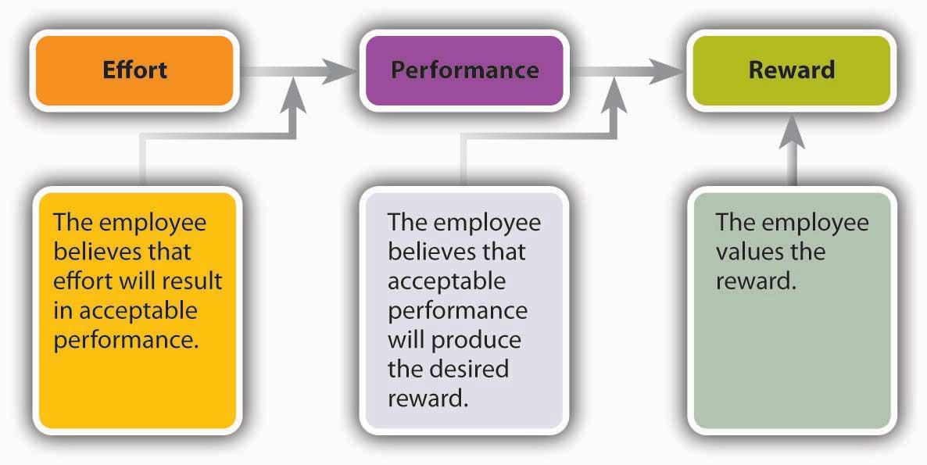
Figure 2 Vroom’s theory (1964)

The theory suggests that each individual view will determine its level of motivation. Individual factors such as knowledge, abilities, skills and experience have an impact on their performances. Vroom suggested that the source of motivation in Expectancy Theory is a "multiplicative function of instrumentality, valence and expectancy" (Stecher, 2009).
To accomplish my goals, I will need to increase my confidence and my positive thinking. I am applying Vroom's theory that taught me that I have to put more effort and improve my skills, get more knowledge, set my goals properly to meet my expectations. As a student of UWTSD while I am gathering information to complete my assessments, I will improve my skills and I will be rewarded with a Certificate in Higher Education Skills for the Workplace.

Kolb’s learning style

In furtherance to find my learning style I discovered Kolb's (1986) learning cycle (figure 3).
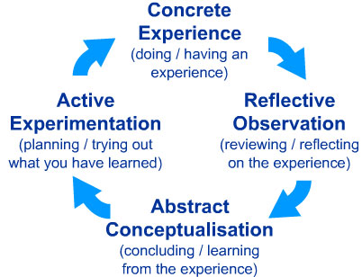
Figure 3 Kolb’s Learning Style (1986)

Kolb’s learning cycle contains four stages: concrete experience, reflective observation, abstract conceptualisation and active experimentation (Cottrell, 2010).
Analysing all my work experience in different positions during my career life I passed through different difficulties, I faced with different kind of problems. Knowledge gained during my studies was not enough in real life. Through my work experience, I learnt much more information about sales, people, business, customers. Put into practice what I learnt have improved my skills.
The second step was to make observations about my experience in the past, ask for feedback from my co-workers and employers. What I did right and what I did wrong? were the most important questions that I gave to myself.
Making a step back and reflecting, I am thankful for all my work experiences. What I have done, and I know already? Using constructive observations from my past experiences I could step into the fourth stage of Kolb's theory.
The final stage - active experimentation, analysing my experience and my current knowledge I will put into practice with a good plan my business idea.
Unconsciously, I have applied Kolb's Learning Cycle in my personal work life and on the strength of Module Personal Career Development and now I am more confident and experienced about my future career development.

Honey & Mumford learning styles
In addition to Kolb's learning cycle, I found Honey & Mumford (1986) learning styles which were expanded from David Kolb's learning model by Alan Mumford and Peter Honey. Honey & Mumford said that in order to complete their activities individuals must use one of four different learning styles. These four learning styles are activists, reflectors, pragmatists and theorists (Honey, 1982). Figure 4 Honey and Mumford’s Learning style (1986)
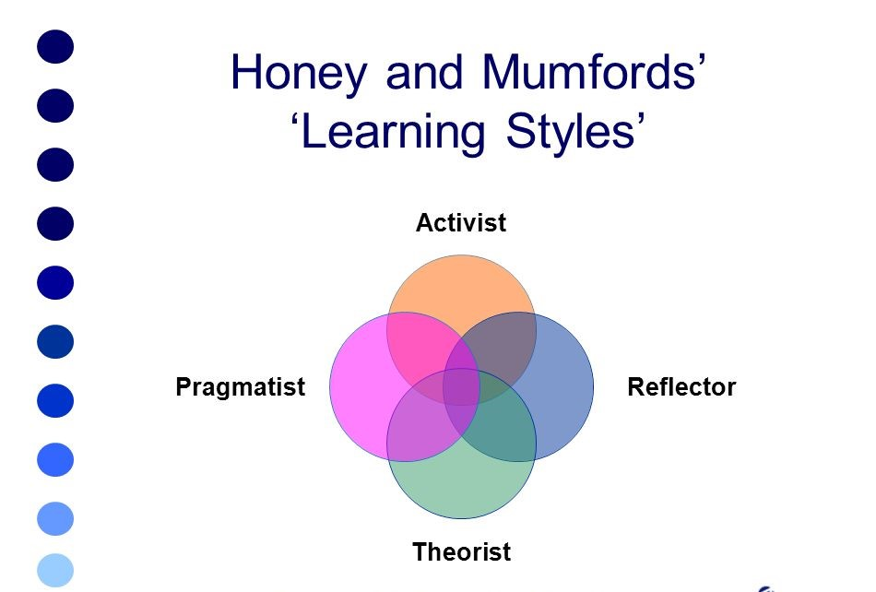
The theory also includes a learning styles questionnaire to help people to find their correct learning style or preference. Knowing my learning style will help me to find the quickest way to learn new skills, will increase my potential and improvement of myself.
The activists are people who learn by doing something rather than reading, listening or reading. Their learning activities can be problem-solving, competitions, brainstorming and finding new ideas to solve the problems.
The reflectors are people who learn by observing, watching and contemplating on what happens. They are collecting information in order to make a decision avoiding confrontation. They are gathering information from different perspectives at the same time watching from the side-lines. Learning activities: seminaries, observing activities, feedback from others, interviews.
The theorist will prefer to collect the data. They build upon theories, models, facts and concepts. Learning activities: models, statistics, quotes, stories.
Pragmatists are people who are enjoying experimenting with new information. They have the capacity to put the learning into practice with the desire to see if that will work. They learn through case studies, discussions and taking time to think about how to apply everything in reality (Pritchard, 2009).
After studying about four learning styles I did Honey & Mumford learning styles questionnaire that I found on our Moodle which helped me to find my personal learning style.
The results showed that I am an activist (18 of 20) and a pragmatist (16 of 20). I am that kind of person who likes to do new things, enjoying where I am and getting new knowledge through experimenting with new ideas, putting them into practice. I am acting first, and I consider the consequences later. An unknown author says; "Take risks: If you win, you will be happy; if you lose, you will be wise". In both cases, I win. From my experience at my workplaces and from my workmates feedback I can tell that I am the person who produces ideas, acting quickly and putting them into practice. I like taking risks and experiment new ideas, I am open minded enthusiastic and flexible.

Personal development plan

The personal development plan is the process of self-analysis, of establishing objectives and aims for the short and long term in my career, identifying the skills that I have, the skills that I have to improve and selecting the best method to achieve it.
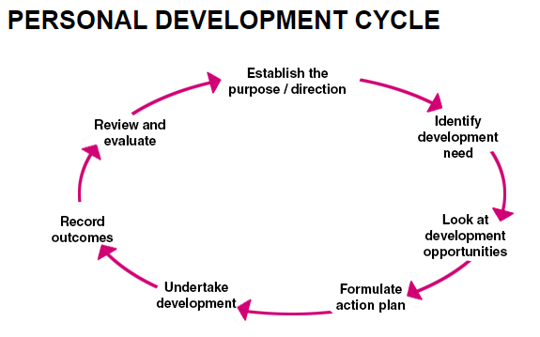
Figure 5 Personal Development Cycle

So far, during my career life, I can say that I obtained valuable experience and knowledge that helping now with my business and will help me in my future as well. Various types of jobs that I did during my life taught me how to deal with different kind of problems and persons. To help my business to grow and to become successful I needed to plan my personal career development. When reflecting on myself I will use three methods: SWOT analysis, SMART and Johari Window. Using these three different methods will help me to discover, improve my self-awareness, to enhance my strengths and to reduce my weaknesses and to discover more opportunities. Finally, this will improve the quality of my life, my ambition to become a better person and a successful businesswoman.

SWOT Analysis

SWOT Analysis is a helpful technique for a better understanding and analysing my strengths, weaknesses and to help me identify my opportunities and threats that I will confront.

STRENGTHS | WEAKNESSES
- Creativity  - Team player  - Hard working  - Continuous learner | - Communications skill  - Presentation skill  - Time management  - Too sensitive  - Initiative
OPPORTUNITIES | THREATS
- fewer competitors in my area  - the emerging need for education  - customer reviews | - emerging competitors  - regularly changing of legislation  - negative/stressful customers

Strengths

Creativity
I describe myself as a creative person, no matter of the domain I work for. Whenever I work in a group with my classmates or workmates, I tend to create wonderful solutions and ideas that everyone likes from the first second of sharing. For instance, for the first presentation at the UWTSD, we had to develop a business plan. I shared my idea to open a fresh juice shop, where everyone can create their own juices by choosing fruits and vegetables from the shop. Analyzing the score for our presentation, our group had the best results.

Team player
In my academic life, I worked in groups in which I manage to discuss and share my ideas. Also, I can listen to the team members and that makes a group stronger.

Hard working
I am a hardworking person especially when I am motivated. During my career, due to my effort to do my best, I was quickly promoted and appreciated for my hard work. Also, I increased the number of customers and sales by 10% in a very short time.

Continuous learner
I can say about myself that I always had the desire to learn, I never stopped learning. Even when I come in the UK first time, I could not speak any English, but my desire to become a better and qualified person made I learn the language and at the moment I am a student enrolled in UWTSD. I am proud of myself, but I am not planning to stop. I am developing myself in different areas, that is the only method to find my way in my career life.

Weaknesses

Communication skill
As English is not my first and even not my second language, I had difficulties talking and properly express myself. But the good thing is I am not giving up, and I keep improving by reading, watching English movies, talking with native English people whenever I have the occasion.
Presentation skill
The presentation is the best method to show yourself. The fear not to say wrong words or do mistakes sometimes stop me to do presentations and to speak in public.
Time management
Even though I am always planning ahead sometimes I got troubles with my time management. At the end of the day, I am cutting from my sleep time to get everything done.
Too sensitive
One of the weaknesses that I have, I am too sensitive to criticism. I simply do not accept it, I do not accept the fact that I am wrong. In a team is important to accept constructive criticism. I am working on that, and I am trying not to take it personally but instead listen to it and try to learn from it. On the other hand, this skill can be qualified as a strengths and I can use it to perform myself.
Initiative
I feel very confident and I can work and share ideas in a group of people, but when it comes to take initiative and speak in public, I remain silent. Once I will improve my English, I know this will come automatically.

Opportunities

Fewer competitors in my area - We choose to rent our office in an area with fewer competitors, so our clients will not be tempted to go with our competitors. So, in our building, we are the only company who is doing this type of business.

The emerging need for education - Everyone needs an education in this country, for a better life, and better opportunities. To convince our customers to choose our services it becomes a need for them.

Customer reviews - We are having different customers, with different types of problems. We are doing our best to solve its problems and they highly recommend us to all their friends.

Threats

Emerging competitors - As we are a small company at the moment, we deal with our competitors, trying to offer the best options to our potential customers, so they will choose our company, instead of our competitors. As a company, we see each of our clients as a friend, trying to get deeper into their situations and find the best solution for them.
Regularly changing of legislation - our business is mostly based on the legislation. Regularly changes in the legislation can cause us difficulties. We should be aware of that and try to be informed all the times with any changes in legislation, as this can affect our clients.

Johari Window

Joseph Luft and Harry Ingham created Johari Window in 1955 (figure 6) as a tool for understanding and training personal development, relationships with different groups of people, improve the communication skill and team development.
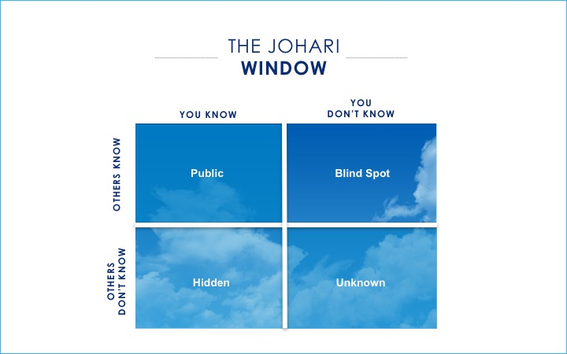
Figure 6 Johari Window
Johari Window is very useful to reflect on: how I see myself, how others see myself, what is hidden and what is unknown.
To improve my self-awareness and personal development between me and individuals I decided that is necessary to ask for feedback from others. Johari Window contains four sections which are: open/free area, blind area, hidden area and unknown area. The open and hidden are is what I know about myself. Blind spot is information about myself that others know about myself, but I am not aware of. The unknown area is information that I am unaware of as well as for others (Morgan, 2016).
I asked people that surround me what they knew about me, that I knew? And another question: what did they know about me that I did not know about myself?
The hidden area includes information about myself that I do not want others to know about, and this includes personal information or fears. The unknown area includes information about me that I am not aware of and either the people that surround me do not know about this anything.
Analysing all the answers and feedback increased my open area and reduce the size of my blind area. My open area showed that I am an organized, honest, trustworthy, friendly and optimistic person. I found out about me (blind area) that I talk more than I listen, sometimes I interrupt the discussions to say my idea, I have no patience with people. My hidden area showed that I am a conservative, spontaneous and idealistic person. The unknown area which I did not know, and no one knew showed that I do not have enough confidence, lack of opportunities and encouragement.
By working through Johari Window, I discovered aspects that neither I or my colleagues did not know about. I decided to think about how I can improve my skills and develop a strategy to improve myself. I start to think that I have to listen more, and that will allow people to be more opened with me and share their ideas, that will increase their confidence in me. Another step is to increase my personal confidence by getting more knowledge in my field and attend some pieces of training.

S.M.A.R.T. Objectives

Having a goal whether in my business or personal life gives me something to work towards and focus on. When studying online sources and books I come across a goal setting method called Smart Goals by George T. Doran (Doran, There's a S.M.A.R.T. Way to Write Management's Goals and Objectives", 1981). Setting goals provide the motivational energy to continue even when your level of energy is low. The most well-known goal setting method is SMART that encourages to make goals Specific, Measurable, Agreed or Attainable, Realistic and Time-bound.
By analysing the theory, I decided to set a few goals for myself, that will increase my chances of success in my personal and professional life. The first goal about my professional life is to be more serious when discussing with partners and customers. For this, I have to train myself in being more serious about deadlines, making a diary with all the calls I have to give, and all the jobs I have to do.
Another goal is to improve my communication techniques and academic skills. Till the end of the summer, I am planning to register for some English Courses and to attend some training about how to increase the profit of my new company.
The most important goal for me will refer to my personal life. As I got very busy with my new job, University, customers and all this stuff I do not have free time to spend it with my little son which requires a lot of attention. I feel very guilty because of that and I am planning in the next couple of months to arrange everything and to allow more free time for my son.

Personal development plan

After analysing all the data, analysing the theories and different methods to discover myself and to improve my skills, I decided is time to set up three goals which will be fundamental for my life. The first goal is short-term and should be achieved by me in the next three months, the second goal is mid-term and should be done in six to twelve months and the third and last one is a long-term goal which should be achieved in the one-two years’ time.
My short-term plan is to finish my Certificate in Higher Education Skills for the Workplace successfully. I am doing very well till now and I am very proud of myself that I could manage to do it by myself without any help. I become more confident and I earned a lot of knowledge during this year.
My mid-term goal is to enrol in University for a BA degree, but for this, I will need to graduate with success from higher education. For this, I have to do my assignments on time and to meet all the criteria. To be prepared I have to make sure I have the rights resources for my assignments and the right techniques. I have started my assignments from the third week of the last term as I did not want to leave it for the last minute.
My long-term plan is related to my business. After finishing this course, I am more experienced, with new knowledge about how to manage and grow my business. In the next two years’ time, I am planning to extend my business and I am excepting to earn more money. To make my dream become reality I have to stay more focused and to be more organized in my activities. Also, I am doing research related to my business so I will be more informed, and I would help my customers with their problems.

Conclusion

During this course "Personal Career Development" I learned a lot of new information. I discovered more myself, I learned that to make plans is very important, I learned. Also due to feedback from my colleagues, I succeed to become a better person and employer. I consider this course essential for my future and is not just a particular course at the University, it became a very important lesson for my entire life. I am thankful for the chance I had to be the student of this University and to take part in it. One year ago, my life was completely different with lack of confidence, personality and ideas. I can see that my life improved its quality and completely changed in a better way.

Bibliography
Adar, J. (2009). Effective Motivation . London: Pan Macmilllan.
Cottrell, S. (2010). Skills for Success: Personal Development and Employability. Hampshire: Palgrave MacMillan.
Doran, G. T. (1981). There's a S.M.A.R.T. Way to Write Management's Goals and Objectives. Management Review, 35-36.
Doran, G. T. (1981). There's a S.M.A.R.T. Way to Write Management's Goals and Objectives". Management Review, 35-36.
Honey, P. &. (1982). Manual of Learning Styles. London: Honey.
Kolb, D. A. (1984). The process of experiential learning. New Jerssey: Prentice Hall.
Morgan, P. (2016). The Business Student’s Guide to Study and Employability. London: Sage Publications.
Pritchard, A. (2009). Ways of learning: Learning theories and learning styles in the classroom (2nd ed.). New York: Routledge.
Rohn, J. (2014). 8 Best Success Lessons . London: Amazon.
Stecher, M. a. (2009). Understanding reactions to workplace injustice trhough process theories of motivation: A teaching module and simulation. Journal of Management Education , 781.
University League Tables . (2019, March 25). Retrieved from The Complete University Guide: https://www.thecompleteuniversityguide.co.uk/league-tables/rankings
Vroom, V. H. (1964). On the validity of the Vroom-Yetton model. Journal of Applied Psychology, 151-162.

